SOL 1:

#include <stdio.h>

#include <stdlib.h>

int main()

{

int n;

double \*data;

printf("Enter the total number of elements: ");

scanf("%d", &n);

data = (double \*)calloc(n, sizeof(double));

if (data == NULL)

{

printf("Error!!! memory not allocated.");

exit(0);

}

for (int i = 0; i < n; ++i)

{

printf("Enter number%d: ", i + 1);

scanf("%lf", data + i);

}

for (int i = 1; i < n; ++i)

{

if (\*data < \*(data + i))

{

\*data = \*(data + i);

}

}

printf("Largest number = %.2lf", \*data);

free(data);

return 0;

}

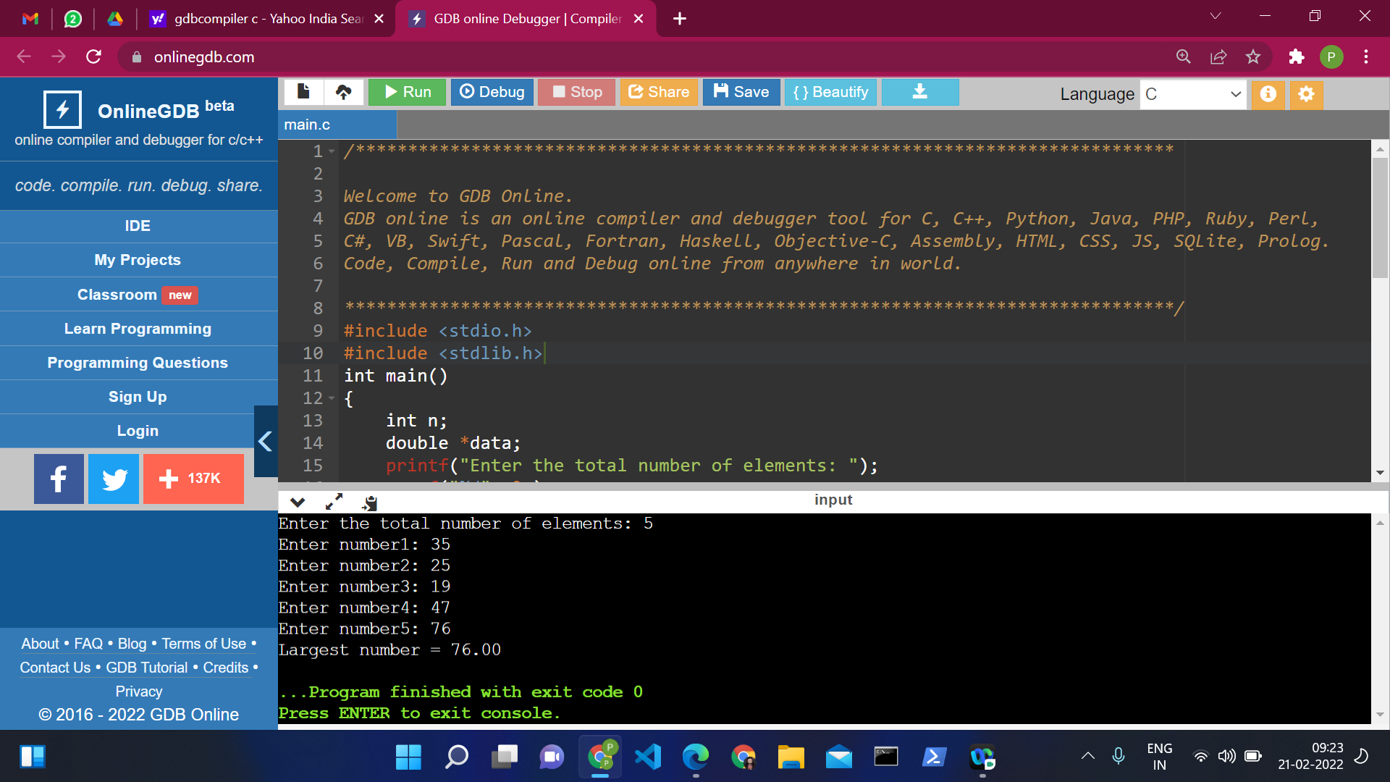

SOL 2:

#include <stdio.h>

#include <stdlib.h>

int main()

{

int \*ptr;

int n, i;

printf("Enter number of elements: ");

scanf("%d",&n);

ptr = (int\*)calloc(n, sizeof(int));

if (ptr == NULL)

{

printf("No memory allocated.\n");

exit(0);

}

else

{

printf("Memory successfully allocated using calloc.\n");

free(ptr);

printf("Calloc Memory successfully freed.\n");

}

return 0;

}

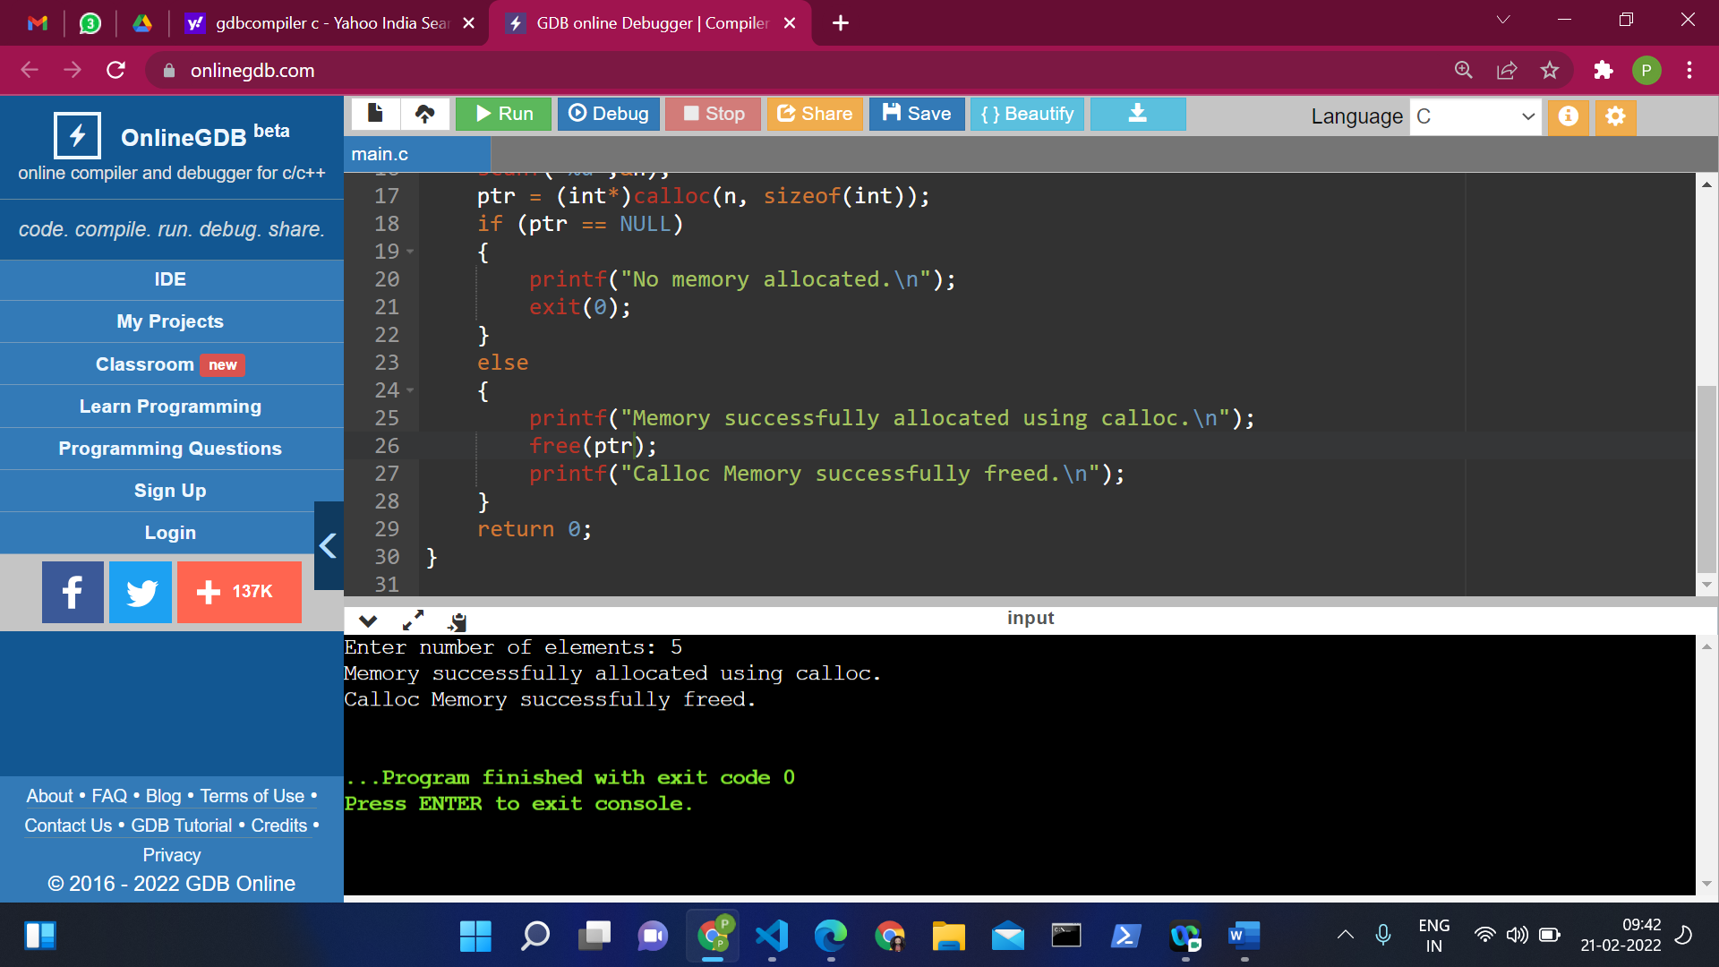

SOL 3:

#include<stdio.h>

void fact(int,int \*\*);

int main()

{

int i,factorial,n, \*ptr1, \*\*ptr2;

ptr1= &factorial;

ptr2 = &ptr1;

printf("Enter a number: ");

scanf("%d",&n);

fact(n, &ptr1);

printf("Factorial of %d is: %d",n,factorial);

return 0;

}

void fact(int n,int \*\*factorial)

{

int i;

\*\*factorial =1;

for(i=1;i<=n;i++)

{

\*\*factorial=\*\*factorial\*i;

}

}

