SOL1:

#include <stdio.h>

#include <string.h>

struct personal

{

char name[30],address[100],doj[10];

int age;

float salary;

};

int main()

{

struct personal details;

int i;

char det[5];

printf("--Enter details--\n");

printf("Name: ");

gets(details.name);

printf("Age: ");

scanf("%d",&details.age);

printf("Address: ");

gets(details.address);

printf("\nDate Of Joining: ");

gets(details.doj);

printf("Salary: ");

scanf("%f",&details.salary);

printf("\nEntered detail is:");

printf("\nName: %s",details.name);

printf("\nAge: %d",details.age);

printf("\nAddress: %s",details.address);

printf("\nDate Of Joining: %s",details.doj);

printf("\nSalary: %f\n",details.salary);

return 0;

}

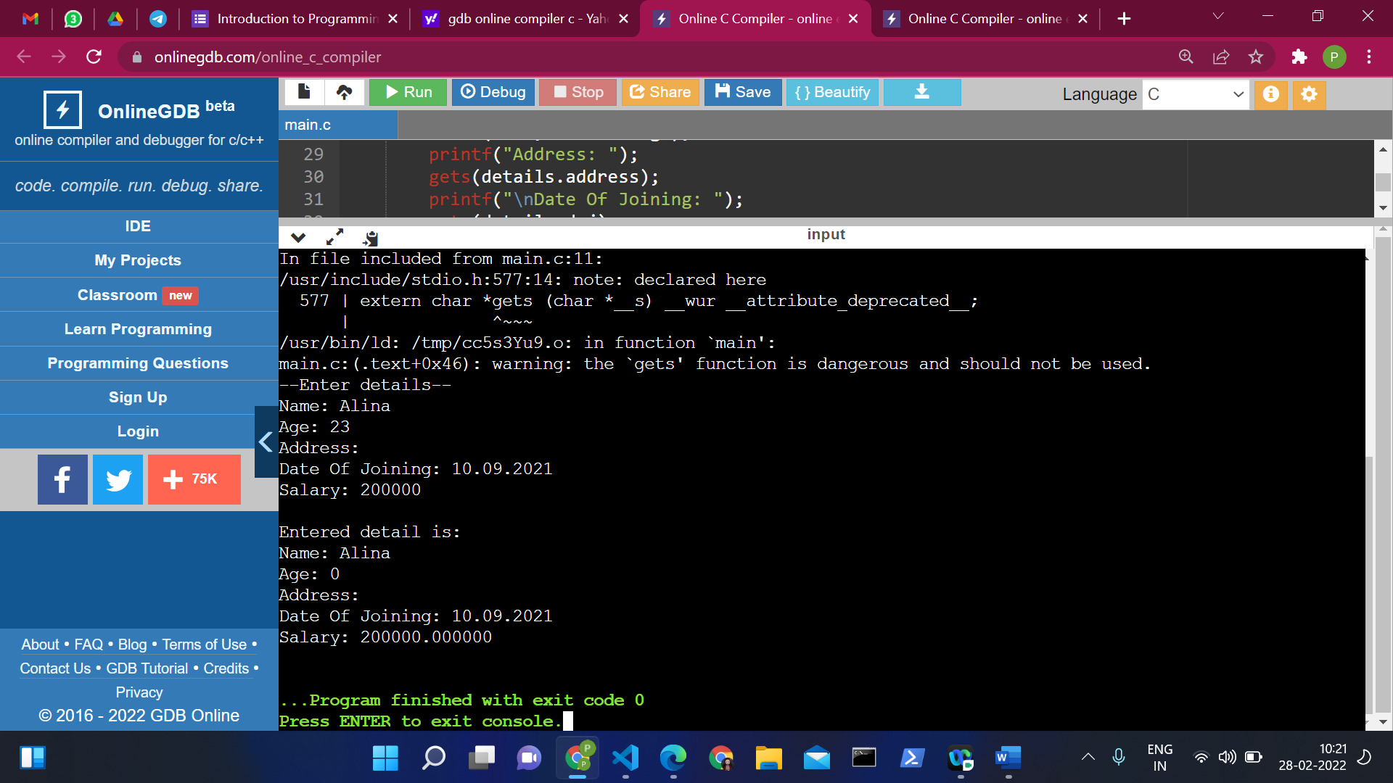

Sol 2:

#include <stdio.h>

#include <stdlib.h>

typedef struct

{

char name[30],address[30],doj[10];

int age;

double salary;

}

personal;

int main()

{

//number of employees

int n=5;

//array to store structure values of all employees

personal employees[n];

//Taking each employee detail as input

printf("Enter %d Employee Details \n \n",n);

for(int i=0; i<n; i++){

printf("Employee %d:- \n",i+1);

//Name

printf("Name: ");

scanf("%[^\n]s",employees[i].name);

//AGE

printf("Age: ");

scanf("%d",&employees[i].age);

printf("Address: ");

scanf("%[^\n]s",employees[i].address);

printf("Date of joining: ");

scanf("%[^\n]s",employees[i].doj);

//Salary

printf("Salary: ");

scanf("%lf",&employees[i].salary);

//to consume extra '\n' input

char ch = getchar();

printf("\n");

}

//Displaying Employee details

printf("-------------- All Employees Details ---------------\n");

for(int i=0; i<n; i++){

printf("Name \t: ");

printf("%s \n",employees[i].name);

printf("Age \t: ");

printf("%d \n",employees[i].age);

printf("Address \t: ");

scanf("%s\n",employees[i].address);

printf("Date of joining \t: ");

scanf("%s\n",employees[i].doj);

printf("Salary \t: ");

printf("%.2lf \n",employees[i].salary);

printf("\n");

}

return 0;

}

