SOL1:

#include<stdio.h>

struct student

{

int sub1;

int sub2;

int sub3;

};

void main()

{

struct student s[10];

int i,total=0;

for(i=0;i<=2;i++)

{

printf("\nEnter Marks in Three Subjects = ");

scanf("%d%d%d",& s[i].sub1,&s[i].sub2,&s[i].sub3);

total=s[i].sub1+s[i].sub2+s[i].sub3;

printf("\nTotal marks of s[%d] Student= %d",i,total);

}

}

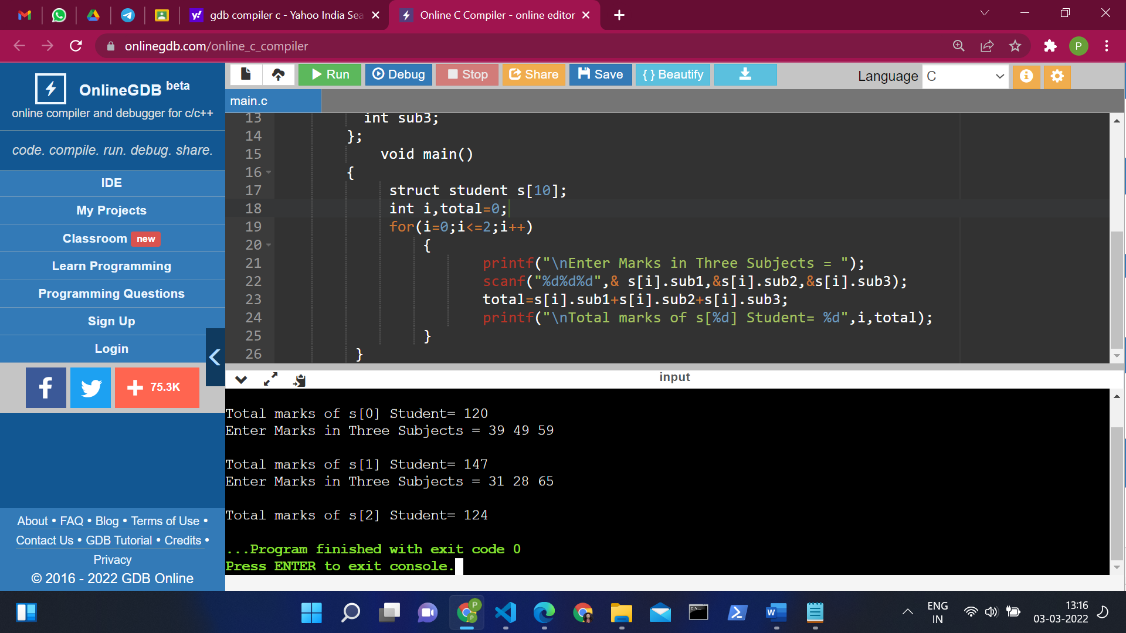

SOL 2:

#include <stdio.h>

struct student

{

char name[50];

int age;

};

void display(struct student s);

int main() {

struct student s1;

printf("Enter name: ");

scanf("%[^\n]%\*c", s1.name);

printf("Enter age: ");

scanf("%d", &s1.age);

display(s1);

return 0;

}

void display(struct student s)

{

printf("\nDisplaying information\n");

printf("Name: %s", s.name);

printf("\nAge: %d", s.age);

}

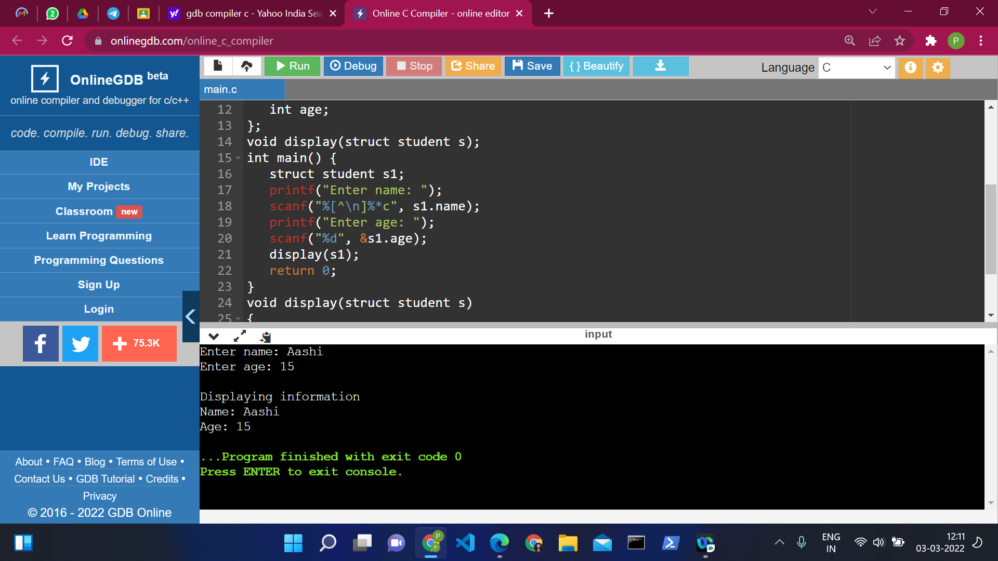

SOL 3:

#include <stdio.h>

#include <stdlib.h>

void main()

{

    FILE \*fp;

    char str;

    fp=fopen("A.c","r");

    printf("\nThe content of the file %s is :\n");

    str = fgetc(fp);

    while (str != EOF)

        {

            printf ("%c", str);

            str = fgetc(fp);

        }

    fclose(fp);

}

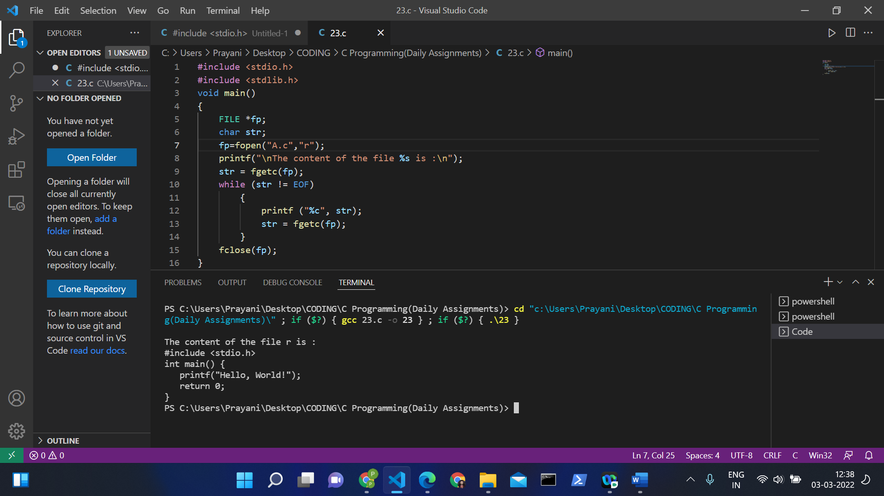

SOL 4:

#include <stdio.h>

#include <ctype.h>

void main()

{

    FILE \*fp;

    char str;

    fp=fopen("A.txt","w");

    do

    {

        putc(toupper(str=getchar()),fp);

    } while (str!='\n');

    fclose(fp);

}

