SOL1:

#include <stdio.h>

int main()

{

    FILE *fp;

    int count_lines = 0;

    char filechar[40], chr;

    printf("Enter file name: ");

    scanf("%s", filechar);

    fp = fopen(filechar, "r");

    chr = getc(fp);

    while (chr != EOF)

    {

        if (chr == 'n')

        {

            count_lines = count_lines + 1;

        }

        chr = getc(fp);

    }

    fclose(fp);

    printf("There are %d lines in %s  in a file\n", count_lines, filechar);

    return 0;

}

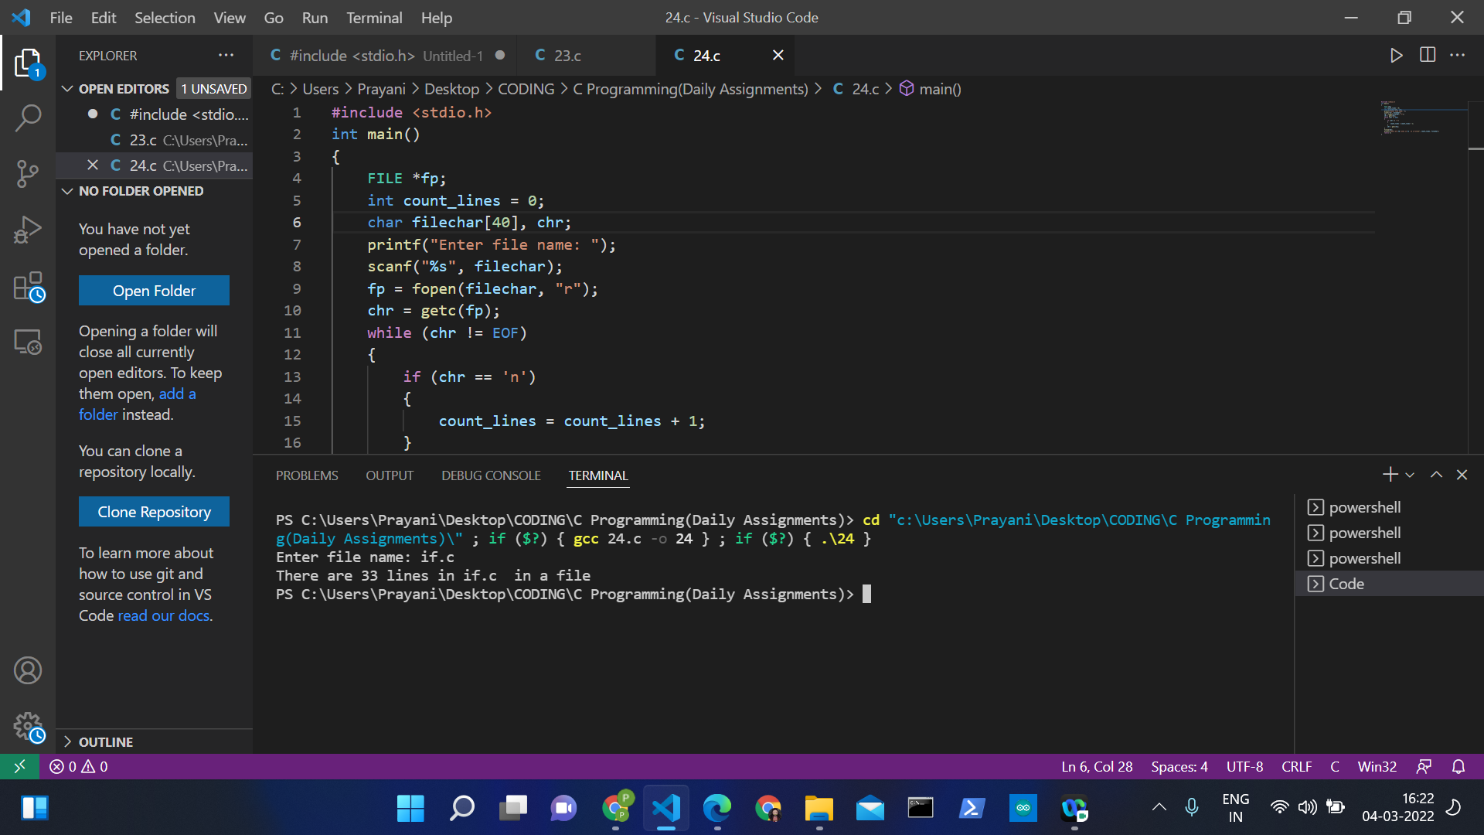

SOL2:

#include <stdio.h>

#include <stdlib.h>

int main()

{

    FILE * file;

    char name[100];

    char ch;

    int characters, words, lines;

    printf("Enter file name: ");

    scanf("%s", name);

    file = fopen(name, "r");

    if (file == NULL)

    {

        printf("\nUnable to open file.\n");

        printf("Please check if file exists and you have read privilege.\n");

        exit(EXIT_FAILURE);

    }

    characters = words = lines = 0;

    while ((ch = fgetc(file)) != EOF)

    {

        characters++;

        if (ch == '\n' || ch == '\0')

            lines++;

        if (ch == ' ' || ch == '\t' || ch == '\n' || ch == '\0')

            words++;

    }

    if (characters > 0)

    {

        words++;

        lines++;

    }

    printf("Total characters = %d\n", characters);

    printf("Total words      = %d\n", words);

    printf("Total lines      = %d\n", lines);

    fclose(file);

    return 0;

}

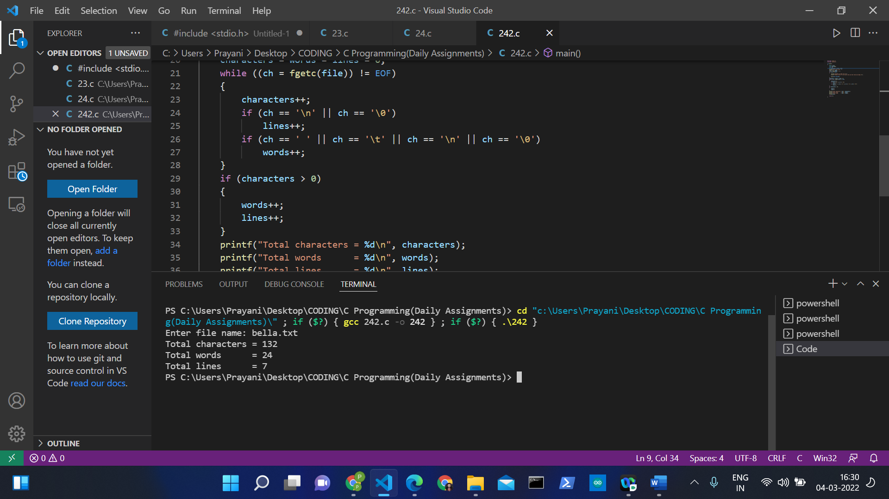

SOL 3:

#include <stdio.h>

int main ()

{

  FILE * fptr;

  int i,n;

  char str[100];

  char fname[20];

  char str1;

  printf("ENTER FILE NAME: ");

  scanf("%s",fname);

  fptr = fopen(fname, "a");

  printf("ENTER NO. OF LINES TO  BE ADDED: ");

  scanf("%d", &n);

  printf("ENTER THE LINES: \n");

  for(i = 0; i < n+1;i++)

  {

    fgets(str, sizeof str, stdin);

    fputs(str, fptr);

  }

  fclose (fptr);

  fptr = fopen (fname, "r");

  printf("\nTHE CONTENT OF THE FILE %s is  :\n",fname);

  str1 = fgetc(fptr);

  while (str1 != EOF)

  {

      printf ("%c", str1);

      str1 = fgetc(fptr);

   }

   printf("\n\n");

   fclose (fptr);

   return 0;

}

