**SOL 1:** Sum of square of first N natural nos.

#include <stdio.h>

int main()

{

int N,i,sum=0;

printf("Enter No. Of Terms:",N);

scanf("%d",&N);

for (i=0;i<=N;i++)

{

sum += (i*i);

}

printf("\n Sum of squares of first %d number is: %d",N,sum);

return 0;

}

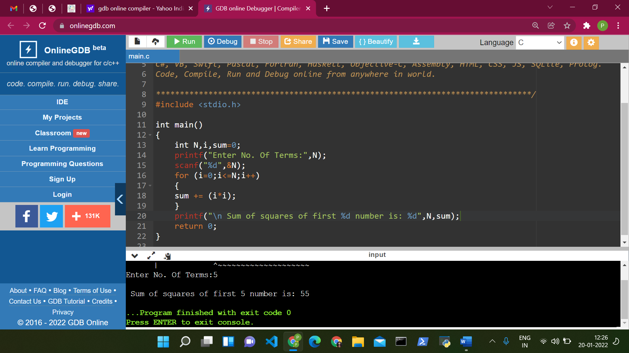

**Sol2:** SUM OF N NATURAL NOS.

#include <stdio.h>

int main()

{

int N,i,sum=0;

printf("Enter The Last Term:",N);

scanf("%d",&N);

for (i=0;i<=N;i++)

{

sum=sum+i;

}

printf("\n Sum of first %d number is: %d",N,sum);

return 0;

}

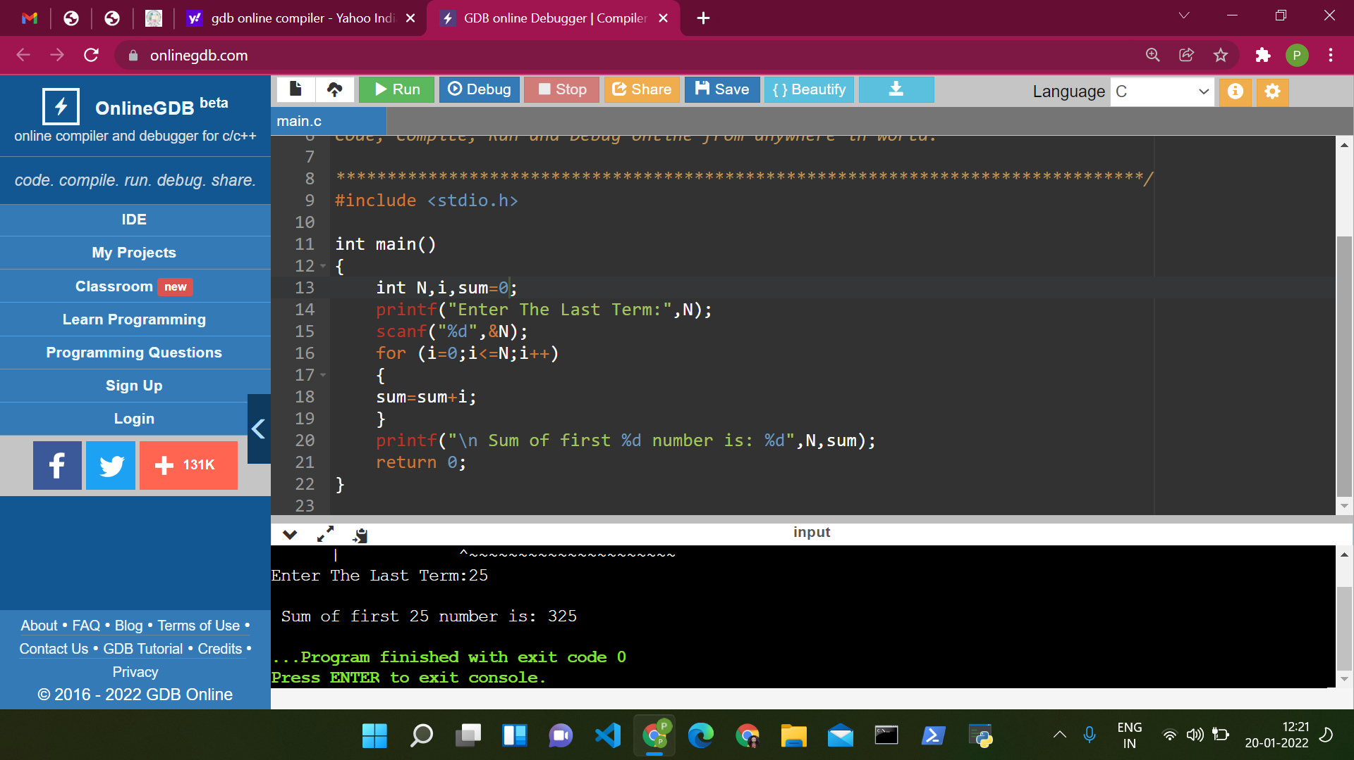

**SOL 3:** Addition of all even and odd number from a to b

#include <stdio.h>

int main()

{

int a,b,i,esum=0,osum=0;

printf("Enter value of a=",a);

scanf("%d",&a);

printf("Enter value of b=",b);

scanf("%d",&b);

for (i=a;i<=b;i++)

{

if (i%2==0)

{

esum=esum+i;

}

else

{

osum=osum+i;

}

}

printf("\n Sum of squares all even numbers is: %d",esum);

printf("\n Sum of squares all odd numbers is: %d",osum);

return 0;

}

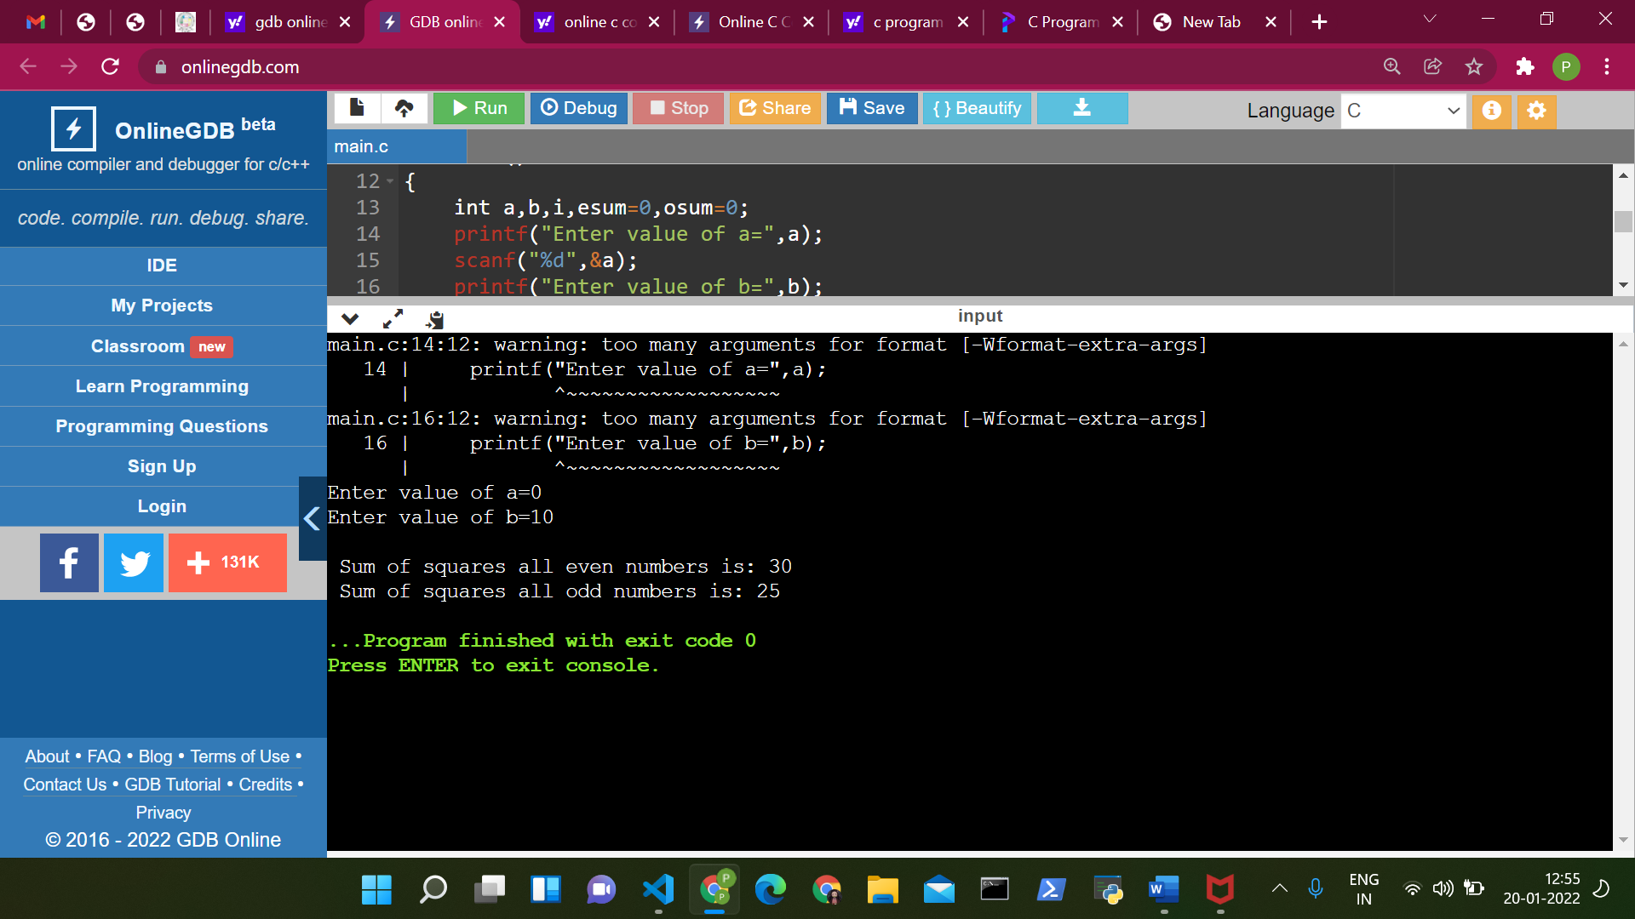

**Sol 4:**

int main()

{

int n,i,rem;

printf("Enter a no.=",n);

scanf("%d",&n);

for (i=2;i<=n/2;i++)

{

if (n%i==0)

{

rem==1;

break;

}

if (n==0||n==1)

{

printf("%d is neither prime nor composite.",n);

}

else

{

printf("%d is not a prime no.",n);

}

}

return 0;

}

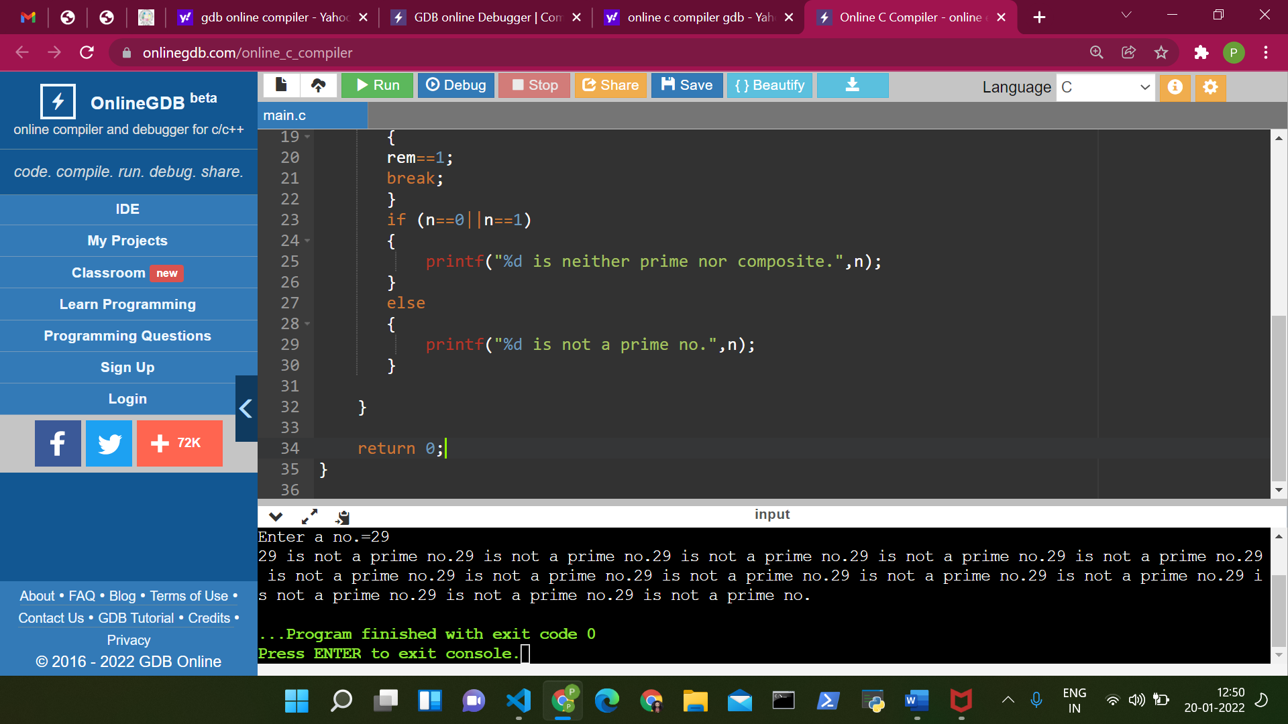

Sol 5:

#include <stdio.h>

int main() {

int num, originalNum, remainder, result = 0;

printf("Enter a three-digit integer: ");

scanf("%d", &num);

originalNum = num;

while (originalNum != 0) {

// remainder contains the last digit

remainder = originalNum % 10;

result += remainder * remainder * remainder;

// removing last digit from the orignal number

originalNum /= 10;

}

if (result == num)

printf("%d is an Armstrong number.", num);

else

printf("%d is not an Armstrong number.", num);

return 0;

}

