**Sol 1:**

#include <stdio.h>

int main()

{int i,j;

for(i=1;i<=5;i++)

{

printf("\n");

for(j=1;j<=i;j++)

{

printf("*");

}

}

return 0;

}

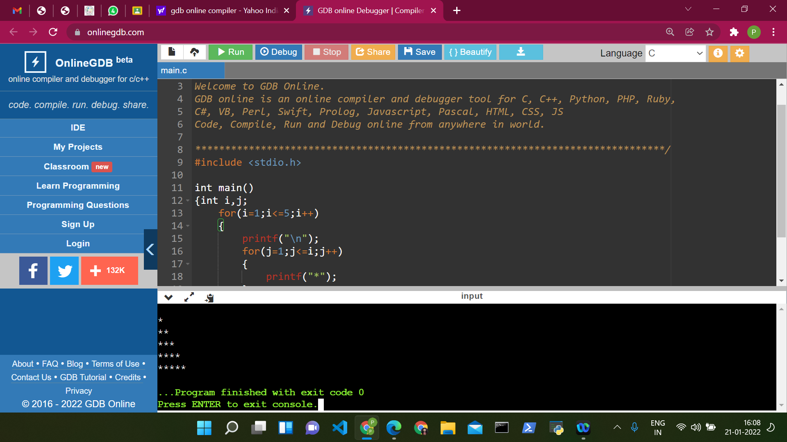

**Sol2:**

**#include <stdio.h>**

**int main()**

**{int i,j;**

**for(i=1;i<=5;i++)**

**{**

**printf("\n");**

**for(j=1;j<=i;j++)**

**{**

**printf("%d",j);**

**}**

**}**

**return 0;**

**}**

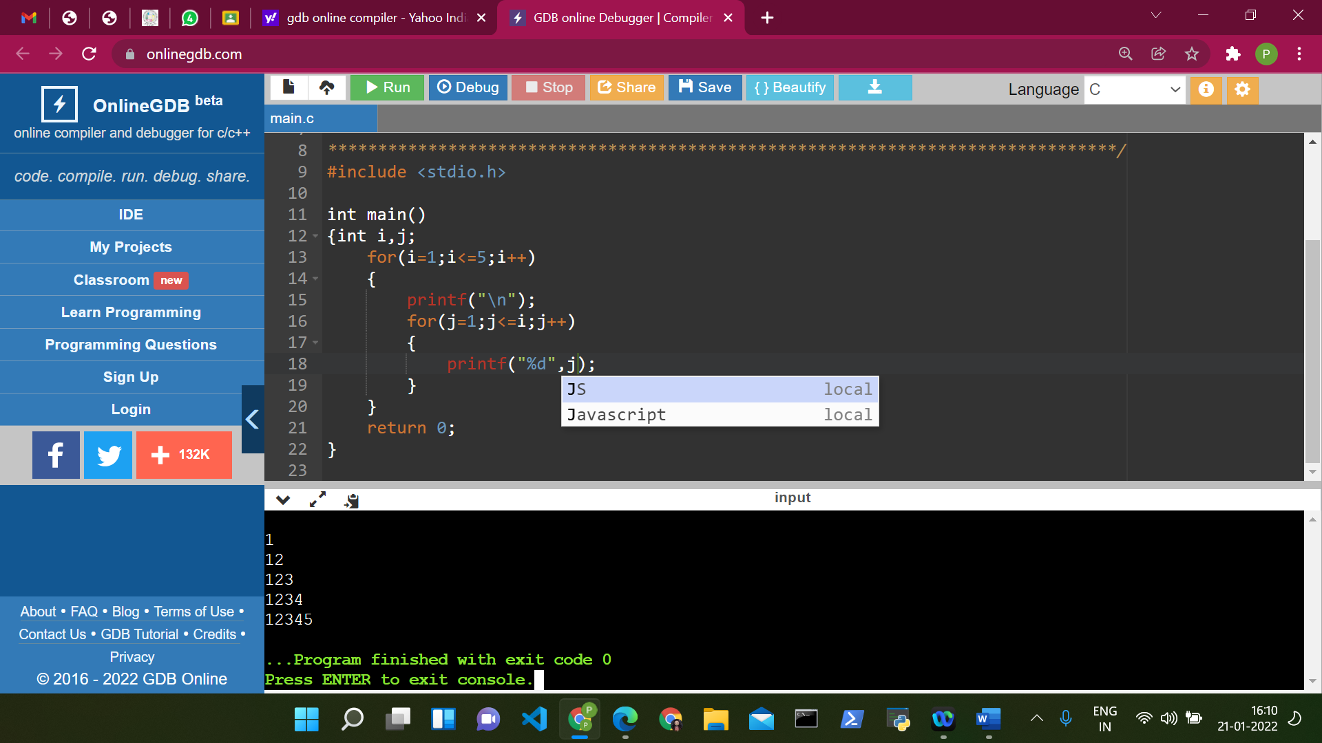

**Sol 3:**

#include <stdio.h>

int main() {

int i, j, rows;

printf("Enter the number of rows: ");

scanf("%d", &rows);

for (i = rows; i >= 1; --i) {

for (j = 1; j <= i; ++j) {

printf("* ");

}

printf("\n");

}

return 0;

}

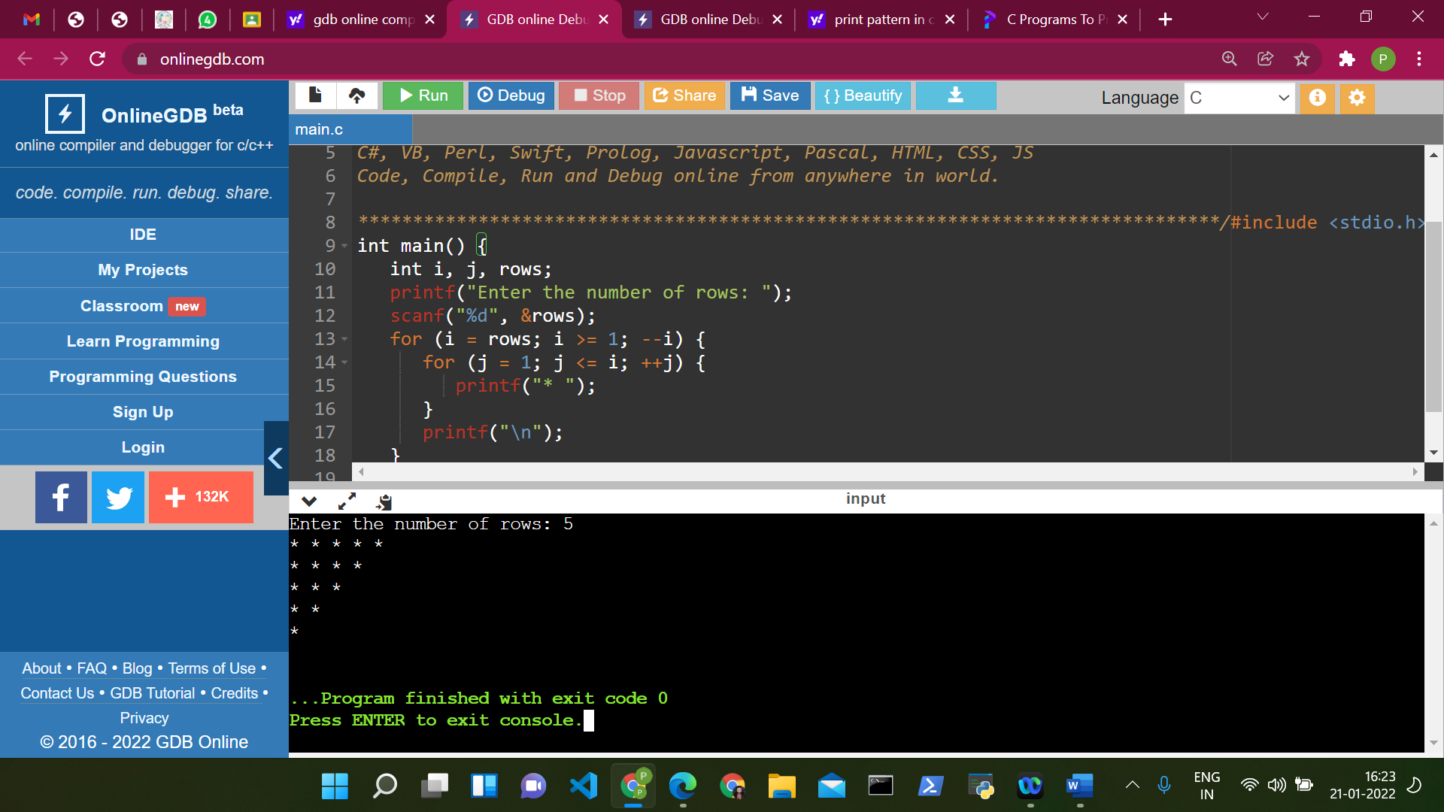

**Sol 4:**

#include <stdio.h>

int main() {

int i, j;

char input, alphabet = 'A';

printf("Enter an uppercase character you want to print in the last row: ");

scanf("%c", &input);

for (i = 1; i <= (input - 'A' + 1); ++i) {

for (j = 1; j <= i; ++j) {

printf("%c ", alphabet);

}

++alphabet;

printf("\n");

}

return 0;

}

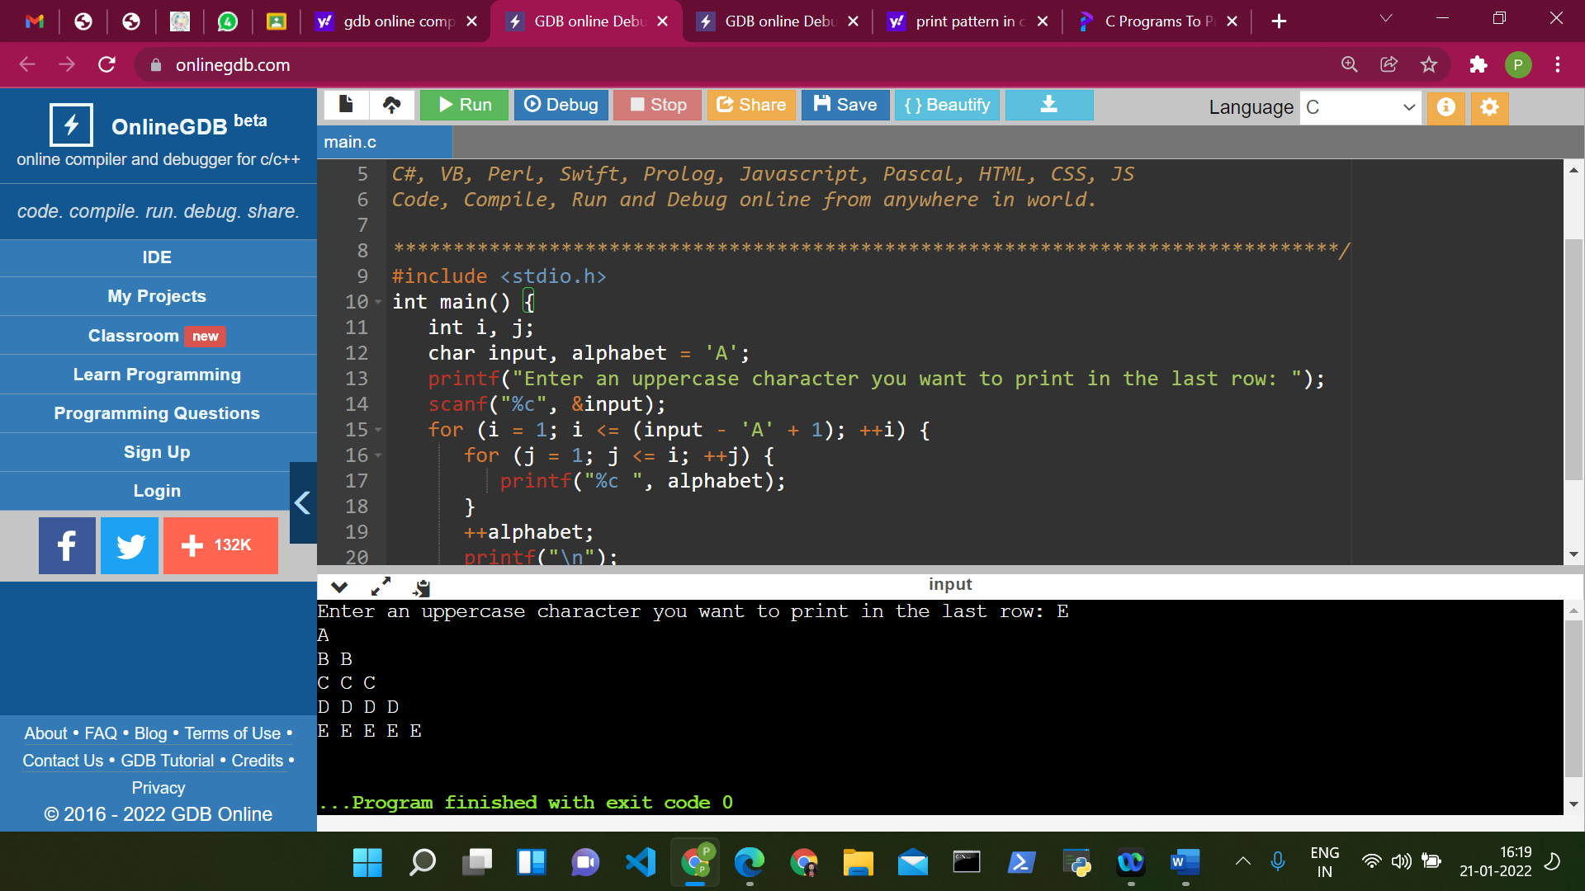

**Sol 5:**

#include <stdio.h>

int main() {

int i, j, rows;

printf("Enter the number of rows: ");

scanf("%d", &rows);

for (i = rows; i >= 1; --i) {

for (j = 1; j <= i; ++j) {

printf("%d ",j);

}

printf("\n");

}

return 0;

}

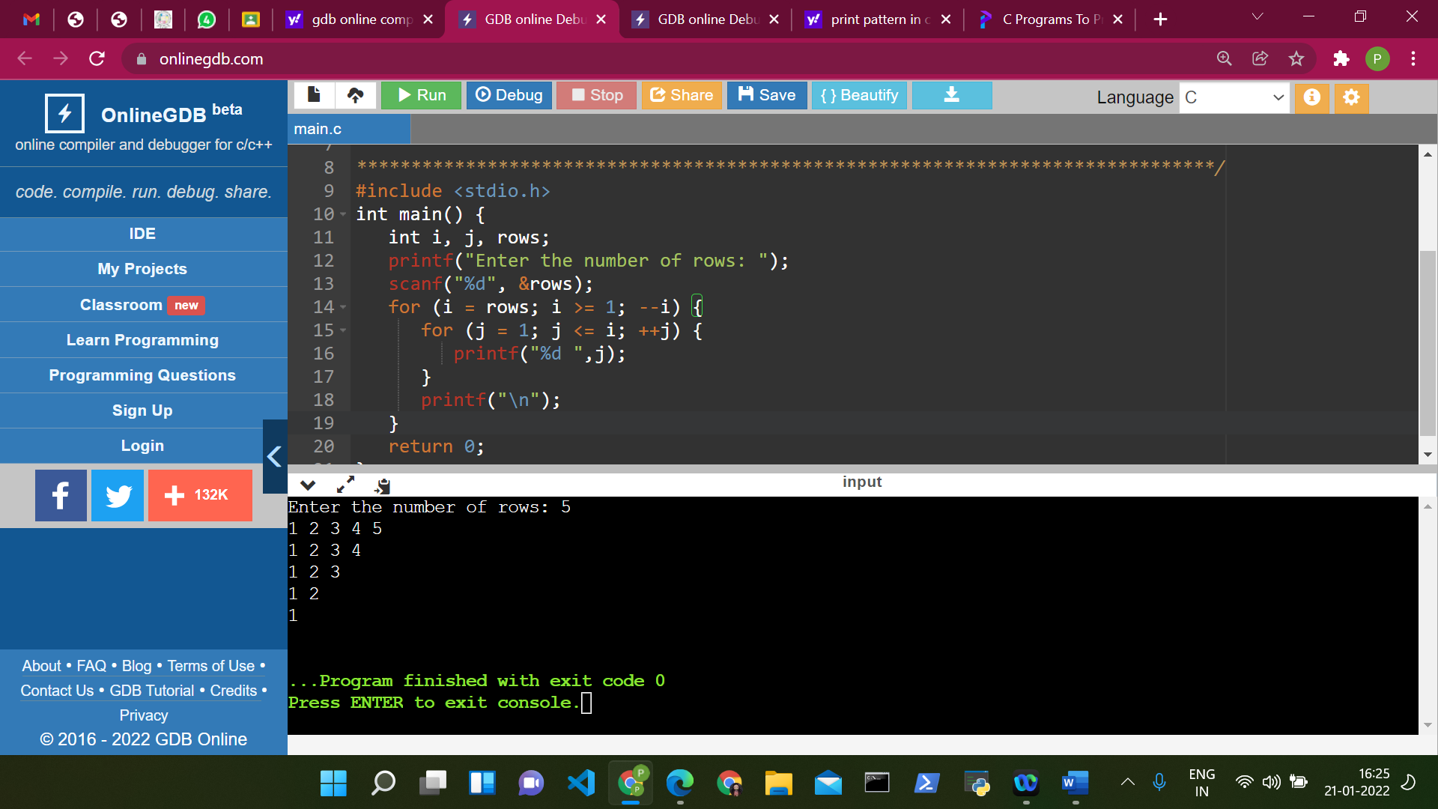

**Sol 6:**

#include <stdio.h>

int main() {

int rows, i, j, number = 1;

printf("Enter the number of rows: ");

scanf("%d", &rows);

for (i = 1; i <= rows; i++) {

for (j = 1; j <= i; ++j) {

printf("%d ", number);

++number;

}

printf("\n");

}

return 0;

}

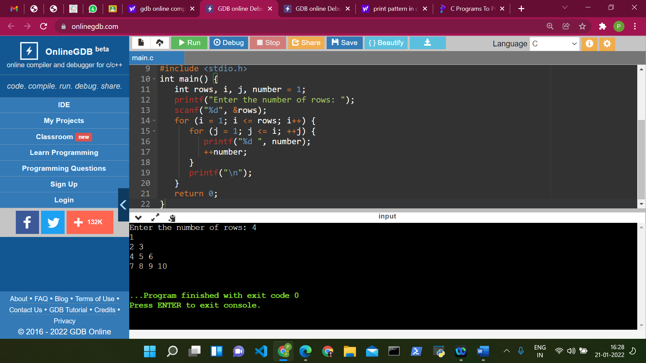

Sol 7:

#include <stdio.h>

int main() {

int i, spc, r, k = 0;

printf("Enter the number of rows: ");

scanf("%d", &r);

for (i = 1; i <= r; ++i, k = 0) {

for (spc = 1; spc <= r - i; ++spc) {

printf(" ");

}

while (k != 2 * i - 1) {

printf("* ");

++k;

}

printf("\n");

}

return 0;

}

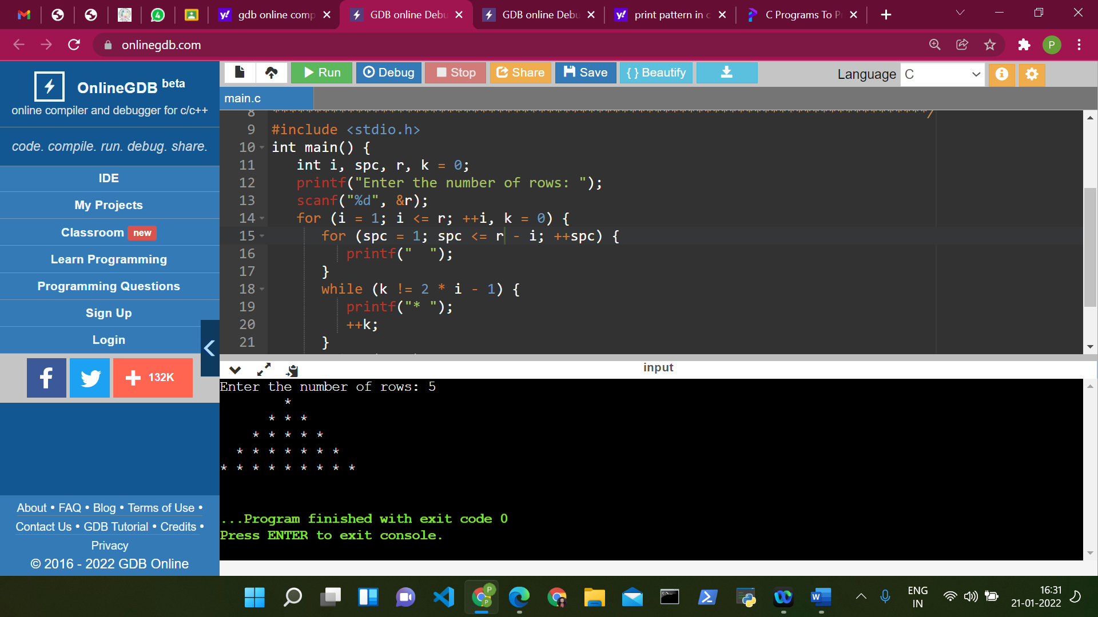

**Sol 8:**

#include<stdio.h>

int main()

{

int n, x, y, k;

printf("Enter the number of rows to show star pattern: ");

scanf("%d",&n);

for(x =1; x <= n; x++)

{

for(y =1; y <= n; y++)

{

if(y <= x)

printf("*");

else

printf(" ");

}

for(y = n; y >= 1;y--)

{

if(y <= x)

printf("*");

else

printf(" ");

}

printf("\n");

}

return 0;

}

