**SOL 1:**

**#include<stdio.h>**

**const float PI = 3.1415927;**

**float area(float radius);**

**void main() {**

**float radius;**

**printf("Enter radius: ");**

**scanf("%f", &radius);**

**printf("Area : %.3f\n", area(radius));**

**}**

**float area(float radius) {**

**return PI * radius * radius;**

**}**

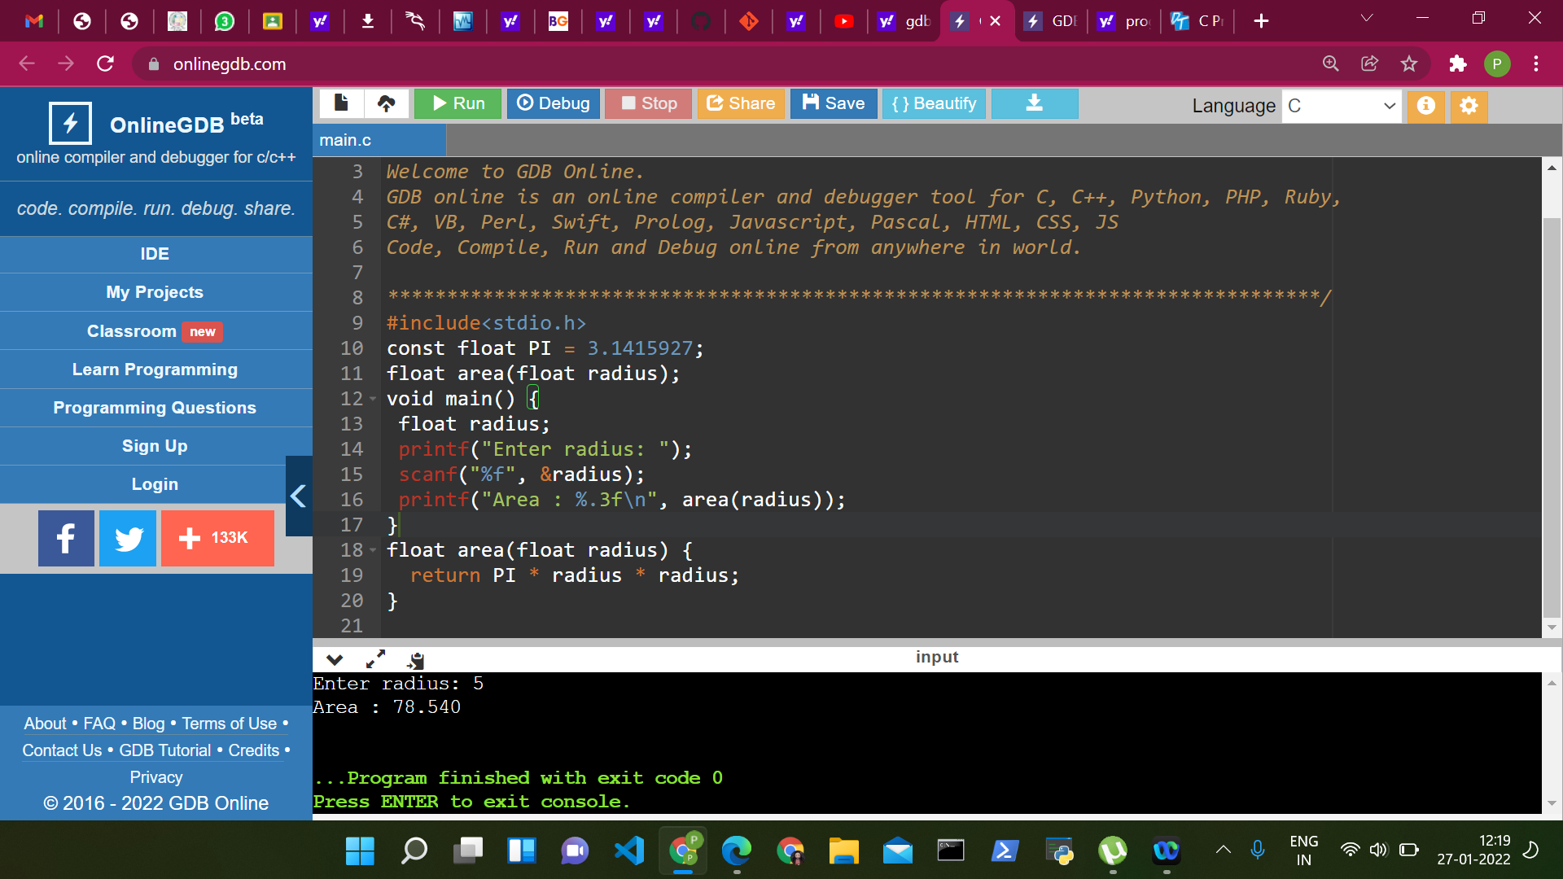

**SOL 2:**

**#include<stdio.h>**

**void swap(int, int);**

**int main()**

**{**

**int a, b;**

**printf("Enter value for a:");**

**scanf("%d",&a);**

**printf("Enter value for b:");**

**scanf("%d",&b);**

**printf("\nBefore swapping: a = %d and b = %d\n", a, b);**

**swap(a, b);**

**return 0;**

**}**

**void swap(int x, int y)**

**{**

**int temp;**

**temp = x;**

**x = y;**

**y = temp;**

**printf("\nAfter swapping: a = %d and b = %d\n", x, y);**

**}**

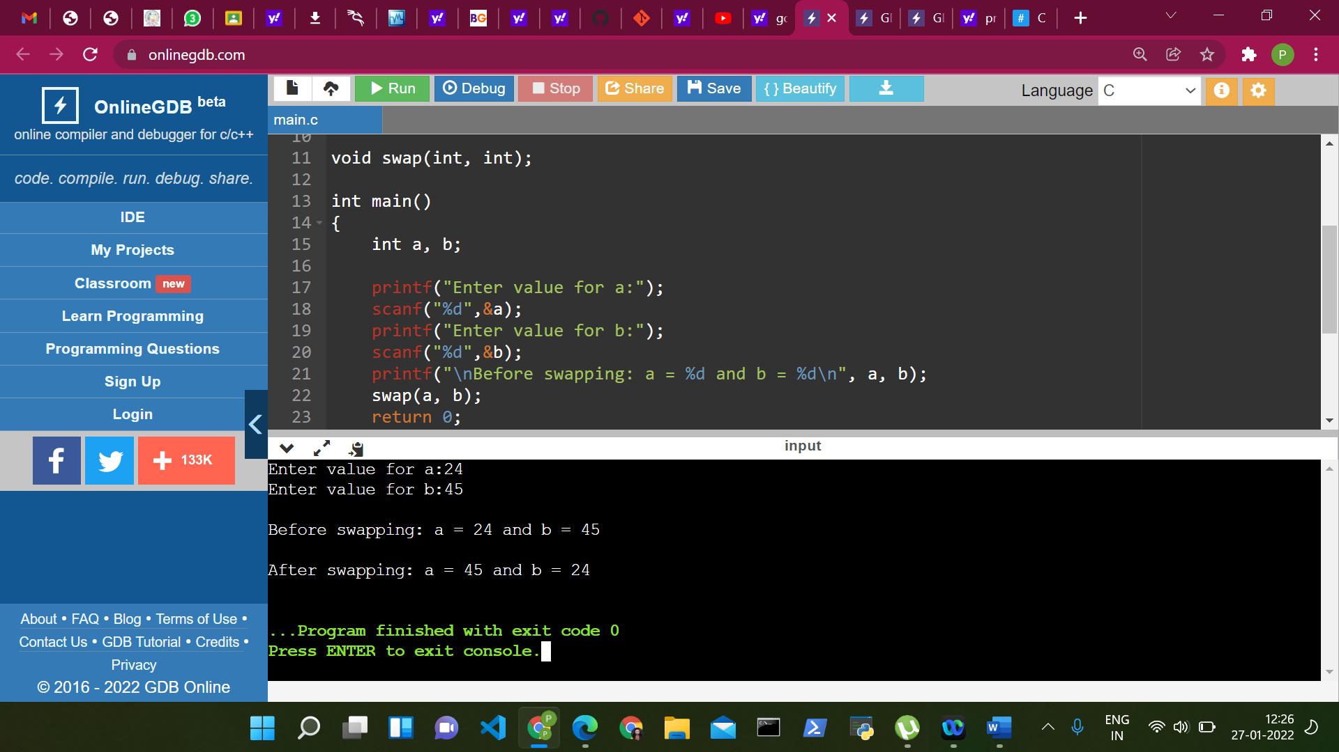

**SOL 3:**

**#include <stdio.h>**

**int fact(int);**

**void main(){**

**int sum;**

**sum=fact(1)/1+fact(2)/2+fact(3)/3+fact(4)/4+fact(5)/5;**

**printf("Sum of the series is : %d\n\n",sum);**

**}**

**int fact(int n)**

**{**

**int num=0,f=1;**

**while(num<=n-1)**

**{**

**f =f+f*num;**

**num++;**

**}**

**return f;**

**}**

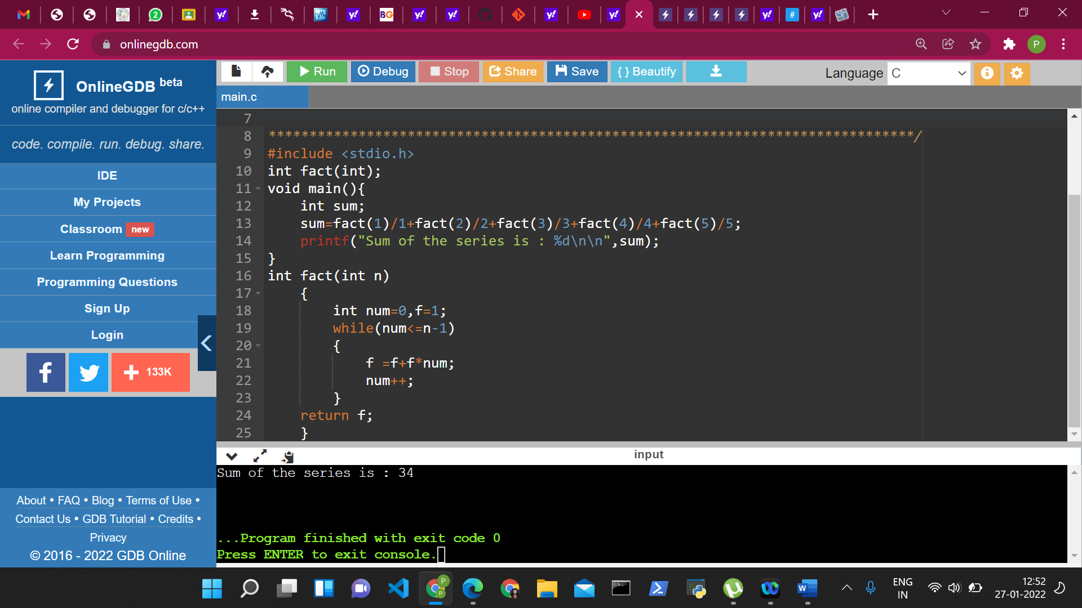

**SOL 4:**

**#include <stdio.h>**

**#include <conio.h>**

**void main()**

**{**

**int num,res=0;**

**clrscr();**

**printf("\nENTER A NUMBER: ");**

**scanf("%d",&num);**

**res=prime(num);**

**if(res==0)**

**printf("\n%d IS A PRIME NUMBER",num);**

**else**

**printf("\n%d IS NOT A PRIME NUMBER",num);**

**getch();**

**}**

**int prime(int n)**

**{**

**int i;**

**for(i=2;i<=n/2;i++)**

**{**

**if(n%i!=0)**

**continue;**

**else**

**return 1;**

**}**

**return 0;**

**}**