# Matrimonial Site

**A PROJECT REPORT**

**Submitted to**



**Noble University, Junagadh**

**for the Partial requirement fulfillment in**

**Bachelor of Computer Applications**

**Sem-4**

**Prepared By**

Priyansh Nihalani & Chirag Karamchandani

Enrollment. No. 220451035 & 220451023

**Guided By**

Faculty of Computer Application, Noble University - Junagadh

**Noble Bca Collage, Noble University - Junagadh**

# Certificate

This is to certify that the Project entitled **MATRIMONY** is a bonafide record of research work done by………

**Priyansh Nihalani & Chirag Karamchandani** Enrollment No: **220451035** **&** **220451023** under my supervision and submitted to Noble University in partial fulfillment for Integrated Masters in Computer Application (IMCA) SEM-4.

**Signature of the Guide**

**Designation:**

# Acknowledgment

Being a student this was really a big task for us to make a project. I/We is/are very thankful to all those who helped us in preparing this project. I/We have been fortune for getting the guidance and kind help from our professor .

I/We are especially thanks to our **Dean and project guide** for providing us such a nice platform for the project it is our great pleasure that for providing the chance for the project in HTML, CSS, Bootstrap and Java Script. I/We is/are thankful for these suggestions. I/We is/are heartily thankful to them.

Student Name: Priyansh Nihalani , Chirag Karamchandani

Enrollment No: 220451035 , 220451023

Program: IMCA

**Table of Content**

|  |  |  |
| --- | --- | --- |
| **Sr. No.** | **Description** | **Page No.** |
| 1 | Introduction | 5 |
| 1.1 | Student Profile | 7 |
| 1.2 | Project Profile | 8 |
| 2 | System Snapshot | 19 |
| 3 | Limitation of Project | 37 |
| 4 | Future scope of the project | 40 |
| 5 | Bibliography | 43 |

**INTRODUCTION**

##### Introduction:

In the contemporary landscape of human relationships, the institution of marriage continues to hold profound significance, serving as a cornerstone for societal structure and personal fulfilment alike. With the advent of technology and shifting cultural norms, the dynamics of how individuals seek and form marital bonds have evolved significantly. In this context, the matrimony project endeavours to explore, analyze, and innovate within the realm of modern matchmaking.

The matrimony project aims to address the multifaceted challenges and opportunities inherent in the process of mate selection and union formation. Through a fusion of traditional wisdom and cutting-edge technological advancements, the project seeks to enhance the efficiency, effectiveness, and inclusivity of the matrimonial journey for individuals across diverse backgrounds and preferences.

This report serves as a comprehensive overview of the matrimony project, encompassing its objectives, methodologies, findings, and implications. By delving into the intricacies of human relationships, societal dynamics, and technological interventions, this report endeavors to shed light on the evolving landscape of matrimony in the digital age.

Through rigorous research, data analysis, and stakeholder engagement, the matrimony project endeavors to offer insights, strategies, and tools to facilitate meaningful connections and sustainable unions. By harnessing the power of data science, artificial intelligence, and human-centered design, the project endeavors to empower individuals in their quest for compatible partners and enduring relationships.

1. **Student Profile**

Team Size : 2

Member 1 details :

Student Name: Priyansh Nihalani Enrollment No 220451035

Member 2 details :

Student Name: Chirag Karamchandani Enrollment No: 220451023

1. **Project Profile**

Project On: - **MATRIMONY**

Developed By: - **Priyansh Nihalani & Chirag Karamchandani**

Sem-Year: - IMCA Sem-4 2023-24

Guidance By: -

Technology: - HTML, JavaScript, Tailwind CSS, Jsp, Servlet.

Platform: Windows

Submitted To: - **NOBLE UNIVERSITY**.

**What is HTML?**

HTML stands for Hypertext Markup Language. It's the code that creates the structure and content of web pages. It tells the web browser how to display text, images, videos, and other elements.

**How Does HTML Work?**

HTML uses tags to define different parts of a web page. These tags are written in angle brackets (< and >). For example, the <p> tag defines a paragraph, and the <h1> tag defines a heading.

Here's a basic structure of an HTML document:

HTML

<!DOCTYPE **html**>

<html>

<head>

<title>My Webpage</title>

</head>

<body>

<h1>Welcome to my website!</h1>

<p>This is my first paragraph.</p>

</body>

</html>

Use code [with caution.](https://gemini.google.com/faq#coding)

In this example, the <title> tag specifies the title of the webpage, the <h1> tag creates a heading, and the <p> tag creates a paragraph.

**Why Learn HTML?**

Learning HTML is a great way to get started with web development. It allows you to understand how websites are built and even create your own simple webpages. HTML is also the foundation for working with other web technologies like CSS (styling) and JavaScript (interactivity).

**Getting Started with HTML:**

There are many resources available online to learn HTML. Here are a few suggestions:

* W3Schools <https://www.w3schools.com/html/>
* freeCodeCamp <https://www.freecodecamp.org/news/html-crash-course/>
* Mozilla Developer Network <https://developer.mozilla.org/en-US/docs/Learn/HTML/Introduction_to_HTML>

These websites provide tutorials, examples, and exercises to help you learn HTML

**Introduction to JavaScript:**

JavaScript is a programming language that adds interactivity and dynamism to web pages. Unlike HTML, which defines the structure and content, JavaScript allows you to create animations, respond to user actions (like button clicks), and manipulate elements on the page.

**Where does JavaScript Run?**

JavaScript code can be embedded within HTML documents or written in separate files. When a web page loads, the JavaScript code is executed by the web browser's built-in JavaScript engine.

**What Can You Do with JavaScript?**

Here are some examples of what you can achieve with JavaScript:

* **Create interactive elements:** Imagine buttons that change color when clicked, forms that validate user input, or menus that expand and collapse.
* **Dynamic content:** Update content on a page without reloading the entire page.
* **Animations and effects:** Bring your web pages to life with smooth animations, transitions, and visual effects.
* **Data manipulation:** Process and manage data within the browser, allowing for complex web applications.

**Why Learn JavaScript?**

JavaScript is one of the most essential languages for web development. Here's why:

* **Widely used:** Almost all websites use JavaScript in some way.
* **Relatively easy to learn:** Compared to other programming languages, JavaScript has a more accessible syntax.
* **Versatile:** JavaScript can be used for both front-end (client-side) and back-end (server-side) development with frameworks like Node.js.

**Getting Started with JavaScript:**

There are many resources available to learn JavaScript. Here are a few recommendations:

* **Codecademy's Javascript Course:** <https://www.codecademy.com/learn/introduction-to-javascript> (This interactive platform offers a structured learning path)
* **JavaScript.info:** <https://javascript.info/> (A comprehensive website with clear explanations and examples)
* **Khan Academy's JavaScript Programming Course:** <https://www.khanacademy.org/computing/computer-programming/programming> (Great for beginners with video tutorials and exercises)

**Introduction to Tailwind CSS:**

Tailwind CSS is a unique approach to CSS styling that emphasizes **utility classes**. Unlike traditional frameworks with pre-built components, Tailwind provides a massive collection of low-level, single-purpose classes. You combine these classes directly in your HTML to achieve the desired design.

**What Makes Tailwind CSS Different?**

Here's what sets Tailwind apart:

* **Utility-first approach:** Tailwind empowers you to build styles from the ground up using granular building blocks.
* **Rapid Prototyping:** Quickly iterate on designs by composing styles directly in your HTML.
* **Highly Customizable:** Tailwind offers extensive customization options to tailor the framework to your specific needs.
* **Responsive Design Built-in:** Responsive classes allow for easy adaptation of layouts across different screen sizes.
* **Reduced CSS File Size:** Tailwind generates only the styles you use, minimizing file size and improving load times.

**Benefits of Using Tailwind CSS:**

* **Faster development:** Streamline styling workflows and focus on building UIs rather than writing CSS.
* **Maintainable code:** Classes are clear and descriptive, promoting clean and readable code.
* **Consistency:** Enforces consistency in styling across your project.
* **Flexibility:** Tailwind offers immense flexibility to achieve a wide range of design requirements.

**Getting Started with Tailwind CSS:**

Here's a quick guide to getting started with Tailwind:

1. **Installation:** Install Tailwind CSS using npm or yarn package managers.
2. **Configuration:** Tailwind provides a configuration file (tailwind.config.js) to customize classes and utilities.
3. **Setup:** Integrate Tailwind with your build process using tools like PostCSS and Autoprefixer.
4. **Learning the Classes:** Tailwind offers a vast library of classes for various styling aspects (padding, margin, colors, typography, etc.). Explore the documentation to understand their usage.

Here are some helpful resources to get you started:

* **Tailwind CSS Official:** <https://tailwindcss.com/docs/installation>
* **Tailwind Play:** <https://play.tailwindcss.com/> (Interactive playground to experiment with Tailwind classes)
* **Introduction to Tailwind Css on Youtube:** <https://m.youtube.com/watch?v=arftp8kFBBg>

Tailwind CSS offers a powerful and efficient approach to styling modern web applications. With its emphasis on utility classes and customization, Tailwind can significantly improve your development workflow and create beautiful and responsive user interfaces.

**Introduction to JSP:**

JSP stands for Java Server Pages. It's a technology used to create dynamic web content on the server-side, employing a combination of HTML, XML, and Java code. JSP pages are processed by a web container (like Tomcat or Jetty) before being sent to the user's browser. This allows for the generation of customized content based on user input or database information.

**Why Use JSP?**

Here are some advantages of using JSP:

* **Separation of Concerns:** JSP separates presentation logic (HTML) from business logic (Java code), promoting maintainability and reusability.
* **Dynamic Content:** JSP enables the creation of web pages that adapt to user requests or data, providing a more interactive user experience.
* **Reduced Server Load:** Complex logic resides in Java code executed on the server, minimizing the workload on the client-side browser.
* **Leverages Java Ecosystem:** JSP integrates seamlessly with Java libraries and frameworks, allowing you to utilize powerful functionalities within your web applications.

**How Does JSP Work?**

1. **Client Request:** A user interacts with a JSP page by making a request to the web server.
2. **JSP Processing:** The web container identifies the JSP page and translates it into a Java servlet (a compiled program).
3. **Java Code Execution:** Any embedded Java code within the JSP is executed, potentially interacting with databases or other resources.
4. **Dynamic Content Generation:** The Java code dynamically generates HTML content.
5. **Response to Client:** The final HTML output is sent back to the user's web browser for display.

**JSP vs. Servlets:**

While similar, JSP offers some advantages over servlets:

* **Easier Syntax:** JSP uses a mix of HTML and Java tags, making it more accessible for developers familiar with HTML.
* **Reduced Code:** JSP often requires less code compared to servlets due to the separation of concerns and built-in functionalities.
* **Faster Development:** The ease of use in JSP can accelerate the development process.

**Learning JSP:**

Here are some resources to get you started with JSP:

* **W3Schools JSP Tutorial:** <https://www.w3schools.in/jsp/tutorials/>
* **Tutorialspoint JSP Tutorial:** <https://www.tutorialspoint.com/jsp/jsp_overview.htm>
* **Java EE Tutorial Jsp:** <https://docs.oracle.com/cd/E13222_01/wls/docs81/jsp/intro.html>

By understanding JSP, you can develop dynamic and interactive web applications that leverage the power of Java on the server-side.

**Introduction to Servlets:**

Servlets are fundamental building blocks for creating dynamic web applications in Java. They reside on the server-side and act as intermediate components between a web server and a client (usually a web browser). Servlets handle client requests, process them using Java functionalities, and generate a response that is sent back to the client.

**How Servlets Work:**

1. **Client Request:** A user interacts with a web page, triggering a request to the web server. This request might involve submitting a form, clicking a link, or simply loading a web page.
2. **Servlet Mapping:** The web server identifies the servlet that should handle the request based on URL patterns or other configurations.
3. **Servlet Invocation:** The web container (like Tomcat or Jetty) instantiates the servlet and invokes its lifecycle methods.
4. **Request Processing:** The servlet's doGet (for GET requests) or doPost (for POST requests) methods are called, providing access to request parameters, headers, and other information.
5. **Business Logic Execution:** Within these methods, the servlet interacts with databases, performs calculations, or executes any necessary Java code.
6. **Response Generation:** The servlet generates the response content, which could be HTML, JSON data, or any other format.
7. **Response Delivery:** The web container sends the servlet's generated response back to the client's web browser for display.

**Benefits of Using Servlets:**

* **Dynamic Content:** Servlets enable the creation of web pages that adapt to user input and database data, providing a richer user experience.
* **Platform Independence:** Written in Java, servlets are platform-independent and can run on any system with a Java Runtime Environment (JRE).
* **Reusable Components:** Servlets can be designed to be modular and reusable, promoting code maintainability and faster development.
* **Powerful Functionality:** Servlets leverage the capabilities of the Java language, allowing for complex logic and database interactions.

**Getting Started with Servlets:**

Here are some resources to help you dive deeper into servlets:

* **Java Servlet Tutorial by Javatpoint:**

<https://www.javatpoint.com/servlet-tutorial>

* **Introduction to servlet by baeldung:**

<https://www.baeldung.com/intro-to-servlets>

* **Official Java Servlet Api:**

<https://docs.oracle.com/javaee/7/tutorial/servlets.htm>l

* By learning servlets, you gain the ability to build robust and scalable web applications that can handle complex user interactions and data processing on the server-side. They are a core technology in the Java web development world.

## SYSTEM SNAPSHOTS

#### Home Page Without Login:

#### 

**Description:**

Welcome to our homepage! You don't need to sign in to see what's going on. We've got a cool feature called 'Find My Match' where you can discover someone special. If you're not signed in, no worries! Just click on 'Find My Match,' and we'll help you get started. You'll be taken to a page where you can sign up or log in. Once you do that, you can explore even more. So, come on in and let's begin this adventure together!

* 1. **Home Page with logged in:**

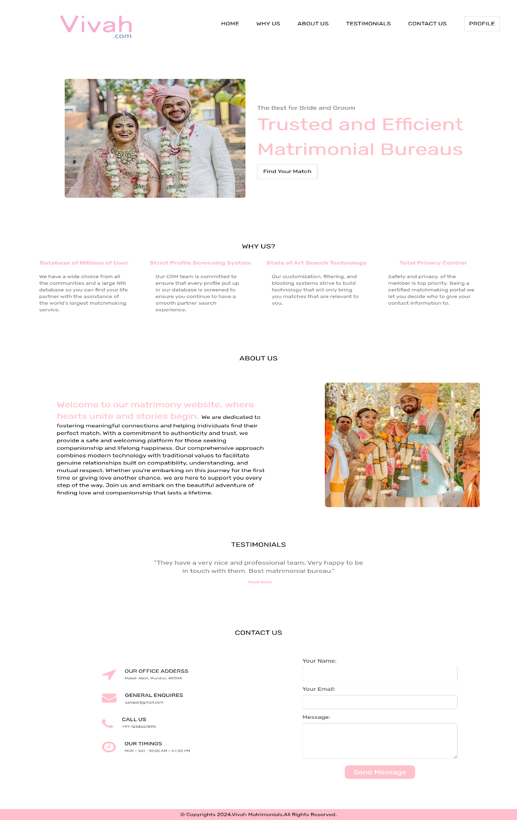

**Description:**

When you're logged in, look for the profile tab up there. Give it a hover, and you'll see your username and any feedback you've received. It's like your own little corner! Now, feeling adventurous? Click on 'Find Your Match.' That button will take you to a page where you can browse through profiles of other users. Who knows, you might find someone interesting! Ready to dive in?

* 1. **Sign In Page:**

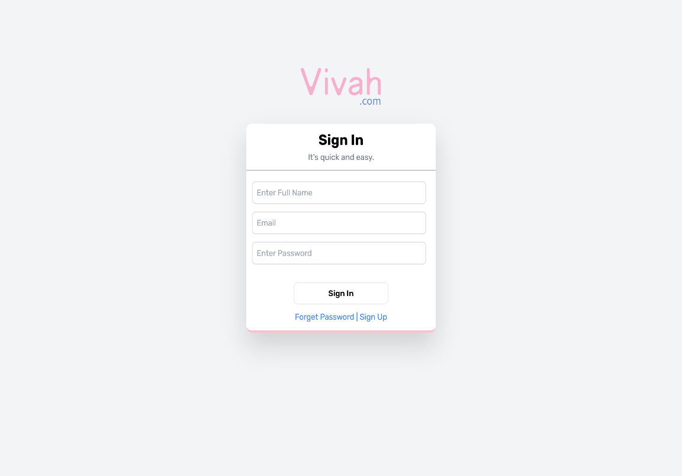

**Description:**

Welcome to our sign-in page. We're thrilled to have you here! To get started, just fill in your name, email, and password. Your name helps us personalize your experience, while your email ensures we can stay in touch. And of course, your password keeps your account safe and secure. Once you're signed in, you'll have access to all the amazing features our platform has to offer. So go ahead, enter your details, and let's begin this exciting journey together!

* 1. **Sign Up Page:**

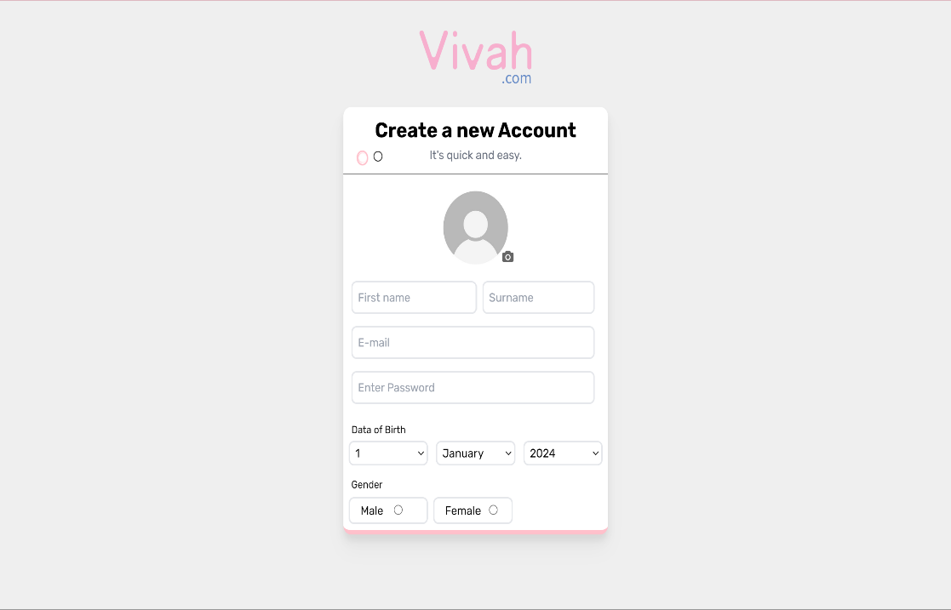

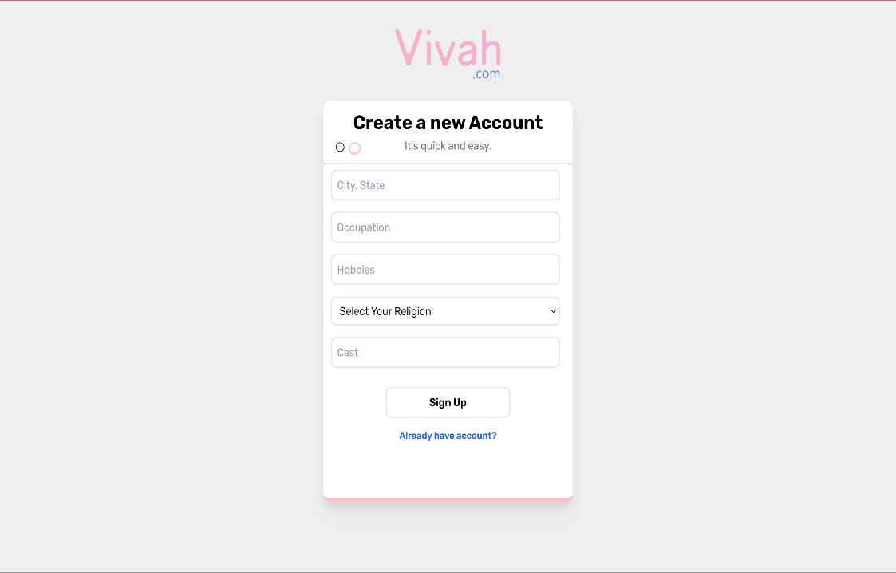

**Description:**

Welcome to our signup page! We're excited to have you join our community. To create your account, please provide the following information:

1. **Photo Upload:** Add a photo of yourself to personalize your profile and connect with others visually.
2. **First and Last Name:** Let us know your full name so we can address you properly.
3. **Date of Birth:** Share your birthdate with us to celebrate your special day and ensure you meet age requirements.
4. **Email:** Provide your email address so we can keep you updated and secure your account.
5. **Password:** Choose a secure password to keep your account safe.
6. **City:** Tell us where you're from so we can connect you with people nearby if you wish.
7. **Gender:** Let us know your gender identity to better tailor your experience.
8. **Hobbies:** Share your interests and hobbies with us to find like-minded individuals.
9. **Occupation:** Tell us what you do so we can better understand your interests and experiences.
10. **Religion:** Optionally, let us know your religion if you'd like to connect with others who share your beliefs.
11. **Caste:** Share your caste, if applicable, to help us better understand your cultural background.
    1. **Feedback Page:**

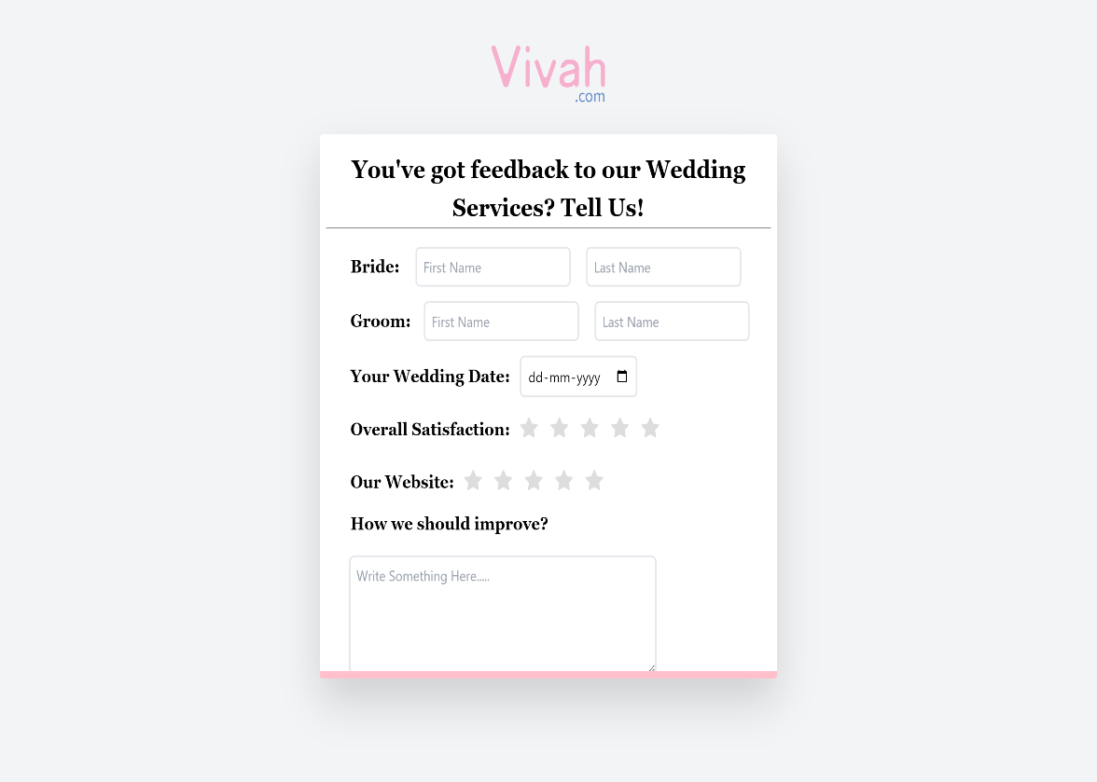

**Description:**

Welcome to our feedback page! We value your opinion and would love to hear about your experience using our website. Please take a moment to share your thoughts with us:

1. **Bride's Name:** Let us know the name of the bride.
2. **Groom's Name:** Tell us the name of the groom.
3. **Wedding Date:** Share the date of your wedding.
4. **Overall Satisfaction:** Rate your overall satisfaction with our website on a scale from 1 to 5, with 5 being highly satisfied.
5. **How can we improve?** We're always striving to make our website better. Please provide any suggestions or feedback on how we can improve your experience.

Your feedback helps us understand what we're doing well and where we can make enhancements to better serve you and others like you. Thank you for taking the time to share your thoughts with us!"

1. **Profile Page:**

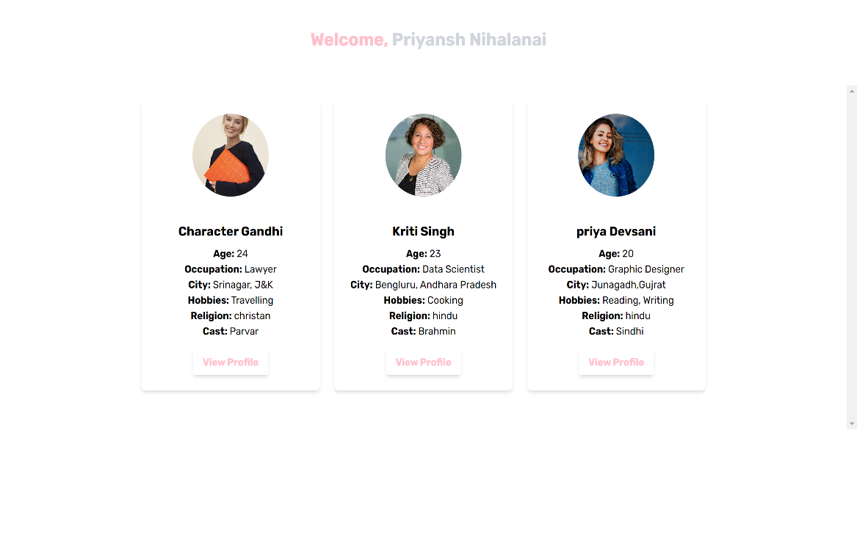

**Description:**

Welcome to your profile page! Here, we tailor your experience based on your preferences. Our website uses cookies to understand your interests. If it identifies you as male, it will display profiles of females, and vice versa. This personalized approach ensures that you see profiles that align with what you're looking for. Take a moment to explore the profiles and connect with someone who catches your eye. Your journey starts here!

1. **Received Feedback Page on Admin :**

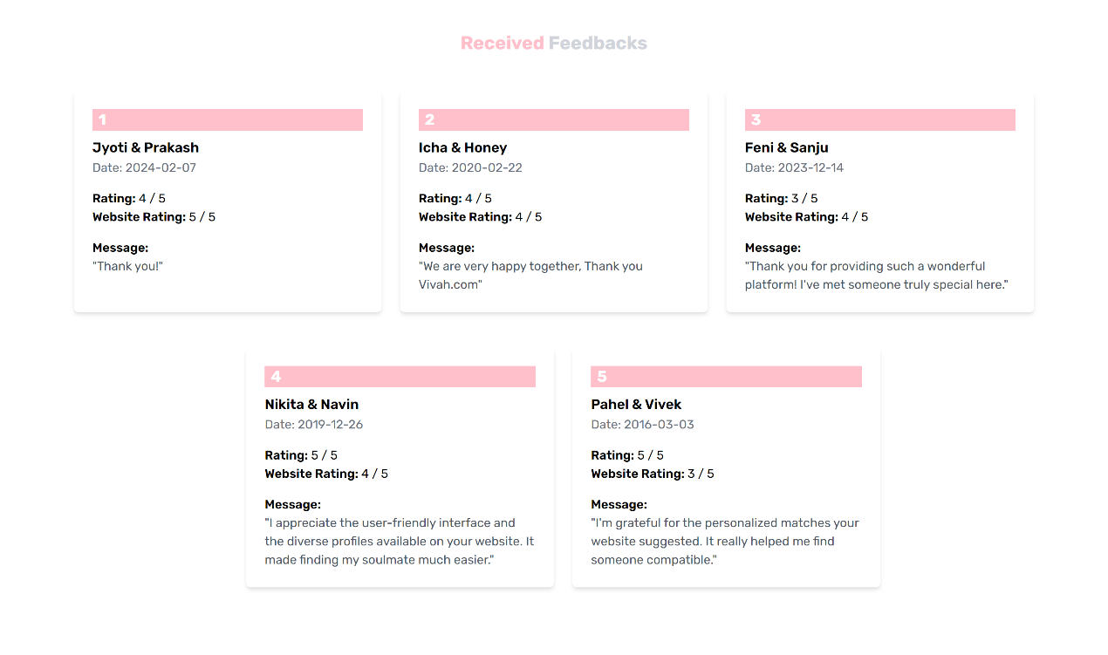

**Description:**

Welcome to the admin feedback dashboard! Here, you can review and manage the feedback we've received from our users. Take a moment to browse through the feedback provided by our users, including their ratings and comments. Use this valuable information to gain insights into user satisfaction and identify areas for improvement. With your attention to user feedback, we can continuously enhance our website to better meet the needs of our community. Thank you for your dedication to improving our platform!

1. **Logged in Users:**

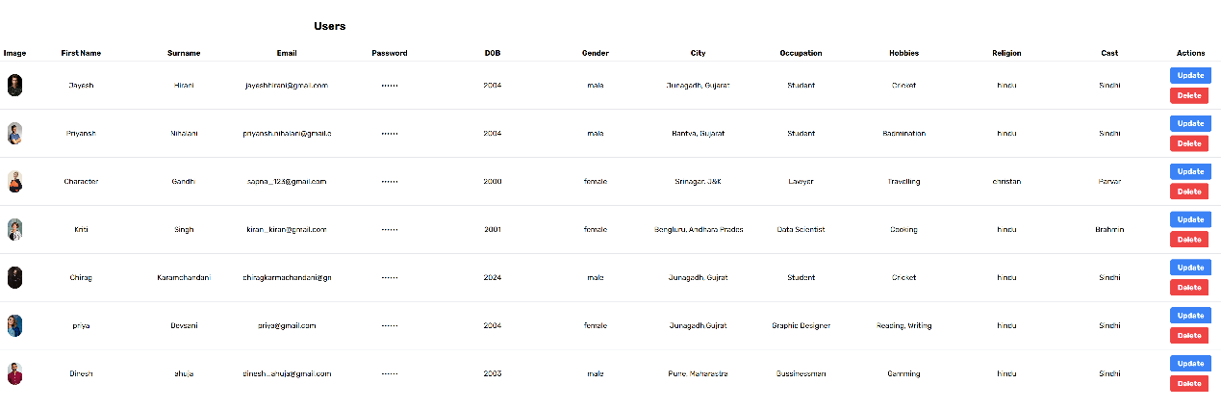

**Description:**

Welcome to the user management page! As an administrator, you have the ability to view and modify user information. From this page, you can easily update details such as usernames, email addresses, passwords, and more for each user. Additionally, you have the authority to delete user accounts if necessary. This control ensures the integrity and security of our platform while also allowing you to provide support to our users as needed. Thank you for your diligence in maintaining our community!

1. **Sign Up Table Structure:**

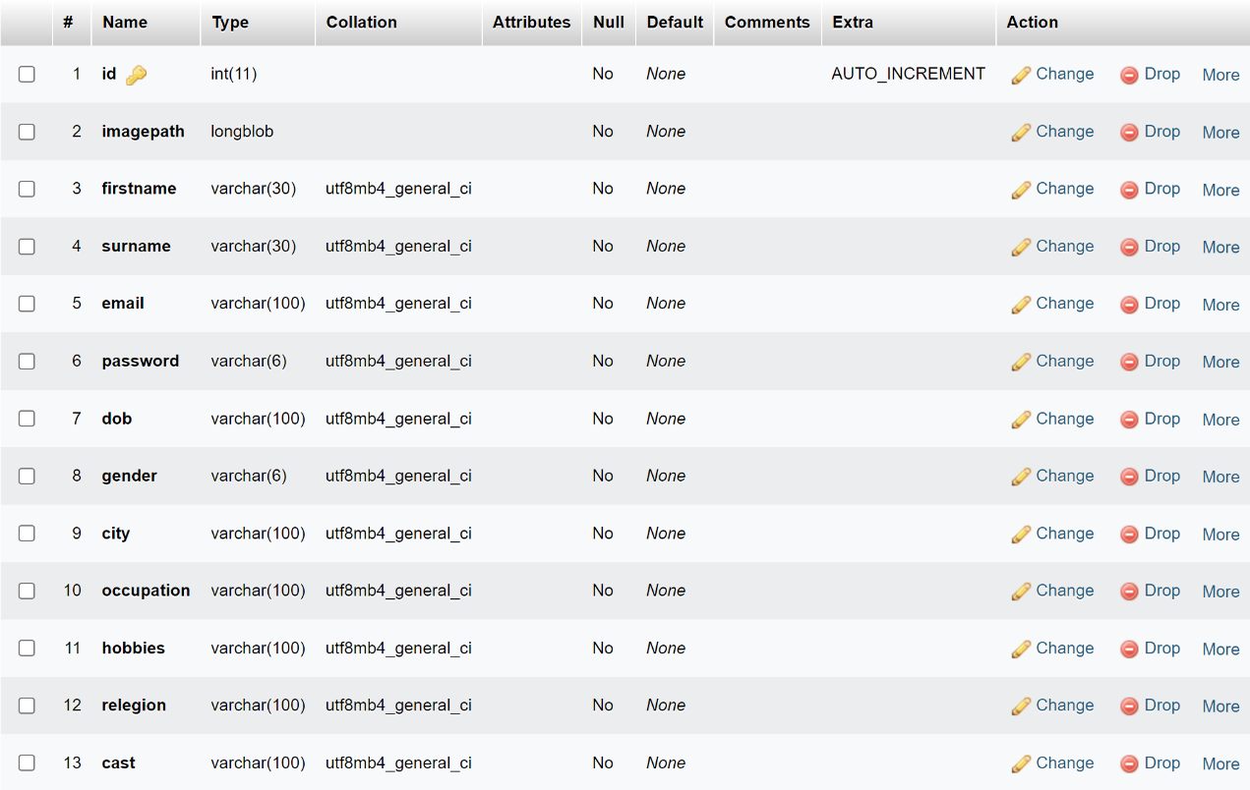

**Description:**

| **Field Name** | **Data Type** | **Description** |
| --- | --- | --- |
| User ID | Integer | Primary key, auto-incremented ID for each user |
| Photo | Image | Profile picture uploaded by the user |
| First Name | Text | First name of the user |
| Last Name | Text | Last name of the user |
| Date of Birth | Date | Date of birth of the user |
| Email | Text | Email address of the user |
| Password | Text | Encrypted password for user authentication |
| City | Text | City where the user resides |
| Gender | Text | Gender identity of the user |
| Hobbies | Text | Interests and hobbies of the user |
| Occupation | Text | Profession or occupation of the user |
| Religion | Text | Optional field for the user's religion |
| Caste | Text | Optional field for the user's caste |

This table structure reflects the information collected during the signup process, as described in the previous sign up page. Each row represents a user, and each column represents a specific attribute or detail about the user**.**

1. **Feedback Table Structure:**

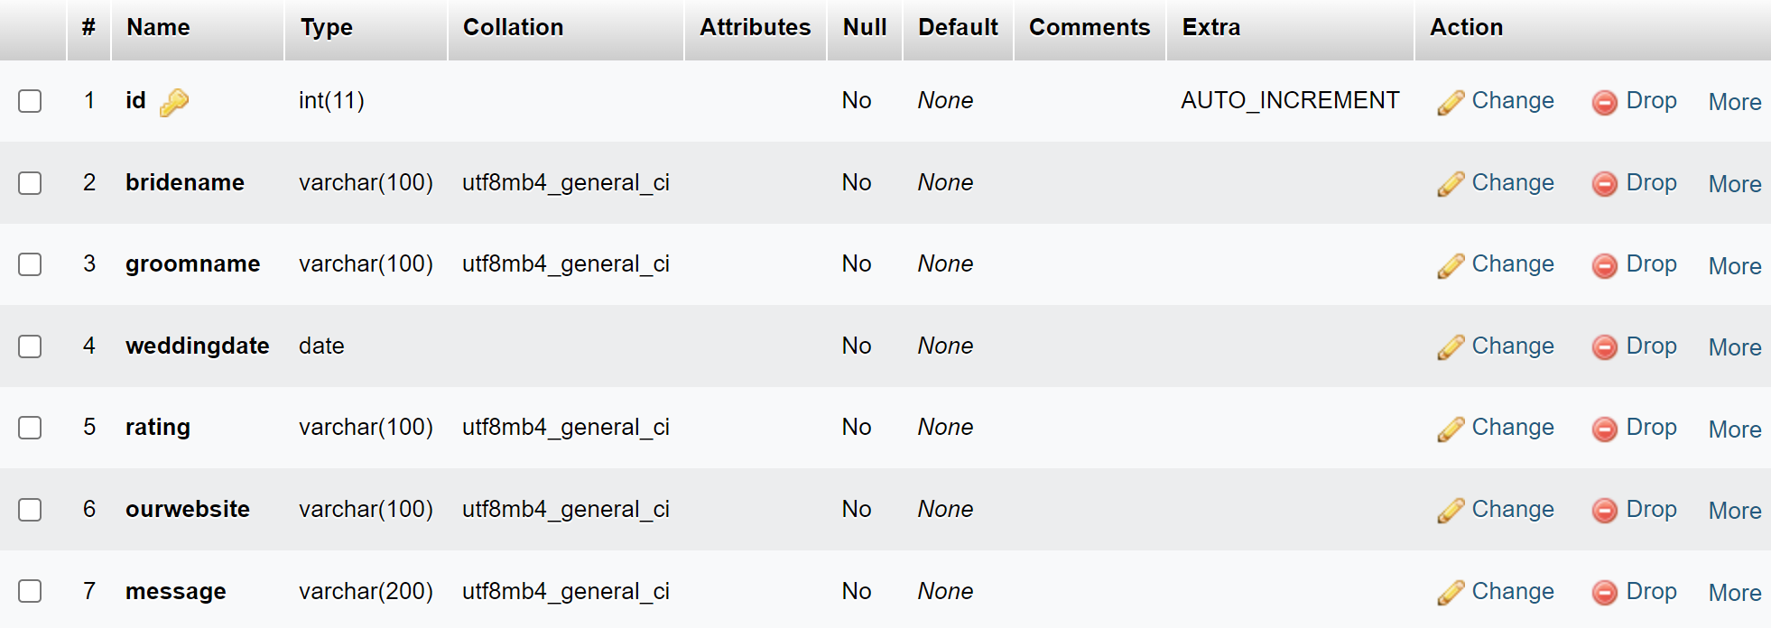

**Description:**

| **Field Name** | **Data Type** | **Description** |
| --- | --- | --- |
| Feedback ID | Integer | Primary key, auto-incremented ID for each feedback entry |
| Bride's Name | Text | Name of the bride provided in the feedback |
| Groom's Name | Text | Name of the groom provided in the feedback |
| Wedding Date | Date | Date of the wedding provided in the feedback |
| Website Rating | Integer | Rating of the website satisfaction (1 to 5) provided in the feedback |
| Overall Satisfaction | Integer | Rating of overall satisfaction (1 to 5) provided in the feedback |
| Suggestions | Text | Suggestions for improvement provided in the feedback |

This table structure represents the information collected from user feedback, as described in the previous feedback page. Each row represents a feedback entry, and each column represents a specific attribute or detail about the feedback provided by the users.

1. **Contact Us Table Structure:**

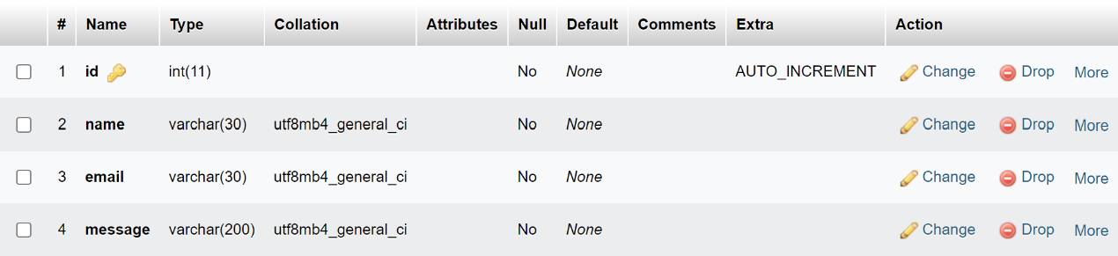

**Description:**

| **Field Name** | **Data Type** | **Description** |
| --- | --- | --- |
| Contact ID | Integer | Primary key, auto-incremented ID for each contact entry |
| Name | Text | Name of the person contacting |
| Email | Text | Email address of the person contacting |
| Message | Text | Message or inquiry sent by the person |

Top of Form

## LIMITATION OF THE PROJECT

#### 3. Limitation of the system

**1. Profile Information Enhancement:**

* **Detailed Personal Information:** This caters to a wider range of compatibility factors, going beyond just basic demographics.
* **Questionnaires and Personality Tests:** Provides valuable insights into user values and expectations.
* **Social Media Integration:** Offers a more well-rounded picture of potential matches.

**2. Payment Information:**

* **Subscription Plans:** Creates a sustainable revenue model while offering tiered value to users.
* **Secure Payment Gateway:** Ensures user trust and data security.
* **Renewal and Billing Management:** Provides transparency and convenience for users.

**3. Communication Features:**

* **In-App Messaging:** Enables direct communication and initial connection building.
* **Voice and Video Calling:** Allows for more personal interaction before meeting in person.
* **Virtual Events and Workshops:** Creates a platform for engagement and potentially sparks connections.

**4. Additional Dynamic Functionality:**

* **Match Recommendations:** Leverages data and algorithms for efficient matchmaking.
* **Interactive User Dashboard:** Provides a personalized experience and keeps users engaged.
* **Community Forums and Groups:** Fosters a sense of community and support among users.

## FUTURE SCOPE OF THE PROJECT

#### Future scope of the System

1. **Payment Gateway Integration**:

Multiple Payment Options: Integrate popular payment gateways to offer users flexibility in choosing their preferred payment method, including credit/debit cards, net banking, digital wallets, and UPI (Unified Payment Interface).

Secure Transactions: Implement industry-standard security protocols such as SSL encryption and PCI compliance to safeguard users' financial data during transactions, instilling trust and confidence in the platform.

Subscription Management: Enable users to easily manage their subscription plans, including upgrading/downgrading plans, viewing payment history, and cancelling subscriptions, enhancing transparency and user control.

2. **Forgot Password Functionality**:

Password Recovery Options: Provide users with multiple options for resetting their password, such as email verification, SMS verification, or security questions, ensuring accessibility and convenience for all users.

Account Verification: Implement account verification mechanisms to prevent unauthorized access to user accounts during the password recovery process, enhancing security and mitigating the risk of account hijacking.

User Guidance: Offer clear instructions and guidance to users on how to reset their password, including links to relevant support resources or FAQs, minimizing user frustration and support requests.

3. **Calling Features:**

Voice Calling: Enable users to initiate voice calls directly within the platform, allowing them to have real-time conversations with potential matches without disclosing personal contact information, enhancing privacy and safety.

Video Calling: Integrate video calling functionality for users to engage in face-to-face conversations, facilitating deeper connections and rapport building, especially for users in long-distance relationships or unable to meet in person.

Call Recording and Logging: Provide users with the option to record and log their calls for future reference or review, enhancing accountability and transparency in communication, particularly for users assessing multiple potential matches.

## BIBLIOGRAPHY

#### Bibliography

**\*\*ChatGPT\*\***

OpenAI. (2022, November 30). ChatGPT. OpenAI API. https://platform.openai.com/

**\*\*Gemini AI\*\***

Google AI. (2023). Bard: A large language model for conversation and question answering. [URLlamda language model ON Google Research ai.googleblog.com]