Priyansh Salian

C31,2003148

**Experiment 5**

Code:

package com.example.expt_5;

import androidx.appcompat.app.AppCompatActivsity;

import android.os.Bundle; import android. view.View; import android.widget.Button; import android.widget.EditText; import android.widget. TextView; import android.widget.Toast;

public class MainActivity extends AppCompatActivity {

@Override protected void onCreate(Bundle savedInstanceState) { super.onCreate(savedInstanceState); setContentV1ew(R.layout.activity_main);

EditText pa = findViewById(R.id.pa);

EditText rate = findViewById(R.id.rate);

EditText tenure findViewById(R.id.tenure);

TextView emiAns = findViewById(R.id.emiAns);

Button calculateBttn findViewById(R.id.calculateBttn);

calculateBttn.setOnClickListener(new View.OnClickListener() {

@Override public void onClick(Vrew view) { String total_erm = float p, r, emi; int t; boolean isCorrect true;

if(pa.getText().toString().length() == pa.setError("Enter a pa")isCorrect = false;

if(rate.getText().toString().Iength() 0){ a rate"); isCorrect = false;

if(tenure.getText().toString().length() 0){ tenure.setError("Enter a tenure"); isCorrect = false;

if(isCorrect){

String finalMssg;

p = Float.parseFloat(pa.getText().toString()); r = (Float.parseFIoat(rate.getText().toString())/12)/100; t = (Integer.parseInt(tenure.getText().toString()))* 12;

emi = (float) ((float)(p*r) * Math.pow((l+r),t))/(float)

(Math.pow((l+r),t)-l);

total_emi = Float.toString(emi); finalMssg = total_emi;

Toast.makeText(getAppIicationContext(), finalMssg,

Toast.LENGTH emiAns.setText("The EMI is: "+ total_emi + " Rs");

XML:

<?xml

<androidx.constraintlayout.widget.ConstraintLayout

XmI http://schemas.android.com/apk/res/android" xmlns:app="http://schemas.android.com/apk/res-auto" xmlns:tools—"http://schemas.android.eom/tools"

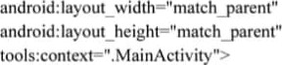

<TextView

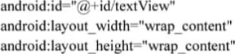

android:text="EMl Calculator"

toBottomOf="parent" app: layout_constraintEnd_toEndOf="parent"

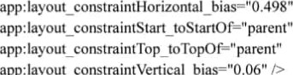

app:layout_constraintVertical_bias="0.06"

<EditText



android: layout_width="268dp" android:layout_height="47dp" android:ems—•• I O" android: Amount" android: inputType="textPersonName" app:layout constraintBottom toBottomOf—"parent"

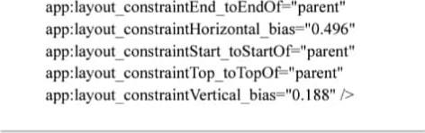

<EditText

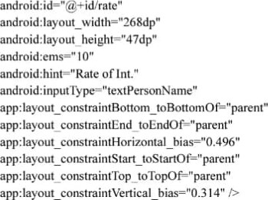

<EditText android:id="@+id/tenure" android:layout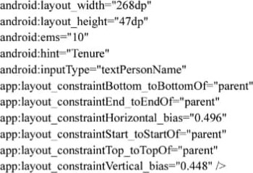

<TextView

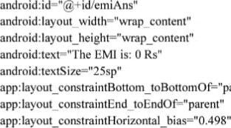parent"

app:layout_constraintStart toStartOf="parent" app:layout_constraintTop_toTopOf="parent" app:layout_constraintVertical_bias="0.553" />

<Button android:id="@+id/calculateBttn" android: 132dp" android:layout_height="57dp" android:text="Calculate" app:layout_constraintBottom_toBottomOf="parent" app:layout_constraintEnd_toEndOf="parent" app:layout_constraintHorizontal bias="0.498" app:layout_constraintStart toStartOf="parent" app:layout_constraintTop_toTopOf="parent" app:layout_constraintVertical_bias="0.674" />

**Output:-**

