Priyansh Salian

2003148,C31

**Experiment No:-6**

**1. MainActivity.java**

package com.example.experiment6;

import androidx.appcompat.app.AppCompatActivity; import androidx.core.app.NotificationCompat; import android.app.Notification; import android.app.NotificationChannel; import android.app.NotificationManager; import android.app.PendingIntent; import android.app.TaskStackBuilder; import android.content.Context; import android.content.Intent; import android.graphics.Color; import android.os.Bundle; import android.view.View; import android.widget.Button; import android.widget.EditText;

public class MainActivity extends AppCompatActivity {

@Override

protected void onCreate(Bundle savedInstanceState){ super.onCreate(savedInstanceState); setContentView(R.layout.activity_main);

Button notify = findViewById(R.id.button);

EditText msg = findViewById(R.id.editTextTextPersonName); notify.setOnClickListener(new View.OnClickListener() {

@Override public void onClick(View view) { addNotification(msg.getText().toString()); }

});

}

private void addNotification(String msg) {

String CHANNEL_ID = "my_channel_01"; CharSequence name = "my_channel";

String Description = "This is my channel"; int NOTIFICATION_ID = 234;

NotificationManager notificationManager = (NotificationManager) this.getSystemService(Context.NOTIFICATION_SERVICE); if (android.os.Build.VERSION.SDK_INT >= android.os.Build.VERSION_CODES.O) {

int importance = NotificationManager.IMPORTANCE_HIGH;

NotificationChannel mChannel = new NotificationChannel(CHANNEL_ID, name, importance);

mChannel.setDescription(Description); mChannel.enableLights(true); mChannel.setLightColor(Color.RED); mChannel.enableVibration(true); mChannel.setVibrationPattern(new long[]{100, 200, 300, 400, 500, 400, 300,

200, 400});

mChannel.setShowBadge(false);

notificationManager.createNotificationChannel(mChannel);

}

NotificationCompat.Builder builder = new NotificationCompat.Builder(this,

CHANNEL_ID).setSmallIcon(R.mipmap.ic_launcher).setContentTitle("Message Received").setContentText(msg);

Intent resultIntent = new Intent(this, MainActivity.class); TaskStackBuilder stackBuilder = TaskStackBuilder.create(this); stackBuilder.addParentStack(MainActivity.class); stackBuilder.addNextIntent(resultIntent);

PendingIntent resultPendingIntent = stackBuilder.getPendingIntent(0,

PendingIntent.FLAG_UPDATE_CURRENT);

builder.setContentIntent(resultPendingIntent);

notificationManager.notify(NOTIFICATION_ID, builder.build());

}

}

**2. Activity_main.xml**

<?xml version="1.0" encoding="utf-8"?>

<androidx.constraintlayout.widget.ConstraintLayou t [xmlns:android="http://schemas.android.com/apk/res/android](http://schemas.android.com/apk/res/android) " xmlns:app[="http://schemas.android.com/apk/res-auto"](http://schemas.android.com/apk/res-auto) [xmlns:tools="http://schemas.android.com/tools"](http://schemas.android.com/tools)

android:layout_width="match_parent" android:layout_height="match_parent" tools:context=".MainActivity">

<TextView

android:id="@+id/message_label" android:layout_width="wrap_content" android:layout_height="wrap_content" android:text="Enter Message" android:textSize="24sp" app:layout_constraintBottom_toBottomOf="parent" app:layout_constraintLeft_toLeftOf="parent" app:layout_constraintRight_toRightOf="parent” app:layout_constraintTop_toTopOf="parent" app:layout_constraintVertical_bias="0.218" />

<EditText

android:id="@+id/editTextTextPersonName" android:layout_width="wrap_content" android:layout_height="wrap_content" android:ems="10" android:inputType="textPersonName" android:minHeight="48dp" app:layout_constraintBottom_toBottomOf="parent" app:layout_constraintEnd_toEndOf="parent" app:layout_constraintHorizontal_bias="0.497" app:layout_constraintStart_toStartOf="parent" app:layout_constraintTop_toTopOf="parent" app:layout_constraintVertical_bias="0.374" tools:ignore="SpeakableTextPresentCheck" />

<Button

android:id="@+id/button" android:layout_width="wrap_content" android:layout_height="wrap_content" android:text="Notify" app:layout_constraintBottom_toBottomOf="parent" app:layout_constraintEnd_toEndOf="parent" app:layout_constraintHorizontal_bias="0.498" app:layout_constraintStart_toStartOf="parent" app:layout_constraintTop_toTopOf="parent" app:layout_constraintVertical_bias="0.532" />

</androidx.constraintlayout.widget.ConstraintLayout>

**Output:**

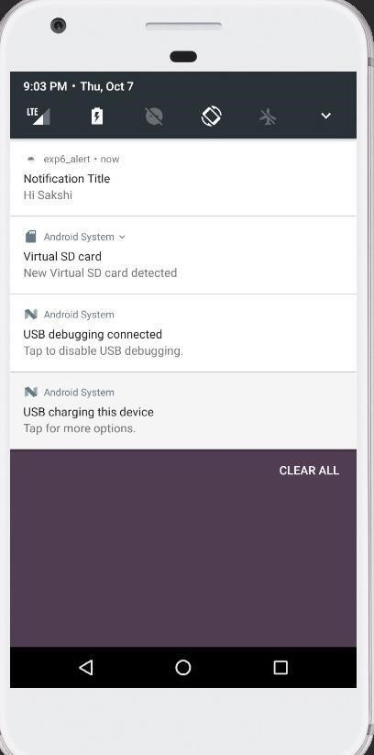

**Conclusion:** SMS Alert Notification has been implemented.