| **Date: 05-06-25** | | **Test - 2** | **Max. Marks: 50** | | | |
| --- | --- | --- | --- | --- | --- | --- |
| **Semester: VI** | | **UG** | **Duration: 1 Hrs** | | | |
| **Course: Digital Signal Processing and Machine Learning** | | | **Code: EC364TA** | | | |
| **S No** | | **Questions** | | | **M** | **BT** | **CO** | |
|  | | Obtain the coefficients of an FIR filter to meet the specifications given below using the appropriate window method.  Passband edge frequency: 1.5KHz  Stopband edge frequency: 2 KHz  Minimum stopband attenuation: 50 dB  Sampling frequency: 8 KHz.  Find h(0), h(1), h(2), h(3), h(4) , h(5) and h((N -1) /2) . | | | 10 | 4 | 2 | |
|  | | Determine the filter coefficients h(n) obtained by sampling Hd(ω) given by  Hd(ω) = e-j3ω, 0 < ω < π/2  0, π/2 < ω < π  Also obtain the frequency response H(ω). Take N = 7. | | | 10 | 3 | 2 | |
|  | | a) Implement of k nearest neighbors considering height and weight with corresponding T shirt size as given below. Consider k = 5, what would be the T shirt size for person with weight 61 kg and height of 161cm.    b) What is logistic regression? How does application of logit function odds make the output pruned to classification? Explain with the example of gender prediction with height and weight. | | | 06  04 | 3  2 | 4  3 | |
|  | | a). The x and y coordinates of the data set is [(13, 17), (46, 46), (13, 10), (79, 77), (53, 50)], perform stochastic Gradient descent on linear regression to minimize error. Clearly, mention the equation used .Show intermediate steps of calculation for two iteration. Assume learning rate is 0.02 and initial weights are zero.  b) The coordinates of sample distribution of three class of balls: Blue, Green and red are given below. Blue balls: (1.5, 2) (2.5, 1.5), Green balls: (7, 1) (9, 1.5), Red balls: (4, 9) (5, 7). Let the coordinates of a new ball is given by (1.25, 2.75). Estimate and classify the new ball using the conditional probability log likelihood function. | | | 05  05 | 3  4 | 3  4 | |
|  | | a) The sales of a company (in million dollars) for each year are shown in the table below.   |  |  |  |  |  |  | | --- | --- | --- | --- | --- | --- | | x (year) | 2015 | 2016 | 2017 | 2018 | 2019 | | y (sales) | 24 | 38 | 58 | 74 | 90 |    Find the least square regression line y = a x + b. Use the least squares regression line as a model to estimate the sales of the company in 2022.  b) Explain with an example of principle behind Support Vector Machines (SVM). | | | 06  04 | 3  2 | 4  3 | |

BT-Blooms Taxonomy, CO-Course Outcomes, M-Marks

|  |  |  |  |  |  |  |  |  |  |  |  |  |
| --- | --- | --- | --- | --- | --- | --- | --- | --- | --- | --- | --- | --- |
| Marks Distribution | Particulars | | CO1 | CO2 | CO3 | CO4 | L1 | L2 | L3 | L4 | L5 | L6 |
| Test | Max Marks | _ | 20 | 13 | 17 | - | 08 | 27 | 15 | -- | -- |

| **Date: 05-06-25** | | **Quiz - 2** | **Max. Marks: 10** | | | |
| --- | --- | --- | --- | --- | --- | --- |
| **Semester: IV** | | **UG** | **Duration: 20 Mins** | | | |
| **Course: Digital Signal Processing and Machine Learning** | | | **Code: EC364TA** | | | |
| **S No** | | **Questions** | | | **M** | **BT** | **CO** | |
| 1. | | The Hammimg window coefficient w(4) of type 1 (symmetric odd) FIR filter whose slope is 3 is given by _______________. | | | 1 | 2 | 2 | |
| 2. | | For an FIR filter designed using frequency sampling method, sampled uniformly. What is the spcing between the frequency samples for a filter of length N = 8. | | | 1 | 2 | 3 | |
| 3. | | What is the transition width and stop band attenuation for Hammimg window and rectangular window. | | | 2 | 3 | 2 | |
| 4. | | Distinguish between bias and variance. | | | 2 | 2 | 3 | |
| 5. | | The equation of the regression line is y = 8x - 2. Compute the error for the point (4, 28). | | | 1 | 3 | 4 | |
| 6. | | For the ML model log(p1/1-p1) = 1.63312+(-0.07820*x1)+1.59729*x2, compute the output class (0 or 1) for x1 = 25 and x2 = 1. | | | 1 | 3 | 4 | |
| 7. | | The estimate of the poisson model (data table as given below) using the following equation is _______ with n=647. | | | 2 | 4 | 3 | |

Blooms Taxonomy, CO-Course Outcomes, M-Marks

|  |  |  |  |  |  |  |  |  |  |  |  |  |  |
| --- | --- | --- | --- | --- | --- | --- | --- | --- | --- | --- | --- | --- | --- |
| Marks Distribution |  | Particulars | | CO1 | CO2 | CO3 | CO4 | L1 | L2 | L3 | L4 | L5 | L6 |
|  | Test | Max Marks | _ | 03 | 05 | 02 | - | 04 | 04 | 02 | -- | -- |

| **Date: 05-06-25** | **Test - 2** | **Max. Marks: 50** |
| --- | --- | --- |
| **Semester: IV** | **UG** | **Duration: 1 Hrs** |
| **Course: Digital Signal Processing and Machine Learning** | | **Code: EC364TA** |

| **S No** | **Solutions with Scheme** | **Marks** |
| --- | --- | --- |
|  |  | 10 |
|  |  | 10 |
|  | a)            b)  **Logistic Regression:**  In [statistics](https://en.wikipedia.org/wiki/Statistics), linear regression is a [linear](https://en.wikipedia.org/wiki/Linearity) approach to modelling the relationship between a [scalar](https://en.wikipedia.org/wiki/Scalar_(mathematics)) response and one or more explanatory variables (also known as [dependent and independent variables](https://en.wikipedia.org/wiki/Dependent_and_independent_variables)). The case of one explanatory variable is called [simple linear regression](https://en.wikipedia.org/wiki/Simple_linear_regression); for more than one, the process is called multiple linear regression.[[1]](https://en.wikipedia.org/wiki/Linear_regression#cite_note-Freedman09-1) This term is distinct from [multivariate linear regression](https://en.wikipedia.org/wiki/Multivariate_linear_regression), where multiple [correlated](https://en.wikipedia.org/wiki/Correlation_and_dependence) dependent variables are predicted, rather than a single scalar variable.  **Logit Function:**  The logit function is used to model the probability of ‘success’ as a function of covariates (e.g., logistic regression). The purpose of the logit link is to take a [linear combination](https://www.sciencedirect.com/topics/mathematics/linear-combination) of the [covariate](https://www.sciencedirect.com/topics/mathematics/covariate) values (which may take any value between ±∞) and convert those values to the scale of a probability, i.e., between 0 and 1. The logit link function is defined in Eq. | 06  04 |
|  | a)              b)  https://lh6.googleusercontent.com/aAuoaM_a4Tykgi-bU3egTzLJSRI4L1r31b1dgoKRBt-RNU02Xih0z8pXO_6SJdC2D-nehZQrvCUWOF23Z8FbL3mcsNPM1WDsuXcXNAou2gvKq8DP9mqL2IgoPhTiqbOi9n_QjIUk77EtmMlP4T9e5K8LxmuJ7O8I5tMuKJ-eCMJdnC87Q9Ps6U2oB8LDfW9oiwLrwz6iSw | 05  05 |
|  | a)        b) | 06  04 |

| **Date: 05-06-25** | **Quiz - 2** | **Max. Marks: 10** |
| --- | --- | --- |
| **Semester: IV** | **UG** | **Duration: 20 Mins** |
| **Course: Digital Signal Processing and Machine Learning** | | **Code: EC364TA** |

**SCHEME & SOLUTIONS**

1.

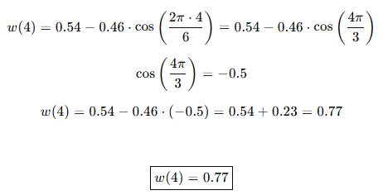

2**.**

π/ 4

3.

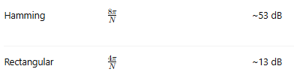

4. Bias and variance are two fundamental sources of accuracy and prediction of the model.

5.

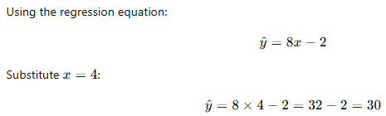

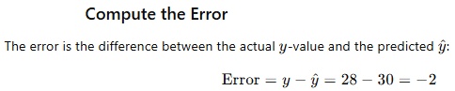



6.

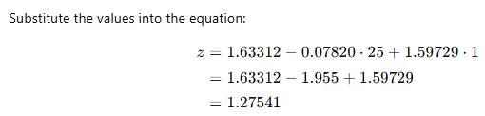

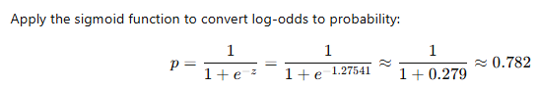

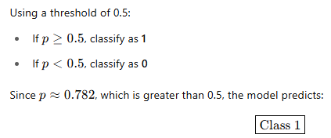

7.

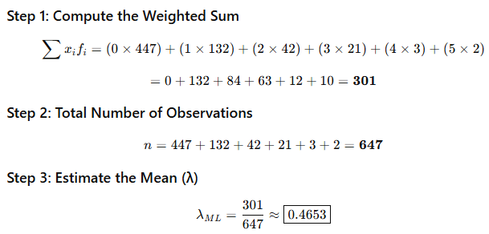

| **Date: 05-06-2025** | **CIE 2** | **Max. Marks: 50** |
| --- | --- | --- |
| **Semester: IV** | **UG** | **Duration: 1 Hrs** |
| **Course: Digital Signal Processing and Machine Learning** | | **Code: EC364TA** |

**SCRUTINY & EVALUATION OF CIE QUESTION PAPER**

**Declaration by the Course handling faculties:**

As a teaching faculty of the course **Digital Signal Processing and Machine Learning**: **EC364TA**,

we hereby confirm that the question paper with Scheme and Solutions is thoroughly reviewed and we

ensure that it adheres to the following criteria:

|  |  |  |
| --- | --- | --- |
| **Sl. No** | **Criteria** | **Yes/No** |
| 1 | The question paper adequately covers the prescribed syllabus contents. |  |
| 2 | The question paper is in line with the recommended pattern, taking into consideration the structure and format suitable for the Continuous Internal Evaluation. |  |
| 3 | The question paper is designed to align with the Revised Bloom's Taxonomy, encompassing various levels of cognitive skills such as remembering, understanding, applying, analyzing, evaluating, and creating. |  |
| 4 | The question paper is aligned with the defined course outcomes, ensuring that it effectively assesses the knowledge and skills acquired during the course. |  |
| 5 | Course handling faculty (As applicable) are responsible for preparing the question paper, scheme, and solution have unanimously agreed to utilize this question paper for conducting the Continuous Internal Evaluation. |  |
| 6 | The question paper, Scheme and Solution has been submitted to the Test coordinators within the designated timeframe to ensure the smooth conduction of Continuous Internal |  |

**Course handling Faculties:**

**Name: Signature**

1.

**To be filled by the Scrutinizer:**

|  |  |  |  |
| --- | --- | --- | --- |
| **Sl. No** | **Rubrics** | **Points** | |
| **Max** | **Awarded** |
| 1 | Timely submission of the question paper along with the scheme & solution | 10 |  |
| 2 | Heterogeneous nature of QP with respect to BTs and Cos | 10 |  |
| 3 | Format with proper entry of all particulars including test, course name, code, date, max marks, BT CO table, efficient use of paper (proper spacing, figures) | 10 |  |
| 4 | No handwritten data or diagrams | 10 |  |
| 5 | Scheme & Solution in the format | 10 |  |
|  | **Total points** | **50** |  |
| Any other comments by the scrutinizer : | | | |

**Note:** Course coordinators to obtain scrutinizer's acceptance by incorporating all suggestions from scrutiny into the final versions of QP, Scheme, and Solutions.

|  |  |
| --- | --- |
| All corrections suggested by the scrutinizer are incorporated and both the copies are re-submitted | **Signature of Course coordinator** |
| Accepted/Rejected | **Signature of Scrutinizer**  **(Name: )** |

**Signature of HOD**