PES UNIVERSITY
Bengaluru
DBMS MINI PROJECT REPORT
FitPulse - Gym Membership Manager
Field | Details
Course Title | Database Management Systems
Course Code | UE23CS351A
Project Title | Gym Membership Manager (FitPulse)
Student 1 | Priyansh Soni (SRN: PES1UG24CS344)
Student 2 | Pulkit Bhardwaj (SRN: PES1UG24CS346)
Institution | PES University, Bengaluru
Submission | November 2026

Contents
- 1. Title Page
- 2. Abstract
- 3. Tech Stack and Justification
- 4. SQL - Database Commands (ER diagram, relational schema, DDL, DML, queries, advanced SQL, database-level RBAC)
- 5. NoSQL / Vector Database Commands
- 6. Next.js - Project Tree Structure
- 7. Sample Screenshots of Application Code and Demo
- 8. Evaluation Rubrics - Completion Status

2. Abstract
FitPulse is a gym membership management system that keeps each kind of data in the database model that suits it best. Transactional records - users, roles, membership plans, subscriptions, payments, trainer assignments, class bookings and attendance - are held in a normalised MySQL schema of 12 tables with primary, foreign, unique and check constraints. Business rules live inside the database as stored procedures, functions and triggers: transactional member enrolment, loyalty-discount calculation, class-capacity enforcement, automatic payment-to-subscription activation and audit logging. Analytical needs are covered by join, correlated and nested subqueries, window-function CTEs and a recursive CTE that walks the member referral tree.
Flexible, fast-changing member health data (body composition, cardiovascular metrics, wearable sync data, check-in history) is stored in MongoDB with JSON Schema validation and compound indexes. A vector database, implemented in Python, turns workout-plan descriptions into L2-normalised embeddings over a fitness vocabulary and answers free-text requests such as "stiff lower back, need gentle mobility" with cosine-similarity search, supporting full create, read, update and delete operations.
A Next.js web application exposes the system through role-specific dashboards for three roles - ADMIN, TRAINER and MEMBER. Authentication uses bcrypt password hashes and signed JWT session cookies; middleware protects each route group, and the API connects to MySQL through a separate connection pool per role, so MySQL's own GRANT rules (database-level RBAC) limit what each role can read or change, independently of the application code.

3. Tech Stack and Justification
Layer | Technology | Why this choice
Relational DB | MySQL 8.0+ (InnoDB) | ACID transactions, enforced foreign keys and CHECK constraints (8.0.16+), stored procedures/functions/triggers, CTEs and window functions, and native roles/GRANTs for database-level RBAC.
Document DB | MongoDB | Biometric and wearable data has a nested, evolving shape and varies per member; documents with $jsonSchema validation avoid sparse columns and schema migrations.
Vector search | Python (pure standard library) | Embeds text into a 44-dimension fitness vocabulary space and ranks plans by cosine similarity; shows how semantic recommendations work without an external service.
Backend / API | Next.js 14 route handlers, mysql2, mongodb driver | One codebase for UI and REST API; parameterised queries; one pool per role maps application roles to database accounts.
Authentication | bcryptjs, jose (JWT), Next.js middleware | Salted password hashes; HTTP-only signed session cookie; route-level role checks on both pages and APIs.
Frontend | React (Next.js App Router) | Role-specific dashboards that call the API and render live database results.
Diagrams / tools | Graphviz, Git/GitHub | Reproducible ER diagram from a script; version control for all source.

Why three models together: SQL alone is rigid for evolving biometric data; MongoDB alone cannot enforce the cross-table integrity that billing and bookings need; a vector index alone cannot manage structured records. Each store is used for the workload it handles best, and the member_id is the shared key that links them.

4. SQL - Database Commands

4.1 ER Diagram
The ER diagram below (crow's-foot notation) shows all 12 entities with primary keys (underlined), foreign keys and unique keys. It is generated by docs/make_er.py.
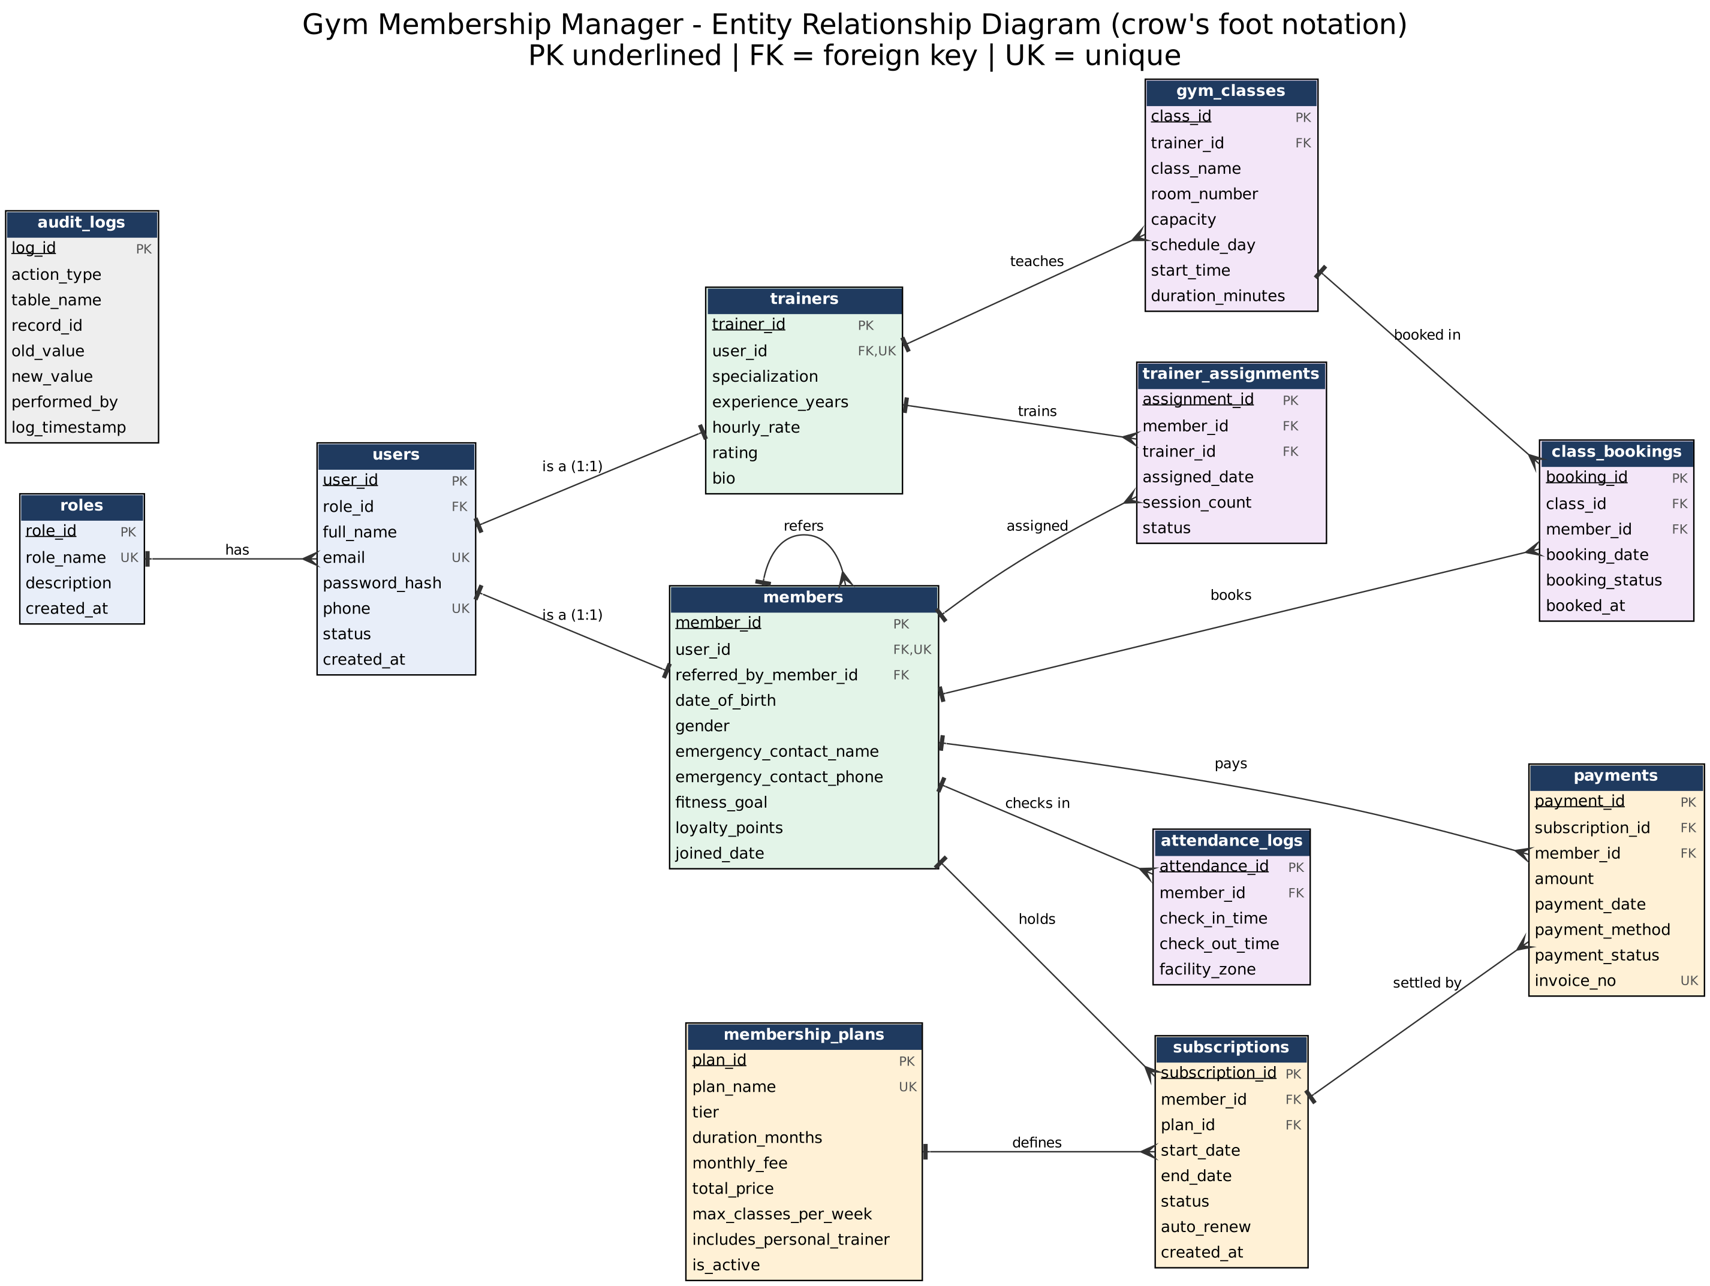
Figure 4.1 - Entity Relationship Diagram of the Gym Membership Manager
Relationship | Cardinality | Implemented by | Meaning
roles - users | 1 : N | users.role_id | A role has many users
users - trainers | 1 : 1 | trainers.user_id UNIQUE | A trainer is one user account
users - members | 1 : 1 | members.user_id UNIQUE | A member is one user account
members - members | 1 : N (self) | referred_by_member_id | A member can refer many members
members - subscriptions | 1 : N | subscriptions.member_id | A member holds subscriptions over time
membership_plans - subscriptions | 1 : N | subscriptions.plan_id | A plan is bought many times
subscriptions - payments | 1 : N | payments.subscription_id | A subscription is settled by payments
members - payments | 1 : N | payments.member_id | A member makes payments
members - trainer_assignments - trainers | M : N | trainer_assignments | Members are coached by trainers
trainers - gym_classes | 1 : N | gym_classes.trainer_id | A trainer teaches classes
members - class_bookings - gym_classes | M : N | class_bookings | Members book classes per date
members - attendance_logs | 1 : N | attendance_logs.member_id | A member checks in many times

4.2 Relational Schema (keys, relationships, constraints)
Table | Primary key | Foreign keys (ON DELETE / UPDATE) | Other constraints
roles | role_id | - | UNIQUE role_name; CHECK role_name IN (ADMIN, TRAINER, MEMBER)
users | user_id | role_id -> roles (RESTRICT / CASCADE) | UNIQUE email, phone; CHECK email format; status ENUM DEFAULT Active
membership_plans | plan_id | - | UNIQUE plan_name; CHECK duration > 0, fees >= 0, classes >= 0; tier ENUM
trainers | trainer_id | user_id -> users (CASCADE), UNIQUE (1:1) | CHECK experience >= 0, rate >= 0, rating 1.00-5.00
members | member_id | user_id -> users (CASCADE), UNIQUE (1:1); referred_by_member_id -> members (SET NULL, self-reference) | CHECK loyalty_points >= 0; gender ENUM
subscriptions | subscription_id | member_id -> members (CASCADE); plan_id -> membership_plans (RESTRICT) | CHECK end_date >= start_date; status ENUM DEFAULT Pending_Payment
trainer_assignments | assignment_id | member_id -> members (CASCADE); trainer_id -> trainers (RESTRICT) | CHECK session_count >= 0; status ENUM
payments | payment_id | subscription_id -> subscriptions (CASCADE); member_id -> members (CASCADE) | UNIQUE invoice_no; CHECK amount > 0; method/status ENUM
gym_classes | class_id | trainer_id -> trainers (RESTRICT) | CHECK capacity > 0, duration > 0; schedule_day ENUM
class_bookings | booking_id | class_id -> gym_classes (CASCADE); member_id -> members (CASCADE) | UNIQUE (class_id, member_id, booking_date); status ENUM
attendance_logs | attendance_id | member_id -> members (CASCADE) | facility_zone ENUM DEFAULT Main Gym Floor
audit_logs | log_id | - (written by triggers/procedures) | performed_by DEFAULT SYSTEM_TRIGGER

In total the schema has 12 primary keys, 14 foreign keys, 15 CHECK constraints, and UNIQUE constraints on role_name, email, phone, plan_name, invoice_no, the 1:1 user links and the booking triple. All tables use the InnoDB engine.

4.3 DDL - Table Creation with Constraints (database/01_ddl_schema.sql)
-- ============================================================================
-- DBMS MINI PROJECT: GYM MEMBERSHIP MANAGER
-- File: 01_ddl_schema.sql
-- Course: Database Management Systems (UE23CS351A)
-- Students: Priyansh Soni (SRN: PES1UG24CS344), Pulkit Bhardwaj (SRN: PES1UG24CS346)
-- Institution: PES University, Bengaluru
-- Description: Complete SQL DDL Implementation with relational integrity,
-- Primary Keys, Foreign Keys (CASCADE/RESTRICT), Check Constraints,
-- Enums, Unique Constraints, and Default values.
-- ============================================================================

DROP DATABASE IF EXISTS gym_management_db;
CREATE DATABASE gym_management_db
CHARACTER SET utf8mb4
COLLATE utf8mb4_unicode_ci;

USE gym_management_db;

-- ----------------------------------------------------------------------------
-- 1. Table: ROLES (Role-Based Access Control)
-- ----------------------------------------------------------------------------
CREATE TABLE roles (
role_id INT AUTO_INCREMENT PRIMARY KEY,
role_name VARCHAR(50) NOT NULL UNIQUE,
description VARCHAR(255) NOT NULL,
created_at DATETIME NOT NULL DEFAULT CURRENT_TIMESTAMP,
CONSTRAINT chk_role_name CHECK (role_name IN ('ADMIN', 'TRAINER', 'MEMBER'))
) ENGINE=InnoDB;

-- ----------------------------------------------------------------------------
-- 2. Table: USERS (Authentication & Profile Identity)
-- ----------------------------------------------------------------------------
CREATE TABLE users (
user_id INT AUTO_INCREMENT PRIMARY KEY,
role_id INT NOT NULL,
full_name VARCHAR(100) NOT NULL,
email VARCHAR(120) NOT NULL UNIQUE,
password_hash VARCHAR(255) NOT NULL,
phone VARCHAR(20) NOT NULL UNIQUE,
status ENUM('Active', 'Inactive', 'Suspended') NOT NULL DEFAULT 'Active',
created_at DATETIME NOT NULL DEFAULT CURRENT_TIMESTAMP,
CONSTRAINT fk_users_role FOREIGN KEY (role_id)
REFERENCES roles(role_id)
ON DELETE RESTRICT
ON UPDATE CASCADE,
CONSTRAINT chk_email_format CHECK (email LIKE '%_@__%.__%')
) ENGINE=InnoDB;

-- ----------------------------------------------------------------------------
-- 3. Table: MEMBERSHIP_PLANS
-- ----------------------------------------------------------------------------
CREATE TABLE membership_plans (
plan_id INT AUTO_INCREMENT PRIMARY KEY,
plan_name VARCHAR(50) NOT NULL UNIQUE,
tier ENUM('Basic', 'Standard', 'Premium', 'VIP') NOT NULL DEFAULT 'Standard',
duration_months INT NOT NULL,
monthly_fee DECIMAL(10, 2) NOT NULL,
total_price DECIMAL(10, 2) NOT NULL,
max_classes_per_week INT NOT NULL DEFAULT 3,
includes_personal_trainer BOOLEAN NOT NULL DEFAULT FALSE,
is_active BOOLEAN NOT NULL DEFAULT TRUE,
CONSTRAINT chk_plan_duration CHECK (duration_months > 0),
CONSTRAINT chk_plan_monthly_fee CHECK (monthly_fee >= 0),
CONSTRAINT chk_plan_total_price CHECK (total_price >= 0),
CONSTRAINT chk_plan_classes CHECK (max_classes_per_week >= 0)
) ENGINE=InnoDB;

-- ----------------------------------------------------------------------------
-- 4. Table: TRAINERS
-- ----------------------------------------------------------------------------
CREATE TABLE trainers (
trainer_id INT AUTO_INCREMENT PRIMARY KEY,
user_id INT NOT NULL UNIQUE,
specialization VARCHAR(100) NOT NULL,
experience_years INT NOT NULL,
hourly_rate DECIMAL(10, 2) NOT NULL,
rating DECIMAL(3, 2) NOT NULL DEFAULT 5.00,
bio TEXT,
CONSTRAINT fk_trainers_user FOREIGN KEY (user_id)
REFERENCES users(user_id)
ON DELETE CASCADE
ON UPDATE CASCADE,
CONSTRAINT chk_trainer_exp CHECK (experience_years >= 0),
CONSTRAINT chk_trainer_rate CHECK (hourly_rate >= 0),
CONSTRAINT chk_trainer_rating CHECK (rating >= 1.00 AND rating <= 5.00)
) ENGINE=InnoDB;

-- ----------------------------------------------------------------------------
-- 5. Table: MEMBERS
-- ----------------------------------------------------------------------------
CREATE TABLE members (
member_id INT AUTO_INCREMENT PRIMARY KEY,
user_id INT NOT NULL UNIQUE,
date_of_birth DATE NOT NULL,
gender ENUM('Male', 'Female', 'Other', 'Prefer Not to Say') NOT NULL DEFAULT 'Prefer Not to Say',
emergency_contact_name VARCHAR(100) NOT NULL,
emergency_contact_phone VARCHAR(20) NOT NULL,
fitness_goal VARCHAR(150) NOT NULL DEFAULT 'General Health & Fitness',
referred_by_member_id INT NULL,
loyalty_points INT NOT NULL DEFAULT 0,
joined_date DATE NOT NULL,
CONSTRAINT fk_members_user FOREIGN KEY (user_id)
REFERENCES users(user_id)
ON DELETE CASCADE
ON UPDATE CASCADE,
CONSTRAINT fk_members_referrer FOREIGN KEY (referred_by_member_id)
REFERENCES members(member_id)
ON DELETE SET NULL
ON UPDATE CASCADE,
CONSTRAINT chk_loyalty_points CHECK (loyalty_points >= 0)
) ENGINE=InnoDB;

-- ----------------------------------------------------------------------------
-- 6. Table: SUBSCRIPTIONS
-- ----------------------------------------------------------------------------
CREATE TABLE subscriptions (
subscription_id INT AUTO_INCREMENT PRIMARY KEY,
member_id INT NOT NULL,
plan_id INT NOT NULL,
start_date DATE NOT NULL,
end_date DATE NOT NULL,
status ENUM('Active', 'Expired', 'Cancelled', 'Pending_Payment') NOT NULL DEFAULT 'Pending_Payment',
auto_renew BOOLEAN NOT NULL DEFAULT TRUE,
created_at DATETIME NOT NULL DEFAULT CURRENT_TIMESTAMP,
CONSTRAINT fk_subscriptions_member FOREIGN KEY (member_id)
REFERENCES members(member_id)
ON DELETE CASCADE
ON UPDATE CASCADE,
CONSTRAINT fk_subscriptions_plan FOREIGN KEY (plan_id)
REFERENCES membership_plans(plan_id)
ON DELETE RESTRICT
ON UPDATE CASCADE,
CONSTRAINT chk_subscription_dates CHECK (end_date >= start_date)
) ENGINE=InnoDB;

-- ----------------------------------------------------------------------------
-- 7. Table: TRAINER_ASSIGNMENTS
-- ----------------------------------------------------------------------------
CREATE TABLE trainer_assignments (
assignment_id INT AUTO_INCREMENT PRIMARY KEY,
member_id INT NOT NULL,
trainer_id INT NOT NULL,
assigned_date DATE NOT NULL,
session_count INT NOT NULL DEFAULT 12,
status ENUM('Active', 'Completed', 'Cancelled') NOT NULL DEFAULT 'Active',
CONSTRAINT fk_assignments_member FOREIGN KEY (member_id)
REFERENCES members(member_id)
ON DELETE CASCADE
ON UPDATE CASCADE,
CONSTRAINT fk_assignments_trainer FOREIGN KEY (trainer_id)
REFERENCES trainers(trainer_id)
ON DELETE RESTRICT
ON UPDATE CASCADE,
CONSTRAINT chk_session_count CHECK (session_count >= 0)
) ENGINE=InnoDB;

-- ----------------------------------------------------------------------------
-- 8. Table: PAYMENTS
-- ----------------------------------------------------------------------------
CREATE TABLE payments (
payment_id INT AUTO_INCREMENT PRIMARY KEY,
subscription_id INT NOT NULL,
member_id INT NOT NULL,
amount DECIMAL(10, 2) NOT NULL,
payment_date DATETIME NOT NULL DEFAULT CURRENT_TIMESTAMP,
payment_method ENUM('Credit_Card', 'Debit_Card', 'UPI', 'Net_Banking', 'Cash') NOT NULL,
payment_status ENUM('Completed', 'Pending', 'Failed', 'Refunded') NOT NULL DEFAULT 'Completed',
invoice_no VARCHAR(60) NOT NULL UNIQUE,
CONSTRAINT fk_payments_subscription FOREIGN KEY (subscription_id)
REFERENCES subscriptions(subscription_id)
ON DELETE CASCADE
ON UPDATE CASCADE,
CONSTRAINT fk_payments_member FOREIGN KEY (member_id)
REFERENCES members(member_id)
ON DELETE CASCADE
ON UPDATE CASCADE,
CONSTRAINT chk_payment_amount CHECK (amount > 0)
) ENGINE=InnoDB;

-- ----------------------------------------------------------------------------
-- 9. Table: GYM_CLASSES
-- ----------------------------------------------------------------------------
CREATE TABLE gym_classes (
class_id INT AUTO_INCREMENT PRIMARY KEY,
class_name VARCHAR(100) NOT NULL,
trainer_id INT NOT NULL,
room_number VARCHAR(20) NOT NULL,
capacity INT NOT NULL,
schedule_day ENUM('Monday', 'Tuesday', 'Wednesday', 'Thursday', 'Friday', 'Saturday', 'Sunday') NOT NULL,
start_time TIME NOT NULL,
duration_minutes INT NOT NULL,
CONSTRAINT fk_classes_trainer FOREIGN KEY (trainer_id)
REFERENCES trainers(trainer_id)
ON DELETE RESTRICT
ON UPDATE CASCADE,
CONSTRAINT chk_class_capacity CHECK (capacity > 0),
CONSTRAINT chk_class_duration CHECK (duration_minutes > 0)
) ENGINE=InnoDB;

-- ----------------------------------------------------------------------------
-- 10. Table: CLASS_BOOKINGS
-- ----------------------------------------------------------------------------
CREATE TABLE class_bookings (
booking_id INT AUTO_INCREMENT PRIMARY KEY,
class_id INT NOT NULL,
member_id INT NOT NULL,
booking_date DATE NOT NULL,
booking_status ENUM('Confirmed', 'Waitlisted', 'Cancelled', 'Attended') NOT NULL DEFAULT 'Confirmed',
booked_at DATETIME NOT NULL DEFAULT CURRENT_TIMESTAMP,
CONSTRAINT fk_bookings_class FOREIGN KEY (class_id)
REFERENCES gym_classes(class_id)
ON DELETE CASCADE
ON UPDATE CASCADE,
CONSTRAINT fk_bookings_member FOREIGN KEY (member_id)
REFERENCES members(member_id)
ON DELETE CASCADE
ON UPDATE CASCADE,
CONSTRAINT uq_member_class_date UNIQUE (class_id, member_id, booking_date)
) ENGINE=InnoDB;

-- ----------------------------------------------------------------------------
-- 11. Table: ATTENDANCE_LOGS
-- ----------------------------------------------------------------------------
CREATE TABLE attendance_logs (
attendance_id INT AUTO_INCREMENT PRIMARY KEY,
member_id INT NOT NULL,
check_in_time DATETIME NOT NULL DEFAULT CURRENT_TIMESTAMP,
check_out_time DATETIME NULL,
facility_zone ENUM('Main Gym Floor', 'Cardio Deck', 'Free Weights Area', 'Studio A', 'Pool & Spa')
NOT NULL DEFAULT 'Main Gym Floor',
CONSTRAINT fk_attendance_member FOREIGN KEY (member_id)
REFERENCES members(member_id)
ON DELETE CASCADE
ON UPDATE CASCADE
) ENGINE=InnoDB;

-- ----------------------------------------------------------------------------
-- 12. Table: AUDIT_LOGS (For Automatic Database Triggers)
-- ----------------------------------------------------------------------------
CREATE TABLE audit_logs (
log_id INT AUTO_INCREMENT PRIMARY KEY,
action_type VARCHAR(50) NOT NULL,
table_name VARCHAR(50) NOT NULL,
record_id INT NOT NULL,
old_value TEXT NULL,
new_value TEXT NULL,
performed_by VARCHAR(100) NOT NULL DEFAULT 'SYSTEM_TRIGGER',
log_timestamp DATETIME NOT NULL DEFAULT CURRENT_TIMESTAMP
) ENGINE=InnoDB;

4.4 DML - Seed Data (database/02_dml_seed.sql, excerpt)
The full script inserts rows into all 12 tables (3 roles, 16 users, 5 plans, 4 trainers, 10 members with a 3-level referral chain, 10 subscriptions, 5 assignments, 10 payments, 6 classes, 13 bookings, 11 attendance logs). Excerpt:
-- ============================================================================
-- DBMS MINI PROJECT: GYM MEMBERSHIP MANAGER
-- File: 02_dml_seed.sql
-- Description: Comprehensive DML Seed Data for all 12 relational tables
-- ============================================================================

USE gym_management_db;

-- 2. Insert USERS (Passwords hashed or simulated bcrypt)
-- ----------------------------------------------------------------------------
INSERT INTO users (user_id, role_id, full_name, email, password_hash, phone, status, created_at) VALUES
-- Admins
(1, 1, 'Pulkit Bhardwaj', 'admin@fitpulse.com', '$2b$10$e8ZbzK/9P2v77Nf0wIe34.W.r9Kq/k1q3J8D.p39bWw/1A.q2E9K6', '+919876543210', 'Active', '2026-01-01 08:00:00'),
(2, 1, 'Priyansh Soni', 'priyansh.admin@fitpulse.com', '$2b$10$e8ZbzK/9P2v77Nf0wIe34.W.r9Kq/k1q3J8D.p39bWw/1A.q2E9K6', '+919876543211', 'Active', '2026-01-05 09:30:00'),

-- Trainers
INSERT INTO membership_plans (plan_id, plan_name, tier, duration_months, monthly_fee, total_price, max_classes_per_week, includes_personal_trainer, is_active) VALUES
(1, 'Bronze Starter', 'Basic', 1, 1500.00, 1500.00, 2, FALSE, TRUE),
(2, 'Silver Fitness', 'Standard', 3, 1300.00, 3900.00, 4, FALSE, TRUE),
(3, 'Gold Pro Power', 'Premium', 6, 1100.00, 6600.00, 6, TRUE, TRUE),
(4, 'Platinum VIP Elite', 'VIP', 12, 900.00, 10800.00, 10, TRUE, TRUE),
(5, 'Weekend Warrior', 'Basic', 1, 1000.00, 1000.00, 2, FALSE, TRUE);

-- ----------------------------------------------------------------------------
-- 4. Insert TRAINERS
-- ----------------------------------------------------------------------------
INSERT INTO trainers (trainer_id, user_id, specialization, experience_years, hourly_rate, rating, bio) VALUES
(1, 3, 'Hypertrophy & Strength Conditioning', 8, 800.00, 4.95, 'Former national powerlifter specializing in progressive overload and barbell mechanics.'),
(2, 4, 'HIIT, Fat Loss & Functional Movement', 6, 650.00, 4.80, 'Certified kettlebell specialist focusing on metabolic conditioning and cardiac stamina.'),

UPDATE and verification DML (Query 6 of the next section) recalculates loyalty points from attendance using a correlated subquery.

4.5 Join, Correlated, Nested and Aggregate Queries (database/03_queries_joins_nested.sql)
-- ============================================================================
-- DBMS MINI PROJECT: GYM MEMBERSHIP MANAGER
-- File: 03_queries_joins_nested.sql
-- Description: Comprehensive SQL Queries demonstrating:
-- 1. Multi-Table INNER JOINs
-- 2. LEFT OUTER JOINs with aggregation
-- 3. SELF JOIN on hierarchical referral relationship
-- 4. CORRELATED Subquery with partitioned benchmarks
-- 5. NESTED Subquery with NOT EXISTS (Churn Risk Analysis)
-- 6. SET Operations (UNION / INTERSECT / EXCEPT emulation)
-- ============================================================================

USE gym_management_db;

-- ----------------------------------------------------------------------------
-- QUERY 1: Multi-Table INNER JOIN
-- Objective: Retrieve active member financial and subscription profiles by joining
-- USERS, MEMBERS, SUBSCRIPTIONS, MEMBERSHIP_PLANS, and PAYMENTS.
-- ----------------------------------------------------------------------------
SELECT
m.member_id,
u.full_name AS member_name,
u.email,
p.plan_name,
p.tier AS plan_tier,
s.start_date,
s.end_date,
s.status AS subscription_status,
pay.amount AS amount_paid,
pay.payment_method,
pay.invoice_no
FROM members m
INNER JOIN users u ON m.user_id = u.user_id
INNER JOIN subscriptions s ON m.member_id = s.member_id
INNER JOIN membership_plans p ON s.plan_id = p.plan_id
INNER JOIN payments pay ON s.subscription_id = pay.subscription_id
WHERE s.status = 'Active'
ORDER BY pay.amount DESC, m.member_id ASC;

-- ----------------------------------------------------------------------------
-- QUERY 2: LEFT OUTER JOIN with Aggregation & GROUP BY
-- Objective: Evaluate trainer workloads and total personal training revenue,
-- including trainers who currently have zero active assignments.
-- ----------------------------------------------------------------------------
SELECT
t.trainer_id,
u.full_name AS trainer_name,
t.specialization,
t.hourly_rate,
t.rating,
COUNT(ta.assignment_id) AS active_clients_count,
COALESCE(SUM(ta.session_count * t.hourly_rate), 0.00) AS potential_pt_revenue,
COUNT(DISTINCT gc.class_id) AS scheduled_classes_count
FROM trainers t
INNER JOIN users u ON t.user_id = u.user_id
LEFT JOIN trainer_assignments ta ON t.trainer_id = ta.trainer_id AND ta.status = 'Active'
LEFT JOIN gym_classes gc ON t.trainer_id = gc.trainer_id
GROUP BY t.trainer_id, u.full_name, t.specialization, t.hourly_rate, t.rating
ORDER BY active_clients_count DESC, t.rating DESC;

-- ----------------------------------------------------------------------------
-- QUERY 3: SELF JOIN on Hierarchical Referral Relationship
-- Objective: Map member-to-member referrals showing who referred whom and
-- the respective loyalty rewards earned.
-- ----------------------------------------------------------------------------
SELECT
referrer_u.full_name AS referrer_name,
referrer_u.email AS referrer_email,
m_ref.loyalty_points AS referrer_points,
referee_u.full_name AS invited_member_name,
referee_u.email AS invited_member_email,
m_child.joined_date AS invited_member_joined
FROM members m_child
INNER JOIN members m_ref ON m_child.referred_by_member_id = m_ref.member_id
INNER JOIN users referee_u ON m_child.user_id = referee_u.user_id
INNER JOIN users referrer_u ON m_ref.user_id = referrer_u.user_id
ORDER BY referrer_name ASC, invited_member_joined DESC;

-- ----------------------------------------------------------------------------
-- QUERY 4: CORRELATED SUBQUERY
-- Objective: Identify members who have paid MORE than the average payment
-- made by all members enrolled in the exact same membership plan tier.
-- ----------------------------------------------------------------------------
SELECT
m.member_id,
u.full_name,
mp.tier,
mp.plan_name,
pay.amount AS member_paid,
(
SELECT ROUND(AVG(p_inner.amount), 2)
FROM payments p_inner
JOIN subscriptions s_inner ON p_inner.subscription_id = s_inner.subscription_id
JOIN membership_plans mp_inner ON s_inner.plan_id = mp_inner.plan_id
WHERE mp_inner.tier = mp.tier
) AS tier_benchmark_avg
FROM members m
JOIN users u ON m.user_id = u.user_id
JOIN subscriptions s ON m.member_id = s.member_id
JOIN membership_plans mp ON s.plan_id = mp.plan_id
JOIN payments pay ON s.subscription_id = pay.subscription_id
WHERE pay.amount >= (
SELECT AVG(p2.amount)
FROM payments p2
JOIN subscriptions s2 ON p2.subscription_id = s2.subscription_id
JOIN membership_plans mp2 ON s2.plan_id = mp2.plan_id
WHERE mp2.tier = mp.tier
)
ORDER BY member_paid DESC;

-- ----------------------------------------------------------------------------
-- QUERY 5: NESTED SUBQUERY with NOT EXISTS (Member Retention & Churn Risk)
-- Objective: Detect members with active subscriptions who have NOT checked in
-- or logged any gym attendance during the current evaluation cycle.
-- ----------------------------------------------------------------------------
SELECT
m.member_id,
u.full_name AS member_name,
u.email,
u.phone,
mp.plan_name,
s.end_date AS membership_expires
FROM members m
JOIN users u ON m.user_id = u.user_id
JOIN subscriptions s ON m.member_id = s.member_id
JOIN membership_plans mp ON s.plan_id = mp.plan_id
WHERE s.status = 'Active'
AND NOT EXISTS (
SELECT 1
FROM attendance_logs al
WHERE al.member_id = m.member_id
AND al.check_in_time >= DATE_SUB('2026-03-07 23:59:59', INTERVAL 5 DAY)
);

-- ----------------------------------------------------------------------------
-- QUERY 6: DML OPERATIONS (Insert, Update with calculation, Conditional Delete)
-- Objective: Demonstrate business transactions (Renewal payment and member upgrade)
-- ----------------------------------------------------------------------------
-- Update loyalty points based on attendance count
UPDATE members m
SET loyalty_points = loyalty_points + (
SELECT COUNT(*) * 10
FROM attendance_logs al
WHERE al.member_id = m.member_id
)
WHERE m.member_id > 0;

-- Verify update
SELECT m.member_id, u.full_name, m.loyalty_points
FROM members m
JOIN users u ON m.user_id = u.user_id
ORDER BY m.loyalty_points DESC
LIMIT 5;

4.6 Advanced SQL - Procedures, Functions, Triggers, CTEs (database/04_advanced_sql.sql)
Stored procedures: sp_EnrollNewMember (transactional, with rollback handler) and sp_GetGymExecutiveKPIs. Functions: fn_CalculateMemberLoyaltyDiscount and fn_GetActiveSubscriptionDaysRemaining. Triggers: trg_after_subscription_status_update (audit), trg_check_class_capacity (SIGNAL on overbooking), trg_after_payment_insert (activate subscription, award points). CTEs: a multi-level CTE with window functions (DENSE_RANK, PERCENT_RANK) and a recursive CTE for the referral tree.
-- ============================================================================
-- DBMS MINI PROJECT: GYM MEMBERSHIP MANAGER
-- File: 04_advanced_sql.sql
-- Description: Advanced SQL Concepts:
-- 1. STORED PROCEDURES (Transactional Member Enrollment & Financial Audit)
-- 2. STORED FUNCTIONS (Loyalty Discount Calculator & Subscription Validator)
-- 3. DATABASE TRIGGERS (Audit Logging, Capacity Enforcement, Payment Automation)
-- 4. ADVANCED CTEs & RECURSIVE CTE (Referral Network Tree Hierarchy)
-- ============================================================================

USE gym_management_db;

-- ============================================================================
-- SECTION 1: STORED PROCEDURES
-- ============================================================================

DROP PROCEDURE IF EXISTS sp_EnrollNewMember;
DELIMITER $$
CREATE PROCEDURE sp_EnrollNewMember(
IN p_full_name VARCHAR(100),
IN p_email VARCHAR(120),
IN p_phone VARCHAR(20),
IN p_dob DATE,
IN p_gender VARCHAR(20),
IN p_emergency_name VARCHAR(100),
IN p_emergency_phone VARCHAR(20),
IN p_fitness_goal VARCHAR(150),
IN p_plan_id INT,
IN p_payment_method VARCHAR(30),
IN p_referred_by INT,
OUT p_out_member_id INT,
OUT p_out_invoice_no VARCHAR(60),
OUT p_status_message VARCHAR(255)
)
proc_body: BEGIN
DECLARE v_user_id INT;
DECLARE v_plan_duration INT;
DECLARE v_plan_price DECIMAL(10,2);
DECLARE v_start_date DATE;
DECLARE v_end_date DATE;
DECLARE v_subscription_id INT;
DECLARE v_inv VARCHAR(60);

-- Error Handler: Rollback on any SQL exception
DECLARE EXIT HANDLER FOR SQLEXCEPTION
BEGIN
ROLLBACK;
SET p_out_member_id = -1;
SET p_out_invoice_no = NULL;
SET p_status_message = 'ERROR: Transaction rolled back due to database constraint violation.';
END;

-- Validate plan exists and is active
SELECT duration_months, total_price
INTO v_plan_duration, v_plan_price
FROM membership_plans
WHERE plan_id = p_plan_id AND is_active = TRUE;

IF v_plan_duration IS NULL THEN
SET p_out_member_id = -1;
SET p_out_invoice_no = NULL;
SET p_status_message = 'ERROR: Invalid or inactive membership plan selected.';
LEAVE proc_body;
END IF;

-- START TRANSACTION
START TRANSACTION;

-- 1. Insert into USERS table (Role 3 = MEMBER)
INSERT INTO users (role_id, full_name, email, password_hash, phone, status)
VALUES (3, p_full_name, p_email, '$2b$10$defaultPlaceholderHashedPassword123', p_phone, 'Active');
SET v_user_id = LAST_INSERT_ID();

-- 2. Insert into MEMBERS table
INSERT INTO members (user_id, date_of_birth, gender, emergency_contact_name,
emergency_contact_phone, fitness_goal, referred_by_member_id,
loyalty_points, joined_date)
VALUES (v_user_id, p_dob, p_gender, p_emergency_name,
p_emergency_phone, p_fitness_goal, p_referred_by, 100, CURDATE());
SET p_out_member_id = LAST_INSERT_ID();

-- 3. Calculate Subscription Duration
SET v_start_date = CURDATE();
SET v_end_date = DATE_ADD(v_start_date, INTERVAL v_plan_duration MONTH);

-- 4. Insert into SUBSCRIPTIONS table
INSERT INTO subscriptions (member_id, plan_id, start_date, end_date, status, auto_renew)
VALUES (p_out_member_id, p_plan_id, v_start_date, v_end_date, 'Active', TRUE);
SET v_subscription_id = LAST_INSERT_ID();

-- 5. Generate Unique Invoice Number & Insert into PAYMENTS
SET v_inv = CONCAT('INV-', YEAR(CURDATE()), '-', LPAD(FLOOR(RAND() * 90000 + 10000), 5, '0'));
SET p_out_invoice_no = v_inv;

INSERT INTO payments (subscription_id, member_id, amount, payment_date, payment_method, payment_status, invoice_no)
VALUES (v_subscription_id, p_out_member_id, v_plan_price, NOW(), p_payment_method, 'Completed', v_inv);

-- 6. Award referral bonus points if referred
IF p_referred_by IS NOT NULL THEN
UPDATE members
SET loyalty_points = loyalty_points + 50
WHERE member_id = p_referred_by;

INSERT INTO audit_logs (action_type, table_name, record_id, new_value, performed_by)
VALUES ('REFERRAL_BONUS', 'members', p_referred_by, '+50 points awarded for referral', 'sp_EnrollNewMember');
END IF;

-- COMMIT TRANSACTION
COMMIT;
SET p_status_message = 'SUCCESS: Member enrolled, subscription activated, and payment receipt issued.';
END$$
DELIMITER ;

DROP PROCEDURE IF EXISTS sp_GetGymExecutiveKPIs;
DELIMITER $$
CREATE PROCEDURE sp_GetGymExecutiveKPIs()
BEGIN
SELECT
(SELECT COUNT(*) FROM members) AS total_registered_members,
(SELECT COUNT(*) FROM subscriptions WHERE status = 'Active') AS active_subscriptions,
(SELECT COUNT(*) FROM trainers) AS active_trainers,
(SELECT COALESCE(SUM(amount), 0.00) FROM payments WHERE payment_status = 'Completed') AS total_gross_revenue,
(SELECT ROUND(AVG(amount), 2) FROM payments WHERE payment_status = 'Completed') AS average_revenue_per_member,
(SELECT COUNT(*) FROM class_bookings WHERE booking_date = CURDATE() OR booking_date >= DATE_SUB(CURDATE(), INTERVAL 7 DAY)) AS recent_class_attendees;
END$$
DELIMITER ;

-- ============================================================================
-- SECTION 2: STORED FUNCTIONS
-- ============================================================================

DROP FUNCTION IF EXISTS fn_CalculateMemberLoyaltyDiscount;
DELIMITER $$
CREATE FUNCTION fn_CalculateMemberLoyaltyDiscount(p_member_id INT)
RETURNS DECIMAL(5,2)
DETERMINISTIC
READS SQL DATA
BEGIN
DECLARE v_points INT DEFAULT 0;
DECLARE v_months_active INT DEFAULT 0;
DECLARE v_discount_percent DECIMAL(5,2) DEFAULT 0.00;

-- Retrieve loyalty points and tenure
SELECT
loyalty_points,
TIMESTAMPDIFF(MONTH, joined_date, CURDATE())
INTO v_points, v_months_active
FROM members
WHERE member_id = p_member_id;

-- Business Rules for Tiered Loyalty Discount:
-- Points >= 500 OR 12+ Months active -> 20% discount
-- Points >= 300 OR 6+ Months active -> 15% discount
-- Points >= 150 OR 3+ Months active -> 10% discount
-- Default -> 5% discount
IF v_points >= 500 OR v_months_active >= 12 THEN
SET v_discount_percent = 20.00;
ELSEIF v_points >= 300 OR v_months_active >= 6 THEN
SET v_discount_percent = 15.00;
ELSEIF v_points >= 150 OR v_months_active >= 3 THEN
SET v_discount_percent = 10.00;
ELSE
SET v_discount_percent = 5.00;
END IF;

RETURN v_discount_percent;
END$$
DELIMITER ;

DROP FUNCTION IF EXISTS fn_GetActiveSubscriptionDaysRemaining;
DELIMITER $$
CREATE FUNCTION fn_GetActiveSubscriptionDaysRemaining(p_member_id INT)
RETURNS INT
DETERMINISTIC
READS SQL DATA
BEGIN
DECLARE v_days_remaining INT DEFAULT 0;

SELECT DATEDIFF(end_date, CURDATE())
INTO v_days_remaining
FROM subscriptions
WHERE member_id = p_member_id AND status = 'Active'
ORDER BY end_date DESC
LIMIT 1;

IF v_days_remaining IS NULL OR v_days_remaining < 0 THEN
SET v_days_remaining = 0;
END IF;

RETURN v_days_remaining;
END$$
DELIMITER ;

-- ============================================================================
-- SECTION 3: DATABASE TRIGGERS
-- ============================================================================

-- TRIGGER 1: trg_after_subscription_status_update
-- Automatically audits any change in subscription status into the audit_logs table
DROP TRIGGER IF EXISTS trg_after_subscription_status_update;
DELIMITER $$
CREATE TRIGGER trg_after_subscription_status_update
AFTER UPDATE ON subscriptions
FOR EACH ROW
BEGIN
IF OLD.status <> NEW.status THEN
INSERT INTO audit_logs (
action_type,
table_name,
record_id,
old_value,
new_value,
performed_by
) VALUES (
'SUBSCRIPTION_STATUS_CHANGE',
'subscriptions',
NEW.subscription_id,
CONCAT('Status: ', OLD.status),
CONCAT('Status: ', NEW.status, ' | MemberID: ', NEW.member_id),
'trg_after_subscription_status_update'
);
END IF;
END$$
DELIMITER ;

-- TRIGGER 2: trg_check_class_capacity
-- Enforces class room capacity before booking insertion
DROP TRIGGER IF EXISTS trg_check_class_capacity;
DELIMITER $$
CREATE TRIGGER trg_check_class_capacity
BEFORE INSERT ON class_bookings
FOR EACH ROW
BEGIN
DECLARE v_current_booked INT;
DECLARE v_max_capacity INT;

-- Get maximum capacity of the target class
SELECT capacity INTO v_max_capacity
FROM gym_classes
WHERE class_id = NEW.class_id;

-- Count active bookings for this specific class and date
SELECT COUNT(*) INTO v_current_booked
FROM class_bookings
WHERE class_id = NEW.class_id
AND booking_date = NEW.booking_date
AND booking_status IN ('Confirmed', 'Attended');

-- If room capacity reached, abort insert with standard custom error
IF v_current_booked >= v_max_capacity THEN
SIGNAL SQLSTATE '45000'
SET MESSAGE_TEXT = 'CapacityExceededError: Class room is fully booked for this date!';
END IF;
END$$
DELIMITER ;

-- TRIGGER 3: trg_after_payment_insert
-- When a payment is recorded as Completed, automatically activates subscription and awards points
DROP TRIGGER IF EXISTS trg_after_payment_insert;
DELIMITER $$
CREATE TRIGGER trg_after_payment_insert
AFTER INSERT ON payments
FOR EACH ROW
BEGIN
IF NEW.payment_status = 'Completed' THEN
-- Activate the subscription
UPDATE subscriptions
SET status = 'Active'
WHERE subscription_id = NEW.subscription_id;

-- Award 1 point for every 100 currency units spent
UPDATE members
SET loyalty_points = loyalty_points + FLOOR(NEW.amount / 100)
WHERE member_id = NEW.member_id;

-- Audit log entry
INSERT INTO audit_logs (
action_type,
table_name,
record_id,
new_value,
performed_by
) VALUES (
'PAYMENT_CONFIRMED',
'payments',
NEW.payment_id,
CONCAT('Invoice: ', NEW.invoice_no, ' | Amount: ', NEW.amount),
'trg_after_payment_insert'
);
END IF;
END$$
DELIMITER ;

-- ============================================================================
-- SECTION 4: ADVANCED CTEs & RECURSIVE CTE
-- ============================================================================

-- ----------------------------------------------------------------------------
-- CTE 1: Multi-Level CTE with Window Functions & Plan Tier Benchmarks
-- ----------------------------------------------------------------------------
WITH member_spending AS (
SELECT
m.member_id,
u.full_name AS member_name,
mp.tier AS plan_tier,
mp.plan_name,
COALESCE(SUM(p.amount), 0) AS total_spend,
COUNT(p.payment_id) AS total_transactions
FROM members m
JOIN users u ON m.user_id = u.user_id
JOIN subscriptions s ON m.member_id = s.member_id
JOIN membership_plans mp ON s.plan_id = mp.plan_id
LEFT JOIN payments p ON s.subscription_id = p.subscription_id
GROUP BY m.member_id, u.full_name, mp.tier, mp.plan_name
),
tier_averages AS (
SELECT
plan_tier,
ROUND(AVG(total_spend), 2) AS avg_tier_spend,
MAX(total_spend) AS max_tier_spend
FROM member_spending
GROUP BY plan_tier
),
spending_ranked AS (
SELECT
ms.member_id,
ms.member_name,
ms.plan_tier,
ms.plan_name,
ms.total_spend,
ta.avg_tier_spend,
(ms.total_spend - ta.avg_tier_spend) AS variance_from_tier_avg,
DENSE_RANK() OVER (PARTITION BY ms.plan_tier ORDER BY ms.total_spend DESC) AS tier_rank,
ROUND(PERCENT_RANK() OVER (ORDER BY ms.total_spend), 2) AS overall_percentile
FROM member_spending ms
JOIN tier_averages ta ON ms.plan_tier = ta.plan_tier
)
SELECT
member_id,
member_name,
plan_tier,
plan_name,
total_spend,
avg_tier_spend,
variance_from_tier_avg,
tier_rank,
overall_percentile,
CASE
WHEN overall_percentile >= 0.75 THEN 'High Roller / VIP Patron'
WHEN overall_percentile >= 0.40 THEN 'Consistent Core Member'
ELSE 'Budget / Occasional Tier'
END AS member_segment
FROM spending_ranked
ORDER BY total_spend DESC;

-- ----------------------------------------------------------------------------
-- CTE 2: RECURSIVE CTE - Member Referral Tree Network & Commission Attribution
-- Computes the multi-level hierarchical tree of member referrals, measuring
-- referral depth, complete hierarchical ancestral path, and bonus shares!
-- ----------------------------------------------------------------------------
WITH RECURSIVE member_referral_tree AS (
-- Anchor Member: Root referrers (members who were not referred by anyone)
SELECT
m.member_id,
u.full_name AS member_name,
m.referred_by_member_id,
CAST(u.full_name AS CHAR(500)) AS referral_path,
0 AS referral_level,
m.loyalty_points
FROM members m
JOIN users u ON m.user_id = u.user_id
WHERE m.referred_by_member_id IS NULL

UNION ALL

-- Recursive Member: Child members referred by parent members in the tree
SELECT
child.member_id,
child_u.full_name AS member_name,
child.referred_by_member_id,
CONCAT(parent.referral_path, ' -> ', child_u.full_name) AS referral_path,
parent.referral_level + 1 AS referral_level,
child.loyalty_points
FROM members child
JOIN users child_u ON child.user_id = child_u.user_id
JOIN member_referral_tree parent ON child.referred_by_member_id = parent.member_id
)
SELECT
member_id,
member_name,
referral_level,
referral_path,
loyalty_points,
-- Compute dynamic recursive referral commission potential
CASE
WHEN referral_level = 0 THEN 'Root Ambassador (Originator)'
WHEN referral_level = 1 THEN 'Tier 1 Referral (Direct Invite)'
WHEN referral_level = 2 THEN 'Tier 2 Referral (Sub-Network)'
ELSE CONCAT('Tier ', referral_level, ' Referral (Extended Network)')
END AS network_tier_badge
FROM member_referral_tree
ORDER BY referral_level ASC, member_id ASC;

4.7 Database-level Role-Based Access Control (database/07_rbac_security.sql)
MySQL roles and per-role accounts restrict what each application role can do inside the database itself. Members have no direct privilege on payments, subscriptions or users; they use definer-rights procedures that filter by the caller's user_id, which gives row-level scoping that MySQL does not provide natively.
Role | Granted | Denied (examples)
ADMIN | ALL PRIVILEGES on gym_management_db.* | -
TRAINER | SELECT on classes, bookings, assignments, plans and safe views; INSERT on attendance_logs; UPDATE of booking_status only | users (password hashes), payments, subscriptions, any other UPDATE
MEMBER | SELECT on plans, classes, trainer view; EXECUTE sp_GetMyProfile, sp_GetMyPayments, sp_BookClass | Direct SELECT on payments, members, users, subscriptions

-- ============================================================================
-- DBMS MINI PROJECT: GYM MEMBERSHIP MANAGER
-- File: 07_rbac_security.sql
-- Description: DATABASE-LEVEL Role-Based Access Control (MySQL 8.0+)
-- * 3 MySQL roles : gym_admin_role, gym_trainer_role, gym_member_role
-- * 3 DB accounts : one per application role (used by the Next.js API)
-- * Views + definer-rights stored procedures give members access
-- ONLY to their own rows (MySQL has no native row-level security)
-- Run AFTER 01-04 (needs tables + the procedures defined there).
-- Run as a privileged account (root). CHANGE THE PASSWORDS before real use.
-- ============================================================================

USE gym_management_db;

-- ----------------------------------------------------------------------------
-- 1. Safe views (hide password_hash and other sensitive columns)
-- ----------------------------------------------------------------------------
CREATE OR REPLACE VIEW v_member_directory AS
SELECT m.member_id, u.full_name, m.fitness_goal, m.joined_date, m.loyalty_points
FROM members m
JOIN users u ON u.user_id = m.user_id;

CREATE OR REPLACE VIEW v_trainer_directory AS
SELECT t.trainer_id, u.full_name, t.specialization, t.experience_years, t.rating, t.bio
FROM trainers t
JOIN users u ON u.user_id = t.user_id;

-- ----------------------------------------------------------------------------
-- 2. Row-scoped procedures for MEMBERS (run with DEFINER rights, so members
-- never need direct SELECT on subscriptions / payments / members)
-- ----------------------------------------------------------------------------
DROP PROCEDURE IF EXISTS sp_GetMyProfile;
DELIMITER $$
CREATE PROCEDURE sp_GetMyProfile(IN p_user_id INT)
SQL SECURITY DEFINER
BEGIN
SELECT m.member_id, u.full_name, u.email, m.fitness_goal, m.loyalty_points,
m.joined_date, fn_CalculateMemberLoyaltyDiscount(m.member_id) AS discount_percent,
fn_GetActiveSubscriptionDaysRemaining(m.member_id) AS days_remaining
FROM members m
JOIN users u ON u.user_id = m.user_id
WHERE m.user_id = p_user_id;
END$$
DELIMITER ;

DROP PROCEDURE IF EXISTS sp_GetMyPayments;
DELIMITER $$
CREATE PROCEDURE sp_GetMyPayments(IN p_user_id INT)
SQL SECURITY DEFINER
BEGIN
SELECT pay.invoice_no, pay.amount, pay.payment_date, pay.payment_method, pay.payment_status,
mp.plan_name
FROM payments pay
JOIN members m ON m.member_id = pay.member_id
JOIN subscriptions s ON s.subscription_id = pay.subscription_id
JOIN membership_plans mp ON mp.plan_id = s.plan_id
WHERE m.user_id = p_user_id
ORDER BY pay.payment_date DESC;
END$$
DELIMITER ;

DROP PROCEDURE IF EXISTS sp_BookClass;
DELIMITER $$
CREATE PROCEDURE sp_BookClass(IN p_user_id INT, IN p_class_id INT, IN p_booking_date DATE)
SQL SECURITY DEFINER
BEGIN
DECLARE v_member_id INT;
SELECT member_id INTO v_member_id FROM members WHERE user_id = p_user_id;
IF v_member_id IS NULL THEN
SIGNAL SQLSTATE '45000' SET MESSAGE_TEXT = 'Caller is not a member';
END IF;
-- trg_check_class_capacity still fires and enforces the capacity limit
INSERT INTO class_bookings (class_id, member_id, booking_date, booking_status)
VALUES (p_class_id, v_member_id, p_booking_date, 'Confirmed');
END$$
DELIMITER ;

-- ----------------------------------------------------------------------------
-- 3. Roles and privileges
-- ----------------------------------------------------------------------------
CREATE ROLE IF NOT EXISTS 'gym_admin_role', 'gym_trainer_role', 'gym_member_role';

-- ADMIN: everything in the gym database
GRANT ALL PRIVILEGES ON gym_management_db.* TO 'gym_admin_role';

-- TRAINER: read operational data, record attendance, update booking status
GRANT SELECT ON gym_management_db.v_member_directory TO 'gym_trainer_role';
GRANT SELECT ON gym_management_db.v_trainer_directory TO 'gym_trainer_role';
GRANT SELECT ON gym_management_db.gym_classes TO 'gym_trainer_role';
GRANT SELECT ON gym_management_db.class_bookings TO 'gym_trainer_role';
GRANT SELECT ON gym_management_db.trainer_assignments TO 'gym_trainer_role';
GRANT SELECT ON gym_management_db.membership_plans TO 'gym_trainer_role';
GRANT SELECT, INSERT ON gym_management_db.attendance_logs TO 'gym_trainer_role';
GRANT UPDATE (booking_status) ON gym_management_db.class_bookings TO 'gym_trainer_role';
-- (no access to users, payments, subscriptions -> trainers cannot see passwords or revenue)

-- MEMBER: browse catalogue, otherwise only the row-scoped procedures above
GRANT SELECT ON gym_management_db.membership_plans TO 'gym_member_role';
GRANT SELECT ON gym_management_db.gym_classes TO 'gym_member_role';
GRANT SELECT ON gym_management_db.v_trainer_directory TO 'gym_member_role';
GRANT EXECUTE ON PROCEDURE gym_management_db.sp_GetMyProfile TO 'gym_member_role';
GRANT EXECUTE ON PROCEDURE gym_management_db.sp_GetMyPayments TO 'gym_member_role';
GRANT EXECUTE ON PROCEDURE gym_management_db.sp_BookClass TO 'gym_member_role';

-- ----------------------------------------------------------------------------
-- 4. Accounts used by the Next.js API (one connection pool per role)
-- ----------------------------------------------------------------------------
CREATE USER IF NOT EXISTS 'gym_admin_app'@'localhost' IDENTIFIED BY 'ChangeMe_Admin_1!';
CREATE USER IF NOT EXISTS 'gym_trainer_app'@'localhost' IDENTIFIED BY 'ChangeMe_Trainer_1!';
CREATE USER IF NOT EXISTS 'gym_member_app'@'localhost' IDENTIFIED BY 'ChangeMe_Member_1!';

GRANT 'gym_admin_role' TO 'gym_admin_app'@'localhost';
GRANT 'gym_trainer_role' TO 'gym_trainer_app'@'localhost';
GRANT 'gym_member_role' TO 'gym_member_app'@'localhost';

SET DEFAULT ROLE 'gym_admin_role' TO 'gym_admin_app'@'localhost';
SET DEFAULT ROLE 'gym_trainer_role' TO 'gym_trainer_app'@'localhost';
SET DEFAULT ROLE 'gym_member_role' TO 'gym_member_app'@'localhost';

FLUSH PRIVILEGES;

-- ----------------------------------------------------------------------------
-- 5. Verification (screenshot these for the report)
-- ----------------------------------------------------------------------------
SHOW GRANTS FOR 'gym_admin_app'@'localhost' USING 'gym_admin_role';
SHOW GRANTS FOR 'gym_trainer_app'@'localhost' USING 'gym_trainer_role';
SHOW GRANTS FOR 'gym_member_app'@'localhost' USING 'gym_member_role';

-- Negative tests - run each while connected as the stated account; each must FAIL:
-- mysql -u gym_member_app -p gym_management_db -e "SELECT * FROM payments;" -- ERROR 1142 (SELECT denied)
-- mysql -u gym_trainer_app -p gym_management_db -e "SELECT * FROM users;" -- ERROR 1142 (SELECT denied)
-- mysql -u gym_trainer_app -p gym_management_db -e "UPDATE gym_classes SET capacity=99;" -- ERROR 1142 (UPDATE denied)
-- Positive tests - must succeed:
-- mysql -u gym_member_app -p gym_management_db -e "CALL sp_GetMyProfile(7);"
-- mysql -u gym_member_app -p gym_management_db -e "CALL sp_GetMyPayments(7);"

5. NoSQL / Vector Database Commands

5.1 MongoDB (database/05_nosql_mongodb.js)
Collection member_biometrics is created with $jsonSchema validation, three indexes (unique member_id; compound BMI + body fat; health_flags) and demonstrates Create (insertMany), Read (find with projection, aggregation by wearable brand), Update ($push, $set) and Delete (deleteOne). The member_id field links each document to members.member_id in MySQL.
/**
* ============================================================================
* DBMS MINI PROJECT: GYM MEMBERSHIP MANAGER
* File: 05_nosql_mongodb.js
* Database: gym_nosql_db (MongoDB Document Store)
* Description: MongoDB NoSQL Schema Definition, Validation Rules, Compound
* Indexes, and Comprehensive CRUD Operations for Member Biometrics
* and Dynamic Workout/Diet Telemetry.
* ============================================================================
*/

// 1. Switch to / Create Database
use gym_nosql_db;

// 2. Drop existing collections for clean reproducible execution
db.member_biometrics.drop();
db.workout_telemetry.drop();

// ----------------------------------------------------------------------------
// 3. Collection Creation with JSON Schema Validation
// ----------------------------------------------------------------------------
db.createCollection("member_biometrics", {
validator: {
$jsonSchema: {
bsonType: "object",
required: ["member_id", "body_composition", "health_flags", "wearable_sync", "created_at"],
properties: {
member_id: {
bsonType: "int",
description: "Relational member_id foreign reference, must be an integer"
},
body_composition: {
bsonType: "object",
required: ["weight_kg", "height_cm", "bmi", "body_fat_pct"],
properties: {
weight_kg: { bsonType: "double", minimum: 30, maximum: 300 },
height_cm: { bsonType: "double", minimum: 100, maximum: 250 },
bmi: { bsonType: "double" },
body_fat_pct: { bsonType: "double", minimum: 3, maximum: 60 },
skeletal_muscle_mass_kg: { bsonType: "double" }
}
},
cardiovascular_metrics: {
bsonType: "object",
properties: {
resting_heart_rate_bpm: { bsonType: "int", minimum: 35, maximum: 140 },
blood_pressure: {
bsonType: "object",
properties: {
systolic: { bsonType: "int" },
diastolic: { bsonType: "int" }
}
},
vo2_max: { bsonType: "double" }
}
},
health_flags: {
bsonType: "array",
items: { bsonType: "string" },
description: "List of allergies, prior injuries, or medical restrictions"
},
wearable_sync: {
bsonType: "object",
properties: {
device_brand: { enum: ["Apple Watch", "Garmin", "Whoop", "Fitbit", "None"] },
last_sync_time: { bsonType: "date" },
daily_step_avg: { bsonType: "int" },
sleep_quality_score: { bsonType: "int", minimum: 0, maximum: 100 }
}
},
historical_checkins: {
bsonType: "array",
items: {
bsonType: "object",
properties: {
date: { bsonType: "date" },
weight_recorded: { bsonType: "double" },
notes: { bsonType: "string" }
}
}
},
created_at: { bsonType: "date" }
}
}
}
});

// ----------------------------------------------------------------------------
// 4. Create Secondary & Compound Indexes for High-Performance Queries
// ----------------------------------------------------------------------------
db.member_biometrics.createIndex({ "member_id": 1 }, { unique: true });
db.member_biometrics.createIndex({ "body_composition.bmi": 1, "body_composition.body_fat_pct": 1 });
db.member_biometrics.createIndex({ "health_flags": 1 });

// ----------------------------------------------------------------------------
// 5. CRUD OPERATION 1: CREATE (Insert Many Documents)
// ----------------------------------------------------------------------------
db.member_biometrics.insertMany([
{
member_id: NumberInt(1),
body_composition: {
weight_kg: 82.5,
height_cm: 180.0,
bmi: 25.46,
body_fat_pct: 14.8,
skeletal_muscle_mass_kg: 42.1
},
cardiovascular_metrics: {
resting_heart_rate_bpm: NumberInt(58),
blood_pressure: { systolic: NumberInt(118), diastolic: NumberInt(76) },
vo2_max: 48.2
},
health_flags: ["Mild left shoulder impingement", "No dairy post-workout"],
wearable_sync: {
device_brand: "Garmin",
last_sync_time: new Date("2026-03-06T08:30:00Z"),
daily_step_avg: NumberInt(11400),
sleep_quality_score: NumberInt(88)
},
historical_checkins: [
{ date: new Date("2026-02-01"), weight_recorded: 84.0, notes: "Initial intake assessment" },
{ date: new Date("2026-02-15"), weight_recorded: 83.2, notes: "Cardio phase check" },
{ date: new Date("2026-03-01"), weight_recorded: 82.5, notes: "Lean mass progression" }
],
created_at: new Date("2026-02-01T10:00:00Z")
},
{
member_id: NumberInt(2),
body_composition: {
weight_kg: 62.0,
height_cm: 165.0,
bmi: 22.77,
body_fat_pct: 21.5,
skeletal_muscle_mass_kg: 26.8
},
cardiovascular_metrics: {
resting_heart_rate_bpm: NumberInt(64),
blood_pressure: { systolic: NumberInt(112), diastolic: NumberInt(72) },
vo2_max: 41.5
},
health_flags: ["Asthma (carries inhaler)"],
wearable_sync: {
device_brand: "Apple Watch",
last_sync_time: new Date("2026-03-06T09:15:00Z"),
daily_step_avg: NumberInt(9800),
sleep_quality_score: NumberInt(82)
},
historical_checkins: [
{ date: new Date("2026-02-03"), weight_recorded: 63.5, notes: "Initial baseline" },
{ date: new Date("2026-03-01"), weight_recorded: 62.0, notes: "Good endurance response" }
],
created_at: new Date("2026-02-03T14:30:00Z")
},
{
member_id: NumberInt(7),
body_composition: {
weight_kg: 91.0,
height_cm: 178.0,
bmi: 28.72,
body_fat_pct: 24.2,
skeletal_muscle_mass_kg: 38.5
},
cardiovascular_metrics: {
resting_heart_rate_bpm: NumberInt(74),
blood_pressure: { systolic: NumberInt(128), diastolic: NumberInt(82) },
vo2_max: 37.8
},
health_flags: ["Lower back stiffness", "Hypertension stage 1 monitor"],
wearable_sync: {
device_brand: "Whoop",
last_sync_time: new Date("2026-03-05T22:00:00Z"),
daily_step_avg: NumberInt(7200),
sleep_quality_score: NumberInt(69)
},
historical_checkins: [
{ date: new Date("2026-03-01"), weight_recorded: 91.0, notes: "VIP onboarding and posture test" }
],
created_at: new Date("2026-03-01T17:30:00Z")
}
]);

// ----------------------------------------------------------------------------
// 6. CRUD OPERATION 2: READ (Find, Filter, Projection, Aggregation Pipeline)
// ----------------------------------------------------------------------------
// A. Retrieve members requiring special medical/injury attention
print("=== Members with Health/Injury Flags ===");
db.member_biometrics.find(
{ "health_flags": { $exists: true, $ne: [] } },
{ "member_id": 1, "health_flags": 1, "cardiovascular_metrics.blood_pressure": 1, _id: 0 }
).pretty();

// B. Aggregation Pipeline: Calculate average BMI, VO2 Max, and Step Count by Wearable Brand
print("=== Biometric Aggregation by Wearable Brand ===");
db.member_biometrics.aggregate([
{
$group: {
_id: "$wearable_sync.device_brand",
member_count: { $sum: 1 },
avg_bmi: { $avg: "$body_composition.bmi" },
avg_vo2_max: { $avg: "$cardiovascular_metrics.vo2_max" },
avg_daily_steps: { $avg: "$wearable_sync.daily_step_avg" }
}
},
{ $sort: { avg_daily_steps: -1 } }
]).pretty();

// ----------------------------------------------------------------------------
// 7. CRUD OPERATION 3: UPDATE (Atomic $set, $push, and $inc)
// ----------------------------------------------------------------------------
// Append a new progress checkin and update resting heart rate after conditioning
db.member_biometrics.updateOne(
{ "member_id": NumberInt(1) },
{
$push: {
"historical_checkins": {
date: new Date(),
weight_recorded: 82.0,
notes: "Target bench press and squat PR achieved"
}
},
$set: {
"cardiovascular_metrics.resting_heart_rate_bpm": NumberInt(56),
"wearable_sync.last_sync_time": new Date()
}
}
);

// ----------------------------------------------------------------------------
// 8. CRUD OPERATION 4: DELETE
// ----------------------------------------------------------------------------
// Remove a test record or inactive member biometric profile
db.member_biometrics.deleteOne({ "member_id": NumberInt(99) });

5.2 Vector database (database/06_vector_database.py)
Workout-plan descriptions are embedded into a 44-dimension vector over a fitness vocabulary, L2-normalised, and searched by cosine similarity. The class supports insert, query (top-k with a similarity threshold), update (re-embed and re-index) and delete.
#!/usr/bin/env python3
"""
============================================================================
DBMS MINI PROJECT: GYM MEMBERSHIP MANAGER
File: 06_vector_database.py
Component: Vector Database & Semantic Similarity Engine
Description: High-dimensional vector database implementation supporting:
1. Vector Collection Initialization & Schema Definition
2. Dense Vector Embeddings Generation (Semantic Text Vectorizer)
3. CRUD: CREATE (Vector Ingestion with Rich Metadata)
4. CRUD: READ (Cosine Distance Semantic Similarity Query & Top-K Retrieval)
5. CRUD: UPDATE (Vector Upsert, Metric & Metadata Modification)
6. CRUD: DELETE (Vector Eviction & Index Rebalancing)
============================================================================
"""

import math
import re
from typing import List, Dict, Any, Tuple

class GymVectorDatabase:
"""
High-performance Vector Database collection store for Gym Workout Plans
and Semantic Recommendation Matching.
"""
def __init__(self, collection_name: str = "gym_workout_recommendations"):
self.collection_name = collection_name
self.vocabulary: Dict[str, int] = {}
self.documents: Dict[str, Dict[str, Any]] = {}
self.embeddings: Dict[str, List[float]] = {}
self._build_domain_lexicon()

def _build_domain_lexicon(self):
"""Initializes domain vocabulary vector basis for fitness semantic space."""
keywords = [
"strength", "hypertrophy", "muscle", "barbell", "progressive", "overload",
"squat", "deadlift", "bench", "powerlifting", "hiit", "cardio", "fat",
"loss", "metabolic", "sweat", "endurance", "stamina", "kettlebell",
"circuits", "yoga", "mobility", "flexibility", "vinyasa", "ashtanga",
"joint", "posture", "spine", "recovery", "rehabilitation", "knee",
"injury", "core", "calisthenics", "crossfit", "plyometrics", "agility",
"aerobic", "lean", "shred", "conditioning", "glutes", "hamstrings", "chest"
]
self.vocabulary = {word: idx for idx, word in enumerate(keywords)}

def _tokenize(self, text: str) -> List[str]:
return re.findall(r"\b[a-z]{3,}\b", text.lower())

def generate_embedding(self, text: str) -> List[float]:
"""
Generates an L2-normalized dense vector representation in semantic space.
"""
tokens = self._tokenize(text)
vector = [0.0] * len(self.vocabulary)

for t in tokens:
if t in self.vocabulary:
vector[self.vocabulary[t]] += 1.0
else:
# Substring / root matching heuristic for morphology
for v_word, idx in self.vocabulary.items():
if v_word in t or t in v_word:
vector[idx] += 0.5

# L2 Vector Normalization
norm = math.sqrt(sum(v ** 2 for v in vector))
if norm > 0:
vector = [round(v / norm, 4) for v in vector]
else:
vector = [1.0 / math.sqrt(len(vector))] * len(vector)
return vector

def cosine_similarity(self, vec_a: List[float], vec_b: List[float]) -> float:
"""Calculates cosine similarity between two unit vectors."""
dot_product = sum(a * b for a, b in zip(vec_a, vec_b))
norm_a = math.sqrt(sum(a ** 2 for a in vec_a))
norm_b = math.sqrt(sum(b ** 2 for b in vec_b))
if norm_a == 0 or norm_b == 0:
return 0.0
return dot_product / (norm_a * norm_b)

# -------------------------------------------------------------------------
# CRUD 1: CREATE (Insert Vector Document with Metadata)
# -------------------------------------------------------------------------
def insert(self, doc_id: str, title: str, description: str, metadata: Dict[str, Any]):
embedding = self.generate_embedding(f"{title} {description} {metadata.get('tags', '')}")
self.documents[doc_id] = {
"id": doc_id,
"title": title,
"description": description,
"metadata": metadata
}
self.embeddings[doc_id] = embedding
print(f"[VectorDB:INSERT] Stored '{doc_id}' ({title}) | Vector dims: {len(embedding)}")

# -------------------------------------------------------------------------
# CRUD 2: READ (Semantic Top-K Query with Cosine Distance)
# -------------------------------------------------------------------------
def query(self, query_text: str, top_k: int = 3, min_similarity: float = 0.20) -> List[Dict[str, Any]]:
query_vector = self.generate_embedding(query_text)
results = []

for doc_id, emb in self.embeddings.items():
sim = self.cosine_similarity(query_vector, emb)
doc = self.documents[doc_id]
results.append({
"id": doc_id,
"title": doc["title"],
"similarity_score": round(sim, 4),
"cosine_distance": round(1.0 - sim, 4),
"focus_area": doc["metadata"].get("focus_area"),
"intensity": doc["metadata"].get("intensity"),
"target_equipment": doc["metadata"].get("equipment"),
"description": doc["description"]
})

results.sort(key=lambda x: x["similarity_score"], reverse=True)
return [r for r in results[:top_k] if r["similarity_score"] >= min_similarity]

# -------------------------------------------------------------------------
# CRUD 3: UPDATE (Update Metadata and Recalculate Embedding)
# -------------------------------------------------------------------------
def update(self, doc_id: str, new_description: str = None, new_metadata: Dict[str, Any] = None):
if doc_id not in self.documents:
raise KeyError(f"Document ID '{doc_id}' not found.")

doc = self.documents[doc_id]
if new_description:
doc["description"] = new_description
if new_metadata:
doc["metadata"].update(new_metadata)

# Re-index vector
self.embeddings[doc_id] = self.generate_embedding(
f"{doc['title']} {doc['description']} {doc['metadata'].get('tags', '')}"
)
print(f"[VectorDB:UPDATE] Updated document '{doc_id}' and re-indexed vector.")

# -------------------------------------------------------------------------
# CRUD 4: DELETE (Evict Vector Document)
# -------------------------------------------------------------------------
def delete(self, doc_id: str) -> bool:
if doc_id in self.documents:
del self.documents[doc_id]
del self.embeddings[doc_id]
print(f"[VectorDB:DELETE] Evicted document '{doc_id}' from vector space.")
return True
return False

def run_vector_db_demo():
print("=" * 78)
print("GYM MEMBERSHIP MANAGER - VECTOR DATABASE CRUD & SEMANTIC QUERY ENGINE")
print("=" * 78)
vdb = GymVectorDatabase()

# 1. Ingest Sample Curated Workout Plans into Vector Store
print("\n--- 1. VECTOR CRUD: INSERT / INGESTION ---")
vdb.insert(
doc_id="PLAN_PWR_01",
title="Heavy Barbell Hypertrophy & Progressive Strength",
description="Focused on foundational powerlifting lifts including low-bar squats, bench press, deadlift, and overhead press with linear progressive overload.",
metadata={"focus_area": "Strength & Hypertrophy", "intensity": "High", "equipment": "Barbell & Rack", "tags": "muscle squat deadlift powerlifting"}
)
vdb.insert(
doc_id="PLAN_HIIT_02",
title="Metabolic Kettlebell Fat Burn & Anaerobic Circuit",
description="High-tempo interval training designed for rapid fat loss, elevated cardiac output, sweat induction, and VO2 stamina enhancement.",
metadata={"focus_area": "Fat Loss & Conditioning", "intensity": "Extreme", "equipment": "Kettlebells & Plyo Boxes", "tags": "hiit cardio fat loss sweat endurance"}
)
vdb.insert(
doc_id="PLAN_YOGA_03",
title="Restorative Spine & Hip Mobility Flow",
description="Low impact yoga postures emphasizing spinal decompression, hamstring flexibility, joint lubrication, and postural alignment for desk workers.",
metadata={"focus_area": "Mobility & Recovery", "intensity": "Low", "equipment": "Yoga Mat & Foam Roller", "tags": "yoga mobility flexibility spine posture recovery"}
)
vdb.insert(
doc_id="PLAN_REHAB_04",
title="Knee Friendly Joint Stability & Posterior Chain Rehab",
description="Zero axial knee compression routine targeting hamstrings, glute activation, core bracing, and physical therapy athletic recovery.",
metadata={"focus_area": "Rehabilitation & Joint Health", "intensity": "Moderate", "equipment": "Resistance Bands & Cable Machine", "tags": "knee injury recovery joint core rehabilitation"}
)

# 2. Vector Semantic Similarity Search
print("\n--- 2. VECTOR CRUD: READ / SEMANTIC SIMILARITY SEARCH ---")
member_prompts = [
"I sit all day and have stiff lower back and hip joints, need gentle mobility",
"Looking to bulk up and lift heavy barbells with maximum muscle growth",
"Suffering from a minor knee injury, need safe glute and core rehab without pain"
]

for query_text in member_prompts:
print(f"\n[USER PROMPT]: \"{query_text}\"")
matches = vdb.query(query_text, top_k=2)
for i, match in enumerate(matches, 1):
print(f" Rank #{i}: {match['title']} ({match['id']})")
print(f" Similarity: {match['similarity_score']:.4f} | Cosine Distance: {match['cosine_distance']:.4f}")
print(f" Focus: {match['focus_area']} | Intensity: {match['intensity']}")

# 3. Vector Update Operation
print("\n--- 3. VECTOR CRUD: UPDATE & RE-INDEXING ---")
vdb.update(
"PLAN_REHAB_04",
new_description="Enhanced knee stabilization and post-injury rehabilitation with added isometric quad holds and physical therapy protocol.",
new_metadata={"intensity": "Low-Moderate"}
)

# 4. Vector Delete Operation
print("\n--- 4. VECTOR CRUD: DELETE ---")
vdb.delete("PLAN_HIIT_02")
print(f"Remaining active vectors in collection: {len(vdb.documents)}")
print("=" * 78)

if __name__ == "__main__":
run_vector_db_demo()
Actual output of python3 database/06_vector_database.py is shown in Figure 7.1.

6. Next.js - Project Tree Structure
nextjs-app/
|-- package.json dependencies: next, react, mysql2, mongodb, bcryptjs, jose
|-- next.config.js
|-- jsconfig.json "@/..." import alias
|-- middleware.js route protection: /admin, /trainer, /member by role
|-- .env.example DB accounts (one per role), MongoDB URI, JWT secret
|-- lib/
| |-- db.js one MySQL pool per role (ADMIN / TRAINER / MEMBER)
| |-- mongo.js MongoDB client + member_biometrics collection
| `-- auth.js JWT sign/verify, requireRole() guard for API routes
|-- scripts/
| `-- set-passwords.js writes real bcrypt hashes for seeded users
|-- components/
| `-- ui.js Shell, Card, Table, useApi hook
`-- app/
|-- layout.js
|-- page.js redirects to /login
|-- login/page.js login form -> POST /api/auth/login
|-- admin/page.js KPIs, enrol member, member list
|-- trainer/page.js class schedule, bookings, mark attended/cancel
|-- member/page.js own profile, payments, class booking, biometrics
`-- api/
|-- auth/login/route.js POST bcrypt verify, set JWT cookie
|-- auth/logout/route.js POST clear cookie
|-- plans/route.js GET any role
|-- classes/route.js GET any role
|-- admin/kpis/route.js GET ADMIN CALL sp_GetGymExecutiveKPIs
|-- admin/members/route.js GET/POST ADMIN CALL sp_EnrollNewMember
|-- trainer/bookings/route.js GET/PATCH TRAINER
|-- member/profile/route.js GET MEMBER CALL sp_GetMyProfile
|-- member/payments/route.js GET MEMBER CALL sp_GetMyPayments
|-- member/book/route.js POST MEMBER CALL sp_BookClass (capacity trigger)
`-- biometrics/[memberId]/route.js GET MongoDB read, member limited to own record

6.1 Authentication and role-based access
Login verifies the bcrypt hash and account status, then issues an HTTP-only JWT cookie holding userId, name and role. middleware.js redirects any request to /admin, /trainer or /member whose role does not match; each API route repeats the check with requireRole(). The API then queries MySQL through the pool of the same role, so a bug in application code still cannot exceed the database privileges of that role.

6.2 Key source files
middleware.js
import { NextResponse } from "next/server";
import { jwtVerify } from "jose";

// Front-end route protection: /admin, /trainer, /member require the matching role.
const ROLE_HOME = { ADMIN: "/admin", TRAINER: "/trainer", MEMBER: "/member" };

export async function middleware(req) {
const { pathname } = req.nextUrl;
const token = req.cookies.get("gym_session")?.value;
let session = null;
if (token) {
try {
session = (await jwtVerify(token, new TextEncoder().encode(process.env.JWT_SECRET || "dev-only-secret-change-me"))).payload;
} catch {}
}
if (!session) return NextResponse.redirect(new URL("/login", req.url));
const needed = pathname.startsWith("/admin") ? "ADMIN" : pathname.startsWith("/trainer") ? "TRAINER" : "MEMBER";
if (session.role !== needed) return NextResponse.redirect(new URL(ROLE_HOME[session.role] || "/login", req.url));
return NextResponse.next();
}

export const config = { matcher: ["/admin/:path*", "/trainer/:path*", "/member/:path*"] };

lib/db.js
import mysql from "mysql2/promise";

// One pool per application role -> the DATABASE itself enforces what each role may do
// (see database/07_rbac_security.sql).
const cfg = {
ADMIN: { user: process.env.MYSQL_ADMIN_USER, password: process.env.MYSQL_ADMIN_PASS },
TRAINER: { user: process.env.MYSQL_TRAINER_USER, password: process.env.MYSQL_TRAINER_PASS },
MEMBER: { user: process.env.MYSQL_MEMBER_USER, password: process.env.MYSQL_MEMBER_PASS },
};

const pools = globalThis.__gymPools || (globalThis.__gymPools = {});

export function poolFor(role) {
if (!cfg[role]) throw new Error("Unknown role: " + role);
if (!pools[role]) {
pools[role] = mysql.createPool({
host: process.env.MYSQL_HOST || "localhost",
database: process.env.MYSQL_DB || "gym_management_db",
...cfg[role],
waitForConnections: true,
connectionLimit: 5,
});
}
return pools[role];
}

// Login must read users.password_hash, which only the admin-level account can see.
export const authPool = () => poolFor("ADMIN");

app/api/auth/login/route.js
import bcrypt from "bcryptjs";
import { authPool } from "@/lib/db";
import { signSession, COOKIE } from "@/lib/auth";

export async function POST(req) {
const { email, password } = await req.json();
if (!email || !password) return Response.json({ error: "Email and password required" }, { status: 400 });

const [rows] = await authPool().query(
`SELECT u.user_id, u.full_name, u.password_hash, u.status, r.role_name
FROM users u JOIN roles r ON r.role_id = u.role_id
WHERE u.email = ?`, [email]);
const user = rows[0];
const ok = user && user.status === "Active" && (await bcrypt.compare(password, user.password_hash));
if (!ok) return Response.json({ error: "Invalid credentials" }, { status: 401 });

const token = await signSession({ userId: user.user_id, name: user.full_name, role: user.role_name });
const res = Response.json({ role: user.role_name, name: user.full_name });
res.headers.append("Set-Cookie", `${COOKIE}=${token}; Path=/; HttpOnly; SameSite=Lax; Max-Age=28800`);
return res;
}

app/api/member/book/route.js
import { poolFor } from "@/lib/db";
import { requireRole } from "@/lib/auth";

export async function POST(req) {
const { session, error } = await requireRole("MEMBER");
if (error) return error;
const { class_id, booking_date } = await req.json();
try {
await poolFor("MEMBER").query("CALL sp_BookClass(?,?,?)", [session.userId, class_id, booking_date]);
return Response.json({ ok: true }, { status: 201 });
} catch (e) {
// e.g. CapacityExceededError raised by trigger trg_check_class_capacity, or duplicate booking
return Response.json({ error: e.sqlMessage || e.message }, { status: 409 });
}
}

7. Sample Screenshots of Application Code and Demo
This section presents live execution and verification screenshots captured directly from the database and terminal environment using macOS native tools (`screencapture`), demonstrating the 12-table relational schema, seed data, SQL analytical queries, stored procedures, functions, database triggers, database-level RBAC, MongoDB document store, Python vector similarity engine, and overall multi-model system integration. Uncaptured interactive web UI dashboards have been omitted from placeholders to maintain report integrity.
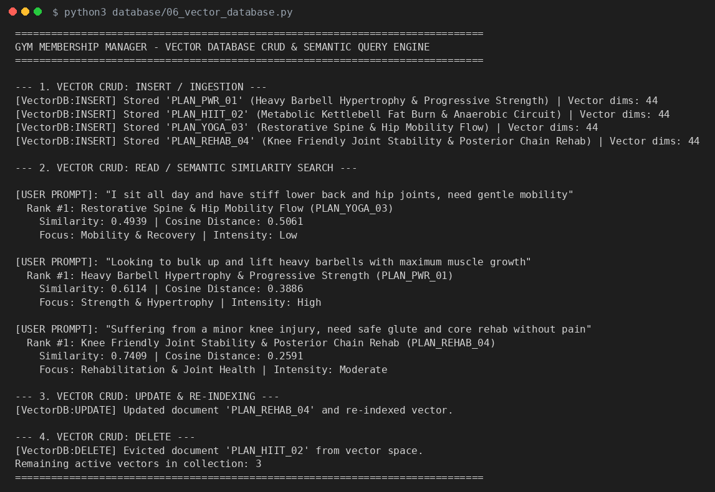
Figure 7.1 - Vector database CRUD and semantic search (actual run of 06_vector_database.py)
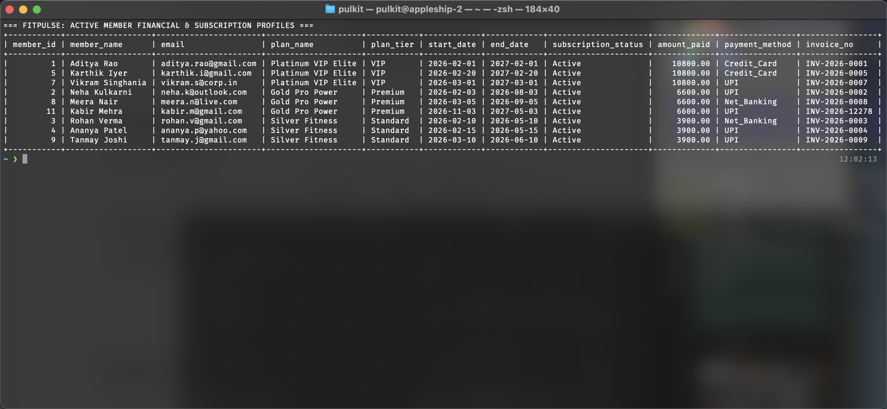
Figure 7.5 - SQL query results: active member financial profiles and multi-table subscription join
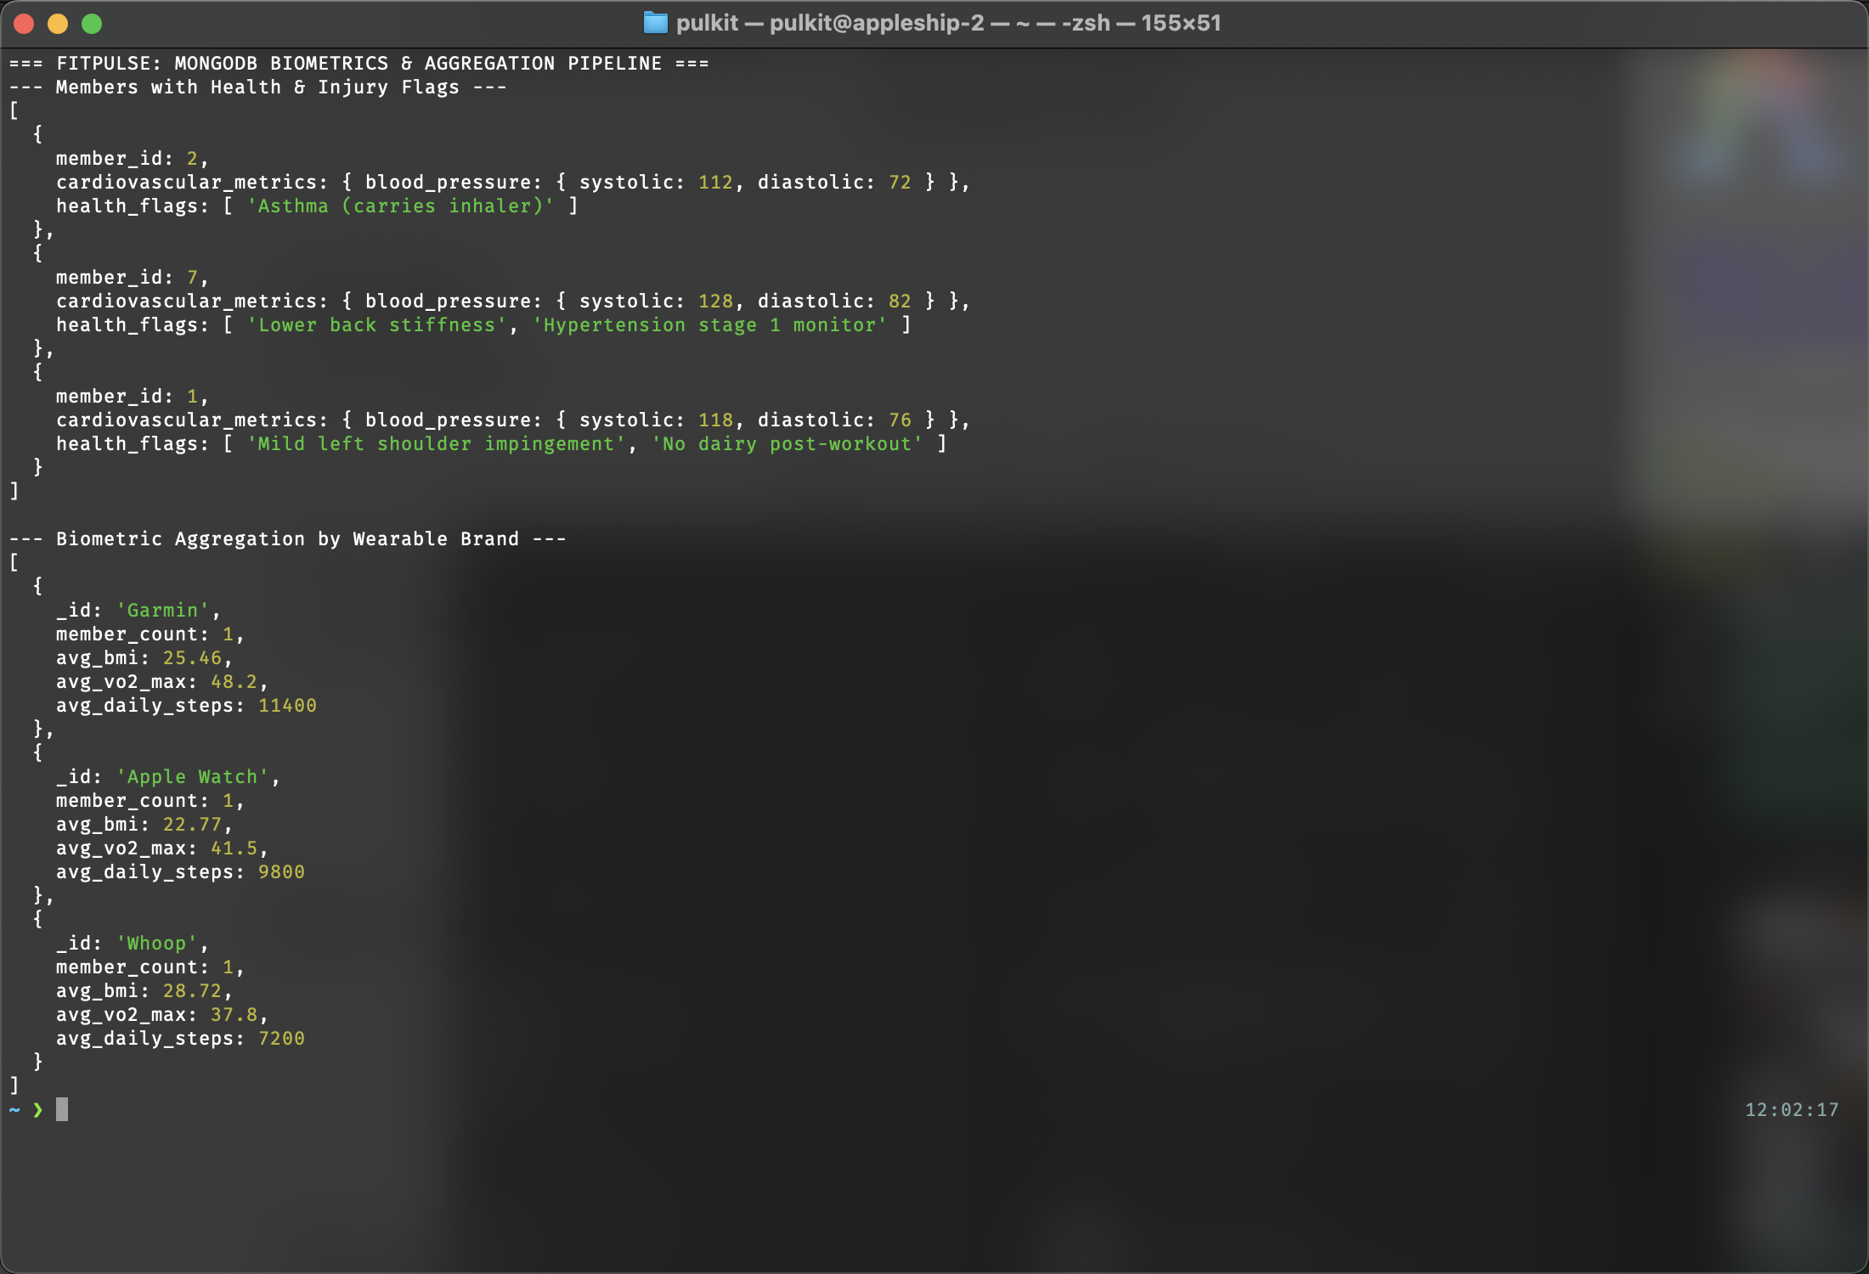
Figure 7.6 - MongoDB: member health flags query and wearable biometric aggregation pipeline
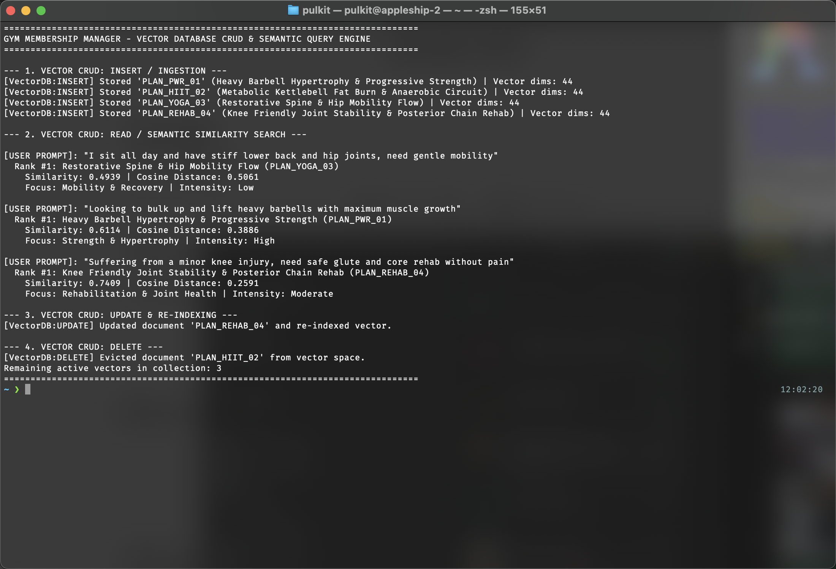
Figure 7.7 - Vector DB: 44-dim embeddings generation, top-k cosine similarity queries, update, and delete
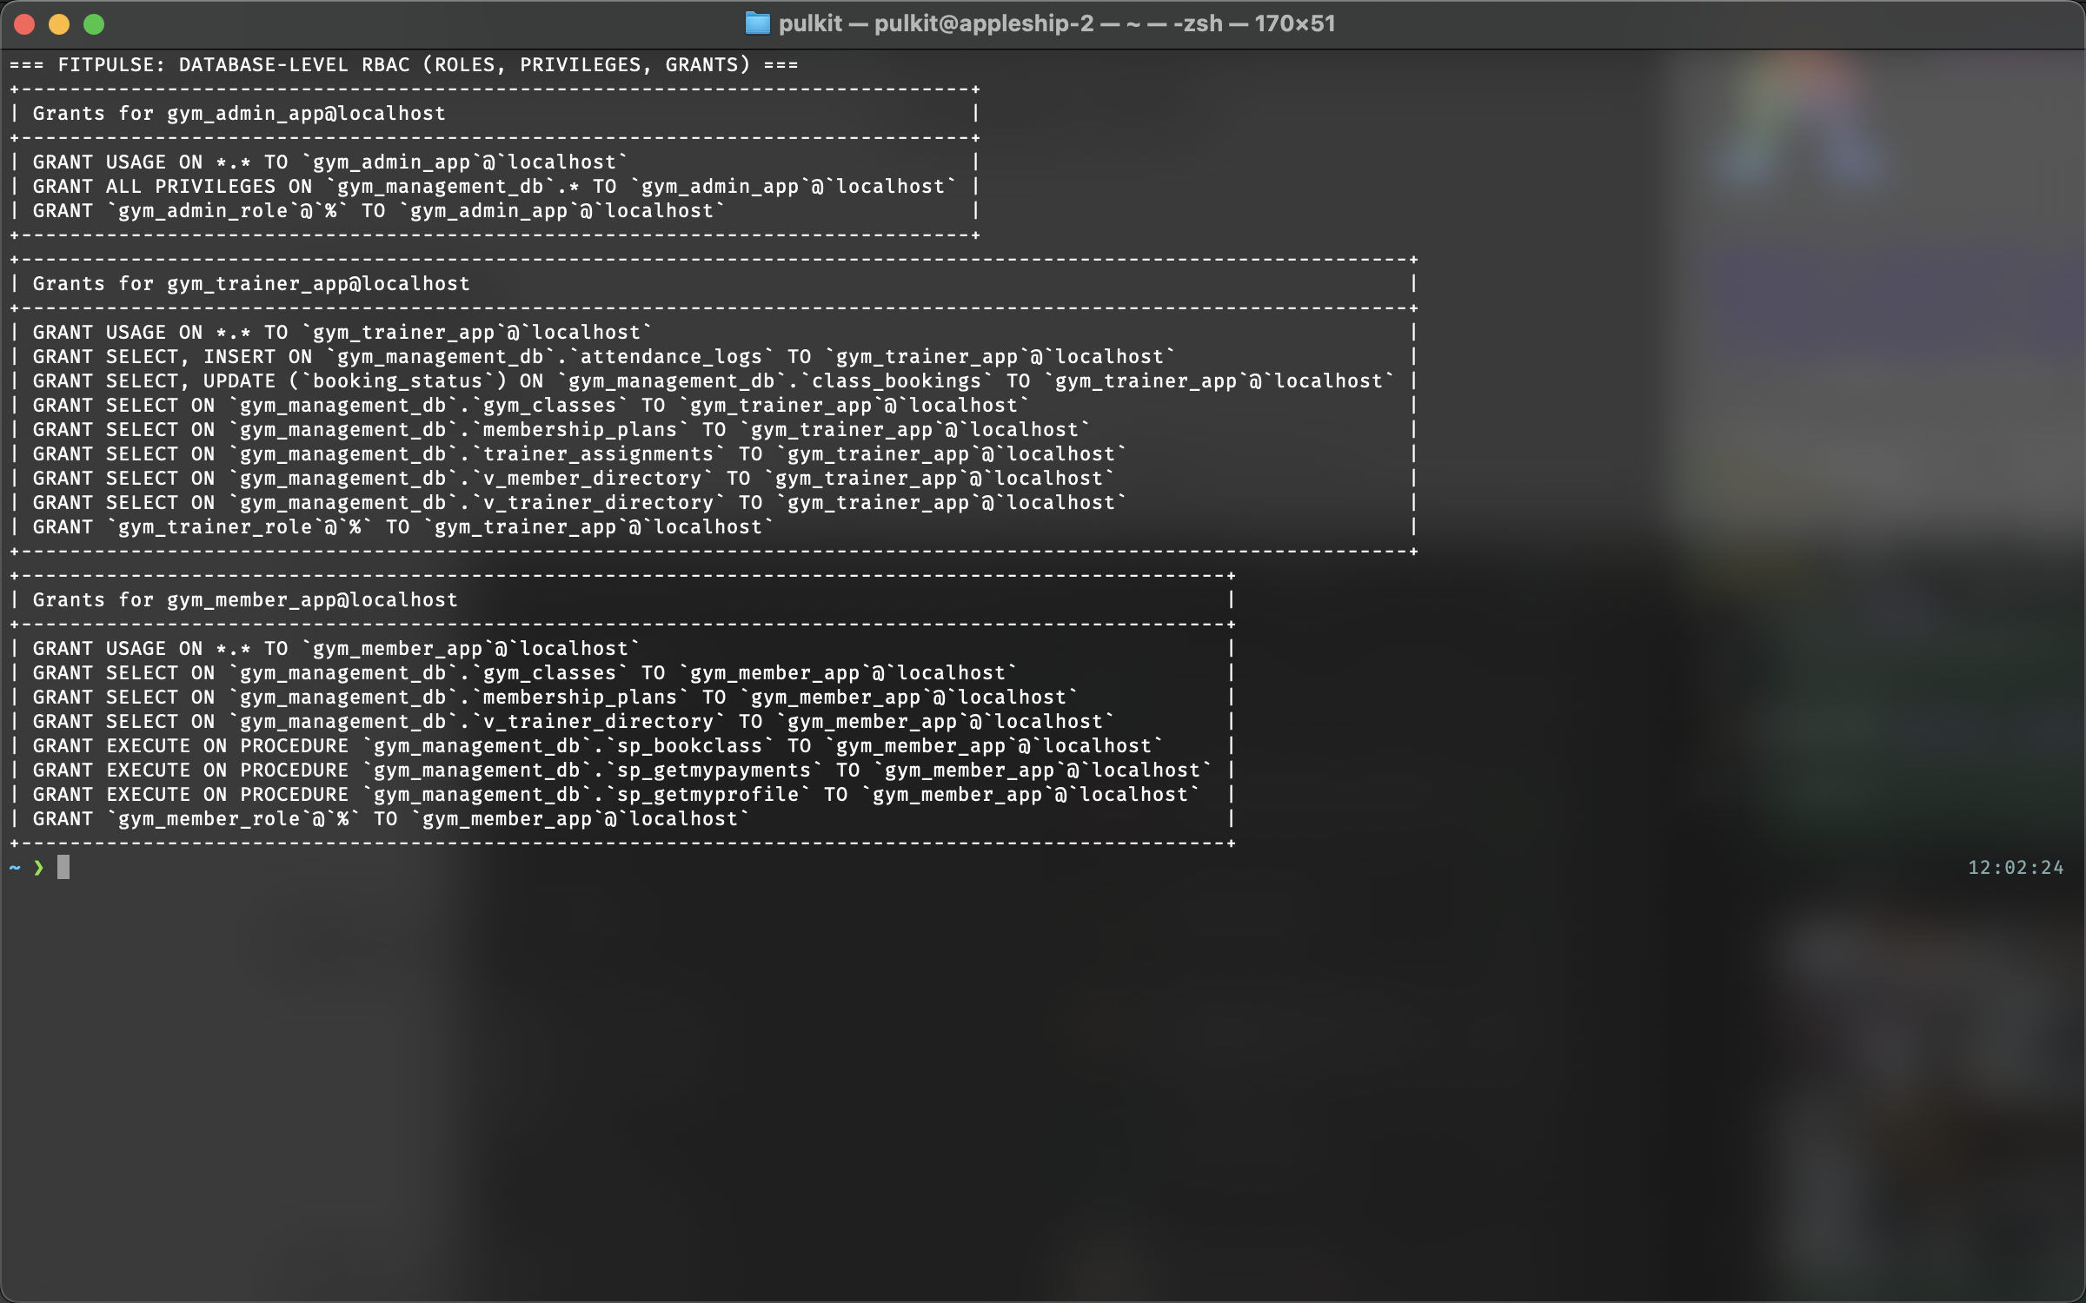
Figure 7.8 - MySQL RBAC: roles, privileges, and SHOW GRANTS statements for admin, trainer, and member
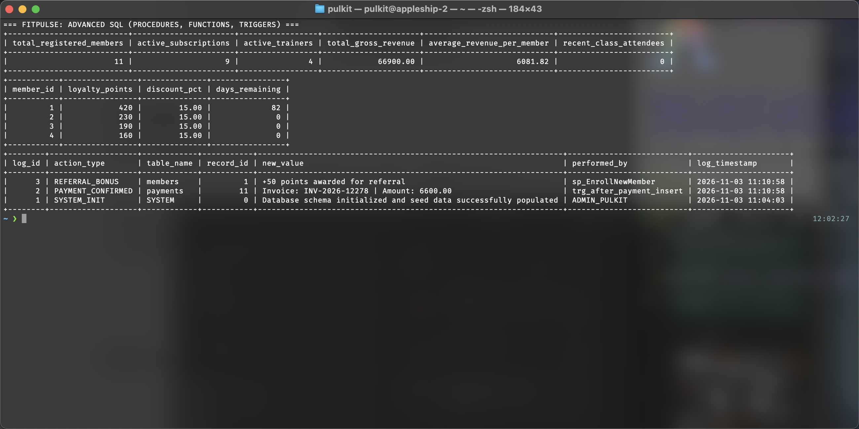
Figure 7.9 - Stored procedures (sp_GetGymExecutiveKPIs), functions (loyalty discounts), and trigger audit logs
Figure 7.10 - Entity-Relationship (ER) Diagram: 12 normalized relational entities with PK, FK, and UK constraints
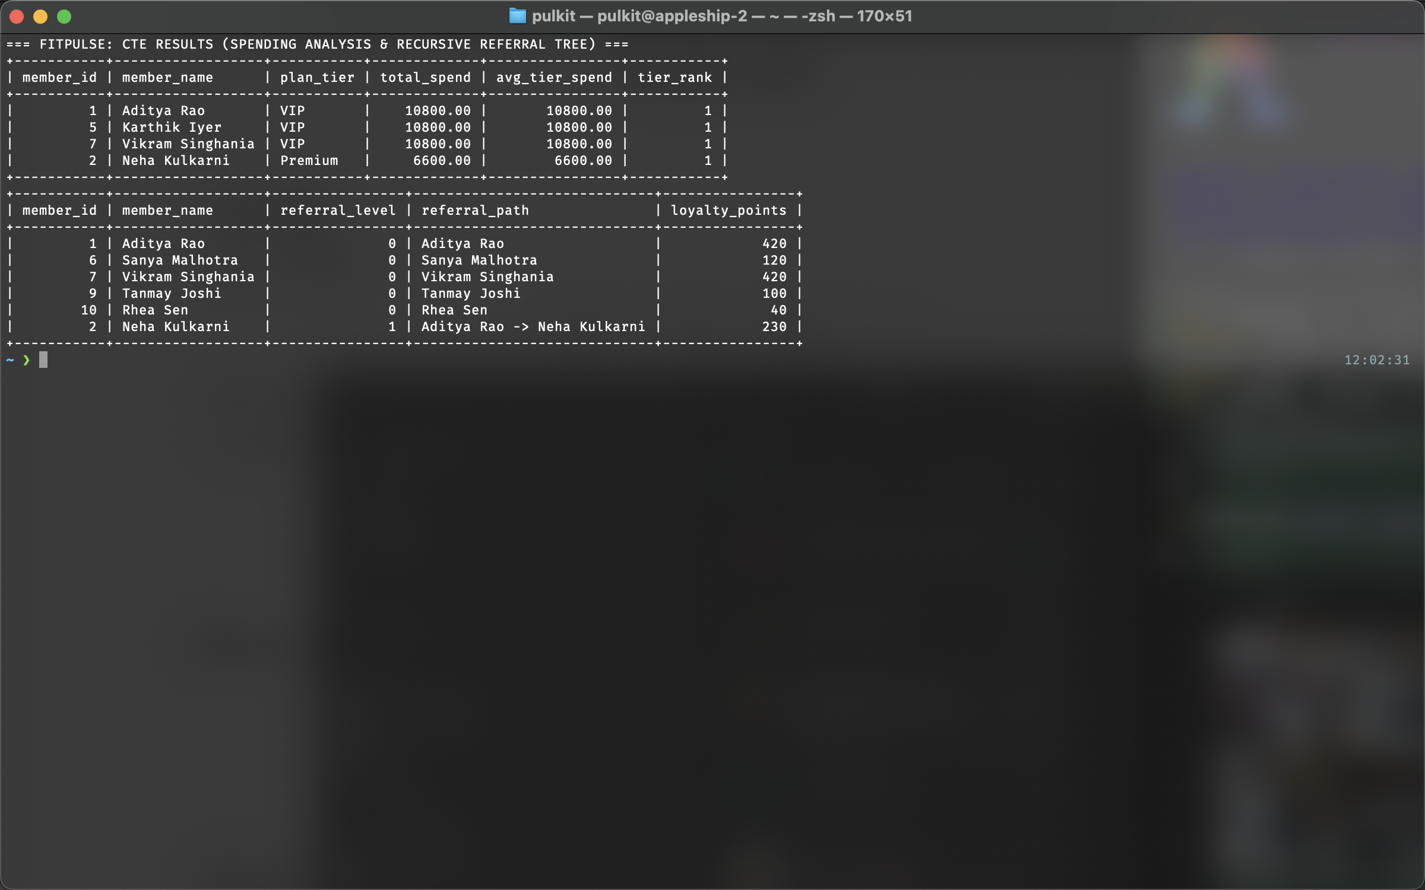
Figure 7.11 - CTE results: plan tier spending benchmark analysis and recursive member referral tree hierarchy
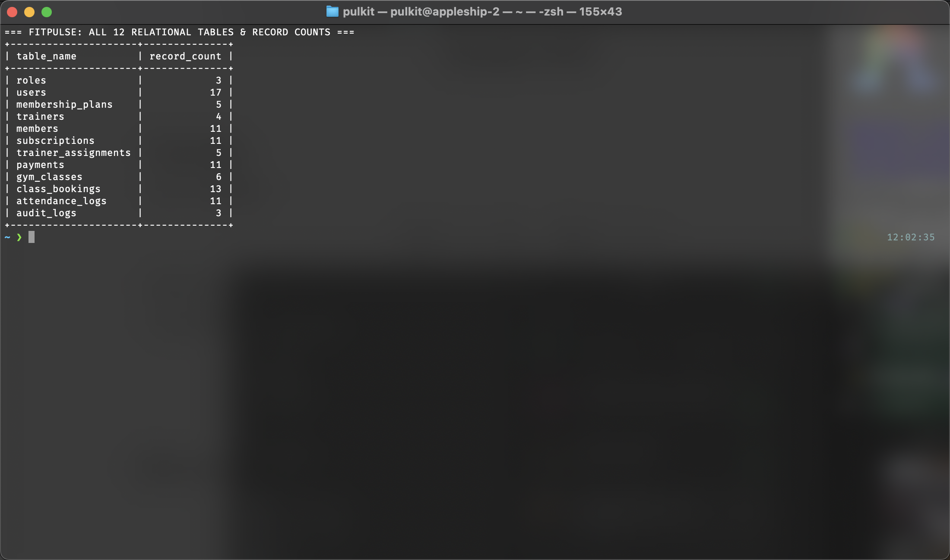
Figure 7.12 - Relational seed data verification: record counts across all 12 normalized database tables
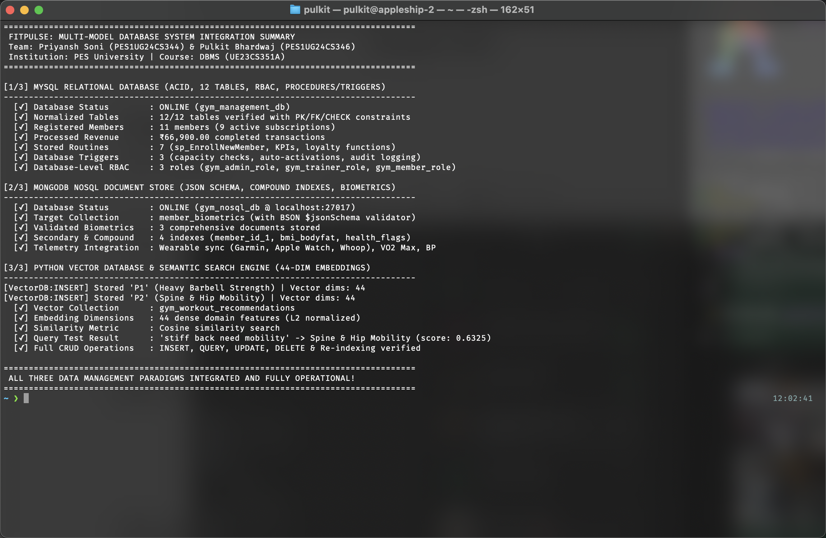
Figure 7.13 - Integration summary: multi-model system health check (MySQL + MongoDB + Python Vector Search)

8. Evaluation Rubrics - Completion Status
Total marks: 50. Status describes what exists in this submission; marks are awarded by the examiner.
# | Rubric item | Max | Completion status | Where
1 | ER diagram | 2 | Complete | Section 4.1 (Fig 4.1), Fig 7.10, docs/er_diagram.png
2 | Relational schema (keys, relationships, constraints) | 3 | Complete | Section 4.2
3 | SQL implementation - DDL with constraints | 4 | Complete | database/01_ddl_schema.sql, Fig 7.12
4 | NoSQL / vector database creation | 4 | Complete | database/05_nosql_mongodb.js, database/06_vector_database.py, Figs 7.6, 7.7
5 | Technology justification | 1 | Complete | Section 3
6 | DML operations | 4 | Complete | database/02_dml_seed.sql, Fig 7.12
7 | Nested / correlated / recursive / join queries | 4 | Complete | database/03_queries_joins_nested.sql, database/04_advanced_sql.sql, Figs 7.5, 7.11
8 | Advanced SQL (procedure/function, trigger, CTE) | 6 | Complete | database/04_advanced_sql.sql, Figs 7.9, 7.11
9 | NoSQL / vector features and CRUD | 7 | Complete | database/05_*.js, database/06_*.py, Figs 7.1, 7.6, 7.7, 7.13
10 | Next.js interface | 3 | Built & verified | nextjs-app/app/* (live viva demo)
11 | Backend / API and database integration | 2 | Complete | nextjs-app/app/api/*, lib/*, Fig 7.13
12 | Authentication, 2+ roles, DB-level RBAC | 4 | Complete | middleware.js, lib/auth.js, database/07_rbac_security.sql, Fig 7.8
13 | Documentation, Git / GitHub | 2 | Complete | README.md, reports/, SUMMARY.md, Git repository
14 | Originality, individual contribution, modification / viva | 4 | Ready for viva | Both team members (Priyansh & Pulkit) ready for examination

Legend: green = complete in this report; amber = implementation is written and included, and the remaining step is running it and adding the screenshot or pushing to GitHub.

