SVKM’s NMIMS
Mukesh Patel School of Technology Management & Engineering
Department of Aritificial Intelligence, Mumbai Campus
Program: B.Tech/MBA Tech AI Semester: VI

Course: Evolutionary Computing
List of Experiments

Faculty:Dr. Ami Munshi WEF Jan 2026

Exp No. | Title | Prerequisite* | CO#
1 | Optimisation, Modelling and Simulation  - To comprehend the concept of optimisation, modelling and simulation  - To implement the given constraint satisfaction problem in Python | Concept of optimization, modelling and simulation | 1
2. | Knapsack Problem using Evolutionary Computing Concept  - To understand the concept of evolutionary computing  - To comprehend knapsack problem  - To solve knapsack problem using any classical approach  - To solve knapsack problem using evolutionary approach  - To compare your observations for both the approaches  - To identify the domains/application where knapsack problem can be utilised | Idea of evolutionary algorithm and the steps involved, concept of knapsack problem | 1
3. | N-Queen Problem using Evolutionary Computing Concept  - To comprehend N-Queens’ problem  - To solve N queens’ problem using any other approach such as hill climbing or back tracking  - To solve N queens’ problem using genetic algorithm  - To compare your observations for both the approaches | Idea of evolutionary algorithm and the steps involved, concept of N-Queen problem | 1
4 | Implementation of various techniques of Representation, Mutation and Recombination  - Comprehend and implement the techniques of the Binary/Integer/Real/Permutation /Tree Representation  - Comprehend and implement the crossover techniques for Binary/Integer/Real/Permutation/Tree Representation  - Comprehend and implement the mutation techniques for Binary/Integer/Real/Permutation/Tree Representation | Idea of the genetic operators and the different techniques for representations, recombination and mutation | 2
5 | Implementation of various parent selection algorithms such as Roulette Wheel Selection, Tournament Selection, Rank selection  - To understand the significance of parent selection algorithm in evolutionary computing  - To identify, explore and elucidate various parent selection algorithms available in literature of evolutionary computing  - To implement Roulette Wheel Selection algorithm for the given problem  - To implement Tournament Selection for the given problem  - To implement Rank selection for the given problem  - To Analyze and compare all the implemented algorithms | CO2
6 | Implementation of Evolutionary Algorithm Variants  - Understand the notion of evolutionary algorithm variants such as Genetic Programming, Evolutionary Programming, Differential Evolution and Evolutionary Strategies  - Implement optimization regression problem using genetic programming algorithm  - Implement minimization problem using differential evolution  - Analyse the performance of genetic programming and differential evolution algorithms
7 | Implementation of Ant Colony Optimization Algorithms  - Explore, understand and draw parallels between real ants and artificial ants concept  - Implement Ant System Algorithm on Travelling Salesman Problem  - Apply Min Max Ant System Algorithm on the above problem  - Compare and analyse both the algorithms
8 | Implementation of Ant Colony Optimization(ACO) Algorithms  - Implement Elitist Ant System Algorithm on Travelling Salesman Problem  - Extend Elitist Ant System Algorithm to Rank Based Ant System Algorithm  - Compare and analyze both the algorithms with Ant System Algorithm
9 | Implementation of Travelling Salesman Problem using Particle Swarm Optimization
10 | Practicuum- Self experiment
11

* Students are expected to be ready with the prerequisite before attending the lab

Experiment No.08
PART A
(PART A: TO BE REFFERED BY STUDENTS)
A.1 Aim: Implementation of Ant Colony Optimization(ACO) Algorithms
- Implement Elitist Ant System Algorithm on Travelling Salesman Problem
- Extend Elitist Ant System Algorithm to Rank Based Ant System Algorithm
- Compare and analyze both the algorithms with Ant System Algorithm

A.2 Prerequisite:
Concept of Ant Colony Optimization, Ant System(AS) Algorithm and its variants
A.3 Learning Outcome:
After completing this experiment, you will be able to-
- Familiarize with various ACO algorithms
- Devise and compare the performance of all the implemented AS algorithm variants
A.4 Theory:
A.4.1 Ant Colony Optimization
- Borrows ideas from biological ants
- Ants are able to find shortest path between their colony and source of food
- Shortest path is found using pheromone trails which ants deposit when they travel
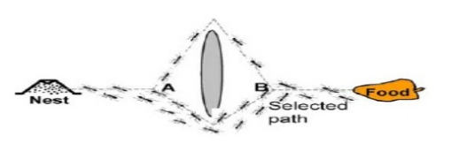
Figure 1 Ants Foraging from nest to food
- When ants leave their nest to search for a food
- They follow random path
- When the ant finds the food source, it walks back to the nest leaving “markers” or pheromone that shows that the path has food
- When other ants come across the markers, they are likely to follow that path.
- If they do, then the populate the path with more pheromone.
- Shortest path gets stronger pheromone trail
- An ant is most likely to choose path with pheromone trail which makes it stronger
- Other ants follow stronger path which is the shortest path
- Positive feedback process prompts other ants to follow shorter path
A.4.2 Ant System Algorithm
- Its main characteristic is that, at each iteration, the pheromone values are updated by all the m ants that have built a solution in the iteration itself
- The pheromone $τ_{i, j}$, associated with the edge joining cities $i and j$, is updated as follows-
  - $τ_{i,j}=\sum_{k=1}^{m}{∆τ_{i,j}^{k}}$ This is the equation without evaporation
  - $τ_{i,j}=(1-ρ)τ_{i,j}\text{ + }\sum_{k=1}^{m}{∆τ_{i,j}^{k}}$ This is the equation with evaporation
    - where ρ is the evaporation rate, $m$ is the number of ants, and $τ_{k}$
- $∆τ_{i,j}^{k}$is the quantity of pheromone laid on edge (i, j) by ant k
  - $∆τ_{i,j}^{k}= \left\{\begin{aligned}\frac{Q}{L_{k}}, if ant k used edge \left(i,j\right)in its tour \\ 0, otherwise \end{aligned}\right.$
  - Where $Q$ is a constant, generally Q=1 and $L_{k}$ is length of tour constructed by ant k
- Probability of choosing a path is given by
$$P_{i,j}=\left(\frac{{\left(τ_{i,j}\right)}^{α}{\left(η_{i,j}\right)}^{β}}{\sum{{\left(τ_{i,j}\right)}^{α}{\left(η_{i,j}\right)}^{β}}}\right)$$
- Where $η_{i,j}=\frac{1}{L_{i,j}}, L_{i,j}is the length of edge \left(i,j\right)$
- $α and β control the relative importance of$
$$pheromone versus the heuristic information η_{i,j}$$

A.4.3 Max Min Ant System
- This algorithm is an improvement over the original Ant System. Its characterizing elements are that only the best ant updates the pheromone trails and that the value of the pheromone is bound
- The pheromone update is implemented as follows:
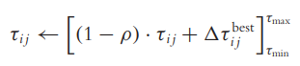
where τmax and τmin are respectively the upper and lower bounds imposed on the pheromone; the operator is defined as
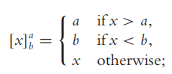
And
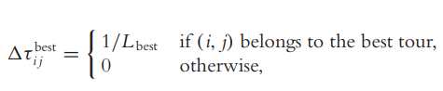
where Lbest is the length of the tour of the best ant.

A.4.3 Elitist Ant System Algorithm
- The idea is to provide strong additional reinforcement to the arcs belonging to the best tour found since the start of the algorithm
  - this tour is denoted as Tbs (best-so-far tour)
- Update of Pheromone Trails
- Additional reinforcement of tour $T^{bs}$is achieved by adding a quantity $e/C^{bs}$ to its arcs
- where $e$ is a parameter that defines the weight given to the best-so-far tour $T^{bs}$, $C^{bs}$is its length
- Thus, equation for the pheromone deposit becomes
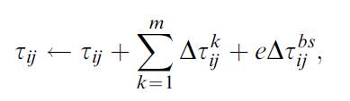
  - where
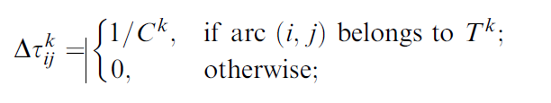
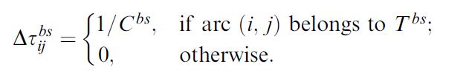

where $C_{k}$, the length of the tour $T_{k}$ built by the $kth$ ant

A.4.3 Rank based Ant System Algorithm
- In $AS_{rank}$
  - each ant deposits an amount of pheromone that decreases with its rank
  - the best-so-far ant always deposits the largest amount of pheromone in each iteration
- Update of Pheromone Trails
  - Before updating the pheromone trails, the ants are sorted by increasing tour length and the quantity of pheromone an ant deposits is weighted according to the rank r of the ant
  - Ties can be solved randomly (in our implementation they are solved by lexicographic ordering on the ant name k)
  - In each iteration only the $(w-1)$bestranked ants and the ant that produced the best-so-far tour (this ant does not necessarily belong to the set of ants of the current algorithm iteration) are allowed to deposit pheromone
  - The best-so-far tour gives the strongest feedback, with weight w
    - (i.e., its contribution $1/C_{bs}$ is multiplied by w);
  - the $rth$ best ant of the current iteration contributes to pheromone updating with the value $1/Cr$ multiplied by a weight given by $\max\left\{0,w-r\right\}.$
- Thus, the $AS_{rank}$ pheromone update rule is
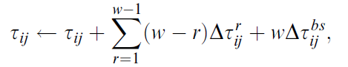
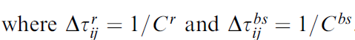
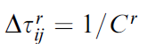
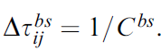

A.5 Task to be completed:
1. Extend Travelling Salesman Problem for the given distance matrix and initial pheromone level using the concept of AS Algorithm to implement Elitist AS and Randk Based AS

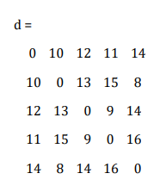 | 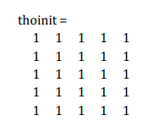

2. Compare the algorithms in terms of time and complexity
References:
- A.E. Eiben, J.E. Smith, Introduction to Evolutionary Computing, 2nd edition, Natural Computing Series, Springer, 2015
- William B. Langdon, Riccardo Poli, Nicholas F. McPhee, and John R. Koza, Genetic Programming: An Introduction and Tutorial, with a Survey of Techniques and Applications
- https://www.maths.uq.edu.au/MASCOS/Multi-Agent04/Fleetwood.pdf
- https://machinelearningmastery.com/differential-evolution-from-scratch-in-python/

PART B
(PART B: TO BE COMPLETED BY STUDENTS)
(Students must submit the soft copy as per following segments within two hours of the practical. The soft copy must be uploaded on the Portal/MS Teams assignment link at the end of the practical)
Roll No. | Name:
Program : | Division:
Batch: | Date of Experiment:
Date of Submission: | Grade :

B.1 Tasks given in PART A to be completed here
(Students must write the answers of the task(s) given in the PART A /Students must copy the code, output screenshots here based on the task(s) given in section A.5)

B.2 Observations and Learning:
(Students must write the observations and learning based on their understanding built about the subject matter and inferences drawn)

B.3 Conclusion:
(Students must write the conclusive statements as per the actual attainment of individual outcomes listed above and learning/observation noted in section B.2)
B.5 Curiosity Questions
1. Identify some real world applications where ACO can be implemented.
2. Share the links of resources where these implementations are found

