A PROJECT SYNOPSIS ON
SECURING WEBSITES WITH
HTTPS CERTIFICATES
( A Study and Practical Implementation using SSL/TLS, PKI and AWS Cloud Security )
Network Security • Web Infrastructure • Cloud Computing
Submitted in partial fulfilment of the requirements for the award of the degree of
BACHELOR OF TECHNOLOGY
in
COMPUTER SCIENCE & ENGINEERING
Submitted by
Saurabh Chahar (2415001446)
Sachin (2415001348)
Harshit Pandey (2415000663)
Priyanshu Pandey (2415001211)
Under the Guidance of
Mr. Raushan Kumar Singh
DEPARTMENT OF COMPUTER SCIENCE & ENGINEERING
ACADEMIC YEAR 2024–2025

Project Details
Field | Details
Project Title | Securing Websites with HTTPS Certificates
Project Category | Network Security / Web Infrastructure
Technology Domain | SSL/TLS, PKI and AWS Cloud Security
Department | Computer Science & Engineering
Academic Year | 2024–2025
Mentor | Mr. Raushan Kumar Singh

Submitted By
Student Name | Roll Number
Saurabh Chahar | 2415001446
Sachin | 2415001348
Harshit Pandey | 2415000663
Priyanshu Pandey | 2415001211

Declaration
We, Saurabh Chahar (2415001446), Sachin (2415001348), Harshit Pandey (2415000663) and Priyanshu Pandey (2415001211), students of the Department of Computer Science & Engineering, hereby declare that the project synopsis entitled “Securing Websites with HTTPS Certificates” is an original record of work carried out by us under the guidance of Mr. Raushan Kumar Singh.
The content presented in this document, including the system design, implementation steps, command references and the AWS cloud demonstration, reflects our own understanding and hands-on practice. Screenshots included in this report were captured directly from our own AWS Management Console session during the course of the project and are used solely for academic evaluation.
We further declare that this work has not been submitted elsewhere for the award of any other degree or diploma.
Place: ———————
Date: ———————

Acknowledgement
We wish to express our sincere gratitude to our mentor, Mr. Raushan Kumar Singh, for his continuous guidance, valuable suggestions and encouragement throughout the planning and execution of this project. His feedback at every stage — from the initial security-gap analysis to the AWS cloud implementation — was instrumental in shaping the direction of this work.
We are also thankful to the Department of Computer Science & Engineering for providing the resources, laboratory access and academic environment necessary to complete this synopsis. We extend our appreciation to our peers for their support during testing and review.
Finally, we acknowledge the open documentation provided by Amazon Web Services, the CA/Browser Forum, and the IETF, which served as reference material for the technical sections of this report.

Table of Contents
1. Abstract
2. Introduction
3. Problem Statement
4. Project Objectives
5. Scope of the Project
6. Background and Literature Context
7. HTTPS and SSL/TLS Fundamentals
8. Digital Certificates and Certificate Authorities
9. Security Threats in HTTP
10. System Architecture
11. Implementation Methodology
12. Server-Side HTTPS Implementation
13. HTTPS Configuration and Hardening
14. Validation and Testing
15. AWS Cloud Implementation (Step-by-Step, with Screenshots)
16. Tools and Technologies
17. Expected Outcomes and Benefits
18. Limitations
19. Future Work
20. Conclusion
21. References

List of Figures
Figure 15.1 – AWS Certificate Manager landing page
Figure 15.2 – Request certificate: choosing “Request a public certificate”
Figure 15.3 – Fully qualified domain names entered for the certificate
Figure 15.4 – Key algorithm and DNS validation method selection
Figure 15.5 – Certificate successfully requested (Pending validation)
Figure 15.6 – Certificate detail page listing both domains as Pending validation
Figure 15.7 – Route 53 hosted zone for my-secure-project.com
Figure 15.8 – Selecting domains to auto-create DNS validation records
Figure 15.9 – Confirmation: DNS validation records created in Route 53
Figure 15.10 – Final certificate details — key type, signature algorithm, validation method

1. Abstract
The project “Securing Websites with HTTPS Certificates” presents a structured study and practical implementation of HTTPS for protecting web communication. The project is centred on SSL/TLS digital certificates, which provide encryption of data in transit and help browsers authenticate the identity of a web server. The work begins by examining the security weaknesses of an HTTP-only website and establishes a baseline for comparison.
The implementation covers the complete HTTPS enablement lifecycle: security-gap identification, selection of an appropriate certificate and Certificate Authority, cryptographic key and Certificate Signing Request (CSR) preparation, certificate installation, HTTPS server configuration, HTTP-to-HTTPS redirection, HSTS enforcement, mixed-content remediation, and independent validation. The validation stage uses browser developer tools, curl and Qualys SSL Labs to assess certificate validity, protocol support, redirect behaviour, security headers and overall TLS configuration.
A second implementation track maps the same objectives onto Amazon Web Services. AWS Certificate Manager (ACM) is used to request and manage a public certificate, Route 53 is used for DNS hosting and automated DNS-based domain validation, CloudFront can provide edge HTTPS termination, and an Application Load Balancer can terminate HTTPS and distribute traffic to backend EC2 instances. This report documents this cloud track in full step-by-step detail, supported by console screenshots captured during the actual certificate request and validation process, to demonstrate how managed cloud services reduce the operational effort associated with certificate deployment and renewal.
Overall, the synopsis combines conceptual grounding in cryptography and PKI with a reproducible, evidence-backed implementation, making it suitable both as an academic report and as a practical reference for securing a real web deployment.

2. Introduction
The modern web is used for communication, commerce, financial transactions, social interaction and information exchange. Because these activities frequently involve sensitive information, protection of data while it travels between a client and a server is a fundamental security requirement. HTTP, by itself, does not encrypt application data in transit. An intermediary capable of observing the network path may therefore be able to read or manipulate information transmitted through an HTTP connection.
HTTPS addresses this weakness by operating HTTP over the SSL/TLS security layer. TLS establishes a secure session through a handshake, authenticates the server using a digital certificate, negotiates cryptographic parameters and protects subsequent application data. The project therefore treats HTTPS not merely as a browser feature but as an important part of professional web infrastructure.
The project is designed around a practical before-and-after comparison. In the initial state, the target site is evaluated as an HTTP deployment. Network requests, response headers, cookies and browser security information are examined to identify gaps. The second state is a secured HTTPS deployment in which the certificate is installed correctly, port 443 is configured, HTTP requests are redirected to HTTPS, HSTS is enabled and mixed-content references are removed.

2.1 Rationale
A certificate alone does not guarantee a secure deployment. Incorrect certificate chains, weak protocol configurations, insecure redirects, mixed content and missing security headers can leave a site exposed even when HTTPS appears in the browser address bar. The project therefore includes configuration hardening and independent testing rather than treating certificate installation as the final step.

2.2 Significance
The practical significance of the project lies in demonstrating the complete certificate lifecycle and the relationship between cryptographic controls and web-server configuration. The project also introduces a cloud-native model in which certificate issuance and renewal can be managed by AWS services rather than maintained entirely by an administrator.

2.3 Why AWS Certificate Manager and Route 53 Were Chosen
For the cloud track, AWS Certificate Manager was selected because it issues and renews public certificates at no additional cost when used with supported AWS resources, and it removes the manual key-generation and CSR steps required in the self-managed track. Route 53 was chosen as the DNS provider because ACM can write its DNS validation record directly into a Route 53 hosted zone with a single click, which shortens the validation cycle from hours (in the case of manual CNAME creation on a third-party registrar) to a few minutes. Together, ACM and Route 53 show a minimal-friction path from “domain registered” to “valid public TLS certificate,” which this report reproduces step by step in Section 15.

3. Problem Statement
Websites that rely on plain HTTP transmit application data without transport-layer encryption. This creates security risks including passive interception, manipulation of traffic and impersonation-related attacks. In addition, poorly configured HTTPS deployments may suffer from incomplete certificate chains, deprecated TLS protocols, redirect loops, mixed-content warnings or expired certificates.
A related, often under-documented problem is operational: even after a certificate is correctly issued, administrators frequently forget to renew it before expiry, or the DNS validation record required to prove domain ownership is created incorrectly, causing the certificate request to remain stuck in a “Pending validation” state indefinitely.
The problem addressed by this project is therefore twofold: (a) the systematic conversion of an HTTP website into a properly configured HTTPS deployment, and (b) the demonstration of a managed cloud approach — using AWS Certificate Manager together with Route 53 — that automates domain validation and certificate renewal, thereby reducing the most common certificate-management errors.

4. Project Objectives
- Identify and analyse the security gap in an HTTP-only website by examining traffic, response headers and potential attack vectors.
- Evaluate certificate requirements and select an appropriate Certificate Authority and certificate type.
- Generate or procure the required certificate and configure HTTPS on the production web server.
- Enforce HTTPS using permanent redirection and HSTS and remediate mixed-content references.
- Validate the final deployment using browser tools, curl and Qualys SSL Labs.
- Demonstrate, with console screenshots, the complete step-by-step process of requesting a public certificate in AWS Certificate Manager and validating it automatically through Amazon Route 53.
- Document the resulting certificate metadata (key algorithm, signature algorithm, validation method, associated AWS services) as evidence of a correctly issued certificate.

5. Scope of the Project

5.1 Included Scope
- Assessment of an existing HTTP website and documentation of security weaknesses.
- SSL/TLS certificate concepts, certificate selection and Certificate Authority considerations.
- Cryptographic key and CSR generation using OpenSSL.
- Certificate installation and web-server configuration for HTTPS.
- HTTP-to-HTTPS 301 redirection and HSTS configuration.
- Identification and remediation of mixed-content resources.
- TLS protocol and certificate-chain validation.
- Testing through browser developer tools, curl and Qualys SSL Labs.
- AWS implementation using ACM and Route 53, documented step by step with screenshots; CloudFront, ALB and EC2 covered at architecture level.

5.2 Out-of-Scope Areas
- Private or internal PKI deployment.
- Mutual TLS (mTLS) client-certificate authentication.
- Code-signing certificates.
- Email/S/MIME certificates.
- Application-layer security controls that are not directly part of TLS transport security.

6. Background and Literature Context
The project follows the development of secure web transport from SSL to modern TLS. SSL was introduced to protect web communication, and subsequent TLS versions progressively improved security and performance. TLS 1.2 became a widely deployed standard, while TLS 1.3 introduced a simplified handshake, removed several legacy cryptographic mechanisms and made forward secrecy a mandatory property of compliant cipher suites.
The CA/Browser Forum defines requirements for publicly trusted TLS certificates. Modern certificate ecosystems also favour shorter validity periods and automated renewal. Let's Encrypt provides an example of an automated Certificate Authority using the ACME protocol, while commercial CAs such as DigiCert and Sectigo represent commercial certificate-management options. AWS Certificate Manager follows a similar automation philosophy for certificates that are used exclusively with integrated AWS services.
HSTS is an important complement to HTTPS because it allows a browser to enforce HTTPS for a site after receiving the policy. The project incorporates HSTS as a defence against downgrade and SSL-stripping scenarios.

7. HTTPS and SSL/TLS Fundamentals

7.1 HTTP versus HTTPS
Feature | HTTP | HTTPS
Transport security | No TLS protection | TLS protection
Typical port | 80 | 443
Data confidentiality | Not provided by HTTP | Provided through encryption
Server authentication | Not provided by HTTP itself | Certificate-based TLS authentication
Integrity protection | Not provided by HTTP itself | Provided by TLS
Browser security indication | May be marked insecure | Secure connection when valid

7.2 TLS Handshake
The TLS handshake is the process through which a client and server establish the parameters needed for secure communication. The client and server negotiate supported protocol and cryptographic parameters, the server presents its certificate, and the client verifies that the certificate is trusted and applicable to the requested domain. Key-establishment mechanisms then provide the basis for protected application traffic.

7.3 Confidentiality, Integrity and Authentication
- Confidentiality: protects transmitted information from unauthorised disclosure.
- Integrity: helps detect modification of protected traffic during transmission.
- Authentication: enables the client to verify the identity represented by the server certificate.

7.4 TLS Versions
The project targets modern TLS configurations and specifically treats SSL 3.0, TLS 1.0 and TLS 1.1 as deprecated protocols that should not be offered. TLS 1.2 and TLS 1.3 are the relevant modern protocol versions for the implementation and validation stages.

8. Digital Certificates and Certificate Authorities

8.1 Digital Certificate
A digital certificate binds a domain identity to a public key and contains information that allows a client to evaluate the certificate's validity. The certificate is signed by a Certificate Authority whose trust anchor is recognised by operating systems and browsers. During an HTTPS connection, the certificate contributes to authentication of the server.

8.2 Certificate Types
Type | Purpose | Typical Use
DV | Domain control validation | General websites and applications
OV | Domain plus organisation validation | Organisational websites requiring identity information
EV | Higher-assurance organisational validation | Use cases needing extra assurance
Wildcard | Covers a domain and its subdomains | Multiple subdomains, e.g. *.my-secure-project.com
SAN / Multi-domain | Covers multiple names | Multiple domains or hostnames on one certificate

8.3 Certificate Authority Selection
The project evaluates CA selection using factors such as domain count, sensitivity of the data handled, regulatory considerations, automation capability, validation turnaround, browser trust coverage, support and cost. Let's Encrypt is considered as a free automated option for self-managed servers, DigiCert and Sectigo are examples of commercial providers, and Amazon (through ACM) is used as the managed CA for the AWS track of this project because it is Amazon-Issued and trusted by all major browsers by default.

8.4 Certificate Lifecycle
- Generate or obtain the private key.
- Create a Certificate Signing Request (CSR) — or, in ACM, let AWS generate and manage the key pair automatically.
- Submit the CSR or request a managed certificate.
- Complete domain validation (DNS or email).
- Receive and install the certificate and CA chain.
- Monitor validity and renew before expiration.

9. Security Threats in HTTP

9.1 Passive Eavesdropping
Because plain HTTP does not encrypt application data, an attacker positioned on an appropriate network path may be able to observe transmitted information. Sensitive form data, session identifiers or credentials can therefore be exposed.

9.2 Man-in-the-Middle (MitM)
A Man-in-the-Middle attack involves an adversary positioned between communicating parties. HTTPS mitigates this class of risk through authenticated TLS connections and cryptographic protection of application traffic, assuming the certificate and TLS configuration are correctly validated.

9.3 Session Hijacking
If session information is transmitted insecurely, an attacker may attempt to obtain or reuse session identifiers. Transport encryption reduces the opportunity to observe session information in transit.

9.4 SSL-Stripping / Downgrade Risk
If a user begins with an HTTP request, an attacker may attempt to prevent the transition to HTTPS. HSTS helps after the browser has received a valid HSTS policy by instructing the browser to use HTTPS for subsequent connections.

9.5 Content Injection and Tampering
Unprotected traffic can be modified in transit. HTTPS provides integrity protection for the TLS-protected connection, reducing the feasibility of undetected modification of application traffic.

10. System Architecture

10.1 Self-Managed Architecture
The self-managed architecture consists of a client browser, DNS resolution and a web server. The web server exposes an HTTP virtual host on port 80 that redirects to HTTPS and an HTTPS virtual host on port 443 that presents the certificate and serves encrypted content.
Browser -> DNS Resolver -> Web Server
HTTP :80 -> 301 Redirect -> HTTPS :443 -> Secure Content

10.2 AWS Architecture
The AWS architecture adds managed infrastructure. Route 53 provides DNS management and supports DNS-based ACM validation. CloudFront can provide edge HTTPS termination and content delivery, while an Application Load Balancer can terminate HTTPS for dynamic traffic and distribute requests to EC2 instances.
Browser -> Route 53 -> CloudFront / ALB -> EC2 Web Application

10.3 Certificate-Request Architecture (this project's AWS track)
For the specific demonstration carried out in this project, the architecture is simplified to the certificate-issuance path: the AWS account holder requests a public certificate in ACM for the domain my-secure-project.com and its wildcard *.my-secure-project.com; ACM generates a unique CNAME validation record for each name; Route 53, already hosting the zone for my-secure-project.com, accepts these validation records automatically through the “Create records in Route 53” action; once Route 53's authoritative name servers publish the CNAME records, ACM's validation service queries DNS, confirms ownership, and moves the certificate from Pending validation to Issued.

11. Implementation Methodology

11.1 Phase 1 – Requirements and Gap Analysis
The target website is first examined in its HTTP state. Browser developer tools are used to inspect network requests, response headers and security information. The absence of appropriate security controls and the presence of insecure traffic are documented as the baseline.

11.2 Phase 2 – Certificate Procurement
The project determines the number of domains and subdomains to be protected and evaluates certificate requirements. A suitable CA is selected. For a self-managed deployment, OpenSSL can be used to create an RSA key pair and CSR; for the AWS track, ACM itself generates and manages the key pair, so this step is reduced to specifying the domain names.

11.3 Phase 3 – Server Configuration
The issued certificate and CA chain are installed on the selected web server. HTTPS is bound to port 443. Modern TLS protocol support is configured, while deprecated protocol versions are disabled. The HTTP virtual host is configured to issue a permanent 301 redirect to HTTPS.

11.4 Phase 4 – Mixed-Content Remediation
All page resources are inspected for hard-coded HTTP references. Images, scripts, stylesheets, iframes and other resources are updated to use HTTPS or relative URLs. Browser console output is used to confirm that mixed-content warnings are removed.

11.5 Phase 5 – Validation
The live deployment is tested for successful TLS negotiation, certificate-chain completeness, trusted certificate status, protocol support, redirect correctness, HSTS behaviour and absence of mixed content. Qualys SSL Labs provides an independent assessment of the server configuration.

11.6 Phase 6 – Monitoring and Renewal Planning
Certificate expiration is treated as an operational risk. The project documents renewal procedures and, where applicable, uses managed AWS certificate renewal to reduce the likelihood of an unnoticed certificate expiry.

12. Server-Side HTTPS Implementation

12.1 Preparing the Web Server
A Linux server can be prepared with Apache or Nginx. The website files are placed in the server's document root or configured virtual host directory. Before HTTPS is enabled, the HTTP deployment is tested to establish a working baseline.

12.2 OpenSSL Verification
The OpenSSL toolkit is used for cryptographic operations. The installed version can be checked using the command-line utility.
openssl version

12.3 RSA Private Key
For the project workflow, a 2048-bit RSA private key is sufficient as a minimum example. The private key must be protected because possession of the private key can undermine the security of the certificate identity.
openssl genrsa -out server.key 2048

12.4 Certificate Signing Request
A CSR contains the information required by a CA to issue a certificate. The Common Name or requested domain names must correspond to the hostname that users will access.
openssl req -new -key server.key -out server.csr

12.5 Domain Validation
The selected CA validates control of the requested domain. Depending on the CA and workflow, validation can use DNS records, an HTTP challenge or another supported method. The project documents the selected method and preserves evidence of successful validation. Section 15 of this report shows this exact process performed through AWS Certificate Manager and Route 53, using DNS validation.

12.6 Certificate Installation
After issuance, the certificate, private key and required CA chain are placed in appropriate protected locations. The web server configuration references these files and enables the TLS listener on port 443.

12.7 Apache Configuration Concept
Apache uses a virtual host configuration for HTTPS. The configuration must specify the domain, port 443, the certificate, the private key and the certificate chain as appropriate for the installed Apache version. The SSL module must be enabled and the configuration should be tested before the service is reloaded.
<VirtualHost *:443>
ServerName yourdomain.com
SSLEngine on
SSLCertificateFile /path/to/certificate
SSLCertificateKeyFile /path/to/private-key
# CA chain configuration as required
</VirtualHost>

12.8 Nginx Configuration Concept
Nginx configures a server block for port 443 and references the certificate and private key. The exact directives depend on the certificate bundle and installed Nginx version.
server {
listen 443 ssl;
server_name yourdomain.com;
ssl_certificate /path/to/fullchain.pem;
ssl_certificate_key /path/to/private.key;
}

12.9 HTTP Redirect
The HTTP virtual host on port 80 should issue a permanent redirect to the HTTPS URL. The redirect must be tested to ensure that it does not create a loop and that the destination preserves the intended path.

12.10 Configuration Safety
- Back up configuration files before modifying them.
- Protect private-key files with appropriate file permissions.
- Test configuration syntax before restarting or reloading the web server.
- Keep certificate and key paths consistent with the active server configuration.

13. HTTPS Configuration and Hardening

13.1 TLS Protocol Configuration
The project validates that modern TLS versions are available and that deprecated protocols are not offered. The final configuration should be checked rather than assumed, because server defaults can vary between operating systems and software versions.

13.2 Cipher Suites and Key Exchange
TLS security depends on the negotiated cryptographic algorithms as well as the certificate. Weak or deprecated cipher suites should not be offered. The project uses Qualys SSL Labs to provide an independent view of protocol and cipher configuration.

13.3 HSTS
HSTS is configured using the Strict-Transport-Security response header. A suitable max-age is selected for the deployment. HSTS configuration must be introduced carefully because browsers that receive the policy will apply it for the specified period.
Strict-Transport-Security: max-age=31536000

13.4 Security Headers
The project checks security-related response headers as part of its baseline and final comparison. HSTS is directly relevant to HTTPS enforcement. Other headers such as Content-Security-Policy and X-Content-Type-Options may be assessed where applicable, but their exact policies depend on the application.

13.5 Mixed Content
Mixed content occurs when an HTTPS document requests resources through HTTP. Such references should be replaced with HTTPS or relative references where appropriate. The browser console and Network panel are useful for locating these issues.

13.6 Certificate Chain
The server must provide the appropriate certificate chain so that clients can build a trusted path to a recognised trust anchor. An incomplete chain can cause browser or client compatibility problems even when the leaf certificate itself is valid.

14. Validation and Testing

14.1 Browser Validation
The browser is used to verify the presence of HTTPS, certificate validity and absence of obvious security warnings. Developer Tools can expose the negotiated protocol, certificate details and network requests.

14.2 Redirect Testing
The project verifies that a request to the HTTP endpoint produces a 301 response and a Location header pointing to the HTTPS endpoint. Redirect loops and incorrect host or path transformations are specifically checked.
curl -I http://yourdomain.com

14.3 HTTPS Header Testing
The HTTPS endpoint is queried directly to inspect security headers such as Strict-Transport-Security and other application response headers.
curl -I https://yourdomain.com

14.4 Certificate Chain Testing
Certificate information is inspected using browser certificate viewers and, where necessary, OpenSSL-based verification. The test confirms the requested domain, issuing CA, validity period and chain information.

14.5 Qualys SSL Labs
Qualys SSL Labs Server Test is used as an independent assessment of certificate validity, protocol support, key exchange, cipher suites and client compatibility. The project targets a minimum A rating as the principal quality metric.

14.6 Test Matrix
Test | Expected Result | Evidence
HTTP request | 301 redirect to HTTPS | curl/browser screenshot
HTTPS request | Successful secure response | Browser screenshot
Certificate | Valid and trusted | Certificate viewer
HSTS | Header present with intended policy | curl headers
TLS protocols | Modern protocols supported; deprecated absent | SSL Labs
Mixed content | No insecure resource warnings | DevTools
Overall TLS rating | A or better target | SSL Labs report

14.7 Before-and-After Comparison
Security Aspect | Before HTTPS | After HTTPS
Data in transit | HTTP / plain transport | TLS-protected transport
Server identity | Not authenticated by HTTP | Certificate-based authentication
HTTP access | Direct HTTP | Redirected to HTTPS
HSTS | Not enabled | Configured
Mixed content | Potentially present | Audited and remediated
Certificate validation | Not applicable | Validated (see Section 15)
Independent TLS test | Not applicable | Qualys SSL Labs

14.8 Evidence Collection
For the academic project, screenshots were captured at each significant stage. Section 15 documents, step by step, the complete AWS Certificate Manager and Route 53 evidence trail: certificate request, domain-name entry, key-algorithm and validation-method selection, the pending-validation state, automatic DNS record creation in Route 53, and the confirmation of successfully created DNS records.

14.9 Acceptance Criteria
- The website is accessible through a valid HTTPS URL.
- The certificate matches the domain and is trusted by the browser.
- HTTP requests are permanently redirected to HTTPS.
- Modern TLS configuration is available and deprecated protocols are not offered.
- HSTS is present with the intended policy.
- Mixed-content warnings are resolved.
- The deployment achieves the targeted SSL Labs rating.

15. AWS Cloud Implementation (Step-by-Step, with Screenshots)

15.1 AWS Architecture Overview
The AWS implementation demonstrates the same security outcome — a valid, browser-trusted HTTPS certificate — through managed services instead of manual OpenSSL commands. AWS Certificate Manager (ACM) handles certificate issuance, and Amazon Route 53 manages DNS and performs the domain-ownership validation automatically. This section documents the exact sequence of console actions that were carried out for this project, under the AWS account Harshit_gla, in the Asia Pacific (Mumbai) region, for the domain my-secure-project.com.

15.2 Prerequisites
- An active AWS account with console access (account used: Harshit_gla, account ID 938147493912).
- A registered domain name — my-secure-project.com — whose DNS is already hosted on an Amazon Route 53 public hosted zone.
- Sufficient IAM permissions to use AWS Certificate Manager and Route 53.

15.3 Step-by-Step Certificate Request and DNS Validation
The following steps were performed in order on the AWS Management Console. Each step is supported by a screenshot captured during the actual session.

Step 1: Open AWS Certificate Manager
AWS Certificate Manager (ACM) is opened from the AWS Console under “Security, Identity, & Compliance.” The service landing page summarises ACM's purpose — to provision, manage, deploy and renew SSL/TLS certificates — and offers three entry points: requesting a new managed certificate, importing a certificate obtained outside AWS, and creating a private certificate authority. For this project, “Request a certificate” is selected to begin issuing a new public certificate for my-secure-project.com.
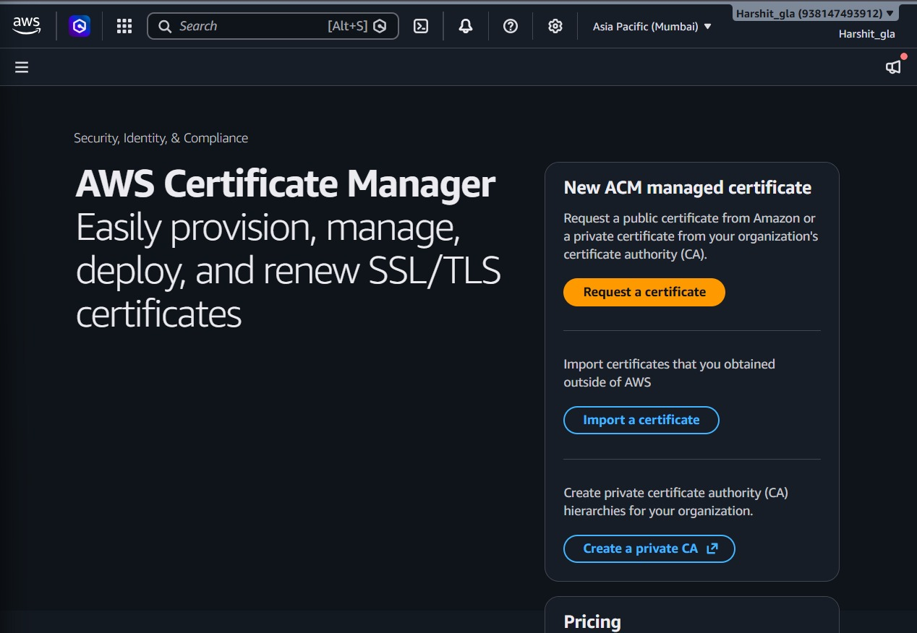
Figure 15.1 – AWS Certificate Manager landing page in the Asia Pacific (Mumbai) region

Step 2: Choose the Certificate Type
On the “Request certificate” screen, ACM asks whether to request a public certificate or a private certificate. “Request a public certificate” is selected because the target website will be accessed over the public internet and needs a certificate trusted by default in every browser and operating system. The private-certificate option is greyed out because no private Certificate Authority has been created in this account, which is expected since this project uses only the public-CA workflow.
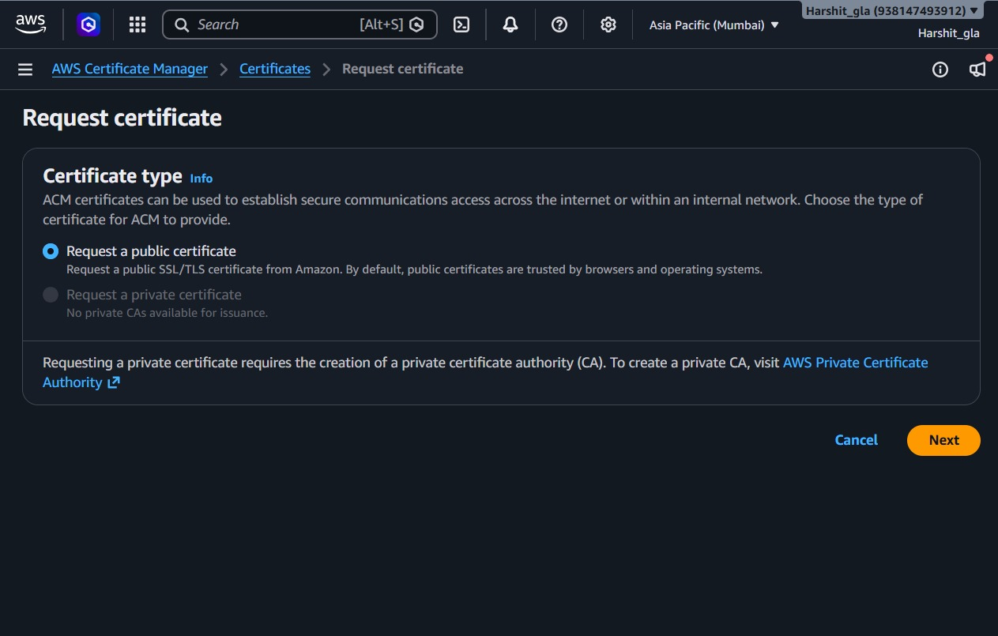
Figure 15.2 – Selecting “Request a public certificate” on the Request certificate screen

Step 3: Enter the Fully Qualified Domain Names
The next screen collects the domain names to secure. Two fully qualified domain names are entered: the apex domain my-secure-project.com, and the wildcard *.my-secure-project.com so that any subdomain (such as www or api) is also covered by the same certificate. The “Allow export” option is left at “Disable export,” which restricts the certificate to use only with integrated AWS services such as CloudFront, Elastic Load Balancing and API Gateway — an appropriate setting for a certificate that will never leave the AWS ecosystem.
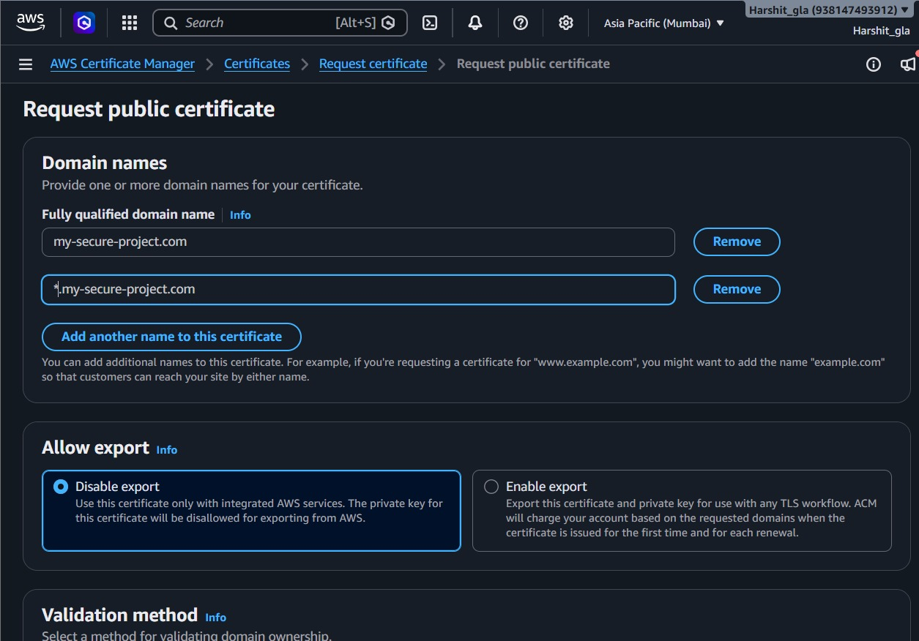
Figure 15.3 – Fully qualified domain name and wildcard domain entered for the certificate request

Step 4: Select the Validation Method and Key Algorithm
ACM offers two validation methods: DNS validation and the deprecated email validation. DNS validation is selected because the project domain is hosted in Route 53, which allows ACM to insert the required validation record automatically instead of relying on an inbox check. For the key algorithm, RSA 2048 is chosen — the most widely supported option — over the ECDSA alternatives (P-256, P-384), since RSA offers the broadest client compatibility for a general-purpose public website.
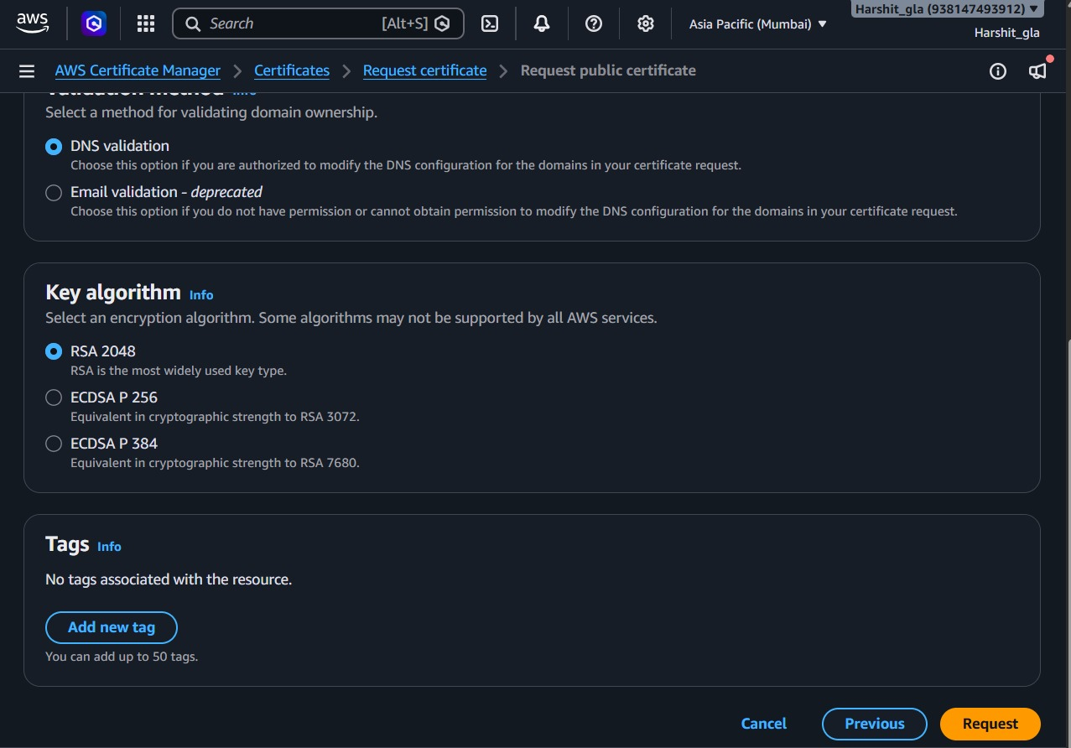
Figure 15.4 – DNS validation method and RSA 2048 key algorithm selected

Step 5: Submit the Request
After reviewing the domain names, export setting, validation method and key algorithm, the request is submitted by clicking “Request.” ACM immediately creates a certificate resource, visible by its unique identifier (aa528e8d-d4bf-4bc8-8ceb-b9e401b49b1d) and its Amazon Resource Name (ARN). The console confirms: “Successfully requested certificate… A certificate request with a status of pending validation has been created. Further action is needed to complete the validation and approval of the certificate.” At this point the certificate exists but is not yet trusted — domain ownership must still be proven.
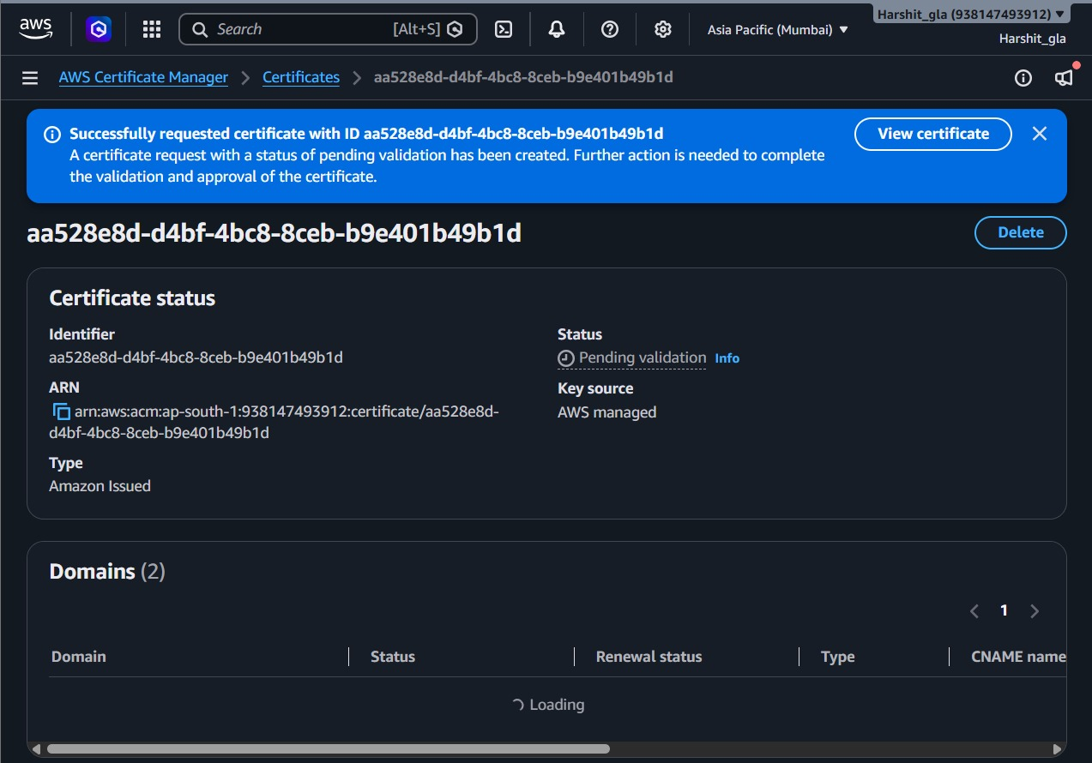
Figure 15.5 – Confirmation banner: certificate successfully requested, status Pending validation

Step 6: Review the Pending Certificate and its Domains
Opening the newly created certificate shows its full status page: Identifier, ARN, Key source (AWS managed) and Type (Amazon Issued). The “Domains” panel lists both requested names — my-secure-project.com and *.my-secure-project.com — each showing status “Pending validation” and a CNAME record type with a unique validation name and value that ACM generated for each domain. This is the information that must be published in DNS before ACM can verify ownership.
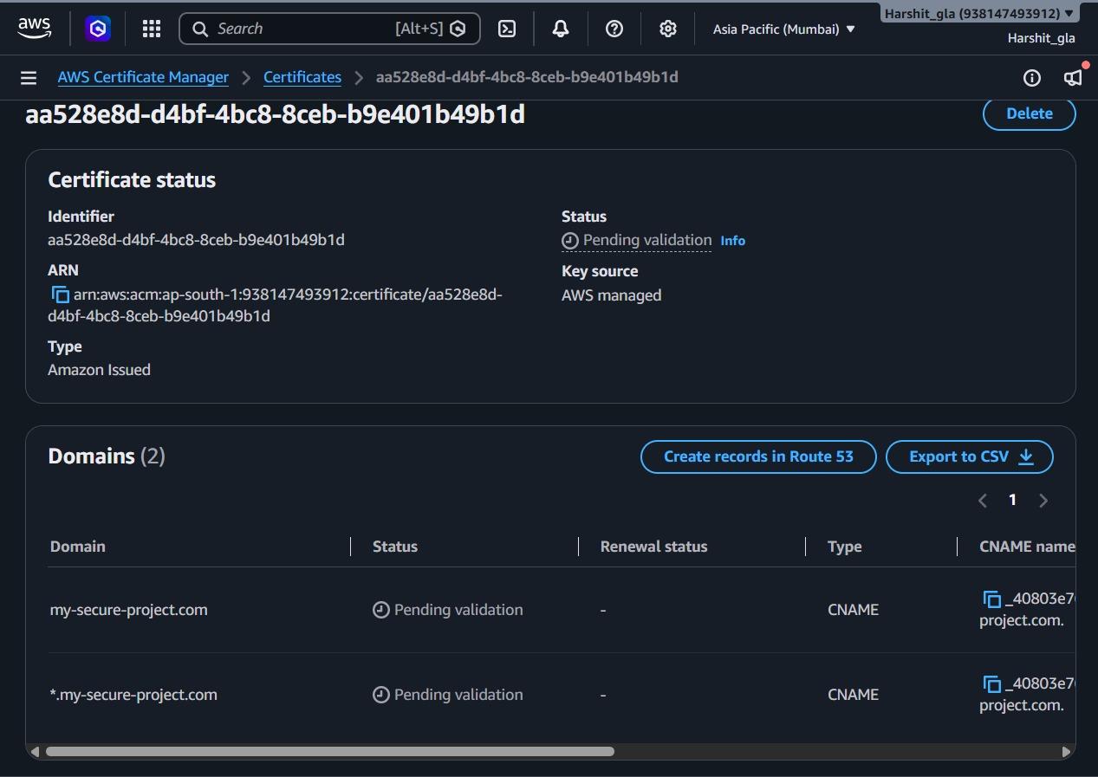
Figure 15.6 – Certificate detail page showing both domains awaiting DNS validation

Step 7: Confirm the Route 53 Hosted Zone
Before creating the validation records, the existing Route 53 public hosted zone for my-secure-project.com is confirmed. The hosted zone already contains the default NS (name server) and SOA records automatically created when the zone was provisioned, alongside one CNAME record. Because this zone is authoritative for the domain, ACM can write directly into it using the “Create records in Route 53” integration, avoiding any manual copy-paste of record names and values.
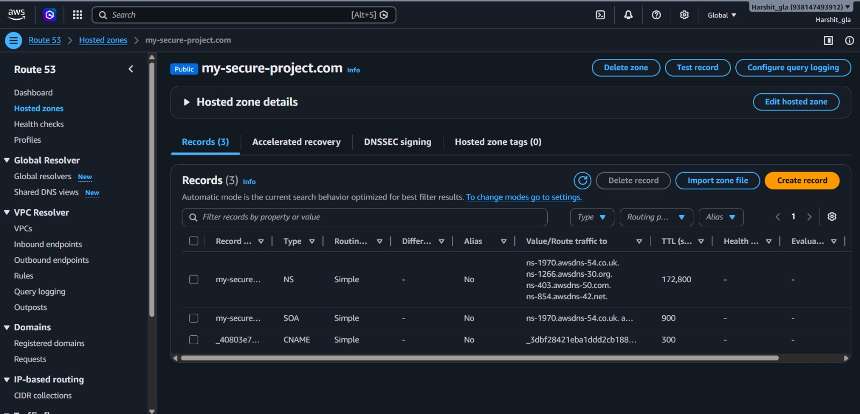
Figure 15.7 – Route 53 hosted zone for my-secure-project.com prior to adding the ACM validation records

Step 8: Create the DNS Validation Records in Route 53
From the certificate detail page, “Create records in Route 53” is clicked. ACM presents a filtered list of domains whose validation status is Pending validation (or Failed) and that are confirmed to belong to a Route 53 hosted zone in this account. Both my-secure-project.com and *.my-secure-project.com are shown with “Is domain in Route 53? = Yes” and are selected (checked) so that their corresponding CNAME validation records will be created automatically in a single action.
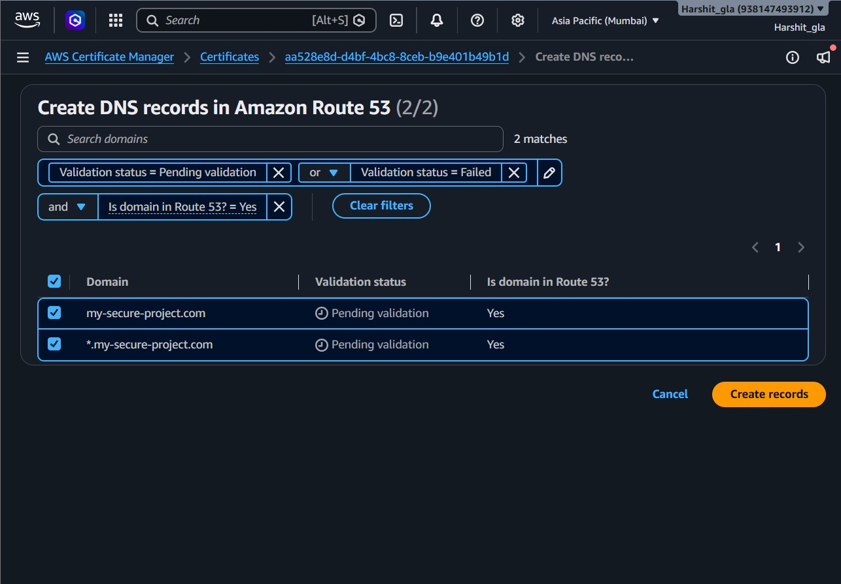
Figure 15.8 – Selecting both domains before creating their DNS validation records in Route 53

Step 9: Confirm the DNS Records Were Created
After clicking “Create records,” Route 53 confirms success: “Successfully created DNS records — Successfully created DNS records in Amazon Route 53 for certificate with ID aa528e8d-d4bf-4bc8-8ceb-b9e401b49b1d.” From this point, ACM's validation service periodically queries the DNS system; once it can resolve the expected CNAME value for each domain, it marks that domain as validated. Typically this completes within a few minutes once the records have propagated.
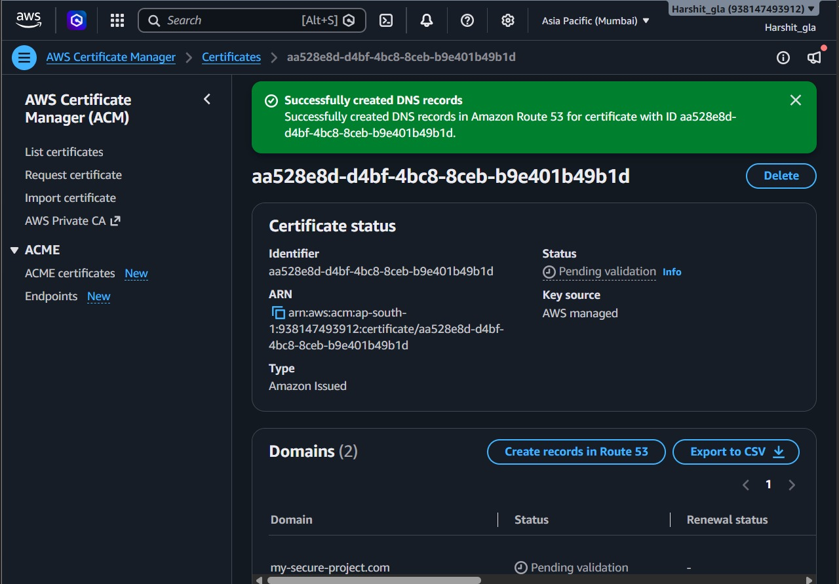
Figure 15.9 – Confirmation that the DNS validation CNAME records were created successfully in Route 53

Step 10: Review the Final Certificate Details
The certificate's “Details” panel is reviewed to confirm the full configuration: Domain name my-secure-project.com with one additional name (the wildcard), Validation method DNS, Signature algorithm SHA-256 with RSA, Public key info RSA 2048, and Requested at timestamp September 24, 2026, 19:01:42 (UTC+5:30). The panel also lists the AWS services the certificate can be used with once issued — CloudFront, Elastic Load Balancing, API Gateway and other integrated services — confirming that the certificate, once validated, is ready to be attached to a CloudFront distribution or an Application Load Balancer listener as described in Section 10.2.
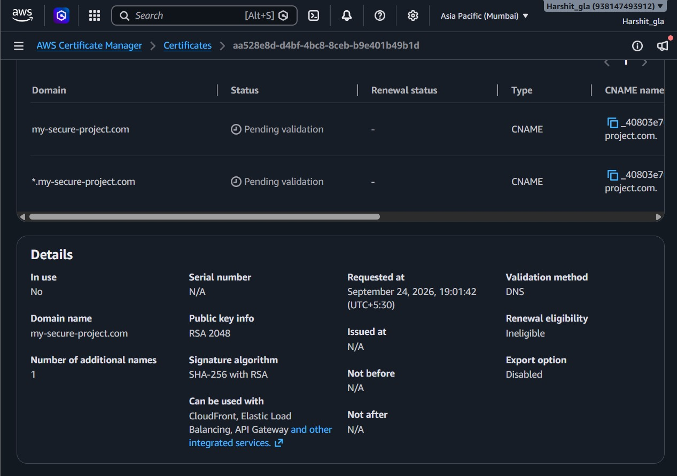
Figure 15.10 – Final certificate details: key type, signature algorithm, validation method and compatible AWS services

15.4 Interpreting the Result
At the end of this workflow, the certificate identified as aa528e8d-d4bf-4bc8-8ceb-b9e401b49b1d moves from “Pending validation” to “Issued” once Route 53's authoritative name servers have propagated the CNAME records and ACM's automated checker has confirmed them (this typically happens within a few minutes to a few hours, and no manual polling is required). No private key ever left AWS, no CSR file had to be generated manually, and no DNS record had to be typed in by hand — all of which reduces the two most common sources of certificate-management error identified in Section 3: incorrectly copied validation records and forgotten renewals.

15.5 Remaining Architecture: EC2, ALB and CloudFront
With the certificate issued, the remaining architecture follows the design in Section 10.2. An EC2 instance hosts the web application; a target group registers that instance; an Application Load Balancer is created with an HTTPS listener that references the ACM certificate; and, optionally, a CloudFront distribution is placed in front of the ALB (or origin) with the same certificate attached, to provide edge caching and global HTTPS termination. Because the certificate is AWS-managed, if it is used with CloudFront, an ALB, or an API Gateway, ACM renews it automatically before expiry, removing the manual renewal step that is otherwise a recurring operational task.

15.6 Consolidated Step List
- Open AWS Certificate Manager and choose “Request a certificate.”
- Select “Request a public certificate” and click Next.
- Enter the fully qualified domain name(s) — apex and wildcard — and choose the export setting.
- Select DNS validation and the RSA 2048 key algorithm, then submit the request.
- Confirm the certificate is created with status Pending validation.
- Open the certificate and review the CNAME name/value generated for each domain.
- Confirm the domain's DNS is hosted in the matching Route 53 public hosted zone.
- Click “Create records in Route 53,” select the pending domains, and create the records.
- Wait for the confirmation that the DNS records were created, then allow DNS propagation.
- Reopen the certificate to confirm it has moved to Issued and review its final details before attaching it to CloudFront, an ALB listener, or another integrated AWS service.

15.7 AWS Security Considerations
- Restrict EC2 security-group access to required ports only (80/443 for web traffic, a restricted source for SSH/RDP).
- Keep “Disable export” selected for certificates that are only ever used with AWS-integrated services, to prevent the private key from leaving AWS.
- Use HTTPS for all public traffic and validate the certificate at the final hostname the user actually visits.
- Keep the certificate's region consistent with the AWS service being used — for example, a certificate used with CloudFront must be requested in the us-east-1 (N. Virginia) region, while a certificate used with a regional ALB must be requested in the same region as the load balancer.

16. Tools and Technologies

16.1 Core Technologies
Technology / Tool | Role | Project Use
OpenSSL | Cryptographic toolkit | RSA key, CSR and certificate-chain tasks
Apache / Nginx / IIS | Web server | HTTPS listener and redirect configuration
SSL/TLS | Transport security | Encryption and authentication
PKI | Trust infrastructure | Certificate and CA concepts
Let's Encrypt | Automated CA option | Free certificate workflow (self-managed track)
DigiCert / Sectigo | Commercial CA options | Commercial certificate comparison
Chrome / Firefox DevTools | Browser testing | Certificate, headers and mixed-content inspection
curl | CLI testing | Redirect and response-header validation
Qualys SSL Labs | Independent testing | TLS configuration grading

16.2 AWS Services Used
- AWS Certificate Manager (ACM) — certificate request, DNS validation and automatic renewal (demonstrated step by step in Section 15).
- Amazon Route 53 — DNS hosting for my-secure-project.com and automated creation of DNS validation records.
- Amazon CloudFront — HTTPS edge termination and content delivery (architecture level).
- Application Load Balancer — HTTPS termination and traffic distribution to EC2 (architecture level).
- Amazon EC2 — backend compute and web hosting.
- AWS CLI / Management Console — provisioning and configuration; the Management Console was used for all screenshots in this report.

16.3 Why These Tools Are Used
The selected tools collectively cover the complete workflow: OpenSSL supports cryptographic preparation for the self-managed track, the web server provides the actual HTTPS service, browser tools and curl provide functional verification, SSL Labs supplies independent assessment, and ACM together with Route 53 demonstrates a managed, largely automated certificate lifecycle with verifiable evidence at every stage.

17. Expected Outcomes and Benefits

17.1 Expected Outcomes
- A functioning HTTPS deployment for the target website.
- Successful certificate-based server authentication.
- Encrypted web traffic using TLS.
- Permanent HTTP-to-HTTPS redirection.
- Correct HSTS configuration.
- Removal of mixed-content issues.
- Valid certificate chain and trusted browser connection.
- Modern TLS configuration without deprecated protocol support.
- Independent SSL Labs validation with the project target of A or better.
- A fully documented, screenshot-backed AWS demonstration of managed certificate infrastructure using ACM and Route 53.

17.2 Security Benefits
HTTPS improves confidentiality and integrity of data in transit and supports authentication of the server identity. HSTS provides an additional browser-enforcement mechanism that helps reduce downgrade opportunities after policy delivery. Proper certificate-chain configuration improves client trust and compatibility.

17.3 Operational Benefits
A structured certificate lifecycle reduces configuration errors and makes renewal responsibilities explicit. AWS ACM, combined with Route 53's automated DNS-record creation, further reduces manual renewal and validation work for supported AWS deployments, as directly demonstrated in Section 15.

17.4 User and Business Benefits
A valid HTTPS deployment removes common browser “Not Secure” indicators associated with plain HTTP and can improve user confidence. The project also documents HTTPS as an important baseline for modern web infrastructure and for environments where data protection and regulatory requirements are relevant.

17.5 Academic Benefit
The project integrates networking, cryptography, web-server administration, PKI concepts, cloud computing and security testing into one reproducible workflow. This provides practical evidence of both theoretical understanding and implementation skills.

18. Limitations
The project focuses on transport-layer web security and certificate management. HTTPS protects the communication channel, but it does not automatically make the application itself secure. Vulnerabilities such as insecure application logic, weak passwords, SQL injection, cross-site scripting or compromised endpoints require separate security controls and are outside the defined scope.
The self-managed certificate workflow also depends on correct server configuration and timely renewal. A valid certificate can still be deployed insecurely if protocol settings, redirects, certificate chains or application resources are misconfigured.
On the AWS track specifically, the certificate demonstrated in Section 15 is restricted to use with integrated AWS services (export disabled), so it cannot be exported for use on a self-managed server outside AWS; and DNS validation depends on the domain's authoritative name servers already pointing to the Route 53 hosted zone used in this project.

19. Future Work
- Implement Mutual TLS (mTLS) in which both client and server authenticate using certificates for high-assurance API scenarios.
- Deploy a private internal PKI using services such as AWS Private CA for internal service-to-service communication.
- Study Certificate Transparency logs and certificate mis-issuance monitoring.
- Investigate DANE and DNSSEC-based approaches as an alternative trust mechanism.
- Benchmark TLS 1.2 and TLS 1.3 under different network conditions to quantify latency differences.
- Extend monitoring to certificate expiration, availability of port 443 and security-header changes.
- Complete the remaining AWS architecture (EC2 target group, ALB HTTPS listener and CloudFront distribution) once the certificate in Section 15 reaches the Issued state, and capture the corresponding screenshots.

20. Conclusion
This project demonstrates that migration from HTTP to HTTPS is a practical and necessary step for modern web deployments. The work establishes a repeatable lifecycle that begins with security-gap analysis and continues through certificate selection, cryptographic preparation, server configuration, HTTPS enforcement, HSTS, mixed-content remediation and independent validation.
The AWS implementation complements the self-managed approach by demonstrating, step by step and with console evidence, how ACM and Route 53 together automate certificate issuance and DNS-based domain validation — from requesting the public certificate for my-secure-project.com and *.my-secure-project.com, through selecting DNS validation and RSA 2048, to Route 53 automatically publishing the required CNAME records and confirming their creation. Together, the two tracks show both the technical mechanisms and the operational considerations involved in deploying secure web communication.

21. References
- Rescorla, E. (2018). The Transport Layer Security (TLS) Protocol Version 1.3. RFC 8446. Internet Engineering Task Force (IETF).
- Dierks, T., & Rescorla, E. (2008). The Transport Layer Security (TLS) Protocol Version 1.2. RFC 5246. IETF.
- CA/Browser Forum. Baseline Requirements for the Issuance and Management of Publicly-Trusted Certificates.
- Hodges, J., Jackson, C., & Barth, A. (2012). HTTP Strict Transport Security (HSTS). RFC 6797. IETF.
- Let's Encrypt. How It Works.
- Amazon Web Services. AWS Certificate Manager User Guide.
- Amazon Web Services. Amazon Route 53 Developer Guide.
- Qualys SSL Labs. SSL Server Rating Guide.
- National Institute of Standards and Technology (NIST). (2020). Guidelines for the Selection, Configuration, and Use of Transport Layer Security (TLS) Implementations. SP 800-52 Rev. 2.
- PCI Security Standards Council. PCI DSS v4.0 — Payment Card Industry Data Security Standard.
- Project source document: “Project Synopsis — Securing Websites with HTTPS Certificates,” Computer Science & Engineering Department.

Project Team
Student | Roll Number | Role
Saurabh Chahar | 2415001446 | Project Team Member
Sachin | 2415001348 | Project Team Member
Harshit Pandey | 2415000663 | Project Team Member
Priyanshu Pandey | 2415001211 | Project Team Member
Mentor: Mr. Raushan Kumar Singh

