**KIST College of Information Technology**

Affiliated to Purbanchal University

Kamalpokhari, Kathmandu, Nepal



**Lab report of**

**Numerical Methods**

**Subject code:** BIT201HS

**Program:** BIT

**Faculty of Science and Technology**

**Submitted by:**   **Submitted to:**

**Name: Priyanshu Kushawaha** **Instructor:** Rishav Acharya

**Semester:** Third

**Level:** Bachelor

**Symbol no:** 6679



**Subject name:** Numerical Method **Code:** BIT201HS

|  |  |  |  |  |
| --- | --- | --- | --- | --- |
| S.N | UNIT | TITLE | PRACTICAL DATE | SUBMISSION DATE |
|  |  |  |  |  |
|  |  |  |  |  |
|  |  |  |  |  |
|  |  |  |  |  |
|  |  |  |  |  |
|  |  |  |  |  |
|  |  |  |  |  |
|  |  |  |  |  |
|  |  |  |  |  |
|  |  |  |  |  |
|  |  |  |  |  |
|  |  |  |  |  |
|  |  |  |  |  |
|  |  |  |  |  |
|  |  |  |  |  |
|  |  |  |  |  |
|  |  |  |  |  |
|  |  |  |  |  |
|  |  |  |  |  |
|  |  |  |  |  |
|  |  |  |  |  |
|  |  |  |  |  |
|  |  |  |  |  |
|  |  |  |  |  |
|  |  |  |  |  |
|  |  |  |  |  |
|  |  |  |  |  |

1. Bisection Method:

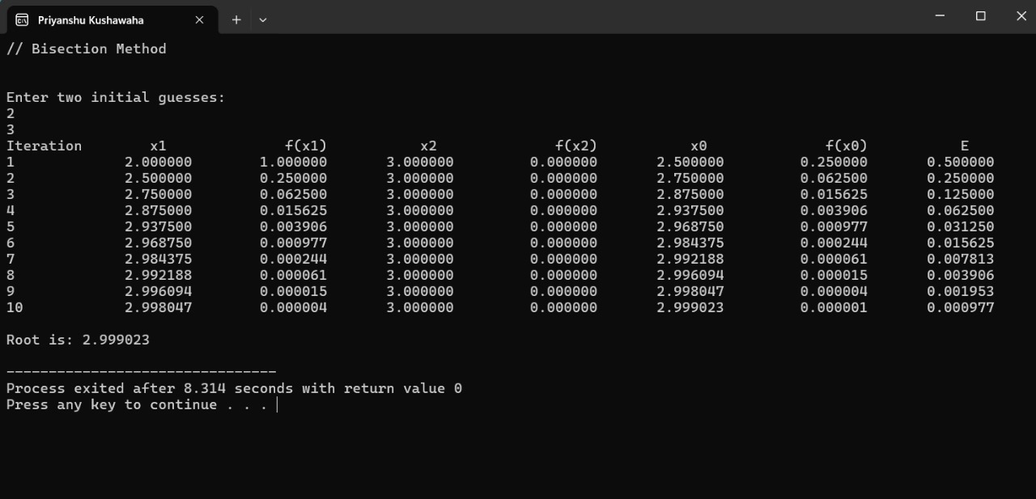

1. Newton Raphson method**:**

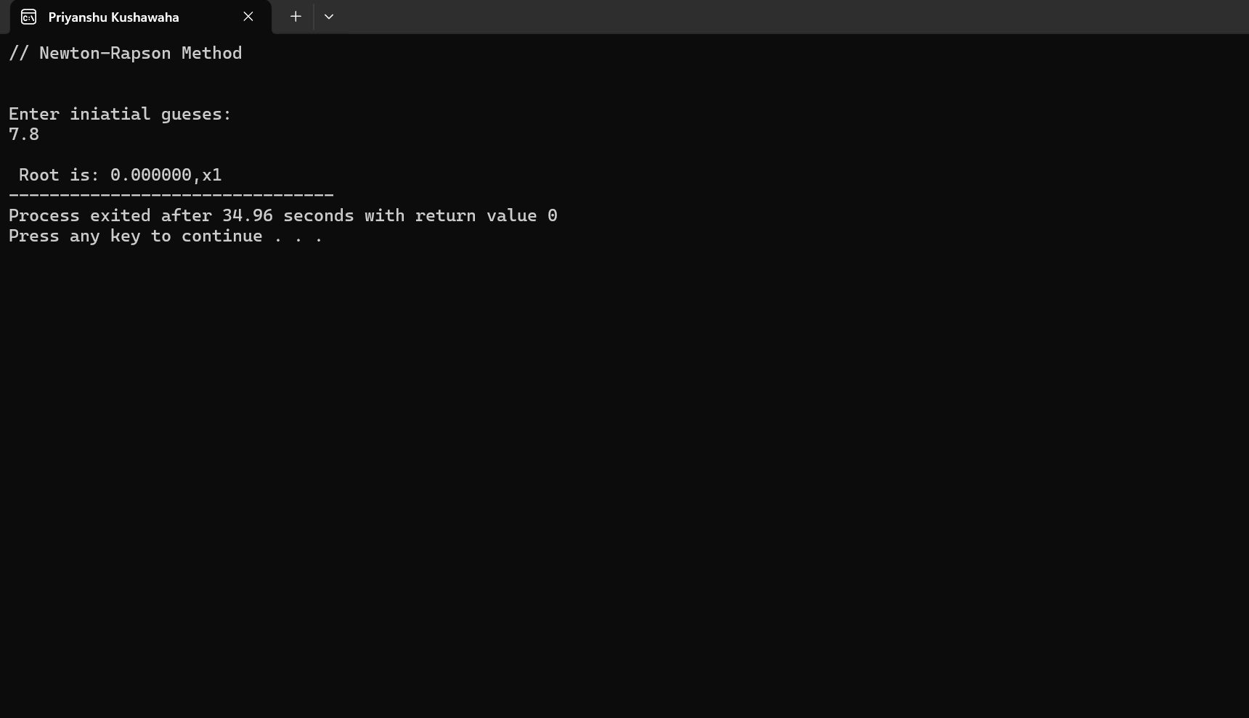

1. Secant method:

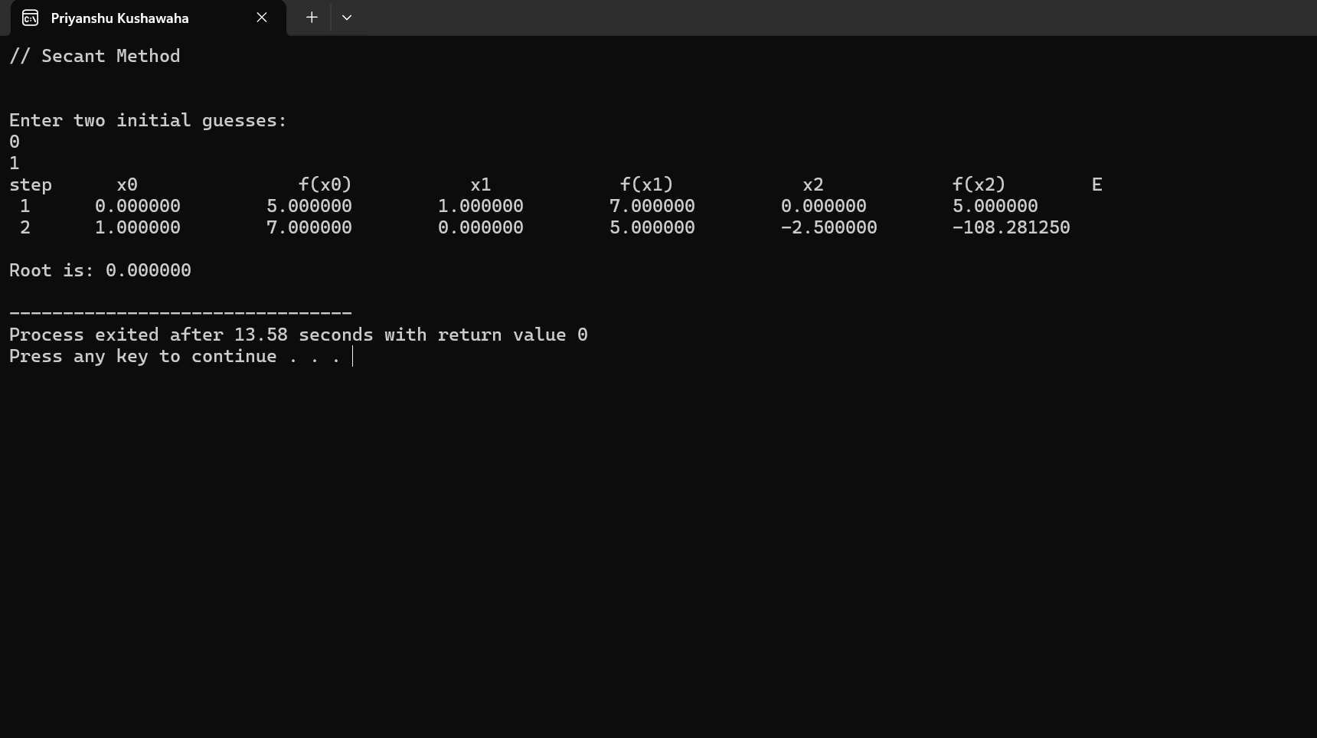

1. Horner's method:

