PREDICTIVE ANALYTICS (INT234)
PROJECT REPORT
(Project Semester August-December 2026)

CROP YIELD PREDICTION IN INDIA USING DISTRICT-WISE AGRICULTURAL DATA AND MACHINE LEARNING

Submitted by

Priyanshu Kumar
Registration No. 12417262
Programme and Section: B.Tech (CSE), K3P24PS
Course Code: INT234

Under the Guidance of

Dr. Tanima Thakur
U.Id: ____________ Designation: ______________________

Discipline of CSE/IT
Lovely School of Computer Science and Engineering
Lovely Professional University, Phagwara
DECLARATION
I, Priyanshu Kumar, student of B.Tech (Computer Science and Engineering) under CSE/IT Discipline at Lovely Professional University, Punjab, hereby declare that all the information furnished in this project report is based on my own intensive work and is genuine.

Date: 28 October 2026 Signature: ______________________
Registration No. 12417262 Name of the student: Priyanshu Kumar
CERTIFICATE
This is to certify that Priyanshu Kumar bearing Registration no. 12417262 has completed INT234 project titled, "Crop Yield Prediction in India using District-wise Agricultural Data and Machine Learning" under my guidance and supervision. To the best of my knowledge, the present work is the result of his original development, effort and study.

Signature and Name of the Supervisor: Dr. Tanima Thakur
Designation of the Supervisor: ______________________
School of Computer Science and Engineering
Lovely Professional University
Phagwara, Punjab.
Date: 28 October 2026
ACKNOWLEDGEMENT
I would like to express my sincere gratitude to my faculty coordinator, Dr. Tanima Thakur, for her valuable guidance, constant encouragement and constructive suggestions throughout this project. Her support helped me to understand the practical side of predictive analytics and to complete this work successfully.
I am thankful to Lovely Professional University and the School of Computer Science and Engineering for providing the learning environment and resources needed for this project. I also thank the Government of India for making the district-wise agricultural statistics available as open data.
Finally, I thank my parents, friends and classmates for their motivation and support during the preparation of this report.

Priyanshu Kumar
Registration No. 12417262
TABLE OF CONTENTS
1. Introduction 8
1.1 Background 8
1.2 Problem Statement 8
1.3 Objectives 8
1.4 Scope of the Project 9
1.5 Tools and Technologies 9
1.6 Organisation of the Report 9
2. Source of Dataset 10
2.1 Origin of the Data 10
2.2 Structure of the Dataset 10
2.3 Overview of the Raw Data 11
3. EDA Process 12
3.1 Loading and Inspection 12
3.2 Missing Values and Duplicates 12
3.3 Distribution of Records 12
3.4 Data Cleaning 13
3.5 Descriptive Statistics of the Cleaned Data 14
3.6 Visual Exploration 15
4. Analysis on Dataset 18
4.1 Descriptive Statistics 18
4.2 Correlation Analysis 20
4.3 Independent Samples t-Test (Kharif versus Rabi) 21
4.4 Shapiro-Wilk Normality Test 23
4.5 Multicollinearity Check using VIF 24
4.6 Preparation of Data for Machine Learning 25
4.7 Linear Regression 26
4.8 Polynomial Regression 27
4.9 Decision Tree Regression 28
4.10 Random Forest Regression 30
4.11 K-Nearest Neighbours (KNN) Regression 33
4.12 Comparison of the Models 34
5. Conclusion 37
6. Future Scope 38
Appendix A: Python Source Code 39
7. References 49
LIST OF FIGURES
Figure 1: Histogram of crop yield (values clipped at the 99th percentile) 15
Figure 2: Top 10 crops by number of records 15
Figure 3: Number of records by season 16
Figure 4: Season-wise distribution of records (pie chart) 16
Figure 5: Year-wise median crop yield 17
Figure 6: Area versus Production (random sample of 3,000 records) 17
Figure 7: Correlation heatmap of Area, Production, Yield and Year 21
Figure 8: Box plot of yield by season 23
Figure 9: Linear Regression: actual versus predicted yield 27
Figure 10: Polynomial Regression: actual versus predicted yield 28
Figure 11: Decision Tree: actual versus predicted yield 30
Figure 12: Random Forest: actual versus predicted yield 32
Figure 13: Feature importance in the Random Forest 32
Figure 14: Distribution of Random Forest residuals 33
Figure 15: KNN Regression: actual versus predicted yield 34
Figure 16: RMSE comparison of the models 36
Figure 17: R2 score comparison of the models 36
Figure 18: Actual versus predicted yield of the best model (Random Forest) 36
LIST OF TABLES
Table 1: Tools and libraries used in the project 9
Table 2: Description of the dataset columns 10
Table 3: Summary of the raw dataset 11
Table 4: Missing values in the raw dataset 12
Table 5: Season-wise record counts in the raw dataset 12
Table 6: Ten most frequently recorded crops (raw data) 13
Table 7: Ten states with the most records (raw data) 13
Table 8: Effect of data cleaning on the number of records 14
Table 9: Descriptive statistics of Area, Production and Yield 14
Table 10: Season-wise yield in the cleaned data 19
Table 11: Ten crops with the highest median yield 19
Table 12: Year-wise median yield 20
Table 13: Pearson correlation matrix 21
Table 14: Result of Welch's t-test 22
Table 15: Result of the Shapiro-Wilk test and shape measures 23
Table 16: VIF of Area and Production 24
Table 17: Input features and target 25
Table 18: Models and their settings 25
Table 19: Test performance of Linear Regression 26
Table 20: Test performance of Polynomial Regression 28
Table 21: Test performance of the Decision Tree 29
Table 22: Test performance of Random Forest 31
Table 23: Feature importance in the Random Forest 31
Table 24: Test performance of KNN Regression 33
Table 25: Final comparison of the regression models (sorted by RMSE) 35
Table 26: First ten test predictions of the Random Forest 35

1. Introduction

1.1 Background
Agriculture is the backbone of the Indian economy. It employs a large share of the country's workforce, supplies the raw material for many industries and, above all, determines the food security of more than a billion people. Because most Indian farming still depends on monsoon rainfall, soil quality, the choice of crop and the season of sowing, the output of a district can differ sharply from year to year and from crop to crop. Planners, policy makers, agricultural scientists and farmers therefore need reliable ways of understanding how much a field is likely to produce.
Crop yield is the most useful single measure of agricultural performance. It is defined as the quantity of a crop produced per unit of cultivated area, and it is normally reported in tonnes per hectare. Unlike total production, which grows simply when more land is brought under cultivation, yield reflects how productive the land actually is. A model that can estimate yield from information such as the state, district, crop, season and year is useful for planning procurement, storage, crop insurance, import and export decisions and the allocation of subsidies.
Data science provides the tools to study this problem in a systematic way. Government agencies have collected district-wise crop statistics for decades, and these records are now available as open data. In this project, one such dataset is cleaned, explored, statistically tested and finally used to train several machine-learning regression models that predict crop yield.

1.2 Problem Statement
The aim of the project is to analyse district-wise agricultural statistics of India for the crop years 1998-99 to 2011-12 and to build and compare regression models that can predict the yield of a crop from its location (state and district), crop type, season and year. The project also investigates how yield is distributed, whether it differs between the Kharif and Rabi seasons, and how strongly the numerical variables of the dataset are related to each other.

1.3 Objectives
- To load, inspect and clean the district-wise Area, Production and Yield (APY) dataset published by the Government of India.
- To perform exploratory data analysis (EDA) using descriptive statistics and visualisations such as histograms, bar charts, line charts, scatter plots, box plots, pie charts and a correlation heatmap.
- To apply statistical techniques: Pearson correlation, Welch's independent t-test, the Shapiro-Wilk normality test and the Variance Inflation Factor (VIF).
- To train five regression models, namely Linear Regression, Polynomial Regression, Decision Tree, Random Forest and K-Nearest Neighbours (KNN), for predicting crop yield.
- To evaluate the models with MAE, MSE, RMSE and the R2 score, to identify the best model, and to discuss the limitations and the future scope of the work.

1.4 Scope of the Project
The project is limited to the variables available in the dataset. Weather, rainfall, soil quality, fertiliser use, irrigation and market prices are not part of the data, so the models can learn only from where, what, when and in which season a crop was grown. The work is carried out entirely in Python using the pandas, NumPy, Matplotlib, seaborn, SciPy, statsmodels and scikit-learn libraries.

1.5 Tools and Technologies
Table 1: Tools and libraries used in the project
Tool / Library | Purpose
Python 3 (IDLE) | Programming language and development environment
pandas, NumPy | Data loading, cleaning, grouping and numerical computation
Matplotlib, seaborn | Static visualisations (histogram, bar, line, scatter, box, pie, heatmap)
SciPy | Welch's t-test and Shapiro-Wilk normality test
statsmodels | Variance Inflation Factor (VIF) for multicollinearity check
scikit-learn | Encoding, scaling, train-test split, regression models and error metrics

1.6 Organisation of the Report
Chapter 2 describes the source and structure of the dataset. Chapter 3 explains the exploratory data analysis process, including data cleaning. Chapter 4 presents each analysis in turn, with its introduction, general description, formulas, results and visualisation. Chapter 5 gives the conclusion, Chapter 6 the future scope and Chapter 7 the references. The complete Python source code is given in Appendix A.

2. Source of Dataset

2.1 Origin of the Data
The dataset used in this project was obtained from the Government of India's open data resources. It is a district-wise, season-wise crop production statistics file, commonly referred to as the APY (Area, Production and Yield) dataset, and it is distributed as a single comma-separated values (CSV) file named district_apy.csv. The Government of India publishes such statistics so that researchers, students and the public can use them freely for analysis and decision making.

2.2 Structure of the Dataset
The raw file contains 177,600 records and 10 columns. Each record describes one crop grown in one district during one season of one crop year, together with the area sown, the quantity produced and the resulting yield. Table 2 describes every column.
Table 2: Description of the dataset columns
Column | Type | Description
ID | Integer | Serial number of the record in the file
Sno | Integer | Serial number in the original source
State | Text | State or union territory of India
District | Text | District within the state
Year | Text | Crop year in the form 1998-99
Crop | Text | Name of the crop (49 different crops)
Season | Text | Kharif, Rabi, Summer, Winter, Autumn, Whole year or Total
Area | Numeric | Area under the crop (hectares)
Production | Numeric | Quantity produced (tonnes; for some crops other units are used)
Yield | Numeric | Production divided by Area; the target variable

2.3 Overview of the Raw Data
Table 3: Summary of the raw dataset
Property | Value
Number of records | 177,600
Number of columns | 10
Number of states / union territories | 33
Number of districts | 643
Number of crops | 49
Crop years covered | 1998-99 to 2011-12 (14 years; some records carry the invalid year value 0)
Duplicate rows | 0

The data are of a panel type: the same districts and crops appear repeatedly across years. Uttar Pradesh contributes the largest number of records, followed by Karnataka, Bihar, Madhya Pradesh and Andhra Pradesh. Rice and Maize are the most frequently recorded crops. A few points about the data are important for the later analysis. First, the Season column contains both individual seasons (Kharif, Rabi, Summer, Winter, Autumn) and aggregate categories (Whole year and Total) that summarise the same fields. Second, the unit of production differs for some crops, such as coconut, which is recorded in nuts rather than tonnes, so its yield values are numerically very large. Third, Yield is mathematically derived from Production and Area.

3. EDA Process
Exploratory Data Analysis (EDA) is the first stage of any data science project. Its purpose is to understand the structure and quality of the data, to detect problems such as missing values, duplicates and outliers, and to form hypotheses that can be tested later. The EDA in this project followed the sequence of loading, inspection, cleaning, descriptive statistics and visualisation.

3.1 Loading and Inspection
The CSV file was loaded into a pandas DataFrame with read_csv. The head() and tail() functions were used to view the first and last five records, info() to see the column data types and non-null counts, shape to confirm the size of the table, and describe() to obtain a statistical summary. The inspection showed 177,600 rows and 10 columns, with Year, State, District, Crop and Season stored as text and Area, Production and Yield stored as numbers.

3.2 Missing Values and Duplicates
Table 4: Missing values in the raw dataset
Column | Missing values
Area | 4
Production | 10,575
Yield | 10,576
All other columns | 0

Production and Yield are missing in about 6% of the records. Most of these gaps (9,731 of the 10,576 records without Yield) belong to the aggregate Total season, which suggests that the source did not report values for those rows. The duplicate check found no duplicate records.

3.3 Distribution of Records
Table 5 shows how the 177,600 raw records are divided over the seasons. Kharif and Rabi, the two main cropping seasons of India, contain roughly 63% of all records.
Table 5: Season-wise record counts in the raw dataset
Season | Records | Share (%)
Kharif | 67,209 | 37.8
Rabi | 45,359 | 25.5
Whole year | 36,039 | 20.3
Total | 14,849 | 8.4
Summer | 8,548 | 4.8
Winter | 3,065 | 1.7
Autumn | 2,531 | 1.4

Tables 6 and 7 list the ten most frequent crops and the ten states with the most records.
Table 6: Ten most frequently recorded crops (raw data)
Crop | Records
Rice | 12,768
Maize | 11,661
Moong | 8,481
Urad | 7,653
Groundnut | 7,452
Sesamum | 6,888
Jowar | 6,128
Wheat | 5,634
Sugarcane | 5,633
Rapeseed & Mustard | 5,474

Table 7: Ten states with the most records (raw data)
State | Records
Uttar Pradesh | 25,763
Karnataka | 15,473
Bihar | 14,083
Madhya Pradesh | 12,550
Andhra Pradesh | 12,083
Orissa | 11,207
Maharashtra | 10,782
Rajasthan | 10,646
Assam | 9,783
Tamil Nadu | 7,817

3.4 Data Cleaning
The cleaning stage prepared the data for analysis and modelling. The following operations were performed:
- Column names and text: leading and trailing spaces were removed from column names and from the State, District, Crop and Season values (for example, the season label "Total " contained a trailing space). Missing text values would have been replaced by the label Unknown.
- Duplicates: the drop_duplicates() function was applied; no rows were removed.
- Numeric conversion: Area, Production and Yield were converted to numbers with pd.to_numeric(errors="coerce"), so that any invalid entry becomes a missing value.
- Year: the starting year was extracted from the crop-year text with a regular expression, so that 1998-99 becomes the number 1998. The invalid value 0 became a missing value.
- Infinite values were converted to missing values.
- Required fields: rows without a valid Yield or Year were dropped, because both are needed for prediction.
Table 8: Effect of data cleaning on the number of records
Step | Records
Raw dataset | 177,600
After removing duplicates | 177,600
Rows removed (10,576 with missing Yield and 306 more with an invalid Year) | 10,882
Cleaned dataset used for analysis | 166,718

After cleaning, the dataset has 166,718 records covering the crop years 1998 to 2011, 33 states, 643 districts and 49 crops, with no missing values. The cleaned data were saved as cleaned_crop_yield_data.csv. Only 36 records belong to the last year (2011-12), so conclusions about that year must be treated with caution.

3.5 Descriptive Statistics of the Cleaned Data
Table 9: Descriptive statistics of Area, Production and Yield
Statistic | Area | Production | Yield
Count | 166,718 | 166,718 | 166,718
Mean | 13,330.84 | 59,329.00 | 6.27
Std. deviation | 41,447.00 | 2,060,099.20 | 144.01
Minimum | 1 | 0 | 0.00
25th percentile | 100 | 100 | 0.50
Median | 734 | 832 | 1.00
75th percentile | 5,536.8 | 8,000 | 2.17
Maximum | 1,020,181 | 527,381,820 | 14,483.00

The numbers reveal a strongly right-skewed distribution. The mean yield (6.27) is more than six times the median (1.00), and the maximum (14,483) is thousands of times larger than the typical value. Area and Production are skewed in the same way. This is why the median, rather than the mean, is used in several of the later summaries.

3.6 Visual Exploration
Figure 1 is the histogram of Yield. To keep the shape visible, values above the 99th percentile were clipped before plotting. Nearly all records fall in the first few bins, and the long tail to the right is formed by high-yield crops such as sugarcane, banana and potato.
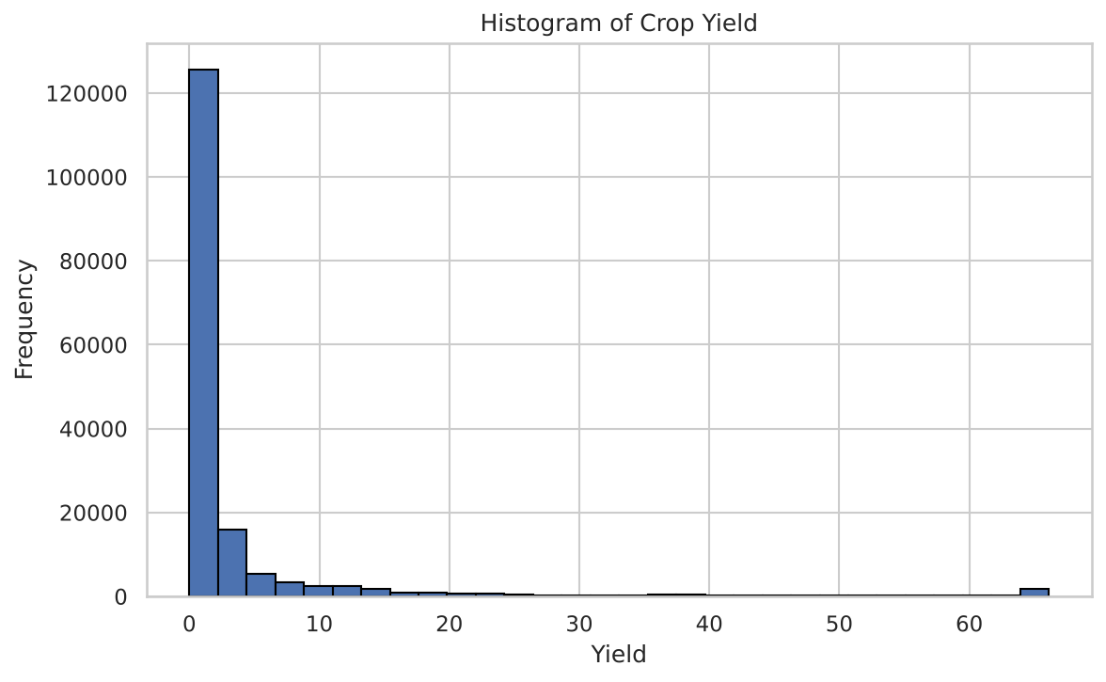
Figure 1: Histogram of crop yield (values clipped at the 99th percentile)
Figure 2 shows the ten most frequent crops in the cleaned data. Rice leads, followed by Maize, Moong, Groundnut and Urad, which matches the raw counts of Table 6.
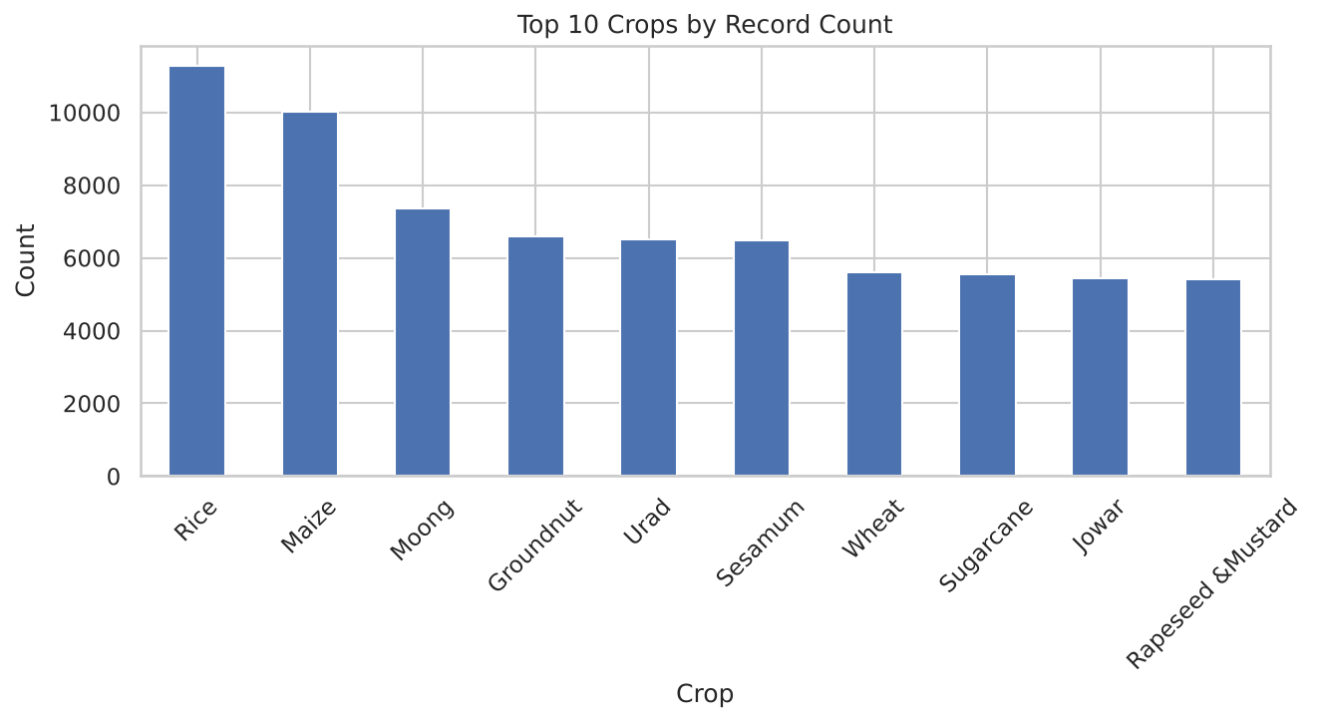
Figure 2: Top 10 crops by number of records
Figure 3 and Figure 4 show the number of records by season, as a bar chart and as a pie chart. Kharif has the highest share (40.1%), followed by Rabi (27.1%) and Whole year (21.4%). The remaining seasons together make up about 11%.
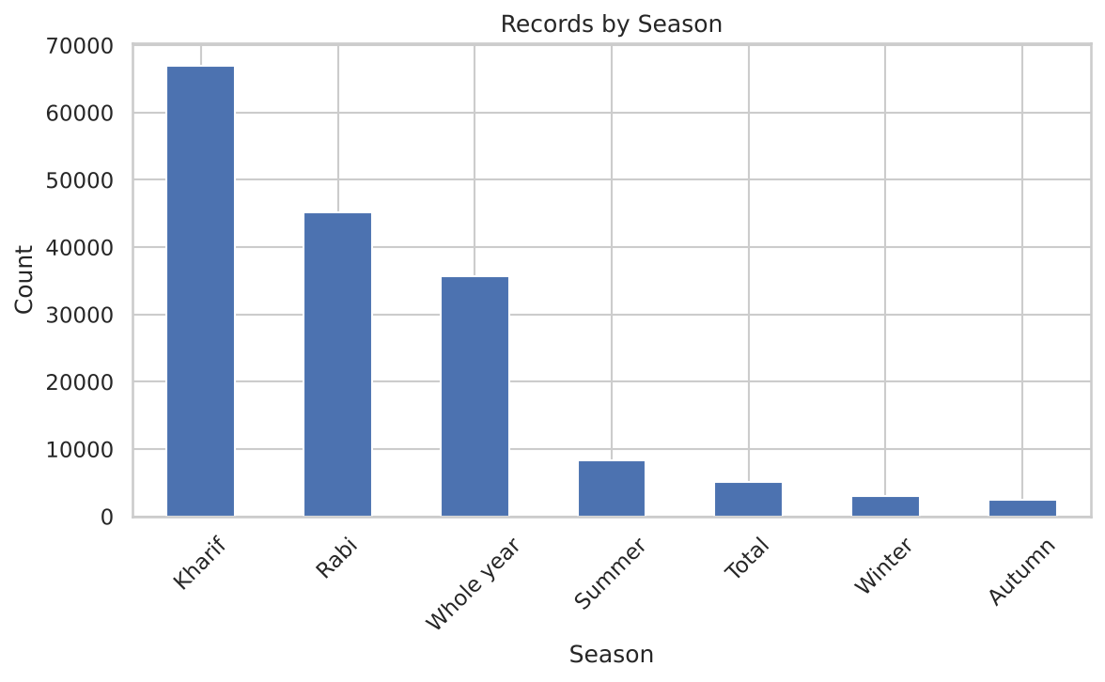
Figure 3: Number of records by season
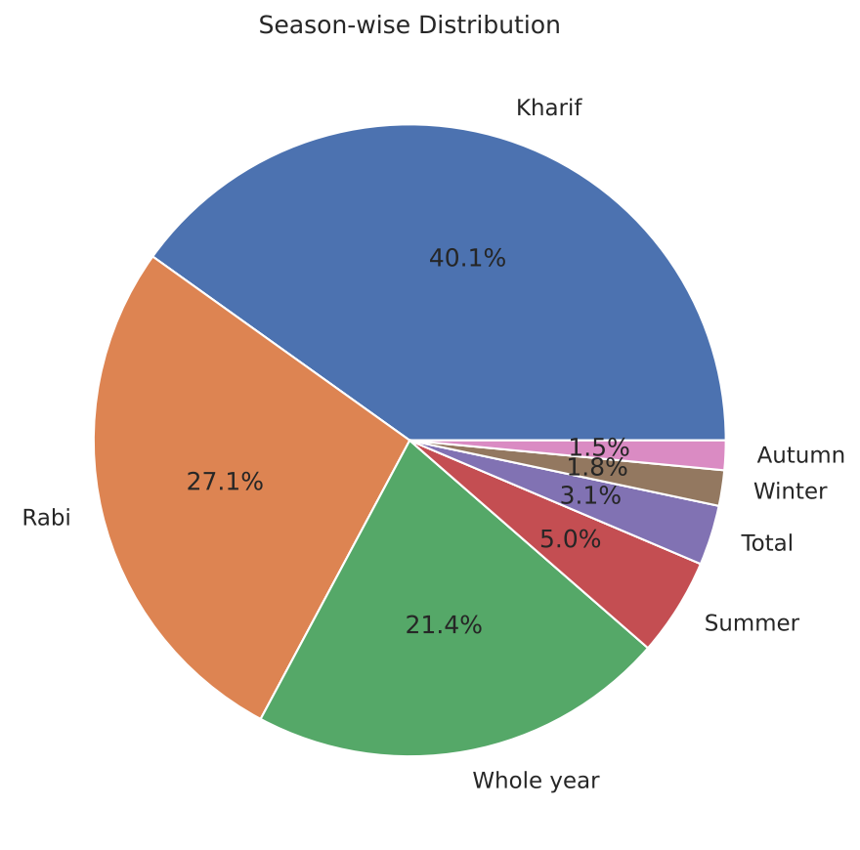
Figure 4: Season-wise distribution of records (pie chart)
Figure 5 plots the median yield for each year. The median stays very close to 1.0 for the whole period, with small dips in 2000 to 2002. A flat median does not mean that nothing changed: the median is dominated by the many small-yield crops, and it hides differences between crops, states and districts.
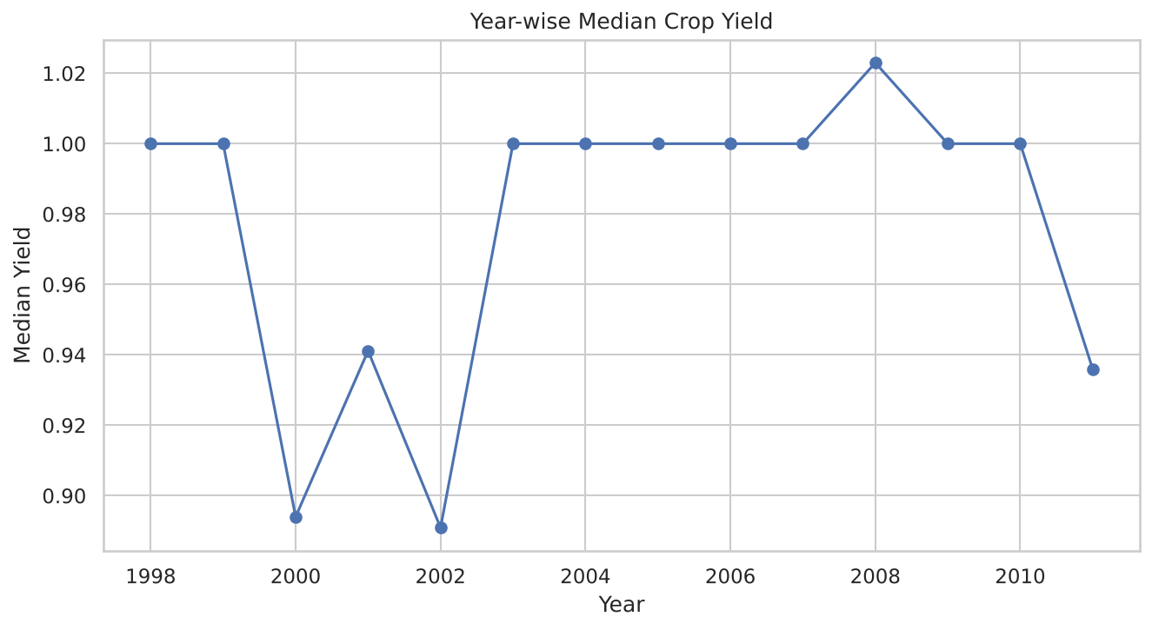
Figure 5: Year-wise median crop yield
Figure 6 is a scatter plot of Area against Production for a random sample of 3,000 records. Production generally increases with Area, but the points are very scattered because different crops produce very different quantities per hectare. A few very large values stretch the axes.
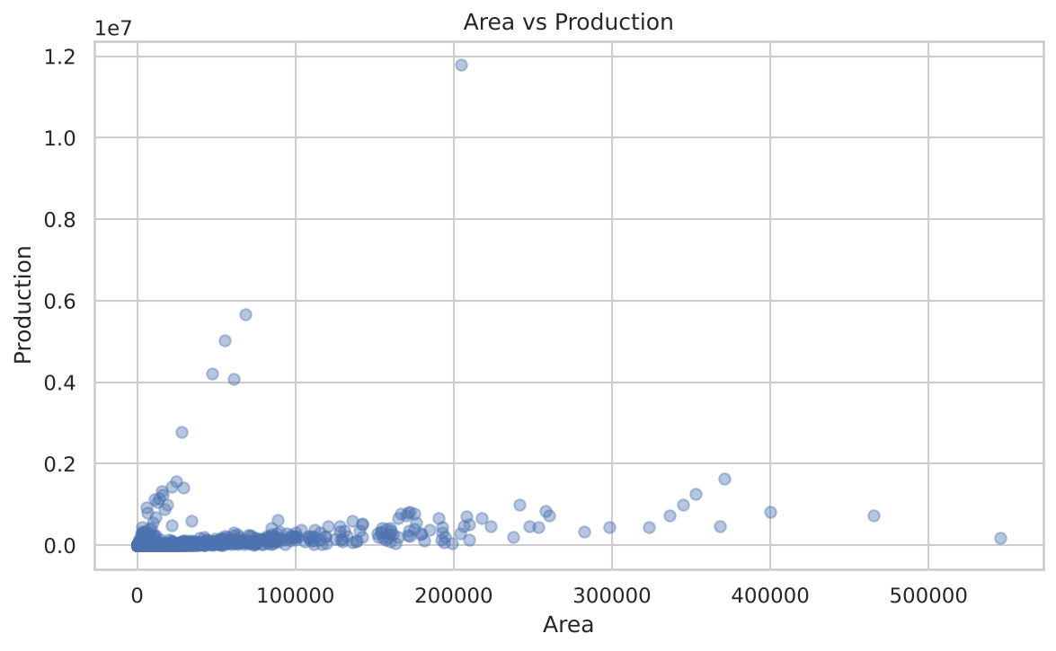
Figure 6: Area versus Production (random sample of 3,000 records)

4. Analysis on Dataset
This chapter presents each analysis carried out in the project. For every analysis the report follows the same five-part structure: introduction, general description, specific requirements with functions and formulas, analysis results and visualisation. The analyses are: descriptive statistics, correlation, the independent t-test, the Shapiro-Wilk normality test, multicollinearity (VIF), and the five regression models together with their comparison.

4.1 Descriptive Statistics

i. Introduction
Descriptive statistics summarise a data set with a few numbers such as the mean, median and standard deviation. They are the starting point of every analysis because they show the centre, spread and range of a variable.

ii. General Description
The descriptive analysis in this project concentrates on the target variable Yield, and also reports the average Area and Production. Yield was further summarised by season, by crop and by year using the groupby() function of pandas. Medians are used for these group summaries because the mean is badly affected by extreme values.

iii. Specific Requirements, Functions and Formulas
The functions used were mean(), median(), std(), min(), max() and groupby().median(). The main formulas are:
Mean = (x1 + x2 + ... + xn) / n
Standard deviation s = sqrt( sum (xi - mean)^2 / (n - 1) )
Yield = Production / Area

iv. Analysis Results
The overall yield statistics are: mean 6.274, median 1.000, standard deviation 144.010, minimum 0.000 and maximum 14,483.000. The mean area is 13,330.84 hectares and the mean production is 59,329.00. Table 10 shows the yield by season. Whole year records have by far the highest median (3.54), because they contain perennial and long-duration crops such as sugarcane, banana and coconut. Among the main seasons, Summer has the highest median (1.50), while Kharif (0.77) and Rabi (0.86) are lower.
Table 10: Season-wise yield in the cleaned data
Season | Records | Mean yield | Median yield
Autumn | 2,515 | 1.168 | 0.997
Kharif | 66,880 | 4.685 | 0.773
Rabi | 45,124 | 1.760 | 0.861
Summer | 8,365 | 2.444 | 1.500
Total | 5,118 | 1.970 | 1.184
Whole year | 35,690 | 16.924 | 3.538
Winter | 3,026 | 5.213 | 1.200

Table 11 lists the ten crops with the highest median yield. Sugarcane is far ahead (median 50.90), followed by Banana (18.38) and Potato (10.53). The maximum values of Potato (14,483) and Coconut (14,116) are not realistic tonnes-per-hectare figures. They arise from records with a tiny reported area (for example 2 hectares for 28,966 units of production) or from crops recorded in nuts, and they are the main source of the very large standard deviation.
Table 11: Ten crops with the highest median yield
Crop | Records | Mean | Median | Maximum
Sugarcane | 5,556 | 52.22 | 50.90 | 314.74
Banana | 2,194 | 24.71 | 18.38 | 137.40
Potato | 5,056 | 15.46 | 10.53 | 14,483.00
Tapioca | 993 | 18.20 | 10.33 | 70.52
Onion | 4,959 | 11.22 | 10.25 | 71.36
Jute | 910 | 9.11 | 9.35 | 22.13
Sweet potato | 2,859 | 8.62 | 8.10 | 38.11
Coconut | 1,384 | 246.78 | 6.59 | 14,116.44
Mesta | 1,166 | 5.42 | 4.83 | 17.51
Garlic | 2,255 | 3.19 | 2.75 | 23.64

Table 12 gives the median yield for every year. The values lie between 0.89 and 1.02 and show no clear upward or downward trend. The value for 2011 rests on only 36 records.
Table 12: Year-wise median yield
Year | Median yield | Year | Median yield
1998 | 1.000 | 2005 | 1.000
1999 | 1.000 | 2006 | 1.000
2000 | 0.894 | 2007 | 1.000
2001 | 0.941 | 2008 | 1.023
2002 | 0.891 | 2009 | 1.000
2003 | 1.000 | 2010 | 1.000
2004 | 1.000 | 2011 | 0.936

v. Visualization
The distribution of Yield is shown in Figure 1, the season-wise distribution of records in Figures 3 and 4, and the year-wise median in Figure 5 (Chapter 3). The box plot of yield by season appears in Section 4.3.

4.2 Correlation Analysis

i. Introduction
Correlation analysis measures the strength and direction of a linear relationship between two numerical variables. It helps to find out which variables move together and whether a variable may be useful for prediction.

ii. General Description
The Pearson correlation coefficient was calculated for the four numerical variables Area, Production, Yield and Year. The resulting correlation matrix was displayed as a heatmap in which warm colours indicate positive and cool colours negative correlation.

iii. Specific Requirements, Functions and Formulas
The function df[[...]].corr() computes the Pearson coefficient r between every pair of columns:
r = sum (xi - mean_x)(yi - mean_y) / sqrt( sum (xi - mean_x)^2 x sum (yi - mean_y)^2 )
The value of r lies between -1 (perfect negative relation) and +1 (perfect positive relation), and 0 means no linear relation.

iv. Analysis Results
Table 13: Pearson correlation matrix
 | Area | Production | Yield | Year
Area | 1.0000 | 0.0524 | -0.0041 | -0.0060
Production | 0.0524 | 1.0000 | 0.4482 | 0.0101
Yield | -0.0041 | 0.4482 | 1.0000 | 0.0221
Year | -0.0060 | 0.0101 | 0.0221 | 1.0000

The only moderate relation is between Production and Yield (r = 0.448), which is expected because Yield is calculated from Production. Area and Yield are practically uncorrelated (r = -0.004), which means that a larger cultivated area does not by itself imply a higher yield. Year has almost no linear relation with any variable (|r| < 0.03), so there is no evidence of a steady linear trend in yield over 1998-2011. The weak Area-Production correlation (0.052) is caused by extreme values and by the mixture of crops with very different output per hectare.

v. Visualization
Figure 7 shows the correlation matrix as a heatmap.
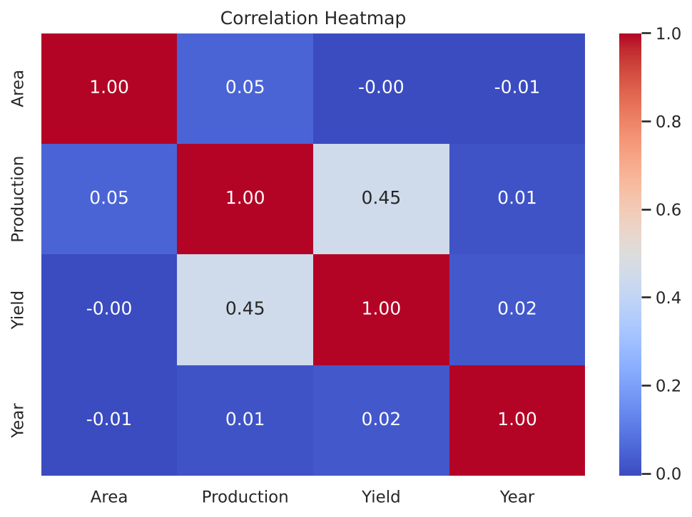
Figure 7: Correlation heatmap of Area, Production, Yield and Year

4.3 Independent Samples t-Test (Kharif versus Rabi)

i. Introduction
A t-test is used to decide whether the means of two groups differ by more than what could be expected from chance. Here it is used to examine whether the mean yield of the Kharif season (sown with the monsoon, harvested in autumn) differs from that of the Rabi season (sown in winter, harvested in spring).

ii. General Description
The null hypothesis H0 states that the mean yield of Kharif and Rabi crops is the same; the alternative hypothesis H1 states that the means differ. A random sample of 5,000 records was drawn from each season (random_state = 42) and Welch's version of the test, which does not assume equal variances, was applied at the 5% significance level.

iii. Specific Requirements, Functions and Formulas
The function used is scipy.stats.ttest_ind(sample1, sample2, equal_var=False). The test statistic is:
t = (mean1 - mean2) / sqrt( s1^2 / n1 + s2^2 / n2 )
H0 is rejected if the p-value is less than 0.05.

iv. Analysis Results
Table 14: Result of Welch's t-test
Item | Value
Records available (Kharif / Rabi) | 66,880 / 45,124
Sample size used (each season) | 5,000
Mean yield, all Kharif records | 4.685
Mean yield, all Rabi records | 1.760
t-statistic | 1.2500
p-value | 0.2114
Decision at 5% level | Fail to reject H0

The p-value (0.2114) is greater than 0.05, so the test does not find a significant difference between the mean yields of the two seasons. It is worth noting that the mean of all Kharif records (4.685) looks much larger than that of Rabi (1.760). The difference is not significant in the test because Yield has extreme outliers and a very large variance, which makes the standard error large. The result should therefore be read as "no reliable evidence of a difference" and not as proof that the seasons are equally productive.

v. Visualization
Figure 8 compares the yield distribution of the seasons with a box plot. The boxes are very compressed and many points are shown as outliers, which confirms the heavy tail.
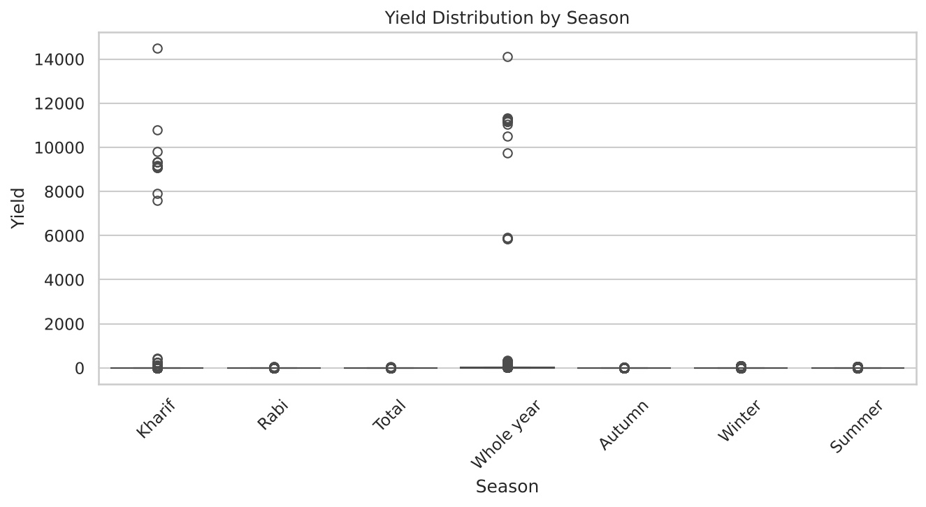
Figure 8: Box plot of yield by season

4.4 Shapiro-Wilk Normality Test

i. Introduction
Many statistical methods assume that the data are normally distributed. The Shapiro-Wilk test checks this assumption and is regarded as one of the most powerful normality tests.

ii. General Description
The test was applied to a random sample of 5,000 yield values. H0 states that the sample comes from a normal distribution; H1 states that it does not. The skewness and kurtosis of the complete cleaned Yield column were also calculated.

iii. Specific Requirements, Functions and Formulas
The function is scipy.stats.shapiro(sample). The statistic is:
W = ( sum ai x(i) )^2 / sum (xi - mean)^2
where x(i) are the ordered sample values and ai are constants derived from the expected values of normal order statistics. W is close to 1 for normal data, and H0 is rejected if p < 0.05.

iv. Analysis Results
Table 15: Result of the Shapiro-Wilk test and shape measures
Item | Value
W statistic | 0.2691
p-value | 1.43 x 10^-88
Skewness of Yield | 72.23
Excess kurtosis of Yield | 5,425.66
Records above the upper IQR fence (Q3 + 1.5 IQR) | 14.65%
Decision | Reject H0 (not normal)

W is only 0.27 and the p-value is practically zero, so Yield is clearly not normally distributed. The skewness of 72 and the kurtosis of more than 5,000 describe an extremely long right tail. This result explains why the median is a better measure than the mean, why linear models perform poorly on the raw target, and why tree-based models that make no distributional assumption suit this data better. It also suggests that a log transformation of Yield may help in future work.

v. Visualization
The shape of the distribution is shown by the histogram in Figure 1 (Chapter 3) and by the box plot in Figure 8.

4.5 Multicollinearity Check using VIF

i. Introduction
Multicollinearity occurs when two explanatory variables are strongly correlated with each other. It makes the coefficients of regression models unstable. The Variance Inflation Factor (VIF) measures how much the variance of a coefficient is increased because of such correlation.

ii. General Description
The VIF was calculated for Area and Production, using a random sample of 1,000 records and a constant term. These two columns are used only for diagnosis. They are not used as inputs of the prediction models, because Yield is calculated directly from them and using them would leak the answer into the model.

iii. Specific Requirements, Functions and Formulas
The function is variance_inflation_factor() from statsmodels. For the j-th variable:
VIF_j = 1 / (1 - R_j^2)
where R_j^2 is the R-squared obtained when variable j is regressed on all other variables. A VIF below 5 is usually considered acceptable and above 10 problematic.

iv. Analysis Results
Table 16: VIF of Area and Production
Feature | VIF
const (intercept) | 1.0000
Area | 1.7368
Production | 1.7368

Both VIF values are 1.74, well below the threshold of 5, so there is no serious multicollinearity between Area and Production. (The VIF of the constant is not interpreted.) The two values are identical because only two variables are involved.

v. Visualization
The relation between Area and Production in the data is shown by the scatter plot in Figure 6 and the correlation heatmap in Figure 7.

4.6 Preparation of Data for Machine Learning
Before the models could be trained, the data were prepared in the following way.
- Feature selection: the input variables (features) are State, District, Crop, Season and Year, and the target is Yield. Area and Production were deliberately excluded because Yield = Production / Area; including them would let a model recover Yield almost exactly and would give a misleading picture of its predictive ability.
- Encoding: State, District, Crop and Season are text columns. LabelEncoder from scikit-learn replaced each category with an integer code.
- Train-test split: the data were split into 80% training (133,374 records) and 20% testing (33,344 records) with train_test_split(test_size = 0.20, random_state = 42).
- Scaling: StandardScaler was fitted on the training data and applied to both sets. The scaled data are used by Linear Regression, Polynomial Regression and KNN, which are sensitive to the size of the features. Tree-based models use the unscaled data.
Table 17: Input features and target
Variable | Role | Treatment
State | Feature | Label encoded
District | Feature | Label encoded
Crop | Feature | Label encoded
Season | Feature | Label encoded
Year | Feature | Numeric (starting year)
Yield | Target | Numeric

Table 18: Models and their settings
Model | Main settings | Input data
Linear Regression | Ordinary least squares | Scaled
Polynomial Regression | Degree 2 features + least squares | Scaled
Decision Tree | max_depth = 15, min_samples_leaf = 5 | Unscaled
Random Forest | 50 trees, max_depth = 15, min_samples_leaf = 3 | Unscaled
KNN Regression | k = 5, first 20,000 training records | Scaled

The metrics used to judge the models are the Mean Absolute Error (MAE), Mean Squared Error (MSE), Root Mean Squared Error (RMSE) and the coefficient of determination (R2):
MAE = (1/n) sum |yi - ypred_i| MSE = (1/n) sum (yi - ypred_i)^2 RMSE = sqrt(MSE)
R2 = 1 - sum (yi - ypred_i)^2 / sum (yi - mean_y)^2
A lower MAE, MSE and RMSE means smaller errors. R2 equals 1 for a perfect model and 0 for a model that simply predicts the mean; it becomes negative when a model is worse than predicting the mean.

4.7 Linear Regression

i. Introduction
Linear regression is the simplest regression technique. It assumes that the target is a weighted sum of the input features and finds the weights that make the sum of squared errors as small as possible.

ii. General Description
The model was trained on the standardised training data and used to predict the yield of the 33,344 test records. It serves as the baseline against which the other models are compared.

iii. Specific Requirements, Functions and Formulas
The class is sklearn.linear_model.LinearRegression, and the model equation is:
Yield = b0 + b1 x State + b2 x District + b3 x Crop + b4 x Season + b5 x Year

iv. Analysis Results
Table 19: Test performance of Linear Regression
Metric | Value
MAE | 9.6959
MSE | 30,005.8183
RMSE | 173.2219
R2 score | 0.0017

The R2 of 0.0017 means that the model explains almost none of the variation in yield. There are two reasons. First, the label codes of State, District and Crop are arbitrary numbers; a straight line through them has no real meaning, because, for example, a crop with the code 20 is not "twice" a crop with the code 10. Second, the target contains extreme outliers that dominate the squared error. About 14% of the predictions are negative, which is impossible for a yield. The standardised coefficients were -1.74 (State), 0.88 (District), -0.89 (Crop), 4.11 (Season) and 2.73 (Year), with an intercept of 6.09.

v. Visualization
Figure 9 compares actual and predicted values for 4,000 test records. If the model were perfect the points would lie on the dotted line. The predictions form an almost flat band instead.
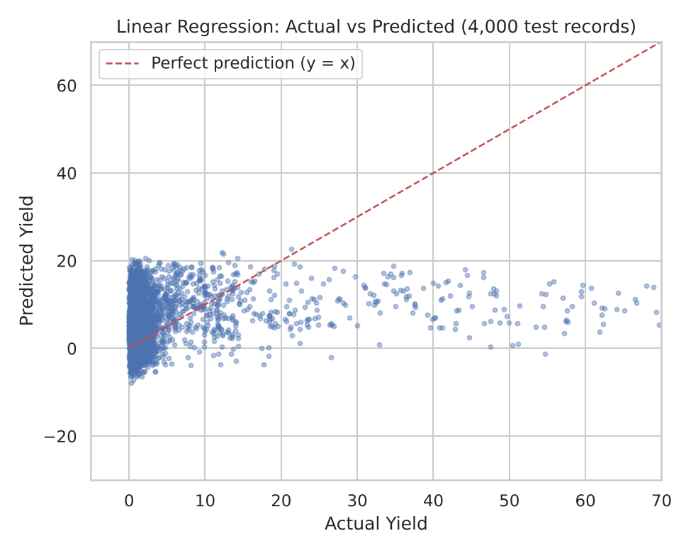
Figure 9: Linear Regression: actual versus predicted yield

4.8 Polynomial Regression

i. Introduction
Polynomial regression extends linear regression by adding powers and products of the features. This allows the model to follow curved relations while remaining linear in its coefficients.

ii. General Description
PolynomialFeatures of degree 2 were applied to the five standardised features. This creates squares and pairwise products in addition to the original features (21 columns in total, including the constant). A linear regression was then fitted on these columns.

iii. Specific Requirements, Functions and Formulas
For two features x1 and x2 the degree-2 expansion is:
[1, x1, x2, x1^2, x1 x2, x2^2]
The model is Yield = b0 + sum bj x (expanded feature j). The classes used are PolynomialFeatures(degree = 2) and LinearRegression.

iv. Analysis Results
Table 20: Test performance of Polynomial Regression
Metric | Value
MAE | 11.3541
MSE | 29,899.4784
RMSE | 172.9147
R2 score | 0.0052

The RMSE (172.91) and R2 (0.0052) are only slightly better than the linear model, and the MAE (11.35) is actually worse. Interactions between encoded categories do not help much, because the codes carry no real order. About 34% of the predictions are negative. The model is not suitable for this problem in its present form.

v. Visualization
Figure 10 shows the actual-versus-predicted plot of the model.
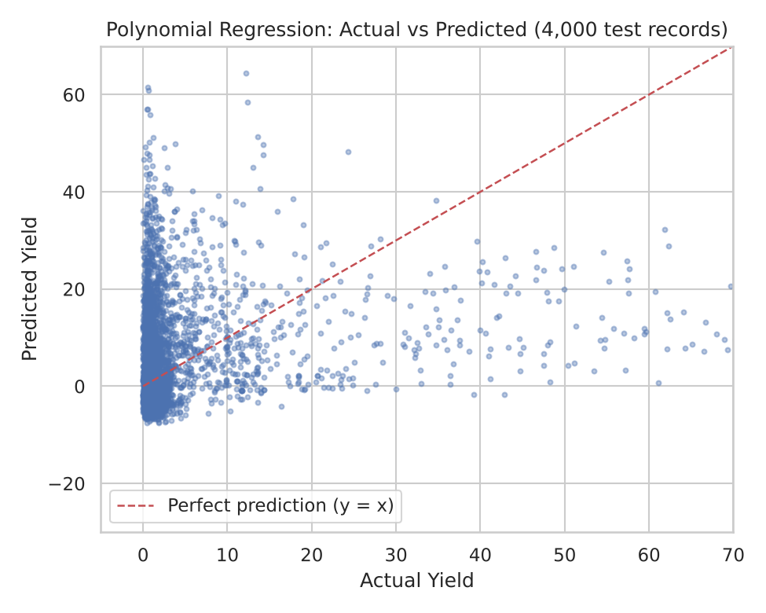
Figure 10: Polynomial Regression: actual versus predicted yield

4.9 Decision Tree Regression

i. Introduction
A decision tree repeatedly splits the data into smaller groups using simple yes/no questions on the features, such as "Crop code <= 12?". The prediction for a record is the average target value of the group (leaf) it falls into. Trees can model non-linear relations and interactions and need no scaling.

ii. General Description
A DecisionTreeRegressor with a maximum depth of 15 and at least 5 records per leaf was trained on the unscaled training data. Limiting the depth and the leaf size reduces over-fitting.

iii. Specific Requirements, Functions and Formulas
At each node the tree chooses the split that most reduces the squared-error impurity:
Impurity(node) = (1/N) sum (yi - mean of node)^2

iv. Analysis Results
Table 21: Test performance of the Decision Tree
Metric | Value
MAE | 3.9265
MSE | 24,277.0681
RMSE | 155.8110
R2 score | 0.1923

The Decision Tree performs much better than the two linear models. Its MAE (3.93) is less than half of theirs and R2 rises to 0.19. This confirms that the relation between the categories and yield is highly non-linear, and that the tree can learn the typical yield of each crop and district. It predicts no negative values. An RMSE of 155.8 shows, however, that a small number of extreme records still produce large errors.

v. Visualization
Figure 11 shows the actual-versus-predicted values of the tree. The points follow the line much more closely than in the linear models.
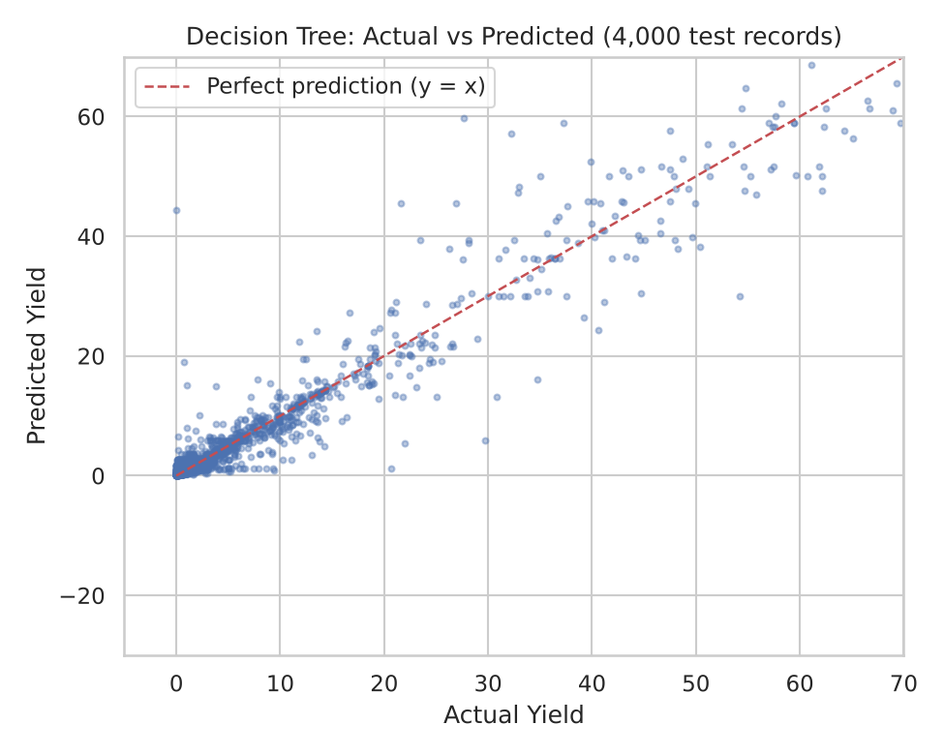
Figure 11: Decision Tree: actual versus predicted yield

4.10 Random Forest Regression

i. Introduction
Random Forest is an ensemble method proposed by Breiman. It builds many decision trees, each on a different random sample of the data and with random subsets of features, and averages their predictions. Averaging reduces the variance of a single tree and usually gives higher accuracy.

ii. General Description
A RandomForestRegressor with 50 trees, a maximum depth of 15 and at least 3 records per leaf was trained on the unscaled data (random_state = 42, n_jobs = -1 to use all processor cores).

iii. Specific Requirements, Functions and Formulas
The forest prediction for a record is the average of the predictions of the B trees:
Yield_pred = (1/B) sum Tb(x), b = 1 ... B
The importance of a feature is the total reduction of impurity that results from the splits on that feature, averaged over all trees.

iv. Analysis Results
Table 22: Test performance of Random Forest
Metric | Value
MAE | 3.5125
MSE | 20,487.8767
RMSE | 143.1359
R2 score | 0.3183

Random Forest is the best of the five models: it has the lowest MAE (3.51), MSE and RMSE (143.14) and the highest R2 (0.318). A closer look at the errors shows that the typical error is small. The median absolute error is 0.21, and 86.7% of the test predictions are within 1.0 unit of the actual yield. The large RMSE is caused by a small number of extreme records, since squaring the error gives them a very large weight. About two thirds of the variance is still unexplained, which is not surprising when weather, soil and irrigation data are not available.
Table 23: Feature importance in the Random Forest
Feature | Importance
Year | 0.6069
Crop | 0.2399
District | 0.1083
Season | 0.0397
State | 0.0051

Year has the highest importance (0.61), followed by Crop (0.24) and District (0.11). It must be explained carefully. The linear analysis showed no trend in yield over time, so a high importance of Year most likely reflects year-specific groups of records with extreme values (for example the very large yields that occur in particular years), which reduce the squared error when separated. It should not be read as meaning that yields rise or fall systematically with time. Importance values based on label-encoded features also tend to favour features with many distinct values.

v. Visualization
Figures 12 to 14 show the actual-versus-predicted values, the feature importance and the distribution of the residuals (actual minus predicted, clipped at +/-20) for the Random Forest. The residuals are concentrated around zero.
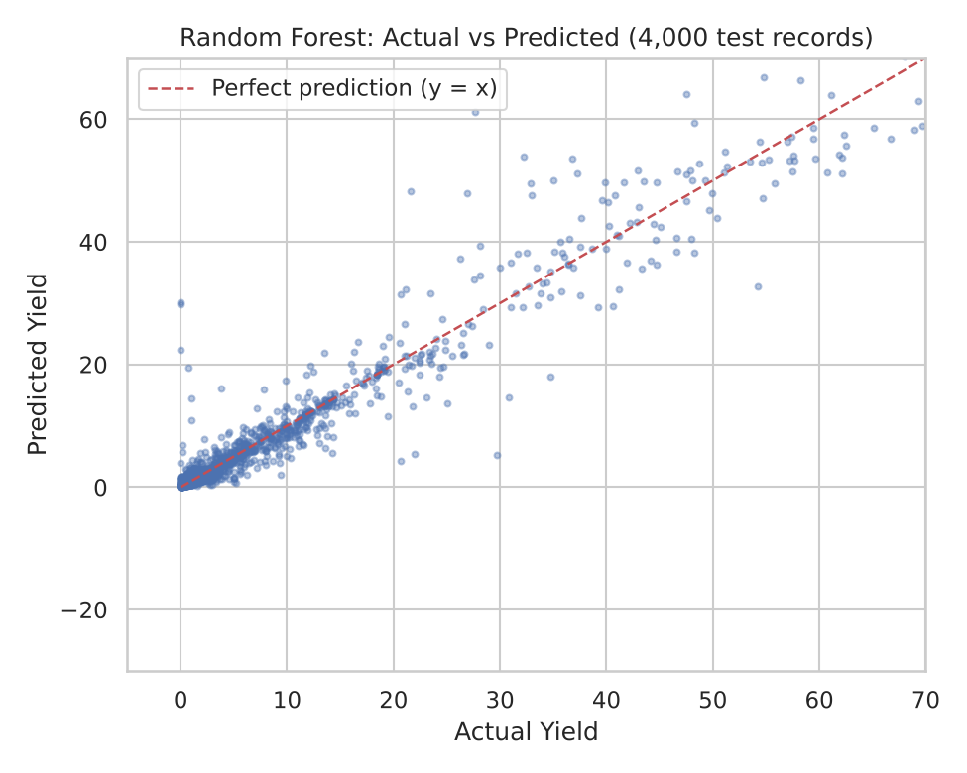
Figure 12: Random Forest: actual versus predicted yield
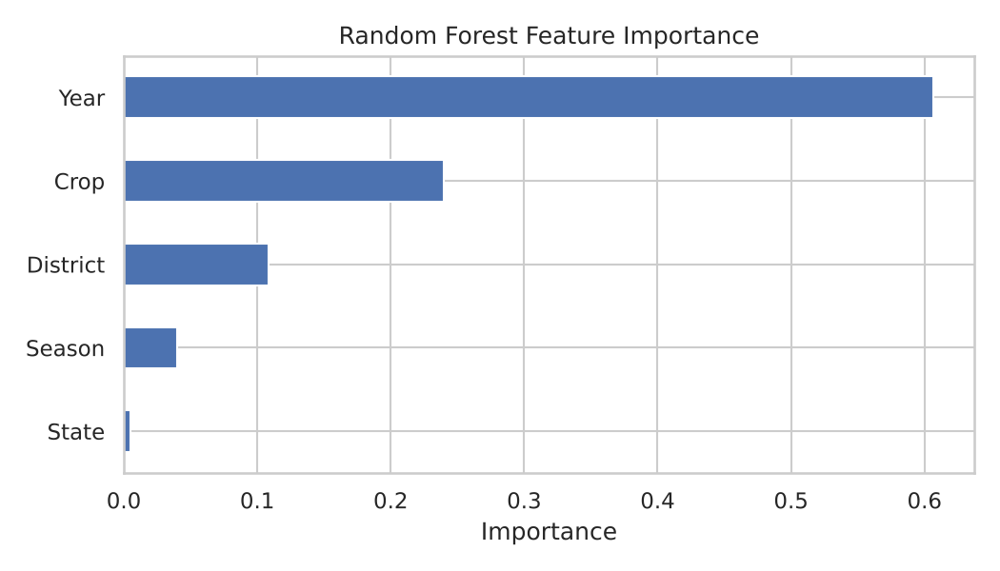
Figure 13: Feature importance in the Random Forest
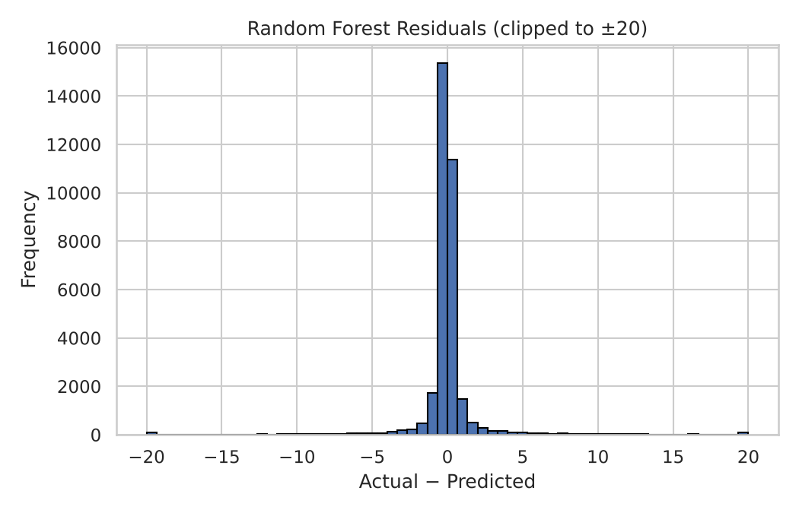
Figure 14: Distribution of Random Forest residuals

4.11 K-Nearest Neighbours (KNN) Regression

i. Introduction
KNN regression predicts the target of a record as the average target of its k closest records in the training data. It is a simple, non-parametric method that stores the training data and does the calculation at prediction time.

ii. General Description
Because the full training set is large, only the first 20,000 standardised training records were used to fit the model, with k = 5 neighbours. The model then predicted the yield of the 33,344 test records.

iii. Specific Requirements, Functions and Formulas
The distance between two records is the Euclidean distance, and the prediction is the mean of the k nearest targets:
d(a, b) = sqrt( sum (aj - bj)^2 ) Yield_pred = (1/k) sum yi over the k nearest neighbours

iv. Analysis Results
Table 24: Test performance of KNN Regression
Metric | Value
MAE | 9.4625
MSE | 36,589.3790
RMSE | 191.2835
R2 score | -0.2174

KNN is the weakest model. Its R2 is negative (-0.217), which means that it is worse than simply predicting the average yield. Its MAE is high (9.46) and its RMSE is the largest of all (191.28). Distances computed on label-encoded categories are not meaningful, and the use of only 20,000 of the 133,374 training records reduces the information available. In addition, with k = 5 a single extreme neighbour can strongly pull the average.

v. Visualization
Figure 15 shows the actual-versus-predicted plot of the KNN model.
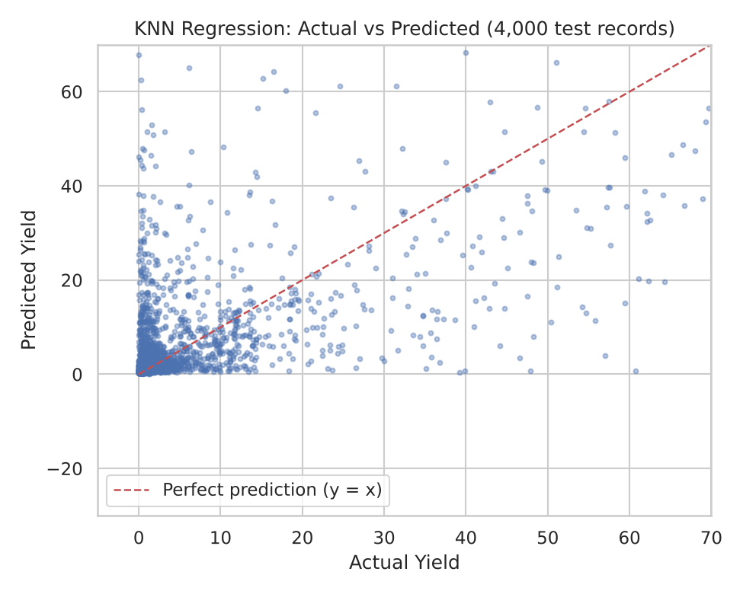
Figure 15: KNN Regression: actual versus predicted yield

4.12 Comparison of the Models

i. Introduction
After training, all models must be compared on the same unseen test data so that the most suitable one can be selected. The comparison uses the four error metrics defined in Section 4.6.

ii. General Description
The metrics of the five models were collected in a table sorted by RMSE, and saved as crop_yield_model_comparison.csv. The model with the smallest RMSE was chosen as the best model, and its predictions were plotted against the actual values.

iii. Specific Requirements, Functions and Formulas
RMSE is used as the main criterion because it expresses the error in the units of Yield and penalises large errors strongly. R2 shows the share of variance explained. The two are consistent in this experiment: the model with the lowest RMSE also has the highest R2.

iv. Analysis Results
Table 25: Final comparison of the regression models (sorted by RMSE)
Model | MAE | MSE | RMSE | R2
Random Forest | 3.5125 | 20,487.88 | 143.1359 | 0.3183
Decision Tree | 3.9265 | 24,277.07 | 155.8110 | 0.1923
Polynomial Regression | 11.3541 | 29,899.48 | 172.9147 | 0.0052
Linear Regression | 9.6959 | 30,005.82 | 173.2219 | 0.0017
KNN Regression | 9.4625 | 36,589.38 | 191.2835 | -0.2174

The ranking is clear. The two tree-based models are the best, and the ensemble (Random Forest) improves on the single tree by about 8% in RMSE and by more than 0.12 in R2. The linear and polynomial models explain almost none of the variance, and KNN is worse than the mean predictor. The result shows that the relation between location, crop, season and yield is strongly non-linear and is learned better by tree-based methods than by methods that treat the label codes as ordered numbers. The first ten predictions of the Random Forest are shown in Table 26.
Table 26: First ten test predictions of the Random Forest
No. | Actual yield | Predicted yield
0 | 1.3089 | 1.3224
1 | 1.5631 | 1.4044
2 | 0.2903 | 0.6104
3 | 5.3038 | 6.4392
4 | 0.9500 | 0.8056
5 | 49.0405 | 44.7094
6 | 0.1750 | 0.3902
7 | 0.8265 | 0.9287
8 | 0.0938 | 0.1280
9 | 2.4014 | 1.1576

v. Visualization
Figures 16 and 17 compare the RMSE and R2 score of all models, and Figure 18 shows actual versus predicted yield for the best model (first 100 test records).
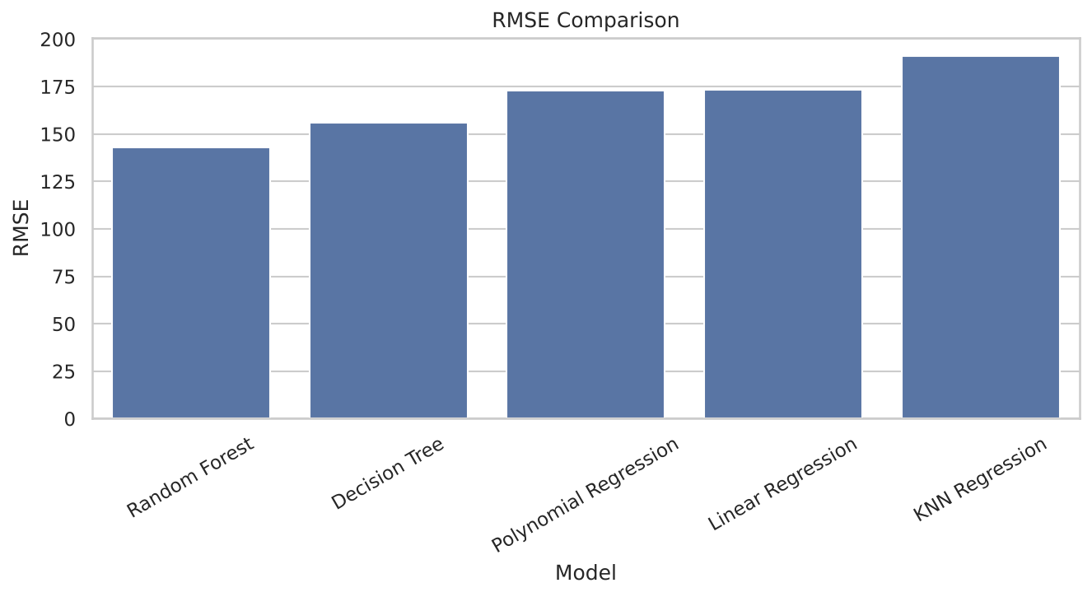
Figure 16: RMSE comparison of the models
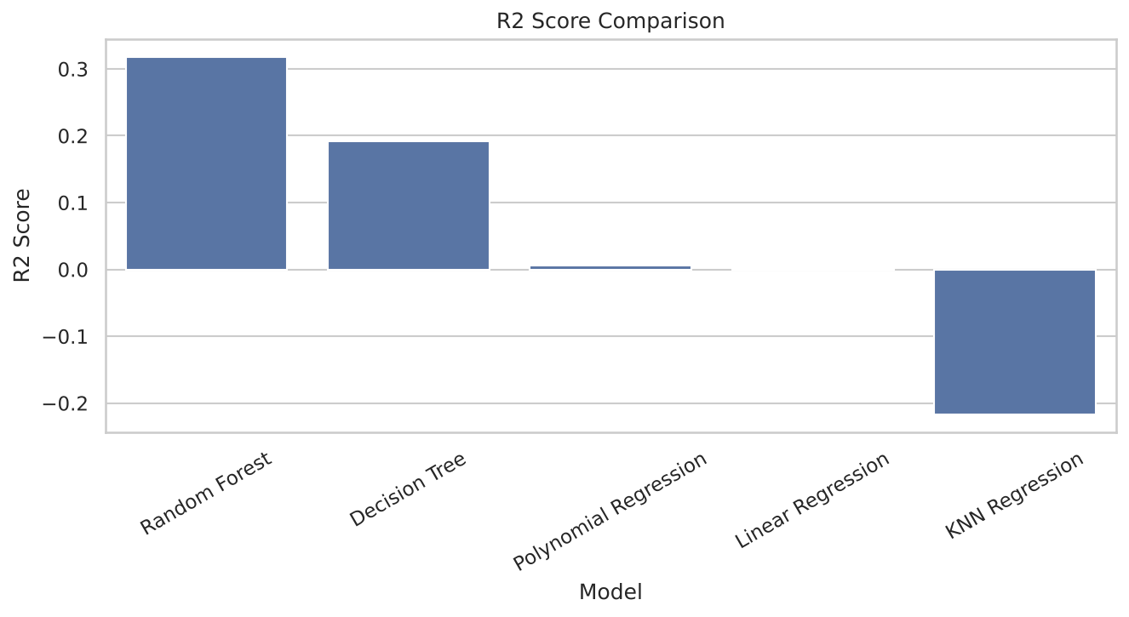
Figure 17: R2 score comparison of the models
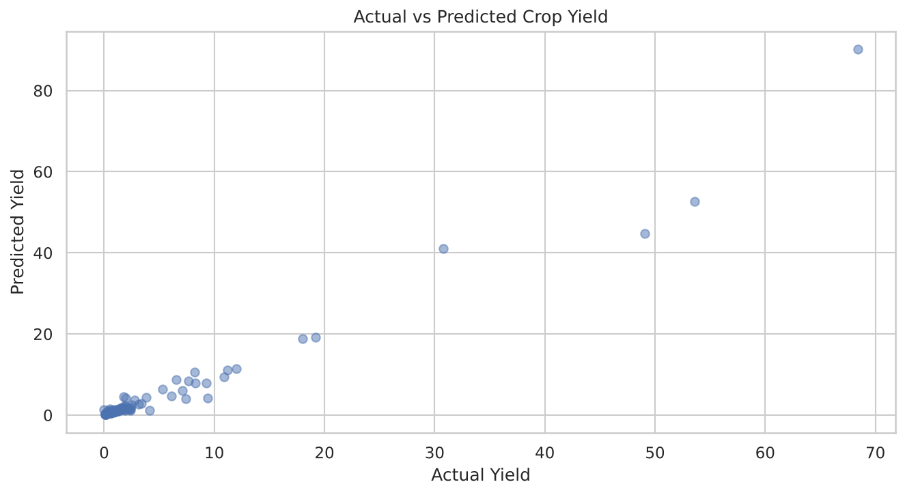
Figure 18: Actual versus predicted yield of the best model (Random Forest)

5. Conclusion
This project analysed 177,600 district-wise crop records of India published by the Government as open data, cleaned them to 166,718 reliable records covering 33 states, 643 districts and 49 crops from 1998 to 2011, and developed five regression models for predicting crop yield. The main findings are:
- Data quality: about 6% of the records lacked Production and Yield, mostly in the aggregate Total season, and a few records had an invalid year. Yield also contains extreme values caused by very small reported areas and by crops recorded in different units, such as coconut.
- Distribution: Yield is extremely right-skewed (median 1.0, mean 6.27, skewness 72). The Shapiro-Wilk test (W = 0.27, p < 0.001) rejects normality.
- Relationships: Area and Yield are practically uncorrelated (r = -0.004), Production and Yield show a moderate correlation (r = 0.448), and Year shows no linear trend. VIF = 1.74 indicates no multicollinearity.
- Seasons: Welch's t-test found no statistically significant difference between Kharif and Rabi yields (t = 1.25, p = 0.211), although the heavy outliers make the test weak.
- Models: Random Forest was the best model (MAE 3.51, RMSE 143.14, R2 0.318), followed by the Decision Tree (R2 0.192). Linear and Polynomial Regression explained almost no variance, and KNN was worse than predicting the mean (R2 -0.217). 86.7% of the Random Forest predictions were within 1.0 unit of the actual yield.
The study shows that tree-based ensemble methods are a sensible choice for district-level yield prediction when only categorical descriptors of crop and place are available. At the same time, the results are honest about the limits of this data: an R2 of 0.32 means that most of the variation in yield is not explained by state, district, crop, season and year alone. The model is therefore a useful baseline and a learning exercise, not a tool to be used for real decisions in its present form.
Finally, the work gave practical experience in the full data science workflow: acquiring open data, cleaning it, exploring it visually, testing hypotheses statistically, building and evaluating several models, and interpreting the results critically.

6. Future Scope
The project can be extended in many directions to obtain more accurate and more reliable predictions.
- Better target handling: apply a log transformation to Yield, standardise units (for example, convert coconut from nuts to a common unit), and treat or remove implausible outliers caused by very small areas.
- Cleaner season structure: remove the aggregate Whole year and Total records or model them separately, so that the same production is not counted more than once.
- Separate models per crop: the yield of sugarcane and the yield of pulses differ by orders of magnitude, so one model per crop or crop group should be more accurate than one global model.
- Better encoding: use one-hot or target encoding instead of label encoding for State, District and Crop, so that models do not treat the codes as ordered numbers.
- More powerful algorithms and tuning: try Gradient Boosting, XGBoost, LightGBM and neural networks, and tune hyper-parameters with grid or random search and cross-validation.
- Additional data: include rainfall, temperature, soil type, irrigation, fertiliser use and market prices, which are known to affect yield strongly.
- Time-aware validation: train on earlier years and test on later years, so that the model is judged on its ability to forecast the future, and extend the data to more recent years.
- Deployment: build a dashboard (for example with Power BI or a web application) that lets a user choose a state, district, crop and season and see the predicted yield.

Appendix A: Python Source Code
The complete program used for data loading, cleaning, visualisation, statistical testing and model building is listed below. The file path in the first section is the path on the author's computer.

import os
import pandas as pd
import numpy as np
import matplotlib.pyplot as plt
import seaborn as sns

from scipy import stats

from sklearn.model_selection import train_test_split
from sklearn.preprocessing import LabelEncoder, StandardScaler, PolynomialFeatures
from sklearn.linear_model import LinearRegression
from sklearn.tree import DecisionTreeRegressor
from sklearn.ensemble import RandomForestRegressor
from sklearn.neighbors import KNeighborsRegressor
from sklearn.metrics import mean_absolute_error, mean_squared_error, r2_score

# ==================================================
# 1. LOAD DATASET
# ==================================================

file_path = r"C:\Users\ps832\Downloads\district_apy.csv"

df = pd.read_csv(file_path)

print("FIRST 5 ROWS:")
print(df.head())

print("\nLAST 5 ROWS:")
print(df.tail())

print("\nDATASET INFORMATION:")
df.info()

print("\nDATASET SHAPE:")
print(df.shape)

print("\nCOLUMN NAMES:")
print(df.columns)

print("\nMISSING VALUES:")
print(df.isnull().sum())

print("\nDUPLICATE ROWS:")
print(df.duplicated().sum())

print("\nSTATISTICAL SUMMARY:")
print(df.describe())

print("\nUNIQUE CROPS:")
print(df["Crop"].nunique())

print("\nCROP COUNTS:")
print(df["Crop"].value_counts().head(10))

print("\nSEASON COUNTS:")
print(df["Season"].value_counts())

print("\nSTATE COUNTS:")
print(df["State"].value_counts().head(10))

# ==================================================
# 2. DATA CLEANING
# ==================================================

df.columns = df.columns.str.strip()

df = df.drop_duplicates().copy()

for col in ["Area", "Production", "Yield"]:
df[col] = pd.to_numeric(df[col], errors="coerce")

# Extract the starting year from values like 1998-99
df["Year"] = pd.to_numeric(
df["Year"].astype(str).str.extract(r"(\d{4})")[0],
errors="coerce"
)

for col in ["State", "District", "Crop", "Season"]:
df[col] = df[col].astype("string").str.strip()
df[col] = df[col].fillna("Unknown").astype(str)

df.replace([np.inf, -np.inf], np.nan, inplace=True)

# Yield and Year are required for prediction
df.dropna(subset=["Yield", "Year"], inplace=True)

print("\nCLEANED DATA SHAPE:")
print(df.shape)

print("\nMISSING VALUES AFTER CLEANING:")
print(df.isnull().sum())

# Save cleaned data
cleaned_path = os.path.join(
os.path.dirname(file_path),
"cleaned_crop_yield_data.csv"
)

df.to_csv(cleaned_path, index=False)

# ==================================================
# 3. DESCRIPTIVE STATISTICS
# ==================================================

print("\nMEAN YIELD:", df["Yield"].mean())
print("MEDIAN YIELD:", df["Yield"].median())
print("STANDARD DEVIATION:", df["Yield"].std())
print("MINIMUM YIELD:", df["Yield"].min())
print("MAXIMUM YIELD:", df["Yield"].max())

print("\nMEAN AREA:", df["Area"].mean())
print("MEAN PRODUCTION:", df["Production"].mean())

print("\nSEASON-WISE MEDIAN YIELD:")
print(df.groupby("Season")["Yield"].median())

print("\nCROP-WISE MEDIAN YIELD:")
print(
df.groupby("Crop")["Yield"]
.median()
.sort_values(ascending=False)
.head(10)
)

print("\nYEAR-WISE MEDIAN YIELD:")
print(df.groupby("Year")["Yield"].median().tail(15))

# ==================================================
# 4. CORRELATION
# ==================================================

correlation = df[
["Area", "Production", "Yield", "Year"]
].corr()

print("\nCORRELATION MATRIX:")
print(correlation)

# ==================================================
# 5. DATA VISUALIZATION
# ==================================================

sns.set_theme(style="whitegrid")

# Histogram
plt.figure(figsize=(8, 5))

plt.hist(
df["Yield"].clip(upper=df["Yield"].quantile(0.99)),
bins=30,
edgecolor="black"
)

plt.title("Histogram of Crop Yield")
plt.xlabel("Yield")
plt.ylabel("Frequency")
plt.tight_layout()
plt.show()

# Bar chart
plt.figure(figsize=(9, 5))

df["Crop"].value_counts().head(10).plot(kind="bar")

plt.title("Top 10 Crops by Record Count")
plt.xlabel("Crop")
plt.ylabel("Count")
plt.xticks(rotation=45)
plt.tight_layout()
plt.show()

# Season-wise bar chart
plt.figure(figsize=(8, 5))

df["Season"].value_counts().plot(kind="bar")

plt.title("Records by Season")
plt.xlabel("Season")
plt.ylabel("Count")
plt.xticks(rotation=45)
plt.tight_layout()
plt.show()

# Line chart
yearly_yield = df.groupby("Year")["Yield"].median()

plt.figure(figsize=(9, 5))

plt.plot(
yearly_yield.index,
yearly_yield.values,
marker="o"
)

plt.title("Year-wise Median Crop Yield")
plt.xlabel("Year")
plt.ylabel("Median Yield")
plt.tight_layout()
plt.show()

# Scatter plot
scatter_data = df.dropna(subset=["Area", "Production"])

if len(scatter_data) > 3000:
scatter_data = scatter_data.sample(
3000, random_state=42
)

plt.figure(figsize=(8, 5))

plt.scatter(
scatter_data["Area"],
scatter_data["Production"],
alpha=0.4
)

plt.title("Area vs Production")
plt.xlabel("Area")
plt.ylabel("Production")
plt.tight_layout()
plt.show()

# Heatmap
plt.figure(figsize=(7, 5))

sns.heatmap(
correlation,
annot=True,
cmap="coolwarm",
fmt=".2f"
)

plt.title("Correlation Heatmap")
plt.tight_layout()
plt.show()

# Boxplot
plt.figure(figsize=(9, 5))

sns.boxplot(data=df, x="Season", y="Yield")

plt.title("Yield Distribution by Season")
plt.xticks(rotation=45)
plt.tight_layout()
plt.show()

# Pie chart
df["Season"].value_counts().plot.pie(
autopct="%1.1f%%",
figsize=(7, 7)
)

plt.title("Season-wise Distribution")
plt.ylabel("")
plt.show()

# ==================================================
# 6. STATISTICAL TESTS
# ==================================================

# Independent T-test: Kharif vs Rabi

kharif = df.loc[
df["Season"].str.lower() == "kharif", "Yield"
].dropna()

rabi = df.loc[
df["Season"].str.lower() == "rabi", "Yield"
].dropna()

if len(kharif) >= 2 and len(rabi) >= 2:

# Sample the groups to keep the test manageable
k_sample = kharif.sample(
min(5000, len(kharif)), random_state=42
)

r_sample = rabi.sample(
min(5000, len(rabi)), random_state=42
)

t_stat, t_pvalue = stats.ttest_ind(
k_sample, r_sample, equal_var=False
)

print("\nINDEPENDENT T-TEST")
print("T-statistic:", t_stat)
print("P-value:", t_pvalue)

if t_pvalue < 0.05:
print("Evidence of a difference in mean yield.")
else:
print("No significant difference detected.")

# Shapiro-Wilk test on a sample
yield_sample = df["Yield"].sample(
min(5000, len(df)), random_state=42
)

shapiro_stat, shapiro_p = stats.shapiro(yield_sample)

print("\nSHAPIRO-WILK TEST")
print("Statistic:", shapiro_stat)
print("P-value:", shapiro_p)

# VIF for Area and Production
# These are diagnostic variables, not model inputs.

try:
from statsmodels.stats.outliers_influence import (
variance_inflation_factor
)
import statsmodels.api as sm

vif_sample = df[
["Area", "Production"]
].dropna()

vif_sample = vif_sample.replace(
[np.inf, -np.inf], np.nan
).dropna()

if len(vif_sample) > 1000:
vif_sample = vif_sample.sample(
1000, random_state=42
)

vif_input = sm.add_constant(vif_sample)

vif_table = pd.DataFrame({
"Feature": vif_input.columns,
"VIF": [
variance_inflation_factor(
vif_input.values, i
)
for i in range(vif_input.shape[1])
]
})

print("\nVIF TABLE:")
print(vif_table)

except ImportError:
print("\nVIF skipped: statsmodels is not installed.")

# ==================================================
# 7. PREPARE DATA FOR MACHINE LEARNING
# ==================================================

# Area and Production are excluded because Yield is
# mathematically related to these columns.

features = [
"State", "District", "Crop", "Season", "Year"
]

X = df[features].copy()
y = df["Yield"].copy()

# Encode categorical columns
# LabelEncoder assigns a number to each category.

encoders = {}

for col in ["State", "District", "Crop", "Season"]:
encoder = LabelEncoder()
X[col] = encoder.fit_transform(X[col].astype(str))
encoders[col] = encoder

# Split data into training and testing sets
X_train, X_test, y_train, y_test = train_test_split(
X, y, test_size=0.20, random_state=42
)

# Standardize features
scaler = StandardScaler()

X_train_scaled = scaler.fit_transform(X_train)
X_test_scaled = scaler.transform(X_test)

print("\nTRAINING RECORDS:", len(X_train))
print("TESTING RECORDS:", len(X_test))

# ==================================================
# 8. LINEAR REGRESSION
# ==================================================

linear_model = LinearRegression()

linear_model.fit(X_train_scaled, y_train)

linear_pred = linear_model.predict(X_test_scaled)

# ==================================================
# 9. POLYNOMIAL REGRESSION
# ==================================================

poly = PolynomialFeatures(degree=2)

X_train_poly = poly.fit_transform(X_train_scaled)
X_test_poly = poly.transform(X_test_scaled)

polynomial_model = LinearRegression()

polynomial_model.fit(X_train_poly, y_train)

poly_pred = polynomial_model.predict(X_test_poly)

# ==================================================
# 10. DECISION TREE REGRESSION
# ==================================================

tree_model = DecisionTreeRegressor(
max_depth=15,
min_samples_leaf=5,
random_state=42
)

tree_model.fit(X_train, y_train)

tree_pred = tree_model.predict(X_test)

# ==================================================
# 11. RANDOM FOREST REGRESSION
# ==================================================

forest_model = RandomForestRegressor(
n_estimators=50,
max_depth=15,
min_samples_leaf=3,
random_state=42,
n_jobs=-1
)

forest_model.fit(X_train, y_train)

forest_pred = forest_model.predict(X_test)

# ==================================================
# 12. KNN REGRESSION
# ==================================================

# Use a subset for KNN because the complete dataset is large.

knn_size = min(20000, len(X_train))

X_knn_train = X_train_scaled[:knn_size]
y_knn_train = y_train.iloc[:knn_size]

knn_model = KNeighborsRegressor(n_neighbors=5)

knn_model.fit(X_knn_train, y_knn_train)

knn_pred = knn_model.predict(X_test_scaled)

# ==================================================
# 13. MODEL EVALUATION
# ==================================================

model_predictions = {
"Linear Regression": linear_pred,
"Polynomial Regression": poly_pred,
"Decision Tree": tree_pred,
"Random Forest": forest_pred,
"KNN Regression": knn_pred
}

results = []

for name, pred in model_predictions.items():

mae = mean_absolute_error(y_test, pred)
mse = mean_squared_error(y_test, pred)
rmse = np.sqrt(mse)
r2 = r2_score(y_test, pred)

print("\n", name)
print("MAE:", round(mae, 4))
print("MSE:", round(mse, 4))
print("RMSE:", round(rmse, 4))
print("R2 Score:", round(r2, 4))

results.append([
name, mae, mse, rmse, r2
])

results_df = pd.DataFrame(
results,
columns=["Model", "MAE", "MSE", "RMSE", "R2 Score"]
)

results_df.sort_values("RMSE", inplace=True)

print("\nFINAL MODEL COMPARISON:")
print(results_df.to_string(index=False))

# Save comparison results
results_path = os.path.join(
os.path.dirname(file_path),
"crop_yield_model_comparison.csv"
)

results_df.to_csv(results_path, index=False)

# ==================================================
# 14. MODEL COMPARISON GRAPHS
# ==================================================

plt.figure(figsize=(9, 5))

sns.barplot(data=results_df, x="Model", y="RMSE")

plt.title("RMSE Comparison")
plt.xticks(rotation=30)
plt.tight_layout()
plt.show()

plt.figure(figsize=(9, 5))

sns.barplot(data=results_df, x="Model", y="R2 Score")

plt.title("R2 Score Comparison")
plt.xticks(rotation=30)
plt.tight_layout()
plt.show()

# ==================================================
# 15. ACTUAL VS PREDICTED GRAPH
# ==================================================

best_model_name = results_df.iloc[0]["Model"]

best_prediction = model_predictions[best_model_name]

comparison = pd.DataFrame({
"Actual Yield": y_test.to_numpy(),
"Predicted Yield": best_prediction
})

comparison = comparison.head(100)

plt.figure(figsize=(9, 5))

plt.scatter(
comparison["Actual Yield"],
comparison["Predicted Yield"],
alpha=0.5
)

plt.xlabel("Actual Yield")
plt.ylabel("Predicted Yield")
plt.title("Actual vs Predicted Crop Yield")
plt.tight_layout()
plt.show()

print("\nBEST MODEL BY RMSE:", best_model_name)

print("\nFIRST 10 PREDICTIONS:")
print(comparison.head(10))

print("\nPROJECT COMPLETED SUCCESSFULLY")
print("Cleaned data:", cleaned_path)
print("Model comparison:", results_path)

7. References
[1] Government of India, Open Government Data (OGD) Platform India, District-wise, Season-wise Crop Production Statistics (Area, Production, Yield). https://data.gov.in
[2] Ministry of Agriculture and Farmers Welfare, Government of India, Directorate of Economics and Statistics, Agricultural Statistics. https://desagri.gov.in
[3] Pedregosa, F. et al. (2011). Scikit-learn: Machine Learning in Python. Journal of Machine Learning Research, 12, 2825-2830.
[4] McKinney, W. (2010). Data Structures for Statistical Computing in Python. Proceedings of the 9th Python in Science Conference, 56-61.
[5] Harris, C. R. et al. (2020). Array programming with NumPy. Nature, 585, 357-362.
[6] Virtanen, P. et al. (2020). SciPy 1.0: Fundamental Algorithms for Scientific Computing in Python. Nature Methods, 17, 261-272.
[7] Seabold, S. and Perktold, J. (2010). Statsmodels: Econometric and Statistical Modeling with Python. Proceedings of the 9th Python in Science Conference.
[8] Hunter, J. D. (2007). Matplotlib: A 2D Graphics Environment. Computing in Science & Engineering, 9(3), 90-95.
[9] Waskom, M. L. (2021). seaborn: statistical data visualization. Journal of Open Source Software, 6(60), 3021.
[10] Breiman, L. (2001). Random Forests. Machine Learning, 45(1), 5-32.
[11] Breiman, L., Friedman, J., Olshen, R. and Stone, C. (1984). Classification and Regression Trees. Wadsworth.
[12] Cover, T. and Hart, P. (1967). Nearest neighbor pattern classification. IEEE Transactions on Information Theory, 13(1), 21-27.
[13] Shapiro, S. S. and Wilk, M. B. (1965). An analysis of variance test for normality (complete samples). Biometrika, 52(3-4), 591-611.
[14] Welch, B. L. (1947). The generalization of Student's problem when several different population variances are involved. Biometrika, 34(1-2), 28-35.
[15] O'Brien, R. M. (2007). A caution regarding rules of thumb for variance inflation factors. Quality & Quantity, 41, 673-690.
[16] James, G., Witten, D., Hastie, T. and Tibshirani, R. (2021). An Introduction to Statistical Learning with Applications in Python. Springer.

