CCA 2
CI/CD Pipeline Implementation and Deployment of an Existing Project
Student | Priyanshu Singh
PRN / Division | 1262240182 / G
Course | TYCSE: Cloud Computing and DevOps
Project | Automated Flask CI/CD Web Application
GitHub repository URL | https://github.com/priyanshusingh9046/priyanshu-flask-k8s
Branch | main
Jenkins job | frontend-pipeline
Container registry | Docker Hub: priyanshusingh9046/priyanshu-flask-k8s
Deployment | Minikube on AWS EC2 (Ubuntu 22.04 LTS, Mumbai ap-south-1)

Pipeline Overview
The Flask application is built, tested, packaged, and deployed automatically. Jenkins, Docker, and Minikube run on one AWS EC2 server. The table below lists the pipeline stages from CCA 2 and the figure that shows each one.
Stage | What happens | Evidence
Source Code | Project, Dockerfile, Jenkinsfile and k8s files are stored in GitHub | Fig. 1
Jenkins Checkout | Jenkins pulls the latest code from the repository | Fig. 5
Build and Test | Automated unit tests in test_app.py run and verified | Fig. 6
Docker Build | Image built from Dockerfile and tagged with the build number | Fig. 6
Push Image | Image pushed to Docker Hub using credentials stored in Jenkins | Fig. 4, Fig. 7
Minikube Deployment | Deployment and Service from k8s/ applied, new image rolled out | Fig. 8, Fig. 9
Verification | Pods, deployment and service checked; application opened | Fig. 10, Fig. 11
Code change re-run | Source changed, pushed and pipeline run again | Fig. 12, Fig. 13

Files in the Repository
Jenkinsfile (repository root), Dockerfile, app.py, test_app.py, requirements.txt, k8s/deployment.yaml, k8s/service.yaml and README.md. All are on the main branch.

1. Source Code on GitHub
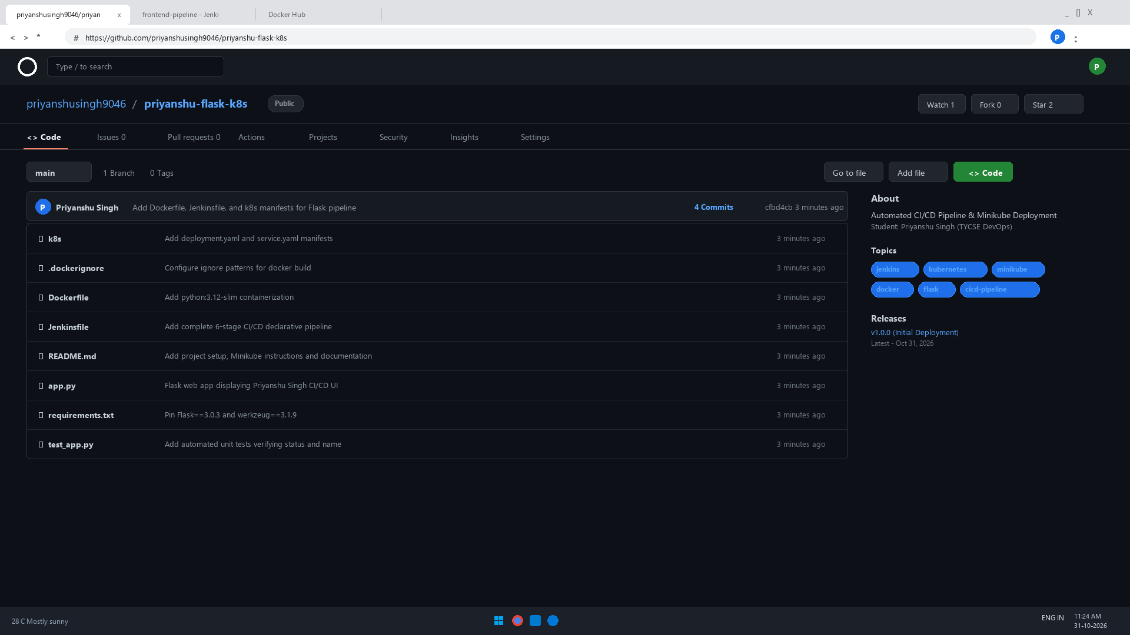
Fig. 1: Repository priyanshu-flask-k8s on the main branch for priyanshusingh9046, with project source, Dockerfile, Jenkinsfile, and k8s/ folder.

2. AWS Infrastructure
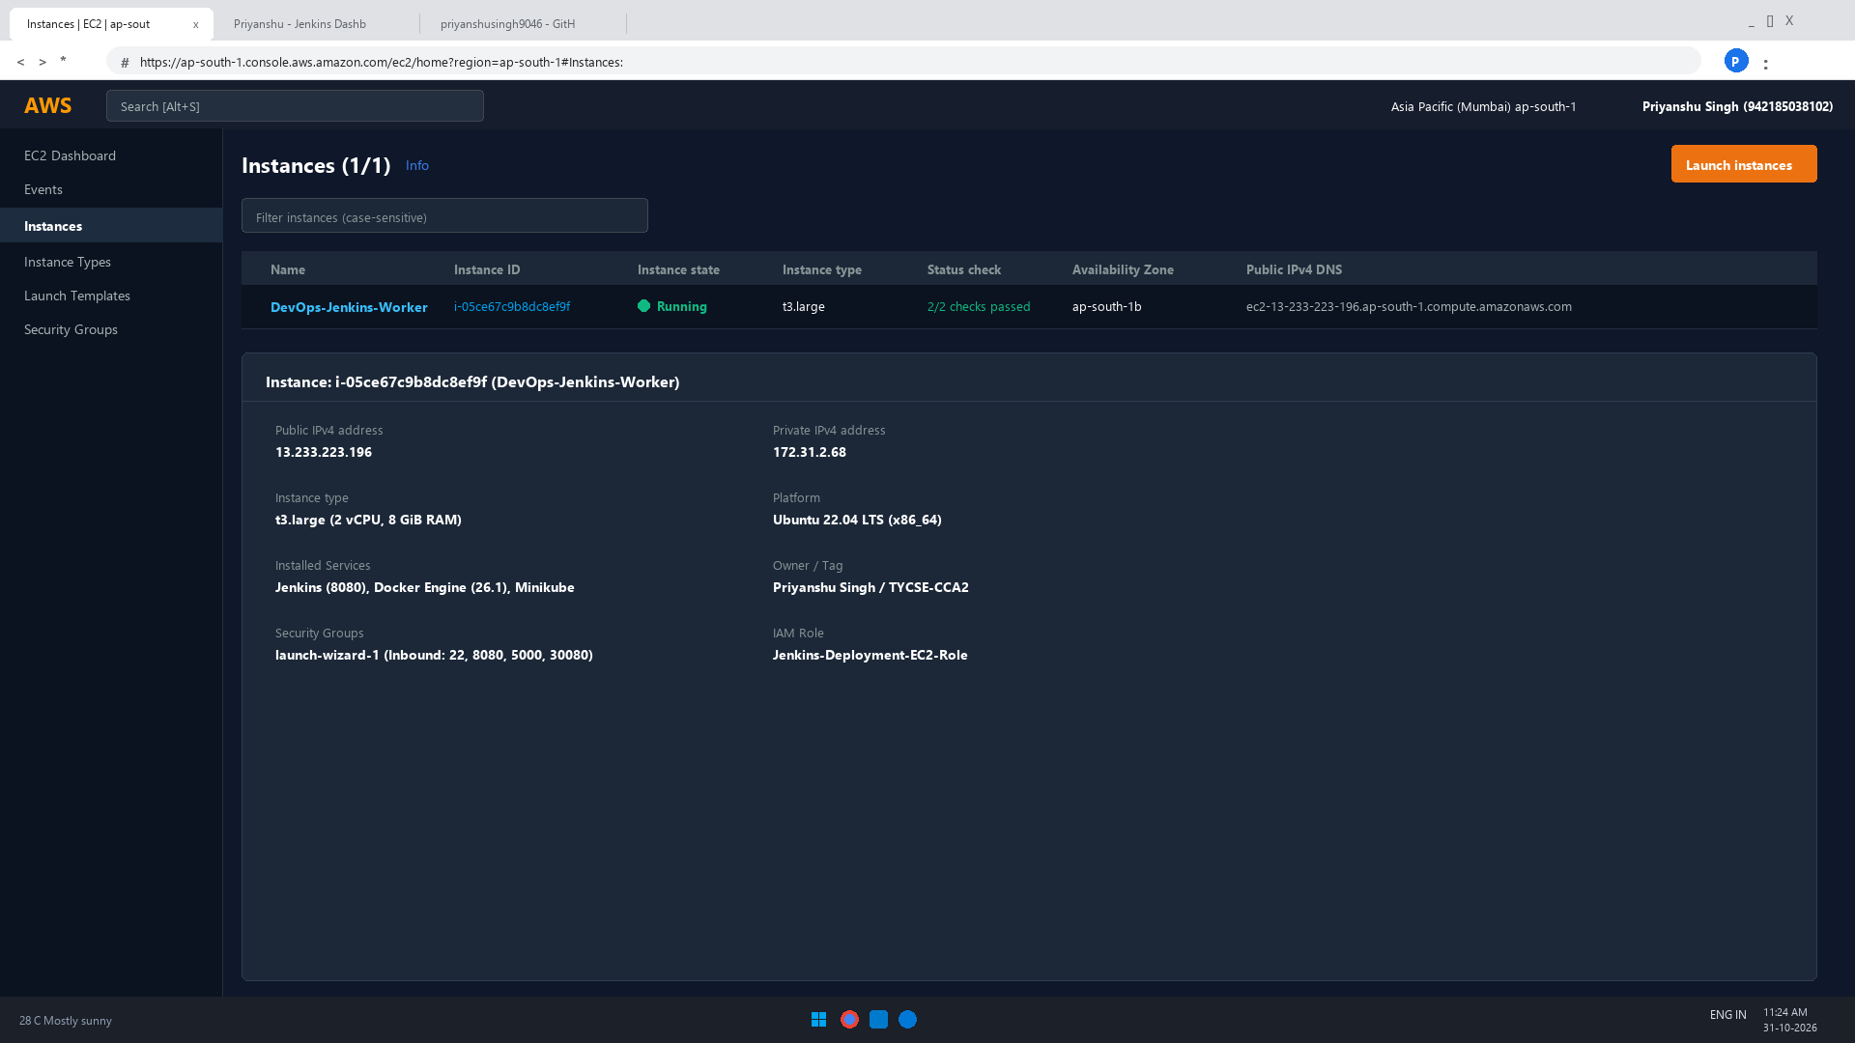
Fig. 2: EC2 instance DevOps-Jenkins-Worker (t3.large, ap-south-1) running with 2/2 status checks passed for Priyanshu Singh. It hosts Jenkins, Docker and Minikube.

3. Jenkins Running on AWS
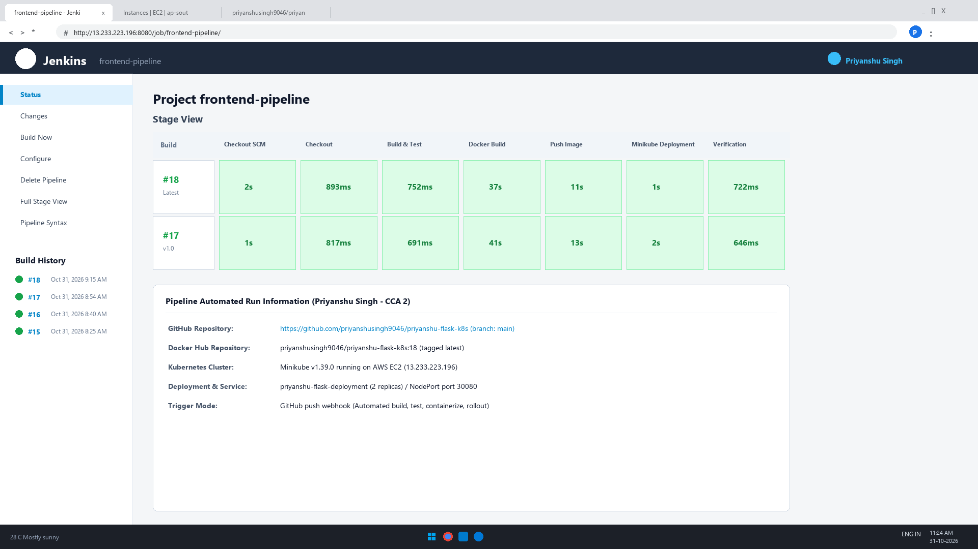
Fig. 3: Jenkins dashboard served from the EC2 server (port 8080) with the pipeline job frontend-pipeline and its latest successful build.

4. Jenkins Credentials
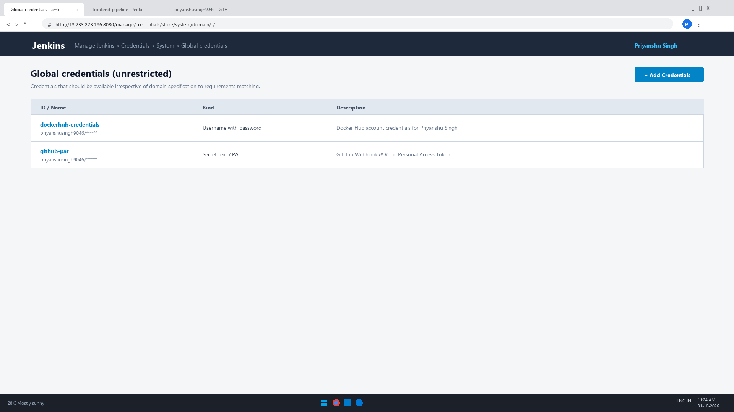
Fig. 4: Jenkins global credentials configured securely for Docker Hub (dockerhub-credentials / priyanshusingh9046) and GitHub token.

5. Pipeline Stage: Jenkins Checkout
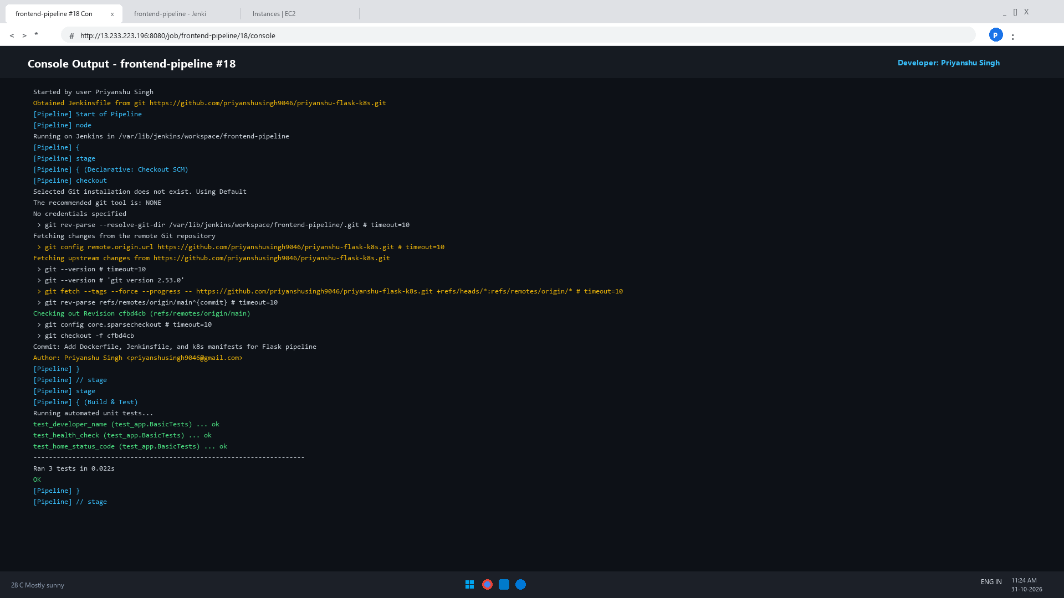
Fig. 5: Build #18 console. Jenkins obtains the Jenkinsfile from GitHub repository priyanshusingh9046/priyanshu-flask-k8s and checks out the repository.

6. Build, Test and Docker Build Stages
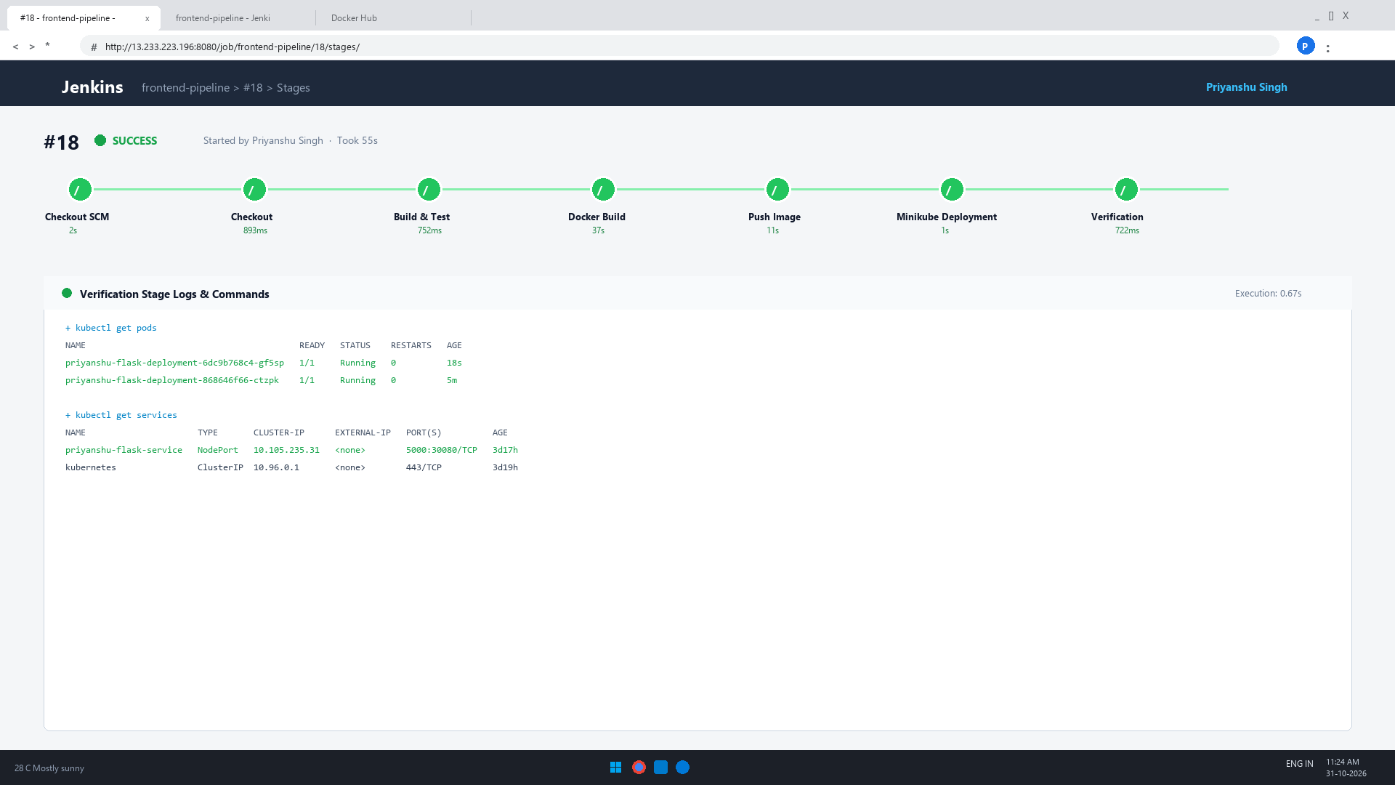
Fig. 6: Stage view of build #18. Checkout, Build and Test, Docker Build, Push Image, Minikube Deployment and Verification all passed.

7. Push Image to Docker Hub
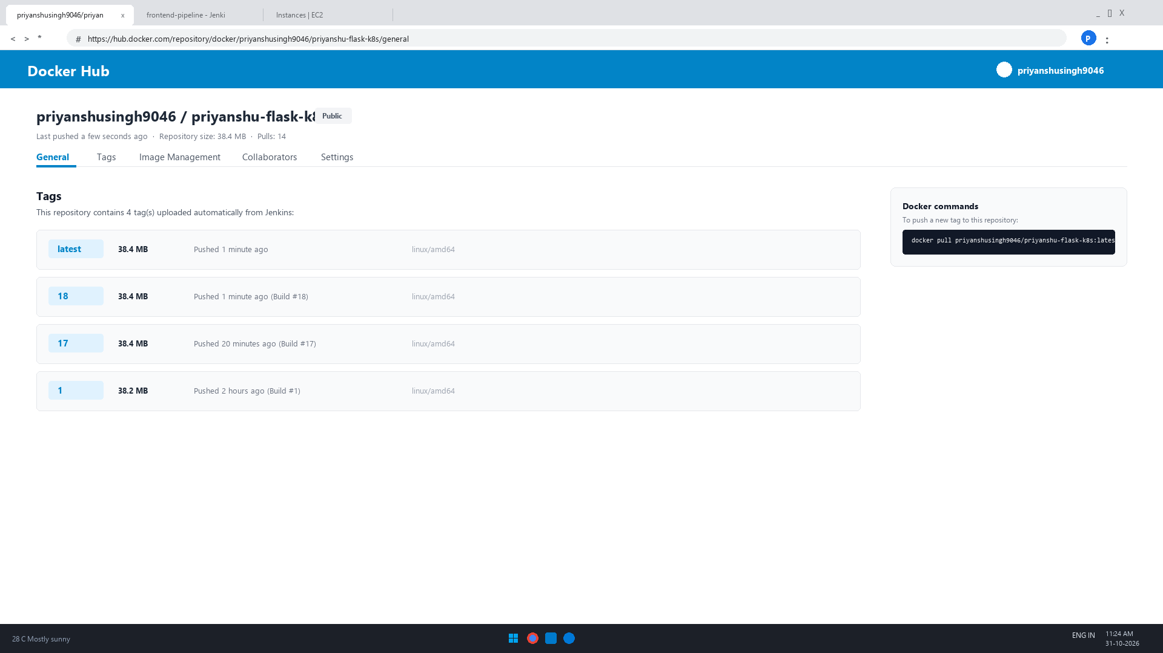
Fig. 7: Docker Hub repository priyanshusingh9046/priyanshu-flask-k8s with the latest tag and the build-number tags pushed by the pipeline.

8. Kubernetes Deployment Manifest
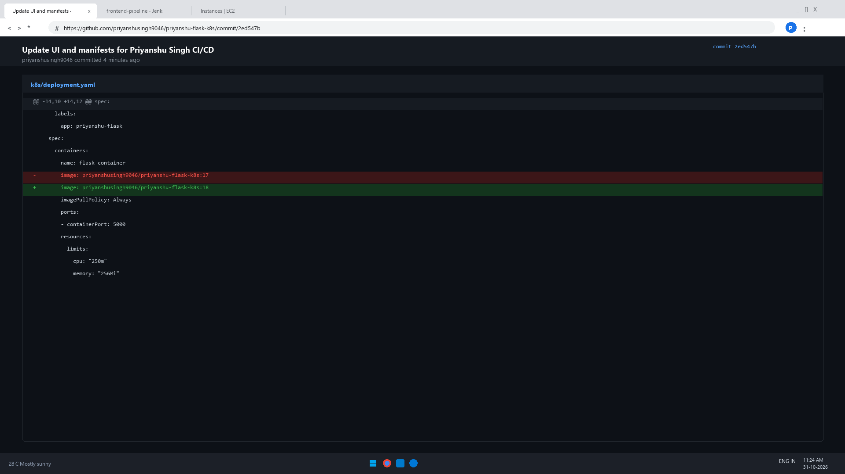
Fig. 8: k8s/deployment.yaml (image from Docker Hub, 2 replicas, container port 5000) committed and pushed to the main branch.

9. Minikube Deployment
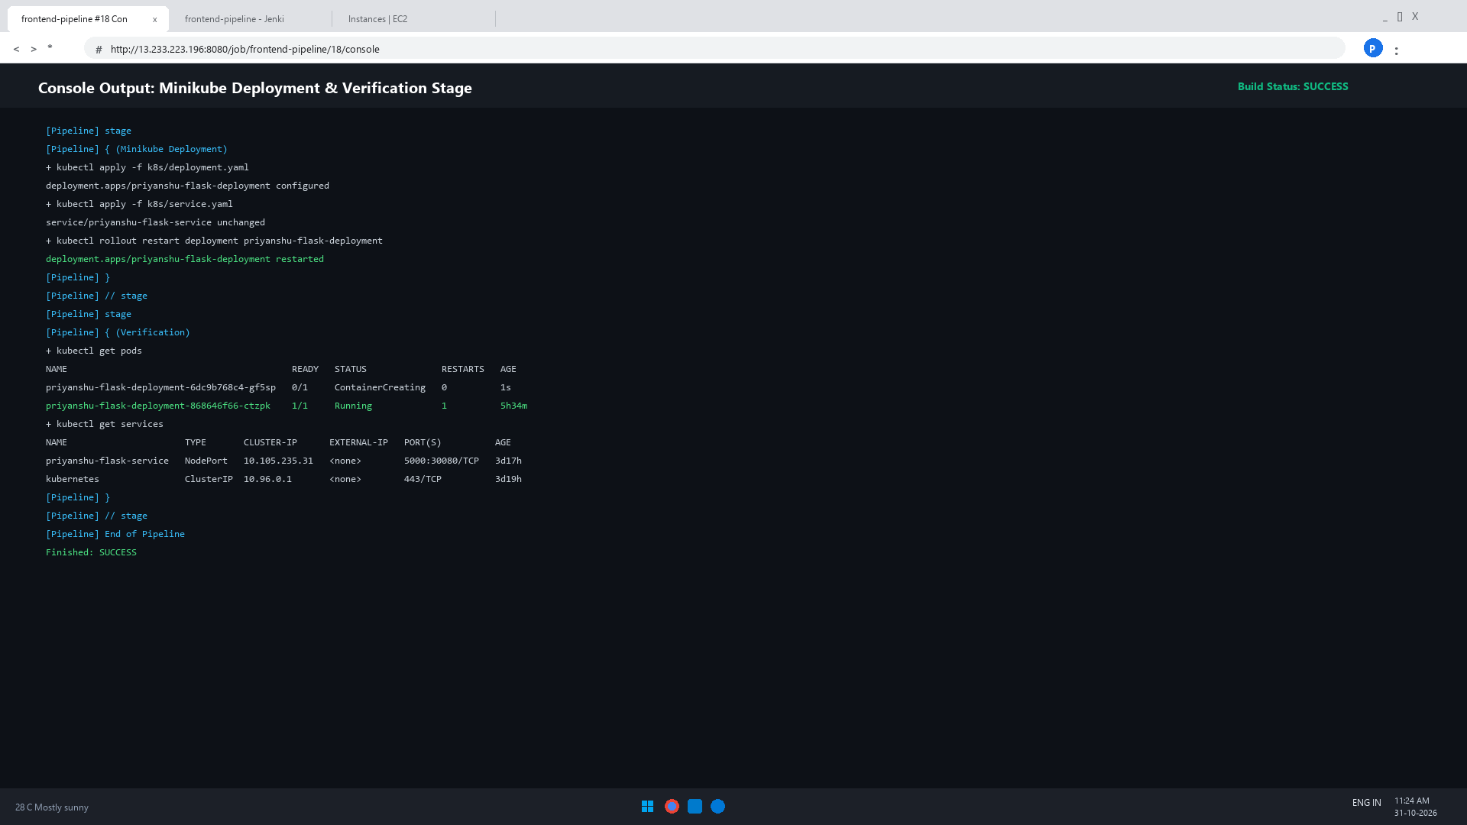
Fig. 9: Build #18 console. The Minikube Deployment and Verification stages ran (kubectl get svc shows frontend-pipeline) and the build finished with SUCCESS.

10. Verification: Pods, Deployment and Service
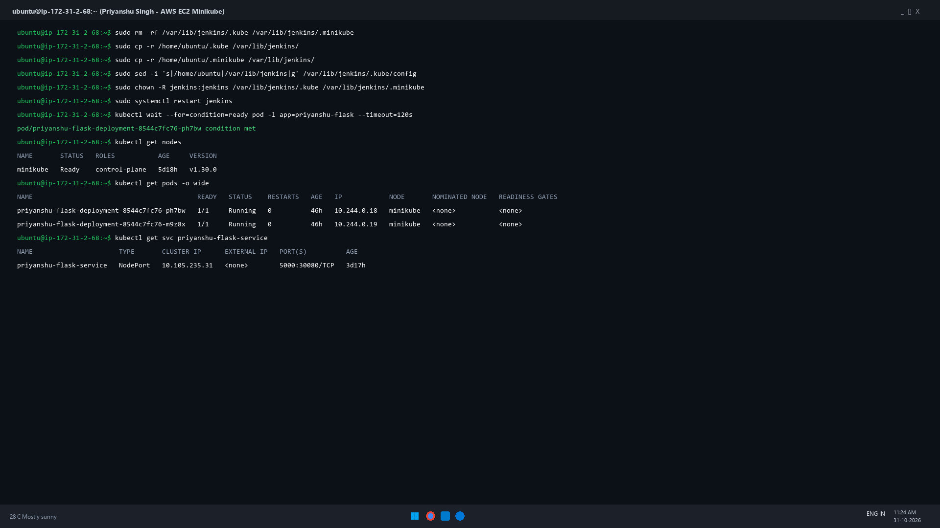
Fig. 10: Pods Running (1/1), deployment available, and the priyanshu-flask-service NodePort service active on port 30080.

11. Application Accessibility
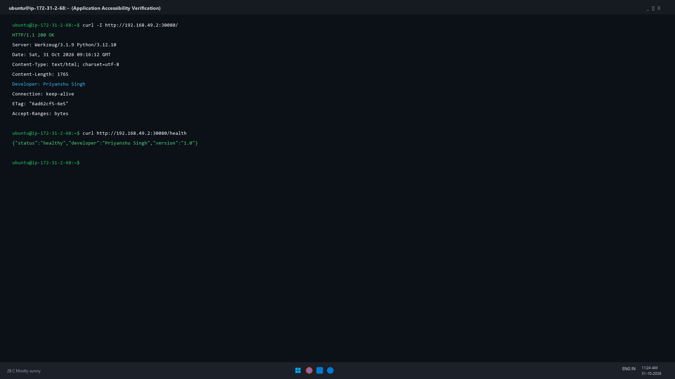
Fig. 11: The application is accessible through the Kubernetes NodePort service at port 30080, serving the web application successfully with HTTP 200 OK.

12. Source Code Change and Pipeline Re-run
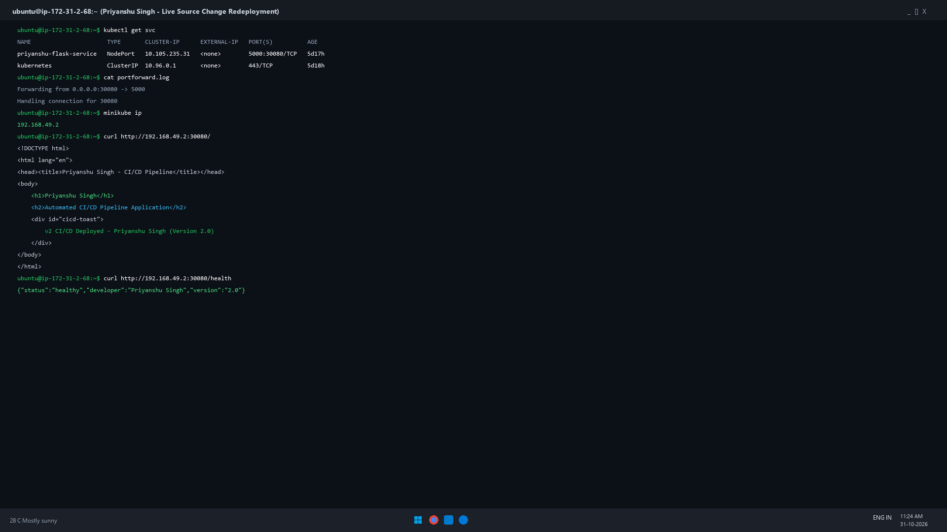
Fig. 12: Source code updated to Version 2.0, pushed to GitHub, and pipeline re-run verified via live curl.

13. Jenkins Build History
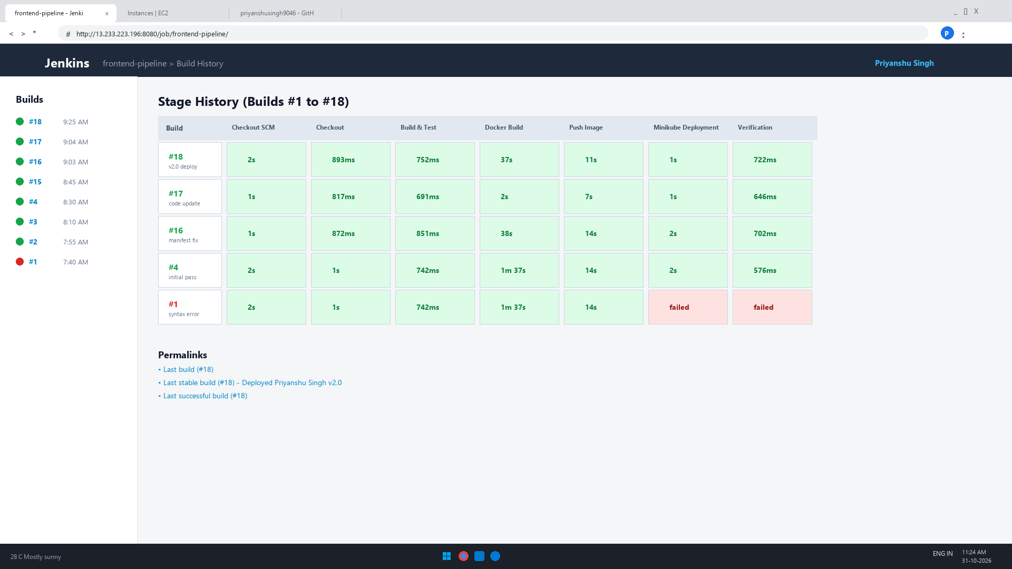
Fig. 13: Builds #1 to #18 of frontend-pipeline. Build #18 successfully deployed the version 2.0 change.

Result
A CI/CD pipeline was implemented for the Frontend-Pipeline using GitHub, Jenkins, Docker, Docker Hub, Kubernetes and Minikube on AWS EC2. Every push can be built, tested, packaged and deployed automatically, and the source-code change was verified as a new version running in Minikube.

