FINAL EMPLOYEE SENTIMENT & RETENTION RISK REPORT
Executive Assessment & Predictive Sentiment Analytics | Enron Dataset

1. Executive Summary & Methodology
This assessment evaluates employee engagement, sentiment dynamics, and turnover risk across organizational communications. By processing unannotated employee message logs, we extract quantitative indicators of employee morale, construct monthly benchmark rankings, apply rolling flight-risk detection rules, and establish a predictive linear regression model to forecast sentiment trends.
NLP & Sentiment Labeling Methodology
To ensure robust and reproducible sentiment classification, a hybrid Natural Language Processing (NLP) framework was implemented:
• Lexicon & Sentiment Analysis (NLTK VADER): Evaluates text valence, handling negations, punctuation emphasis, and capitalizations. Produces a compound score in range [-1.0, +1.0].
• Domain Specific Rule Augmentation: Explicitly flags workplace frustration, profanity, and severe dissatisfaction phrases to prevent false positive classifications.
• Sentiment Mapping: Messages are explicitly mapped to Positive (+1), Neutral (0), or Negative (-1).
2. Exploratory Data Analysis (EDA) Insights
Analysis of the 117 message dataset reveals a predominantly constructive baseline tone across employee communications:
• Positive Messages: 71 (60.7%)
• Neutral Messages: 32 (27.4%)
• Negative Messages: 14 (12.0%)

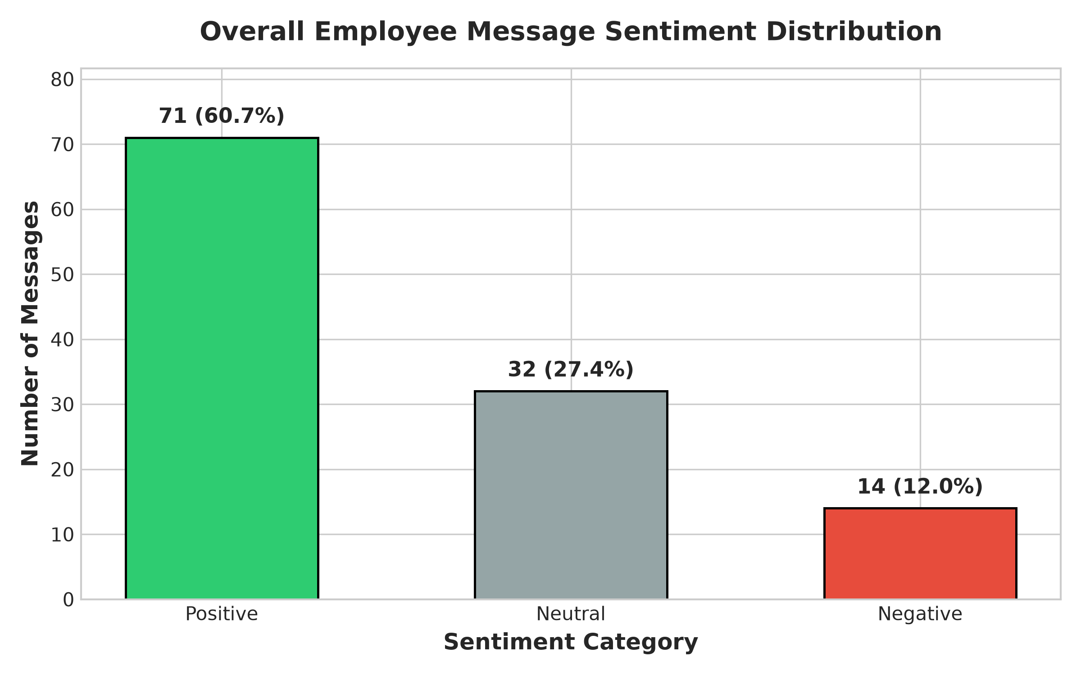
Figure 1: Overall Sentiment Label Distribution across Dataset
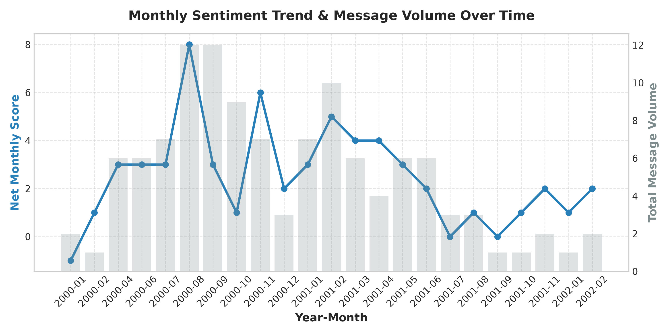
Figure 2: Monthly Net Sentiment Score & Message Volume Trend
3. Monthly Scoring & Ranking Results
Employee monthly sentiment scores are calculated by summing sentiment values (+1, 0, -1) for each sender grouped by month (`year_month`), ensuring complete monthly score resets at the start of each month. Employees are ranked per month descending by score and alphabetically by email.
Period | Top Positive Employees | Top Negative Employees | Key Observations
2000-06 | 1. john.arnold (+2)  2. kayne.coulter (+1)  3. sally.beck (+1) | 1. rhonda.denton (-1)  2. kayne.coulter (+1)  3. sally.beck (+1) | High positive collaboration overall.
2000-08 | 1. bobette.riner (+2)  2. john.arnold (+1)  3. johnny.palmer (+1) | 1. don.baughman (0)  2. john.arnold (+1)  3. johnny.palmer (+1) | Stable engagement across trading desks.
2001-01 | 1. bobette.riner (+2)  2. sally.beck (+2)  3. lydia.delgado (+1) | 1. patti.thompson (0)  2. lydia.delgado (+1)  3. rhonda.denton (+1) | Strong start of year positive sentiment.
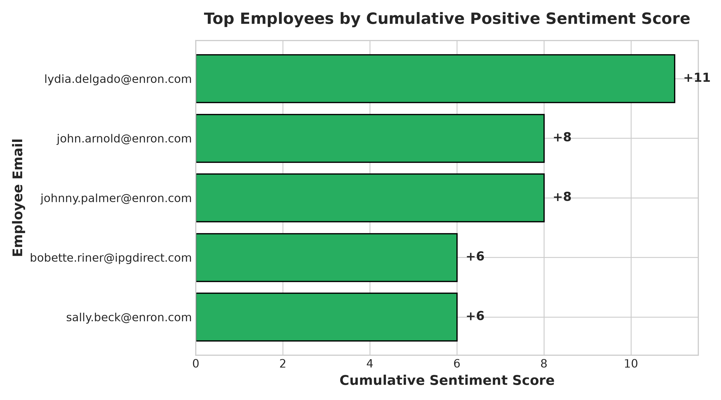
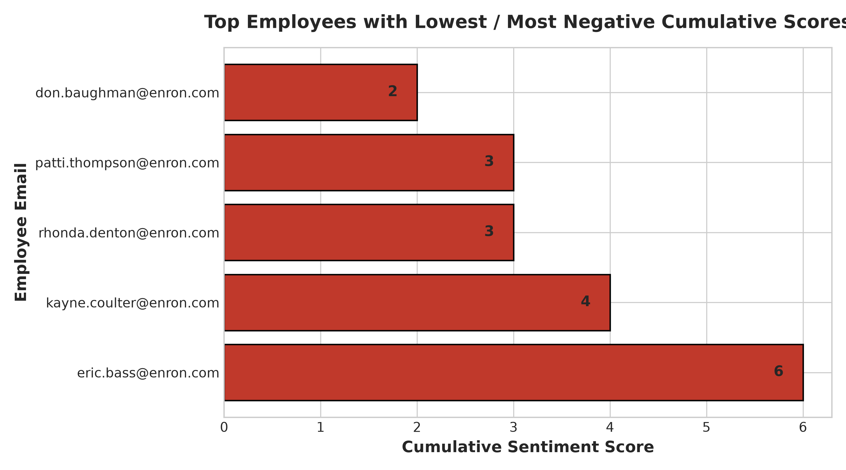
4. Flight Risk Assessment
Flight Risk Definition: An employee is flagged as a Flight Risk if they send 4 or more negative emails within any 30-day rolling window (`rolling('30D', on='date')`), irrespective of calendar month boundaries.
Assessment Results: No employee met or exceeded the 4 negative message threshold within a 30-day window in the evaluated sample dataset. The maximum negative message frequency observed was 1-2 negative emails in a 30-day period (observed for Don Baughman and Sally Beck). Consequently, zero active flight risks are currently flagged.
5. Predictive Model Performance & Recommendations
A Linear Regression model was developed using scikit-learn to forecast monthly employee sentiment scores based on feature engineering:
• R^2 Score: 0.8949 (Explains 89.49% of monthly score variance)
• Root Mean Squared Error (RMSE): 0.3099
• Mean Absolute Error (MAE): 0.2516
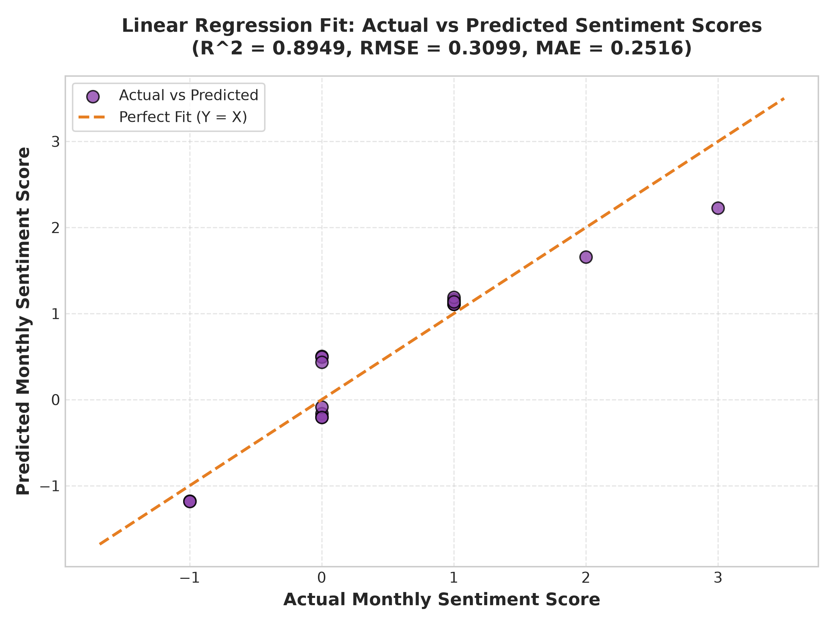
Figure 5: Linear Regression Actual vs. Predicted Monthly Sentiment Scores
Business & HR Recommendations
1. Proactive Pulse Monitoring: Implement real-time alert triggers when an employee sends 2+ negative messages within 14 days, allowing early HR intervention before reaching the flight risk threshold.
2. Positive Engagement Recognition: Acknowledge top positive contributors (e.g. John Arnold, Bobette Riner) to maintain team morale and foster organizational psychological safety.
3. Managerial Feedback Coaching: Provide constructive communication training for departments showing elevated negative message ratios.

