SOG Design
RFP Intelligence Platform
Phase 1 implementation plan: RFP intake, AI normalisation and the review and audit layer
Phase 1: Intake and normalisation
Prepared by Fruition for SOG Design
1 October 2026 · Draft for discussion
Confidential

1. Phase 1 at a glance
Phase 1 builds the foundation of the RFP Intelligence Platform. Every later step, including pricing and proposal drafting, depends on how clean and trustworthy this data is, which is why this phase receives the most care.
The historical archive is treated as part of Phase 1 rather than as a separate preparation task. The reference engine can only check and enrich new RFPs against SOG's history once that history has been structured.

1.1 Scope
In scope | Out of scope (Phase 2 onwards)
Intake from all inbound channels  Reading and classifying RFP documents  AI extraction into SOG's proposal structure  The reference engine built on historical data  Structuring the 500–700 past proposals  A thin frontend to review, change, audit and confirm each RFP | Pricing and fee ranges  Proposal drafting  Word and PDF proposal generation

1.2 Outcome
Every RFP becomes a clean, source-traced, human-confirmed record in the same shape as SOG's past proposals: a qualified lead, ready for pricing.
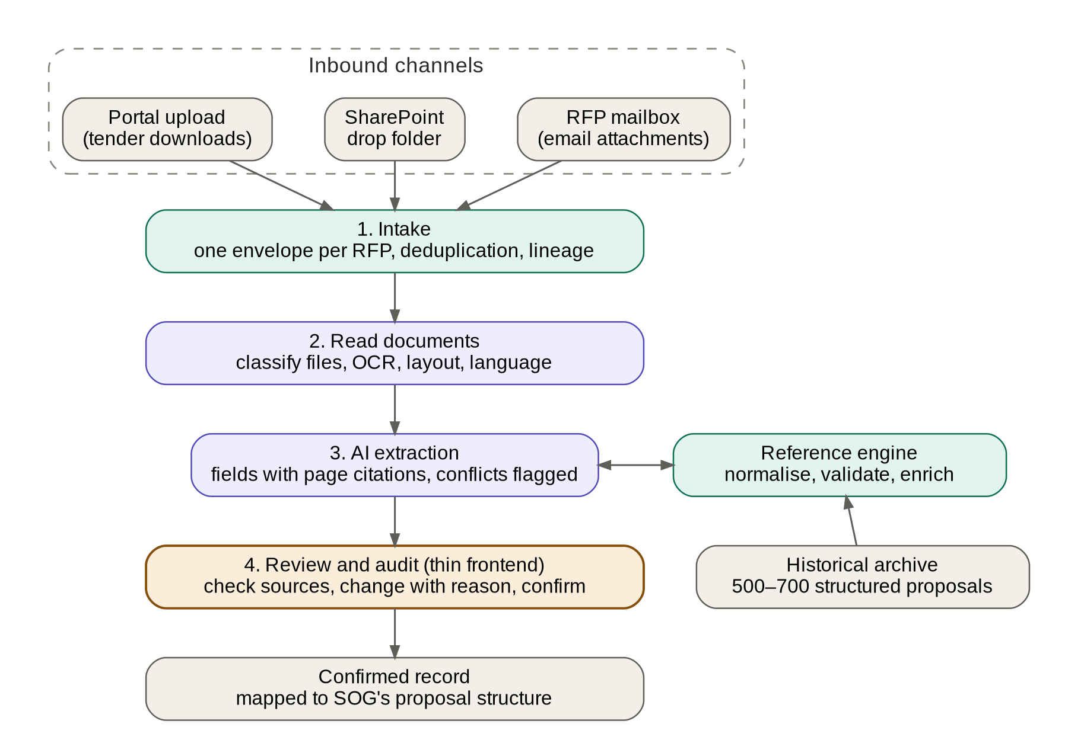
Figure 1. Phase 1 pipeline, from inbound channels to a confirmed record.

2. How each part works

2.1 Intake
Intake is run by the n8n orchestrator inside SOG's Azure environment.
- Channels: a shared RFP mailbox read through Microsoft Graph (so nothing is exposed to inbound traffic), a watched SharePoint folder, and upload through the platform for tender-portal downloads.
- One envelope per RFP: an RFP usually arrives as a pack, with an email body, a brief, client terms, drawings, a schedule of areas and sometimes a zip file. All of it is grouped into a single envelope. The email body is kept, as it often carries the deadline or contact details.
- Lineage and deduplication: each file is stored unchanged in Blob Storage with a fingerprint, its channel, its sender and its arrival time. A file seen before is linked to the existing envelope rather than processed twice, which often happens when the same RFP arrives by email and through a portal.
- Unsupported files: CAD drawings, large models and similar files are stored and listed, but not read, in Phase 1. The reviewer can see that they exist.

2.2 Reading documents
- File classification: each file in the pack is identified as the main RFP, design brief, client terms, area schedule, drawings or other, based on its first pages. Extraction then knows where to look; for example, payment terms come from the client terms and areas from the schedule.
- Layout reading: Azure AI Document Intelligence returns text, tables and the exact position of each line on each page. These positions allow the frontend to highlight the source of every value.
- Language detection: non-English RFPs are identified at intake.

2.3 AI extraction in two passes
- Pass 1, per document: requirements are extracted into the request side of the SOG Proposal Schema. Every value carries its source file, page, highlighted text and a confidence level.
- Pass 2, across the pack: values are consolidated, and conflicts are flagged rather than silently resolved. For example, a brief may state 18,000 m² while the area schedule states 21,500 m². Conflicts are among the most valuable information a reviewer can receive.
- Validation: output must match a fixed schema, with a retry on failure. RFP text is treated as data only, and the AI cannot take any action or change any record.

2.4 The reference engine
In Phase 1 the engine does not price. It normalises, validates and enriches the AI's output against SOG's own history. It is built as a Python service in SOG's Azure environment, so that the same engine grows into pricing in Phase 2.
Function | What it does | Built from
Taxonomy mapping | Locks every value to SOG's own terms for typology, service, stage and deliverable. The AI suggests; the engine accepts only values in the controlled list | Terms used across the archive, confirmed with SOG
Units and formats | Converts square feet to square metres, and standardises hectares, dates and currencies | Fixed rules
Plausibility checks | Flags values outside the historical norm for that typology, such as an efficiency ratio, unit size or site coverage never seen before | Statistical ranges from the archive
Enrichment | Assigns the location tier and matches the client against past clients (new or repeat) | Location tier table and the archive's client list
Suggestions for gaps | Where the RFP is silent, suggests a likely value from similar past projects, always marked as a suggestion and never as fact | Similar past projects
Completeness and lead status | Scores how many pricing-critical fields are present and applies the qualification rules: qualified, needs information or recommend no-bid | Field criticality list and rules set by SOG

2.5 Structuring the historical archive
This work runs in parallel with the intake build.
- Schema workshop (week 1): together with SOG, we review 20–30 past proposals and agree the schema, the taxonomy and the field definitions. The structure comes from SOG's proposals, not from our assumptions.
- Batch extraction: all 500–700 proposals pass through the same pipeline and are joined to the fee track record.
- Quality check: SOG spot-checks around 10% of records in the frontend. Systematic errors are corrected across the whole archive, not one by one.
- Proposal section map: we also derive the standard section structure of SOG's proposals, such as project understanding, scope by service and stage, deliverables, programme, fees, payment, exclusions and terms. New RFPs are mapped to this structure.

2.6 The thin frontend
A web application with Microsoft Entra ID single sign-on, hosted in SOG's Azure environment, with five screens:
Screen | Purpose
Inbox | Every envelope with its channel, deadline, lead status, completeness score and owner
Review | A split view: the RFP document on the left and the structured record on the right. Selecting any value highlights its source on the page. Confidence, conflict and plausibility flags appear on each field, and every change requires a short reason
Proposal mapping | The RFP's requirements arranged under SOG's own proposal sections, with a list of unmapped requirements: requests that have no place in SOG's usual structure. These are often special requests that affect scope and price
Audit trail | The full history of every value: extracted by AI, enriched by the engine or changed by a person, with who, when and why. Confirming a record locks that version
Archive check and admin | Spot-checking past proposals, and maintaining the taxonomy, location tiers, field criticality and qualification rules

2.7 Data model
All data is held in Azure Database for PostgreSQL within SOG's environment.
Data | Holds
Envelopes, documents, pages | The RFP pack, each file, page layout data and lineage
Extraction runs | The model, prompt version and engine version used for every run
Field values | Each value with its source document, page, highlight position, confidence, origin (AI, engine or person) and status
Field changes | The audit trail, which can only be added to, never edited
Opportunities | The confirmed record in the SOG Proposal Schema, versioned
Archive proposals and sections | SOG's structured history and its proposal section map
Reference data | Taxonomy, location tiers, qualification rules and field criticality, editable by administrators

3. Delivery plan
Phase 1 is delivered in two-week sprints, with a short set-up sprint at the start.
Sprint | Delivers
Sprint 0 (1 week) | Azure environment and security baseline, schema workshop, gold test set agreed
Sprint 1 | Intake from all three channels, envelopes, deduplication, document reading and classification
Sprint 2 | Two-pass extraction, conflict detection, reference engine version 1 (taxonomy, normalisation, completeness)
Sprint 3 | Archive batch extraction and quality check; reference engine version 2 (plausibility ranges, client matching, gap suggestions, lead status)
Sprint 4 | Frontend: inbox, review split view, audit trail
Sprint 5 | Proposal mapping view, admin screens, accuracy tuning on the gold test set, user acceptance testing

Expected duration is 9 to 11 weeks. The environment, security, data model and engine built in this phase carry directly into Phase 2.

4. Measuring success
We ask SOG for 20–30 past RFPs together with the proposals SOG submitted for them. These pairs form a gold test set: what the platform extracts from each RFP should match what SOG later wrote in its proposal, which allows accuracy to be measured objectively.
Measure | Target
Accuracy on pricing-critical fields (typology, areas, services, stage package, location) | At least 90%
Extracted values linked to a source page | 100%
Conflicts between documents in a pack | All flagged
Reviewer time per RFP | Under 20 minutes
Audit trail for every confirmed record | Complete

5. What we need from SOG
- An Azure subscription or resource group, with contributor access for the delivery team.
- A shared RFP mailbox and a SharePoint folder for incoming RFPs.
- Access to the 500–700 past proposals and the fee track record.
- The gold test set of 20–30 RFP and proposal pairs.
- Two people for the schema workshop and weekly reviews, ideally one director and one business development lead.

6. Risks and how we manage them
Risk | Mitigation
Past proposals vary by studio or year | The schema workshop samples across studios and years; the quality check catches systematic issues
Scanned or poor-quality RFPs | OCR through Document Intelligence; low-confidence fields flagged for review
RFPs in several languages | Language detected at intake; scope for non-English RFPs agreed in Sprint 0
The AI filling in missing information | Controlled vocabularies in the engine; gap suggestions always labelled as suggestions; human confirmation required
Review taking longer than reading the RFP | Split view with one-click source highlights, tuned against the 20-minute target in Sprint 5

