C Programming Platform Coding Practice Question Bank

  - Module 1 — Input/output, variables and basic arithmetic
Read from STDIN, Write to STDOUT
1) Read different types of data from standard input, process them as shown in output format and print the answer to standard output.
Input format:
First line contains integer N.
Second line contains string S.
Output format:
First line should contain N x 2.
Second line should contain the same string S.
Constraints:
where S length of string S
Examples
Input
5
helloworld
Output
10
Helloworld

Answer
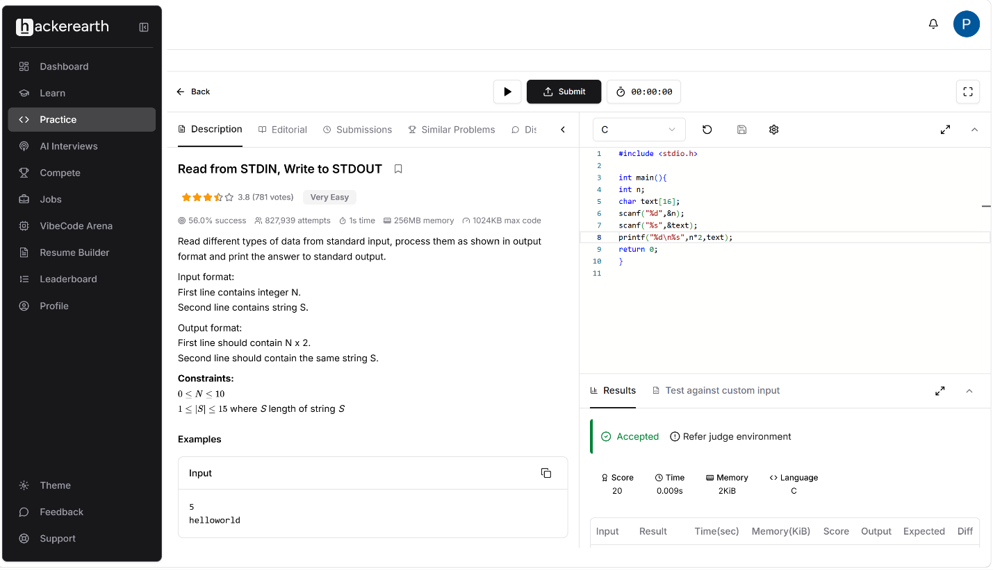
Code :
#include <stdio.h>

int main(){
int n;
char text[16];
scanf("%d",&n);
scanf("%s",&text);
printf("%d\n%s",n*2,text);
return 0;
}

