Python password generator

1. Introduction
Passwords are the first line of defense in digital security. With the rise of online services, weak or reused passwords are a leading cause of account breaches. Many users still rely on easily guessable passwords like "123456" or "password," leaving their personal data vulnerable.
The aim of this project is to develop a Python-based password generator that produces secure, random, and customizable passwords. The program allows users to select password length, include digits, and include symbols, ensuring strong security with minimal effort.

2. Problem Statement
Many people create weak passwords due to convenience, resulting in high vulnerability to hacking and identity theft. A solution is needed to provide:
- Strong and unpredictable passwords
- Customizable options to meet varying security requirements
- Easy-to-use tools for non-technical users
This project addresses these challenges by providing a simple Python program that generates secure passwords with optional digits and symbols.

3. Why It Matters
- Weak passwords are one of the top security risks online.
- Strong passwords significantly reduce the risk of account compromise.
- A tool that automates password generation saves users time while maintaining security.
- This project contributes to digital hygiene and online safety, which is critical in both personal and professional contexts.

4. Approach / Methodology
- Programming Language: Python 3.x, chosen for its simplicity and readability.
- Libraries Used:
  - random – for generating unpredictable selections
  - string – for easily accessing letters and digits
- Algorithm Design:
  - Define character pools: letters, digits, symbols
  - Ensure at least one digit or symbol if the user chooses these options
  - Fill the remaining password length randomly from the combined pool
  - Shuffle characters to randomize placement
- User Input:
  - Prompt user for password length
  - Ask if digits should be included
  - Ask if symbols should be included

5. Key Decisions
- Choice of Python: Simple, widely used, and allows rapid prototyping.
- Minimum one character inclusion: Ensures user-selected categories appear in the password.
- Customizable password length: Gives flexibility for different security needs.
- Console-based interface: Easy to implement and compatible across systems.

6. Challenges Faced
- Ensuring category inclusion: Initially, random selection did not always guarantee that digits or symbols were included. Solved by explicitly adding at least one of each selected type before filling the remaining password.
- Random shuffling: Needed to avoid predictable positions of required characters.

7. Results
- Program successfully generates secure passwords based on user preferences.
- The program is reliable, easy to use, and meets the defined objectives.

8. Learning Outcomes
Through this project, I learned:
- How to design algorithms to meet both security and usability requirements.
- The importance of validating user input to avoid errors.
- Techniques for generating secure random data in Python.
- How to structure a small project with clear documentation and reporting.

9. Future Improvements
- Graphical User Interface (GUI): Improve usability for non-technical users.
- Bulk password generation: Allow generating multiple passwords at once.

Python code
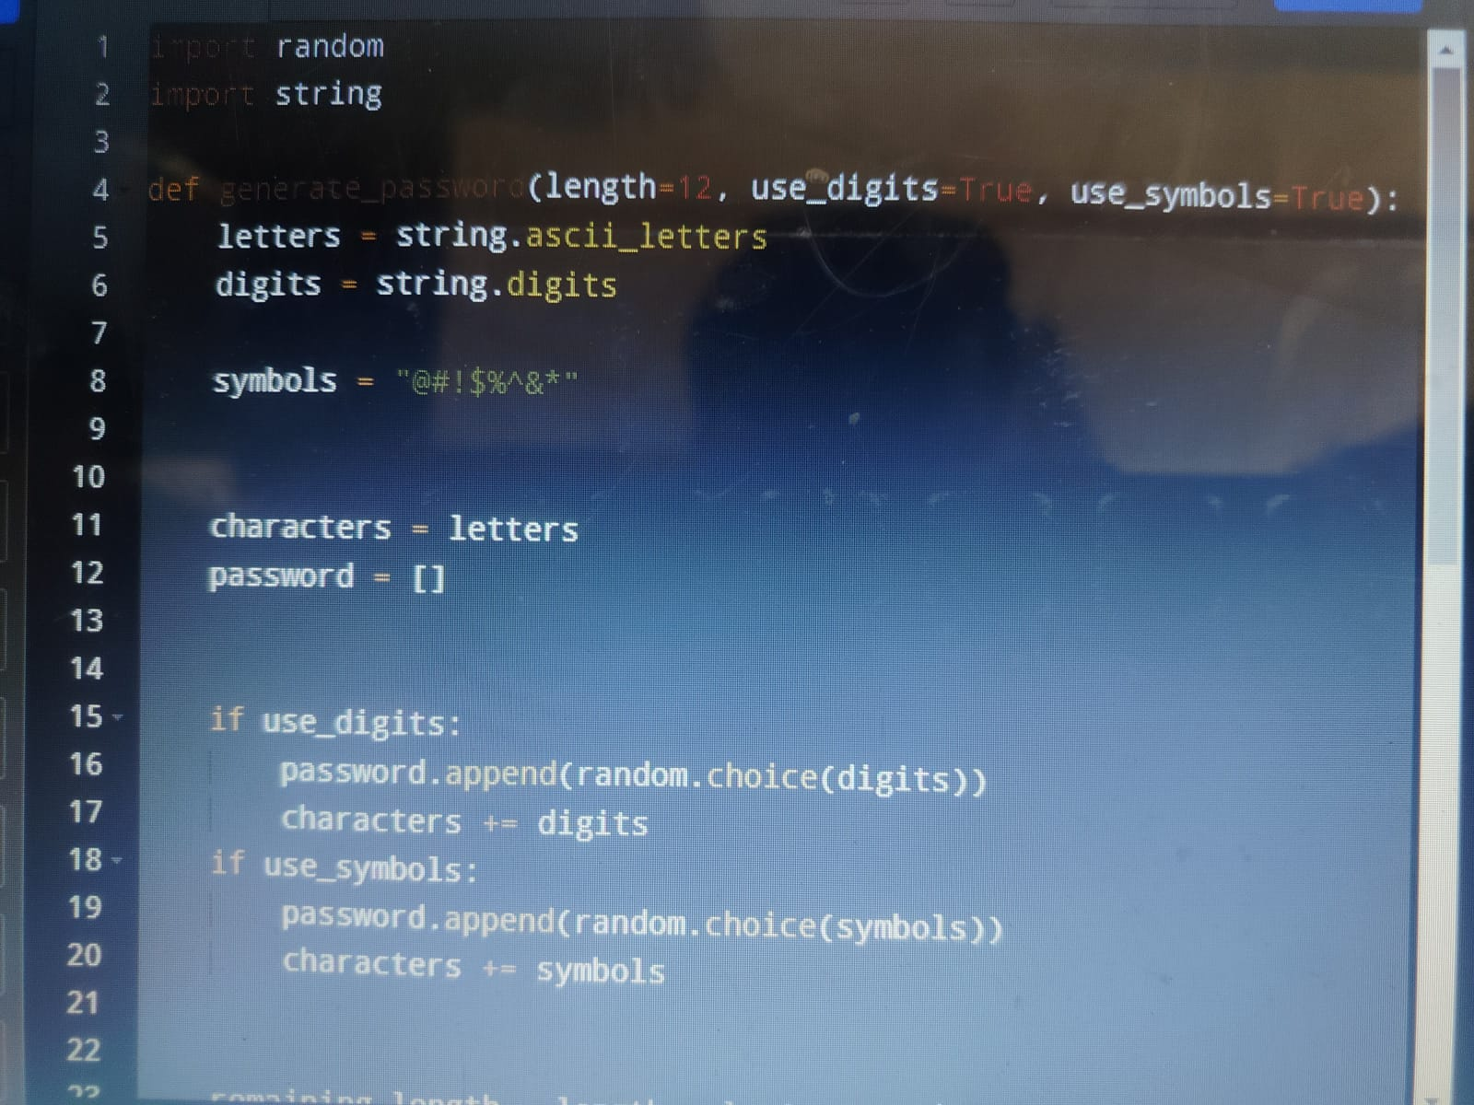

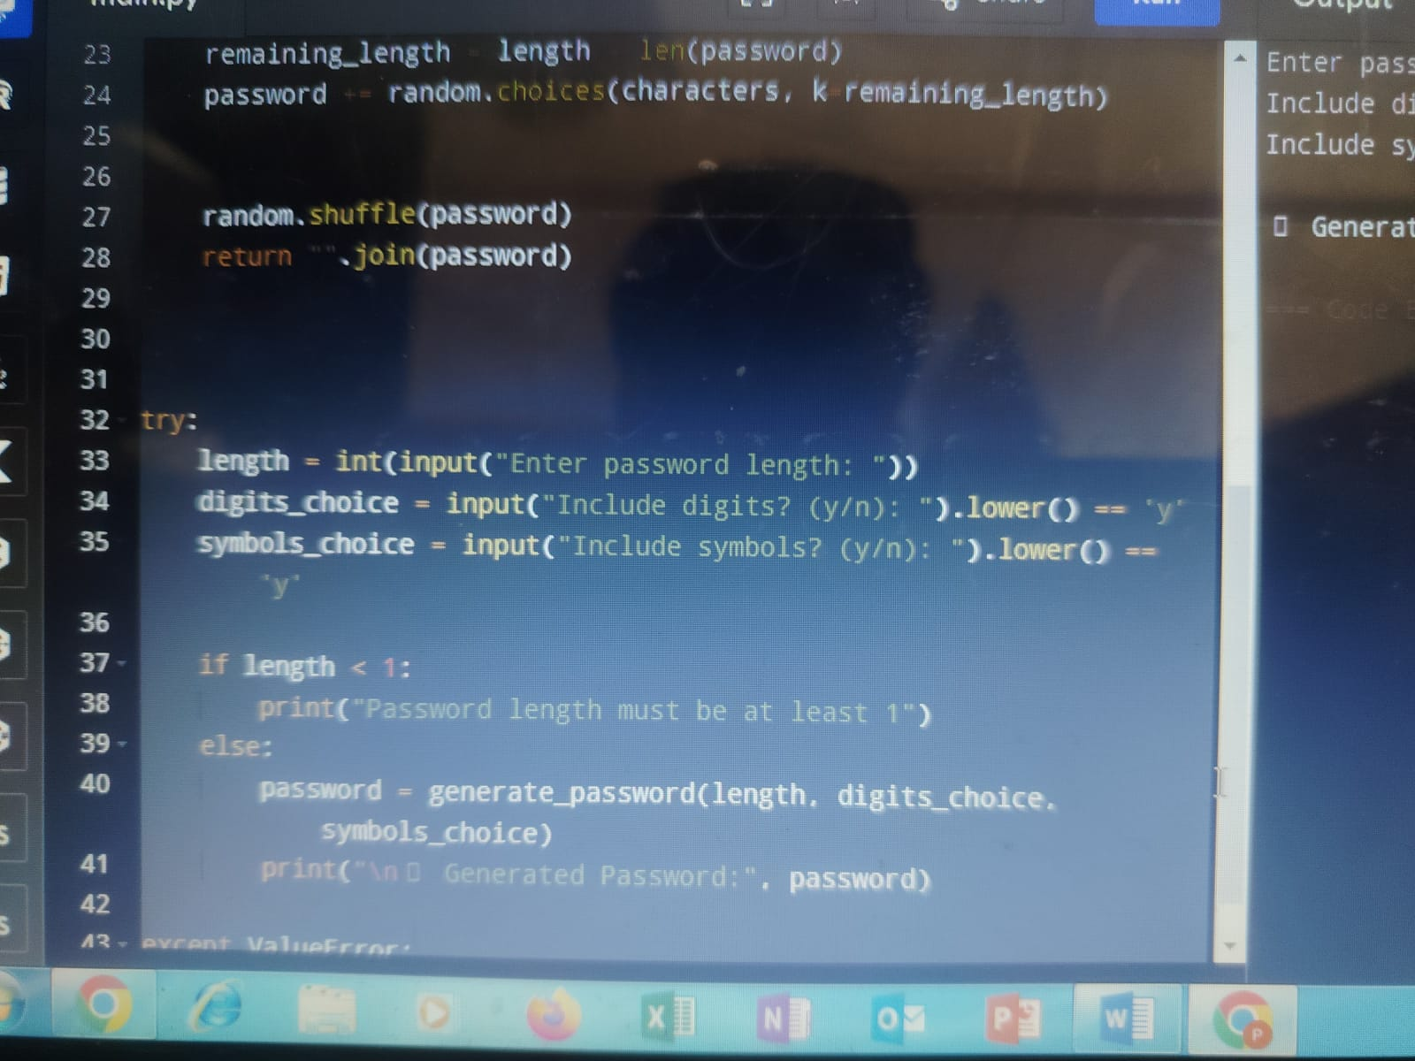

Output-
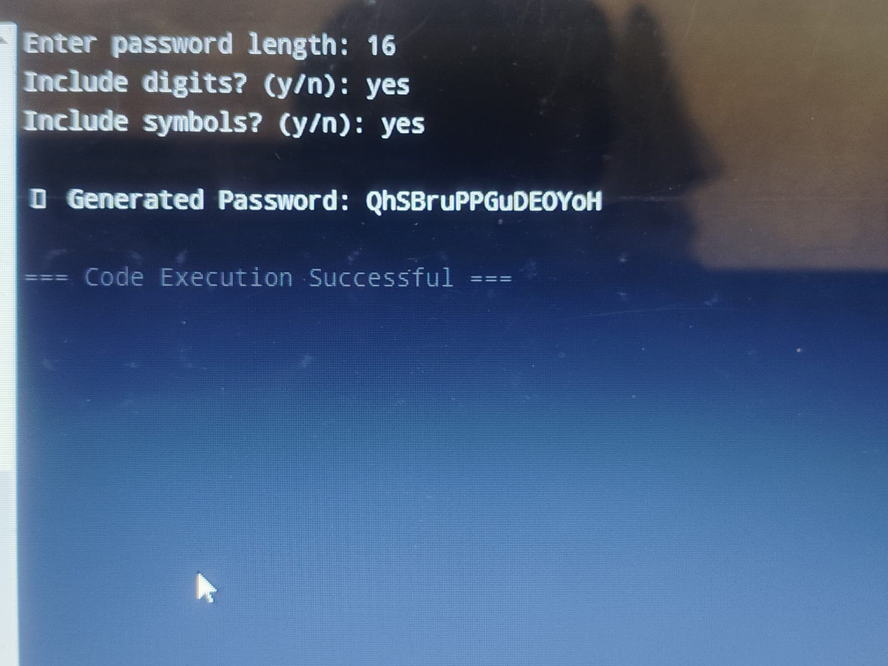

10. Conclusion
The Python Password Generator project successfully solves a real-world problem by providing users with a simple, customizable tool to generate secure passwords. The project not only demonstrates programming and algorithmic skills but also highlights the importance of thoughtful design in creating secure software tools.

