Reading the Texas Housing Market Through Charts
Week 2: Data Visualization and Insight Communication in R
Dataset: monthly home sales in 46 Texas markets, January 2000 to July 2015 | Tools: R, ggplot2, dplyr
Name: Priyanshu Dubey Date: 29 September 2026

1. What this report is about
For this task I used the txhousing dataset that comes with the ggplot2 package. It records monthly home sales in 46 Texas cities and regions between January 2000 and July 2015, collected by the Texas Real Estate Research Center. I picked it over the usual mtcars or iris data because there is an actual story inside it: a long boom, a housing crash, and a recovery, all in the same 15 years. It is also a little messy (missing values, uneven reporting), which meant I had to think about whether each chart was telling the truth.
The report is written for someone who has never opened R. Every chart gets the same treatment: first the question I was asking and why I chose that type of chart, then the chart, then what it tells us in plain language. The R code and its console output come last in each section for anyone who wants to reproduce it. All eight charts were made with ggplot2 and share one custom theme so they read as a set.

2. The data
Each row is one market in one month, 8,602 rows in total. The table below lists what each column holds.
Variable | What it means | Notes
city | Name of the market (Houston, Austin, Collin County, ...) | 46 markets. Some are counties or regional areas, not single cities.
year, month | When the figures were recorded | January 2000 to July 2015.
sales | Number of homes sold in that month | 568 values missing.
volume | Total dollar value of those sales | 568 values missing.
median | Median sale price: half of homes sold for more, half for less | 616 values missing.
listings | Homes actively for sale that month | 1,424 values missing.
inventory | Months of inventory: how long it would take to sell every listed home at the current pace | 1,467 values missing. Low = homes sell fast.
date | Year plus a fraction (2000.083 means February 2000) | Not a true date, so I built real dates where needed.

Three features of the data affected how I built the charts, so it is worth spelling them out:
- 2015 is only seven months long. The data stops in July 2015. If I compared 2015 to a full year, it would look like sales collapsed. In the charts I either mark this clearly or compare January to July with January to July.
- Reporting is uneven. Only 26 of the 46 markets have a sales figure for every month. South Padre Island, Kerrville, Midland and Odessa are each missing well over 70 months. A statewide total that adds up whoever reported that month can rise or fall just because a city started or stopped reporting, so the time-trend chart uses only the 26 complete markets.
- Prices are not adjusted for inflation. A 2015 dollar is worth less than a 2000 dollar, so the price gains I report are larger than the real gains.
The first block of code loads the packages, defines the colours and chart theme, and runs the checks above. Every later block assumes this one has been run.
R CODE
# Packages (all on CRAN; install.packages() once if you don't have them)
library(ggplot2)
library(dplyr)
library(tidyr)
library(scales)

# txhousing ships with ggplot2, so no download is needed
housing <- txhousing

# --- a small custom theme so every chart looks consistent ---
navy <- "#1F3A5F"
rust <- "#C8553D"
sand <- "#E9E2D0"
grey <- "#8A8F98"

theme_report <- function() {
theme_minimal(base_size = 11) +
theme(
plot.title = element_text(face = "bold", size = 13, colour = navy),
plot.subtitle = element_text(colour = "grey30", margin = margin(b = 8)),
plot.caption = element_text(colour = grey, size = 8, hjust = 0),
plot.title.position = "plot",
plot.caption.position = "plot",
panel.grid.minor = element_blank(),
panel.grid.major.x = element_blank(),
axis.title = element_text(colour = "grey25"),
strip.text = element_text(face = "bold", colour = navy)
)
}
src <- "Source: Texas Real Estate Research Center, via the ggplot2 'txhousing' dataset"

# folder for the saved chart images
dir.create("figs", showWarnings = FALSE)

# a helper to save every figure the same way
save_fig <- function(plot, name, w = 7, h = 4.4) {
ggsave(file.path("figs", paste0(name, ".png")), plot,
width = w, height = h, dpi = 300, bg = "white")
}

# --- first look at the data ---
glimpse(housing)
cat("\nMissing values per column:\n")
print(colSums(is.na(housing)))
cat("\nCities:", n_distinct(housing$city),
"| Years:", min(housing$year), "to", max(housing$year),
"| Last month in 2015:", max(housing$month[housing$year == 2015]), "\n")

cat("\nMarkets with the most months of missing sales data (out of 187):\n")
housing %>%
group_by(city) %>%
summarise(missing_months = sum(is.na(sales))) %>%
arrange(desc(missing_months)) %>%
slice_head(n = 5) %>%
as.data.frame() %>%
print()

# Cities that report a sales figure in every single month.
# Used later so statewide totals are not distorted by cities dropping in and out.
complete_cities <- housing %>%
group_by(city) %>%
summarise(missing = sum(is.na(sales))) %>%
filter(missing == 0) %>%
pull(city)
cat("\nCities with a complete sales record:", length(complete_cities), "of 46\n")
CONSOLE OUTPUT
Rows: 8,602
Columns: 9
$ city <chr> "Abilene", "Abilene", "Abilene", "Abilene", "Abilene", "Abil~
$ year <int> 2000, 2000, 2000, 2000, 2000, 2000, 2000, 2000, 2000, 2000, ~
$ month <int> 1, 2, 3, 4, 5, 6, 7, 8, 9, 10, 11, 12, 1, 2, 3, 4, 5, 6, 7, ~
$ sales <dbl> 72, 98, 130, 98, 141, 156, 152, 131, 104, 101, 100, 92, 75, ~
$ volume <dbl> 5380000, 6505000, 9285000, 9730000, 10590000, 13910000, 1263~
$ median <dbl> 71400, 58700, 58100, 68600, 67300, 66900, 73500, 75000, 6450~
$ listings <dbl> 701, 746, 784, 785, 794, 780, 742, 765, 771, 764, 721, 658, ~
$ inventory <dbl> 6.3, 6.6, 6.8, 6.9, 6.8, 6.6, 6.2, 6.4, 6.5, 6.6, 6.2, 5.7, ~
$ date <dbl> 2000.000, 2000.083, 2000.167, 2000.250, 2000.333, 2000.417, ~

Missing values per column:
city year month sales volume median listings inventory
0 0 0 568 568 616 1424 1467
date
0

Cities: 46 | Years: 2000 to 2015 | Last month in 2015: 7

Markets with the most months of missing sales data (out of 187):
city missing_months
1 South Padre Island 116
2 Kerrville 104
3 Midland 75
4 Odessa 72
5 San Marcos 46

Cities with a complete sales record: 26 of 46

3. The charts

Chart 1. What does a typical price look like? (histogram)
Why this chart. A histogram is the obvious first step for a single number. Before comparing cities or years I wanted to know where prices normally sit and whether a few extreme values might distort later charts.
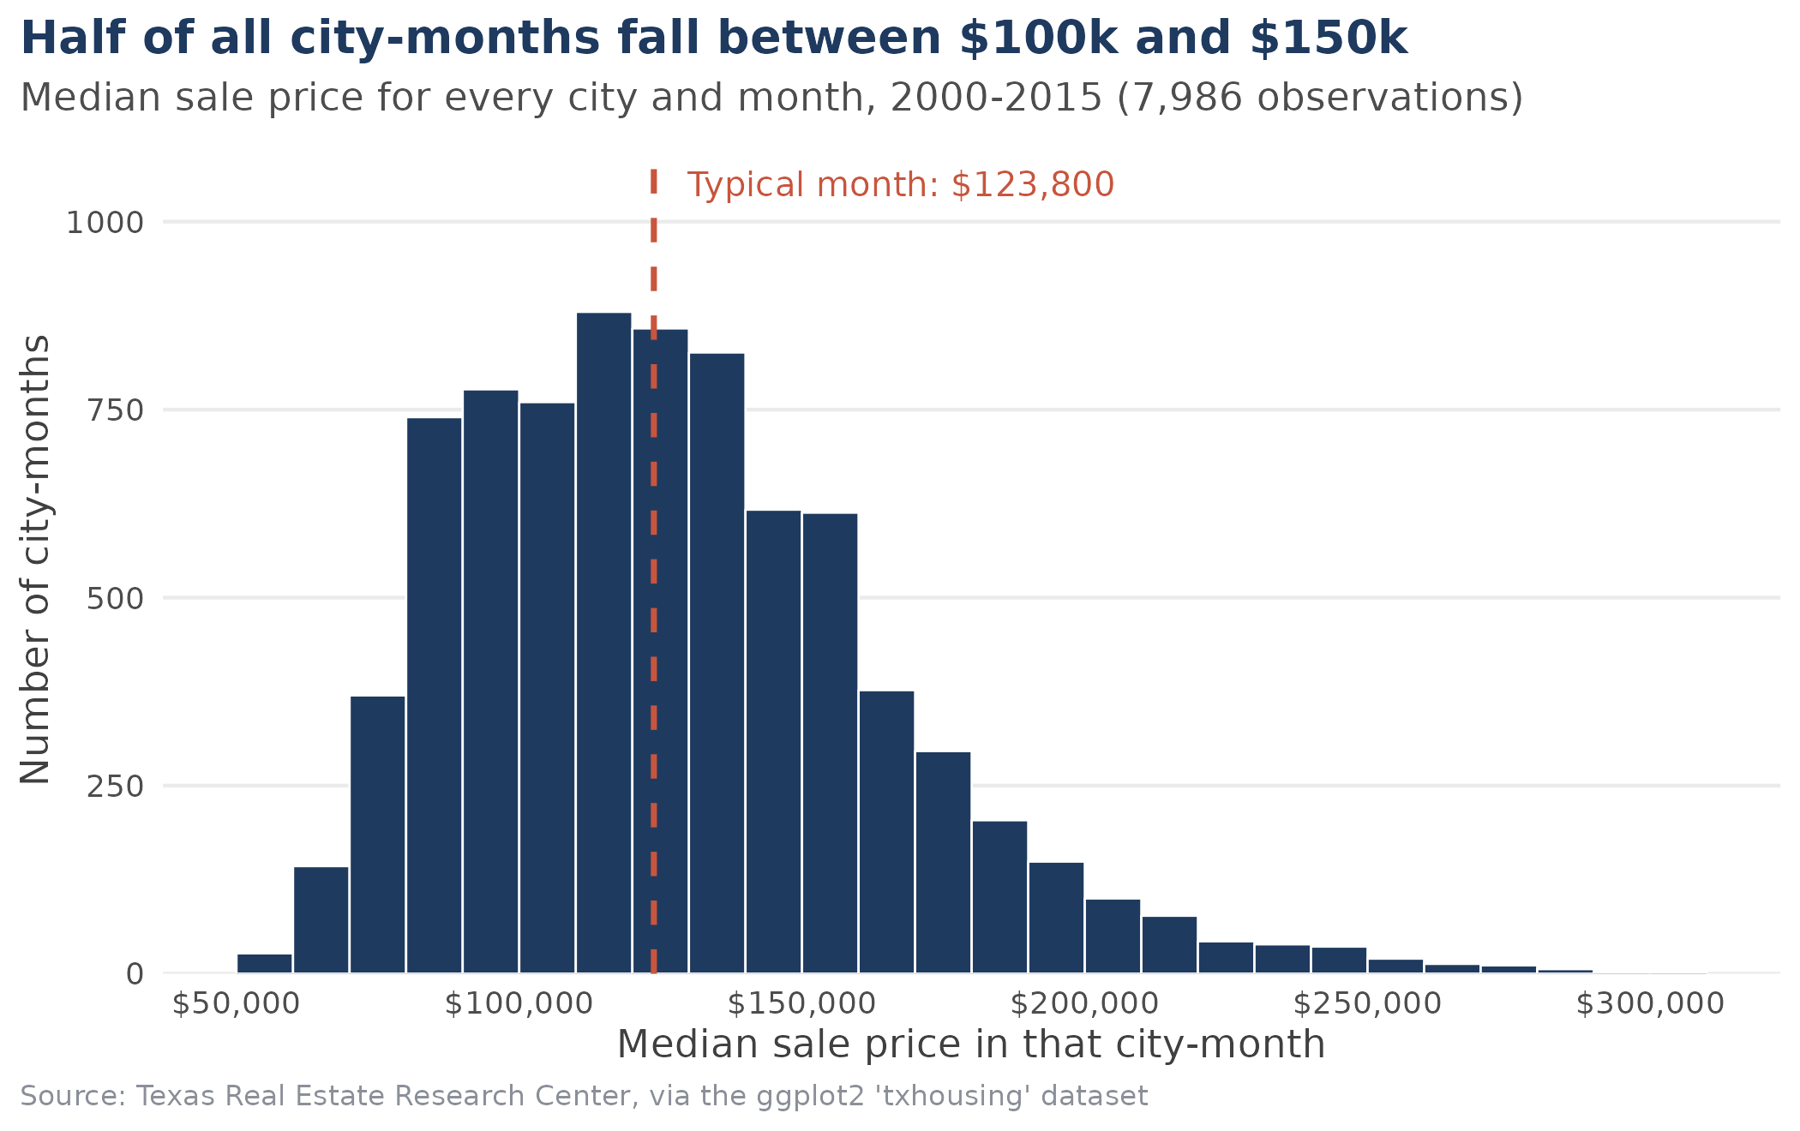
Figure 1. Distribution of monthly median sale prices across all markets and months.
What it shows. Each bar counts how many city-months had a median price inside a $10,000 band. The middle value is $123,800, and half of all city-months fall between $100,000 and $150,000. The shape leans to the right: the mean ($128,131) is higher than the median, and a thin tail reaches out towards $300,000. Only 4.4% of city-months reached $200,000 or more, while about a quarter (24.9%) were under $100,000.
A caution. This pools all sixteen years together, and every city-month counts once whether it is Houston or a town with a few dozen sales. So $123,800 is not "the price of a Texas home"; it is the middle of a pile of monthly city figures. The chart's real job is to set the scale. Prices in this data mostly live between roughly $60,000 and $250,000, and to compare cities that start from different places I need the indexed and percentage charts later on.
R CODE
med_price <- median(housing$median, na.rm = TRUE)

fig1 <- ggplot(housing, aes(x = median)) +
geom_histogram(binwidth = 10000, boundary = 50000,
fill = navy, colour = "white", linewidth = 0.3, na.rm = TRUE) +
geom_vline(xintercept = med_price, colour = rust, linewidth = 0.8, linetype = "dashed") +
annotate("text", x = med_price + 6000, y = 1050, hjust = 0, colour = rust,
size = 3.4, label = paste0("Typical month: ", dollar(med_price))) +
scale_x_continuous(labels = dollar, breaks = seq(50000, 300000, 50000)) +
scale_y_continuous(limits = c(0, 1100), expand = c(0, 0)) +
labs(title = "Half of all city-months fall between $100k and $150k",
subtitle = "Median sale price for every city and month, 2000-2015 (7,986 observations)",
x = "Median sale price in that city-month", y = "Number of city-months",
caption = src) +
theme_report()

save_fig(fig1, "fig1_price_histogram")

cat("Summary of monthly median price:\n")
print(summary(housing$median))
cat("\nShare of city-months at or above $200k:",
percent(mean(housing$median >= 200000, na.rm = TRUE), accuracy = 0.1), "\n")
cat("Share of city-months under $100k:",
percent(mean(housing$median < 100000, na.rm = TRUE), accuracy = 0.1), "\n")
CONSOLE OUTPUT
Summary of monthly median price:
Min. 1st Qu. Median Mean 3rd Qu. Max. NA's
50000 100000 123800 128131 150000 304200 616

Share of city-months at or above $200k: 4.4%
Share of city-months under $100k: 24.9%

Chart 2. Where does the activity happen? (bar chart)
Why this chart. Bars are the clearest way to compare sizes across categories, and sorting them makes the ranking obvious. I turned it sideways because city names are long, and coloured Houston and Dallas differently because the gap between those two and everyone else is the whole point.
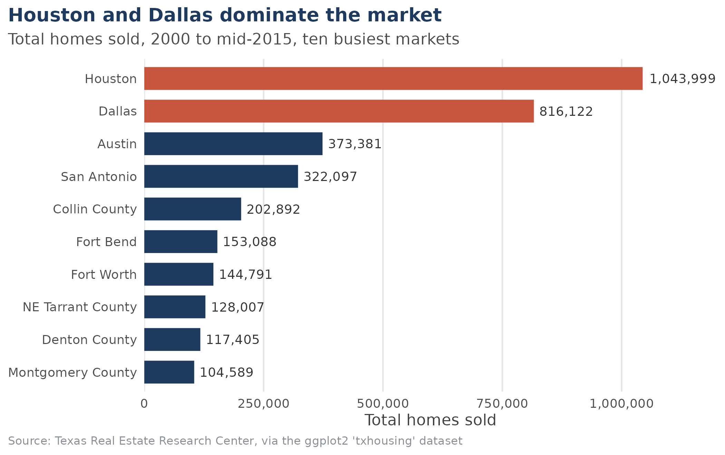
Figure 2. Total homes sold, 2000 to mid-2015, in the ten busiest markets.
What it shows. Between 2000 and mid-2015 Houston recorded 1,043,999 sales and Dallas 816,122. Together that is 42.1% of the 4,415,202 sales in the dataset (23.6% and 18.5%). Austin (373,381) and San Antonio (322,097) come next, but each is under half of Dallas. Several other entries are suburban counties: Collin, Denton and NE Tarrant around Dallas–Fort Worth, Fort Bend and Montgomery near Houston. So the two big metro areas matter even more than the city names alone suggest.
Why it matters. Any statewide total is mostly a Houston and Dallas story. That is why the later charts look at cities one by one and not only at statewide totals.
R CODE
city_totals <- housing %>%
group_by(city) %>%
summarise(total_sales = sum(sales, na.rm = TRUE)) %>%
arrange(desc(total_sales))

top10 <- city_totals %>%
slice_head(n = 10) %>%
mutate(city = reorder(city, total_sales),
big_two = city %in% c("Houston", "Dallas"))

fig2 <- ggplot(top10, aes(x = total_sales, y = city, fill = big_two)) +
geom_col(width = 0.7) +
geom_text(aes(label = comma(total_sales)), hjust = -0.1, size = 3.2, colour = "grey20") +
scale_fill_manual(values = c(`TRUE` = rust, `FALSE` = navy), guide = "none") +
scale_x_continuous(labels = comma, breaks = seq(0, 1000000, 250000),
limits = c(0, 1200000), expand = c(0, 0)) +
labs(title = "Houston and Dallas dominate the market",
subtitle = "Total homes sold, 2000 to mid-2015, ten busiest markets",
x = "Total homes sold", y = NULL, caption = src) +
theme_report() +
theme(panel.grid.major.y = element_blank(), panel.grid.major.x = element_line(colour = "grey90"))

save_fig(fig2, "fig2_top_cities")

state_total <- sum(city_totals$total_sales)
cat("Total homes sold across all 46 markets:", comma(state_total), "\n\n")
top10 %>% arrange(desc(total_sales)) %>%
mutate(share = percent(total_sales / state_total, accuracy = 0.1)) %>%
select(city, total_sales, share) %>% as.data.frame() %>% print()
cat("\nHouston + Dallas together:",
percent(sum(city_totals$total_sales[1:2]) / state_total, accuracy = 0.1), "of all sales\n")
CONSOLE OUTPUT
Total homes sold across all 46 markets: 4,415,202

city total_sales share
1 Houston 1043999 23.6%
2 Dallas 816122 18.5%
3 Austin 373381 8.5%
4 San Antonio 322097 7.3%
5 Collin County 202892 4.6%
6 Fort Bend 153088 3.5%
7 Fort Worth 144791 3.3%
8 NE Tarrant County 128007 2.9%
9 Denton County 117405 2.7%
10 Montgomery County 104589 2.4%

Houston + Dallas together: 42.1% of all sales

Chart 3. How did sales move over time? (line chart)
Why this chart. Anything that changes over time belongs on a line chart, because the eye follows slope and turning points without effort. Raw monthly sales bounce up and down with the seasons, so I added a 12-month moving average. Averaging over exactly one year cancels the seasonal swing and leaves the underlying trend. I also restricted the chart to the 26 markets with complete records, so that the line moves because of the market and not because cities joined or dropped out of the data.
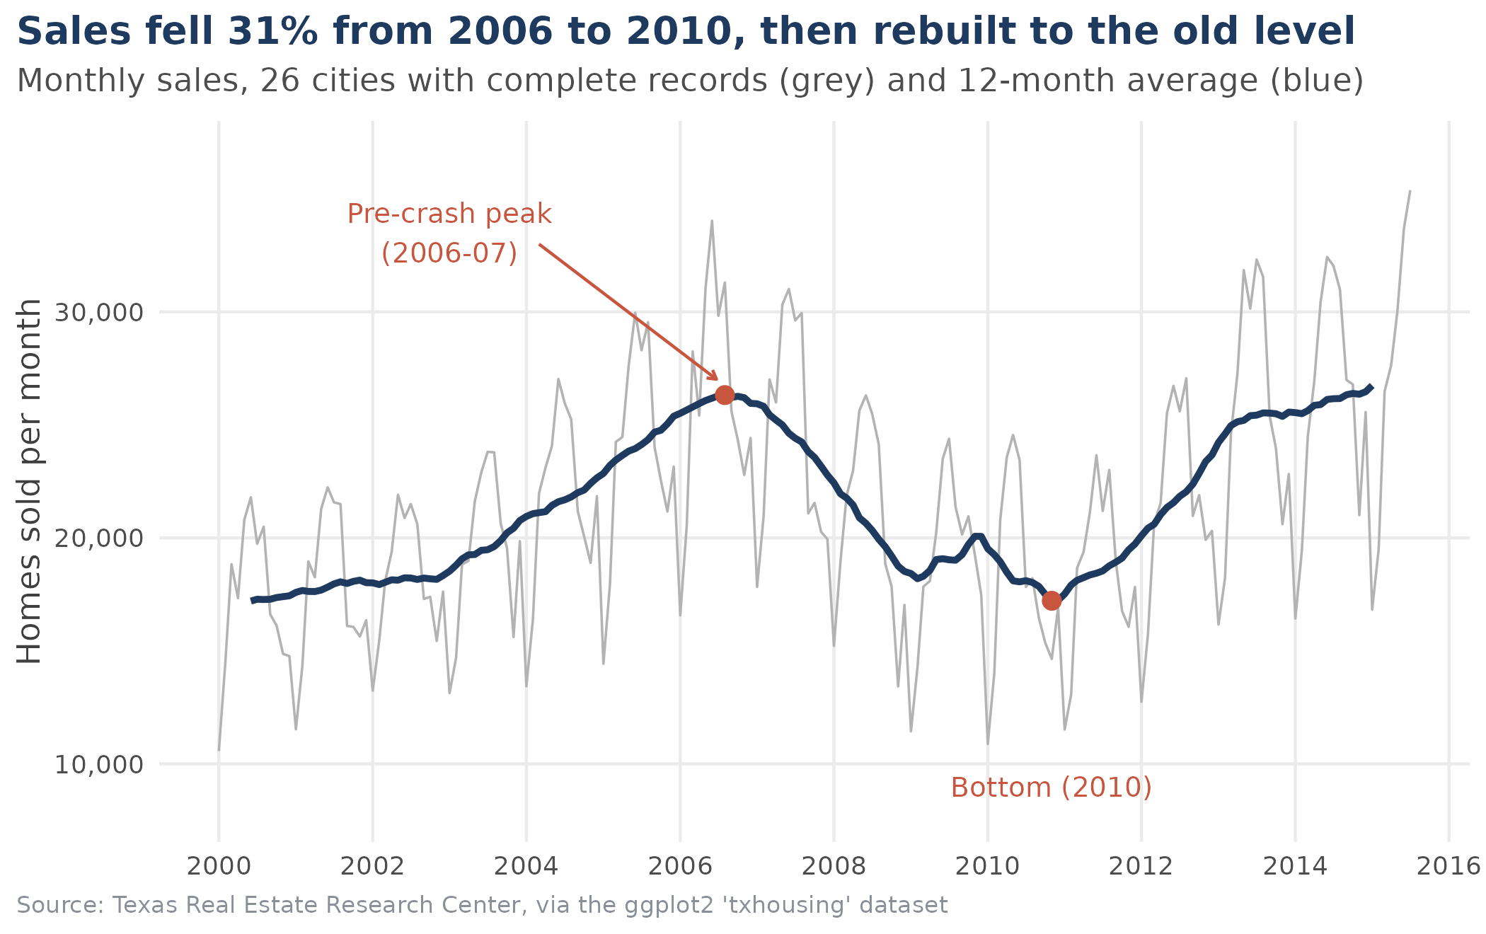
Figure 3. Monthly home sales (grey) and 12-month average (blue) in the 26 markets with complete data.
What it shows. Sales grew steadily from 2000 and peaked around 2006–07 at a 12-month average of about 26,300 sales a month. Then came the downturn: by 2010 the average had fallen to about 17,200. Counted by calendar year, sales in these 26 markets dropped from 314,189 in 2006 to 216,661 in 2010, a fall of 31.0%. Recovery started in 2011 and was steep from 2012. Comparing the same January to July months, 2015 sales were 4.1% above 2014 and 2.1% above 2006, so the market has climbed back to its old peak, though only just.
One thing to keep in mind. What crashed here is the number of sales, not prices. Chart 5 shows that prices in the four largest cities went flat rather than falling. The jagged grey line is the seasonal pattern, which the next chart looks at properly. The last few grey points shoot upwards simply because spring and summer are the busy months.
R CODE
# Use only the 26 cities that report every month, so the line reflects real
# market movement instead of cities appearing and disappearing.
monthly <- housing %>%
filter(city %in% complete_cities) %>%
group_by(year, month) %>%
summarise(sales = sum(sales), .groups = "drop") %>%
mutate(date = as.Date(sprintf("%d-%02d-01", year, month))) %>%
arrange(date)

# 12-month moving average to strip out the seasonal zig-zag
monthly$trend <- as.numeric(stats::filter(monthly$sales, rep(1/12, 12), sides = 2))

low_pt <- monthly %>% filter(year >= 2008 & year <= 2012) %>% slice_min(trend, n = 1)
high_pt <- monthly %>% filter(year <= 2008) %>% slice_max(trend, n = 1)

fig3 <- ggplot(monthly, aes(x = date)) +
geom_line(aes(y = sales), colour = "grey70", linewidth = 0.4) +
geom_line(aes(y = trend), colour = navy, linewidth = 1.1, na.rm = TRUE) +
geom_point(data = high_pt, aes(y = trend), colour = rust, size = 2.5) +
geom_point(data = low_pt, aes(y = trend), colour = rust, size = 2.5) +
annotate("text", x = as.Date("2003-01-01"), y = 33500, colour = rust, size = 3.3,
hjust = 0.5, label = "Pre-crash peak\n(2006-07)") +
annotate("segment", x = as.Date("2004-03-01"), xend = high_pt$date - 40,
y = 33000, yend = high_pt$trend + 700, colour = rust,
arrow = arrow(length = unit(0.12, "cm"))) +
annotate("text", x = low_pt$date, y = 9000, colour = rust, size = 3.3,
label = "Bottom (2010)") +
scale_y_continuous(labels = comma, limits = c(8000, 37000)) +
scale_x_date(breaks = seq(as.Date("2000-01-01"), by = "2 years", length.out = 9),
date_labels = "%Y") +
labs(title = "Sales fell 31% from 2006 to 2010, then rebuilt to the old level",
subtitle = "Monthly sales, 26 cities with complete records (grey) and 12-month average (blue)",
x = NULL, y = "Homes sold per month", caption = src) +
theme_report() +
theme(panel.grid.major.x = element_line(colour = "grey92"))

save_fig(fig3, "fig3_sales_trend")

yearly <- monthly %>% group_by(year) %>% summarise(sales = sum(sales))
cat("Annual sales, 26 complete cities (2015 = Jan-Jul only):\n")
print(as.data.frame(yearly))
peak <- yearly$sales[yearly$year == 2006]; trough <- yearly$sales[yearly$year == 2010]
cat("\n2006 to 2010 change:", percent((trough - peak) / peak, accuracy = 0.1), "\n")
jj <- monthly %>% filter(month <= 7) %>% group_by(year) %>% summarise(s = sum(sales))
cat("Jan-Jul 2015 vs Jan-Jul 2014:",
percent(jj$s[jj$year == 2015] / jj$s[jj$year == 2014] - 1, accuracy = 0.1), "\n")
cat("Jan-Jul 2015 vs Jan-Jul 2006:",
percent(jj$s[jj$year == 2015] / jj$s[jj$year == 2006] - 1, accuracy = 0.1), "\n")
cat("12-month average at the 2006-07 peak:", comma(round(high_pt$trend)),
"sales a month | at the 2010 low:", comma(round(low_pt$trend)), "\n")
CONSOLE OUTPUT
Annual sales, 26 complete cities (2015 = Jan-Jul only):
year sales
1 2000 206455
2 2001 213865
3 2002 218805
4 2003 233401
5 2004 259206
6 2005 287392
7 2006 314189
8 2007 295545
9 2008 247729
10 2009 228938
11 2010 216661
12 2011 221237
13 2012 258666
14 2013 304890
15 2014 313516
16 2015 189581

2006 to 2010 change: -31.0%
Jan-Jul 2015 vs Jan-Jul 2014: 4.1%
Jan-Jul 2015 vs Jan-Jul 2006: 2.1%
12-month average at the 2006-07 peak: 26,319 sales a month | at the 2010 low: 17,217

Chart 4. Is there a seasonal pattern? (boxplot)
Why this chart. The grey line in Chart 3 hinted at a repeating yearly rhythm. A boxplot lets me show, for each calendar month, both the typical value and how much it varied across fifteen years, all in one picture. I converted sales into an index where 1.0 means "an average month of that year", so that good years and bad years can be compared on equal terms. Only full years (2000 to 2014) are used, for the reason given in Section 2.
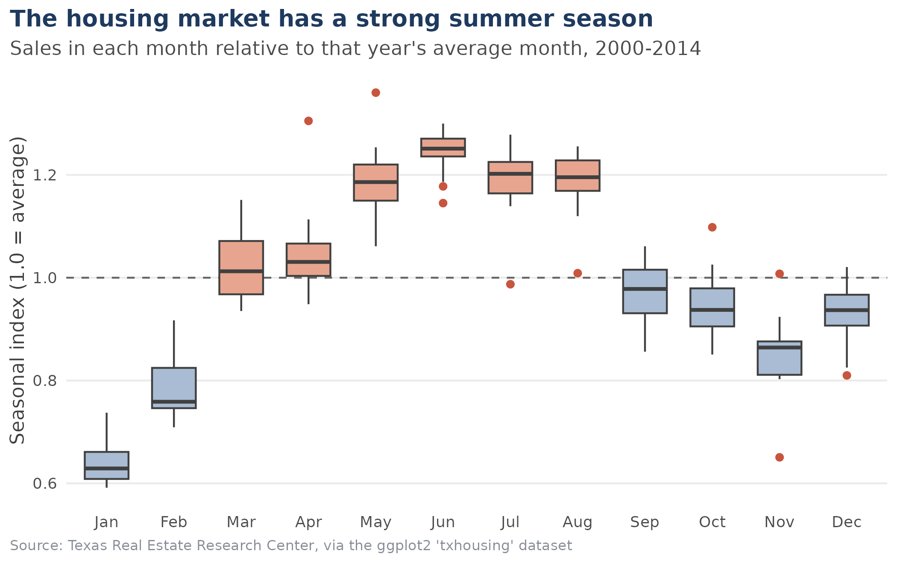
Figure 4. Seasonal index of home sales by calendar month, 2000 to 2014 (1.0 = an average month).
What it shows. The pattern is strong and very consistent. June is the busiest month with a median index of 1.25, and January the quietest at 0.63, so June has almost exactly twice as many sales as January (1.99 times). May to August all sit near 1.2. Activity falls away in September and is lowest in the winter, with November at 0.86 and February at 0.76. The boxes are narrow, meaning the same shape repeated in nearly every year, boom or bust.
The dots are the interesting part. They mark years that broke the pattern. Two stand out. April and May 2010 were unusually strong (index 1.31 and 1.36), and then July 2010 dropped to 0.99, which is low for a summer month. The dataset cannot tell me why, but the timing matches the deadline of a US federal homebuyer tax credit in spring 2010, which would have pulled purchases forward. I treat that as a hypothesis, not a finding. The other is November 2008 at 0.65, the weakest November in the data, which lines up with the financial crisis that autumn.
The practical consequence. A jump in sales from January to June is normal and says nothing about the market getting stronger. This is why I compare January to July with January to July in Chart 8, and why I use a 12-month average in Charts 3 and 5.
R CODE
# Seasonal index: each month's sales divided by that year's monthly average.
# 1.0 = an average month, 1.25 = 25% busier than average.
# Only full years (2000-2014) and the 26 complete cities are used.
season <- housing %>%
filter(city %in% complete_cities, year <= 2014) %>%
group_by(year, month) %>%
summarise(sales = sum(sales), .groups = "drop") %>%
group_by(year) %>%
mutate(index = sales / mean(sales)) %>%
ungroup() %>%
mutate(month_lab = factor(month, levels = 1:12, labels = month.abb))

month_med <- season %>% group_by(month_lab) %>% summarise(med = median(index))
season <- season %>% left_join(month_med, by = "month_lab")

fig4 <- ggplot(season, aes(x = month_lab, y = index, fill = med > 1)) +
geom_hline(yintercept = 1, colour = "grey40", linetype = "dashed") +
geom_boxplot(width = 0.65, colour = "grey25", outlier.colour = rust, outlier.size = 1.6) +
scale_fill_manual(values = c(`TRUE` = "#E7A58F", `FALSE` = "#A9BCD3"), guide = "none") +
scale_y_continuous(breaks = seq(0.6, 1.4, 0.2)) +
labs(title = "The housing market has a strong summer season",
subtitle = "Sales in each month relative to that year's average month, 2000-2014",
x = NULL, y = "Seasonal index (1.0 = average)", caption = src) +
theme_report()

save_fig(fig4, "fig4_seasonality")

cat("Median seasonal index by month:\n")
print(round(setNames(month_med$med, month_med$month_lab), 2))
cat("\nJune vs January (median index):",
round(month_med$med[6] / month_med$med[1], 2), "times as many sales\n")

# Which individual years sit outside the whiskers?
cat("\nUnusual months (outside the box whiskers):\n")
season %>% group_by(month_lab) %>%
filter(index > quantile(index, .75) + 1.5 * IQR(index) |
index < quantile(index, .25) - 1.5 * IQR(index)) %>%
ungroup() %>% transmute(month = month_lab, year, index = round(index, 2)) %>%
as.data.frame() %>% print()
CONSOLE OUTPUT
Median seasonal index by month:
Jan Feb Mar Apr May Jun Jul Aug Sep Oct Nov Dec
0.63 0.76 1.01 1.03 1.19 1.25 1.20 1.20 0.98 0.94 0.86 0.94

June vs January (median index): 1.99 times as many sales

Unusual months (outside the box whiskers):
month year index
1 Jun 2002 1.15
2 Jun 2003 1.18
3 Dec 2007 0.81
4 Nov 2008 0.65
5 Oct 2009 1.10
6 Nov 2009 1.01
7 Apr 2010 1.31
8 May 2010 1.36
9 Jul 2010 0.99
10 Aug 2010 1.01

Chart 5. How did prices move in the biggest cities? (indexed line chart)
Why this chart. Austin and San Antonio start from very different price levels, so plotting dollars would mostly show that Austin is more expensive. To compare growth, I set each city's average 2000 price to 100. A line then reads directly as a percentage of where that city started. I kept to the four largest markets so the chart stays readable, labelled the lines directly instead of using a legend, and used a 12-month average so seasonal wobble does not tangle the lines.
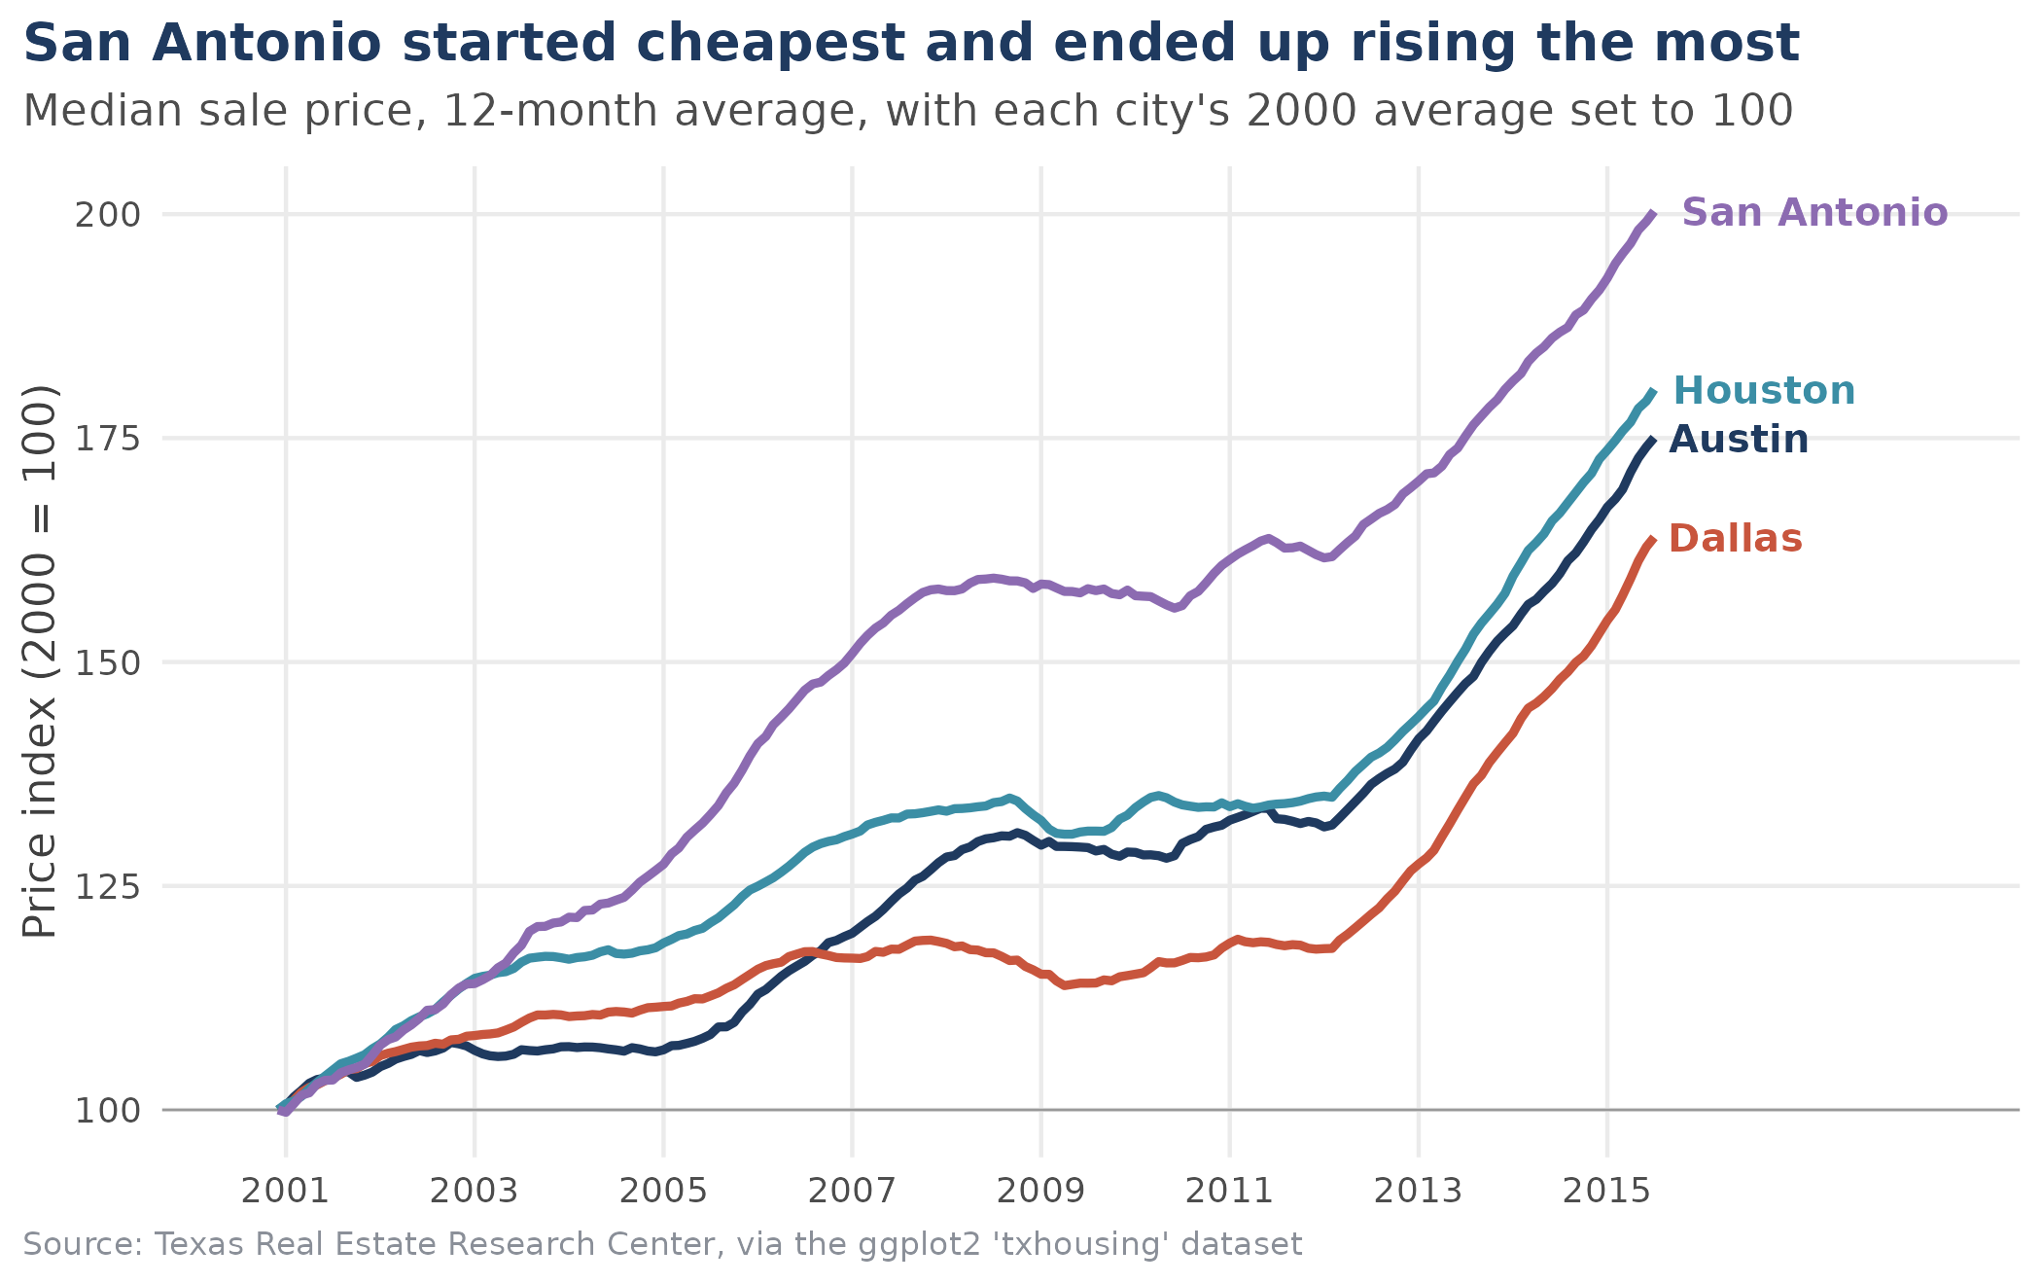
Figure 5. Median sale price in the four largest markets, indexed to each city's 2000 average (=100).
What it shows. By mid-2015 San Antonio's index was 200, meaning prices had doubled since 2000. Houston stood at 180, Austin at 175 and Dallas at 164. San Antonio was the cheapest of the four in 2000 (about $93,000 on average, against about $144,000 in Austin) and gained the most. Much of that lead was built early: it pulled clearly ahead between roughly 2003 and 2008 while the others rose more slowly.
The flat stretch. From about 2008 to 2011 all four lines are close to level. The fall in sales seen in Chart 3 did not bring prices down in these markets; it froze them. From 2012 all four climb steeply, and Dallas, which had been at the bottom for years, is the one moving fastest (see Chart 8).
R CODE
big4 <- c("Austin", "Dallas", "Houston", "San Antonio")

# Put every city on the same starting line: average price in 2000 = 100
base_2000 <- housing %>%
filter(city %in% big4, year == 2000) %>%
group_by(city) %>%
summarise(base = mean(median))

prices <- housing %>%
filter(city %in% big4) %>%
arrange(city, year, month) %>%
left_join(base_2000, by = "city") %>%
group_by(city) %>%
mutate(index = median / base * 100,
smooth = as.numeric(stats::filter(index, rep(1/12, 12), sides = 1)),
date = as.Date(sprintf("%d-%02d-01", year, month))) %>%
ungroup()

end_labels <- prices %>% group_by(city) %>% slice_tail(n = 1)
pal <- c(Austin = navy, Dallas = rust, Houston = "#3B8EA5", `San Antonio` = "#8C6BB1")

fig5 <- ggplot(prices, aes(x = date, y = smooth, colour = city)) +
geom_hline(yintercept = 100, colour = "grey60", linewidth = 0.3) +
geom_line(linewidth = 1.05, na.rm = TRUE) +
geom_text(data = end_labels, aes(label = city), hjust = -0.1, size = 3.4,
fontface = "bold", show.legend = FALSE) +
scale_colour_manual(values = pal, guide = "none") +
scale_x_date(breaks = seq(as.Date("2001-01-01"), by = "2 years", length.out = 8),
date_labels = "%Y", expand = expansion(mult = c(0.02, 0.25))) +
labs(title = "San Antonio started cheapest and ended up rising the most",
subtitle = "Median sale price, 12-month average, with each city's 2000 average set to 100",
x = NULL, y = "Price index (2000 = 100)", caption = src) +
theme_report() +
theme(panel.grid.major.x = element_line(colour = "grey92"))

save_fig(fig5, "fig5_big_four_prices")

cat("Price index at latest reading (Jul 2015, 12-mo average; 100 = 2000 level):\n")
print(end_labels %>% ungroup() %>% mutate(index = round(smooth)) %>%
select(city, index) %>% as.data.frame())
cat("\nMedian sale price, Jan-Jul 2015 (average of monthly medians):\n")
print(housing %>% filter(city %in% big4, year == 2015) %>% group_by(city) %>%
summarise(price = dollar(mean(median))) %>% as.data.frame())
cat("\nMedian sale price, full-year 2000 (average of monthly medians):\n")
print(base_2000 %>% mutate(base = dollar(base)) %>% as.data.frame())
CONSOLE OUTPUT
Price index at latest reading (Jul 2015, 12-mo average; 100 = 2000 level):
city index
1 Austin 175
2 Dallas 164
3 Houston 180
4 San Antonio 200

Median sale price, Jan-Jul 2015 (average of monthly medians):
city price
1 Austin $259,000
2 Dallas $227,271
3 Houston $208,471
4 San Antonio $190,543

Median sale price, full-year 2000 (average of monthly medians):
city base
1 Austin $143,925
2 Dallas $133,758
3 Houston $113,283
4 San Antonio $93,208

Chart 6. Do more listings mean more sales? (scatter plot with trend line)
Why this chart. A scatter plot is the right tool when I want to see whether two measurements move together: does a market with more homes for sale also sell more homes? I used a log scale on both axes because market sizes range from a few dozen sales a month to several thousand. On an ordinary scale nearly every point would be crushed into the bottom-left corner. On a log scale, equal distances mean equal percentage changes, so a straight line means proportional growth.
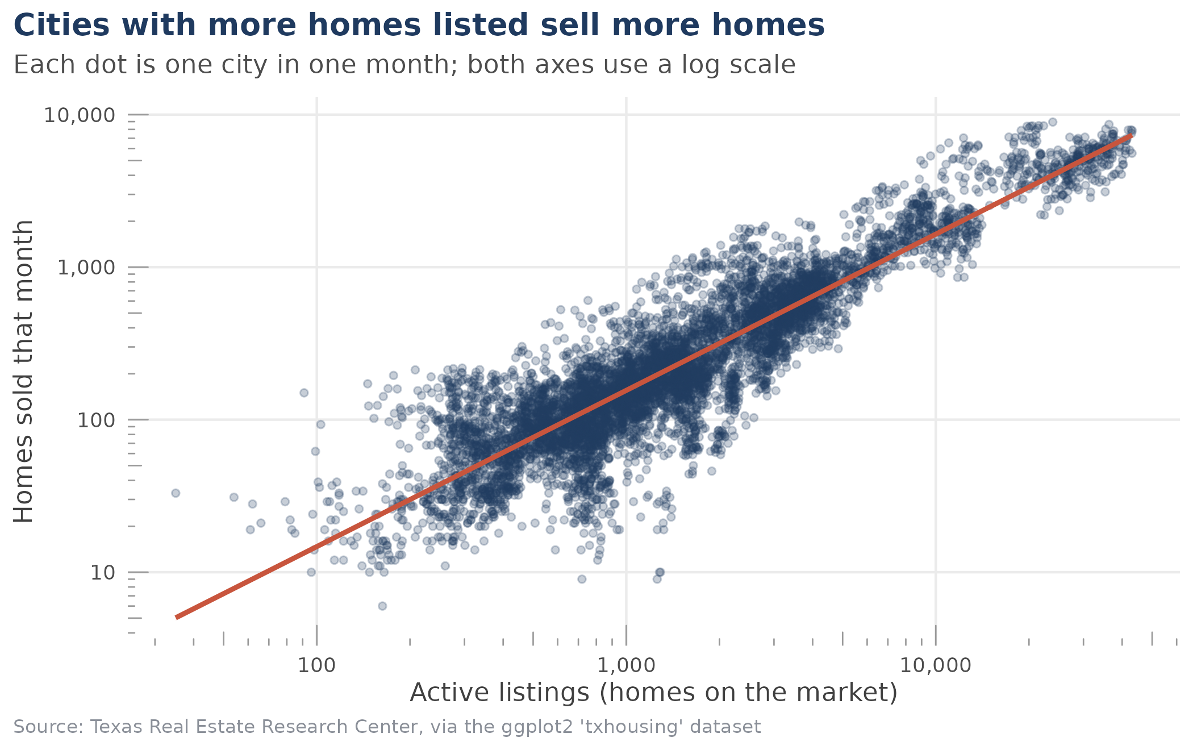
Figure 6. Active listings against homes sold, one dot per market per month (log scales).
What it shows. The relationship is tight. Across 7,175 city-months the correlation on the log scale is 0.90, and listings alone account for about 82% of the variation in sales (R² = 0.817). The slope is 1.02, close to 1, which in plain terms means sales grow roughly one-for-one with listings: about double the listings goes with about double the sales. The fitted line predicts about 156 sales a month for a market with 1,000 listings and about 1,646 for one with 10,000.
How I read it. Market size drives most of this pattern. It does not mean that adding listings creates sales; bigger cities just have more of both. The more interesting part is the spread around the line. Two markets with the same number of listings can have quite different sales, and that gap between listings and sales is exactly what the "months of inventory" variable measures. Which leads to the next chart.
R CODE
# One dot per city-month. Both axes on a log scale because city sizes
# range from tiny (dozens of sales) to huge (thousands).
pairs_df <- housing %>% filter(!is.na(sales), !is.na(listings), listings > 0)

fit <- lm(log10(sales) ~ log10(listings), data = pairs_df)

fig6 <- ggplot(pairs_df, aes(x = listings, y = sales)) +
geom_point(alpha = 0.25, size = 1.2, colour = navy) +
geom_smooth(method = "lm", formula = y ~ x, colour = rust, fill = rust,
alpha = 0.15, linewidth = 1) +
scale_x_log10(labels = comma) +
scale_y_log10(labels = comma) +
annotation_logticks(sides = "bl", colour = "grey60", size = 0.3) +
labs(title = "Cities with more homes listed sell more homes",
subtitle = "Each dot is one city in one month; both axes use a log scale",
x = "Active listings (homes on the market)", y = "Homes sold that month",
caption = src) +
theme_report() +
theme(panel.grid.major.x = element_line(colour = "grey92"))

save_fig(fig6, "fig6_listings_vs_sales")

cat("Observations used:", comma(nrow(pairs_df)), "\n")
cat("Correlation (log scale):",
round(cor(log10(pairs_df$listings), log10(pairs_df$sales)), 3), "\n")
cat("R-squared:", round(summary(fit)$r.squared, 3), "\n")
cat("Slope on log-log scale:", round(coef(fit)[2], 3), "\n")
cat("Example: a city with 1,000 listings is predicted to sell about",
round(10^predict(fit, data.frame(listings = 1000))), "homes a month;\n",
"with 10,000 listings, about", round(10^predict(fit, data.frame(listings = 10000))), "\n")
CONSOLE OUTPUT
Observations used: 7,175
Correlation (log scale): 0.904
R-squared: 0.817
Slope on log-log scale: 1.024
Example: a city with 1,000 listings is predicted to sell about 156 homes a month;
with 10,000 listings, about 1646

Chart 7. Does the number of unsold homes connect to price? (faceted scatter plot)
Why this chart. Months of inventory is a standard way to describe whether it is a buyers' or a sellers' market: a low number means homes sell quickly. I wanted to check whether it relates to price, and whether that relationship stayed the same over the period. Splitting the data into three panels (steady growth, downturn, recovery) shows change over time without needing an animation. Inventory is on a log scale here too, because a handful of extreme values would otherwise squash everything else.
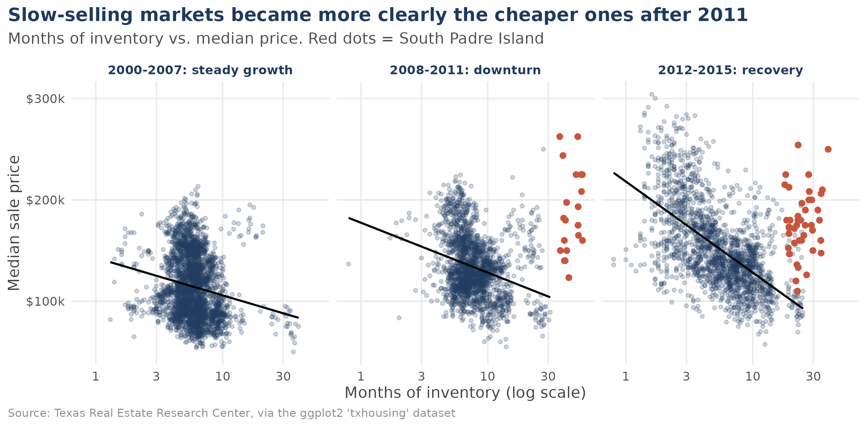
Figure 7. Months of inventory against median price, split into three periods. Red dots are South Padre Island.
What it shows. In every period, markets with fewer months of inventory tended to have higher prices, and the link got stronger over time. The correlation between log inventory and price was −0.18 in 2000–2007, −0.28 in 2008–2011 and −0.59 in 2012–2015. The statewide picture behind this: the median market had 5.3 months of inventory in 2006, 8.1 in 2011, and about 4.4 in the first seven months of 2015. So the market tightened sharply after 2011, and the price gap between tight and loose markets became much clearer.
An anomaly I chose not to hide. The red dots are South Padre Island, which holds the five highest inventory readings in the entire dataset. The worst was November 2010: 10 sales against 1,280 listings, which is 55.9 months of inventory, compared with a typical reading of 6.2 months. Its prices were not especially low, so it does not follow the pattern of the other markets. My guess is that it is a resort-type market where many listed homes are second homes or long-term listings that rarely sell, but the data cannot confirm that. I kept the points on the chart but left them out of the trend lines and correlations, so that one small market does not drag the results.
Association, not cause. Expensive metro areas were also the places with the strongest demand, so this chart shows the two moving together. It does not prove that low inventory pushes prices up.
R CODE
# 'inventory' = months of inventory: how many months it would take to sell
# every listed home at the current pace. Low = sellers' market.
inv_df <- housing %>%
filter(!is.na(inventory), !is.na(median), inventory > 0) %>%
mutate(period = cut(year, breaks = c(1999, 2007, 2011, 2015),
labels = c("2000-2007: steady growth",
"2008-2011: downturn",
"2012-2015: recovery")),
spi = city == "South Padre Island")

fig7 <- ggplot(inv_df, aes(x = inventory, y = median)) +
geom_point(data = filter(inv_df, !spi), alpha = 0.22, size = 1, colour = navy) +
geom_point(data = filter(inv_df, spi), colour = rust, size = 1.6) +
geom_smooth(data = filter(inv_df, !spi), method = "lm", formula = y ~ x,
se = FALSE, colour = "black", linewidth = 0.7) +
facet_wrap(~ period) +
scale_x_log10(breaks = c(1, 3, 10, 30), labels = c("1", "3", "10", "30")) +
scale_y_continuous(labels = dollar_format(scale = 1/1000, suffix = "k")) +
labs(title = "Slow-selling markets became more clearly the cheaper ones after 2011",
subtitle = "Months of inventory vs. median price. Red dots = South Padre Island",
x = "Months of inventory (log scale)", y = "Median sale price", caption = src) +
theme_report() +
theme(panel.grid.major.x = element_line(colour = "grey92"),
plot.subtitle = element_text(colour = "grey30", margin = margin(b = 8)))

save_fig(fig7, "fig7_inventory_vs_price", w = 8.5, h = 4.2)

cat("Correlation between log(inventory) and price, excluding South Padre Island:\n")
inv_df %>% filter(!spi) %>% group_by(period) %>%
summarise(r = round(cor(log10(inventory), median), 2), n = n()) %>%
as.data.frame() %>% print()
cat("\nMedian months of inventory by year, all cities:\n")
print(housing %>% group_by(year) %>% summarise(months = median(inventory, na.rm = TRUE)) %>%
as.data.frame())
cat("\nThe five highest inventory readings in the data:\n")
print(housing %>% arrange(desc(inventory)) %>% slice_head(n = 5) %>%
select(city, year, month, sales, listings, inventory) %>% as.data.frame())
cat("\nTypical reading (median):", median(housing$inventory, na.rm = TRUE),
"months | 99th percentile:", quantile(housing$inventory, 0.99, na.rm = TRUE), "months\n")
CONSOLE OUTPUT
Correlation between log(inventory) and price, excluding South Padre Island:
period r n
1 2000-2007: steady growth -0.18 3115
2 2008-2011: downturn -0.28 2028
3 2012-2015: recovery -0.59 1920

Median months of inventory by year, all cities:
year months
1 2000 5.70
2 2001 5.90
3 2002 5.60
4 2003 6.20
5 2004 6.20
6 2005 5.60
7 2006 5.30
8 2007 5.90
9 2008 6.50
10 2009 7.30
11 2010 7.80
12 2011 8.10
13 2012 7.10
14 2013 5.40
15 2014 4.80
16 2015 4.35

The five highest inventory readings in the data:
city year month sales listings inventory
1 South Padre Island 2010 11 10 1280 55.9
2 South Padre Island 2011 1 9 1258 55.7
3 South Padre Island 2010 5 23 1396 54.9
4 South Padre Island 2010 4 26 1403 54.5
5 South Padre Island 2010 8 27 1340 52.0

Typical reading (median): 6.2 months | 99th percentile: 26.4 months

Chart 8. Did prices rise everywhere? (lollipop chart)
Why this chart. After following four big cities, I wanted to know whether their story is typical. A lollipop chart is a cleaner alternative to a 46-bar chart: each city gets a dot on a thin line, and the eye only has to compare dot positions along one axis. I sorted it by size of change so the ranking is immediate, and used a second colour for the cities where prices fell. To keep the comparison fair I compared January to July 2010 with January to July 2015, because 2015 only runs to July and putting a partial year against a full one could mix in seasonal differences.
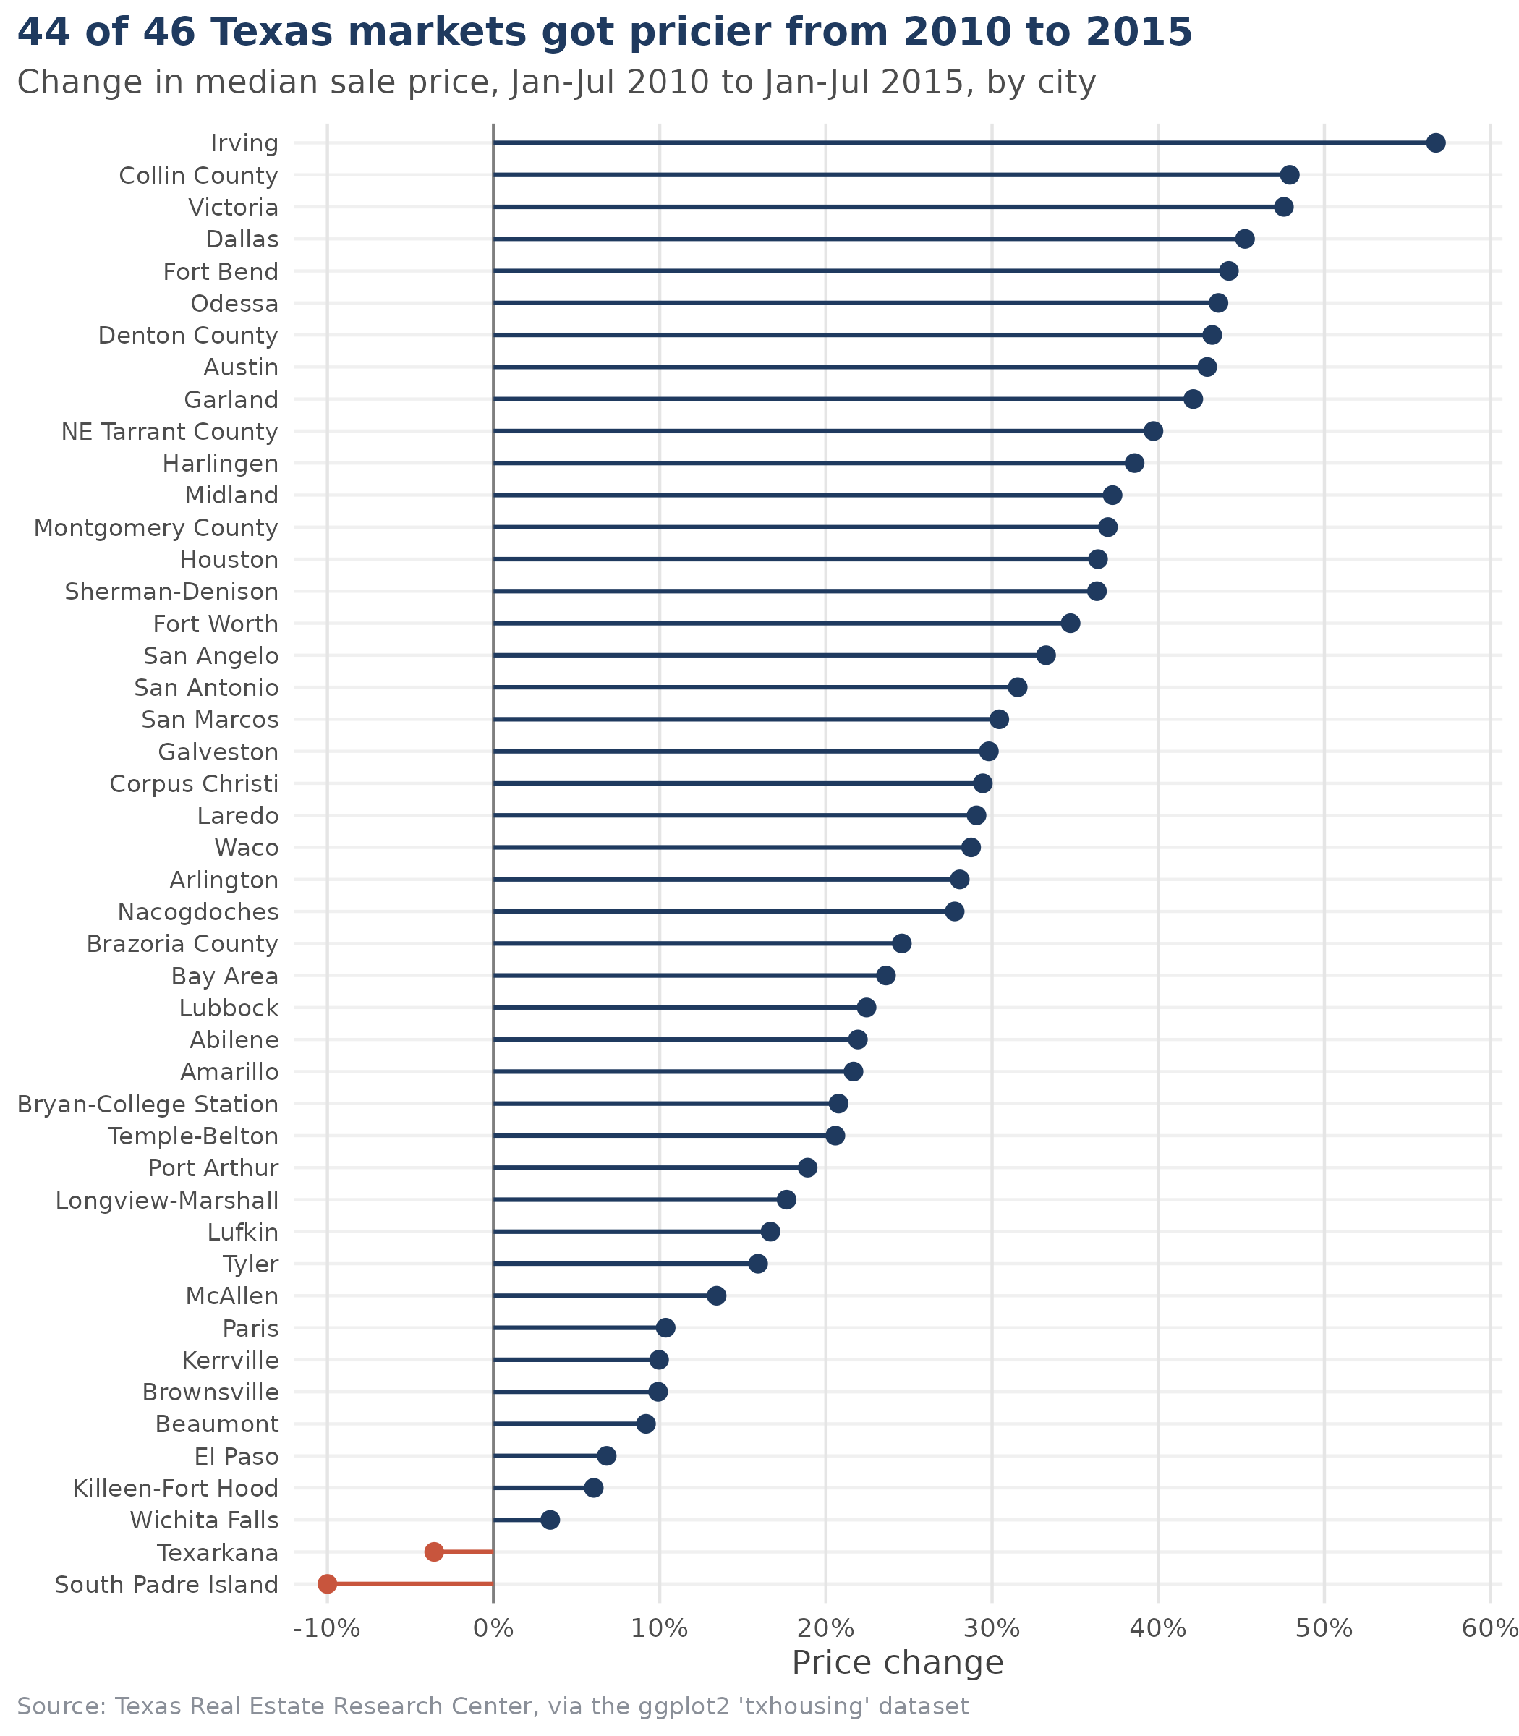
Figure 8. Change in median sale price between Jan–Jul 2010 and Jan–Jul 2015, by market.
What it shows. Prices rose in 44 of 46 markets, and the median market gained 28.4%. The biggest gains were Irving (+56.7%, from $140,000 to $219,400), Collin County (+47.9%), Victoria (+47.6%), Dallas (+45.2%) and Fort Bend (+44.3%). Suburbs of Dallas–Fort Worth and Houston cluster near the top. At the other end, Wichita Falls (+3.4%), Killeen–Fort Hood (+6.0%) and El Paso (+6.8%) barely moved, and two markets went backwards: Texarkana (−3.6%) and South Padre Island (−10.0%), the same market behind the anomaly in Chart 7.
How it changes the story from Chart 5. Since 2000, San Antonio gained the most of the four big cities. Since 2010 it gained the least: 31.5%, against 36.4% for Houston, 42.9% for Austin and 45.2% for Dallas. The two charts answer different questions, and which city looks like the winner depends on where you start the clock. Odessa and Midland are also well above the 28.4% median, which may be linked to the West Texas oil boom, although nothing in this data says so.
R CODE
# Compare the same seven months (Jan-Jul) in 2010 and 2015. 2015 only has
# data up to July and prices rise in summer, so using full-year 2010 against
# partial-year 2015 would flatter the growth figure.
window_price <- function(yr) {
housing %>%
filter(year == yr, month <= 7) %>%
group_by(city) %>%
summarise(price = median(median, na.rm = TRUE),
n_ok = sum(!is.na(median)), .groups = "drop") %>%
filter(n_ok >= 5) %>%
select(city, price)
}

growth <- inner_join(window_price(2010), window_price(2015),
by = "city", suffix = c("_2010", "_2015")) %>%
mutate(change = price_2015 / price_2010 - 1,
direction = ifelse(change >= 0, "up", "down")) %>%
arrange(change) %>%
mutate(city = factor(city, levels = city))

fig8 <- ggplot(growth, aes(x = change, y = city, colour = direction)) +
geom_vline(xintercept = 0, colour = "grey50") +
geom_segment(aes(x = 0, xend = change, yend = city), linewidth = 0.7) +
geom_point(size = 2.4) +
scale_colour_manual(values = c(up = navy, down = rust), guide = "none") +
scale_x_continuous(labels = percent_format(accuracy = 1), breaks = seq(-0.1, 0.6, 0.1),
expand = expansion(mult = c(0.03, 0.06))) +
labs(title = "44 of 46 Texas markets got pricier from 2010 to 2015",
subtitle = "Change in median sale price, Jan-Jul 2010 to Jan-Jul 2015, by city",
x = "Price change", y = NULL, caption = src) +
theme_report() +
theme(panel.grid.major.y = element_line(colour = "grey94"),
panel.grid.major.x = element_line(colour = "grey90"),
axis.text.y = element_text(size = 8))

save_fig(fig8, "fig8_price_growth", w = 7, h = 8)

cat("Cities compared:", nrow(growth), "\n")
cat("Cities where prices rose:", sum(growth$change > 0), "| fell:", sum(growth$change < 0), "\n")
cat("Median change across cities:", percent(median(growth$change), accuracy = 0.1), "\n\n")
cat("Biggest increases:\n")
print(growth %>% arrange(desc(change)) %>% slice_head(n = 5) %>%
transmute(city = as.character(city), from = dollar(price_2010),
to = dollar(price_2015), change = percent(change, accuracy = 0.1)) %>%
as.data.frame())
cat("\nSmallest changes / declines:\n")
print(growth %>% slice_head(n = 5) %>%
transmute(city = as.character(city), from = dollar(price_2010),
to = dollar(price_2015), change = percent(change, accuracy = 0.1)) %>%
as.data.frame())

cat("\nThe four biggest markets, same comparison:\n")
print(growth %>% filter(city %in% c("Austin", "Dallas", "Houston", "San Antonio")) %>%
arrange(desc(change)) %>%
transmute(city = as.character(city), from = dollar(price_2010),
to = dollar(price_2015), change = percent(change, accuracy = 0.1)) %>%
as.data.frame())
CONSOLE OUTPUT
Cities compared: 46
Cities where prices rose: 44 | fell: 2
Median change across cities: 28.4%

Biggest increases:
city from to change
1 Irving $140,000 $219,400 56.7%
2 Collin County $197,000 $291,400 47.9%
3 Victoria $116,900 $172,500 47.6%
4 Dallas $160,100 $232,500 45.2%
5 Fort Bend $191,400 $276,100 44.3%

Smallest changes / declines:
city from to change
1 South Padre Island $200,000 $180,000 -10.0%
2 Texarkana $112,000 $108,000 -3.6%
3 Wichita Falls $96,700 $100,000 3.4%
4 Killeen-Fort Hood $121,900 $129,250 6.0%
5 El Paso $132,200 $141,200 6.8%

The four biggest markets, same comparison:
city from to change
1 Dallas $160,100 $232,500 45.2%
2 Austin $185,100 $264,600 42.9%
3 Houston $152,300 $207,700 36.4%
4 San Antonio $143,300 $188,500 31.5%

4. What the charts say together
- The market is concentrated. Houston and Dallas account for 42% of all recorded sales, so statewide numbers mostly describe those two (Charts 1 and 2).
- The crash was in volume more than in price. Sales fell 31% between 2006 and 2010, but prices in the biggest cities went flat rather than dropping. By 2015 sales were back at their 2006 level (Charts 3 and 5).
- Timing matters. June has about twice the sales of January, every year. Comparing different months, or a partial year with a full one, gives wrong answers (Chart 4).
- Growth was broad but uneven. Prices rose in 44 of 46 markets between 2010 and 2015, with the biggest gains in the Dallas and Houston areas. San Antonio led the four big cities since 2000 but trailed since 2010 (Charts 5 and 8).
- Tight markets carry higher prices, more so after 2011. Months of inventory fell from 8.1 to about 4.4 and its link with price strengthened. South Padre Island is a clear outlier (Charts 6 and 7).

5. Limits of this analysis
- The data holds medians and counts only. It says nothing about the size, age or type of the homes sold, so a rising median can partly reflect a change in what is being sold.
- Prices are in nominal dollars. US consumer prices rose by very roughly a third to two-fifths over 2000–2015, so real gains are noticeably smaller than the ones shown.
- Several markets have large gaps, and the trend and seasonality charts leave out 20 of the 46 markets for that reason. Smaller markets may behave differently.
- Everything here is observational. The explanations I offer for the 2008 and 2010 anomalies, the oil towns and South Padre Island are guesses that fit the timing, not results from the data.
If I had more time I would adjust prices for inflation, bring in population or income figures to compare cities fairly, and draw a map of the 2010–2015 price change to see the geography of Chart 8 directly.

6. Reproducing the work
The code blocks above are the exact code I ran, in order. A single file, analysis_full.R, contains all of them joined together. It needs R and the packages ggplot2, dplyr, tidyr and scales. Run it from an empty folder and it recreates the eight charts as 300 dpi PNG images in a figs folder. The dataset ships inside ggplot2, so nothing has to be downloaded.

