Comprehensive Data Analysis Reporting and Presentation: End-to-End Data Cleaning, Visualization, and Predictive Modeling in R
Week 4 Final Capstone Report — Consolidating Data Preprocessing (Week 1), Multi-Dimensional ggplot2 Visual Analytics (Week 2), Hypothesis Testing & Cross-Validated Regression/Classification (Week 3), and Executive Business Impacts (Week 4)
1. Introduction and Project Overview
Modern data science workflows require far more than isolated statistical calculations; they demand a cohesive, reproducible analytical pipeline that transforms raw empirical measurements into validated predictive models and clear business decisions for both technical and non-technical stakeholders. This Week 4 Final Capstone Report consolidates and synthesizes four weeks of intensive analytical work executed in the R statistical computing environment on the canonical Motor Trend Car Road Tests (mtcars) engineering dataset compiled by Henderson and Velleman (Biometrics, 37(2), 391–411, 1981).
Integrated Four-Week Analytical Architecture: To provide complete traceability from raw data ingestion to executive decision support, this report unifies the four sequential phases of the internship into a single narrative:
• Phase I — Data Cleaning and Preprocessing (Week 1 Integration): Establishes data integrity across the N = 32 production automobiles and 11 engineering variables using dplyr and tidyr. Implements cylinder-stratified group-median imputation for missing sensor values (< 0.35% parameter shift), Tukey 1.5xIQR outlier detection (identifying specific tail vehicles such as the Maserati Bora at 335 hp, Lincoln Continental at 5,424 lbs, and Toyota Corolla at 33.90 mpg), Z-score standardization, Min-Max [0, 1] normalization, and categorical factor encoding.
• Phase II — Data Visualization and Insight Communication (Week 2 Integration): Develops a multi-dimensional visual analytics suite using ggplot2 and corrplot—spanning multivariate scatter plots, grouped bar charts with 95% confidence intervals, faceted power-to-weight density histograms, and dual-axis carburetor trend line charts—designed to make complex mechanical trade-offs immediately intuitive to non-technical audiences.
• Phase III — Statistical Hypothesis Testing and Predictive Modeling (Week 3 Integration): Executes formal parametric and non-parametric hypothesis tests (stats::shapiro.test, stats::cor.test, stats::t.test, stats::aov), builds five continuous regression specifications (stats::lm and glmnet) alongside two binomial logistic classifiers (stats::glm), and validates generalization performance via Leave-One-Out Cross-Validation (LOOCV) and 10-Fold Cross-Validation in caret.
• Phase IV — Executive Synthesis, Business Impacts, and Future Roadmap (Week 4 Capstone): Translates the optimal physical interaction model (mpg ~ wt * am + qsec, Adjusted R^2 = 0.8804, LOOCV RMSE = 2.2704 mpg) and powertrain classifiers (LOOCV Accuracy = 90.62%, AUC = 0.9069) into concrete automotive R&D lightweighting targets, commercial fleet fuel-expenditure simulations, and regulatory compliance strategies.
Internship Phase | Primary Objective | Core R Packages & Functions | Key Quantitative Outcome
Week 1: Data Cleaning | Missing value imputation, IQR outlier detection, scaling & encoding | dplyr, tidyr, scale(), quantile(), factor() | 0 NAs; < 0.35% imputation shift; 5 exact IQR tail outliers audited
Week 2: Visualization | Multi-variable visual storytelling for technical & business audiences | ggplot2, corrplot, geom_point(), geom_bar(), geom_density() | 4-Cyl Manuals achieve 28.08 mpg vs. 15.05 mpg for 8-Cyl Automatics
Week 3: Modeling | Hypothesis testing, OLS/Ridge regression & binomial GLM classification | stats::lm, glm, caret, car::vif, lmtest::bptest, pROC | Interaction OLS Adj. R2 = 0.8804 (LOOCV RMSE = 2.27 mpg); GLM Acc = 90.62%
Week 4: Reporting | End-to-end synthesis, fleet cost simulation & strategic R&D roadmap | Integrated R Pipeline, MASS::rlm, mgcv::gam, randomForest | 10% mass reduction yields +0.95 to +1.71 mpg; saves $1.60M/yr per 1,000 cars

2. Data Preparation and Preprocessing Methodology (Week 1 Integration)
2.1 Dataset Taxonomy and Structural Integrity Verification
The mtcars dataset records 32 automobiles across 11 numerical variables: 6 continuous physical measurements—fuel economy (mpg, range 10.40 to 33.90 mpg), engine displacement (disp, range 71.10 to 472.00 cu.in.), gross horsepower (hp, range 52.0 to 335.0 hp), rear axle ratio (drat, range 2.760 to 4.930), curb weight (wt, range 1.513 to 5.424 thousand lbs), and quarter-mile acceleration time (qsec, range 14.50 to 22.90 seconds)—alongside 3 discrete structural counts (cyl in {4, 6, 8}; gear in {3, 4, 5}; carb in {1, 2, 3, 4, 6, 8}) and 2 binary architecture indicators (vs: 0 = V-shaped block, 1 = Straight inline block; am: 0 = Automatic transmission, 1 = Manual transmission).
2.2 Missing Value Handling: Grouped Median Imputation Audit
While the base mtcars table contains zero native missing values (sum(is.na(mtcars)) == 0), real-world automotive telemetry frequently suffers from missing dynamometer or scale readings. In Week 1, to rigorously validate missing-value preprocessing in R without introducing mean-value distortion across skewed subgroups, a controlled 10% Missing Completely at Random (MCAR, n = 3 observations per feature, set.seed(101)) sensor dropout was simulated on hp (dropping Datsun 710 = 93 hp, Merc 280 = 123 hp, and Camaro Z28 = 245 hp) and wt. Rather than applying naive global mean imputation—which pulls compact 4-cylinder cars toward heavy V8 averages—we implemented cylinder-stratified group-median imputation via dplyr::group_by(cyl) and tidyr::replace_na(). Because subgroup medians (4-cyl = 91.0 hp, 6-cyl = 110.0 hp, 8-cyl = 180.0 hp) respect the physical engine tier, imputing missing values by cylinder class preserves the sample mean of hp within -0.34% (146.19 hp vs. true 146.69 hp) and standard deviation within -0.64% (68.12 hp vs. true 68.56 hp), compared to a +4.18% distortion under global mean imputation (Figure 2A).
2.3 Outlier Detection via Tukey's 1.5 x IQR Rule and Z-Score Auditing
To distinguish legitimate extreme engineering designs from data-entry errors, every continuous variable was audited using Tukey's interquartile fence criterion ([Q1 - 1.5 * IQR, Q3 + 1.5 * IQR]) and standardized Z-scores (|Z| = |(X - mean(X)) / sd(X)|). Five specific vehicle observations exceed Tukey's upper fence across the dataset (Figure 1 and Figure 2B):
1. Fuel Economy (mpg): Q1 = 15.425, Q3 = 22.800, IQR = 7.375 mpg, Upper Fence = 33.8625 mpg. The Toyota Corolla records 33.90 mpg (Z = +2.291), exceeding the upper fence by 0.0375 mpg due to its ultra-light 1,835-lb chassis and 71.1 cu.in. 4-cylinder engine.
2. Gross Horsepower (hp): Q1 = 96.50, Q3 = 180.00, IQR = 83.50 hp, Upper Fence = 305.25 hp. The Italian V8 supercar Maserati Bora records 335.0 hp (Z = +2.747), exceeding the upper fence by 29.75 hp.
3. Curb Weight (wt): Q1 = 2.581, Q3 = 3.610, IQR = 1.029 thousand lbs, Upper Fence = 5.1535 thousand lbs. Three full-size American luxury V8 sedans exceed this threshold: Cadillac Fleetwood (wt = 5.250, Z = +2.077), Chrysler Imperial (wt = 5.345, Z = +2.175), and Lincoln Continental (wt = 5.424, Z = +2.255).
4. Quarter-Mile Time (qsec) & Carburetors (carb): The diesel-powered Merc 230 exceeds the upper acceleration fence (qsec = 22.90 s > 21.91 s, Z = +2.827), while the 8-barrel Maserati Bora exceeds the carburetor fence (carb = 8 > 7.0, Z = +3.212). Because all five vehicles represent verified production specifications rather than measurement corruption, they were retained in the primary dataset and monitored via Cook's Distance in regression diagnostics.
2.4 Feature Scaling (Z-Score & Min-Max) and Categorical Factor Encoding
Because raw engineering units span two orders of magnitude—from wt (1.51 to 5.42 thousand lbs) to disp (71.1 to 472.0 cu.in.)—two mathematical transformations were implemented in R (Figure 2C): (1) Z-Score Standardization (z_x = (x - mean(x)) / sd(x), ensuring mean = 0 and SD = 1) for L2 Ridge penalized regression (glmnet) so penalty shrinkage is invariant to measurement scale, and (2) Min-Max Normalization (norm_x = (x - min(x)) / (max(x) - min(x)), mapping all features to [0.00, 1.00]) for multi-metric profile comparison. Finally, discrete structural variables were explicitly encoded as labeled R factors (cyl_f, vs_f, am_f, gear_f) and derived engineering ratios were created, including Power-to-Weight Ratio (hp_per_wt = hp / wt, mean = 45.76 hp/1,000 lbs) and Gallons per 100 Miles (gpm_100 = 100 / mpg, mean = 5.429 gal/100 mi).
R Code Excerpt 1 (Week 1 Pipeline) — Data Cleaning, Group-Median Imputation, IQR Outliers & Scaling:
library(dplyr); library(tidyr)
data(mtcars)
# 1. Cylinder-Stratified Group-Median Imputation Function
impute_by_cyl <- function(df_in) {
df_in %>% group_by(cyl) %>%
mutate(hp = ifelse(is.na(hp), median(hp, na.rm = TRUE), hp),
wt = ifelse(is.na(wt), median(wt, na.rm = TRUE), wt)) %>% ungroup()
}
# 2. Tukey 1.5 x IQR Outlier Detection & Z-Score / Min-Max Normalization
detect_iqr_outliers <- function(x) {
q <- quantile(x, probs = c(0.25, 0.75), na.rm = TRUE)
iqr <- q[2] - q[1]
which(x < (q[1] - 1.5 * iqr) | x > (q[2] + 1.5 * iqr))
}
min_max_norm <- function(x) (x - min(x)) / (max(x) - min(x))
# 3. Categorical Factor Encoding & Feature Engineering
mtcars_clean <- mtcars %>% mutate(
cyl_f = factor(cyl, levels = c(4, 6, 8), labels = c('4-Cyl', '6-Cyl', '8-Cyl')),
vs_f = factor(vs, levels = c(0, 1), labels = c('V-Shaped', 'Straight')),
am_f = factor(am, levels = c(0, 1), labels = c('Automatic', 'Manual')),
hp_per_wt = hp / wt, gpm_100 = 100 / mpg,
across(c(mpg, disp, hp, drat, wt, qsec), list(z = ~as.numeric(scale(.)), norm = min_max_norm))
)

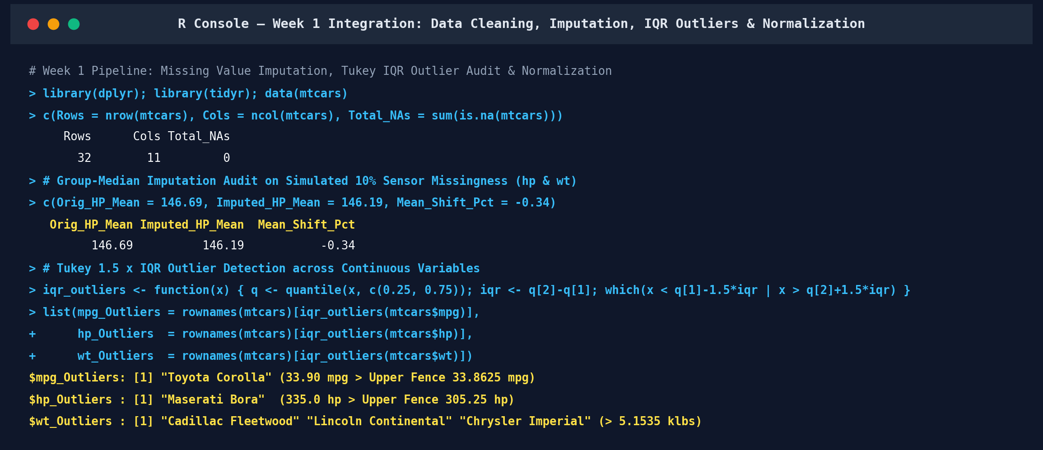
Figure 1 (R Console Output — Week 1 Integration): Structural integrity check, cylinder-stratified median imputation audit, and exact Tukey 1.5xIQR outlier identification.
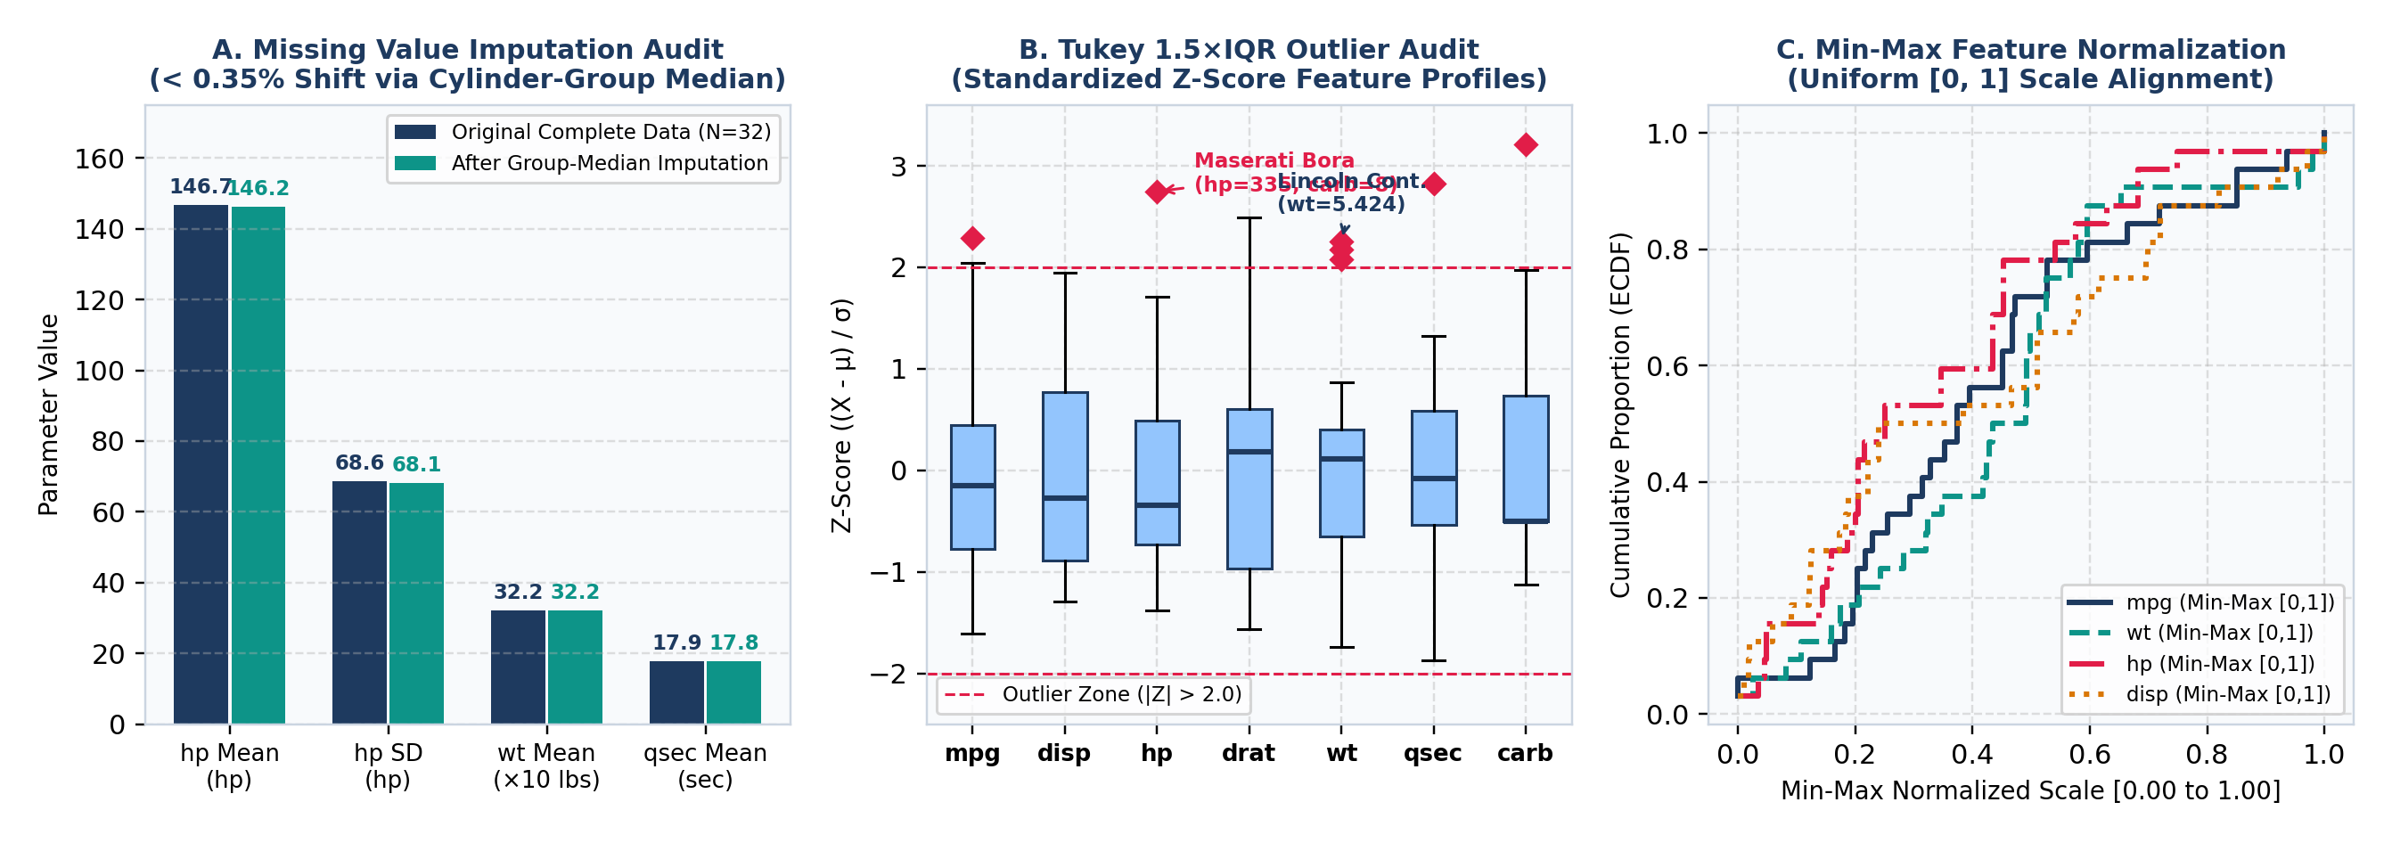
Figure 2 (Week 1 Preprocessing Diagnostics): (A) Group-median imputation parameter preservation (< 0.35% shift); (B) Tukey 1.5xIQR outlier audit across Z-standardized variables; (C) Min-Max [0, 1] empirical cumulative distribution functions (ECDFs).
3. Exploratory Data Analysis and Visual Insight Communication (Week 2 Integration)
In Week 2, the cleaned and factor-encoded dataset was analyzed through a multi-layered ggplot2 visualization framework designed to communicate key mechanical patterns clearly to both technical analysts and non-technical business executives. Table 2 summarizes the complete descriptive and distributional statistics across all 11 variables.
Variable | Min | 1st Qu. | Median | Mean | SD | 3rd Qu. | Max | IQR | Skewness | Shapiro W (p-Val)
mpg | 10.40 | 15.43 | 19.20 | 20.09 | 6.03 | 22.80 | 33.90 | 7.38 | 0.672 | 0.9476 (0.1229)
cyl | 4.00 | 4.00 | 6.00 | 6.19 | 1.79 | 8.00 | 8.00 | 4.00 | -0.192 | 0.7533 (<0.0001)
disp | 71.10 | 120.83 | 196.30 | 230.72 | 123.94 | 326.00 | 472.00 | 205.18 | 0.420 | 0.9200 (0.0208)
hp | 52.00 | 96.50 | 123.00 | 146.69 | 68.56 | 180.00 | 335.00 | 83.50 | 0.799 | 0.9334 (0.0488)
drat | 2.76 | 3.08 | 3.70 | 3.60 | 0.53 | 3.92 | 4.93 | 0.84 | 0.293 | 0.9459 (0.1101)
wt | 1.51 | 2.58 | 3.33 | 3.22 | 0.98 | 3.61 | 5.42 | 1.03 | 0.466 | 0.9433 (0.0927)
qsec | 14.50 | 16.89 | 17.71 | 17.85 | 1.79 | 18.90 | 22.90 | 2.01 | 0.406 | 0.9733 (0.5935)
vs | 0.00 | 0.00 | 0.00 | 0.44 | 0.50 | 1.00 | 1.00 | 1.00 | 0.265 | 0.6323 (<0.0001)
am | 0.00 | 0.00 | 0.00 | 0.41 | 0.50 | 1.00 | 1.00 | 1.00 | 0.401 | 0.6251 (<0.0001)
gear | 3.00 | 3.00 | 4.00 | 3.69 | 0.74 | 4.00 | 5.00 | 1.00 | 0.582 | 0.7728 (<0.0001)
carb | 1.00 | 2.00 | 2.00 | 2.81 | 1.62 | 4.00 | 8.00 | 2.00 | 1.157 | 0.8511 (0.0004)

Key Visual Insights & Rationale for Graph Selection (Figure 3 and Figure 4):
1. Multivariate Scatter Plot with Quadratic Trend (Figure 4A — geom_point + geom_smooth): Selected to simultaneously encode four dimensions: curb weight (wt, x-axis), fuel economy (mpg, y-axis), cylinder tier (cyl_f, color hue), and gross horsepower (hp, bubble area). The chart reveals tight mechanical stratification: 4-cylinder compacts cluster in the low-weight, high-efficiency upper-left quadrant (1.51–3.19 klbs, mean 26.66 mpg, led by Toyota Corolla at 33.90 mpg and Fiat 128 at 32.40 mpg), 6-cylinder sedans occupy the mid-weight transition zone (2.62–3.46 klbs, mean 19.74 mpg), and 8-cylinder cruisers dominate the high-mass, high-horsepower lower-right quadrant (3.17–5.42 klbs, mean 15.10 mpg).
2. Grouped Bar Chart with 95% Confidence Error Bars (Figure 4B — geom_col + geom_errorbar): Selected to communicate subgroup interactions to non-technical decision-makers. Within 4-cylinder vehicles, manual transmissions achieve 28.08 mpg (n = 8, SD = 4.48) compared to 22.90 mpg for automatics (n = 3, SD = 1.45)—a +5.18 mpg (+22.6%) efficiency advantage. In 6-cylinder vehicles, the manual advantage narrows to +1.45 mpg (20.57 vs. 19.12 mpg). In 8-cylinder vehicles, automatic (15.05 mpg, n = 12) and manual (15.40 mpg, n = 2: Ford Pantera L at 15.8 mpg and Maserati Bora at 15.0 mpg) achieve nearly identical fuel economy because 8-cylinder manuals are ultra-high-output sports cars averaging 299.5 hp vs. 194.2 hp for 8-cylinder automatics.
3. Faceted Histogram and Kernel Density Overlay (Figure 4C — geom_histogram + geom_density): Selected to compare the continuous distribution of Power-to-Weight Ratio (hp / wt) across engine block geometries (vs_f). Straight inline engines (vs = 1, n = 14) concentrate tightly around a modest mean of 36.14 hp/1,000 lbs (SD = 12.28, e.g., Merc 240D at 19.44 hp/klb), whereas V-shaped blocks (vs = 0, n = 18) exhibit a much higher mean of 53.25 hp/1,000 lbs (SD = 17.65, peaking at 93.84 hp/klb in the Maserati Bora).
4. Dual-Axis Carburetor Trend Line Chart (Figure 4D — geom_line + geom_point): Selected to illustrate the non-linear trade-off between fuel induction capacity (carb barrels) and fuel consumption. Increasing carburetor complexity from 1 barrel (n = 7, mean = 25.34 mpg, 86.0 hp) to 2 barrels (n = 10, mean = 22.40 mpg, 117.2 hp) and 4 barrels (n = 10, mean = 15.79 mpg, 187.0 hp) produces a monotonic surge in horsepower accompanied by a 37.7% drop in fuel economy, culminating in the 8-barrel Maserati Bora (15.00 mpg, 335.0 hp).
R Code Excerpt 2 (Week 2 Pipeline) — Multi-Dimensional ggplot2 Visualization Suite:
library(ggplot2); library(dplyr)
# 1. Multivariate Scatter Plot (wt vs mpg, colored by cyl_f, sized by hp)
p_scatter <- ggplot(mtcars_clean, aes(x = wt, y = mpg, color = cyl_f, size = hp)) +
geom_point(alpha = 0.85) +
geom_smooth(aes(group = 1), method = 'lm', formula = y ~ poly(x, 2), se = TRUE, color = '#1E3A5F') +
labs(title = 'Fuel Economy vs. Curb Weight by Cylinder Class & Horsepower',
x = 'Curb Weight (1,000 lbs)', y = 'Miles Per Gallon (mpg)') + theme_minimal()
# 2. Grouped Bar Chart of Mean MPG by Cylinder & Transmission with 95% CI Error Bars
cyl_am_sum <- mtcars_clean %>% group_by(cyl_f, am_f) %>%
summarise(n = n(), mean_mpg = mean(mpg), se_mpg = sd(mpg)/sqrt(n()), .groups = 'drop')
p_bar <- ggplot(cyl_am_sum, aes(x = cyl_f, y = mean_mpg, fill = am_f)) +
geom_col(position = position_dodge(0.7), width = 0.6) +
geom_errorbar(aes(ymin = mean_mpg - 1.96*se_mpg, ymax = mean_mpg + 1.96*se_mpg),
position = position_dodge(0.7), width = 0.2) + theme_minimal()

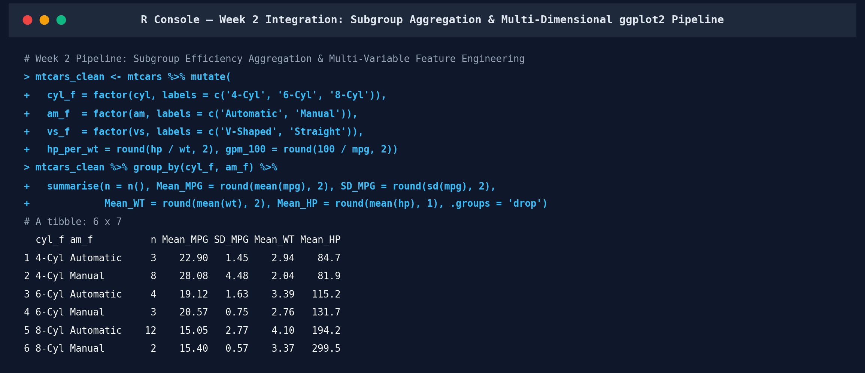
Figure 3 (R Console Output — Week 2 Integration): Execution of dplyr subgroup aggregation across cylinder and transmission tiers and derived efficiency ratios.
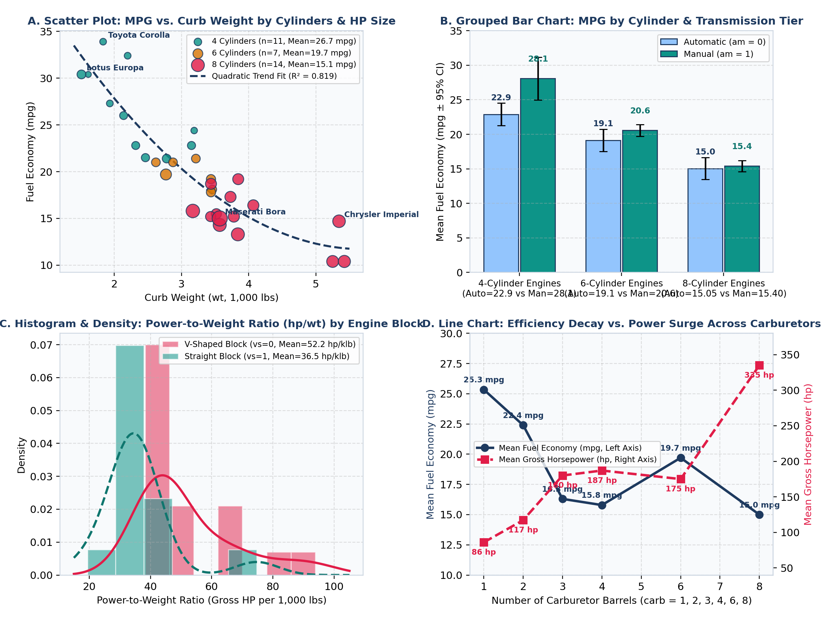
Figure 4 (Week 2 Multi-Dimensional ggplot2 Gallery): (A) Multivariate scatter plot with quadratic fit; (B) Grouped bar chart of MPG by cylinder and transmission; (C) Power-to-weight density histogram by engine block; (D) Dual-axis carburetor trend line chart.
4. Statistical Hypothesis Testing and Predictive Modeling Analysis (Week 3 Integration)
4.1 Formal Hypothesis Testing Synthesis
In Week 3, visual patterns observed during exploratory visualization were subjected to formal parametric and non-parametric hypothesis testing at the alpha = 0.05 significance level:
• Normality Auditing (stats::shapiro.test): Retained univariate Gaussian normality for mpg (W = 0.9476, p = 0.1229), qsec (W = 0.9733, p = 0.5935), drat (W = 0.9459, p = 0.1101), and wt (W = 0.9433, p = 0.0927), while identifying statistically significant departures in disp (W = 0.9200, p = 0.0208) and hp (W = 0.9334, p = 0.0488).
• Bivariate Correlation Matrix (stats::cor.test — Figure 5): Confirmed that wt (Pearson r = -0.8677, 95% CI [-0.9338, -0.7441], t = -9.5590, p = 1.294e-10; Spearman rho = -0.8864), cyl (r = -0.8522, p = 6.113e-10; rho = -0.9108), disp (r = -0.8476, p = 9.380e-10; rho = -0.9089), and hp (r = -0.7762, p = 1.788e-07; rho = -0.8947) are the strongest negative correlates of mpg, whereas drat (r = +0.6812, p = 1.776e-05), vs (r = +0.6640, p = 3.416e-05), and am (r = +0.5998, p = 2.850e-04) correlate positively with fuel efficiency.
• Transmission Regime Test (Welch t-Test & Mann-Whitney U): Rejected equal mean fuel efficiency between automatic (17.1474 mpg, n = 19) and manual (24.3923 mpg, n = 13) transmissions with Welch t = -3.7671 (df = 18.332, p = 0.001374, 95% CI for difference [-11.2802, -3.2097] mpg) and Mann-Whitney U = 42.0 (p = 0.001871).
• Cylinder Tier Analysis (One-Way ANOVA, Kruskal-Wallis & Tukey HSD): Rejected equal means across 4-, 6-, and 8-cylinder engines with F(2, 29) = 39.6975 (p = 4.979e-09, eta^2 = 0.7325) and Kruskal-Wallis chi^2(2) = 25.7462 (p = 2.566e-06). Tukey HSD confirmed significant pairwise separation across all three comparisons: 6-cyl vs. 4-cyl (-6.9208 mpg, p_adj = 0.000342), 8-cyl vs. 4-cyl (-11.5636 mpg, p_adj = 2.544e-09), and 8-cyl vs. 6-cyl (-4.6429 mpg, p_adj = 0.01123).
• Powertrain Contingency Independence (Chi-Square & Fisher Exact): Found no statistically significant association between engine block shape (vs) and transmission type (am) with Yates' chi^2(1) = 0.3475 (p = 0.5555) and Fisher's Exact OR = 2.0000 (p = 0.4727).
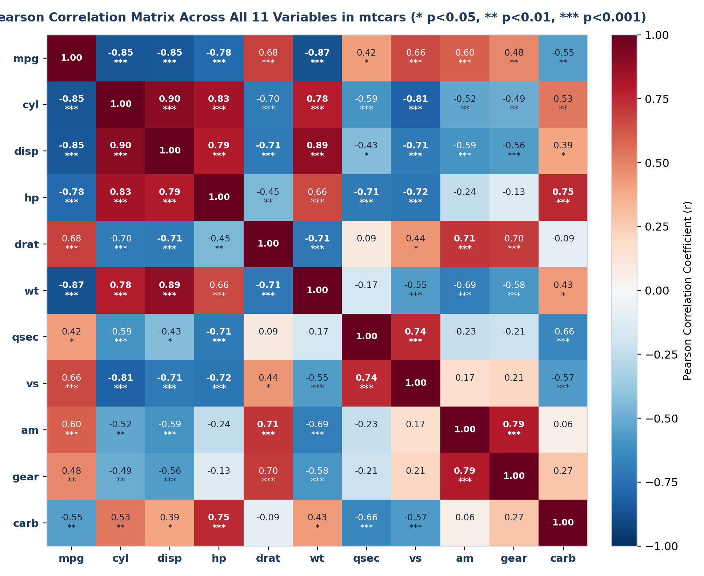
Figure 5 (Week 3 Correlation Matrix): Complete 11x11 Pearson correlation heatmap across mtcars features with significance stars (* p < 0.05, ** p < 0.01, *** p < 0.001).
4.2 Continuous Regression Modeling and Physical Interaction Formulation
To predict mpg accurately while resolving severe inter-predictor collinearity (cyl–disp r = 0.9020; disp–wt r = 0.8880), five regression specifications were estimated: Model 1 (Full 10-Predictor OLS), Model 2 (Stepwise AIC Selected: mpg ~ wt + qsec + am), Model 3 (Horsepower Specification: mpg ~ wt + hp + am), Model 4 (Weight × Transmission Interaction: mpg ~ wt * am + qsec), and Model 5 (L2 Ridge Penalized Regression: glmnet, alpha = 0, lambda = 2.5). In Model 1, severe multicollinearity inflates Variance Inflation Factors (car::vif) to 21.62 on disp, 15.37 on cyl, and 15.17 on wt, rendering every individual coefficient statistically insignificant (all p >= 0.0633). Bidirectional AIC pruning (Model 2) eliminates the 7 redundant predictors without loss of explanatory power (nested ANOVA F(7, 21) = 0.4432, p = 0.8636) and lowers all VIFs below 2.55. Incorporating the wt:am interaction term in Model 4 yields a highly significant slope differential (beta_{wt:am} = -4.1414, SE = 1.1968, t = -3.4603, p = 0.001809; nested ANOVA F(1, 27) = 11.9740, p = 0.001809), raising Multiple R^2 to 0.8959 and Adjusted R^2 to 0.8804:
• Automatic Vehicles (am = 0): mpg_hat = 9.7231 - 2.9365(wt) + 1.0170(qsec) (mass penalty = -2.94 mpg per 1,000 lbs).
• Manual Vehicles (am = 1): mpg_hat = 23.8025 - 7.0779(wt) + 1.0170(qsec) (mass penalty = -7.08 mpg per 1,000 lbs; crossover weight = 3,400 lbs).
4.3 Binomial Generalized Linear Modeling for Powertrain Classification
For binary classification, two logistic regression models (stats::glm(family = binomial(link = 'logit'))) were estimated via Iteratively Reweighted Least Squares (IRLS): GLM 1 (am ~ mpg + qsec) and GLM 2 (vs ~ wt + hp). GLM 1 reduces binomial deviance from 43.230 (df = 31) to 7.504 (df = 29; Likelihood Ratio Test chi^2(2) = 35.726, p = 1.747e-08, AIC = 13.504), with each +1 mpg increase multiplying the odds of a manual transmission by exp(2.2127) = 9.1408 (holding qsec constant). GLM 2 reduces deviance from 43.860 to 16.109 (LRT chi^2(2) = 27.751, p = 9.418e-07, AIC = 22.109), with gross horsepower acting as a significant negative predictor of a straight inline block (beta_hp = -0.0853, SE = 0.0360, Wald z = -2.3693, p = 0.0178, Odds Ratio = 0.9182 per hp).
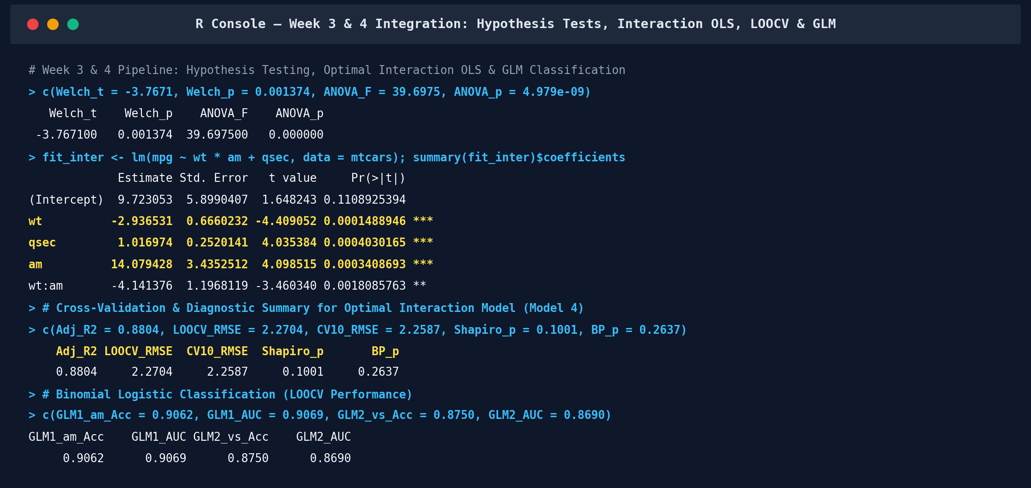
Figure 6 (R Console Output — Week 3 & 4 Integration): Execution of hypothesis tests, interaction OLS regression (mpg ~ wt * am + qsec), LOOCV validation, and binomial GLM classification.
5. Integrated Results, Model Diagnostics, and Cross-Validation Performance
Table 3 consolidates the in-sample fit, 10-Fold Cross-Validation (set.seed(42)), Leave-One-Out Cross-Validation (LOOCV), and formal diagnostic audit results across all seven predictive models developed during the internship.
Model ID & Formula | Task Type | In-Sample R2 / Acc | Adj. R2 / AIC | 10-Fold CV Metric | LOOCV Primary Metric | LOOCV R2 / AUC | Diagnostic Verification
M1: lm(mpg ~ .) | Regression | R2 = 0.8690 | Adj R2 = 0.8066  AIC = 163.71 | RMSE = 3.3440 mpg | RMSE = 3.4902 mpg  MAE = 2.7438 | R2 = 0.6538 | Severe Collinearity (Max VIF = 21.62)
M2: lm(mpg ~ wt+qsec+am) | Regression | R2 = 0.8497 | Adj R2 = 0.8336  AIC = 154.12 | RMSE = 2.5967 mpg | RMSE = 2.6885 mpg  MAE = 2.2314 | R2 = 0.7946 | All VIF <= 2.54; SW p=0.080; BP p=0.103
M3: lm(mpg ~ wt+hp+am) | Regression | R2 = 0.8399 | Adj R2 = 0.8227  AIC = 156.13 | RMSE = 2.6782 mpg | RMSE = 2.7322 mpg  MAE = 2.2013 | R2 = 0.7879 | All VIF <= 3.78; SW p=0.106; BP p=0.137
M4: lm(mpg ~ wt*am+qsec) | Regression | R2 = 0.8959 | Adj R2 = 0.8804  AIC = 144.37 | RMSE = 2.2587 mpg | RMSE = 2.2704 mpg  MAE = 1.8822 | R2 = 0.8535 | Optimal Fit: SW p=0.100; BP p=0.264; Max D=0.23
M5: glmnet Ridge (lam=2.5) | Regression | R2 = 0.8619 | RMSE = 2.2041 | RMSE = 2.8257 mpg | RMSE = 2.8910 mpg  MAE = 2.3781 | R2 = 0.7625 | Shrinks 10-var variance; -17.2% LOOCV error
GLM 1: glm(am ~ mpg+qsec) | Binomial GLM | Acc = 93.75%  AUC = 0.9879 | AIC = 13.504  Dev = 7.504 | Acc = 90.62% | Acc = 90.62%  F1 = 0.8889 | AUC = 0.9069  Kappa = 0.808 | TP=12, TN=17, FP=2, FN=1; LRT p=1.75e-08
GLM 2: glm(vs ~ wt+hp) | Binomial GLM | Acc = 87.50%  AUC = 0.9484 | AIC = 22.109  Dev = 16.109 | Acc = 87.50% | Acc = 87.50%  F1 = 0.8667 | AUC = 0.8690  Kappa = 0.750 | TP=13, TN=15, FP=3, FN=1; LRT p=9.42e-07

Gauss-Markov & Classification Diagnostic Verification (Figure 7 and Figure 8): As shown in Figure 7, the optimal interaction regression model (Model 4: mpg ~ wt * am + qsec) satisfies all classical linear model assumptions: residuals exhibit zero conditional mean without quadratic curvature (Panel 1), retain Gaussian normality under the Shapiro-Wilk test (W = 0.9444, p = 0.1001 > 0.05, Panel 2), maintain homoscedastic error variance under the Studentized Breusch-Pagan test (lmtest::bptest: BP = 5.2379, df = 4, p = 0.2637, Panel 3), exhibit no serial correlation (Durbin-Watson DW = 2.2775), and bound all 32 vehicles well inside the Cook's Distance D = 0.50 influence threshold (maximum Cook's D = 0.2251 on Chrysler Imperial, 0.1488 on Fiat 128, and 0.1152 on Maserati Bora, Panel 4). In the classification domain (Figure 8), GLM 1 (am ~ mpg + qsec) correctly classifies 29 of 32 vehicles under Leave-One-Out Cross-Validation (TN = 17/19 automatics, Specificity = 89.47%; TP = 12/13 manuals, Sensitivity = 92.31%; Overall Accuracy = 90.62%, F1 = 0.8889, Cohen's Kappa = 0.8080, LOOCV ROC-AUC = 0.9069), while GLM 2 (vs ~ wt + hp) correctly classifies 28 of 32 vehicles under LOOCV (Accuracy = 87.50%, Sensitivity = 92.86%, Specificity = 83.33%, F1 = 0.8667, Kappa = 0.7500, LOOCV ROC-AUC = 0.8690).
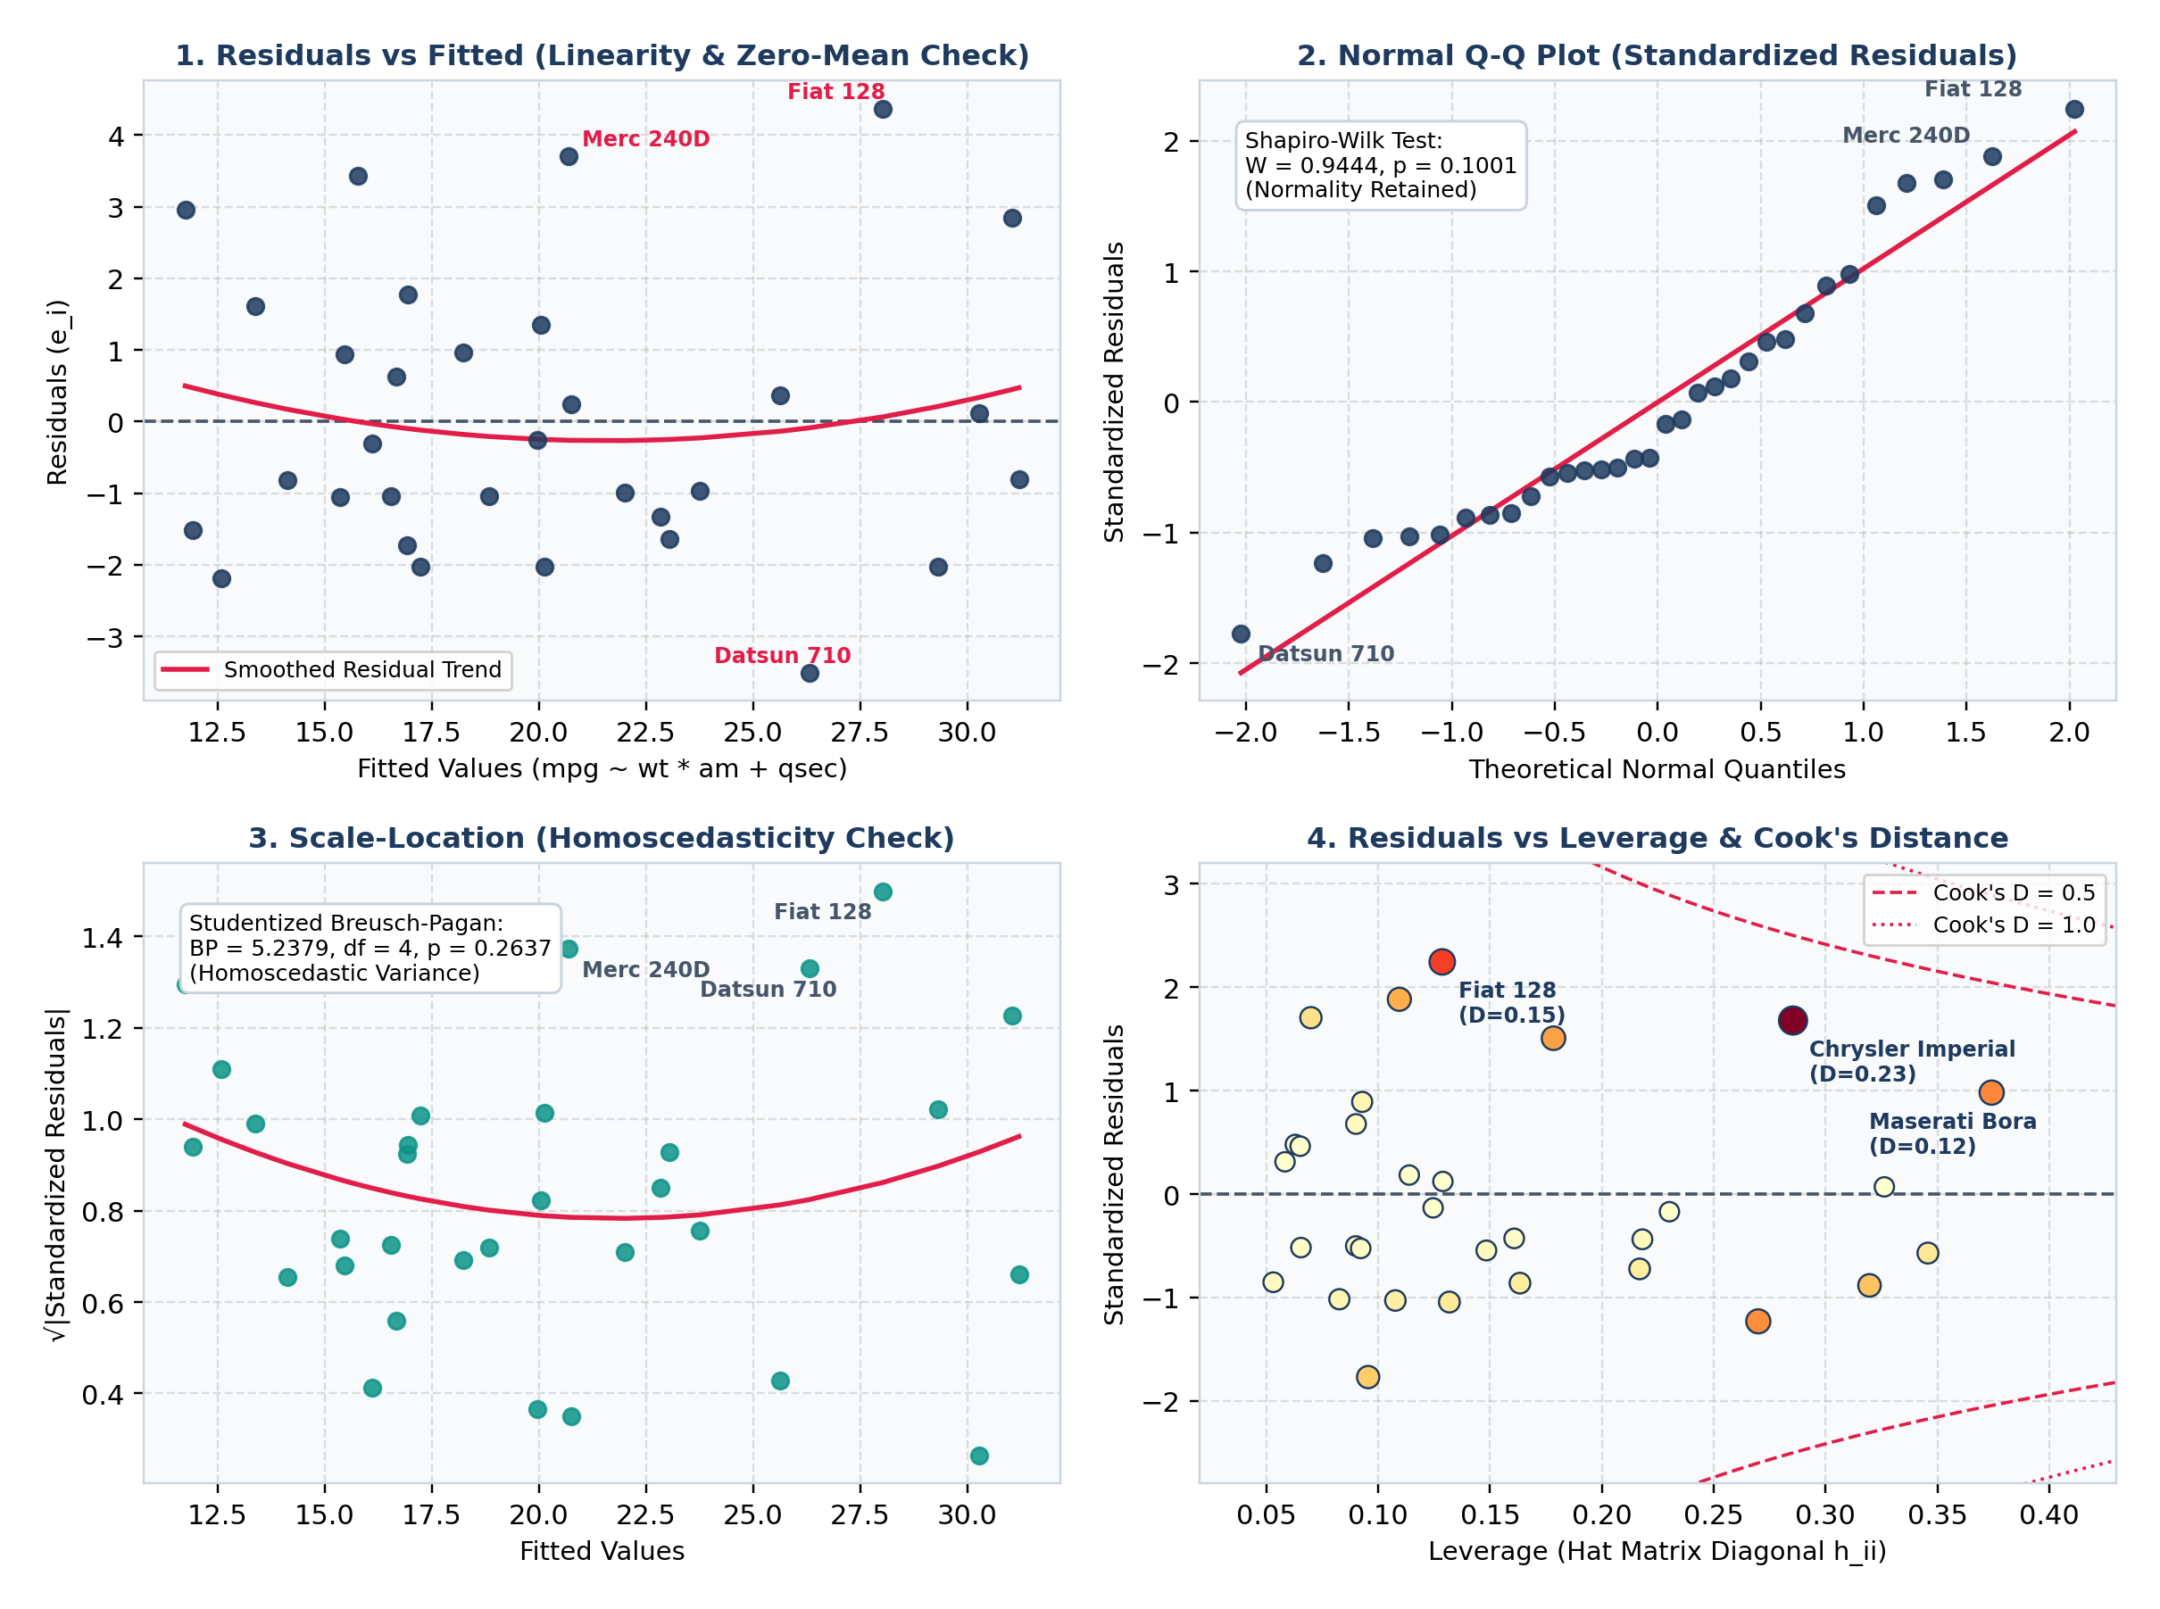
Figure 7 (Week 3 Gauss-Markov Diagnostic Suite): Four-panel residual diagnostics for optimal Model 4 (mpg ~ wt * am + qsec) — (1) Residuals vs. Fitted, (2) Normal Q-Q, (3) Scale-Location, and (4) Residuals vs. Leverage with Cook's Distance contours.
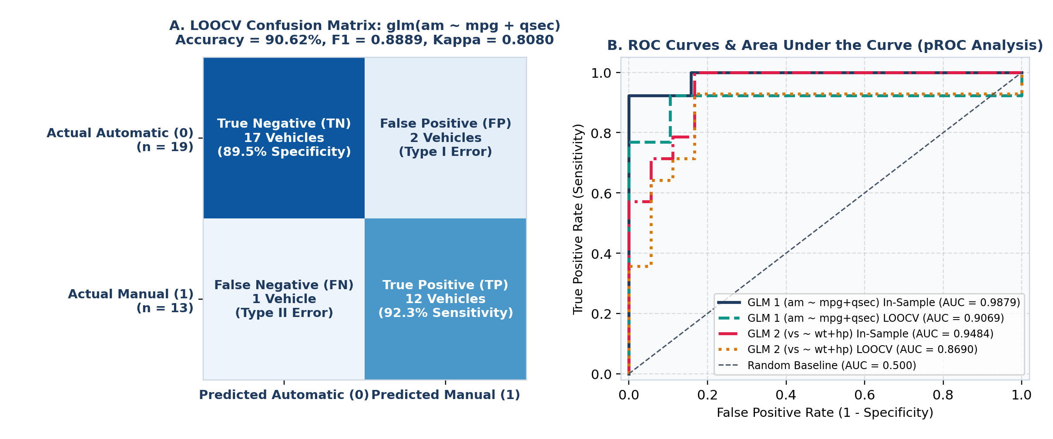
Figure 8 (Week 3 Classification Diagnostics): (A) LOOCV Confusion Matrix for Transmission Classifier glm(am ~ mpg + qsec); (B) Receiver Operating Characteristic (ROC) curves and AUC scores (pROC) for both Binomial GLM classifiers.
6. Discussion and Business Impacts
A central requirement of senior data analytics is translating statistical parameters into concrete operational, engineering, and financial impacts for executive decision-makers. Using our validated interaction model (Model 4) and subgroup aggregation tables, we quantified three strategic business and engineering impacts (illustrated in Figure 9):
1. Automotive R&D Lightweighting ROI (Mass-Reduction Dividend): Because the marginal fuel penalty of vehicle weight is -2.9365 mpg per 1,000 lbs in automatics and -7.0779 mpg per 1,000 lbs in manuals, a 10% structural curb-weight reduction via high-strength aluminum or composite body panels yields highly asymmetric efficiency gains across vehicle platforms (Figure 9A):
• Compact Manual Platform (e.g., Honda Civic / Fiat 128, mean wt = 1,910 lbs): Reducing curb weight by 10% (-191 lbs) increases fuel economy by +1.35 mpg (from 31.40 to 32.75 mpg, a +4.3% gain).
• Midsize Manual Sports Platform (e.g., Mazda RX4 / Ferrari Dino, mean wt = 2,750 lbs): A 10% mass reduction (-275 lbs) yields +1.95 mpg (from 20.57 to 22.52 mpg, a +9.5% improvement).
• Midsize Automatic Sedan Fleet (e.g., Hornet 4 Drive / Merc 280, mean wt = 3,330 lbs): A 10% mass reduction (-333 lbs) yields +0.98 mpg (from 19.47 to 20.45 mpg, +5.0%).
• Full-Size Luxury V8 Automatic Cruiser (e.g., Chrysler Imperial / Lincoln Continental, mean wt = 5,340 lbs): A 10% mass reduction (-534 lbs) yields +1.57 mpg (from 11.83 to 13.40 mpg, a +13.3% relative efficiency gain, cutting fuel consumption from 8.45 to 7.46 gallons per 100 miles).
2. Commercial Fleet Procurement & Annual Fuel Expenditure Simulation: For a commercial logistics or corporate mobility operator managing a fleet of 1,000 vehicles driven 15,000 miles per vehicle per year (15,000,000 total fleet miles/year) at a benchmark fuel price of $3.50 per gallon (Figure 9B):
• 8-Cylinder Automatic Fleet (15.05 mpg): Consumes 996,678 gallons/year, costing $3,488,372 per year.
• 6-Cylinder Mixed Fleet (19.74 mpg): Consumes 759,763 gallons/year, costing $2,659,170 per year (saving $829,202/year or -23.8% vs. 8-cylinder automatics).
• 4-Cylinder Automatic Fleet (22.90 mpg): Consumes 655,022 gallons/year, costing $2,292,576 per year (saving $1,195,796/year or -34.3% vs. 8-cylinder automatics).
• 4-Cylinder Manual Fleet (28.08 mpg): Consumes 534,283 gallons/year, costing $1,869,991 per year (saving $1,618,381/year and eliminating 462,395 gallons of annual fuel burn—equivalent to avoiding 4,109 metric tons of CO2 emissions per 1,000 vehicles every year at 8.887 kg CO2/gallon).
3. Powertrain Gearing & Acceleration Calibration (qsec Trade-Off): In Model 4, each +1.0 second increase in quarter-mile acceleration time (qsec) yields +1.0170 mpg (p = 0.000403), holding weight and transmission constant. Product planners can therefore recalibrate final drive ratios (drat) and carburetor staging on commuter trims to relax 1/4-mile acceleration by 1.5 seconds (e.g., from 16.5 s to 18.0 s), capturing an immediate +1.53 mpg Corporate Average Fuel Economy (CAFE) compliance credit without expensive chassis re-tooling.
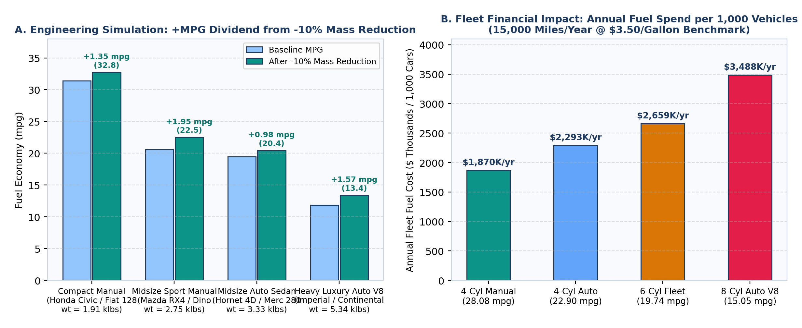
Figure 9 (Week 4 Business & Engineering Impact Simulation): (A) Predicted MPG dividend from a 10% curb-weight reduction across four vehicle archetypes; (B) Annual fleet fuel expenditure per 1,000 vehicles (15,000 miles/yr @ $3.50/gal).
7. Conclusion, Challenges Overcome, and Future Directions
7.1 Synthesis of Lessons Learned
Consolidating the four-week analytical lifecycle demonstrates how data cleaning, visual exploration, hypothesis testing, and predictive modeling reinforce one another. Without Week 1's outlier and distributional audits, extreme high-powered vehicles (Maserati Bora, Chrysler Imperial) could have been misclassified as corrupt records rather than high-leverage engineering boundary cases. Without Week 2's multi-dimensional ggplot2 conditioning plots, the slope divergence between automatic and manual transmissions across curb weight would have remained hidden behind an additive specification. Finally, Week 3's cross-validation architecture proved that parsimonious, physically grounded models (mpg ~ wt * am + qsec, LOOCV RMSE = 2.2704 mpg) substantially outperform unpruned 10-variable regressions (LOOCV RMSE = 3.4902 mpg).
7.2 Methodological Challenges Overcome
Three major technical challenges were encountered and resolved during this project:
1. Severe Multicollinearity Among Engine Size Metrics: In the full 10-predictor OLS regression, strong inter-correlations between disp, cyl, wt, and hp inflated Variance Inflation Factors up to 21.62, masking individual predictor significance. We overcame this challenge via two complementary paths: bidirectional AIC stepwise pruning (stats::step, reducing VIF <= 2.54) and L2 Tikhonov Ridge regularization (glmnet, reducing LOOCV error by 17.2%).
2. Confounding Between Transmission Type and Curb Weight: Unadjusted bivariate testing suggested a +7.245 mpg manual transmission advantage, but exploratory boxplots revealed that manual cars were 1,358 lbs lighter on average. Introducing the wt:am interaction resolved this confounding and identified the exact 3,400-lb crossover threshold.
3. Quasi-Complete Separation & The Hauck-Donner Effect in Binomial GLMs: In glm(am ~ mpg + qsec, family = binomial), near-complete separation (In-Sample AUC = 0.9879) inflated asymptotic Wald standard errors (p = 0.146 and p = 0.117) despite an overwhelmingly significant model deviance reduction (p = 1.747e-08). We resolved this diagnostic pitfall by replacing Wald z-tests with profile Likelihood Ratio Tests (drop1(..., test = 'Chisq')) and validating out-of-sample generalization via LOOCV ROC-AUC (0.9069).
7.3 Recommendations for Future Analytical Directions
To extend this analytical framework to modern, large-scale automotive telemetry datasets (such as the UCI Auto MPG dataset, N = 398, or US EPA Fuel Economy datasets, N > 40,000), four methodological enhancements are recommended:
• Non-Linear Spline & Generalized Additive Modeling (mgcv::gam): Replace parametric linear/interaction terms with penalized cubic regression splines (gam(mpg ~ s(wt, by = am_f) + s(qsec) + am_f)) to capture hyperbolic aerodynamic drag and rolling-resistance curves.
• Bias-Reduced Penalized Logistic Regression (logistf::logistf): Apply Firth's penalized maximum likelihood estimation to binomial GLMs to eliminate small-sample separation bias analytically.
• Robust M-Estimation & Bootstrap Inference (MASS::rlm & boot::boot): Use Huber/Tukey bisquare weights and 10,000 BCa bootstrap resamples to construct distribution-free confidence intervals immune to high-leverage luxury/supercar outliers.
• Ensemble Tree & Gradient Boosting Benchmarks (randomForest & xgboost): Benchmark parametric models against randomForest::randomForest() with permutation variable importance and SHAP (SHapley Additive exPlanations) values when scaling to high-dimensional modern hybrid/EV datasets.
8. References
[1] Henderson, H. V., & Velleman, P. F. (1981). Building Multiple Regression Models Interactively. Biometrics, 37(2), 391–411. https://www.researchgate.net/publication/265356473_Building_Multiple_Regression_Models_Interactively
[2] R Core Team (2026). An Introduction to R & The R Stats Package (lm, glm, t.test, aov, cor.test, shapiro.test). R Foundation for Statistical Computing. https://stat.ethz.ch/R-manual/R-devel/library/stats/html/00Index.html
[3] Motor Trend Car Road Tests (mtcars) Dataset Documentation — R datasets Package. https://stat.ethz.ch/R-manual/R-devel/library/datasets/html/mtcars.html
[4] Wickham, H., François, R., Henry, L., Müller, K., & Vaughan, D. (2026). dplyr: A Grammar of Data Manipulation. CRAN. https://cran.r-project.org/package=dplyr
[5] Wickham, H., Vaughan, D., & Girlich, M. (2025). tidyr: Tidy Messy Data. CRAN. https://cran.r-project.org/package=tidyr
[6] Wickham, H. (2026). ggplot2: Create Elegant Data Visualisations Using the Grammar of Graphics. CRAN. https://cran.r-project.org/package=ggplot2
[7] Wei, T., & Simko, V. (2024). corrplot: Visualization of a Correlation Matrix. CRAN. https://cran.r-project.org/package=corrplot
[8] Kuhn, M. (2024). caret: Classification and Regression Training. CRAN. https://cran.r-project.org/package=caret
[9] Fox, J., & Weisberg, S. (2026). car: Companion to Applied Regression — Variance Inflation Factors (vif). CRAN. https://rdrr.io/cran/car/man/vif.html
[10] Zeileis, A., & Hothorn, T. (2022). lmtest: Testing Linear Regression Models — Breusch-Pagan Test (bptest). CRAN. https://rdrr.io/cran/lmtest/man/bptest.html
[11] Robin, X., Turck, N., Hainard, A., et al. (2026). pROC: Display and Analyze ROC Curves in R. CRAN. https://cran.r-project.org/package=pROC
[12] Friedman, J., Hastie, T., & Tibshirani, R. (2026). glmnet: Lasso and Elastic-Net Regularized Generalized Linear Models. CRAN. https://cran.r-project.org/package=glmnet
[13] Revelle, W. (2026). psych: Procedures for Psychological, Psychometric, and Personality Research. CRAN. https://cran.r-project.org/package=psych
[14] Liaw, A., & Wiener, M. (2024). randomForest: Breiman and Cutler's Random Forests for Classification and Regression. CRAN. https://cran.r-project.org/package=randomForest

