MediCost Lab
Application screenshots: every page and tab
Machine Learning course project, Unit 2: Linear Models
Team: Priyanshu, Ashish Kumar, Salil Pratap Singh, Vedang Pratap Singh
Data: kaggle.com/datasets/mirichoi0218/insurance
The app is built with Streamlit and has a landing page plus seven numbered pages. The Data page has two tabs, each shown separately. Long pages are split across two screenshots.

Overview
Landing page with headline figures, the two prediction tasks and the Unit 2 syllabus map.
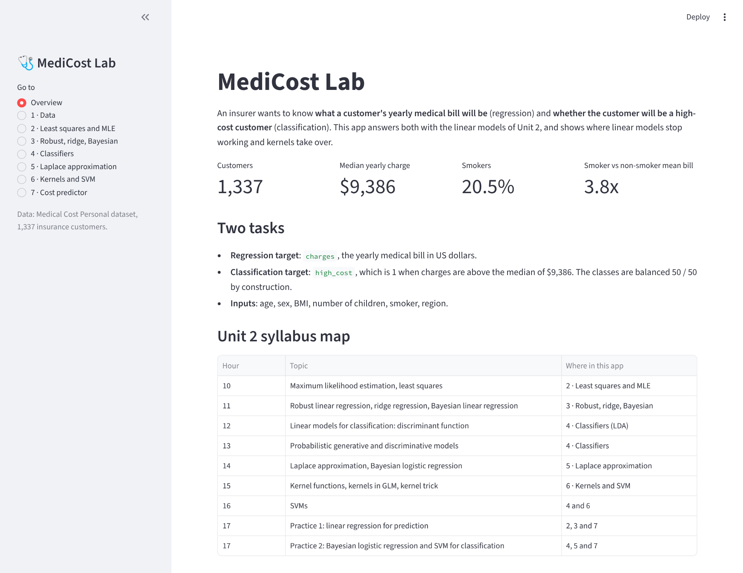
Figure 1. Overview

1 · Data: Table and summary tab
The dataset table, the column dictionary and summary statistics.
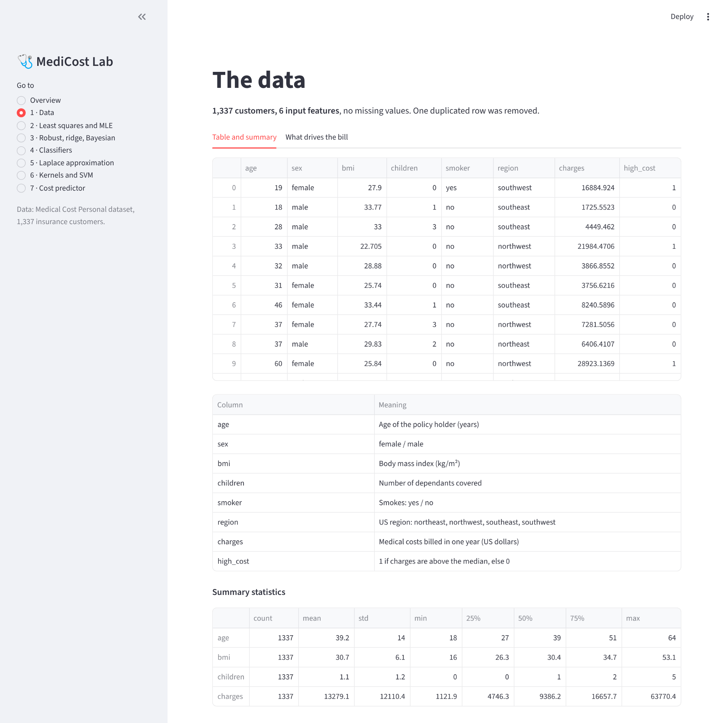
Figure 2. 1 · Data: Table and summary tab

1 · Data: What drives the bill tab
Charges against age and BMI, coloured by smoker, showing the smoker and BMI interaction.
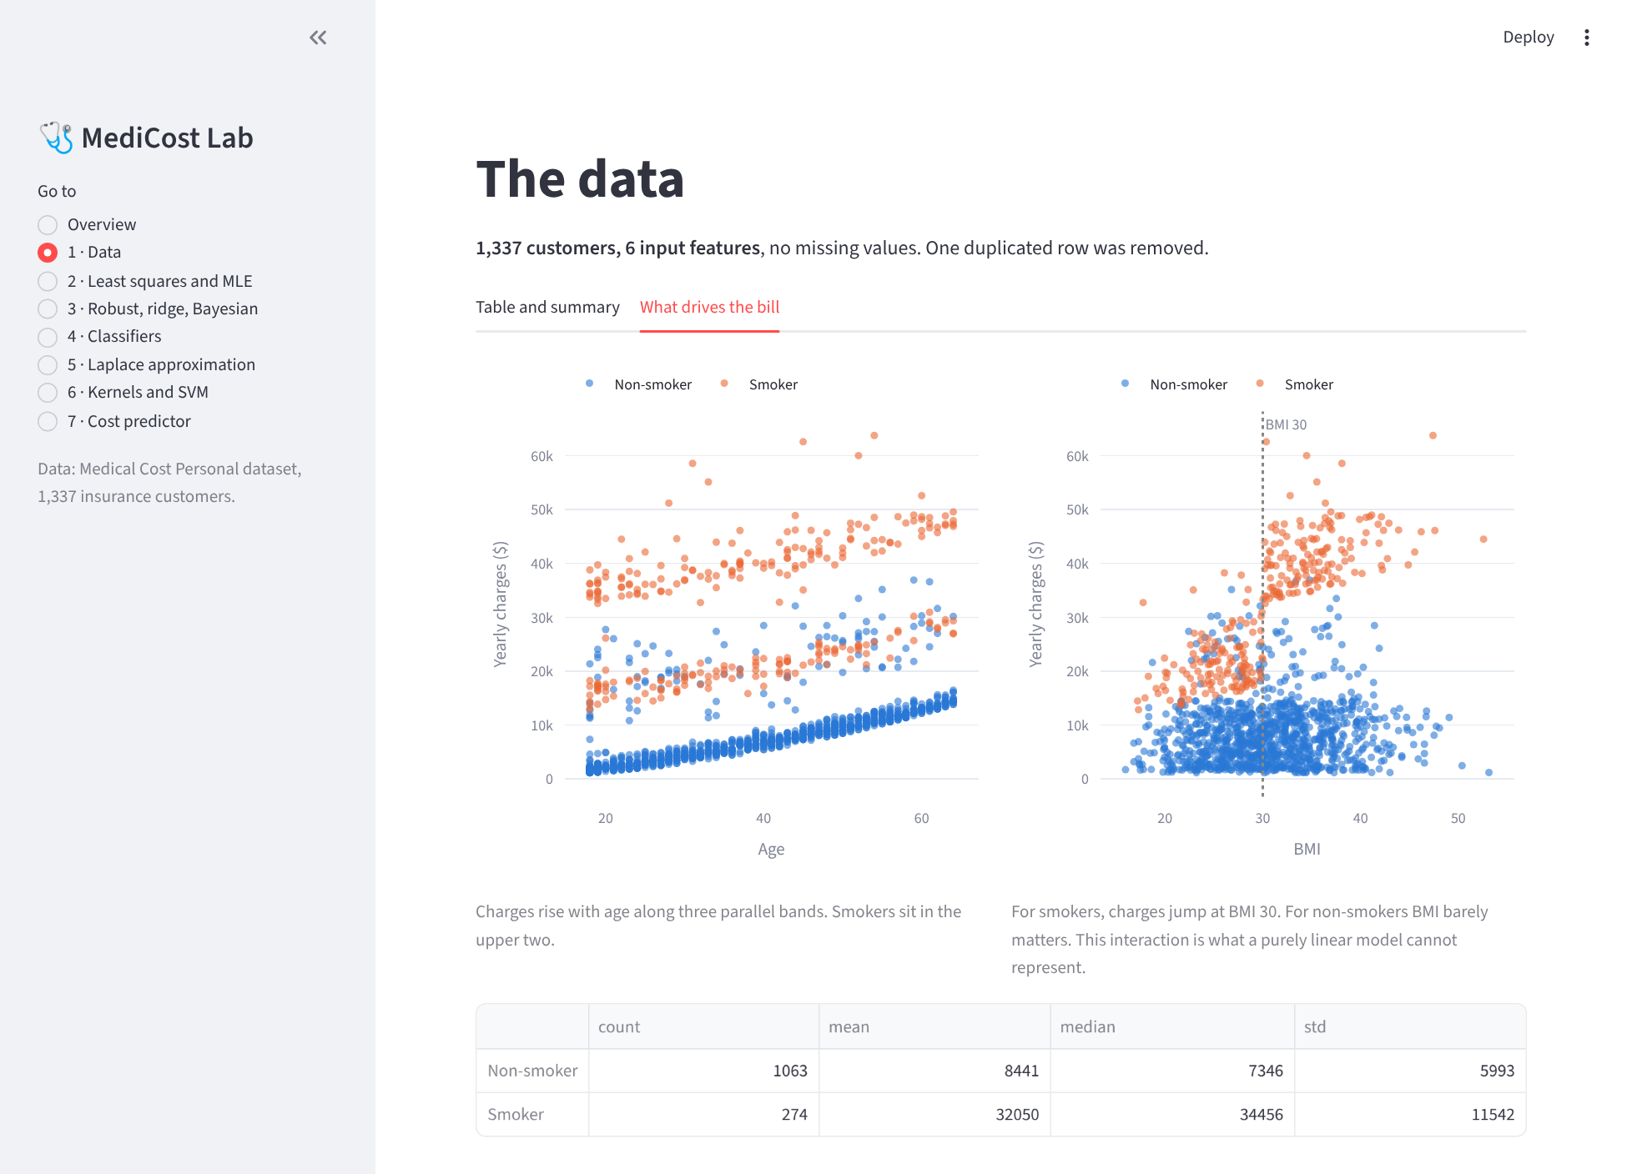
Figure 3. 1 · Data: What drives the bill tab

2 · Least squares and MLE
An interactive demonstration that the least squares slope maximises the Gaussian likelihood, followed by the full six-feature model, its weights and residuals.
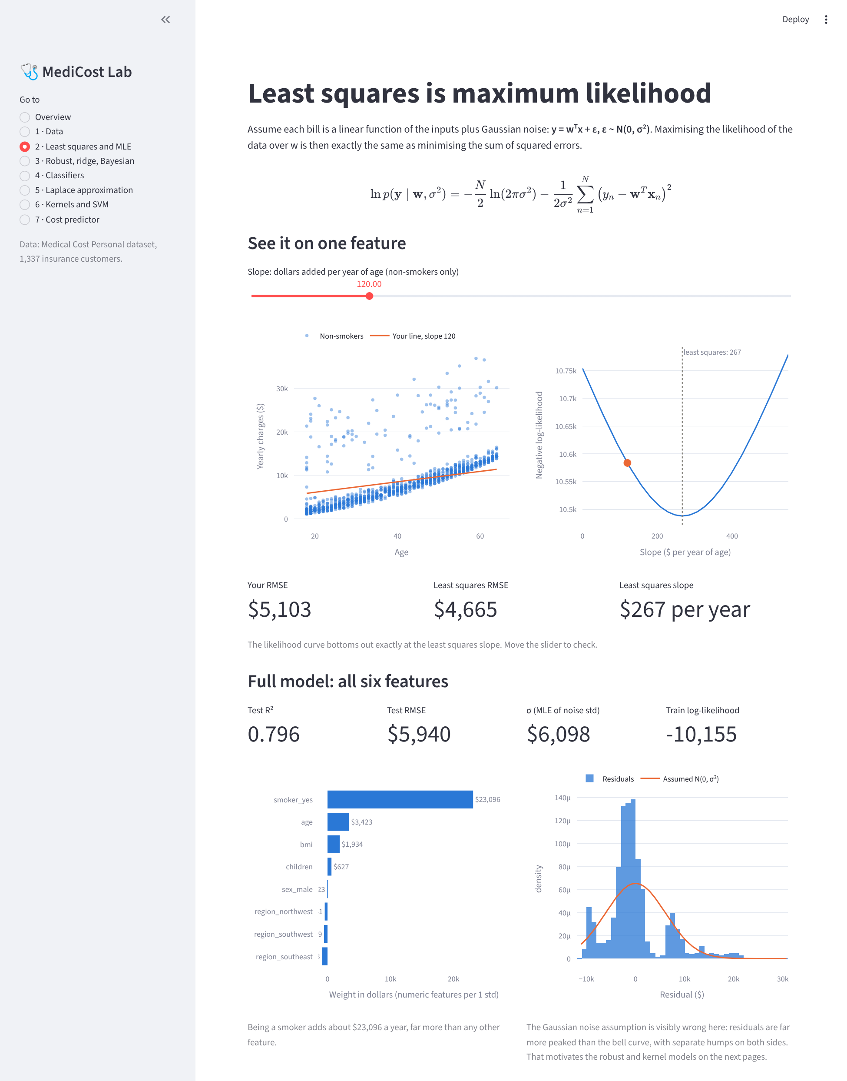
Figure 4. 2 · Least squares and MLE

3 · Robust, ridge, Bayesian
Test results for all regression models, the corrupted-bills experiment for robust regression, ridge coefficient paths and Bayesian predictive intervals.
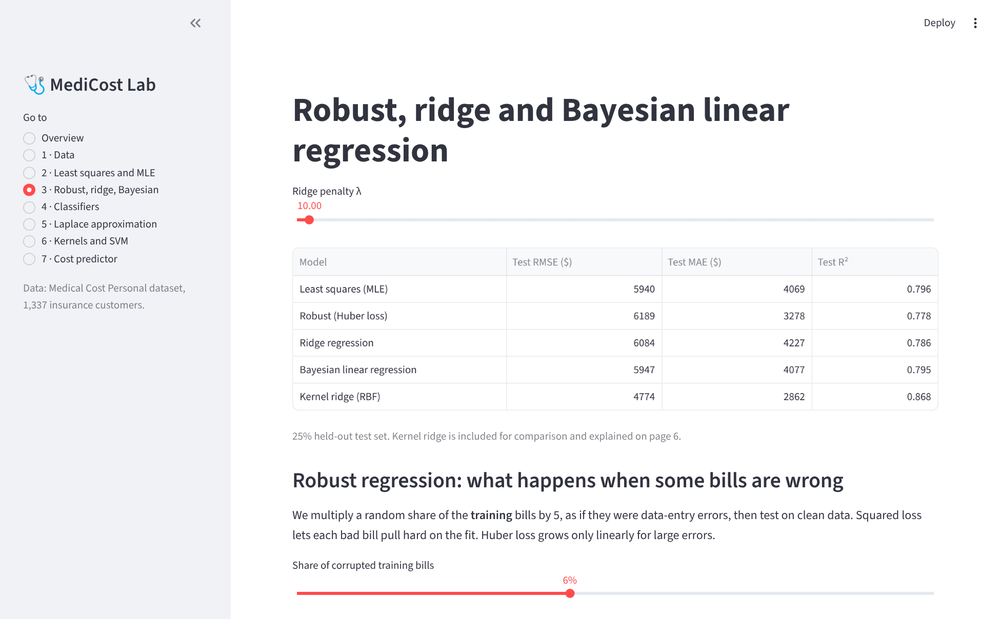
Figure 5. 3 · Robust, ridge, Bayesian (part 1 of 2)
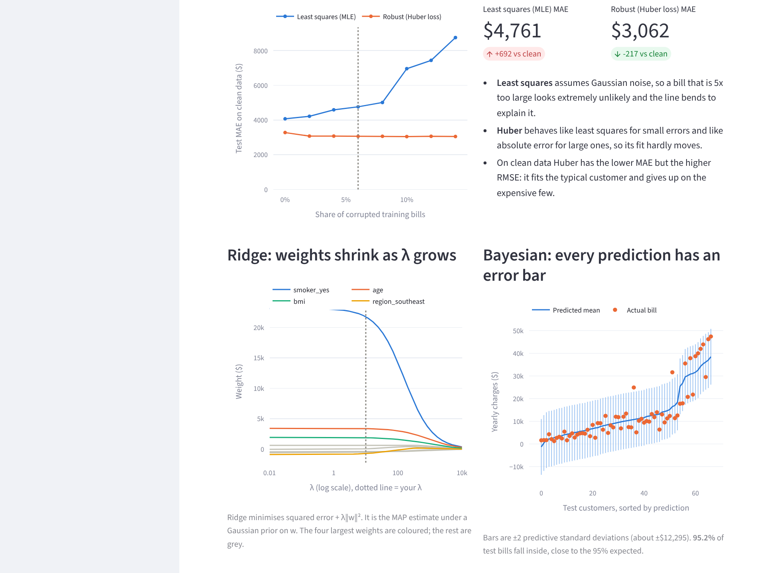
Figure 6. 3 · Robust, ridge, Bayesian (part 2 of 2)

4 · Classifiers
Eight classifiers compared, with ROC curves, a confusion matrix and the Naive Bayes calibration analysis.
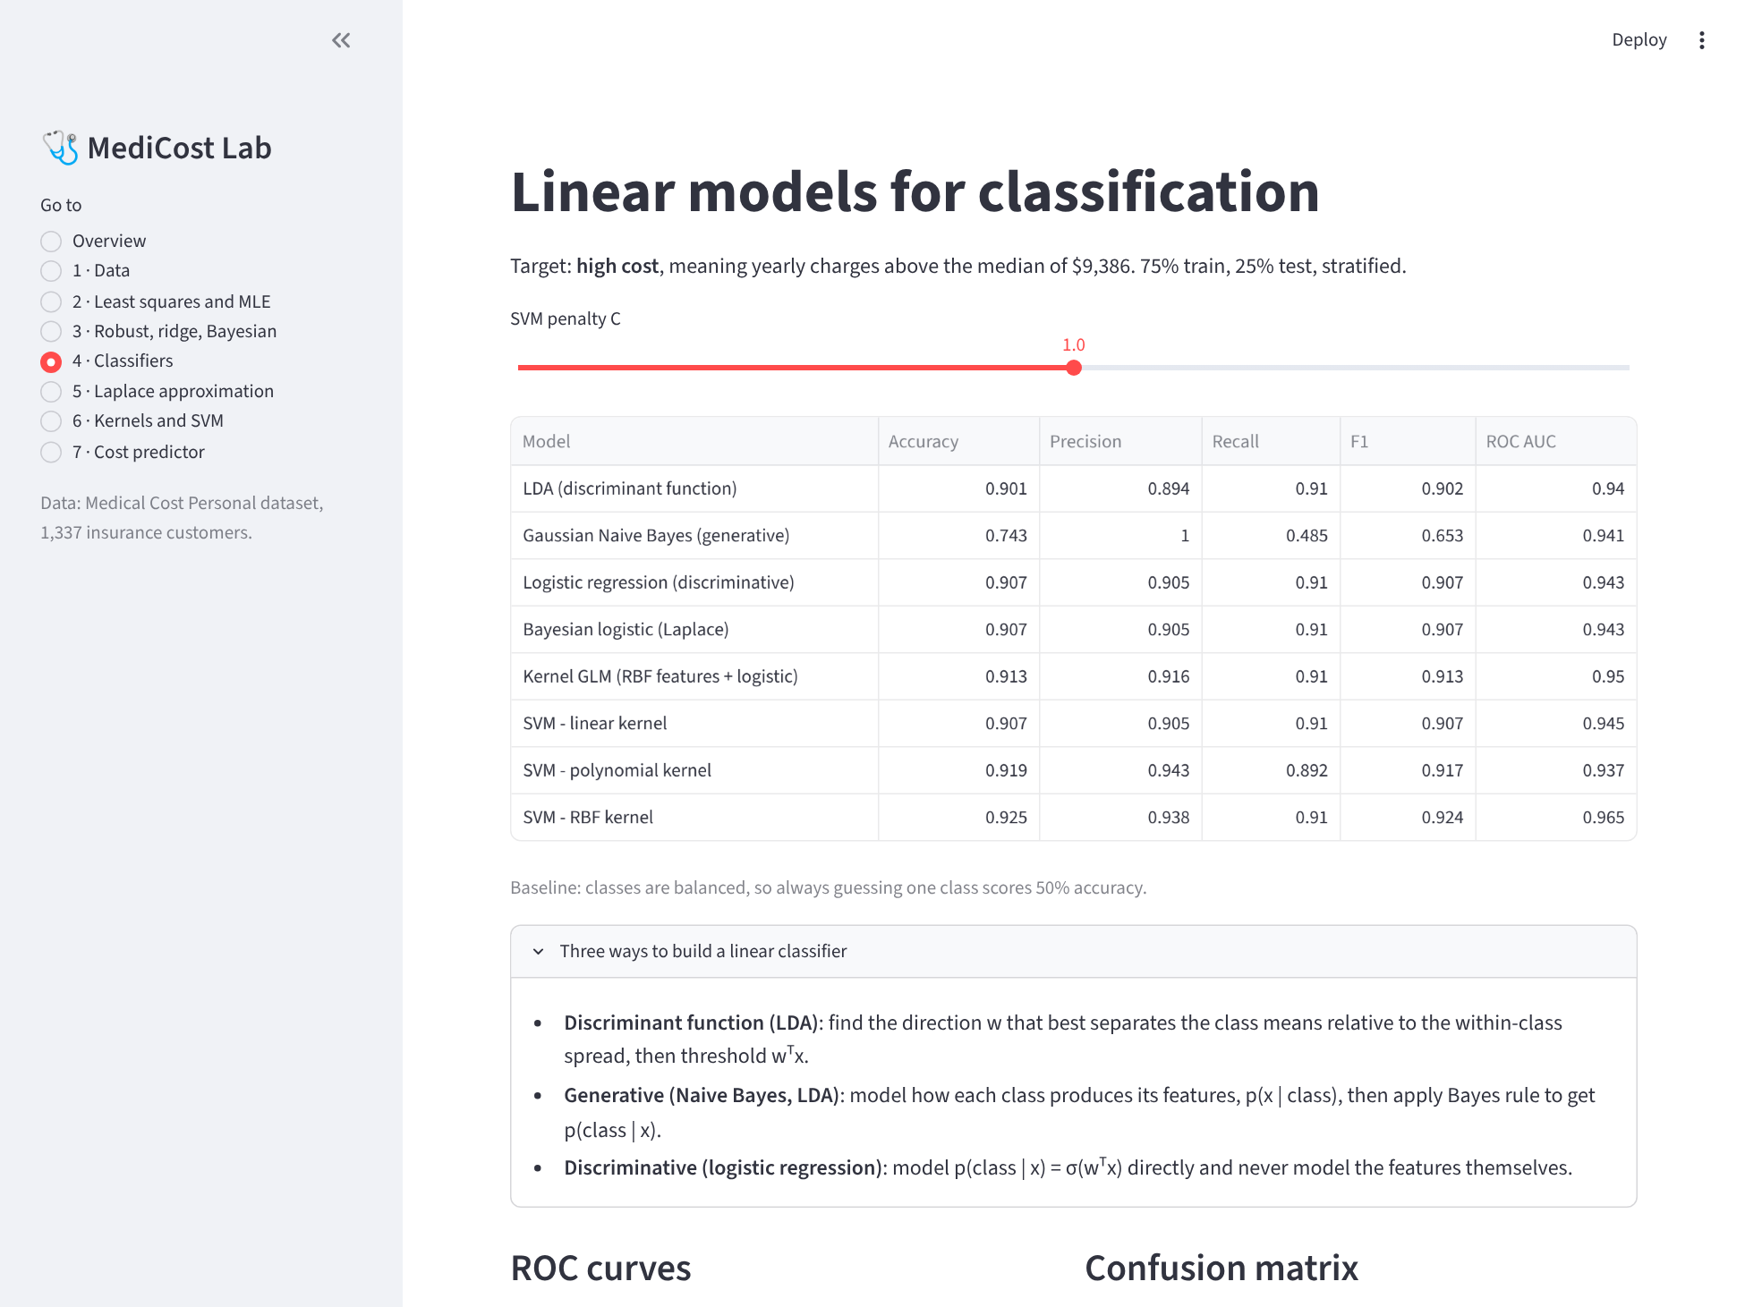
Figure 7. 4 · Classifiers (part 1 of 2)
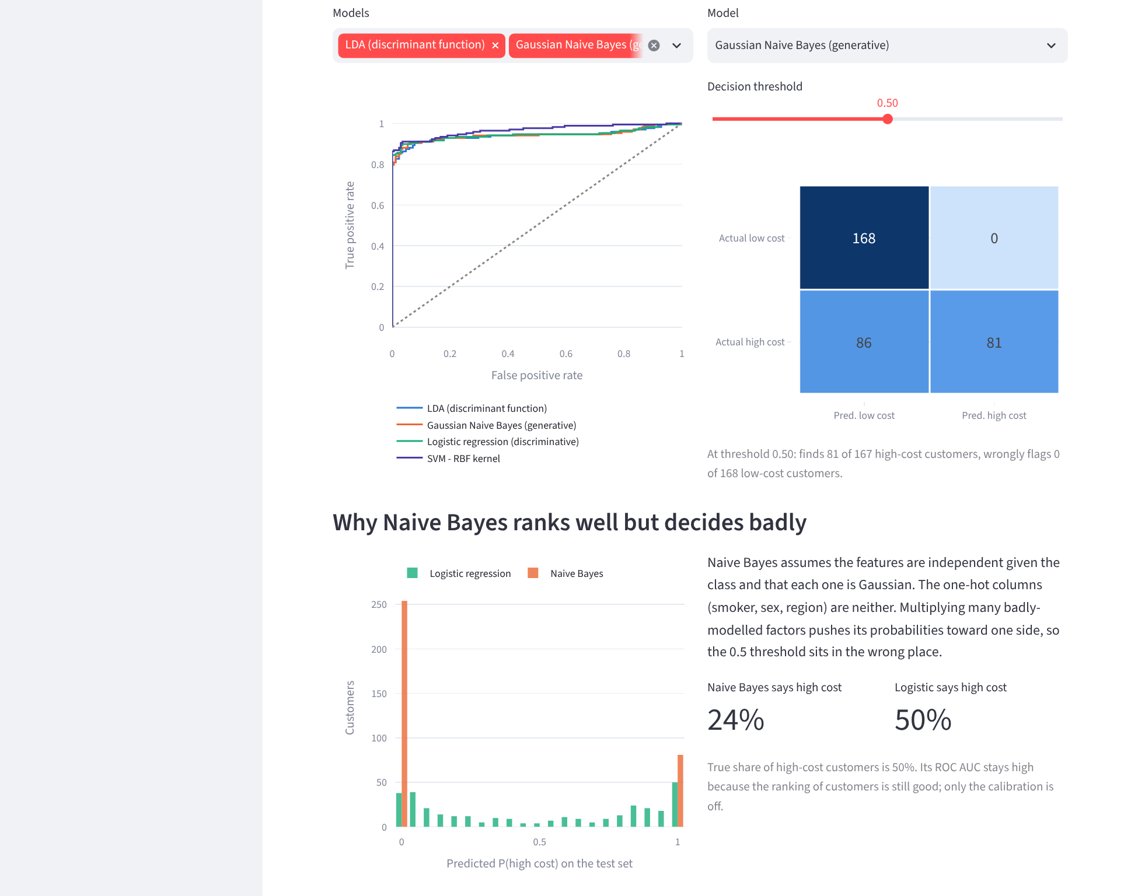
Figure 8. 4 · Classifiers (part 2 of 2)

5 · Laplace approximation
Bayesian logistic regression with the Laplace approximation: point estimate against Bayesian prediction, and posterior weight uncertainty.
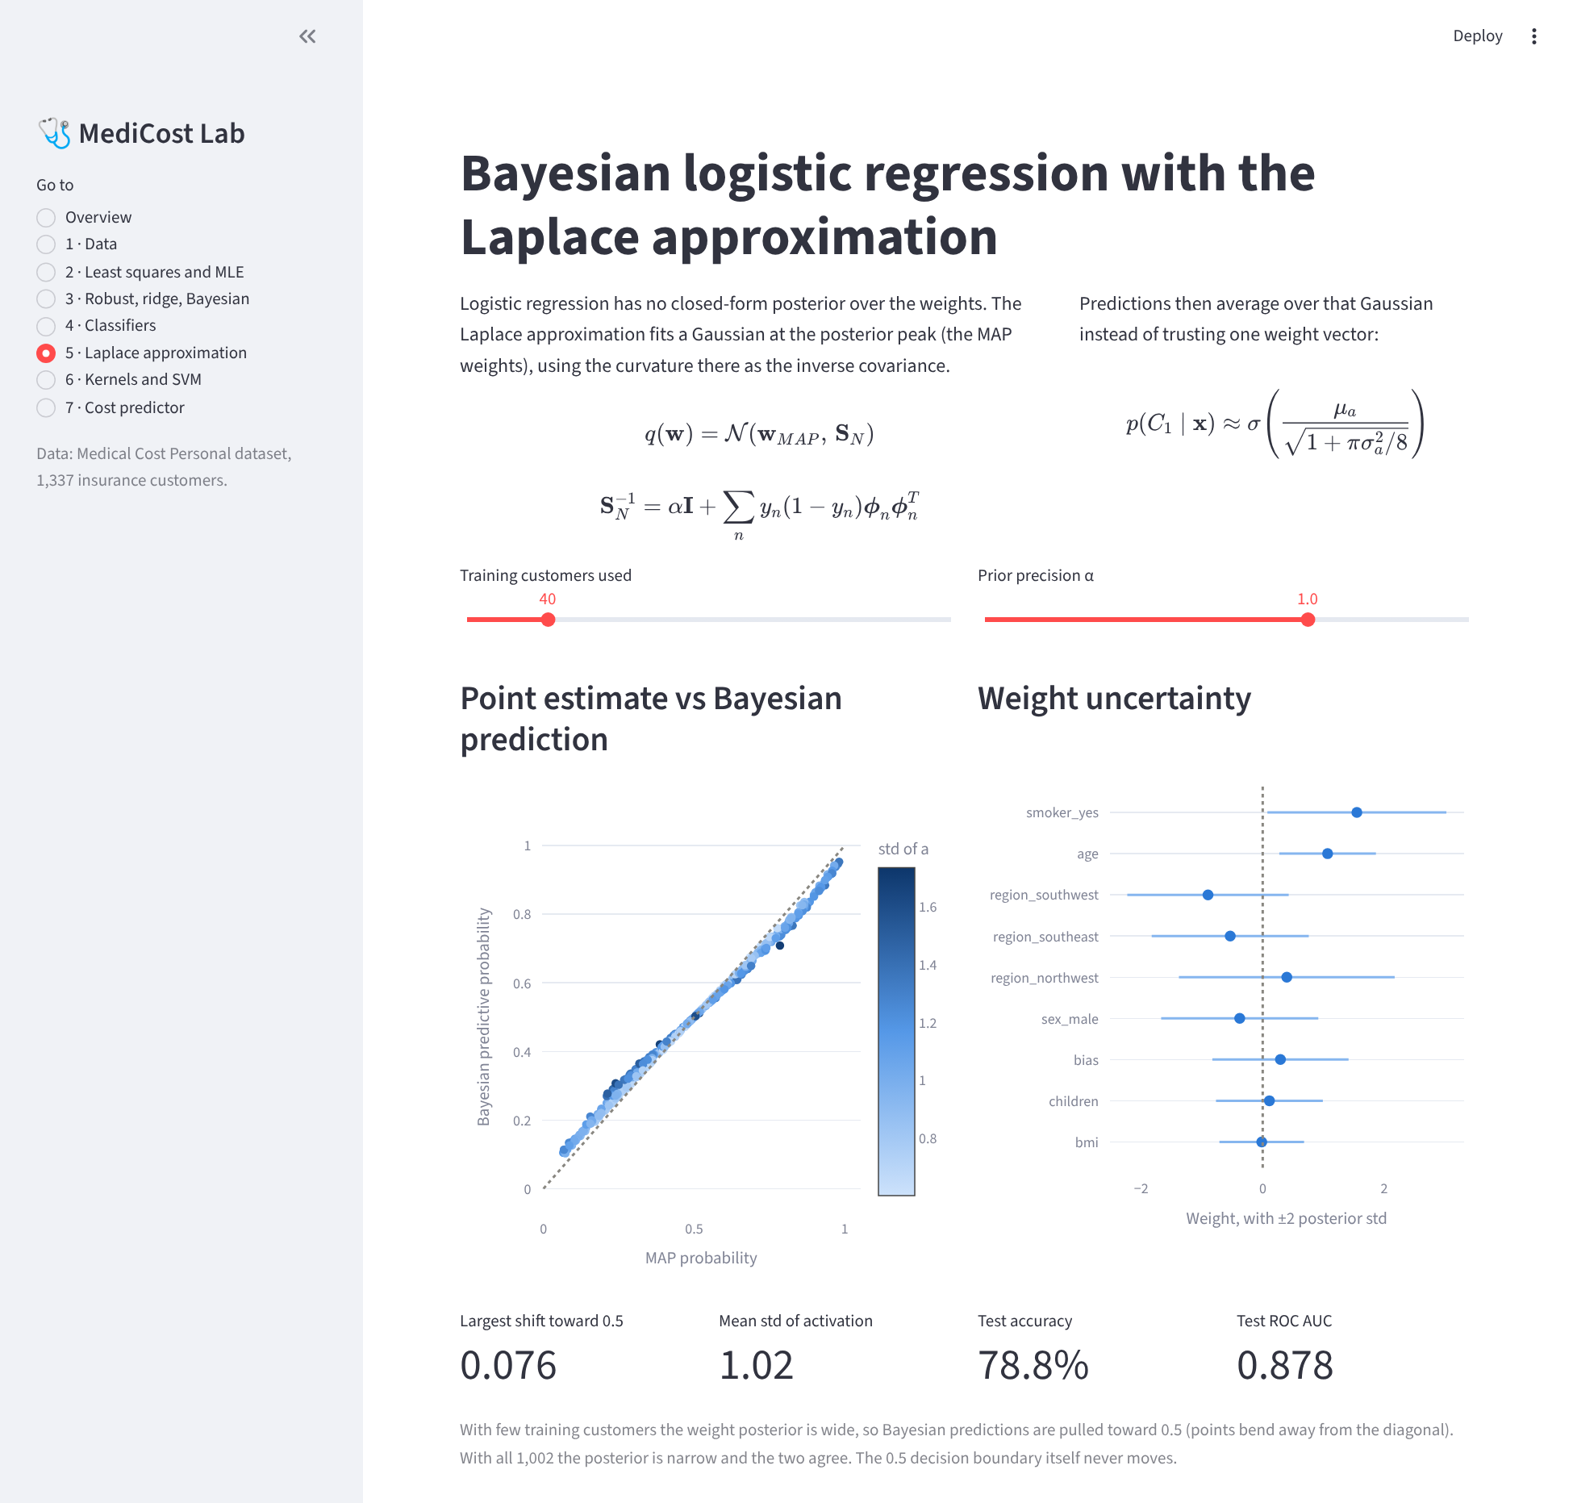
Figure 9. 5 · Laplace approximation

6 · Kernels and SVM
Kernel ridge regression with three kernels on smokers, and an SVM decision boundary on age and BMI.
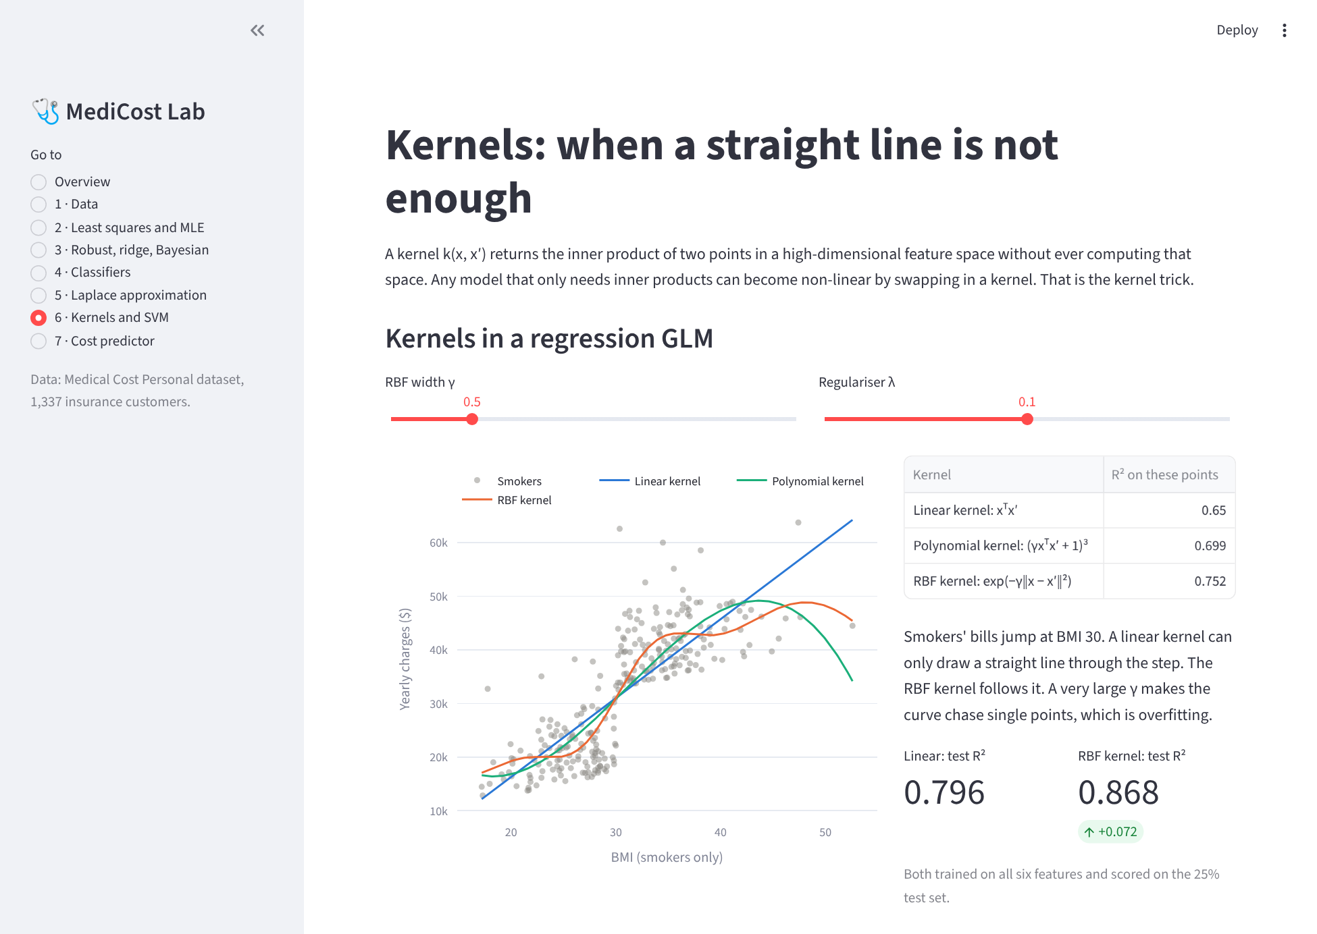
Figure 10. 6 · Kernels and SVM (part 1 of 2)
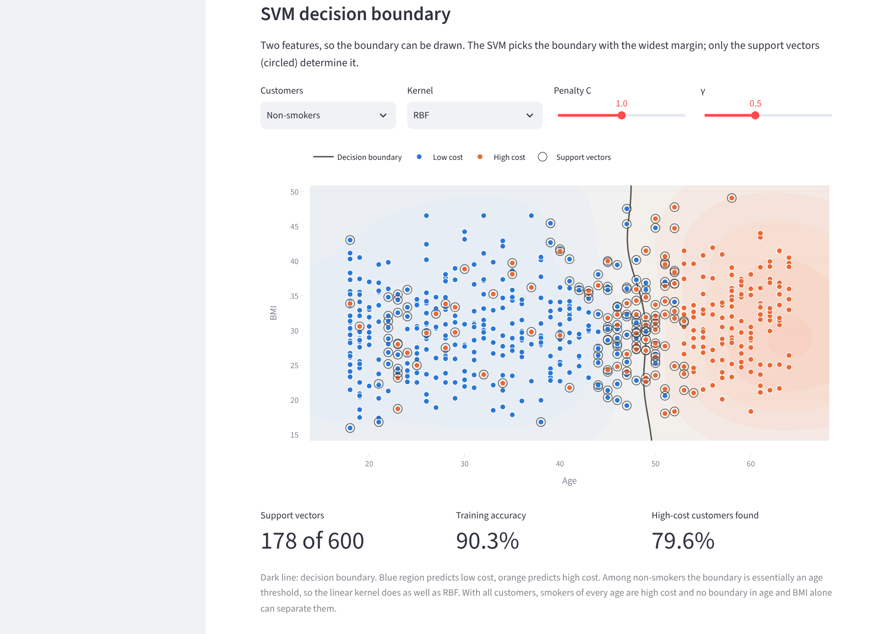
Figure 11. 6 · Kernels and SVM (part 2 of 2)

7 · Cost predictor
The customer form with each regression estimate and each classifier probability for a 35-year-old smoker.
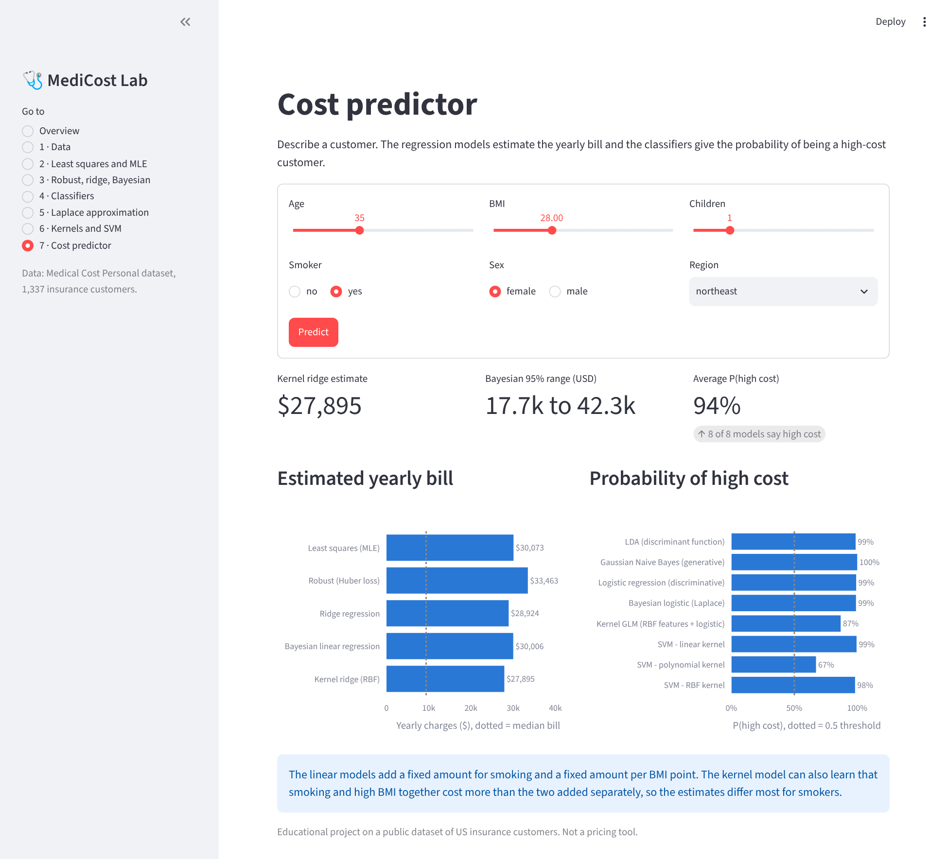
Figure 12. 7 · Cost predictor

