

**Queries link -**

<https://drive.google.com/file/d/15F5vObU20T_VRK27ySUf6Jeqe2o_zue8/view?usp=drive_link>

**Overview**

* **Objective:**

**Obtain Sales Analysis of the following dataset and perform the Following 5 operations:**

1.Top Sales per Customer

2.Average Discount by Product Category

3.Top 5 Cities by Total Sales

4.Product with sales greater than $5000

5.Number of Orders per Shipping Mode

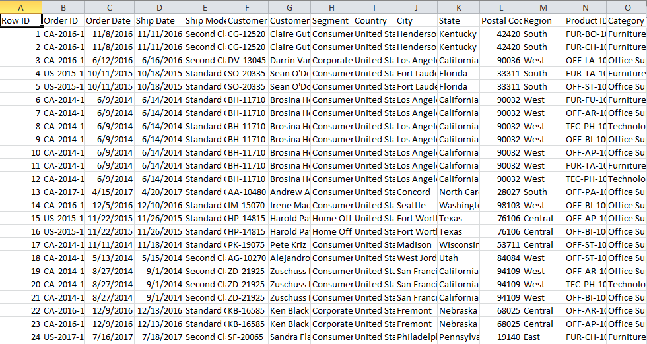

**The Project**

* **About the Project**

This project is focused on analyzing sales data using SQL to generate meaningful insights. The analysis helps identify top customers, products, and cities, as well as calculate average discounts and sales patterns.

* **Goals**

1. Analyze sales data to identify top customers and products.
2. Calculate the average discount by product category.
3. Find the top cities with the highest total sales.
4. Identify products with sales greater than $5000.
5. Analyze the number of orders based on different shipping modes.

**Introduction**

This project involves analyzing sales data to provide insights into customer behavior, product performance, and sales trends. The main focus is on understanding sales performance by identifying top customers, high-selling products, and analyzing discounts and shipping methods. The goal is to extract useful information that can help improve business strategies.

* **Technologies used:**

1. **SQL Server Management Studio (SSMS):** For managing and analyzing the sales database.
2. **Excel:** Used to handle and import bulk data for analysis.
3. **T-SQL (Transact-SQL):** For querying and analyzing the dataset.

**Screenshots:**

* **Creating database, and table:**

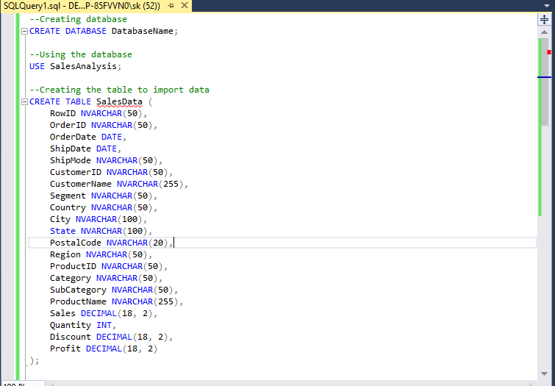

* **Importing and verifying the data is imported correctly:**

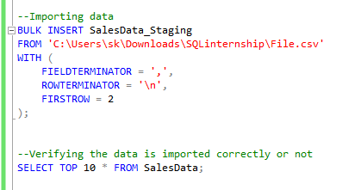

**Operations**

1. **Top sales per customer :**

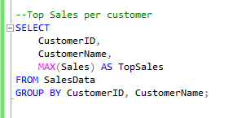

Result:

This part of the project identified which customers made the highest sales, helping to spot loyal and high-spending customers.

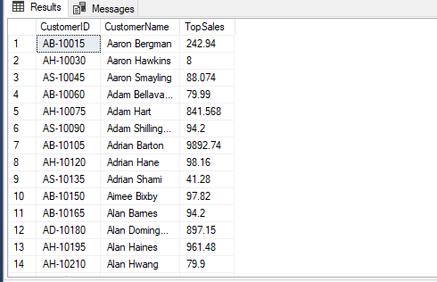

2. **Average Discount by Product Category :**

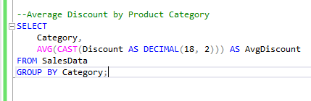

Result:

We calculated the average discount given for each product category, showing which items had more discounts, helping in future pricing decisions.

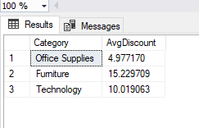

3. **Top 5 Cities by Total Sales :**

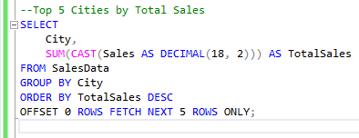

Result:

We found the cities with the highest total sales, giving insight into where the business performs best.

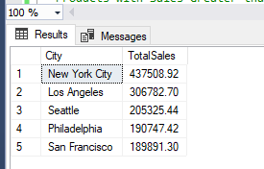

4. **Products with Sales Greater than $5000**

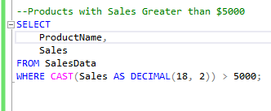

Result:

This part identified which products had sales over $5000, highlighting high-performing items.

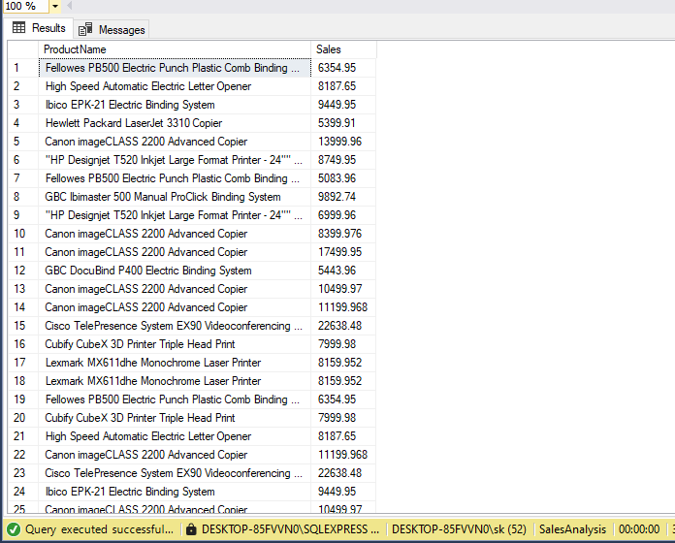

5. **Number of Orders per Shipping Mode :**

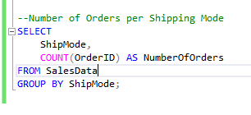

Result:

We analyzed how many orders were delivered using each shipping method, giving insight into popular delivery preferences among customers.

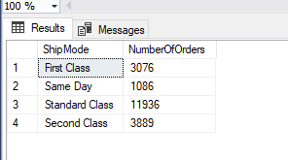

**Conclusion**

**Summary of Findings**:

During the project, I found important information like the best customers, top cities for sales, and products that performed well. I also learned about average discounts by product category and the most common shipping methods. These insights can help make better decisions for improving sales.

**Lessons Learned and Challenges Faced**:

One key lesson was realizing how crucial it is to have clean and accurate data. I faced challenges with handling data formats, especially in fields like Sales and Discount. Solving these issues helped me improve my data processing and cleaning skills.

**Appendices:**

Dataset link -

<https://www.kaggle.com/datasets/vivek468/superstore-dataset-final/code?datasetId=1940216&sortBy=dateRun&tab=profile&excludeNonAccessedDatasources=false>

Query file -

<https://drive.google.com/file/d/15F5vObU20T_VRK27ySUf6Jeqe2o_zue8/view?usp=drive_link>