**WEEK 1 ASSIGNMENT**

**By PRIYANSHU SINGH**

**LEC-1**

**INTRODUCTORY SESSION**

We classify neural network in majorly three categories:

keeping in mind that deep learning and computer vision are completely different terms computer vision is a specialized category whereas deep learning is the combined knowledge of above three

What is deep learning??

deep learning is a specialized form of machine learning where we use algorithms inspired by the structure and function of human brain, called artificial neural network, it helps computer to learn relevant information from large dataset without explicit programming.

ML

DEEP LEARNING

**Common Applications:**

* **Computer Vision** (e.g., facial recognition, object detection)
* **Natural Language Processing** (e.g., chatbots, translation)
* **Speech Recognition**
* **Autonomous Driving**
* **Medical Diagnosis**

WHAT IS CNN??

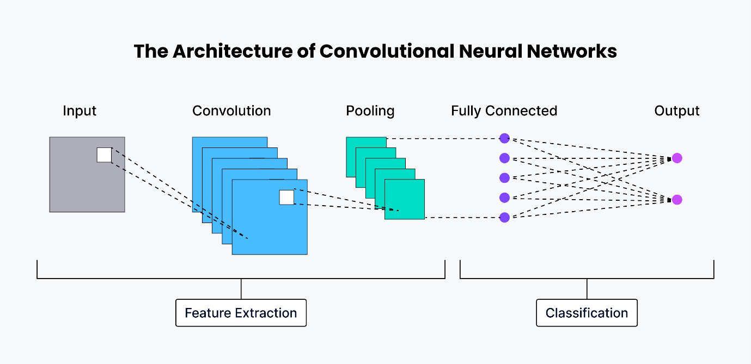A CNN is a specialized type of deep learning neural network where it processes with images and videos.it extract important information from images without needing manual feature engineering

PIPELINE OF OUR PROJECT (FOREST FIRE DETECTION USING DEEP LEARNING)

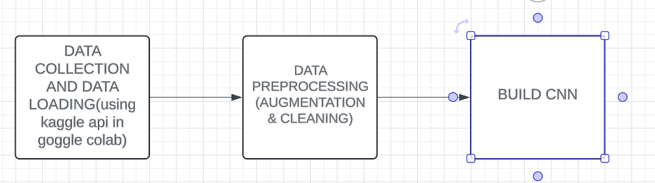

MODEL

IMAGE(TRAINING)

IMAGE(VALIDATION)

IMAGE(TEST) AFTER COMPLETED TRAINING