WEEK 5 REPORT

Model Evaluation and
Reporting Strategy
An evaluation framework for agricultural-yield prediction

Report detail | Information
Intern | Priyanshu Kumar Singh
Program | YuvaIntern — Junior Data Scientist Internship
Task | Week 5: Model Evaluation and Reporting Strategy
Project context | Agribusiness analytics; evaluation of the Week 4 wheat-yield forecasting framework
Worked examples | Illustrative numbers, clearly labelled

1. Executive Summary
This report proposes a reproducible approach for evaluating and communicating predictive-model performance in agribusiness. The main example is a hypothetical model predicting crop yield in tonnes per hectare using information such as historical yield, rainfall, temperature, soil characteristics, irrigation access, and fertilizer use, provided each feature is available at the forecast date. The framework covers data splitting, baseline comparison, metrics, visual diagnostics, reliability checks, stakeholder reporting, limitations, and future refinement.
No single metric is sufficient. MAE describes typical absolute error in the target's units; RMSE gives larger errors greater weight; and R-squared compares squared error with variation around the observed mean. These should be interpreted alongside residual plots, subgroup performance, temporal validation, and the consequences of forecast errors.
The worked examples use illustrative numbers that continue the Week 4 wheat-yield example (section 5.2), so every calculation can be checked by hand. The comparison in section 5.2 covers only 2020 and 2021. It is a two-year illustration, separate from the proposed 2020–2022 evaluation, and its statistical figures are illustrative calculations rather than results from a model run. This report describes a proposed evaluation design: no real model has been trained or evaluated for it. Section 10 applies the same framework to price forecasting, post-harvest loss classification and input demand, and section 12 gives a five-day plan for running the evaluation on the sealed 2020–2022 test years and replacing the illustrative numbers with measured results.

2. Evaluation Problem and Intended Use
Evaluation starts by defining what is predicted, when the prediction is made, and which decision it supports. This report evaluates the framework from Week 4: wheat yield (rabi season) for Uttar Pradesh districts, forecast on 1 January, before the March–April harvest. Candidate inputs are those available by that date: earlier years’ yields, October–December rainfall and temperature, and irrigated-area share, with soil and fertilizer indicators added where reliable data exist. The same process can be adapted to market prices, input demand and other targets by changing the target, units, baseline and error thresholds (section 10).
Item | Proposed definition | Why it matters
Target | Crop yield in tonnes per hectare for a crop, district, and season | Defines the quantity being evaluated
Prediction time | 1 January, before the March–April harvest | Prevents use of future information
Users | Farm managers, planners, analysts, supply-chain teams | Determines acceptable error and reporting format
Intended use | Planning inputs, estimating production, flagging areas needing attention | Connects model errors to decisions
Baseline | Last year’s yield for the same district | Tests whether the model adds value
Evaluation unit | Held-out district-year observation (proposed test years 2020–2022) | Makes scoring auditable

3. Evaluation Design and Data Controls

3.1 Train, validation, and test sets
For forecasting, a time-aware split is generally safer than randomly mixing years. Train on earlier seasons, use a later validation period for feature/model selection, and reserve the latest suitable period as a final test set. Do not repeatedly tune against the final test set. If deployment targets new districts, use a geographic holdout or grouped validation as well. The Week 4 design follows this: rolling validation folds for 2015–2019 and sealed test years 2020–2022, which are to be scored once. This is a proposed design; the test years have not been scored.
- Fit imputers, scalers, encoders, and feature-selection steps on training data only; apply the fitted transformations to validation and test data.
- Exclude features known only after the forecast date, such as final harvest yield, end-of-season totals, or future weather observations.
- Keep related district-season records together where necessary to prevent leakage between splits.
- Record data version, filters, split dates, sample counts, features, model settings, random seeds where relevant, and software environment.

3.2 Compare with a meaningful baseline
A model should be compared with a simple approach a stakeholder could otherwise use, such as previous-season yield or a historical average calculated only from information available at prediction time. Compute baseline and candidate metrics on the same held-out observations. If a complex model does not improve on a suitable baseline, its added complexity may not be justified.

3.3 Define acceptance criteria before evaluation
Discuss with stakeholders what error is tolerable for the intended decision before inspecting final test results. A threshold should reflect consequences, not merely a convenient score. Report sample sizes and uncertainty; a small numerical improvement is not automatically operationally meaningful.

4. Performance Metrics
Let yᵢ be observed yield, ŷᵢ be predicted yield, and n be the number of evaluated observations. Define error eᵢ = yᵢ − ŷᵢ. If yield is measured in tonnes per hectare (t/ha), MAE and RMSE are also in t/ha.

4.1 Mean Absolute Error (MAE)
Formula: MAE = (1/n) × Σ |yᵢ − ŷᵢ|. MAE is the average absolute difference between observed and predicted values. It is intuitive and expressed in the target's units. Lower MAE is better when comparing models on the same observations. However, it does not emphasize large misses as strongly as RMSE.

4.2 Root Mean Squared Error (RMSE)
Formula: RMSE = √[(1/n) × Σ (yᵢ − ŷᵢ)²]. Squaring errors before averaging gives large misses more influence. This is useful when unusually large forecasting errors create substantial planning risk. RMSE can be dominated by outliers, so investigate large residuals instead of interpreting the score alone.

4.3 Coefficient of determination (R²)
Formula: R² = 1 − [Σ(yᵢ − ŷᵢ)² / Σ(yᵢ − ȳ)²], where ȳ is the mean observed value in the evaluated sample. R² closer to 1 indicates better fit under this definition; 0 means squared error equals that of predicting the test-set mean; a negative value means worse performance than that reference. R² is not a percentage accuracy score and does not prove forecasts are unbiased or useful for every decision.
Metric | Answers | Strength | Caution
MAE | How far off are predictions on average? | Intuitive; target units | Less sensitive to large errors than RMSE
RMSE | How much do large misses affect error? | Penalizes large errors | Can be dominated by extremes
R² | How does squared error compare with mean reference? | Context about variation explained | Not an accuracy percentage; can be negative
Mean error / bias | Do predictions tend to over- or under-predict? | Shows directional error | State the sign convention

5. Worked Numerical Examples (Illustrative Numbers)

5.1 Formula walk-through with four observations
The four observations below represent a mock dataset used strictly to demonstrate the mathematical calculation of each metric. They are not measured results from a real agricultural dataset or a trained model.
Obs. | Observed y (t/ha) | Predicted ŷ (t/ha) | Error y−ŷ | Absolute error | Squared error
A | 2.0 | 1.8 | 0.2 | 0.2 | 0.04
B | 3.0 | 3.2 | −0.2 | 0.2 | 0.04
C | 4.0 | 3.5 | 0.5 | 0.5 | 0.25
D | 5.0 | 4.5 | 0.5 | 0.5 | 0.25
Total | 14.0 | 13.0 | 1.0 | 1.4 | 0.58

MAE = (0.2 + 0.2 + 0.5 + 0.5) / 4 = 1.4 / 4 = 0.35 t/ha.
RMSE = √[(0.04 + 0.04 + 0.25 + 0.25) / 4] = √0.145 ≈ 0.381 t/ha.
The mean observed yield is 3.5 t/ha. The total squared deviation from that mean is 5.0, so R² = 1 − (0.58 / 5.0) = 0.884. This is a calculation on four invented examples only, not evidence that a real model achieves this score.
The mean error (observed − predicted) is 1.0 ÷ 4 = 0.25 t/ha. A positive value means the mock model under-predicts on average.
Interpretation: illustrative MAE of 0.35 t/ha means predictions differ from observations by 0.35 t/ha on average in absolute terms in this tiny example. RMSE is higher than MAE because it gives greater weight to larger errors. Four observations are far too few to assess real-world generalization or reliability.

5.2 Baseline versus candidate model (continuing the Week 4 example)
The Week 4 framework uses last year’s yield as the baseline and holds out the 2020–2022 test years for the proposed evaluation. The eight observations below are a separate illustrative two-year example: four districts, 2020 and 2021 only, with no 2022 observations. They repeat the illustrative values from the Week 4 report and are neither the full test set nor measured results. Error = observed − predicted, in t/ha.
District, year | Observed (t/ha) | Baseline prediction | Baseline error | Model prediction | Model error
A 2020 | 3.2 | 3.0 | +0.2 | 3.1 | +0.1
B 2020 | 2.9 | 3.1 | −0.2 | 2.8 | +0.1
C 2020 | 3.5 | 3.3 | +0.2 | 3.4 | +0.1
D 2020 | 3.0 | 3.2 | −0.2 | 3.1 | −0.1
A 2021 | 3.3 | 3.2 | +0.1 | 3.5 | −0.2
B 2021 | 2.6 | 2.9 | −0.3 | 2.7 | −0.1
C 2021 | 3.8 | 3.4 | +0.4 | 3.6 | +0.2
D 2021 | 2.8 | 3.0 | −0.2 | 2.9 | −0.1

Mean observed yield = 25.1 ÷ 8 = 3.1375 t/ha, and the total squared deviation from it is 1.0787. Baseline: MAE = 1.8 ÷ 8 = 0.225 t/ha; RMSE = √(0.46 ÷ 8) = 0.240 t/ha; R² = 1 − 0.46 ÷ 1.0787 = 0.57; mean error = 0.000. Candidate: MAE = 1.0 ÷ 8 = 0.125 t/ha; RMSE = √(0.14 ÷ 8) = 0.132 t/ha; R² = 1 − 0.14 ÷ 1.0787 = 0.87; mean error = 0.000.
Relative to the average yield of 3.14 t/ha, the typical miss is about 7.2% for the baseline and 4.0% for the candidate. The candidate’s MAE is 44% lower and its RMSE 45% lower. Both mean errors are zero because over- and under-predictions cancel, so bias alone would have hidden the baseline’s typical miss of 0.225 t/ha. This is why bias is reported next to MAE and RMSE, never instead of them.
Subgroup errors show where the average hides differences:
Subgroup | Observations | Baseline MAE (t/ha) | Candidate MAE (t/ha)
Year 2020 | 4 | 0.200 | 0.100
Year 2021 | 4 | 0.250 | 0.150
District A | 2 | 0.150 | 0.150
District B | 2 | 0.250 | 0.100
District C | 2 | 0.300 | 0.150
District D | 2 | 0.200 | 0.100

The candidate improves on the baseline in both test years and in districts B, C and D. In district A both have an MAE of 0.15 t/ha (the candidate over-predicts A 2021 by 0.2 t/ha), so district A is flagged for review before any pilot.
Eight pairs leave a lot of uncertainty. The two statistical calculations below are illustrative: they use only these eight invented pairs and are not results from a real model run. A bootstrap interval for the mean improvement in absolute error (baseline minus candidate, 0.10 t/ha), from resampling the eight pairs 10,000 times with a fixed seed, runs from 0.04 to 0.15 t/ha. The interval excludes zero but is wide relative to the improvement. A Wilcoxon signed-rank test on the same eight paired differences (test M-1 in the Week 4 framework) gives an exact p ≈ 0.055. The normal approximation gives p ≈ 0.033, but it is less reliable with only eight pairs and tied differences, so the exact value is the one to report. Both are above the corrected threshold of 0.025. Neither calculation shows that the model performs reliably. At most the result is promising, and it needs retesting on the full 2020–2022 test years.

6. Model Comparison and Decision Rules
Baseline and candidate metrics are always computed on the same held-out observations. Using the worked example in section 5.2 (illustrative numbers, 2020 and 2021 only), the comparison is reported like this:
Model | MAE (t/ha) | RMSE (t/ha) | R² | Mean error | Notes
Baseline (last year’s yield) | 0.225 | 0.240 | 0.57 | 0.000 | Reference performance
Candidate model | 0.125 | 0.132 | 0.87 | 0.000 | Closer to the observed yield in 7 of 8 cases
Change vs baseline | −0.100 (−44%) | −0.108 (−45%) | +0.30 | — | Absolute and relative change

Worked example of the decision rule.
Acceptance criterion (set before testing) | Illustrative result | Met?
MAE no higher than 0.20 t/ha | 0.125 t/ha | Yes
MAE at least 5% lower than the baseline | 44% lower | Yes
No district worse than the baseline | District A equal (0.15 vs 0.15); B, C and D better | Yes
Formal test M-1 passes at the corrected level of 0.025 | Illustrative Wilcoxon signed-rank: exact p ≈ 0.055 (normal approximation ≈ 0.033); both above 0.025 | No

Three of the four criteria are met, but the formal test does not clear the corrected threshold, so the decision under this rule is improve and retest on every district and test year before a pilot, not deploy. The rule is written before the final test is scored, so the decision cannot be adjusted to fit the result. The 0.20 t/ha limit is an invented example of a threshold agreed with stakeholders. Every figure in these two tables, including the p-value, comes from the eight invented observations in section 5.2, so none of it is evidence that a real model performs reliably.

- Choose the primary metric based on the decision cost. MAE is a reasonable default for typical absolute error; RMSE deserves attention when large misses are especially costly.
- Report absolute and relative changes versus baseline, but do not assume a small numerical improvement is meaningful.
- Inspect errors by crop, district, season, irrigation status, and yield range where sample sizes support fair comparison.
- Use repeated time-based validation or uncertainty intervals where feasible; a single split may be unusually easy or difficult.
- Set acceptable error thresholds with stakeholders before examining final test results.

7. Visualization Plan
Visualization | What to plot | Interpretation | Decision value
Observed vs predicted | Observed on x-axis, predicted on y-axis; add 45° reference line | Points near line indicate better predictions; systematic offsets indicate bias | Checks overall fit and extremes
Residual plot | Residual (observed − predicted) against predicted value | Patterns or widening spread may indicate non-linearity or changing error variance | Reveals failure modes
Error distribution | Histogram or box plot of residuals/absolute errors | Shows typical error, skew, and extremes | Communicates spread of errors
Model comparison | Baseline and candidate MAE/RMSE; separate panels if scales differ | Lower MAE/RMSE is better on same test observations | Shows whether complexity adds value
Subgroup performance | MAE by district, crop, or season, with sample counts | Large differences can reveal unreliable groups | Supports targeted review
Forecast over time | Observed and predicted yield by season for selected districts | Persistent divergence or missed turning points can indicate drift | Checks temporal behaviour

Every figure should have a descriptive title, labeled axes, units, a legend if needed, evaluation period, and observation count. Captions should state the main takeaway and caveat. Avoid misleading truncated axes. Figures 1 and 2 below are built from the illustrative data in section 5.2 to show the intended style.

7.1 Example charts from the illustrative data
The two charts use the eight observations from section 5.2. They show the format, not results.
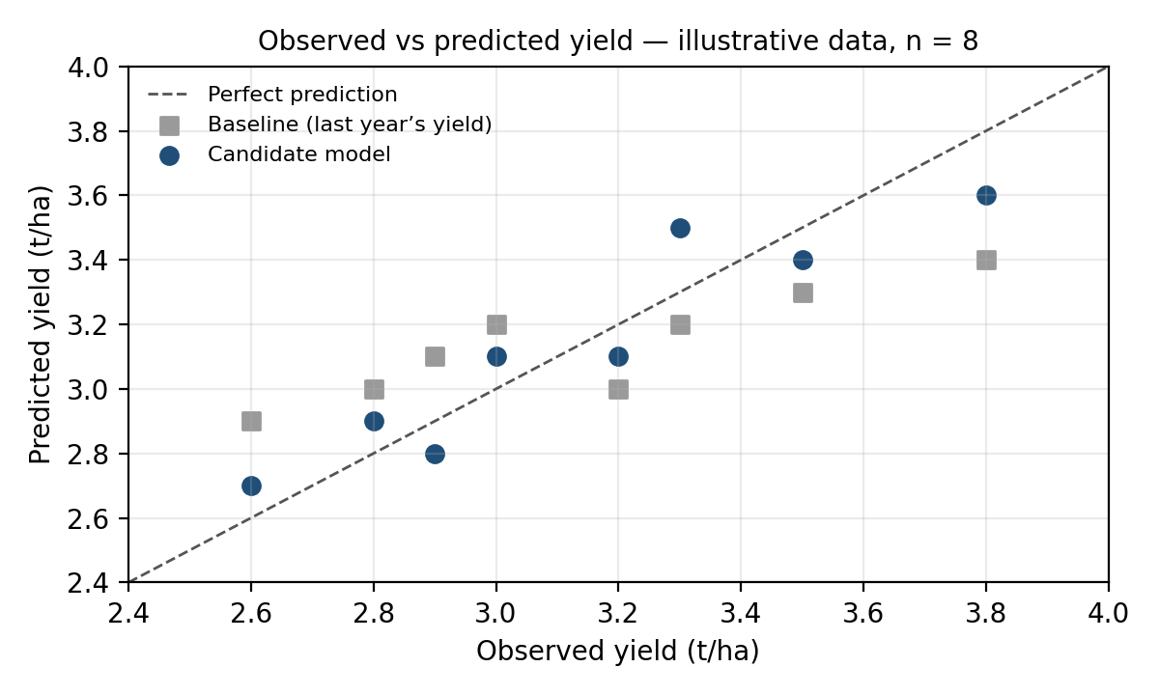
Figure 1. Observed versus predicted yield (illustrative, n = 8). Points closer to the dashed line are better predictions; here the candidate’s points sit closer to the line than the baseline’s.
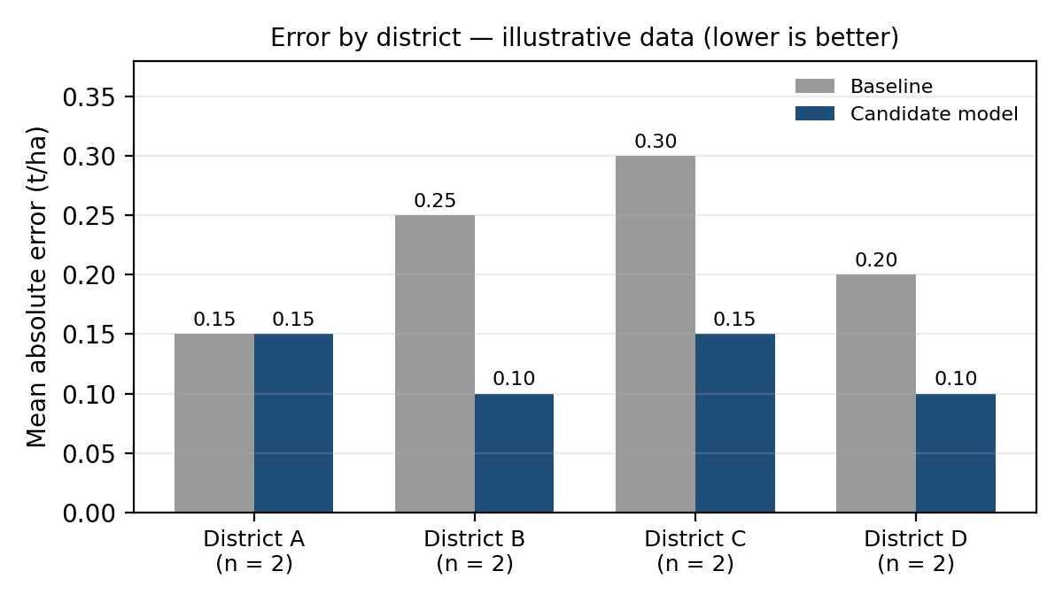
Figure 2. Error by district (illustrative; two observations per district). The candidate is better in districts B, C and D and no better in district A, which is flagged for review. For non-expert readers the chart title would carry the plain-language headline.

8. Reliability, Error Analysis, and Validation

8.1 Systematic error
With the convention e = observed − predicted, positive mean error indicates under-prediction on average and negative mean error indicates over-prediction. Check subgroup and time-period errors because a good overall MAE can hide weak performance for one crop or district.

8.2 Outliers
A large residual may reflect data-entry error, a genuine extreme season, a localized shock, or a model limitation. Verify the source record before correcting, retaining, or excluding it. Document exclusion rules and, where appropriate, compare results with and without questionable records.

8.3 Prediction uncertainty
Point predictions do not communicate all uncertainty. If the method supports prediction intervals, evaluate their coverage and width on held-out data. For example, a nominal 90% interval should be checked for approximately 90% coverage over a sufficiently large, representative sample. Check coverage by region and season because aggregate coverage can hide uneven reliability.

8.4 Monitoring after deployment
Track feature and prediction distributions, delayed actual outcomes, metric trends, and subgroup errors. Agricultural conditions, practices, and data pipelines change. Define who reviews alerts and what actions follow; retraining should be driven by documented evidence and governance.

9. Reporting Findings to Stakeholders

9.1 Suggested report structure
- Executive summary: intended use, evaluation period, primary metric, baseline comparison, major caveat, and recommendation.
- Data and design: source, target, units, time window, split strategy, sample counts, exclusions, and leakage safeguards.
- Results: baseline and candidate metrics, visualizations, subgroup analysis, and uncertainty where available.
- Interpretation: what errors mean for decisions, where the model is strong or weak, and what remains unproven.
- Recommendations: approve a limited pilot, improve and retest, or do not use operationally yet.
- Appendix: feature definitions, formulas, model settings, reproducibility details, and additional plots.

9.2 Executive-summary example (illustrative numbers)
Purpose: estimate wheat yield for Uttar Pradesh districts on 1 January, before the March–April harvest. Evaluation: eight illustrative district-year observations covering 2020 and 2021 only (a two-year illustration, not the proposed 2020–2022 test set), using a time-aware split. Compared with last year’s yield (MAE 0.225 t/ha), the candidate model achieved MAE 0.125 t/ha, RMSE 0.132 t/ha and R² 0.87. The largest weakness was district A, where the candidate was no better than the baseline (MAE 0.15 t/ha for both). Reliability was examined with illustrative calculations: a bootstrap interval for the improvement (0.04 to 0.15 t/ha), errors by district and year, and the pre-specified test M-1 (Wilcoxon exact p ≈ 0.055; the normal approximation gives ≈ 0.033; both are above the corrected threshold of 0.025). Recommendation: improve and retest on all districts and the full 2020–2022 test years before any pilot, because eight observations cannot confirm the improvement. Important limitation: the sample is small, the numbers and statistics are illustrative, and they do not show reliable performance.
Plain-language version for non-technical readers: in this illustrative example the model’s yield forecast is off by about 0.13 t/ha on average, compared with about 0.23 t/ha when last year’s yield is simply repeated. That is roughly 4% of a typical yield against 7%. The model does better in three of the four districts here, but eight observations are not enough to show the improvement is reliable, so the next step is a larger test rather than a rollout.

9.3 Translate metrics into operational meaning
Do not report only “RMSE is 0.13.” State the unit, the comparison and the decision relevance: “On held-out seasons, the candidate’s RMSE was 0.132 t/ha compared with 0.240 t/ha for last year’s yield (illustrative numbers). Large misses are therefore smaller as well as typical ones, but district A needs review and interval coverage should be checked before operational use.” Do not call a model accurate without a defined acceptance threshold and evidence.

10. Applications to Other Agribusiness Scenarios
The evaluation principles transfer to other tasks, but target, split, metric, and decision costs must be adapted. The three worked examples after the table use illustrative numbers.
Scenario | Target and possible inputs | Evaluation approach | Specific checks
Market-price forecasting | Future modal mandi price; historical prices, arrivals, season, location, known-at-forecast features | Chronological holdout; MAE/RMSE in ₹/quintal; compare with last-value or seasonal baseline | Avoid future-price leakage; inspect price spikes and mandi/crop differences
Input/resource demand | Fertilizer, irrigation, or seed demand; cropped area, crop mix, season, usage history | Time-based validation; MAE/RMSE in physical units; compare with current planning method | Over- and under-estimation may have different costs; inspect peak demand
Production volume | Total crop production; yield and harvested area with consistent definitions | Evaluate tonnes of error and compare with historical baseline | Check area-yield consistency and regional aggregation errors
Post-harvest loss | Loss proportion or quantity; storage duration, humidity, handling, crop type | For continuous quantity use MAE/RMSE; for classification use precision, recall, F1 and calibration as suitable | Rare severe events can be hidden by average metrics; inspect imbalance

For classification tasks, regression metrics such as MAE/RMSE are not appropriate for the class label. Select metrics aligned with the outcome and decision, such as precision, recall, F1, ROC-AUC where suitable, and probability calibration. For rare high-impact events, precision-recall analysis and cost-sensitive thresholds may be more informative than accuracy alone.

10.1 Market-price forecasting
Weekly modal price of one crop at one mandi, in ₹ per quintal (illustrative). The baseline forecasts each week with the previous week’s price; the candidate is any price model. Weeks 2–5 are evaluated. Error = observed − forecast.
Week | Observed (₹/quintal) | Baseline forecast | Baseline error | Model forecast | Model error
2 | 2,200 | 2,000 | +200 | 2,150 | +50
3 | 2,100 | 2,200 | −100 | 2,150 | −50
4 | 2,500 | 2,100 | +400 | 2,300 | +200
5 | 2,400 | 2,500 | −100 | 2,450 | −50

Baseline: MAE ₹200, RMSE ₹234.5, MAPE 8.5%. Candidate: MAE ₹87.5, RMSE ₹109.0, MAPE 3.7%. The week-4 price spike produces most of the squared error, which is why RMSE is well above MAE in both cases and why spikes are inspected separately. MAPE (mean absolute percentage error) is added because errors in rupees cannot be compared between a ₹2,400 crop and a ₹6,000 crop, while percentage errors can. The split must be chronological and the baseline may use only past prices.

10.2 Post-harvest loss classification
A model flags storage batches at high risk of loss (illustrative). Of 100 batches, 20 actually suffered high loss; the model flagged 25, of which 16 were truly high-loss.
 | Actually high loss | Actually not high loss
Flagged as high risk | 16 (true positives) | 9 (false positives)
Not flagged | 4 (false negatives) | 71 (true negatives)

Precision = 16 ÷ 25 = 0.64 (of the batches flagged, 64% really were high-loss). Recall = 16 ÷ 20 = 0.80 (80% of the high-loss batches were caught). F1 = 2 × 0.64 × 0.80 ÷ (0.64 + 0.80) = 0.71. Accuracy = (16 + 71) ÷ 100 = 0.87. A rule that never flags any batch scores accuracy 0.80 but recall 0, so accuracy alone makes a useless model look good. Whether precision or recall matters more depends on the cost of an unnecessary inspection compared with a missed loss, which is agreed with stakeholders before testing. MAE and RMSE are not used for a yes/no outcome.

10.3 Input (fertilizer) demand with unequal error costs
Assume an under-forecast of demand (a stock-out) costs ₹3,000 per tonne and an over-forecast (extra storage) costs ₹1,000 per tonne (invented figures). Two forecasts for four districts are compared.
District | Actual demand (t) | Forecast A (t) | Forecast B (t)
1 | 100 | 90 | 110
2 | 120 | 130 | 130
3 | 80 | 70 | 90
4 | 150 | 160 | 160

Both forecasts have an MAE of 10 t, so MAE alone ranks them equally. Forecast A under-forecasts two districts (2 × 10 t × ₹3,000 = ₹60,000) and over-forecasts two (2 × 10 t × ₹1,000 = ₹20,000), a total cost of ₹80,000. Forecast B over-forecasts all four (4 × 10 t × ₹1,000 = ₹40,000). The metric has to follow the decision cost, so a cost-weighted error is reported next to MAE here.

11. Limitations and Future Refinement
- Data quality and coverage: public agricultural records may contain missing, delayed, inconsistent, or differently aggregated observations. Document provenance and coverage.
- Generalization: results for one crop, region, or period may not transfer to other crops or districts. Use temporal or geographic holdouts aligned with intended use.
- Unobserved drivers: pests, local management, extreme weather, policy changes, and reporting differences may be absent from the features.
- Metric limitations: no single metric captures every decision cost. Interpret MAE, RMSE, R², bias, subgroup errors, and uncertainty together.
- Small test samples: metrics can vary substantially with few observations. Report sample counts and avoid strong conclusions from small groups.
- Drift and maintenance: climate patterns, varieties, practices, and data pipelines change. Establish monitoring and review ownership.
- Interpretability: stakeholders need intended use, uncertainty, and failure cases, not only a ranking of models.
- Causality: predictive associations do not prove that changing a feature will cause yield to increase. Do not turn feature importance into causal recommendations without an appropriate design.
Prioritize refinements based on observed failure modes: improve data quality, compare feature sets using leakage-safe validation, tune only within validation, investigate subgroup gaps, quantify uncertainty where feasible, and retest on an untouched final test set. Version the model and evaluation artifacts for reproducibility.

12. Evaluation Plan: Day-by-Day
A five-working-day plan (about 17 hours) for running this evaluation once the Week 4 model and the sealed test years are ready:
Day | Tasks | Output / checkpoint | Time
1 | Freeze the Week 4 model, features and split. Load the sealed 2020–2022 test years once and produce baseline and candidate predictions. | Predictions file with data and code version | 3 h
2 | Compute MAE, RMSE, R² and mean error for both; absolute and relative change; bootstrap interval for the improvement. | Metrics table | 3 h
3 | Draw the diagnostic charts: observed vs predicted, residuals, error distribution, MAE by district and year with counts. | Saved figures with captions and units | 4 h
4 | Run test M-1, apply the acceptance criteria, review subgroups, list the largest errors and verify them against source records. | Decision table; failure-case list | 3 h
5 | Write the executive summary (technical and plain-language), recommendations and limitations; commit the report and notebook to GitHub. | Final evaluation report; repository updated | 4 h

13. Conclusion
A credible model evaluation combines appropriate metrics with a sound test design, a meaningful baseline, diagnostic visualizations, subgroup analysis, uncertainty checks, and a clear explanation of how errors affect agribusiness decisions. MAE, RMSE, and R² provide complementary information; none should be used alone to declare a model ready for deployment.
Together with the Week 4 framework, this report gives a complete path from data to decision: a leakage-safe split, a baseline, three complementary metrics plus bias, diagnostic charts, acceptance criteria and a formal test fixed in advance, and a summary that non-technical stakeholders can act on. The worked examples show each step on illustrative numbers. Running the plan in section 12 on the sealed 2020–2022 test years replaces those numbers with measured results.

