IILM UNIVERSITY
Greater Noida, Uttar Pradesh

Report
Of
FULL STACK DEVELOPMENT INTERNSHIP

Submitted To
School of Computer Science and Engineering
IILM University, Greater Noida, U.P.
In partial fulfilment of the requirement of degree of
BACHELOR OF TECHNOLOGY
(Computer Science and Engineering)

By

Roll Number: 2410030679
Name: PRIYANSHU BISHT
Section: 3CSE21
Batch: 2024-28

1. Candidate's Declaration
I, Priyanshu Bisht, a student of B.Tech (Computer Science and Engineering), School of Computer Science and Engineering, IILM University, Greater Noida, U.P., Batch 2024-28, hereby declare that the Internship Report entitled “Full Stack Development Internship”, undertaken at Thiranex during the period 06 August 2026 to 05 September 2026, is an authentic record of my own work carried out during the course of the internship.
I further declare that this report, and the projects described herein — namely the Personal Portfolio Website, Task Management Application, E-Commerce Web Application, and Blog Platform with Comments — have been completed by me under the guidance of my mentors at Thiranex and the faculty of the School of Computer Science and Engineering. This report is submitted in partial fulfilment of the requirement for the award of the degree of Bachelor of Technology in Computer Science and Engineering, and has not been submitted elsewhere for the award of any other degree or diploma.

Date:10 September 2026
Place: Greater Noida

Priyanshu Bisht
3CSE21
Roll No.: 2410030679

2. Acknowledgement
I would like to express my sincere gratitude to IILM University, Greater Noida, U.P., for providing me with the opportunity and the academic environment necessary to undertake this internship as part of my Bachelor of Technology programme in Computer Science and Engineering.
I am deeply thankful to the School of Computer Science and Engineering and its faculty members for their continuous guidance, encouragement, and valuable feedback throughout the duration of this internship. Their support in helping me connect classroom learning with practical, industry-oriented work has been invaluable.
I extend my heartfelt thanks to Thiranex for providing me with this internship opportunity and enabling me to work on real-world full stack development projects. I am grateful to my mentors and guides at Thiranex, whose technical support, constructive suggestions, and constant motivation helped me complete the Personal Portfolio Website, Task Management Application, E-Commerce Web Application, and Blog Platform with Comments successfully.
Finally, I would like to thank my parents and family for their unwavering support, patience, and encouragement throughout this internship period. Their belief in my abilities has been a constant source of motivation.

Priyanshu Bisht

3. Internship Completion Certificate
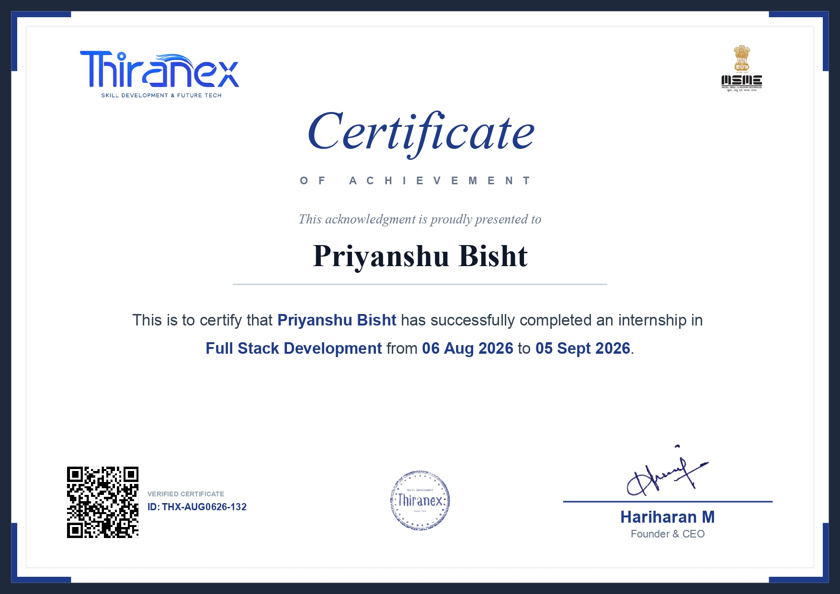

Table of Contents
1. Candidate's Declaration
2. Acknowledgement
3. Internship Completion Certificate
4. Project Description
4.1 Introduction
4.2 Organization Profile
4.3 Problem Statement
4.4 Project Objectives
4.5 Scope of the Project
4.6 Technologies and Tools Used
4.7 System Architecture
4.8 Methodology
4.9 Expected Outcomes
4.10 Certificates of Completion and Other Communication Proof
5. Bibliography / References

4. Project Description

4.1 Introduction
Full Stack Development refers to the practice of designing, building, and maintaining both the client-facing (frontend) and server-side (backend) components of a web application. A full stack developer works across the entire technology stack — from the user interface that a person interacts with, through the application logic and Application Programming Interfaces (APIs) that process requests, to the database layer that stores and retrieves data. This end-to-end skill set makes full stack developers highly valuable in the modern software industry, as they are able to understand and contribute to every layer of an application.
Frontend development focuses on the visual and interactive aspects of an application — the layout, design, responsiveness, and user experience. It is the layer with which end users directly interact, and it is typically built using technologies such as HTML, CSS, and JavaScript, often alongside modern frameworks or libraries. Backend development, on the other hand, deals with the logic, data processing, authentication, and communication between the frontend and the database. It ensures that data is handled securely, efficiently, and correctly, and it exposes this functionality to the frontend through REST APIs or similar interfaces. Both layers are equally important: a well-designed frontend without a robust backend cannot securely manage data, and a powerful backend without a usable frontend cannot serve end users effectively. The integration of these two layers is what makes a web application truly functional.
The purpose of this internship was to provide practical, hands-on exposure to the complete process of building web applications — from planning and interface design to backend logic, database integration, and deployment. Through the Full Stack Development Internship at Thiranex, I was given the opportunity to work independently on four distinct web application projects: a Personal Portfolio Website, a Task Management Application, an E-Commerce Web Application, and a Blog Platform with Comments. Each project was designed to reinforce a different set of full stack development concepts while collectively building a well-rounded understanding of how modern web applications are conceived, designed, developed, and delivered.
This internship offered significant practical learning value. Rather than working through isolated theoretical exercises, I was able to apply concepts learned during my academic coursework — such as data structures, database management, and web technologies — to build complete, functioning applications. This experience strengthened my problem-solving abilities, improved my understanding of how frontend and backend components communicate with one another, and gave me first-hand experience of the software development lifecycle, including requirement analysis, design, implementation, testing, and debugging.

4.2 Organization Profile
Thiranex is the organization through which I undertook and completed my Full Stack Development Internship. It served as the platform that provided the practical development tasks, project assignments, and mentorship that formed the basis of this internship programme.
Over the course of the internship, Thiranex provided structured project assignments covering different aspects of full stack web development, enabling interns to gain exposure to frontend design, backend logic, database integration, and application deployment through real, hands-on project work. This report focuses on the internship experience and the projects completed, in line with the scope of work assigned during the internship period.

4.3 Problem Statement
Each of the four projects undertaken during this internship was designed to address a distinct, real-world problem commonly encountered in web application development. A brief problem statement for each project is presented below.

4.3.1 Personal Portfolio Website
In today's competitive academic and professional environment, individuals — particularly students and early-career professionals — require a dedicated online platform to showcase their skills, projects, educational background, and achievements to potential employers, collaborators, or academic institutions. A well-structured, easily accessible personal portfolio website addresses this need by presenting an individual's profile in a professional and organized manner.

4.3.2 Task Management Application
Individuals and teams often struggle to keep track of tasks, deadlines, and priorities when relying on informal methods such as notes or memory. There is a clear need for an organized digital system that allows users to create, update, track, and manage tasks efficiently, thereby improving productivity and ensuring that important work is not overlooked.

4.3.3 E-Commerce Web Application
Online shopping has become an integral part of modern commerce, and businesses require web platforms where customers can browse available products, manage a shopping cart, and complete purchases seamlessly. This project addressed the need for a functional online platform that allows users to browse products, manage a shopping cart, and place orders through a structured and user-friendly interface.

4.3.4 Blog Platform with Comments
Content creators and readers benefit from platforms that allow the publishing of written content and facilitate discussion around that content. There is a need for a web-based platform where users can publish blog posts and interact with one another through comments, fostering engagement and the exchange of ideas.

4.4 Project Objectives
The overall objective of this internship was to gain comprehensive, practical experience in full stack web development by designing and building complete, functional web applications from the ground up. The specific objectives pursued across the four projects include the following:
- To gain practical experience in full stack web development, covering both frontend and backend layers of an application.
- To design and develop clean, responsive, and user-friendly frontend interfaces for different types of web applications.
- To create and consume backend APIs that handle application logic, data processing, and communication with the database.
- To integrate a database for the persistent storage and retrieval of application data.
- To implement user authentication mechanisms, allowing secure registration, login, and session management where applicable.
- To implement CRUD (Create, Read, Update, Delete) operations as the core functionality of each application.
- To ensure that each application follows responsive design principles, so that it functions correctly across different screen sizes and devices.
- To build real-world, usable applications that reflect common problems and use cases encountered in the software industry.
- To understand the complete software development workflow, from requirement analysis and planning through to development, testing, and final delivery.
In addition to these overall objectives, each individual project carried specific goals: the Personal Portfolio Website aimed to present a professional online profile; the Task Management Application aimed to provide organized task tracking functionality; the E-Commerce Web Application aimed to simulate a functional online shopping experience; and the Blog Platform with Comments aimed to enable content publishing and reader interaction through comments.

4.5 Scope of the Project

4.5.1 Personal Portfolio Website
The scope of this project covers the presentation of an individual's academic background, technical skills, projects, and achievements through a structured, single- or multi-page website. Future enhancements could include the addition of a blog or articles section, integration with a content management system for easier updates, multi-language support, and analytics to track visitor engagement.

4.5.2 Task Management Application
The scope of this project covers the creation, updating, categorization, and tracking of tasks through a web-based interface. Future enhancements could include collaborative/team task assignment, deadline reminders and notifications, integration with calendar applications, and advanced filtering or analytics on task completion trends.

4.5.3 E-Commerce Web Application
The scope of this project covers product browsing, shopping cart management, and order placement within a simulated online shopping environment. Future enhancements could include integration with a real payment gateway, product review and rating systems, personalized product recommendations, and advanced inventory management for administrators.

4.5.4 Blog Platform with Comments
The scope of this project covers the publishing of blog posts and the ability for readers to interact through comments. Future enhancements could include support for rich media embedding, categorization and tagging of posts, comment moderation tools, and social media sharing integration.

4.6 Technologies and Tools Used
The following technologies and tools were used across the four projects developed during this internship. Where the exact library, framework, or service used for a specific project was not confirmed, a placeholder has been provided rather than assuming a technology.

Frontend Technologies
- HTML5, CSS3, and JavaScript (ES6+) — used for building the structure, styling, and interactivity of the user interfaces.
- [CONFIRM FRONTEND FRAMEWORK/LIBRARY USED — e.g., React.js] — used for building component-based, dynamic user interfaces.
- [CONFIRM CSS FRAMEWORK USED, IF ANY — e.g., Tailwind CSS / Bootstrap] — used for responsive styling and layout design.

Backend Technologies
- [CONFIRM BACKEND RUNTIME/FRAMEWORK USED — e.g., Node.js with Express.js] — used for building server-side logic and REST APIs.
- RESTful API architecture — used to enable communication between the frontend and backend layers of each application.

Database
- [CONFIRM DATABASE USED — e.g., MongoDB / MySQL / PostgreSQL] — used for the persistent storage and retrieval of application data such as user accounts, tasks, products, orders, blog posts, and comments.

Development Tools
- Visual Studio Code (or equivalent code editor) — used for writing and organizing project source code.
- Postman (or equivalent API testing tool) — [CONFIRM IF USED] for testing backend API endpoints.
- Web browser developer tools — used for debugging frontend behaviour and inspecting network requests.

Version Control
- Git — used for tracking changes to the source code throughout development.
- GitHub (or equivalent platform) — [CONFIRM IF USED] for hosting project repositories and maintaining version history.

Deployment
- [CONFIRM DEPLOYMENT PLATFORM USED, IF APPLICABLE — e.g., Vercel, Netlify, Render, or a local development environment] — used for hosting and/or running the completed applications.

4.7 System Architecture
All four applications developed during this internship follow a broadly similar full stack web application architecture, structured into distinct layers that communicate with one another through well-defined interfaces. The general architecture can be represented as follows:
USER
↓
FRONTEND / USER INTERFACE (HTML, CSS, JavaScript)
↓
BACKEND / REST API (Application Logic, Authentication)
↓
DATABASE (Persistent Data Storage)

Frontend: The frontend is the layer with which the user directly interacts. It is responsible for rendering the user interface, capturing user input (such as form submissions or button clicks), and displaying data retrieved from the backend. It sends requests to the backend whenever data needs to be created, read, updated, or deleted.
Backend / API: The backend receives requests from the frontend through REST API endpoints, processes the associated business logic, and communicates with the database as required. It acts as the intermediary layer that validates data, enforces rules, and ensures that only authorized and correctly formatted requests are processed.
Authentication: Where applicable (such as in the Task Management Application and the E-Commerce Web Application), an authentication layer verifies user identity during login and restricts access to protected resources and actions, ensuring that only authorized users can perform certain operations.
Database: The database is responsible for the persistent storage and retrieval of application data, including user information, tasks, products, orders, blog posts, and comments, depending on the application. The backend queries the database in response to frontend requests and returns the relevant data back through the API.

4.8 Methodology
The development of each project during this internship followed a structured methodology consisting of the following stages:

1. Requirement Analysis
Each project began with an analysis of the requirements — identifying the core features, target functionality, and expected user interactions for the application in question.

2. Planning and Design
Based on the identified requirements, the overall structure of the application was planned, including page layouts, navigation flow, and the data that would need to be stored and managed.

3. Frontend Development
The user interface for each application was developed, focusing on clean layout, usability, and responsive design so that the application would function well across different devices and screen sizes.

4. Backend Development
Server-side logic was implemented to handle application functionality such as processing form submissions, managing business rules, and preparing data to be sent to or received from the frontend.

5. Database Integration
A database was integrated into each application to store and retrieve data persistently, ensuring that information such as user accounts, tasks, products, or blog posts remained available across sessions.

6. API Development
REST API endpoints were developed to connect the frontend and backend layers, enabling the frontend to send requests and receive structured responses from the backend.

7. Authentication and Authorization
Where required by the application (such as user login for the Task Management Application or the E-Commerce Web Application), authentication and authorization mechanisms were implemented to secure user data and restrict access to protected features.

8. Testing
Each application was tested to verify that its features functioned as intended, including checking that CRUD operations, form validations, and navigation worked correctly.

9. Debugging
Issues identified during testing were investigated and resolved, refining both the frontend behaviour and backend logic to improve the stability and correctness of each application.

10. Final Deployment / Project Completion
Once each application was functioning as intended, it was finalized and prepared for submission, completing the development cycle for that project.

4.9 Expected Outcomes
Through the completion of this internship and the four associated projects, the following learning outcomes were expected and achieved:
- An improved and practical understanding of Full Stack Development, covering both frontend and backend concepts.
- Hands-on experience in building complete, functioning web applications from initial concept to final implementation.
- A clearer understanding of how frontend and backend components integrate and communicate with one another.
- Practical knowledge of database design, integration, and data management within a web application.
- Experience in developing and consuming REST APIs for application functionality.
- An understanding of authentication and authorization concepts as applied to real applications.
- Practical implementation experience of CRUD (Create, Read, Update, Delete) operations across multiple types of applications.
- Improved skills in responsive web design, ensuring applications work well across different devices.
- Familiarity with version control practices and project documentation, including the use of Git and related tools.
- Strengthened problem-solving and debugging skills developed through resolving real issues encountered during project development.

4.10 Certificates of Completion and Other Communication Proof
The Internship Completion Certificate issued by Thiranex is attached in this section.

5. Bibliography / References
The following references were consulted during the course of this internship and the preparation of this report:
- Mozilla Developer Network (MDN Web Docs) — HTML, CSS, and JavaScript documentation. Available at: https://developer.mozilla.org
- W3Schools — Web development tutorials and reference material. Available at: https://www.w3schools.com
- [CONFIRM AND INSERT FRONTEND FRAMEWORK DOCUMENTATION USED — e.g., React.js Official Documentation, https://react.dev]
- [CONFIRM AND INSERT BACKEND FRAMEWORK DOCUMENTATION USED — e.g., Express.js Official Documentation, https://expressjs.com]
- [CONFIRM AND INSERT DATABASE DOCUMENTATION USED — e.g., MongoDB Official Documentation, https://www.mongodb.com/docs]
- Git Documentation — Available at: https://git-scm.com/doc
- [INSERT ANY ADDITIONAL COURSE MATERIAL, ONLINE COURSES, OR REFERENCES USED DURING THE INTERNSHIP]

