PROBLEM STATEMENT PS-13
AI-Powered Air Quality Forecasting
Delhi AirCast
Hyperlocal Short-Term PM2.5 and AQI Forecasting
for Individual Monitoring Stations in Delhi

Data Sources, Acquisition Architecture
and System Design Report
Free Indian government and weather data, checked and ready to use,
for a neighbourhood air-quality forecast in Delhi.
Undergraduate Technical Project Report
City / study region | Delhi, National Capital Territory of India
Primary target | Hourly PM2.5 (µg/m³), converted to Indian National AQI
Forecast horizon | 1–24 hours ahead, neighbourhood / station granularity
Verification date | 7 September 2026
Status | Verified system design · 7 September 2026
Submitted in partial fulfilment of the project requirement
Project team
1 | Priyanshu Chawda
2 | Aryan Babel
3 | Shruti Agrawal
4 | Aditya Gayal
Programme / year | ________________________________
Institution | ________________________________
Project guide | ________________________________
Date | 07 September 2026
All sources used in this report are free for academic use.
Live endpoints were probed on 7 September 2026 before the design was frozen.

Contents
1. Introduction
2. Problem Statement and Objectives
3. Scope, Assumptions and Design Principles
4. What We Are Building
5. Verified Data Landscape
6. Layer A — Primary Historical Air Quality Data
7. Layer B — Official Live CPCB Snapshot
8. Layer C — OpenAQ Archive and Live Backup
9. Layer D — Weather: Open-Meteo
10. Layer E — Auxiliary Free Sources
11. Other Public Datasets
12. Recommended Multi-Source Architecture
13. Target Variable and Indian AQI Methodology
14. Dataset Schema and Feature Engineering
15. Data Collection, Storage and Update Cadence
16. Quality Control and Missing-Value Policy
17. Modelling Strategy
18. Evaluation, Drift and Continuous Learning
19. Dashboard Specification
20. Free Accounts, Keys and Licensing
21. Keeping the System Reliable
22. Implementation Roadmap
23. Future Scope and Growth
24. Conclusion
25. References
Appendix A. Delhi Monitoring Stations in the OpenCity Dump
Appendix B. Live Verification Log (7 September 2026)
Appendix C. CPCB National AQI Breakpoints
Appendix D. Worked Forecast Example
Appendix E. List of Figures
Note. This document is the data, architecture and modelling plan for Delhi AirCast. We build the project from this plan.

1. Introduction
People in Delhi need air information they can use: their own neighbourhood, and the next few hours. That helps someone decide whether to run at 6 a.m., whether a school playground stays open at 4 p.m., or how the next six hours look in their area. Problem Statement PS-13 asks for an AI system that forecasts air quality at neighbourhood scale using station readings, weather, and links between nearby monitoring stations.
We start with good data, then we add the AI. This report shows the free CPCB and weather sources we checked on 7 September 2026, and the clean hourly table we build from them for Delhi.
The system is named Delhi AirCast. It predicts PM2.5 and the Indian National Air Quality Index 1–24 hours ahead for individual monitoring locations, using historical pollution, meteorology, time features and, in a later phase, neighbouring-station information.

2. Problem Statement and Objectives

2.1 Formal problem statement
PS-13 — AI-Powered Air Quality Forecasting. Citizens lack hyperlocal, short-term air quality forecasts to plan outdoor activity, especially in polluted cities. The suggested solution is a time-series / graph neural network model that combines sensor and weather data to forecast AQI at neighbourhood granularity. Suggested technology includes LSTM / Graph Neural Network, CPCB sensor data, a weather API, and an interactive map dashboard.

2.2 Objectives of this report
- Identify every usable free air-quality and weather source relevant to Delhi.
- Distinguish ground-station measurements from satellite / chemical-transport model fields.
- Check which free endpoints respond quickly enough for a college project.
- Set a clear job for each source: training data, live updates, weather, and extra background.
- Define the training table, live update cadence, AQI conversion, modelling stages and dashboard.
- Lay out the model path: simple baseline, then XGBoost, then LSTM, then a station graph.

3. Scope, Assumptions and Design Principles

3.1 Scope
- Geography. Delhi (NCT) for Phase 1. The same method can later cover Pune and other cities.
- Stations. Eight to ten CPCB/DPCC/IMD/IITM stations spanning east, west, south, north and the airport corridor.
- Horizon. Forecasts 1, 6, 12 and 24 hours ahead.
- Resolution. Hourly. 15-minute CPCB files are averaged to the hour for modelling.
- Target. The model predicts PM2.5. The app converts that number to Indian AQI.
- Cost. Free academic sources: OpenCity, data.gov.in, OpenAQ and Open-Meteo.

3.2 Design principles
- Real station data. We train on CPCB station readings and show live CPCB updates on the dashboard.
- Fast weather. Weather comes from Open-Meteo, which is free and works in under a second.
- Step by step. We start with a simple baseline, then XGBoost, then LSTM, then a station graph. Each step has to improve the last one.
- Clear method. The model learns patterns from past pollution, weather, time of day and nearby stations.

4. What We Are Building
Given current and recent pollution plus weather at one Delhi station, forecast PM2.5 for the next few hours, convert that forecast to Indian AQI, and tell a citizen whether outdoor air is expected to improve or deteriorate. A concrete example:
At 10:00 at Anand Vihar: PM2.5 = 145 µg/m³, PM10 = 230, temperature = 27 °C, humidity = 72 %, wind = 4 km/h, no rain. The model emits a six-hour PM2.5 path (for example 151, 158, 163, 157, 149, 142), an AQI near 190 (Poor), and a sentence: “Air quality is expected to deteriorate over the next three hours.”
That is already a legitimate AI forecasting system. Neighbourhood granularity comes from modelling stations separately (and, later, as a graph). Short-term comes from the 1–24 h horizon. The map dashboard is the public interface. Every week we add new data and keep the better model.

5. Verified Data Landscape
We use three kinds of free data, and each has a clear job.
Table 1. Three classes of free data, and the role of each in Delhi AirCast.
Class | What it actually is | Use in Delhi AirCast
Ground station (CPCB / DPCC / IMD / IITM) | A physical analyser at a named site, typically 15-min or hourly PM2.5, PM10, NO2, SO2, CO, O3, plus on-site meteorology. | PRIMARY label and live current conditions
Meteorological reanalysis / forecast | Gridded weather (ERA5 / ECMWF IFS) interpolated to each station. | PRIMARY weather features and future-hour weather
Chemical transport / CAMS model | Satellite-assimilated regional air quality at about 45 km, smooth and complete. | EXTRA background feature and a useful comparison

Table 2 summarises every source that was either downloaded or called on 7 September 2026. Latency numbers are wall-clock times from this workstation on 7 September 2026.
Table 2. Source scorecard after live verification on 7 September 2026.
Verdict | Source | Free? | Key? | What we got | Latency
USE — primary train | OpenCity CPCB dumps | Yes, public domain | No | Anand Vihar 15-min, 2024-01-01 to 2025-12-31, 70,177 rows, full pollutants + station meteo | 3.4 s / 11.8 MB
USE — live official | data.gov.in CPCB API | Yes (NDSAP) | Free key | Delhi stations updating 07-09-2026 21:00 IST (Narela, Rohini, Anand Vihar, NSIT Dwarka, …) | ~3 s
USE — weather | Open-Meteo forecast + archive | Yes | No | Delhi hourly temp/humidity/wind/rain/pressure; archive week of 2024-01-01 returned 168 hours | 0.5–0.7 s
USE — hist/live backup | OpenAQ v3 | Yes | Free key | Free key needed. CPCB Anand Vihar is location 235, reporting since 2016 | ready with key
EXTRA feature | Open-Meteo Air Quality (CAMS) | Yes | No | Regional background PM2.5 for Delhi, 21:30 IST = 103.1 µg/m³ | 0.55 s
EXTRA live | WAQI / aqicn | Yes | Free token | Third live feed once we have a personal token | ready
EXTRA history | OpenAQ + Vonter CPCB archives | Yes | Free key / none | More years and more stations when we want a longer record | ready

6. Layer A — Primary Historical Air Quality Data

6.1 OpenCity CPCB / DPCC station files (recommended core)
The strongest training source found is the OpenCity dataset “Delhi Hourly Air Quality Reports”. It republishes CPCB Continuous Ambient Air Quality Monitoring Station (CAAQMS) files for 39 Delhi sites. The 2024–2025 series is 15-minute resolution with pollutant concentrations and on-site meteorology. Licence is listed as public domain. The original source cited is the CPCB data repository. We use that official Indian monitoring data through a fast public copy that is easy to download.
Direct package API: https://data.opencity.in/api/3/action/package_show?id=delhi-hourly-air-quality-reports (HTTP 200 in 0.19 s; 78 resources). The Anand Vihar 2024–25 file was downloaded in full and profiled.
Table 3. Profile of the Anand Vihar 2024–2025 OpenCity extract.
Field | Observed value (Anand Vihar, site_301)
File | del-anand-vihar-dpcc-2024-25.csv (11.8 MB)
Rows | 70,177 (15-minute)
Time span | 2024-01-01 00:00 UTC → 2025-12-31 23:45 UTC
Pollutants | PM2.5, PM10, NO, NO2, NOx, NH3, SO2, CO, Ozone, BTX
Station meteorology | AT (°C), RH (%), WS (m/s), WD (deg), RF (mm), BP, SR
PM2.5 missing | 10,626 rows (15.1 %) — usual station gaps; we mark them and keep going
PM2.5 range | 1.0 – 998 µg/m³ (998 is a known sensor spike; we clean it in QC)
Licence | Public Domain (OpenCity metadata)

Ten stations hourly-aggregated over two years give on the order of 10 × 24 × 365 × 2 ≈ 175,000 station-hours. That is a complete training set. Two full years already include winter, monsoon, post-monsoon and Diwali. We use the 2024–2025 15-minute files because they have the full pollutant columns and a timestamp on every row.

6.2 How we get CPCB history quickly
The official CAAQMS files come from CPCB. OpenCity, OpenAQ and the Vonter parquet releases already publish those same station readings in an easy, citable form. CPCB is the origin; OpenCity and OpenAQ are the fast access path we use.

7. Layer B — Official Live CPCB Snapshot
India’s Open Government Data platform publishes “Real Time Air Quality Index from various locations” (resource ID 3b01bcb8-0b14-4abf-b6f2-c1bfd384ba69), contributed by CPCB under the Ministry of Environment, Forest and Climate Change. A sample-key call with city = Delhi and pollutant = PM2.5 returned HTTP 200 and stations whose last_update was 07-09-2026 21:00:00 — the same evening this report was written. Example stations in that payload: Narela, Rohini, Sri Aurobindo Marg, Najafgarh, Talkatora Garden, NSIT Dwarka, Anand Vihar, Vivek Vihar.
This endpoint is the official live snapshot for the dashboard. A personal data.gov.in key lets us pull every Delhi station and every pollutant in one job. Pollutant identifiers observed in community documentation: PM2.5, PM10, NO2, NH3, SO2, CO, OZONE.
Field names in the JSON are min_value / avg_value / max_value. We train on OpenCity / OpenAQ concentrations in µg/m³. On the live dashboard we show the official CPCB number clearly, and we check it against the same hour in OpenCity so the units stay clear.
https://api.data.gov.in/resource/3b01bcb8-0b14-4abf-b6f2-c1bfd384ba69?api-key=YOUR_KEY&format=json&filters[city]=Delhi&limit=1000

8. Layer C — OpenAQ Archive and Live Backup
OpenAQ aggregates reference-grade monitors worldwide and exposes them through a documented REST API (v3). India CPCB stations, including Anand Vihar, New Delhi – DPCC, are present (OpenAQ location 235; reporting since 2016; parameters include PM2.5, PM10, NO2, SO2, CO, O3 and some on-site meteorology). A free key from explore.openaq.org unlocks the full API.
OpenAQ gives us extra years before 2024, a second live path, and concentrations in µg/m³. It is the second free key in the stack, after data.gov.in.

9. Layer D — Weather: Open-Meteo
Weather is the easy part, and it should stay easy. Open-Meteo requires no API key for ordinary academic use. Two endpoints were verified:
Table 4. Open-Meteo weather probes (7 September 2026).
Endpoint | Query | Result
api.open-meteo.com/v1/forecast | Delhi 28.6139, 77.2090; hourly temp, RH, rain, pressure, wind, cloud; past 2 days + 1–2 day forecast; Asia/Kolkata | HTTP 200 in 0.53 s; 72-hour series, first 2026-09-05 00:00, last 2026-09-07 23:00
archive-api.open-meteo.com/v1/archive | Same point, 2024-01-01 to 2024-01-07 | HTTP 200 in 0.74 s; 168 hours; temperature at 00:00 IST = 7.0 °C

OpenCity files already include station weather, and Open-Meteo adds a complete history plus the next day’s forecast. That gives the model tomorrow’s wind, rain and temperature while it predicts the next hours of PM2.5 from recent readings.

10. Layer E — Auxiliary Free Sources

10.1 Open-Meteo Air Quality (CAMS) — extra regional background
Open-Meteo also serves Copernicus Atmosphere Monitoring Service (CAMS) global composition. The global domain is about 0.4° (~45 km), updated twice daily, with a multi-day forecast. A live call for Delhi returned PM2.5 = 103.1 µg/m³, PM10 = 113.9, US AQI = 159 at 2026-09-07 21:30. A 2024-01-01 week of history returned 168 hourly PM2.5 values (example 146.7, 130.4, 117.8). We use this as extra regional background, as a second comparison, and as a helpful fill when a station is briefly down. The station forecast still comes from CPCB readings.

10.2 WAQI / World Air Quality Index
WAQI republishes many government stations and offers a free non-commercial token. A personal token gives us an extra live feed for the dashboard.

10.3 Daily CPCB AQI bulletins (UrbanEmissions)
UrbanEmissions.info maintains processed CPCB daily AQI bulletins for Indian cities (2015–2024). We use these city-day numbers for the exploration chapter: winter vs monsoon, Diwali spikes, and year-to-year drift of city AQI. GitHub: urbanemissionsinfo/AQI_bulletins.

10.4 Vonter india-cpcb-aqi parquet
The GitHub project Vonter/india-cpcb-aqi publishes 15-minute national CAAQMS extracts and hourly AQI parquet files (latest release tag 2025). If OpenCity is missing a Delhi station-year, this is another free CPCB archive we can add.

10.5 Vayuayan
The vayuayan Python package wraps CPCB historical and live clients. We can use it later if we want another way to pull CPCB files.

11. Other Public Datasets
Many public Delhi files exist on Hugging Face, Kaggle and Zenodo. They are useful for extra reading and for later experiments. For training and for the live app we stay with OpenCity CPCB station files, the official data.gov.in feed, OpenAQ, and Open-Meteo, because we have already opened those files and confirmed the hours, stations and units.

12. Recommended Multi-Source Architecture
Delhi AirCast uses several free sources, each with a clear job: station readings for training, weather for features, the official API for live “now”, and extra feeds as backup.
Table 5. Frozen multi-layer free-data architecture.
Layer | Source | Cadence | Role
A Historical labels | OpenCity CPCB 2024–2025 (8–10 Delhi stations) | One-time bulk + optional yearly refresh | Train / validate PM2.5
A2 Extra years | OpenAQ CPCB measurements; Vonter parquet if needed | One-time back-fill | 2018–2023 optional
B Live official | data.gov.in CPCB resource 3b01bcb8-… | Every hour | Dashboard “now”
C Live / hist backup | OpenAQ v3 locations and measurements | Every hour / on B failure | Backup now + archive
D Weather hist+fcst | Open-Meteo archive + forecast | Hourly; 48 h forecast | Features now and future
E1 Regional AQ model | Open-Meteo CAMS air-quality | Hourly | Auxiliary feature / baseline
E2 Optional live | WAQI personal token | Hourly if B and C fail | Tertiary nowcast
E3 City climate EDA | UrbanEmissions daily bulletins | Static | Report graphics only

Data flow in one sentence. OpenCity (and optionally OpenAQ) plus Open-Meteo history are cleaned and merged into a station-hour table; models are trained offline; every hour the live CPCB snapshot and Open-Meteo forecast are written to a database; the forecast engine emits PM2.5 paths; an AQI engine converts them; the web dashboard draws the map, charts and alerts.
CPCB/OpenAQ + Open-Meteo → clean & merge → train (XGBoost / LSTM [ / GNN ]) → PM2.5 forecast → CPCB AQI → React (or similar) map dashboard. New measurements every hour. Retrain every week only if validation improves.
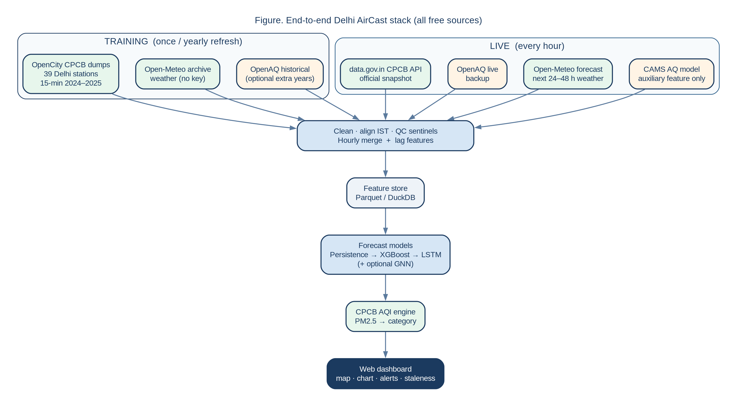
Figure 1. End-to-end Delhi AirCast stack. Green boxes are Phase-1 primary sources; amber boxes are backups or auxiliary features.
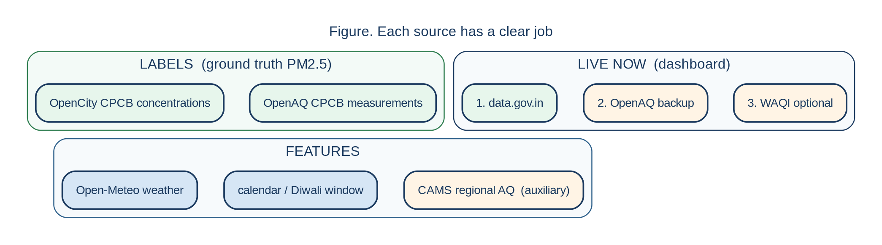
Figure 2. Training labels, weather features and live updates each have a clear job.

12.1 What already works today
On 7 September 2026 we opened the real files and APIs. OpenCity Anand Vihar came down in 3.4 seconds (11.8 MB). Open-Meteo weather and forecast replied in about half a second, with no key. The official data.gov.in CPCB feed was updating at 21:00 IST the same evening. OpenAQ and WAQI join the live path with free keys. This is a working stack we can build on.

13. Target Variable and Indian AQI Methodology
The model predicts hourly PM2.5 in µg/m³. The app then converts that number to the Indian National AQI using CPCB’s official 2014 table, so people see a familiar category such as Good, Poor or Severe.
CPCB computes a sub-index for each pollutant from its averaging period (24 h for PM2.5/PM10/NO2/SO2/NH3, 8 h for CO and O3) and takes the maximum sub-index as the location AQI, provided at least three pollutants are available and one of them is PM2.5 or PM10, with at least 16 hours of data. Categories are Good (0–50), Satisfactory (51–100), Moderately Polluted (101–200), Poor (201–300), Very Poor (301–400), Severe (401–500). PM2.5 breakpoints are 0–30, 31–60, 61–90, 91–120, 121–250, 250+ µg/m³. The full table is reproduced in Appendix C. The AQI engine follows CPCB’s published Indian method.
The dashboard reports three numbers for each forecast hour: (i) hourly PM2.5, (ii) a rolling 24 h mean PM2.5 converted to a CPCB-style sub-index so that the number is comparable to Sameer, and (iii) the plain-language category. The averaging window is printed on the card.

14. Dataset Schema and Feature Engineering

14.1 Canonical station-hour table
After resampling 15-minute OpenCity files to the hour (mean for concentrations and meteorology, sum for rainfall) and joining Open-Meteo on timestamp (Asia/Kolkata), each row looks like:
Table 6. Canonical merged schema (one row = one station-hour).
Column | Origin | Notes
timestamp_ist | OpenCity / OpenAQ | Hour beginning, Asia/Kolkata
station_id | CPCB site_* | e.g. site_301
station_name | CPCB | e.g. Anand Vihar, Delhi - DPCC
latitude, longitude | CPCB / OpenAQ | Fixed per station
pm25, pm10, no2, so2, co, o3, nh3 | OpenCity / OpenAQ | µg/m³ except CO in mg/m³ as reported
temp_station, rh_station, wind_station, … | OpenCity | Station weather, used together with Open-Meteo
temp, rh, wind_speed, wind_dir, pressure, rain, cloud | Open-Meteo | Complete series + forecast
cams_pm25, cams_pm10, cams_no2 | Open-Meteo AQ | Optional regional features
hour, dow, month, season, is_weekend | calendar | Cyclical encodings for hour/month
is_diwali_window, is_crop_burning | calendar rules | Festival and crop-burning season flags

14.2 Lag and horizon features
For a forecast issued at time t, the model uses PM2.5 at t, t−1, t−2, t−3, t−6, t−12, t−24 and the same lags for wind, humidity and rain; plus hour-of-day, day-of-week, month and season; plus Open-Meteo weather from t to t+h. Multi-horizon heads (h = 1, 6, 12, 24) are trained either as separate models or as a multi-output model. A graph model also uses recent PM2.5 at neighbouring stations.

14.3 Phase-1 station set
Ten stations that cover Delhi’s spatial story and appear in both the OpenCity 2024–25 dump and the live data.gov.in feed:
Table 7. Phase-1 hyperlocal station panel.
Station | Operator | Why it is in the set
Anand Vihar | DPCC | East Delhi traffic / ISBT; consistently high PM; problem-statement example
Dwarka Sector 8 | DPCC | South-west residential contrast
NSIT Dwarka | CPCB | Second Dwarka node; useful for a mini-graph later
IGI Airport T3 | IMD | Airport corridor, different siting
Okhla Phase-2 | DPCC | South-east industrial / residential mix
Rohini | DPCC | North-west; winter inversion stories
Punjabi Bagh | DPCC | West Delhi; long CPCB record
R K Puram | DPCC | South-central; often in media AQI tables
ITO | CPCB | Central traffic corridor
Mandir Marg | DPCC | Central / ridge-adjacent contrast

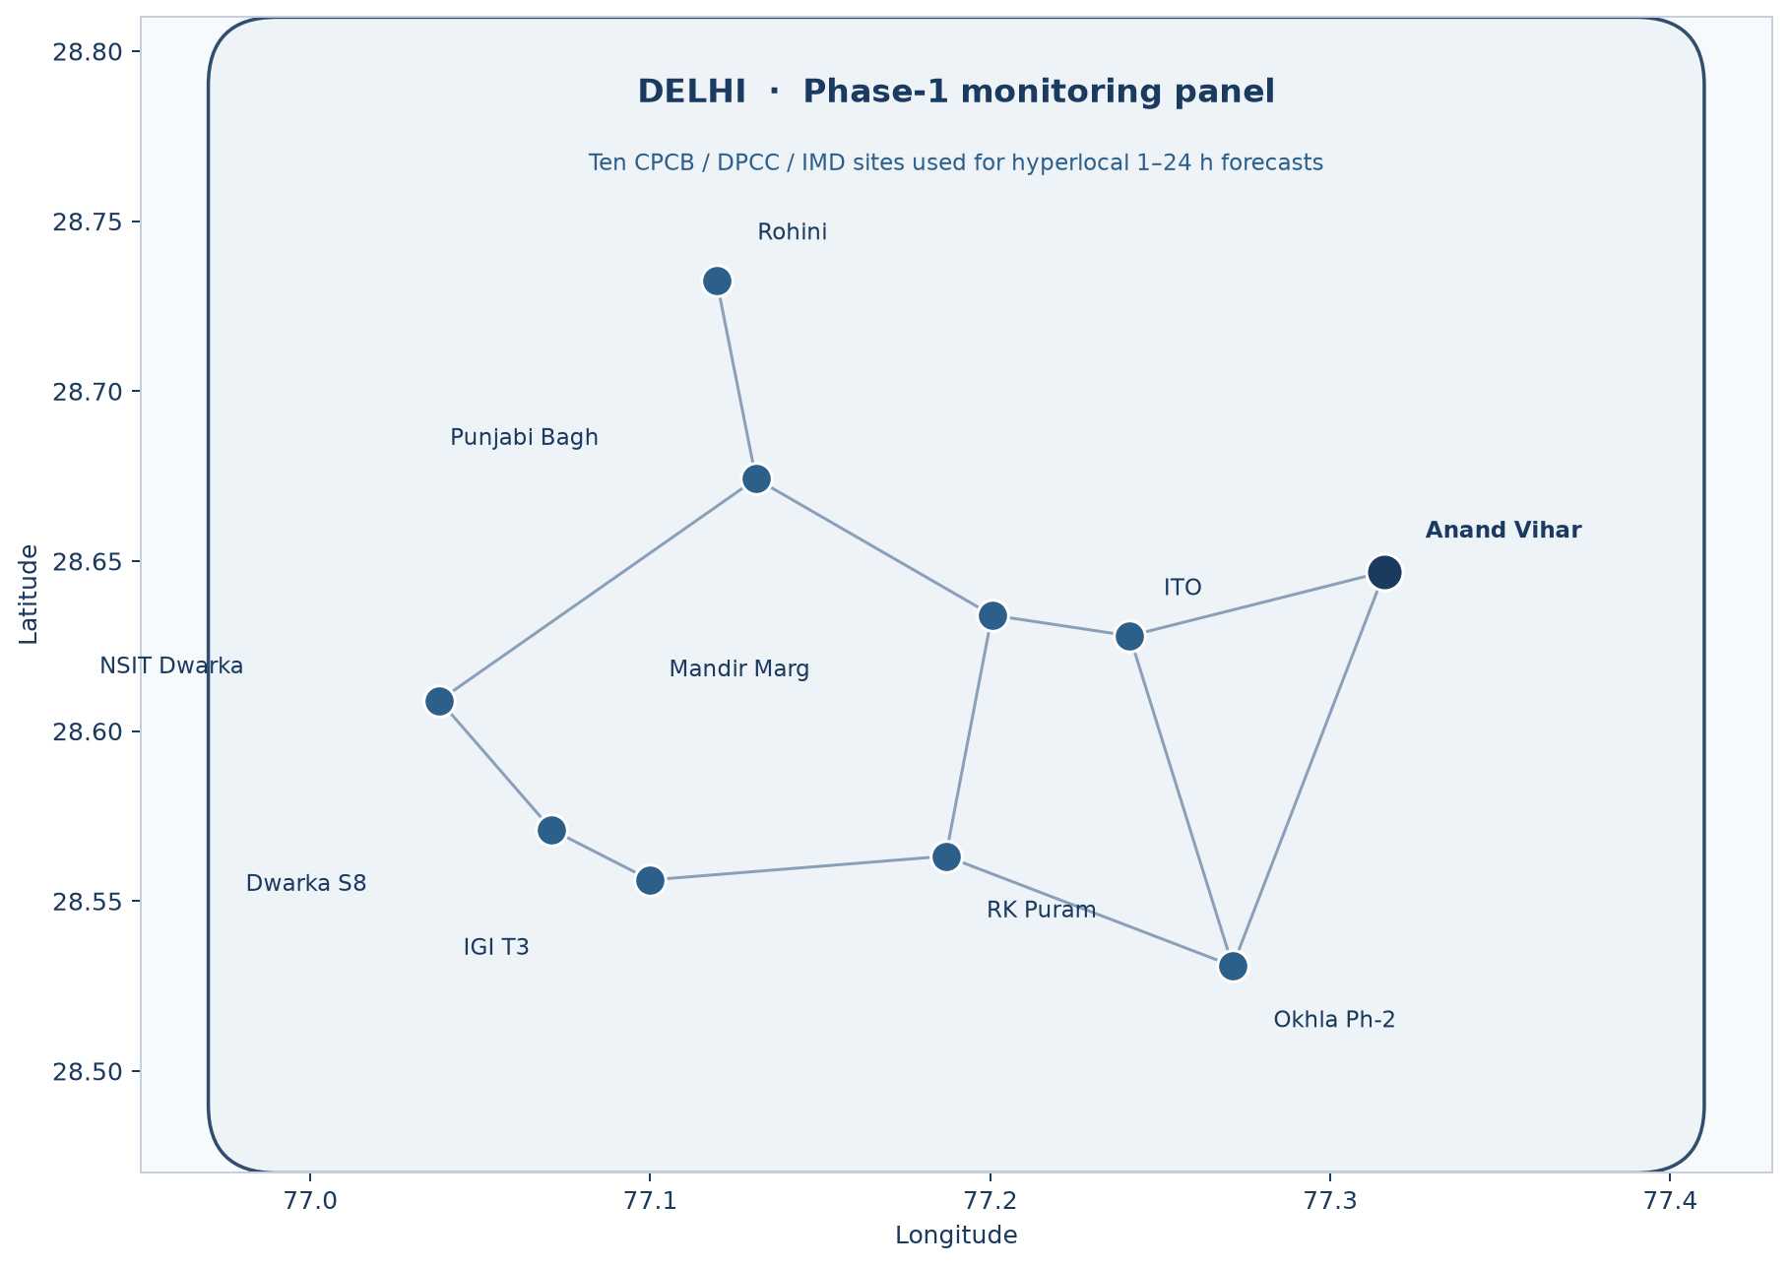
Figure 3. Phase-1 station panel on approximate WGS84 coordinates. Lines show neighbourhood links for a later graph model.

15. Data Collection, Storage and Update Cadence

15.1 One-time historical build
- Download the ten 2024–25 OpenCity 15-minute CSVs (CKAN URLs in Appendix A).
- Parse timestamps to UTC then Asia/Kolkata; coerce numerics; map sentinels (999, 998, −9999, blanks) to NA.
- Resample to hourly means (rainfall: sum). Require at least two valid 15-minute PM2.5 samples to keep an hour, else NA.
- Pull Open-Meteo archive for each station coordinate, 2024-01-01 to yesterday.
- Optionally pull Open-Meteo CAMS PM2.5/PM10/NO2 for the same window.
- Left-join weather onto station-hours; store parquet partitioned by station and year.
- Freeze a train window (e.g. 2024-01 to 2025-09) and a test window (e.g. 2025-10 to 2025-12, including Diwali).

15.2 Hourly live job
Every hour, in order: (1) data.gov.in Delhi snapshot → raw JSON; (2) if that fails or is stale > 2 h, OpenAQ latest measurements for the ten location IDs; (3) optional WAQI; (4) Open-Meteo forecast + current weather; (5) Open-Meteo CAMS current; (6) append to the live table; (7) run the forecast engine; (8) write predictions. Training happens in the weekly job.

15.3 Weekly learning job
Every week: append newly collected hours to the training store; score the production model on the new week; retrain a candidate; compare MAE / RMSE / skill vs persistence on a rolling 28-day window; and keep the better model. That is how the forecast keeps improving.
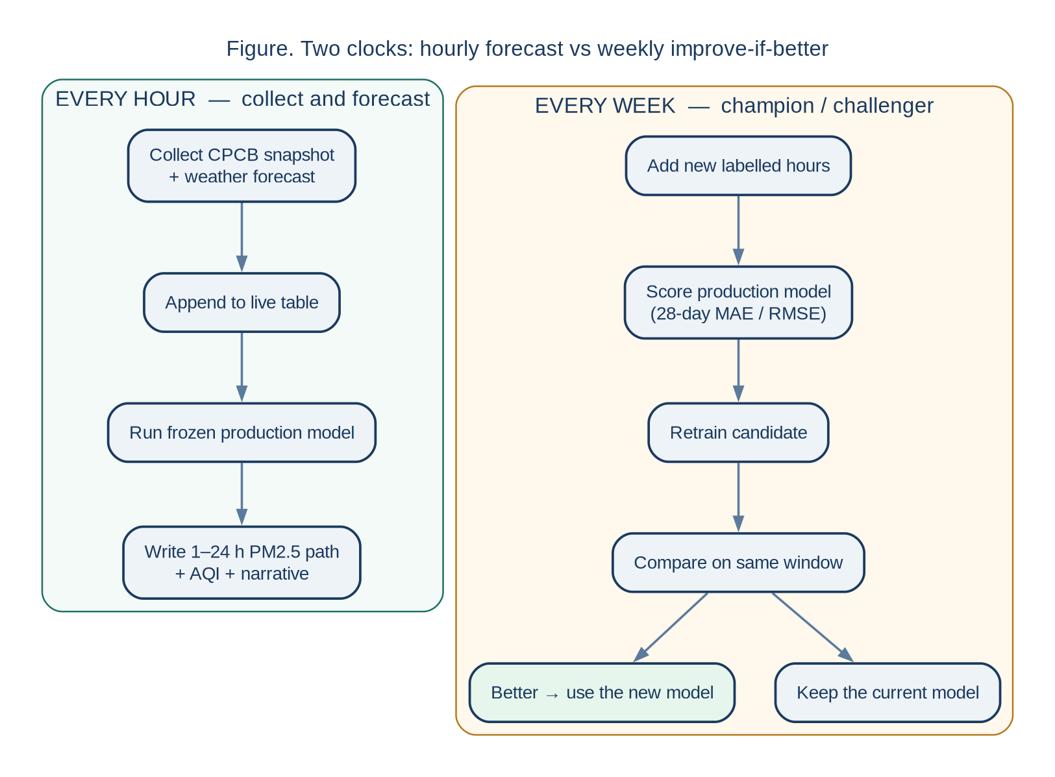
Figure 4. Two clocks. Every hour we collect data and forecast. Every week we add new data and keep the better model.

15.4 Storage
Phase 1 can be local parquet + SQLite or DuckDB (perfectly adequate for < 1 million station-hours). If a web app is deployed, Postgres is enough. Raw JSON payloads are kept for a 30-day audit so a bad parse can be replayed. Secrets live in a gitignored .env: DATA_GOV_IN_KEY, OPENAQ_API_KEY, optional WAQI_TOKEN.

16. Quality Control and Missing-Value Policy
- Sentinels. CPCB 999 / 998 / 985 / 1999 / negative concentrations → NA. Anand Vihar already showed a 998 µg/m³ PM2.5 max.
- Physical bounds. Clip PM2.5 to [0, 1000] µg/m³ after sentinel removal; log remaining extremes for Diwali / stubble-burning.
- Clean training. Lags may carry the last good reading for up to 3 hours. Training uses the real PM2.5 at that hour.
- Gaps. Hours with PM2.5 missing at t are left out of training for that horizon. CAMS stays an extra feature.
- Weather. When station weather is missing, we use Open-Meteo and keep the row.
- Coverage. Record completeness per station-month. Stations below 60 % completeness in a month get a quality flag on the map.
- Units. Unit check: CO in mg/m³ vs µg/m³; OpenAQ vs OpenCity vs data.gov.in sub-index.

17. Modelling Strategy
The problem statement mentions LSTM and Graph Neural Networks. We reach those after a simple baseline and an XGBoost model, so each step is a real improvement we can show.

17.1 Model 1 — Persistence baseline
ŷ(t+h) = y(t) (last observed hourly PM2.5). A seasonal variant uses y(t+h−24). This is the first score we beat. It is a fair, easy starting point and it already gives people a useful “same as now” forecast.

17.2 Model 2 — Gradient boosting (XGBoost or LightGBM)
Tabular model on lags, weather, calendar and optional CAMS background. This usually captures non-linear effects such as “wind falling + winter evening + no rain”. It is the workhorse and often the production model for a college timeline.

17.3 Model 3 — LSTM sequence model
Input: 24 (or 48) hours of multivariate history. Output: 1–24 h PM2.5 path. Trained per station or as a multi-station model with a station embedding. We keep it when it improves on boosting on the same split. This is the time-series deep learning step in PS-13.

17.4 Model 4 — Graph model (spatial rung)
Nodes = stations; edges = k-nearest neighbours by distance, or a distance kernel. A GNN (or a simpler spatial lag of neighbours’ PM2.5 inside XGBoost) tests whether Anand Vihar’s next hour is informed by Okhla, ITO and Vivek Vihar. This is how the project earns “neighbourhood granularity” beyond ten independent point models. Neighbour lags inside XGBoost already encode most of that spatial story; the GNN is the same idea with learned edges.
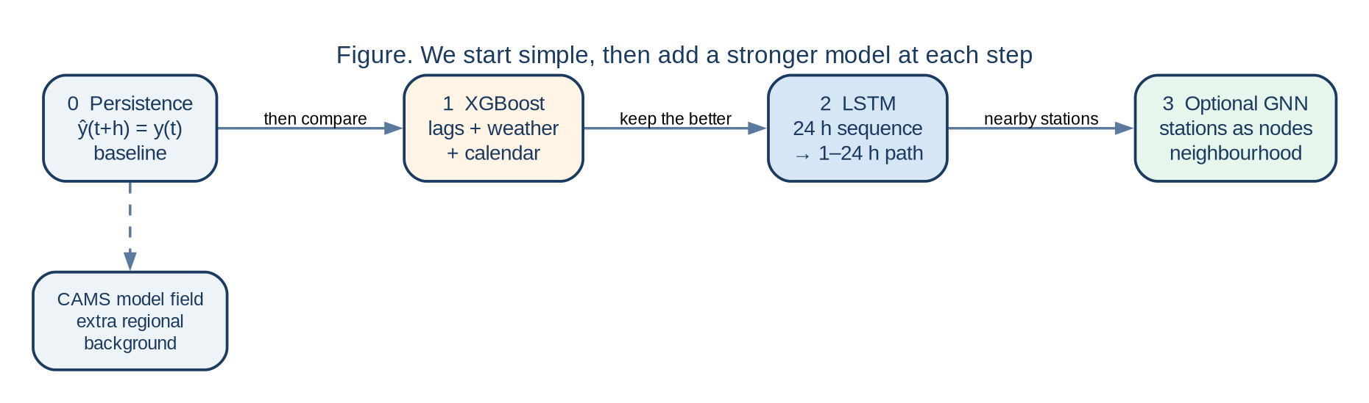
Figure 5. Model ladder. We start simple, then add XGBoost, LSTM and a station graph, and keep the better model.
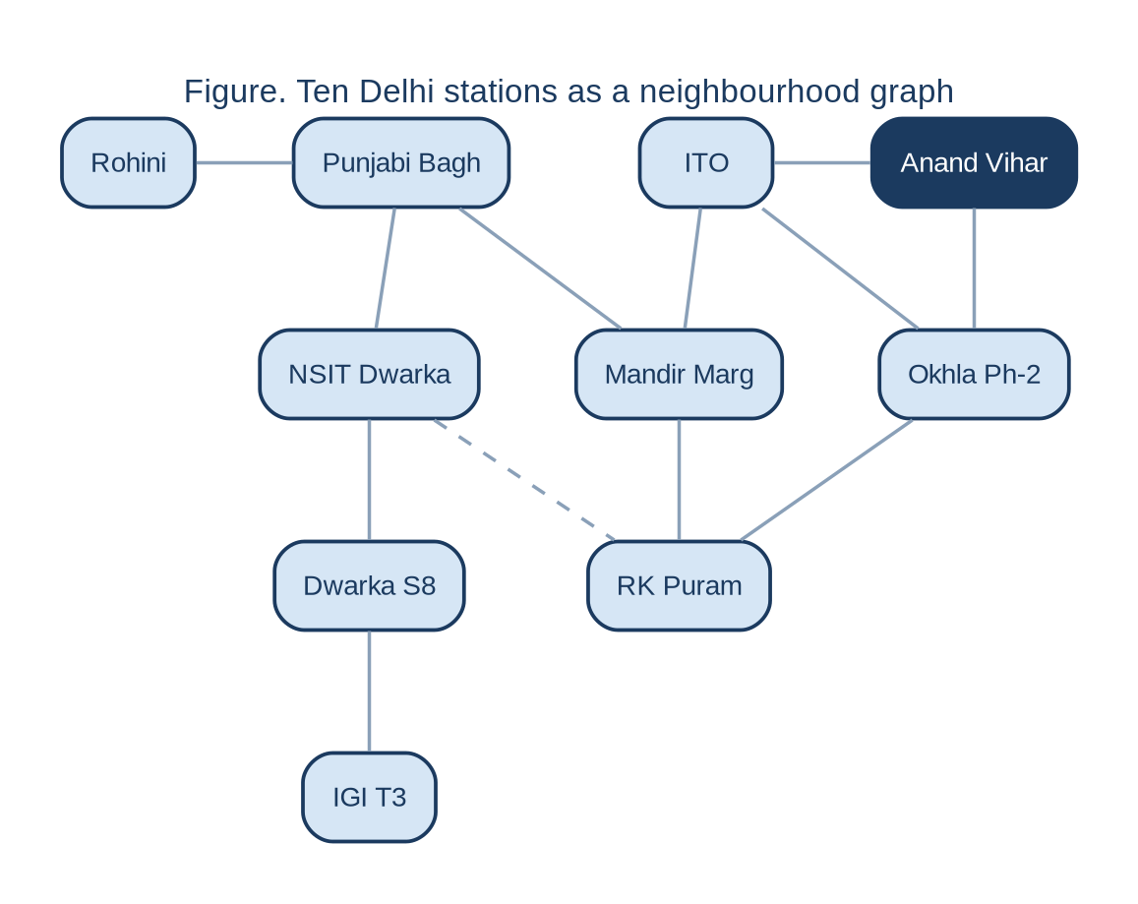
Figure 6. The same ten stations as a neighbourhood graph. Dashed edge = weaker / longer link. This is the GNN topology if Phase 6 is reached.
Every model is scored on the same frozen hold-out with the same three numbers. Persistence defines skill = 0. We keep the model that improves on that score.
Table 8. Evaluation protocol. Scores are computed on the frozen hold-out after training.
Model | MAE (µg/m³) | RMSE (µg/m³) | Skill vs persistence
Persistence (t → t+h) | reference MAE | reference RMSE | 0 by definition
XGBoost / LightGBM | primary production score | primary production score | first model we try to improve
LSTM | compared on the same split | compared on the same split | kept when it improves on boosting
GNN / spatial lag | compared on the same split | compared on the same split | kept when it improves on LSTM
CAMS field as forecast | extra comparison | extra comparison | regional background

18. Evaluation, Drift and Continuous Learning
Metrics: MAE and RMSE on PM2.5; also MAE on the derived AQI sub-index (because a 10 µg/m³ error matters more near a category boundary). Split by season (pre-monsoon, monsoon, post-monsoon, winter) and by hour of day. Pinball loss if a later version emits intervals.
Drift. A model trained on 2024 may degrade in a later winter if emission patterns or meteorology shift. The weekly job plots rolling 28-day MAE. If MAE rises by a pre-set fraction versus the deployment baseline (for example +25 % for two consecutive weeks), the system flags that it is time to retrain. We compare the new model with the old one and keep the better one. That is continuous learning as a weekly loop.

19. Dashboard Specification
The interface is a single-city, multi-station map plus a station detail view. Minimum viable content:
- Selected station name, local time, current PM2.5, derived AQI number and category colour.
- Current PM10, NO2, temperature, humidity, wind (from the live merge).
- PM2.5 forecast chart: now, +2 h, +4 h, +6 h, +12 h, +24 h.
- One-line narrative, templated from the slope of the first three forecast hours (improve / stable / deteriorate).
- Delhi sensor map with the ten stations coloured by current category.
- Data-source badge: “CPCB via data.gov.in, weather via Open-Meteo”, plus a staleness clock.
- Last 28 days of forecast error (MAE) so users can see how the model is doing.
The interface is a map dashboard (Leaflet / MapLibre) with a FastAPI or Streamlit service in front of the forecast engine. The academic value is the forecast; the UI exists to show it.
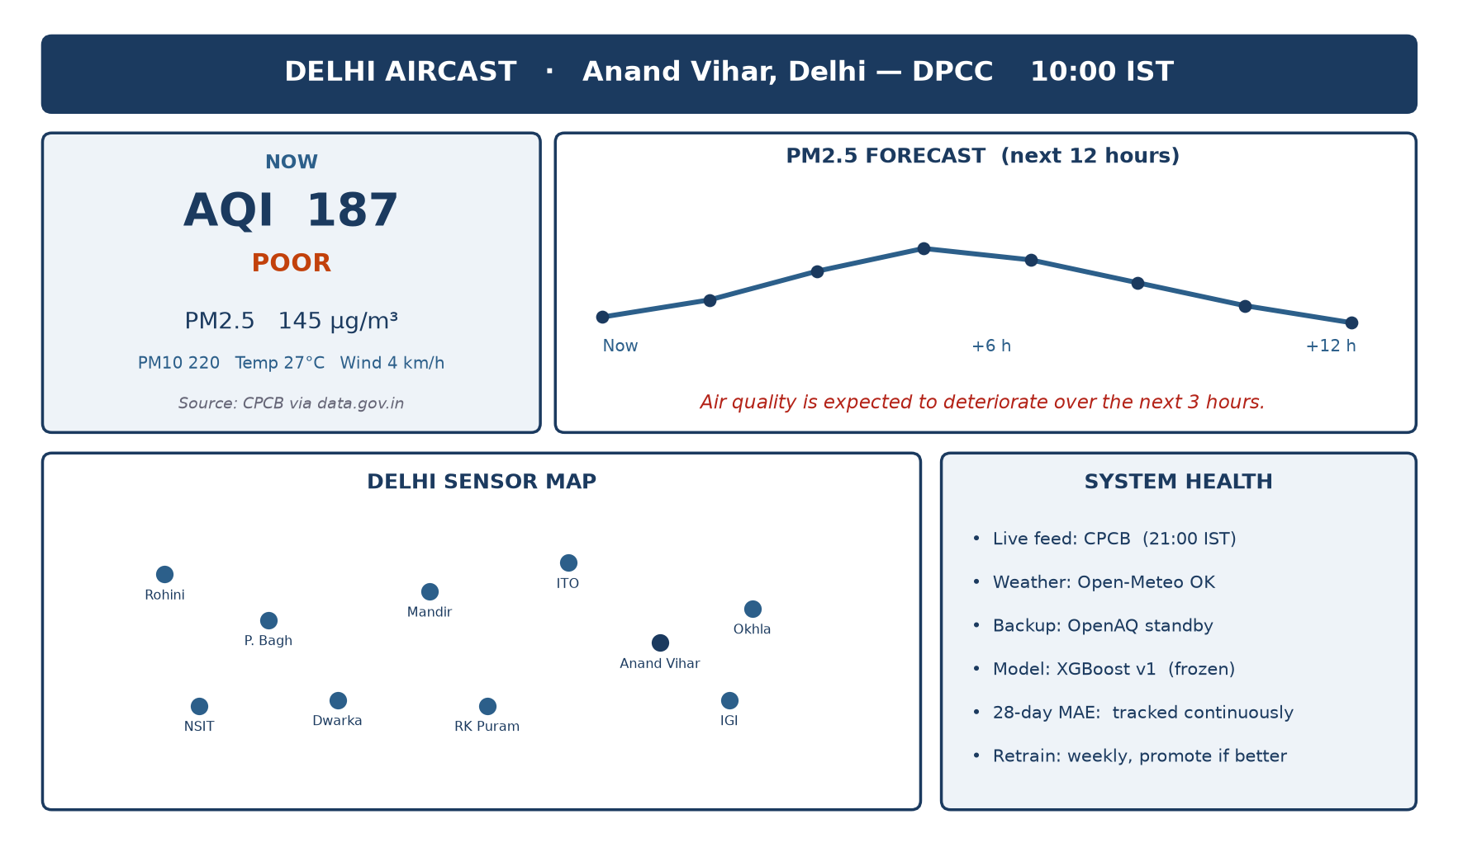
Figure 7. Target dashboard: current AQI, 12-hour PM2.5 path, station map, and system-health pane (source, backup, model version, 28-day MAE).

20. Free Accounts, Keys and Licensing
Table 9. Credentials. Keys stay in a local environment file for the team.
Account | Required? | Where to obtain | What it unlocks
data.gov.in API key | Yes, for live CPCB | https://data.gov.in/user/register → My Account | Full Delhi snapshot (sample key capped at 10 rows)
OpenAQ API key | Yes, for archive + backup | https://explore.openaq.org/register | v3 measurements, historical CPCB
WAQI token | Optional | https://aqicn.org/data-platform/token/ | Extra live feed
Open-Meteo | No | — | Weather + CAMS already work
OpenCity CKAN | No | — | Direct CSV / package_show

Licensing summary for the report’s ethics section: CPCB observations are public environmental monitoring data accessed via OGD (NDSAP) and OpenCity (public domain metadata) / OpenAQ (provider licences, typically public domain for government monitors). Open-Meteo weather is provided for non-commercial and academic use under their terms (attribution required). WAQI is free for non-commercial use with attribution. This project is academic and non-commercial.

21. Keeping the System Reliable

21.1 How we stay online
- Live backup. If data.gov.in is slow, the app uses OpenAQ, then WAQI.
- Gaps. Missing hours are marked. The model uses the last good readings and Open-Meteo weather.
- Units. We check units so training stays in µg/m³ and the dashboard stays clear.
- More data over time. Two full years already cover winter, monsoon, post-monsoon and Diwali. We add every new week as it arrives.

21.2 How the model learns
The model learns from history: how pollution, weather, time of day and nearby stations move together. It then gives a short-term forecast that the app turns into an Indian AQI category people can read.

22. Implementation Roadmap
Table 10. Build order, from clean data to a live weekly-improving app.
Phase | Deliverable | Depends on
0 Design freeze | This report; keys in .env | Done 7 Sep 2026
1 Data | Ten-station hourly parquet, 2024–2025, merged weather | OpenCity + Open-Meteo
2 Exploration | Diurnal, seasonal, rain, wind, Diwali, station contrast plots | Phase 1
3 Baseline | Persistence MAE/RMSE by horizon and station | Phase 1
4 ML | XGBoost/LightGBM vs baseline; feature importance | Phase 3
5 Deep learning | LSTM 24-in / 6–24-out; keep the better model | Phase 4
6 Spatial (optional) | Neighbour lags or GNN | Phase 4/5
7 Live system | Hourly job + database + map dashboard | data.gov.in + OpenAQ keys
8 Continuous learning | Weekly retrain-if-better + drift plot | Phase 7

23. Future Scope and Growth
Delhi AirCast is built to keep answering a simple question: what will PM2.5 be at this station in the next few hours? The same design also grows as we learn more and add more data.

23.1 It keeps working next year
CPCB stations such as Anand Vihar keep reporting. Open-Meteo weather goes back many years and keeps updating. We already hold the 2024–2025 station files on disk. Live updates come from data.gov.in, with OpenAQ and WAQI as extra paths. New hours go into our own store, so the project gets richer every week.

23.2 It keeps getting better
Every hour the app saves the new reading. Every week we add that week to training, compare the new model with the old one, and keep the better one. Winter, monsoon and Diwali each add new examples. Over time the forecast has more seasons to learn from.
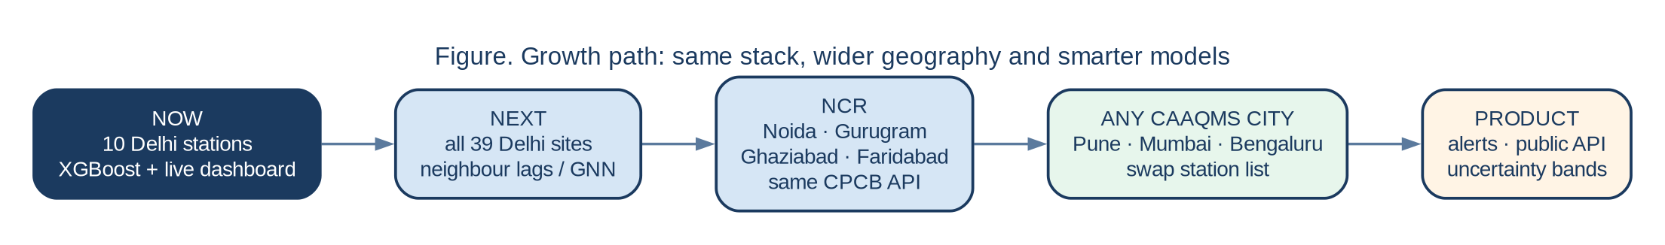
Figure 8. Growth path: more stations, then NCR, then other cities, then alerts and a public API.

23.3 How we grow from here
Table 14. The same pipeline grows by adding stations and a few extra features.
Next step | What we add | Why it is easy
Now | 10 Delhi stations, XGBoost, live dashboard | Data already checked
Deeper models | LSTM and a station graph | Same table, richer model
More of Delhi | All 39 OpenCity stations | Same files, more places
NCR | Noida, Gurugram, Ghaziabad, Faridabad | Same CPCB API, new city name
Other cities | Pune, Mumbai, Bengaluru | Same method, new station list
For people | Alerts, a public API, a school outdoor flag | The forecast is already there

24. Conclusion
Delhi AirCast is a clear college project with real Indian data already in hand. OpenCity gives two years of 15-minute CPCB station readings. Open-Meteo gives weather history and a forecast. The official data.gov.in API was live on 7 September 2026. OpenAQ and WAQI add extra live paths.
We predict PM2.5, turn it into Indian AQI, and show it on a neighbourhood map. We start with a simple baseline, then XGBoost, then LSTM, then a station graph. The app updates every hour and improves every week. The same design can later cover more of Delhi, NCR and other cities. That is PS-13, ready to build and ready to grow.

25. References
[1] Central Pollution Control Board (2014). National Air Quality Index. CPCB, Ministry of Environment, Forest and Climate Change, Government of India. https://airquality.cpcb.gov.in/ccr_docs/How_AQI_Calculated.pdf
[2] Open Government Data Platform India. Real time Air Quality Index. Resource 3b01bcb8-0b14-4abf-b6f2-c1bfd384ba69. https://www.data.gov.in/catalog/real-time-air-quality-index
[3] OpenCity / CivicDataLab. Delhi Hourly Air Quality Reports (39 stations; 2017–2023 AQI tables and 2024–25 15-minute CAAQMS extracts). https://data.opencity.in/dataset/delhi-hourly-air-quality-reports
[4] OpenAQ. API v3 documentation: locations, sensors, measurements. https://docs.openaq.org/
[5] OpenAQ Explorer. Anand Vihar, New Delhi – DPCC (location 235). https://explore.openaq.org/locations/235
[6] Open-Meteo. Historical Weather API (ERA5 / ECMWF IFS). https://open-meteo.com/en/docs/historical-weather-api
[7] Open-Meteo. Air Quality API (CAMS global / European). https://open-meteo.com/en/docs/air-quality-api
[8] World Air Quality Index Project. JSON API. https://aqicn.org/api/
[9] UrbanEmissions.info. CPCB daily AQI bulletins for Indian cities, 2015–2024. https://github.com/urbanemissions-info/AQI_bulletins
[10] Vonter. india-cpcb-aqi: 15-minute CAAQMS and hourly AQI extracts. https://github.com/Vonter/india-cpcb-aqi
[11] Saket Lab. vayuayan: Python clients for CPCB historical and live data. https://github.com/saketlab/vayuayan
[12] Guttikunda, S. Delhi ambient PM2.5, 2006–2018 (Mendeley Data). https://doi.org/10.17632/snp7sbkb36
[13] Kulkarni, N. & Tawade, J. (2026). Air Quality Dataset for Delhi, 2022-08-01 to 2026-02-18 (Open-Meteo CAMS). Zenodo. https://doi.org/10.5281/zenodo.18673773
[14] Kulkarni, N. & Tawade, J. (2026). Air Quality Dataset for Pune, 2022-08-01 to 2026-02-18. Zenodo. https://doi.org/10.5281/zenodo.18677141
[15] Copernicus Atmosphere Monitoring Service. Global atmospheric composition forecasts. ECMWF / CAMS.
[16] Hersbach, H. et al. (2020). The ERA5 global reanalysis. Quarterly Journal of the Royal Meteorological Society.

Appendix A. Delhi Monitoring Stations in the OpenCity Dump
The CKAN package listed 39 stations for 2017–2023 AQI tables and matching 2024–25 15-minute concentration files (package id 0dc7b9fe-9fd4-46ee-a37e-88f0bd6f6362). Phase 1 uses the 2024–25 files. CKAN package_show: https://data.opencity.in/api/3/action/package_show?id=delhi-hourly-air-quality-reports
- Alipur (DPCC)
- Anand Vihar (DPCC) — site_301 in the 2024–25 file
- Ashok Vihar (DPCC)
- Aya Nagar (IMD)
- Bawana (DPCC)
- Burari Crossing (IMD)
- Chandni Chowk (IITM)
- CRRI Mathura Road (IMD)
- Dr. Karni Singh Shooting Range (DPCC)
- DTU (CPCB)
- Dwarka Sector 8 (DPCC)
- IGI Airport T3 (IMD)
- IHBAS Dilshad Garden (CPCB)
- ITO (CPCB)
- Jahangirpuri (DPCC)
- Jawaharlal Nehru Stadium (DPCC)
- Lodhi Road (IITM)
- Lodhi Road (IMD)
- Major Dhyan Chand National Stadium (DPCC)
- Mandir Marg (DPCC)
- Mundka (DPCC)
- Najafgarh (DPCC)
- Narela (DPCC)
- Nehru Nagar (DPCC)
- North Campus DU (IMD)
- NSIT Dwarka (CPCB)
- Okhla Phase-2 (DPCC)
- Patparganj (DPCC)
- Punjabi Bagh (DPCC)
- Pusa (DPCC)
- Pusa (IMD)
- Rohini (DPCC)
- R K Puram (DPCC)
- Shadipur (CPCB)
- Sirifort (CPCB)
- Sonia Vihar (DPCC)
- Sri Aurobindo Marg (DPCC)
- Vivek Vihar (DPCC)
- Wazirpur (DPCC)
Anand Vihar 2024–25 direct URL used in verification: https://data.opencity.in/dataset/0dc7b9fe-9fd4-46ee-a37e-88f0bd6f6362/resource/5ef3f66f-2bb0-4593-91db-ba6e693a77f3/download/del-anand-vihar-dpcc-2024-25.csv

Appendix B. Live Verification Log (7 September 2026)
These calls were made from a workstation in India on 7 September 2026. They show the sources we use, and how quickly they replied.
Table 11. Verification log for the sources we use.
Probe | HTTP | Time | Bytes / notes
Open-Meteo forecast weather (Delhi, 72 h) | 200 | 0.53 s | 4.1 KB; last temp 26.7 °C on 2026-09-07 23:00
Open-Meteo archive weather (2024-01-01..07) | 200 | 0.74 s | 7.5 KB; 168 hours; 00:00 temp 7.0 °C
Open-Meteo AQ current+forecast | 200 | 0.55 s | PM2.5 103.1, PM10 113.9, US AQI 159 at 21:30
Open-Meteo AQ history (2024-01-01..07) | 200 | 0.53 s | 168 hours; PM2.5 sample 146.7, 130.4, 117.8
Open-Meteo forecast next 48 h | 200 | 0.55 s | 48 hours, 2026-09-07 00:00 → 2026-09-08 23:00
OpenCity CKAN package_show | 200 | 0.19 s | 105 KB JSON; 78 resources
OpenCity Anand Vihar 2024–25 CSV | 200 | 3.42 s | 11,812,427 bytes; 70,177 rows
data.gov.in Delhi PM2.5 (sample key) | 200 | ~3 s | Updating 07-09-2026 21:00:00 IST
OpenAQ v3 | ready | — | Free key at explore.openaq.org
WAQI personal token | ready | — | Free token at aqicn.org for an extra live feed

Appendix C. CPCB National AQI Breakpoints
Reproduced from CPCB’s National Air Quality Index methodology for the eight notified pollutants. Units are µg/m³ except CO (mg/m³). Averaging is 24-hour except CO and O3 (8-hour). The location AQI is the maximum sub-index when at least three pollutants are present and one is PM2.5 or PM10.
Table 12. CPCB health breakpoints used in the AQI engine. *O3 very poor/severe uses 1-hour values in the official note.
Category (AQI) | PM2.5 | PM10 | NO2 | SO2 | CO | O3 | NH3
Good (0–50) | 0–30 | 0–50 | 0–40 | 0–40 | 0–1.0 | 0–50 | 0–200
Satisfactory (51–100) | 31–60 | 51–100 | 41–80 | 41–80 | 1.1–2.0 | 51–100 | 201–400
Moderately Polluted (101–200) | 61–90 | 101–250 | 81–180 | 81–380 | 2.1–10 | 101–168 | 401–800
Poor (201–300) | 91–120 | 251–350 | 181–280 | 381–800 | 10.1–17 | 169–208 | 801–1200
Very Poor (301–400) | 121–250 | 351–430 | 281–400 | 801–1600 | 17.1–34 | 209–748* | 1201–1800
Severe (401–500) | 250+ | 430+ | 400+ | 1600+ | 34+ | 748+* | 1800+

Linear interpolation of a sub-index I for concentration C between breakpoints Blo, Bhi with index bounds Ilo, Ihi is I = (Ihi − Ilo) / (Bhi − Blo) × (C − Blo) + Ilo. The AQI engine implements this exactly, with unit tests on the published examples in CPCB’s “How is AQI calculated?” note.

Appendix D. Worked Forecast Example
This is a product sketch of what the dashboard shows: recent hours, the current reading, and the next few forecast hours.
Table 13. Schematic Anand Vihar six-hour path used as the product example in the introduction.
Time (IST) | Role | PM2.5 (µg/m³) | Weather snapshot
07:00 | history | 120 | cool, light wind
08:00 | history | 131 | wind easing
09:00 | history | 138 | humidity rising
10:00 | now (origin) | 145 | 27 °C, 72 % RH, 4 km/h, 0 mm rain
11:00 | forecast h=1 | 151 | Open-Meteo forecast meteorology allowed
12:00 | forecast h=2 | 158
13:00 | forecast h=3 | 163 | peak in this example
14:00 | forecast h=4 | 157
16:00 | forecast h=6 | 142 | afternoon mixing

Derived message (template): if the slope of hours 1–3 is positive beyond a small threshold, print “Air quality is expected to deteriorate over the next 3 hours.” Convert the rolling 24-hour mean ending at each forecast hour through Appendix C to obtain the category (in the example, Poor).

Appendix E. List of Figures
All architecture figures were generated from Graphviz DOT and Matplotlib (scripts: generate_diagrams.py). Source .dot files sit beside the PNGs in the figures/ folder so they can be edited without redrawing by hand.
Table 15. Figure index.
Fig. | File | What it shows
1 | fig01_architecture.png | End-to-end free-source stack
2 | fig06_source_layers.png | Labels vs features vs live backups
3 | fig07_station_map.png | Ten Phase-1 stations on a Delhi coordinate panel
4 | fig02_two_clocks.png | Hourly forecast job vs weekly promote-if-better
5 | fig03_model_ladder.png | Persistence → XGBoost → LSTM → optional GNN
6 | fig04_station_graph.png | Neighbourhood graph for a later GNN
7 | fig08_dashboard_wireframe.png | Target dashboard layout
8 | fig05_future_growth.png | Delhi → NCR → any CAAQMS city → product layer

— End of report —
Delhi AirCast · PS-13 · Generated 7 September 2026 · Data-acquisition design freeze

