MINOR PROJECT REPORT
Breast Cancer Prediction Using Machine Learning
Binary classification of tumours as benign or malignant
Field | Details
Submitted by | Priyanshu Dash
Roll Number | AIML-A6/JN-10471
Branch / Year | Computer Science & Engineering, 4th Year
Institute | Kalinga Institute of Industrial Technology (KIIT), Bhubaneswar, Odisha
Program | Machine Learning Internship, InternsElite
Project Guide | Abhishek Pandey

1. Objective
This project builds a classification model that predicts whether a breast tumour is benign or malignant from measurements of cell nuclei taken from a digitised image of a fine needle aspirate. Four algorithms are compared, the effect of feature scaling is tested, and the best model is evaluated on unseen data.

2. Dataset
The dataset has 569 patient records. The original file has 33 columns: an ID, the diagnosis label, 30 numeric features and one empty column (Unnamed: 32) that was dropped. After setting ID as the index there are 30 predictor features and 1 target.
Item | Details
Records | 569
Target | diagnosis (B = Benign, M = Malignant)
Features | 30 numeric features
Feature groups | 10 measurements each as mean, standard error and worst value: radius, texture, perimeter, area, smoothness, compactness, concavity, concave points, symmetry, fractal dimension
Missing values | None in the 30 features (the empty Unnamed: 32 column was removed)

Class distribution
Class | Label used | Records | Share
Benign (B) | 0 | 357 | 62.7%
Malignant (M) | 1 | 212 | 37.3%

3. Data Preprocessing and Exploration
- Cleaning: The empty Unnamed: 32 column was deleted and id was set as the index so it is not used as a feature.
- Label encoding: The diagnosis column was mapped to numbers: B = 0 and M = 1.
- Visualisation: Histogram of the diagnosis classes, density plots of all 31 numeric variables, and a correlation heatmap of the attributes.
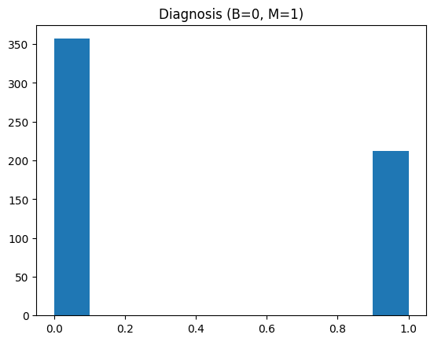
Figure 1: Diagnosis class distribution (0 = benign, 1 = malignant)
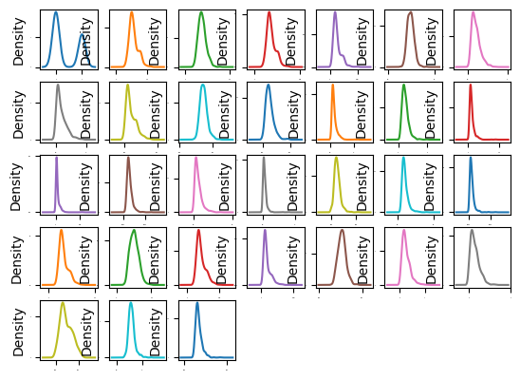
Figure 2: Density plots of all numeric attributes
Most features are right-skewed and several are on very different scales: area values run into the thousands while smoothness values are below 0.2. This is why feature scaling is tested later.
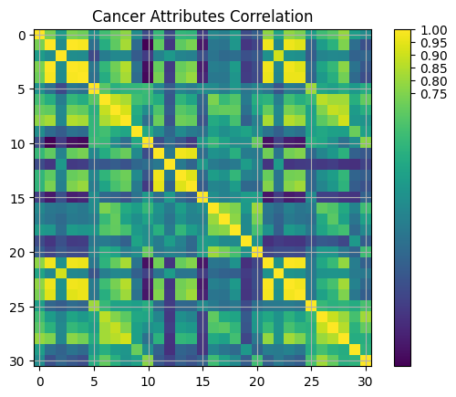
Figure 3: Correlation heatmap of the attributes

4. Methodology

Train-test split
The data was split with 33% held out for testing (random_state = 21), giving 381 training records and 188 test records.

Models compared
Algorithm | Abbreviation | Type
Classification and Regression Trees | CART | Decision tree
Support Vector Machine | SVM | Kernel-based (default RBF kernel)
Gaussian Naive Bayes | NB | Probabilistic
k-Nearest Neighbours | KNN | Distance-based (k = 5)

Evaluation approach
Each model was scored with 10-fold cross-validation on the training set (shuffled, random_state = 123), using accuracy. The four models were first run on the raw features and then again inside a pipeline that applies StandardScaler before the classifier, so that scaling is fitted only on each training fold. The best model was then trained on the full training set and evaluated once on the held-out test set.

5. Results

Cross-validation accuracy
Model | Unscaled Accuracy | Std Dev | Scaled Accuracy | Std Dev
CART | 90.55% | 0.043 | 92.40% | 0.030
SVM | 92.13% | 0.047 | 97.37% | 0.026
NB | 93.95% | 0.044 | 92.89% | 0.044
KNN | 92.12% | 0.041 | 95.53% | 0.033

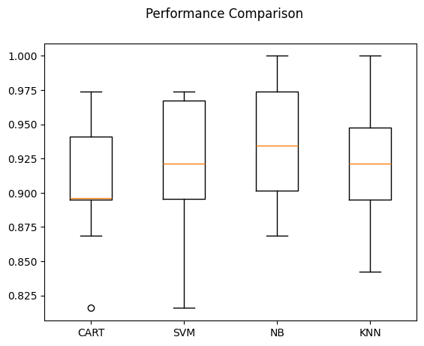
Figure 4: Model comparison before scaling (10-fold CV accuracy)
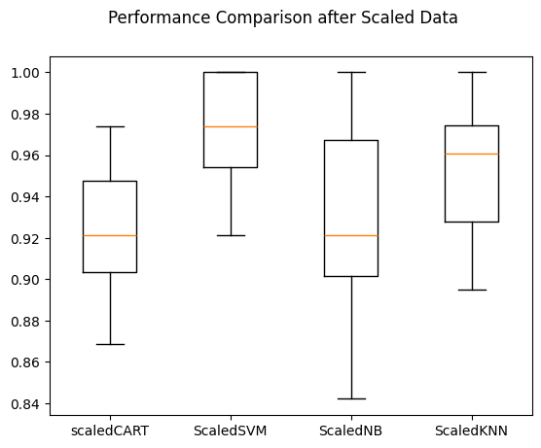
Figure 5: Model comparison after scaling (10-fold CV accuracy)
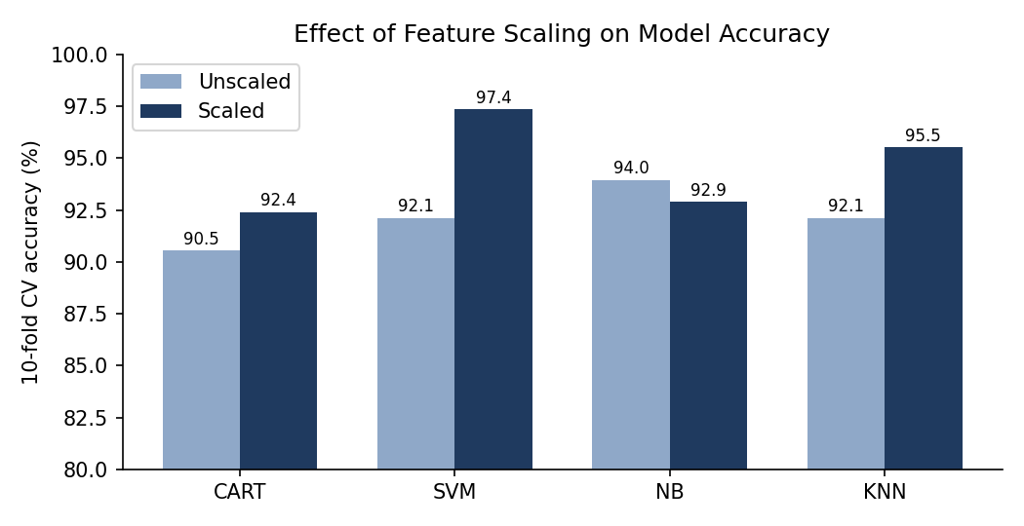
Figure 6: Accuracy before and after feature scaling
Scaling made the biggest difference to the distance and margin based models. SVM improved from 92.13% to 97.37% and KNN from 92.12% to 95.53%. Naive Bayes dipped slightly (93.95% to 92.89%). CART moved from 90.55% to 92.40%. Scaled SVM also has the lowest variation across folds (0.026), so it was chosen as the final model.

Final model: scaled SVM on the test set
Metric | Score
Accuracy | 96.28%
Precision (malignant) | 97.01%
Recall (malignant) | 92.86%
F1 Score (malignant) | 94.89%

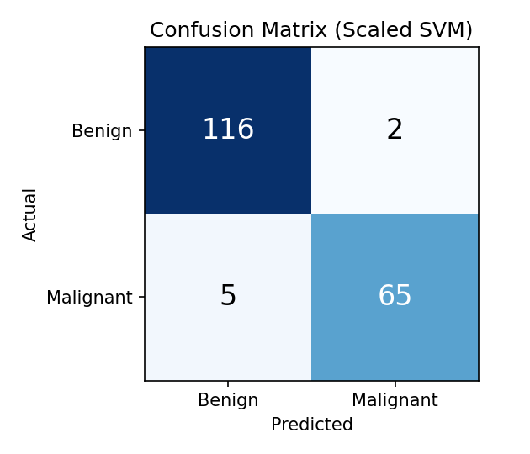
Figure 7: Confusion matrix on the 188 test records
 | Predicted Benign | Predicted Malignant
Actual Benign (118) | 116 (true negatives) | 2 (false positives)
Actual Malignant (70) | 5 (false negatives) | 65 (true positives)

Classification report
Class | Precision | Recall | F1-score | Support
Benign (0) | 0.96 | 0.98 | 0.97 | 118
Malignant (1) | 0.97 | 0.93 | 0.95 | 70
Macro average | 0.96 | 0.96 | 0.96 | 188
Weighted average | 0.96 | 0.96 | 0.96 | 188

6. Interpretation
- Generalisation: Test accuracy of 96.28% is consistent with the 97.37% cross-validation score, so the model generalises well and shows no sign of overfitting.
- Precision: Only 2 benign tumours were wrongly flagged as malignant, so false alarms are rare.
- Recall: The model correctly identified 65 of the 70 malignant tumours (recall 92.86%).
- Use: A model like this can support a clinician as a second opinion, but it is not a substitute for a biopsy result or medical judgement.

7. Conclusion
Four classifiers were compared on the 569-record breast tumour dataset. Standardising the features lifted SVM to the best cross-validated accuracy of 97.37%, and the final scaled SVM reached 96.28% accuracy, 97.01% precision and 92.86% recall on unseen test data, with only 7 errors out of 188 records. The project shows that a simple, well-prepared pipeline can classify tumours reliably from cell nucleus measurements.

8. Future Scope
- Tune the SVM (C, gamma, kernel) with GridSearchCV to push recall higher.
- Try Random Forest, Gradient Boosting and Logistic Regression, and compare using ROC-AUC.
- Apply feature selection or PCA to reduce the 30 highly correlated features.
- Handle class imbalance with class weights or SMOTE.
- Deploy the model as a Streamlit or Flask web app for interactive predictions.

