MINOR PROJECT REPORT
DeepVision: CNN & Transfer Learning for Image Classification
From a from-scratch convolutional network to a fine-tuned ResNet-18 on CIFAR-10
Field | Details
Submitted by | Priyanshu Dash
Roll Number | AIML-A6/JN-10471
Branch / Year | Computer Science & Engineering, 4th Year
Institute | Kalinga Institute of Industrial Technology (KIIT), Bhubaneswar, Odisha
Program | Machine Learning Internship, InternsElite
Project Guide | Abhishek Pandey

1. Objective
DeepVision is an image classification project built on the CIFAR-10 dataset. The goal is to classify small colour photographs into one of ten everyday categories (airplane, automobile, bird, cat, deer, dog, frog, horse, ship, truck) and to study how model accuracy changes as the approach is made more sophisticated.
The project moves through four stages of increasing complexity:
- Stage 1, Basic CNN: a convolutional neural network (CNN) written from scratch and trained directly on raw pixels.
- Stage 2, Improved CNN: the same architecture retrained with data augmentation and dropout regularisation.
- Stage 3, ResNet-18 (head-only): a pretrained ResNet-18 with its convolutional backbone frozen and only a new classification head trained (transfer learning by feature extraction).
- Stage 4, Fine-Tuned ResNet-18: the ResNet-18 backbone partially unfrozen (the last residual block) and trained jointly with the head at a lower learning rate (fine-tuning).
The best-performing model is then saved to disk, tested on a new photograph outside the dataset, and wrapped in an interactive Gradio web demo so it can be used without writing any code.

2. Dataset: CIFAR-10
CIFAR-10 is a standard benchmark dataset for image classification, downloaded automatically through torchvision.datasets.CIFAR10.
Property | Value
Training images | 50,000
Test images | 10,000
Image size | 32 x 32 pixels, RGB (3 channels)
Number of classes | 10
Classes | airplane, automobile, bird, cat, deer, dog, frog, horse, ship, truck
Images per class | 6,000 (balanced dataset)
Training batches (batch size 64) | 782
Testing batches (batch size 64) | 157

Because every class has exactly 6,000 images, the dataset is perfectly balanced, so plain accuracy is a fair headline metric and no class dominates the average.
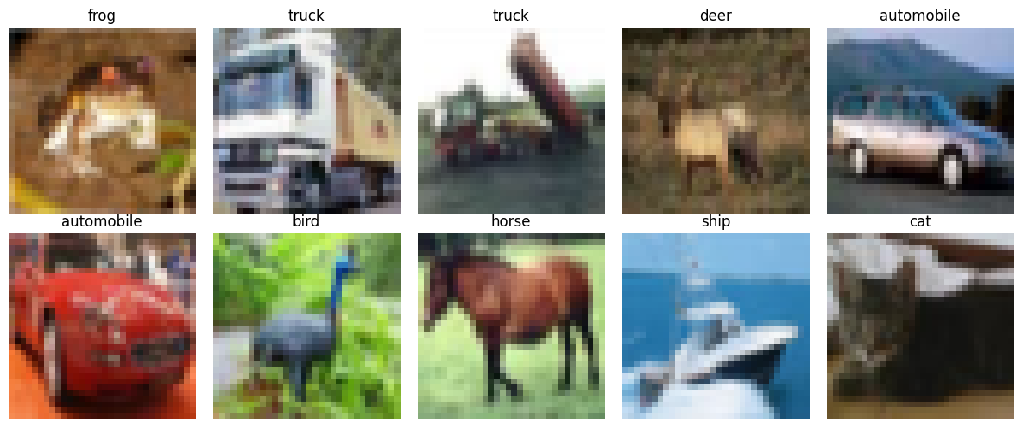
Figure 1: Ten sample training images with their true labels
The sample grid shows the core difficulty of CIFAR-10: images are only 32x32 pixels, so objects are small, sometimes blurry, and can be partially occluded or shown from unusual angles, for example the automobile photographed from directly behind.

3. Background: CNNs and Transfer Learning

3.1 Why convolutional networks
A plain fully-connected network treats every pixel as an independent input and has no notion of spatial structure. Convolutional layers instead slide small learnable filters across the image, so the same filter can detect an edge or a texture wherever it appears. Pooling layers then shrink the spatial size while keeping the strongest signals, which both reduces computation and makes the network tolerant to small shifts in position.

3.2 Why transfer learning
Training a large network from scratch needs a lot of data and compute to learn low-level patterns such as edges, corners and colour gradients. Transfer learning reuses a network already trained on a much larger dataset (ResNet-18 was pretrained on ImageNet, which has over a million images across 1,000 classes) and only retrains the parts needed for the new task. This typically reaches higher accuracy with far less training time than starting from random weights, which is exactly the pattern seen in Section 5 of this report.

3.3 Two transfer-learning strategies used here
- Feature extraction: every pretrained layer is frozen (requires_grad = False) and only a new final layer is trained. The backbone acts as a fixed feature extractor.
- Fine-tuning: a portion of the pretrained network (here, the last residual block, layer4) is unfrozen and trained together with the head, usually at a smaller learning rate so the pretrained weights are adjusted gently rather than overwritten.

4. Stage 1: Basic CNN

4.1 Architecture
A compact convolutional network was built with two convolution-pooling blocks followed by two fully-connected layers.
Layer | Configuration | Output shape
Input | 32 x 32 x 3 RGB image | 3 x 32 x 32
Conv1 + ReLU | 3 -> 32 channels, 3x3 kernel, padding 1 | 32 x 32 x 32
MaxPool1 | 2x2 kernel, stride 2 | 32 x 16 x 16
Conv2 + ReLU | 32 -> 64 channels, 3x3 kernel, padding 1 | 64 x 16 x 16
MaxPool2 | 2x2 kernel, stride 2 | 64 x 8 x 8
Flatten | - | 4,096
FC1 + ReLU | 4,096 -> 128 | 128
FC2 (output) | 128 -> 10 | 10 class scores

4.2 Training setup
Setting | Value
Preprocessing | ToTensor only (pixel values scaled to [0, 1], no augmentation or normalisation)
Loss function | Cross-entropy loss
Optimizer | Adam, learning rate 0.001
Epochs | 10
Batch size | 64
Device | CUDA GPU

4.3 Training loss
Epoch | 1 | 2 | 3 | 4 | 5 | 6 | 7 | 8 | 9 | 10
Loss | 1.475 | 1.107 | 0.959 | 0.870 | 0.790 | 0.717 | 0.658 | 0.597 | 0.540 | 0.482

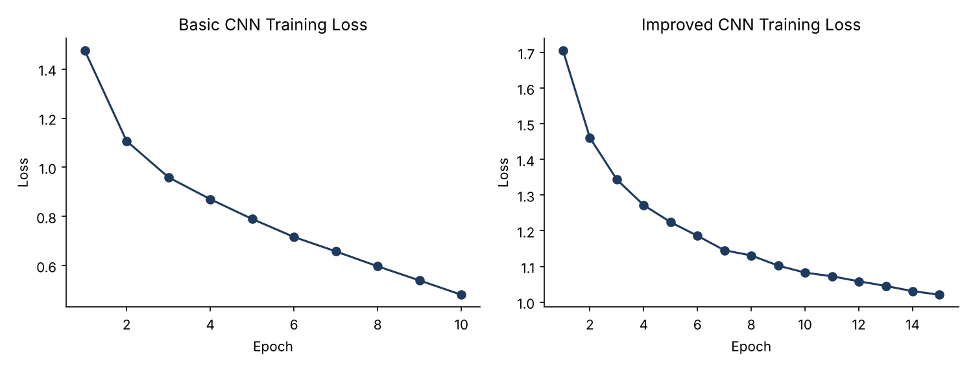
Figure 2: Training loss curves for the Basic CNN (left) and Improved CNN (right)
The loss falls smoothly and consistently across all 10 epochs with no sign of divergence, roughly a 3x reduction from 1.475 to 0.482.

4.4 Result
Test accuracy: 71.41% on the 10,000-image test set.

5. Stage 2: Improved CNN (Augmentation + Dropout)
The same two-convolution architecture was kept, but the training recipe was changed to fight overfitting and improve generalisation.

5.1 Data augmentation and normalisation
Step | Training set | Test set
Random horizontal flip | Yes | No
Random crop (32x32, padding 4) | Yes | No
Convert to tensor | Yes | Yes
Normalise (mean/std per channel) | (0.4914, 0.4822, 0.4465) / (0.2470, 0.2435, 0.2616) | Same statistics

Augmentation (flips and crops) is applied only to the training set so the model sees many slightly different versions of each image and cannot simply memorise exact pixel positions. The test set is left unaugmented so evaluation reflects real-world performance; it is normalised with the same statistics as training for consistency.

5.2 Architecture change: dropout
A Dropout layer (p = 0.5) was added between the first fully-connected layer and the output layer. During training it randomly zeroes half of the 128 hidden activations on each pass, which forces the network to spread out what it learns rather than depending on a handful of neurons.

5.3 Training setup
Setting | Value
Optimizer | Adam, learning rate 0.001
Epochs | 15 (up from 10)
Batch size | 64

5.4 Training loss
Epoch | 1 | 3 | 5 | 7 | 9 | 11 | 13 | 15
Loss | 1.706 | 1.344 | 1.224 | 1.145 | 1.102 | 1.072 | 1.045 | 1.021

5.5 Result
Test accuracy: 72.33% on the same test set.
The gain over the Basic CNN is small (+0.92 points), even though 5 extra epochs were used. Augmented, cropped images are a harder training signal than raw pixels, which is visible in the higher starting and ending loss values in Figure 2. The improvement suggests the architecture itself, not the training recipe, is now the limiting factor — the two-layer CNN has too little capacity to go much further on CIFAR-10, which motivates the move to a deeper, pretrained network in the next stage.

6. Stage 3: Transfer Learning with ResNet-18 (Head-Only)

6.1 Why ResNet-18
ResNet-18 is an 18-layer convolutional network that introduced residual (skip) connections, which let gradients flow through very deep networks without vanishing. The version used here was pretrained on ImageNet (loaded with weights="DEFAULT"), so its convolutional layers already recognise a broad vocabulary of edges, textures and shapes before ever seeing a CIFAR-10 image.

6.2 Adapting ResNet-18 to CIFAR-10
- Input size: ResNet-18 expects 224x224 images (the ImageNet input size), so CIFAR-10's 32x32 images are upscaled with transforms.Resize((224, 224)).
- Normalisation: ImageNet's channel-wise mean (0.485, 0.456, 0.406) and std (0.229, 0.224, 0.225), matching the statistics the pretrained weights were trained with.
- Output layer: the original 1,000-class output layer (resnet.fc) was replaced with a new nn.Linear(in_features, 10) layer sized for CIFAR-10's 10 classes.
- Freezing the backbone: every parameter was frozen (param.requires_grad = False) and then only the new resnet.fc layer's parameters were unfrozen, so only about 5,130 of ResNet-18's roughly 11.2 million parameters were trained.

6.3 Training setup
Setting | Value
Trainable parameters | resnet.fc only
Optimizer | Adam, learning rate 0.001, on resnet.fc.parameters() only
Epochs | 5
Batch size | 64

6.4 Training loss
Epoch | 1 | 2 | 3 | 4 | 5
Loss | 0.821 | 0.617 | 0.593 | 0.581 | 0.573

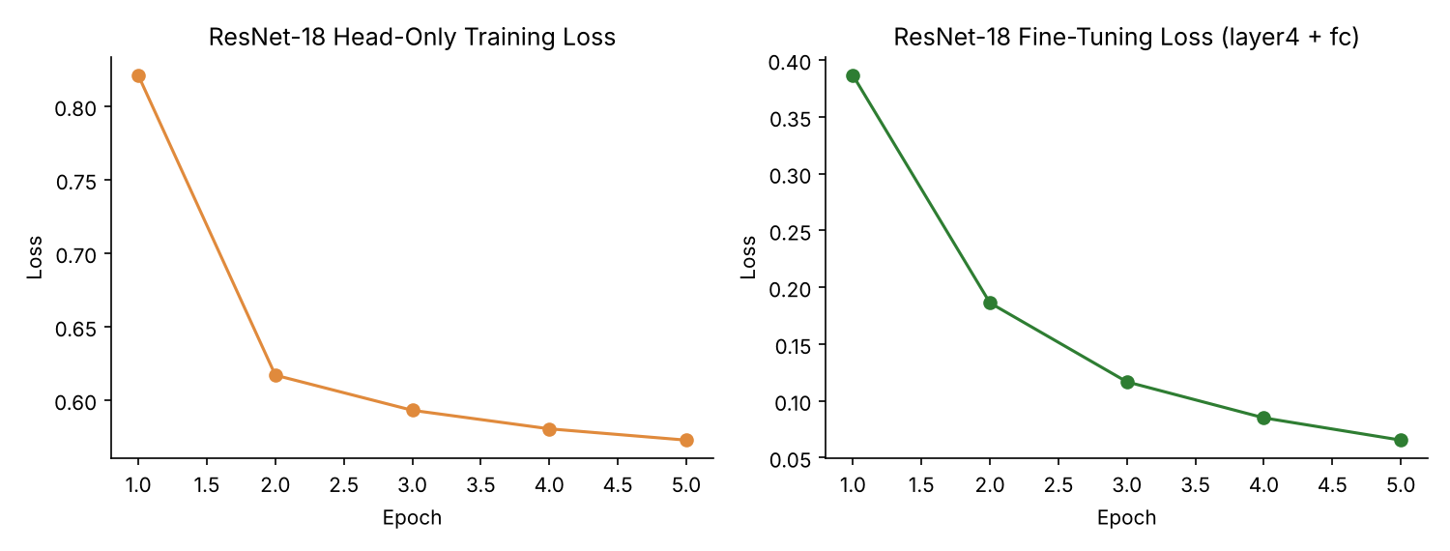
Figure 3: ResNet-18 training loss, head-only (left) vs fine-tuning (right)

6.5 Result
Metric | Value
Test Accuracy | 80.78%
Macro avg F1 | 0.81
Weighted avg F1 | 0.81

Even with its backbone completely frozen and only one new layer trained for 5 epochs, ResNet-18 beats both from-scratch CNNs by a wide margin (+9.37 points over the Improved CNN). This demonstrates the core value of transfer learning: the ImageNet-pretrained features generalise well to CIFAR-10's everyday object categories without any backbone retraining.

6.6 Per-class performance, head-only ResNet-18
Class | Precision | Recall | F1-score
airplane | 0.80 | 0.85 | 0.82
automobile | 0.90 | 0.89 | 0.89
bird | 0.74 | 0.76 | 0.75
cat | 0.73 | 0.65 | 0.69
deer | 0.83 | 0.71 | 0.76
dog | 0.76 | 0.76 | 0.76
frog | 0.81 | 0.88 | 0.84
horse | 0.79 | 0.85 | 0.82
ship | 0.84 | 0.88 | 0.86
truck | 0.88 | 0.86 | 0.87

7. Stage 4: Fine-Tuning ResNet-18

7.1 What changed
Instead of leaving the backbone fully frozen, the last residual stage (layer4) was unfrozen along with the classification head, so the network could adjust its highest-level, most task-specific features for CIFAR-10 while keeping the earlier, more general layers (layer1 to layer3) fixed.
Parameter group | Status
layer1, layer2, layer3 | Frozen (unchanged from ImageNet pretraining)
layer4 | Unfrozen, trainable
fc (classification head) | Unfrozen, trainable (continues from the head-only stage)

7.2 Training setup
Setting | Value
Optimizer | Adam, learning rate 0.0001 (10x lower than the head-only stage)
Trainable parameters | layer4 + fc
Epochs | 5
Batch size | 64

The learning rate was dropped by a factor of 10 for this stage. Fine-tuning adjusts pretrained weights rather than learning from a random start, so large updates risk erasing useful ImageNet features; a smaller learning rate lets the network adapt gently instead.

7.3 Training loss
Epoch | 1 | 2 | 3 | 4 | 5
Loss | 0.386 | 0.186 | 0.117 | 0.085 | 0.065

The loss drops far faster and further than in any previous stage, ending at 0.065 versus 0.573 for the head-only run, a sign that unfreezing layer4 gave the network much more capacity to fit the CIFAR-10-specific patterns.

7.4 Result
Metric | Value
Test Accuracy | 91.61%
Macro avg F1 | 0.92
Weighted avg F1 | 0.92

7.5 Per-class performance, fine-tuned ResNet-18
Class | Precision | Recall | F1-score
airplane | 0.91 | 0.95 | 0.93
automobile | 0.94 | 0.96 | 0.95
bird | 0.91 | 0.91 | 0.91
cat | 0.87 | 0.77 | 0.82
deer | 0.90 | 0.93 | 0.91
dog | 0.85 | 0.87 | 0.86
frog | 0.93 | 0.95 | 0.94
horse | 0.94 | 0.93 | 0.94
ship | 0.94 | 0.96 | 0.95
truck | 0.97 | 0.92 | 0.94

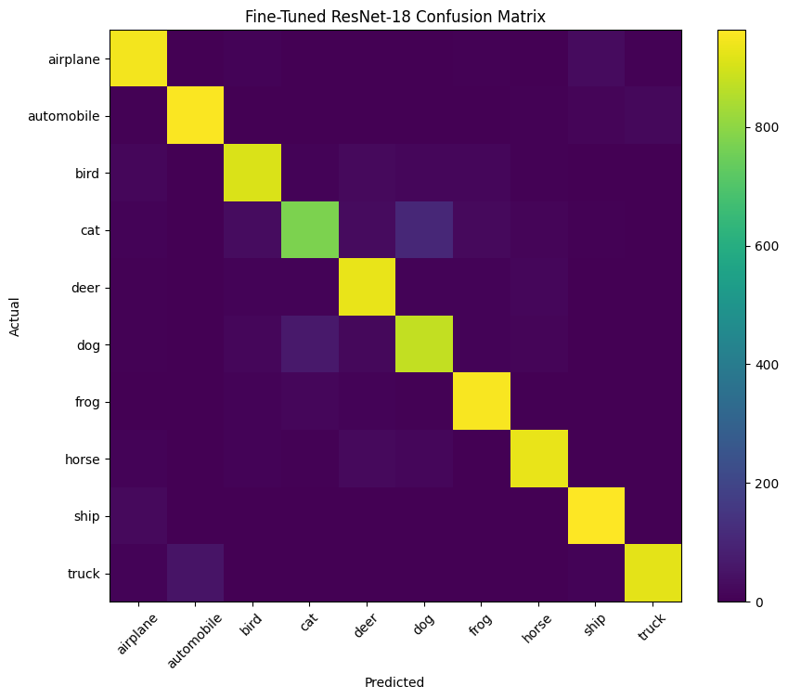
Figure 4: Confusion matrix for the fine-tuned ResNet-18 on the 10,000-image test set
The confusion matrix is strongly diagonal: nearly all mass sits on the correct class for every row. The clearest off-diagonal block is cat vs dog, which together with the per-class table below shows this is the one confusion that survives fine-tuning.

8. Cross-Stage Comparison

8.1 Accuracy across all four stages
Stage | Model | Trainable parameters | Epochs | Test Accuracy
1 | Basic CNN | All (from scratch) | 10 | 71.41%
2 | Improved CNN (augmentation + dropout) | All (from scratch) | 15 | 72.33%
3 | ResNet-18, head only | fc only | 5 | 80.78%
4 | ResNet-18, fine-tuned | layer4 + fc | 5 | 91.61%

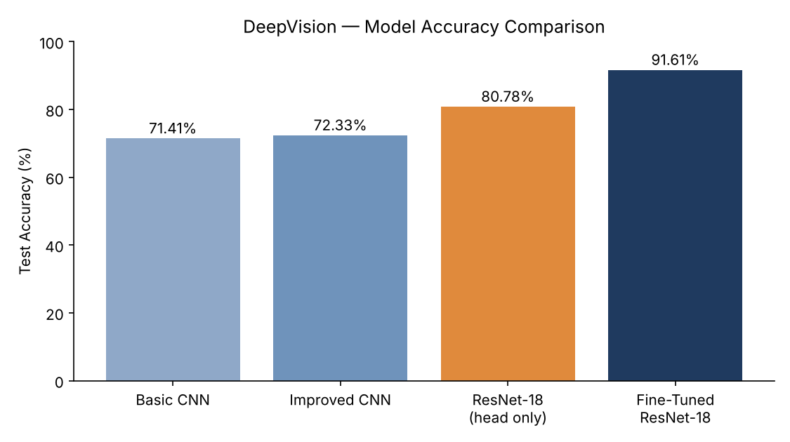
Figure 5: Test accuracy across all four stages
Going from the Improved CNN to head-only ResNet-18 adds 8.45 points without training a single convolutional filter — the entire gain comes from reusing ImageNet features. Unfreezing just one residual block for fine-tuning then adds a further 10.83 points, the single largest jump in the project, for only 5 more epochs at a tenth of the learning rate.

8.2 Per-class F1-score across models
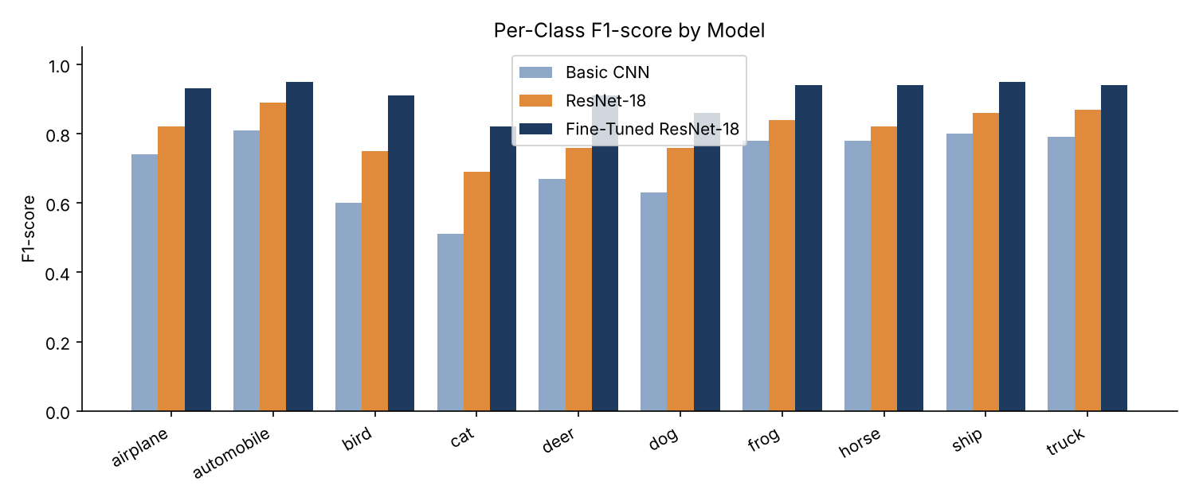
Figure 6: Per-class F1-score for the Basic CNN, head-only ResNet-18 and fine-tuned ResNet-18
Every class improves monotonically from the Basic CNN to the fine-tuned model. Cat is the hardest class throughout (F1 of 0.51, 0.69 and 0.82 respectively) and automobile is consistently the easiest (0.81, 0.89, 0.95). Cats are frequently confused with dogs because both are small four-legged mammals photographed at similar scales and poses in CIFAR-10's low-resolution images, a confusion visible directly in the confusion matrix in Figure 4.

9. Deployment

9.1 Single-image prediction
The fine-tuned ResNet-18 was tested on a photograph uploaded directly to the notebook (outside the CIFAR-10 test set), preprocessed with the same resize-and-normalise pipeline used for ResNet-18 training and evaluation.
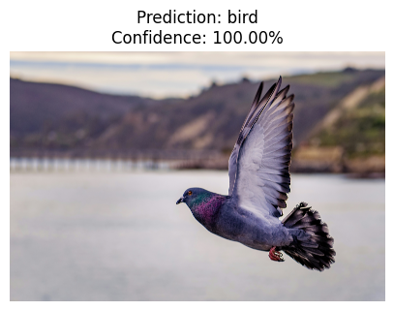
Figure 7: Prediction on an uploaded photograph
The model predicted "bird" with 100.00% confidence, correctly matching the uploaded photograph.

9.2 Saving the model
The fine-tuned ResNet-18's weights were saved to deepvision_resnet18_cifar10.pth using torch.save(resnet.state_dict(), ...), and the class name list was saved separately to classes.json. Saving only the state dictionary (not the full model object) is the standard PyTorch practice, as it is portable across code versions as long as the same model class definition is available when loading.

9.3 Interactive demo with Gradio
A Gradio web interface was built around the fine-tuned model: the user uploads an image, it is preprocessed with the same ResNet-18 transform, and the app displays the top 3 predicted classes with their probabilities. Calling demo.launch() in a hosted notebook created a temporary public URL (valid for up to one week) so the model could be tried from any browser without local setup.

10. Conclusion
DeepVision traced a clear progression on CIFAR-10: a from-scratch CNN reached 71.41% accuracy, data augmentation and dropout nudged that to 72.33%, switching to a frozen, ImageNet-pretrained ResNet-18 jumped to 80.78%, and fine-tuning just one residual block pushed the final accuracy to 91.61% — a 20-point improvement over the original CNN using only 5 extra epochs at a lower learning rate. This demonstrates, with real measurements rather than theory alone, why transfer learning is now the default starting point for image classification: reusing pretrained features is both faster and more accurate than training a comparable network from scratch. The project was carried through to a usable form, with the trained model saved to disk and wrapped in a Gradio demo for interactive use.

11. Future Scope
- Unfreeze more residual blocks (layer3 and layer4) or fine-tune the entire network, with a learning-rate schedule, to test whether accuracy improves further.
- Add targeted augmentation or loss weighting for the cat and dog classes specifically, since they remain the weakest pair after fine-tuning.
- Use k-fold cross-validation or multiple random seeds to measure how much of the stage-to-stage improvement is signal versus run-to-run noise.
- Try other pretrained backbones (ResNet-34, EfficientNet, a Vision Transformer) and compare accuracy against training and inference time.
- Evaluate on a larger, more varied set of external photographs (beyond the single uploaded image) to validate real-world reliability before relying on the model's confidence scores.
- Deploy the Gradio demo permanently on Hugging Face Spaces instead of the temporary share link, so it remains reachable beyond one week.

