MINOR PROJECT REPORT
Laptop Price Prediction Using Machine Learning
Supervised regression on laptop hardware specifications
Field | Details
Submitted by | Priyanshu Dash
Roll Number | AIML-A6/JN-10471
Branch / Year | Computer Science & Engineering, 4th Year
Institute | Kalinga Institute of Industrial Technology (KIIT), Bhubaneswar, Odisha
Program | Machine Learning Internship, InternsElite
Project Guide | Abhishek Pandey

1. Objective
This project builds a regression model that predicts the market price of a laptop from its specifications: manufacturer, type, screen, processor, RAM, storage, graphics card, operating system and weight. Two algorithms, Linear Regression and Random Forest Regressor, are trained and compared to find the more accurate one.

2. Dataset
The dataset holds 1,303 laptops with 12 columns and no missing values. Prices are in Indian Rupees (₹).
Statistic | Inches | Price (₹)
Mean | 15.02 | 59,870
Std Dev | 1.43 | 37,243
Min | 10.1 | 9,271
25% | 14.0 | 31,915
Median | 15.6 | 52,055
75% | 15.6 | 79,274
Max | 18.4 | 324,955

Raw columns: Company, TypeName, Inches, ScreenResolution, Cpu, Ram, Memory, Gpu, OpSys, Weight, Price (plus an unused index column, Unnamed: 0).

3. Data Preprocessing and Feature Engineering
Text-based specification columns were converted into numeric features the models can use.
Original column | Processing | New feature(s)
Unnamed: 0 | Dropped (row index) | -
Ram | Removed 'GB', cast to int | Ram (int)
Weight | Removed 'kg', cast to float | Weight (float)
Cpu | First word of the string | Cpu Brand (Intel / AMD / Samsung)
Memory | Regex extraction of SSD and HDD sizes | SSD, HDD (GB)
ScreenResolution | Keyword and regex parsing | Touchscreen, IPS, X_res, Y_res
Cpu, Memory, ScreenResolution | Dropped after extraction | -

Categorical encoding
Company, TypeName, Gpu, OpSys and Cpu Brand were converted to integers with LabelEncoder. For example, the 19 companies map from Acer = 0 to Xiaomi = 18, and TypeName has 6 classes (2 in 1 Convertible, Gaming, Netbook, Notebook, Ultrabook, Workstation).
The final feature set has 14 inputs: Company, TypeName, Inches, Ram, Gpu, OpSys, Weight, Cpu Brand, SSD, HDD, Touchscreen, IPS, X_res, Y_res. The target is Price.

4. Model Training
- Train-test split: 80% training and 20% testing, random_state = 42.
- Model 1: LinearRegression with default parameters, used as the baseline.
- Model 2: RandomForestRegressor with n_estimators = 200, random_state = 42, able to capture non-linear relationships.

5. Results
Metric | Linear Regression | Random Forest
MAE (₹) | 15,125 | 9,931
MSE | 488,181,447 | 274,077,176
RMSE (₹) | 22,095 | 16,555
R² Score | 0.6614 | 0.8099

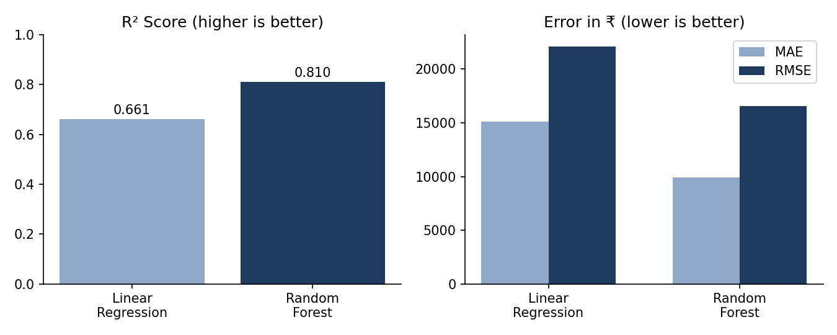
Figure 1: Model comparison on the test set
Random Forest is clearly the better model. It explains about 81% of the variance in price against 66% for the baseline, and cuts the average absolute error from about ₹15,100 to about ₹9,900, a reduction of roughly 34%.

Sample predictions (Random Forest)
Actual Price (₹) | Predicted Price (₹) | Difference (₹)
89,084 | 70,742 | -18,342
61,219 | 67,237 | +6,018
26,587 | 29,953 | +3,366
47,899 | 51,270 | +3,371
66,280 | 78,798 | +12,518
74,538 | 88,533 | +13,994
38,308 | 48,106 | +9,798
24,456 | 32,210 | +7,754
63,456 | 61,473 | -1,983
18,595 | 20,204 | +1,609

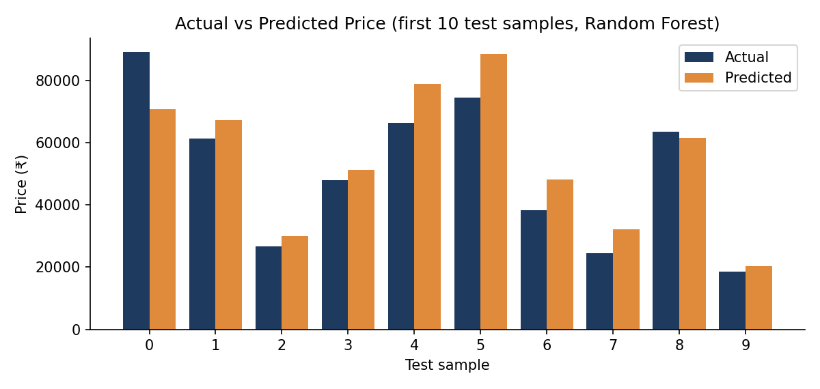
Figure 2: Actual vs predicted price on ten test samples
In these ten samples the model tends to over-predict more often than it under-predicts, and the largest miss is on the most expensive laptop (₹18,342 under).

6. Example Prediction
A new laptop was passed to the trained Random Forest model:
Specification | Value
Company / Type | HP, Notebook
Screen | 15.6 inch, 1920 x 1080, IPS, no touchscreen
CPU / GPU | Intel, Intel UHD Graphics 620
RAM / Storage | 16 GB RAM, 512 GB SSD, no HDD
OS / Weight | Windows 10, 1.8 kg
Predicted price | ₹ 76,058.45

7. Conclusion
The project built an end-to-end price prediction pipeline: cleaning, feature engineering, encoding, training and evaluation. Random Forest outperformed Linear Regression on every metric (R² 0.81 vs 0.66, MAE ₹9,931 vs ₹15,125), showing that laptop pricing depends on non-linear interactions between specifications. The model can serve as a practical pricing aid for customers, retailers and manufacturers.

8. Future Scope
- Add cross-validation and hyperparameter tuning to improve the model.
- Try XGBoost, LightGBM and CatBoost, and model log-price.
- Train on a larger, more recent dataset, ideally with live e-commerce pricing.
- Build a Streamlit or Flask front end and deploy on a cloud platform.

