INT219 – Activity 3
Priyanshu Kamal
12410266
3M036

OUTPUT

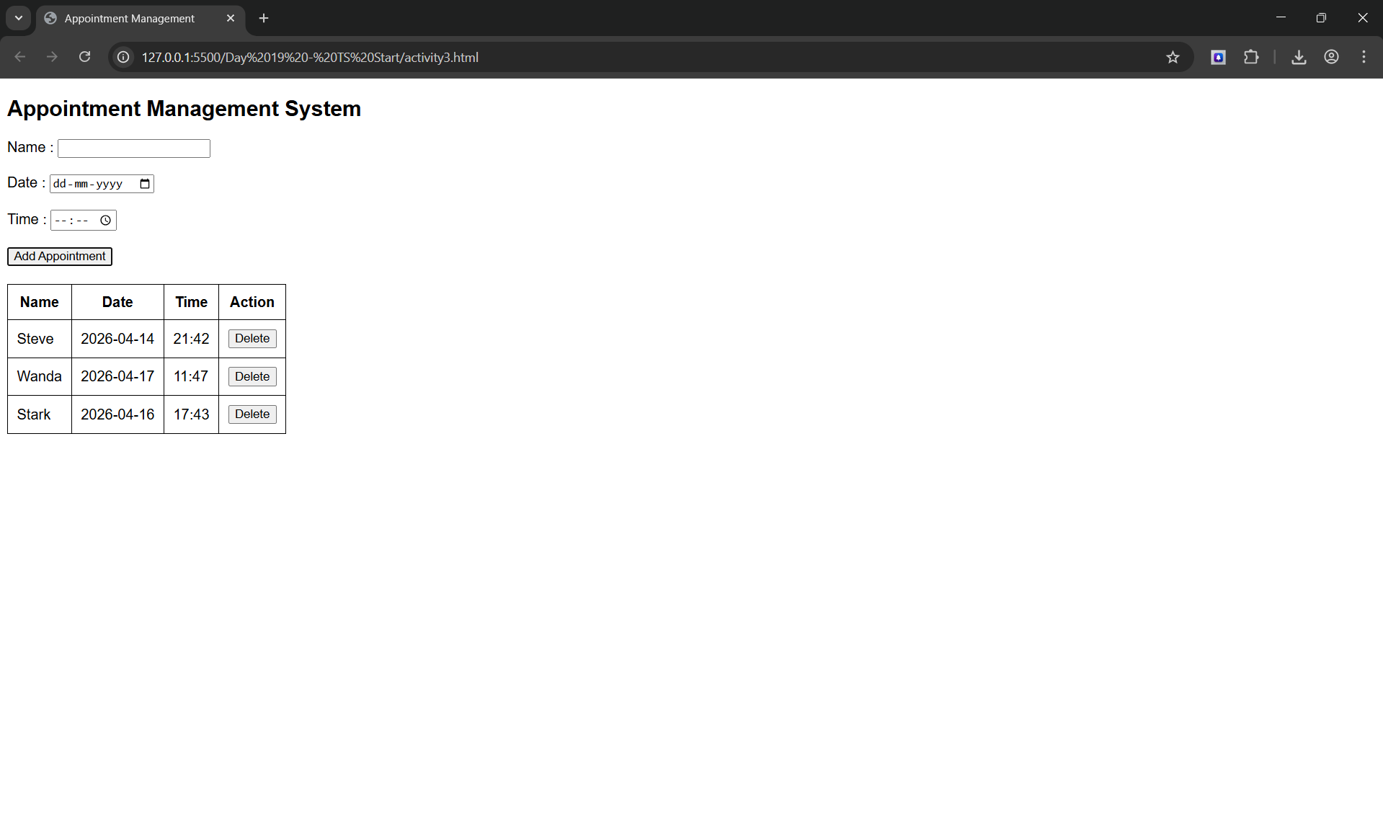

CODE

<!DOCTYPE html>
<html lang="en">
<head>
<meta charset="UTF-8">
<meta name="viewport" content="width=device-width, initial-scale=1.0">
<title>Appointment Management</title>

<style>
body {
font-family: Arial, Helvetica, sans-serif;
}

form {
margin-bottom: 20px;
}

table, th, td {
border: 1px solid black;
border-collapse: collapse;
padding: 10px;
}
</style>
</head>
<body>

<h2>Appointment Management System</h2>

<form action="" id="appointmentForm">
Name : <input type="text" id="name"><br><br>
Date : <input type="date" id="date"><br><br>
Time : <input type="time" id="time"><br><br>
<button type="submit">Add Appointment</button>
</form>

<table>
<thead>
<tr>
<th>Name</th>
<th>Date</th>
<th>Time</th>
<th>Action</th>
</tr>
</thead>
<tbody id="appointmentTable"></tbody>
</table>

<script>
document.getElementById("appointmentForm").addEventListener("submit", function(e) {
e.preventDefault();
let name = document.getElementById("name").value;
let date = document.getElementById("date").value;
let time = document.getElementById("time").value;

let row = document.createElement("tr");

row.innerHTML = `
<td>${name}</td>
<td>${date}</td>
<td>${time}</td>
<td><button class="delete">Delete</button></td>
`;

document.getElementById("appointmentTable").appendChild(row);
this.reset();
});

document.getElementById("appointmentTable").addEventListener("click", function(e) {
if (e.target.classList.contains("delete")) {
e.target.parentElement.parentElement.remove();
}
});
</script>
</body>
</html>

