

Inventory Management Tool

Priyanshu Khanal
International American University (IAU)
AIM401: Python Programming for Data Science
Professor Dhiraj Basyal
26 September 2026

Inventory Management Tool

1. Introduction
This program is a simple inventory management system written in Python. It stores product stock in a dictionary and customer orders in a list (Exercism, 2024). The program checks each order, updates the available stock, handles partial orders, and reports items that cannot be fully supplied.

2. Source Code

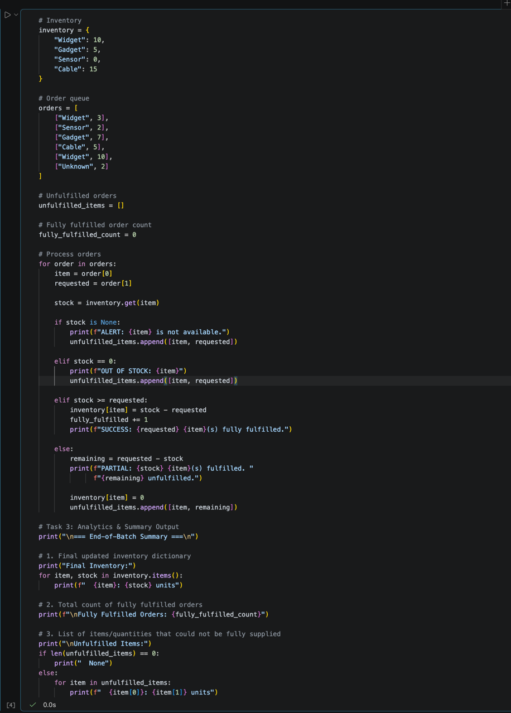

3. Expected Output

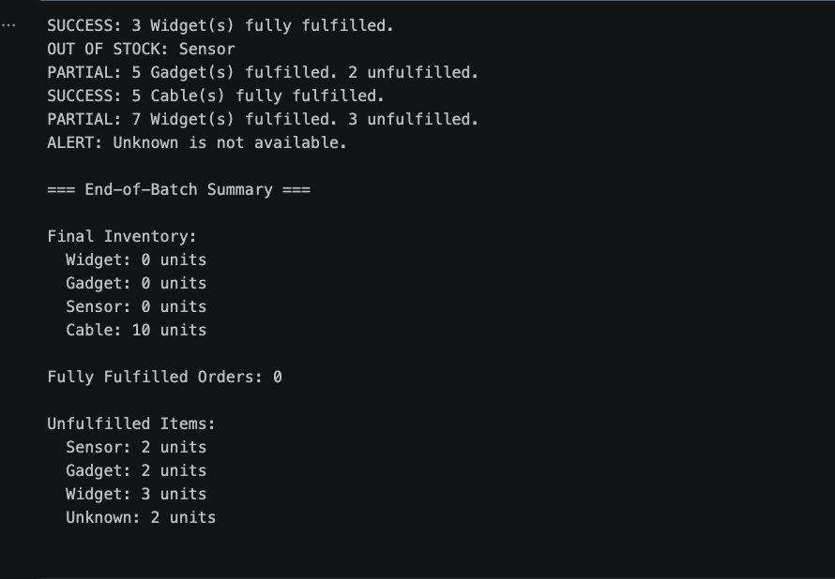

4. Code Explanation
The first step of the program is to establish an inventory dictionary. The key is the product name, the value is the quantity available (W3Schools, 2026).
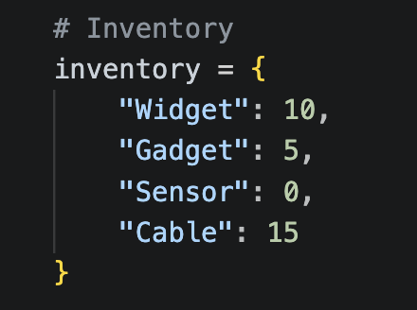
Orders list is used to store Customer orders. The order specifies the product name and the amount of the product ordered.
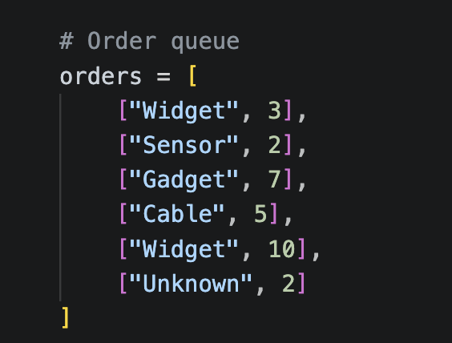
The list is empty at the beginning. It is used for storing products and quantities not available. The total number of orders with all items fulfilled is stored in the variable fully_fulfilled.
Each order is individually processed in the for loop.
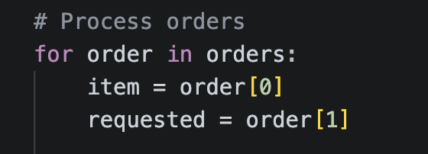
The product name is in order[0] and the quantity ordered is in order[1].
The .get() method determines if the product being requested is in the stock.

If it is not found, the program will alert the user and enter the requested amount as unmet.
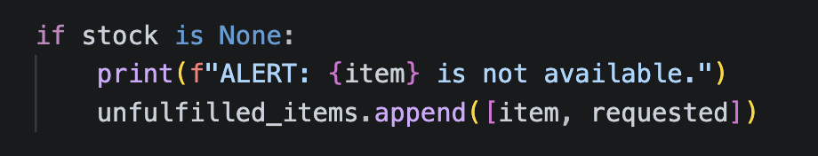
If the product is present in the database but there is no stock, the program will display an ‘out of stock' message and mark the order as unfulfilled.
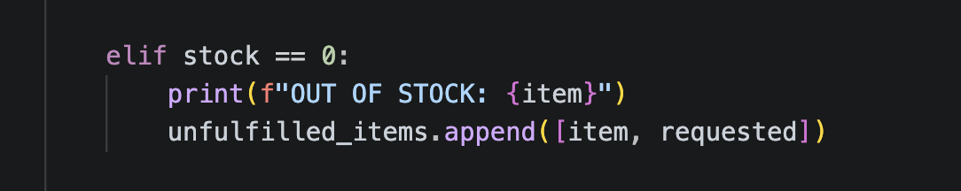
If the stock available in the system is more than or equal to the requested quantity, the order is fulfilled completely. The requested amount is subtracted from the inventory and the fully_fulfilled counter is incremented.
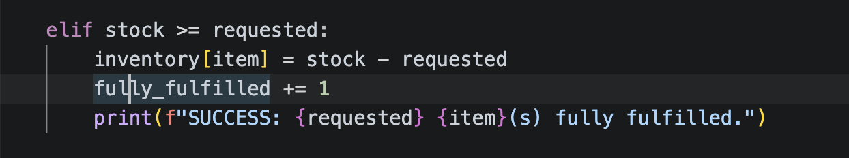
When the amount of stock available is less than the requested amount but more than 0, the program will do a partial fulfillment. The amount of stock available is delivered, the inventory is depleted, and the stock remaining is added to the unfulfilled stock list.
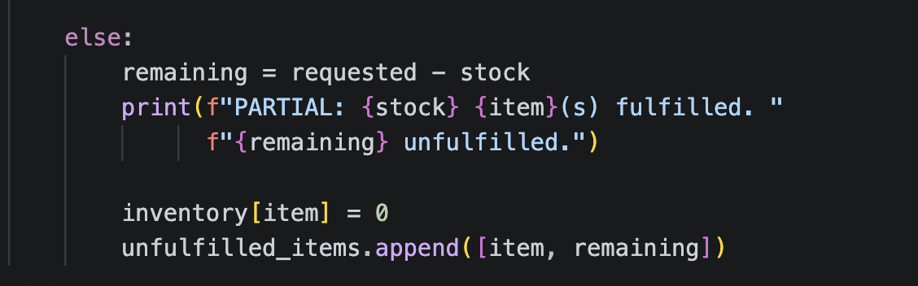
The program then prints the updated inventory, the number of orders that have been completely filled and the items that have not been filled (Nihill, 2025).
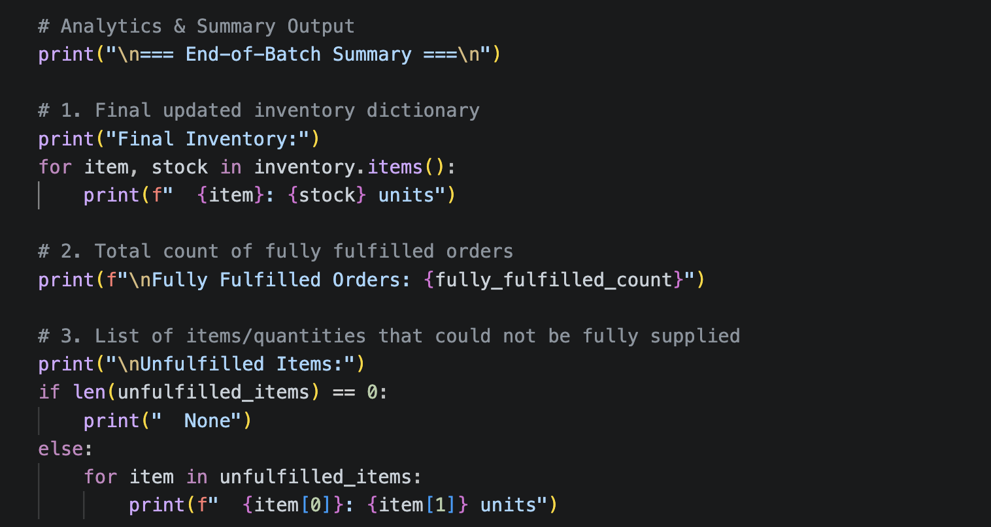
In this way, it guarantees that all orders are verified and that the stock is updated properly each time the transaction is made.

5. Conclusion
The program illustrates the use of Python to keep track of simple inventory and customer orders. Stock checking, order fulfillment, and recording the amount of unfulfilled orders were done using dictionaries, lists, loops, and conditional statements. The last summary will be easy to spot any leftover inventory and orders which were not fully supplied. Generally, the program fulfills the overall needs for the inventory management task.

References
Exercism. (2024). Inventory management in Python. Exercism. https://exercism.org/tracks/python/exercises/inventory-management
W3Schools. (2026). Python dictionaries. W3Schools. https://www.w3schools.com/python/python_dictionaries.asp
Nihill, M. (2025). Managing inventory with Python dictionaries [Slides]. SlideServe. https://www.slideserve.com/maurilio-nihill/cs-931-dictionaries

