Question number 1:
Answer: Python uses dynamic typing, which means you don’t have to declare the type of a variable before using it. A variable is just a name that assigns to an object in memory, and the type will be stored with the object. For instance, assigning x = 5 creates an integer object and x is a reference to it. If you later do x = "hello", then it now is a string object.
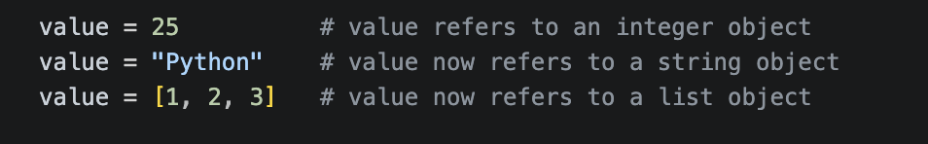
This flexibility makes Python so easy to use but can cause run time errors when mixing up types (GeeksforGeeks, 2025).
In statically typed languages such as Java or C++, the type of a variable has to be explicitly specified and cannot be changed once the variable is declared. This is why they are tougher but still not dangerous, since type errors are detected at compile time and not at runtime.
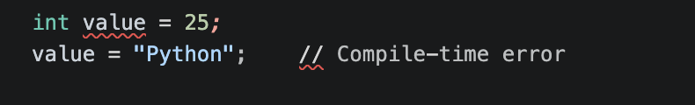
When it comes to division, Python has two operators: floating-point division (/) and integer division (//). The / operator always returns a floating-point division, keeping the fractional part of the result (Leapcell, 2025). For example, 7 / 2 gives 3.5. On the other hand, // does floor division, discards the fractional part and returns the whole number. For instance, 7 // 2 gives 3.
- Floating-point division (/):
7 / 2 = 3.5
This always gives you a decimal (float), even if the numbers divide evenly.
- Integer division (//):
7 // 2 = 3
This chops off the decimal part (truncates toward negative infinity). It doesn’t round, it just drops the fraction.
Inside the operators, both do the same calculation, but // rounds down to negative numbers, while / keeps the decimal. It is significant when processing numbers with both positive and negative values since truncation can act differently than simple rounding.
In conclusion, unlike fixed boxes in a static language, Python variables are flexible labels that are attached to objects, and / keeps all the decimals, while / discards them.
References
GeeksforGeeks. (2025, August 14). Why Python is called Dynamically Typed? GeeksforGeeks. https://www.geeksforgeeks.org/python/why-python-is-called-dynamically-typed/
Leapcell. (2025, July 25). Understanding division operators in Python. Leapcell. https://leapcell.io/blog/understanding-division-operators-in-python

Question number 2:
Answer: Short-circuit evaluation is when Python evaluates a Boolean condition from left to right, and it breaks out of the evaluation when it knows the result (Python, 2026). The condition if A and B or C is interpreted by Python as if (A and B) or C since the and is more tightly coupled to the or.
Then, Python evaluates B. Then, Python evaluates B. When A is false, it does not compute B since the whole A and B part is false. Python next tests C. B is evaluated if A is true. Python will not test C – if both A and B are true, then Python won't test C as the full condition is true.
To improve execution speed, simple and likely-to-fail conditional structures may be placed first when using and. For example:
In this instance, the costly check is only carried out if the first two are true. Generally, with, or, likely-to-be-true conditions should be listed first:
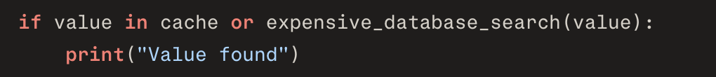
If the value already exists in the cache, then Python doesn't do the database search (Boolean expressions, 2026). Thus, the use of short-circuit evaluation can save time and avoid unnecessary operations. Use parentheses in complex conditions to ensure the logical order of the conditions and to avoid logical errors.
References
Python. (2026). Built-in types. Python Documentation. https://docs.python.org/3/builtins/stdtypes.html.
Boolean expressions. (2026). Python Guide. https://cs.stanford.edu/people/nick/py/python-boolean.html.

