

Three-Day Budget Tracker

Priyanshu Khanal
International American University (IAU)
AIM401: Python Programming for Data Science
Professor Dhiraj Basyal
26 September 2026

Three-Day Budget Tracker
Introduction
The objective of this project is to develop a small financial tool that will keep track of the amount that a person spends in a span of three days. The program asks the user for their name and then requests the amount spent each day. Compares each daily amount to a budget of $20 and shows the user if they overspent their daily allowance or not.
The program also works out the total expenditure for the three days. The total is compared to the overall budget of $60. This project employs simple Python concepts, such as variables, input, floating point numbers, for loop, arithmetic operators, and if/else statements (Strurtz, 2018). To execute instructions over and over, Python has for statements, and to select instructions depending on a Boolean expression, there are conditional statements.
Program Objectives
The main objectives of the program are:
- Prompt the user to enter his/her name.
- Save the sum of the expenditures into a variable called total_spent.
- Repeat the spending question three times.
- Compare each daily amount with the $20 daily budget.
- Count up the daily totals to make the total.
- Compare the three day total to the overall budget of $60.
- Present clear and informative messages about daily and overall results.
This program does not rely on lists, dictionaries, sets, files, custom functions or user defined classes. This is as per the restrictions mentioned in the assignment. It employs only variables, input conversion, arithmetic, conditional statements and a simple loop.
Figure 1:
Program code
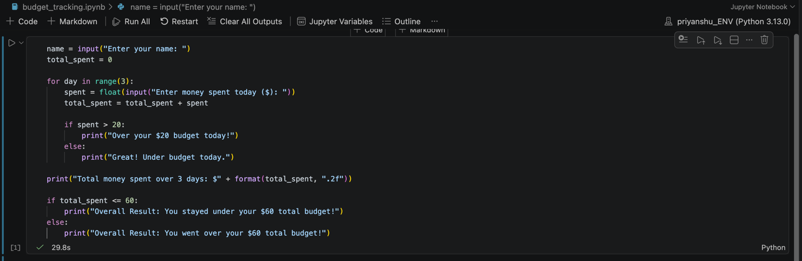
Code explanation:
The first line uses input() to ask the user for their name. The input given by the user is not the name, which must remain as text only. The second line is used to make a new variable total_spent, with its initial value of zero.
The for loop is used to loop the spending process three times using the range(3). One day is considered one rep. The program will ask the user to input the amount of money he spent for each repetition. The float() conversion enables the program to accept decimal numbers like 15.50 or 22.00.
The statement total_spent = total_spent + spent is an update to the total amount of money that has been spent to date. If the user adds $10 on day one and $25 on day two, for example, then after two days he or she has $35.
The message is printed out daily as long as spent is over 20, otherwise, it prints out the other message. If it is, then the over budget message will be printed (Python Software Foundation, 2026). If it doesn't, it will say the under budget message. Using a conditional statement enables a program to run different instructions based on the truth of a condition.
At the end of the loop the program will print the amount of money that the student has spent. The format(total_spent, ".2f") expression formats the total_spent value so that it only shows two digits after the decimal point (Strurtz, 2018). This last if/else statement is used to determine if the total is less than or equal to 60. If the user did overspend the overall budget, the program states so. If it's not, it will say that the user spent more than the budget.
Testing and Results
For testing, my name is Priyanshu and I am using the following amounts:
• Day 1: $15.50
• Day 2: $22.00
• Day 3: $18.25
The total amount of spending is $55.75. The second day exceeds the budget by $22.00 after all the operations are completed. The first and third days have been used up, they are the daily budget days. The overall result indicates that the user has been within the budget of $60 a day for three days, because $55.75 is less than $60.
Figure 2:
The three daily spending entries
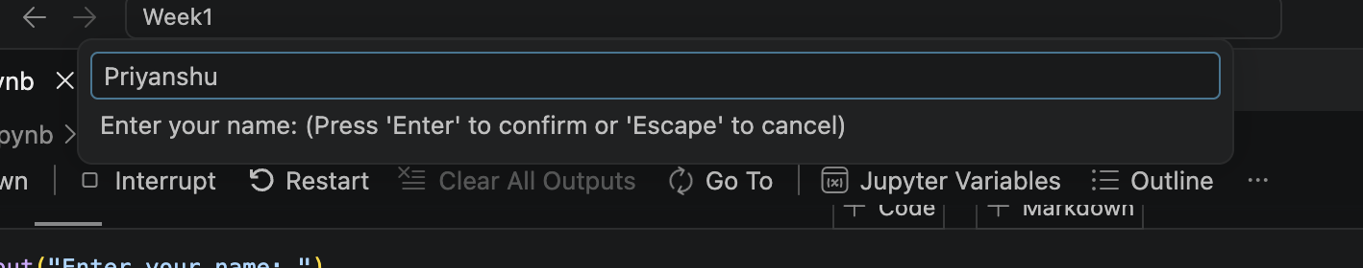
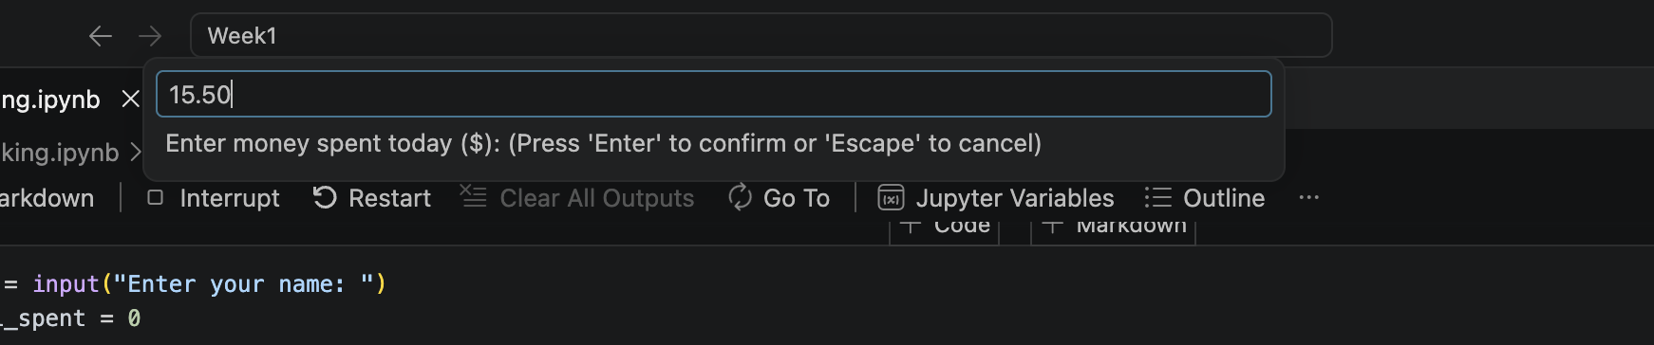
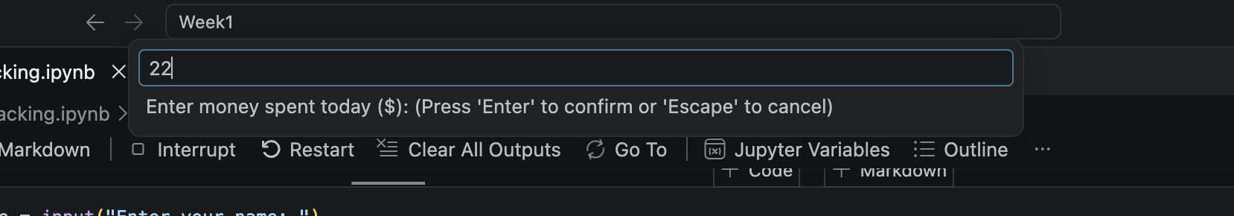
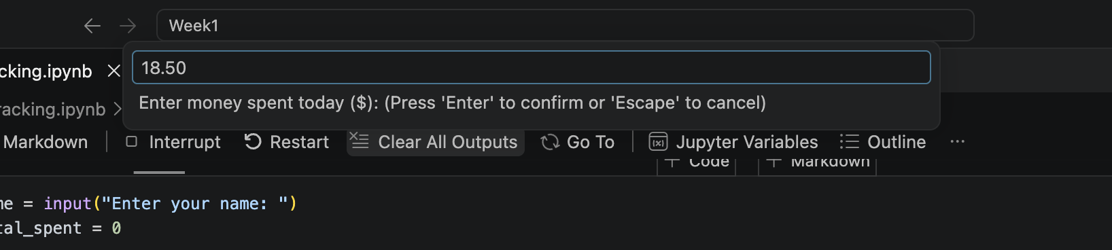

Figure 3:
Expected output
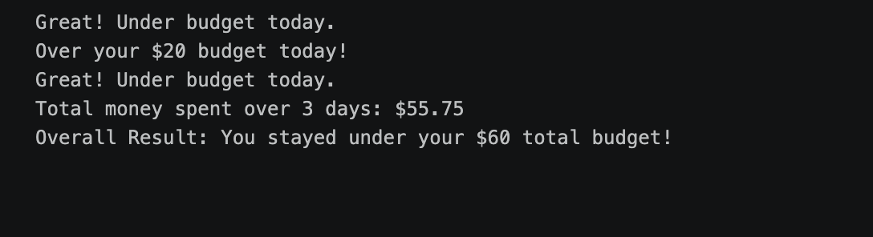
Git hub link:
https://github.com/priyanshukhanal/Python_assignments.
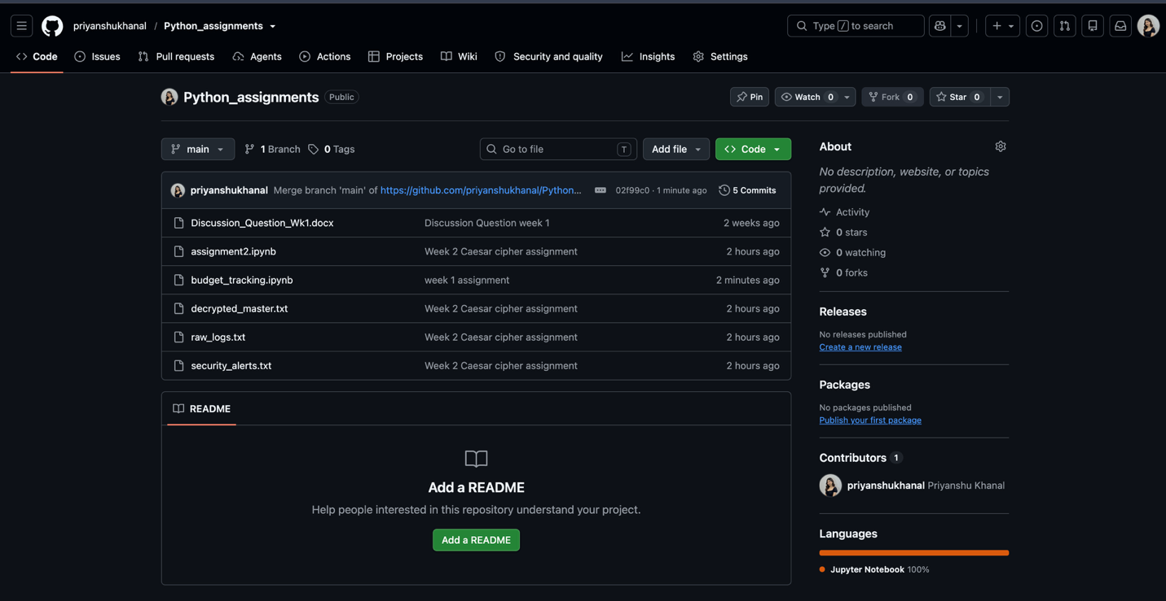

Conclusion
For the three days, this program offers a straightforward means of tracking expenses. It compares every amount against the $20 limit, and compares the final amount with the $60 total limit. The program illustrates the use of variables to hold information, the use of a loop to repeat an action, and the use of a conditional statement to provide different messages depending on the financial outcomes.
The program is kept as simple as possible and it adheres to the restrictions in the assignments. It relies on no external collections or files, no custom functions or advanced Python features. While this is a small tool, it can be scaled up to be used for more days, other budgets, and other areas of financial responsibility in the future.

References
Python Software Foundation. (2026). More control flow tools. Python 3.14 documentation. https://docs.python.org/3/tutorial/controlflow.html.
Strurtz, J. (2018, September 4). Conditional statements in Python. Real Python. https://realpython.com/python-conditional-statements/.

