

Caesar Cipher Decryption and Security Log Analysis Using Python

Priyanshu Khanal
International American University (IAU)
AIM401: Python Programming for Data Science
Professor Dhiraj Basyal
26 September 2026

Caesar Cipher Decryption and Security Log Analysis Using Python
Introduction
This project is a Python application for a company’s security company. The program decryption the encrypted log entries of a text file with a Caesar shift decryption. A Caesar cipher is a type of cipher in which letters are replaced with letters a certain number of places removed in the alphabet (Geeksforgeeks, 2025). The encrypted text in this assignment has a shift of 3 positions; in this program, each letter is shifted 3 places to the left to get the original text.
It also filters out security information from regular log information. Each of the lines is saved in a master output file after being decrypted. If the word BREACH appears in the line in the decrypted file, the program copies the line to a second alert file. In this approach we show how to use file input and output, loops, conditional statements, string processing, ord() and chr() functions in Python.
Program Implementation
There are three text files used in the program. The raw file is called raw_logs.txt and it contains dummy security logs, encrypted. The program is opened in read mode, which is denoted by “r”. It also produces two output files: decrypted_master.txt and security_alerts.txt in write mode (“w”). If the file exists, write mode will replace it, otherwise it will create it.
The program reads line by line and implements a for-loop for that purpose. A second loop is used to check all characters of the current line. Spaces and newlines are retained because they shouldn’t be altered when decrypting (Bharadwaj, 2021). For alphabetic characters, ord() changes a character into its numeric character code. The program subtracts 3 from that code to perform the left shift. Next, chr() will change the new numeric code back into a readable character. The ord() function gets the codepoint of one character; and the chr() function does the opposite.
Once a line has been decrypted, the strip() function is used to get rid of the unwanted spaces from the start and end of the line. This program outputs a decrypted_master.txt file. Then it uses the upper() function to make the line uppercase and looks for the word “BREACH.” Capitalized keyword will check case-insensitively. If the keyword is found, an if statement prints the same decrypted line to security_alerts.txt.
Testing and Output
The test data comprises normal server activity, successful login activity, a firewall update and two messages with a breach alert. Once the program has been run, you should have all the following five readable log records contained in the file decrypted_master.txt. The security_alerts.txt file should have just the 2 lines that contain the word ‘BREACH’.
Figure 1:
raw.logs.txt showing encrypted text
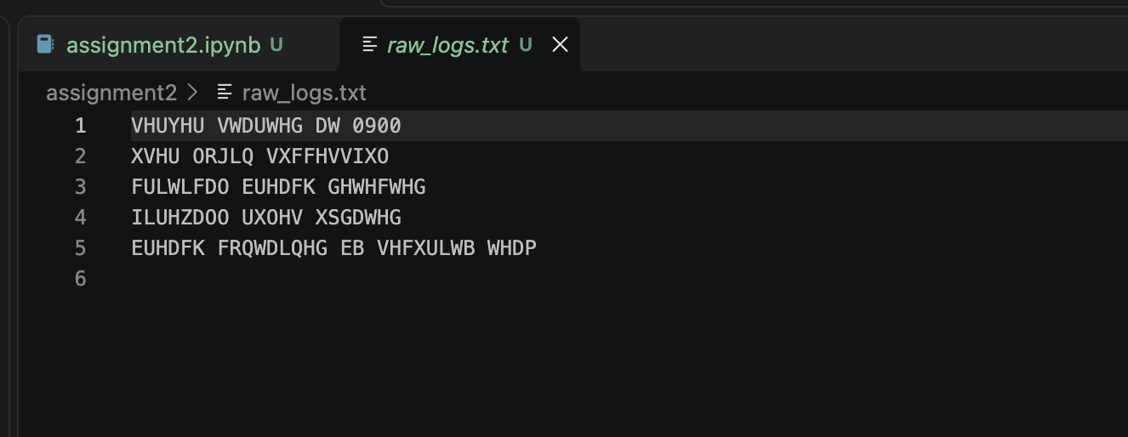
This figure shows the encrypted log data stored in the raw_logs.txt file. Caesar cipher is used to shift the log messages by three characters.

Figure 2:
Code I use in notebook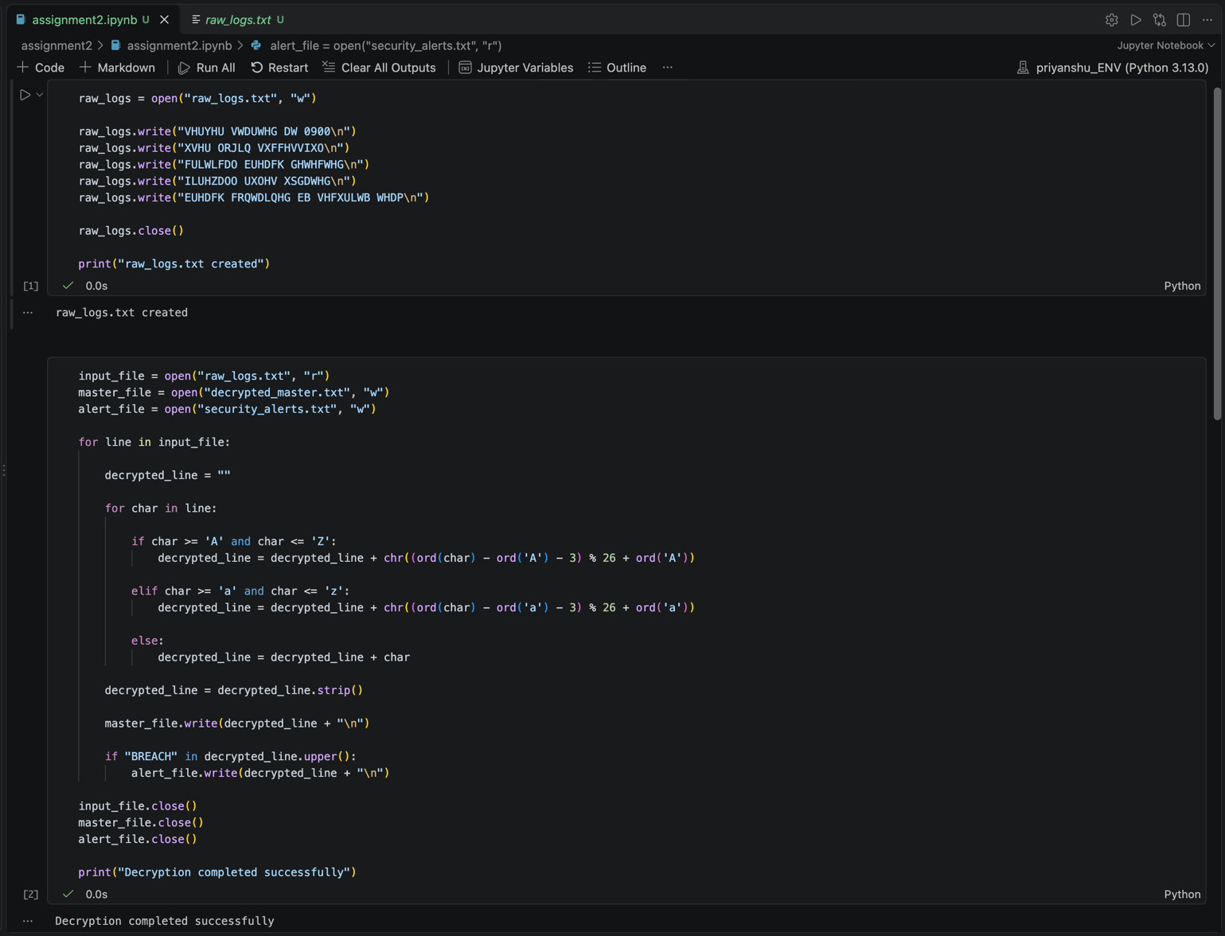
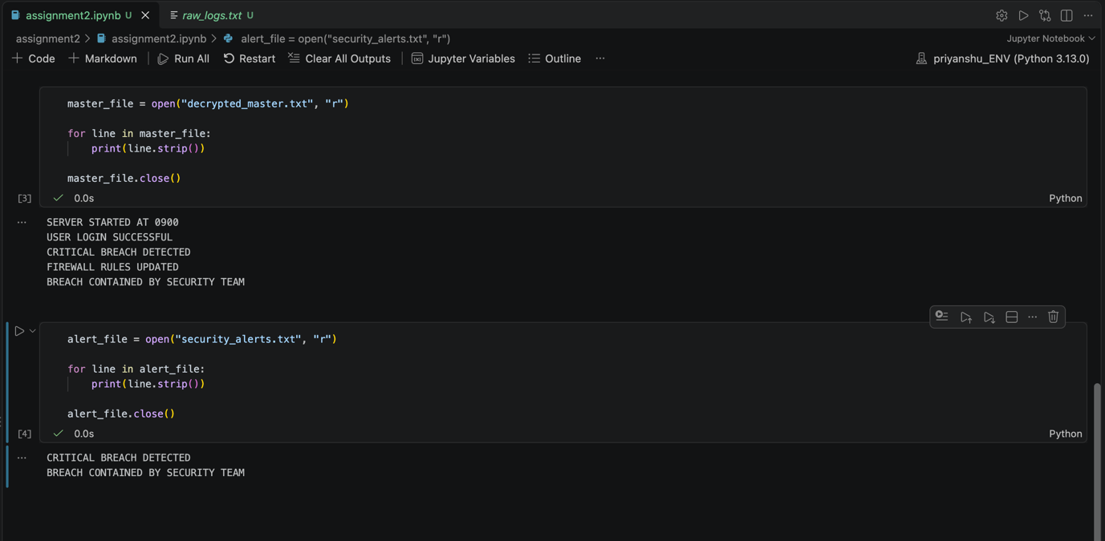
This figure shows the main Python program. It reads the encrypted file, decrypts each character, shifting it 3 positions to the left, then looks for the word BREACH.
Figure 3:
Decrypted_master.txt result
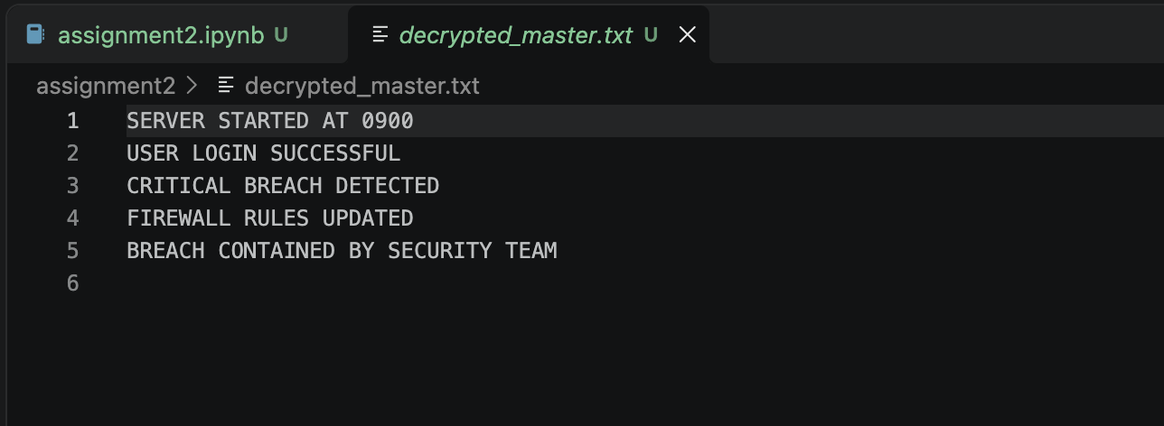
This figure shows the final decrypted log messages. The program has converted the encrypted text into readable text and saved all the lines in decrypted_master.txt.

Figure 4:
Security_alert.txt result
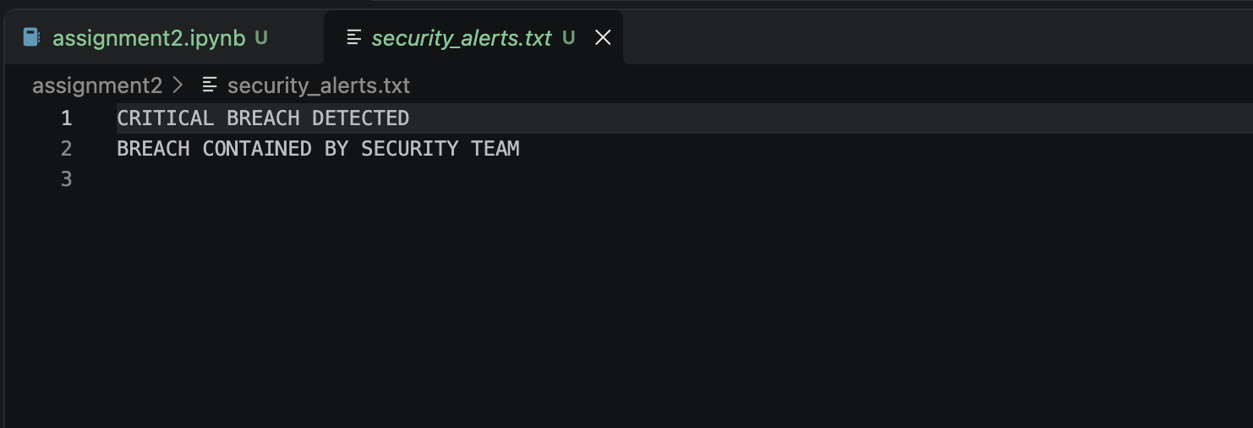
This figure displays the Lines with the Critical Word BREACH. The program scans each line that has been decrypted and appends a line that is a match to the security alert file.
Figure 5:
GitHub Repository
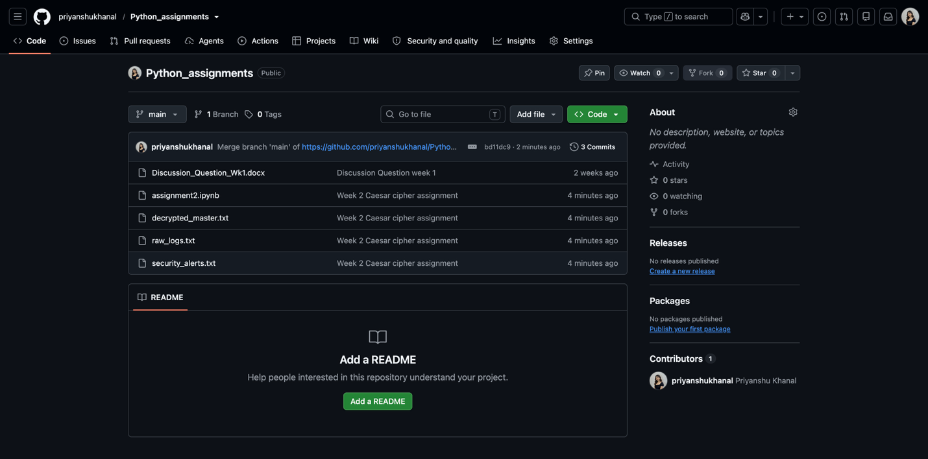
This is the GitHub repository where the source code for the assignment is stored. The repository contains the Python program submitted and other assignment files. Github link: https://github.com/priyanshukhanal/Python_assignments
Conclusion
This assignment demonstrates the use of Python to automate a simple security-log workflow. The program decrypts a Caesar-shifted file and saves all the readable logs into one master file, while marking all the ones that contain “BREACH” into a separate alert file. There are no list, dictionary, custom function, or external library restrictions in the implementation, but file operations are required, loops are allowed, conditionals are allowed, string methods are allowed, ord() is allowed, and chr() is allowed. The project also illustrates the benefits and ease of implementing text filtering, a capability that can assist in security monitoring by making it easier to find important events.

References
Bharadwaj, V. (2021). Caesar Cipher in Python. Bharadwaj. https://bharadwaj.hashnode.dev/caesar-cipher-in-python.
Geeksforgeeks. (2025). Caesar Cipher in Cryptography. Geeksforgeeks. https://www.geeksforgeeks.org/ethical-hacking/caesar-cipher-in-cryptography/.

