

Digital Banking Audit Tool: Cleaning, Fee Calculation, and Recursive Totals

Priyanshu Khanal
International American University (IAU)
AIM401: Python Programming for Data Science
Professor Dhiraj Basyal
14 October 2026

Table of Contents
Introduction 3
Task 1: Cleaning Transactions and Applying Fees 3
Task 2: The Recursive Search Engine 4
Testing and Output 5
Git URL: 6
References 8

Introduction
Banks perform large volumes of transactions per day, with some transactions causing smaller transactions to be made within them. The auditor should not take the bad ones into account, calculate the fees and total up all that really performed. It is a small Python audit tool which performs these 3 jobs. It applies functional tools (filter() and map() using lambda expressions) for the cleaning and fee steps; and it uses a purely recursive function for adding up the amounts defined in deeply nested lists.
Functional tools are appropriate for this function since they accept a list as an argument and return a new list back, without altering the original list (Python Software Foundation, 2024). The nested part is the one that goes best with recursion because the data itself is composed of smaller copies of itself, similar in form (Abelson & Sussman, 1996).The nested part is the one that fits recursion best, as the data is composed of smaller copies of itself data similar in form.

Task 1: Cleaning Transactions and Applying Fees
The first function clean_transactions() filters out the kind of transactions that should not be audited. The transaction is stored only if it exceeds the minimum value (default 10.0) and is positive. The rule is stored in the lambda expression, and it's applied to each amount by the filter() function (Python Software Foundation, 2024a). Min_threshold is a default argument so the default limit can be changed by the caller without editing the function.
The second function, apply_service_fee(), applies the fee_rate to each amount in the list using map() and a lambda. With the default 2% rate, 250.0 becomes 245.0. In Python 3, map() and filter() return lazy iterators, so I wrapped both of the results in list() in order to return a clean list. Also used round(..., 2) to make the results appear as real money values.
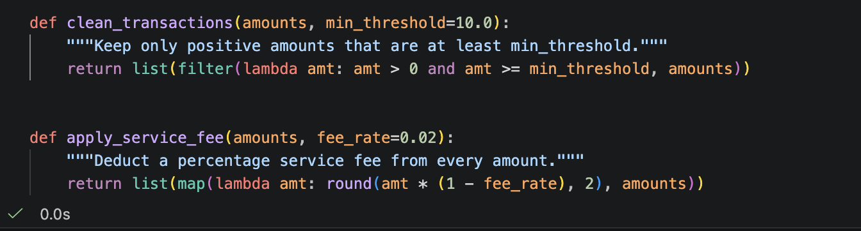
Figure 1: Cleaning transaction and applying fees

Task 2: The Recursive Search Engine
So a normal loop wouldn't know how deep it needs to go, as there can be sub-transactions within sub-transactions in transaction batches, such as [[10, 5], 40], [[50, 25]], [100]. The function calculate_nested_total() does this recursively and has not for or while loops and no global variable. It follows the two base cases and the recursive step as described in the brief. If the list is empty it returns 0.0, otherwise it returns the number if it's an int or float. If the list isn't the list [1, 2, 3], the function breaks up the list into a head (data[0]) and tail (data[1:]), calls itself on both parts, and returns the answers (Downey, 2015).
This is because the head can be a number, or a shorter list. Thus, on each call, it brings itself closer to the base case and will never get stuck in an infinite loop. The arguments and return values are all in the state, thereby maintaining the purity of the function. There is one note to remember: Python does not have many recursion calls (about 1,000, although it could change). Use some other method if the batch is very long.

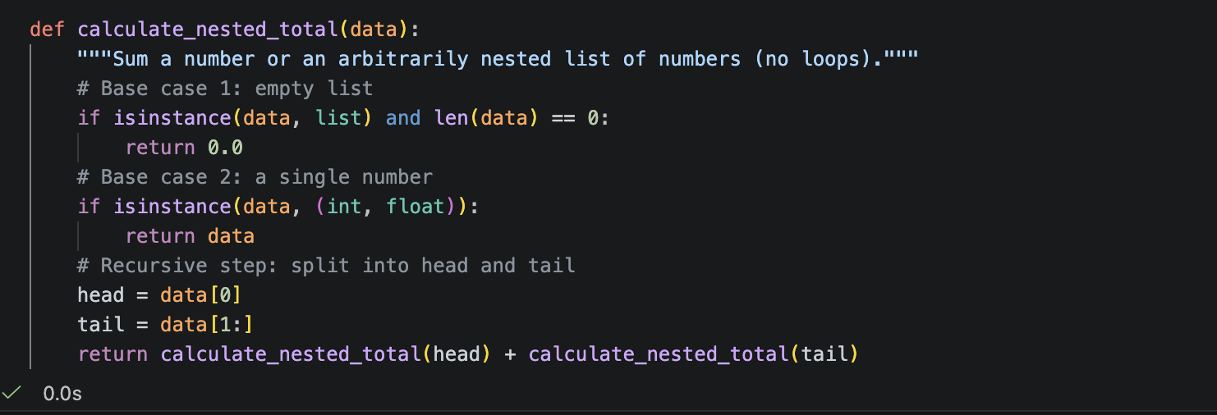
Figure 2: The Recursive Search Engine

Testing and Output
I have tested it on a mixed batch of a negative, a zero and two numbers below 10. As you can see from Figure 1, these values are kept by the default threshold: 250.0, 10.0, 99.99, and 1200.0, while the threshold 10 keeps only the two largest: 1200.0, 99.99. The fee step then turned those into 245.0, 9.8, 97.99, and 1176.0 at 2%. For the recursive function I looked at the example in the brief (230.0), the empty list (0.0), a single number (75.5) and lists nested 4 levels deep. All results were verified by hand calculation. The last test used a nested batch of [[500, −20, [150, 8]], [300, [12, 3]], 45], which gave 998.0. Notice that the recursive function adds up exactly what it is supposed to add up: −20 is included. During a full audit the flat sub-lists would be cleaned first.
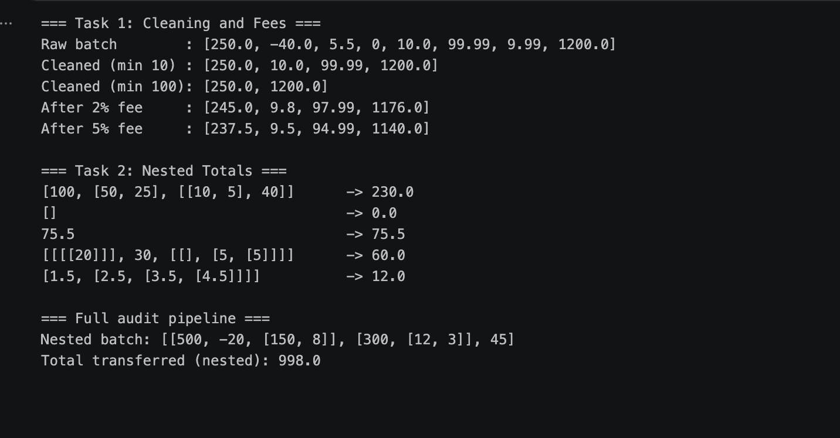
Figure 3: Program Output for the Cleaning, Fee, and Nested Total Tests

Git URL:
https://github.com/priyanshukhanal/Python_assignments/tree/main/week4
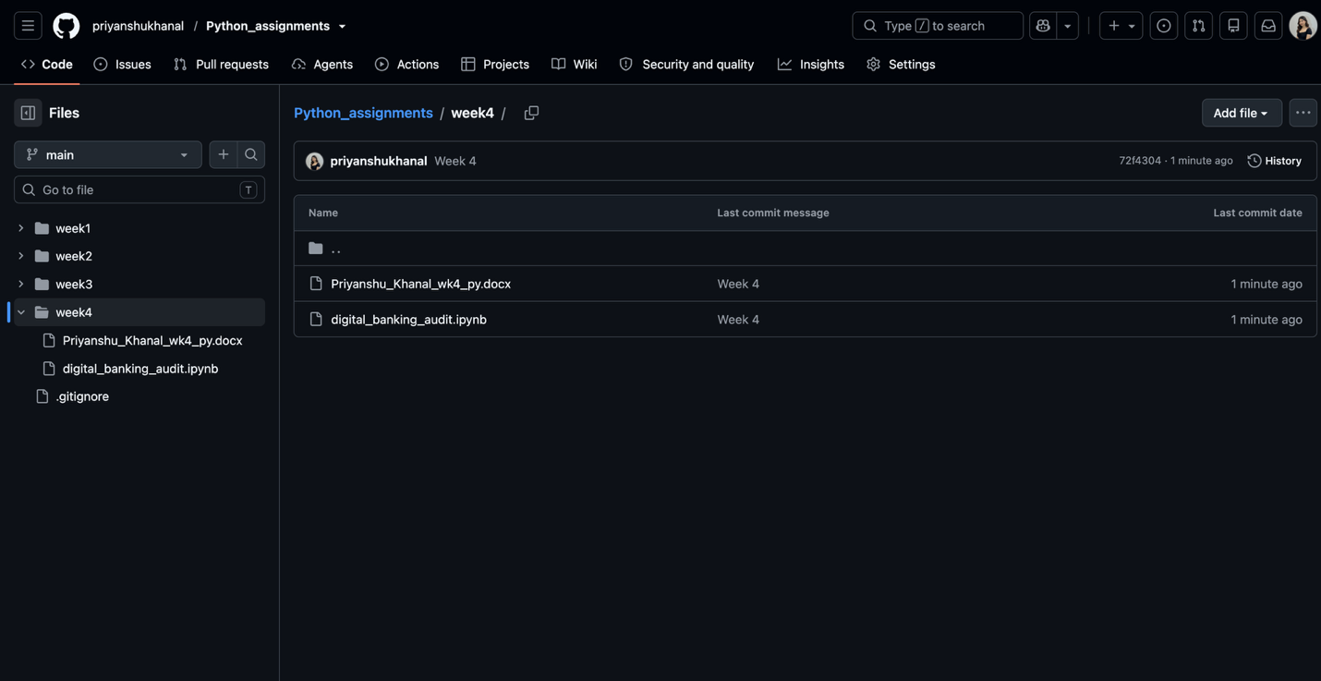
Conclusion
The audit tool is suitable for the requirements. The filter() and map() functions with lambdas don't require any extra steps to clean, are succinct, easy to read and the recursive function is performed without loops or global state, regardless of nesting depth. I found from that experience that there are different types of data; flat lists call for map() and filter(), nested lists call for recursion. In the future, the tool could be used to read actual batch files and notify of unusual quantities to be reviewed, which dovetails with data analysis tasks.

References
Abelson, H., & Sussman, G. J. (1996). Structure and interpretation of computer programs (2nd ed.). MIT Press.
Downey, A. B. (2015). Think Python: How to think like a computer scientist (2nd ed.). O’Reilly Media. https://greenteapress.com/wp/think-python-2e/.
Python Software Foundation. (2024a). Built-in functions. In The Python standard library. https://docs.python.org/3/library/functions.html.
Python Software Foundation. (2024b). Functional programming HOWTO. https://docs.python.org/3/howto/functional.html.

