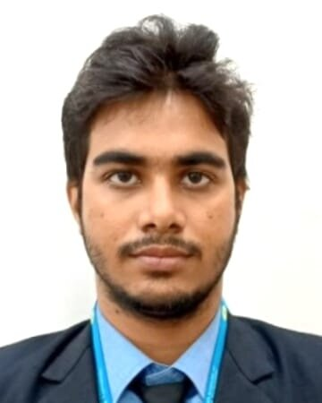**Resume**

**Priyanshu Mishra**

**Address :** Belkharia Ka Pura Durga Bazar Mirzapur Uttar Pradesh.

**Mob. :** **9839095052**

**E Mail :** pm2732257@gmail.com

**CAREER OBJECTIVE**

A challenging carrer which offers an opportunity to apply my skills knowledge with continous learning and growth

**EDUCATION QUALIFICATION**

|  |  |  |  |  |
| --- | --- | --- | --- | --- |
| Serial No | Degree | Year | Board | Percentage |
| 1 | 10th | 2015 | CBSE Board | 77.9% |
| 2 | Diploma Engineering | 2021 | BTEUP | 70.68% |
| 3 | BTech | 2025 | AKTU |  |

**COMPUTER SKILLS**

JAVA , WEB DEVLOPEMENT.

**PERSONAL DETAILS**

Father’s Name : Santosh Kumar Mishra

Date of Birth : 06/07/2000

Marital Status : Single

Gender : Male

Religion : Hindu

Nationality : Indian

Language : Hindi,English

**DECLARATION**

I here by declare that the information provided above is true to the best of my knowledge.

Date…………………….

Place……………………

( Priyanshu Mishra)