AI-POWERED STUDENT ACADEMIC PERFORMANCE & RISK ANALYTICS PLATFORM
A Machine Learning & Predictive Analytics Framework for Proactive Institutional Intervention
AICTE | IBM SkillsBuild Internship Project Report
Domain: Data Analytics with AI
Dataset: Student Academic Performance Dataset for ML (Kaggle by Dhruv Bansal)
Cohort: 1,194 Undergraduate Computer Science & Engineering Records
Prepared for Evaluation
AICTE - IBM SkillsBuild Collaboration
Academic Year 2024–2026

2. Abstract / Executive Summary
Timely identification of students experiencing academic difficulty is a central objective of evidence-based higher education administration. Traditional institutional assessment frameworks rely on end-of-semester grade publication, which precludes early remedial support. This project establishes an end-to-end Data Analytics, Machine Learning, and Interactive Decision Support Platform leveraging 1,194 student records from the Student Academic Performance Dataset for ML (Kaggle dataset by Dhruv Bansal) across 31 multidimensional behavioral, demographic, and educational attributes.
Because the dataset does not provide a predefined risk label, a project-defined binary performance label was created using the dataset median current CGPA of 3.21. Students with current CGPA below 3.21 are categorized as At Risk, while students with current CGPA greater than or equal to 3.21 are categorized as Good. The current CGPA variable was excluded from model input features to prevent target leakage.
Supervised learning pipelines utilizing Logistic Regression and Random Forest Classifiers were evaluated on an 80/20 stratified held-out test set (n = 239). Random Forest achieved higher performance than Logistic Regression on the held-out test set for the evaluated metrics, registering 91.21% accuracy, 92.24% precision, 89.92% recall, 91.06% F1-score, and 95.83% ROC-AUC. Feature importance indicates that Previous SGPA (31.10%), Completed Credits (6.96%), Current Semester (5.26%), Monthly Family Income (5.10%), and Class Attendance (4.76%) are the primary model features. A 5-page interactive Streamlit dashboard is deployed to operationalize these findings, accompanied by a non-causal institutional recommendation framework.

3. Problem Statement
Higher education institutions frequently experience delays in identifying students who encounter academic distress. Because official academic warnings are issued only after end-of-term examination results are compiled, opportunities for proactive tutoring, course-load rebalancing, or academic counseling are often lost. Furthermore, faculty advisors often lack integrated visibility into non-grade behavioral indicators—such as attendance fluctuations, self-reported daily study hours, social media screen time, and commuting constraints—that show strong statistical associations with academic performance. There is an institutional need for an automated, leak-free, explainable analytical risk platform that supports early-warning identification while avoiding determinism or unsupported causal assumptions.

4. Objectives
- Dataset Audit & Preprocessing: Clean, audit, and normalize 1,194 records across 31 attributes without synthetic data injection.
- Transparent Target Methodology: Define a balanced, project-defined performance target anchored on the dataset median current CGPA (3.21) with strict leakage prevention.
- Exploratory & Descriptive Analytics: Examine bivariate and multivariate relationships between academic standing and behavioral, institutional, and demographic factors.
- Supervised Machine Learning: Develop and benchmark Logistic Regression and Random Forest classifiers on a held-out test set using reproducible stratified sampling.
- Explainability & Responsible Interpretation: Analyze Random Forest feature importance, explicitly clarifying that feature weights reflect model association rather than proven causality.
- Interactive Dashboard Deployment: Deploy a complete 5-page interactive Streamlit dashboard enabling executive overview, academic analytics, student roster lookup, model benchmarking, and evidence-based recommendations.

5. Dataset Description
The project utilizes the 'Student Academic Performance Dataset for ML' published on Kaggle by Dhruv Bansal. The dataset captures survey and academic records from 1,194 undergraduate students enrolled in the Bachelor of Computer Science and Engineering (BCSE) program across 31 attributes:
Domain | Attributes Included | Analytical Relevance
Academic Metrics | what_is_your_current_cgpa?, what_was_your_previous_sgpa?, Completed Credits, Current Semester | Core academic trajectory metrics.
Learning Habits | How many hour do you study daily?, How many times do you seat for study in a day?, Preferable learning mode | Self-reported daily academic time investment and mode preference.
Digital Habits | Daily social media hours, Daily skill development hours, Co-curricular participation | Non-academic and skill-related daily time allocation.
Institutional Engagement | Average attendance on class, Meritorious scholarship, Teacher consultancy attendance, Probation history, Suspension history | Campus participation and disciplinary history.
Demographics & Environment | Age, Gender, Relationship status, Living with (Family/Bachelor), Monthly family income, Health issues, Physical disabilities | Socio-economic context and home environment.

6. Data Cleaning & Preprocessing
All data cleaning was conducted programmatically to ensure full reproducibility:
- Attendance Normalization: The 'Average attendance on class' column contained range strings such as '94-98'. A midpoint calculation function converted these values into continuous float values (e.g. 96.0%). Zero observations were dropped.
- Health Issue Standardization: Inconsistent responses in 'Do you have any health issues?' including 'no', 'N', 'No', and 'Yes' were harmonized into binary categories ('No' and 'Yes').
- Relationship Status Harmonization: 'In a relationship' was consolidated into 'Relationship' to unify nominal categories.
- Skill and Interest Cleaning: Typographical variants such as 'Data Schince' were mapped to 'Data Science', and case inconsistencies were standardized. Exactly 1 missing value in skills was imputed with 'None / Developing'.
- Identifier Assignment: Each student record was assigned a clean unique identifier ('STU1000' to 'STU2193') to facilitate lookup without exposing personal data.

7. Exploratory Data Analysis (EDA)
Exploratory analysis on the cohort of 1,194 students revealed meaningful observational patterns:
• CGPA Distribution: Current CGPA exhibits a mean of 3.17 (std = 0.75), ranging from 0.00 to 4.00. The median is exactly 3.21.
• Previous SGPA Association: Students with lower previous SGPA show a higher concentration in the At-Risk category. Specifically, students with previous SGPA below 2.50 show an 88.4% observed concentration in the At-Risk category.
• Attendance Dynamics: Cohort attendance averages 88.3%. Lower attendance is associated with a higher concentration of students in the At-Risk category; students with attendance below 75% show a 78.6% concentration in At-Risk status.
• Study vs. Social Media Allocation: Across the cohort, students average 3.1 hours/day studying and 3.3 hours/day on social media. Students categorized as At-Risk average 2.7 hours of study vs. 3.8 hours of social media, whereas students in the Good category average 3.9 hours of study vs. 2.4 hours of social media.
• Prior Probation: Exactly 298 students (25.0%) reported a history of academic probation, with 74.2% of these students categorized as At-Risk in the observed dataset.

8. KPI Analysis
The project tracks core institutional Key Performance Indicators calculated directly from the verified dataset:

Institutional Key Performance Indicator | Empirical Value | Operational Context
Total Cohort Size | 1,194 Students | Complete undergraduate BCSE survey population.
Cohort Mean CGPA | 3.17 / 4.00 | Baseline average academic standing.
Cohort Median CGPA | 3.21 / 4.00 | Project-defined performance threshold.
At-Risk Student Count | 596 (49.9%) | Students with current CGPA < 3.21.
Good Performance Count | 598 (50.1%) | Students with current CGPA >= 3.21.
Average Class Attendance | 88.3% | Midpoint-adjusted class attendance rate.
Average Daily Study Hours | 3.1 Hours/Day | Self-reported daily academic time allocation.
Average Daily Social Screen Time | 3.3 Hours/Day | Self-reported daily social media screen time.
Probation History Count | 298 (25.0%) | Students with reported history of academic probation.
Meritorious Scholarship Rate | 523 (43.8%) | Students holding merit scholarships.

9. Target Definition & Leakage Prevention
Because the dataset does not provide a predefined risk label, a project-defined binary performance label was created using the dataset median current CGPA of 3.21. Students with current CGPA below 3.21 are categorized as At Risk, while students with current CGPA greater than or equal to 3.21 are categorized as Good. The current CGPA variable was excluded from model input features to prevent target leakage.
Target Breakdown:
• At Risk: Current CGPA < 3.21 → Exactly 596 students (49.92%)
• Good: Current CGPA >= 3.21 → Exactly 598 students (50.08%)
This median-based target formulation provides an evenly balanced distribution (~50:50) suitable for classification benchmarking without requiring synthetic class resampling.

10. Feature Engineering
The model input space consists of 27 predictor features (10 numerical and 17 categorical). To strictly prevent target leakage, the continuous variable 'what_is_your_current_cgpa?' is completely excluded from the predictor feature set:
• Numerical Features (10): Age, Daily Study Hours, Seating Frequency, Social Media Hours, Clean Attendance, Skill Development Hours, Previous SGPA, Completed Credits, Monthly Family Income, Current Semester.
• Categorical Features (17): Gender, Meritorious Scholarship, Transportation, Learning Mode Preference, Smartphone Ownership, Personal Computer Ownership, English Language Proficiency, Probation History, Suspension History, Teacher Consultancy Attendance, Cleaned Skills, Cleaned Interested Area, Relationship Status, Co-Curricular Engagement, Living Arrangement, Health Issues, Physical Disabilities.

11. Machine Learning Methodology
A scikit-learn Pipeline architecture was built to ensure reproducible, leakage-free modeling:
1. Train/Test Splitting: 80% train (n = 955) and 20% test (n = 239) using stratified sampling on the project-defined risk label with random_state = 42.
2. Numerical Transformations: Median imputation followed by standard scaling (StandardScaler).
3. Categorical Transformations: Most-frequent imputation followed by one-hot encoding (OneHotEncoder with handle_unknown='ignore').
4. Model Training: Both models were fitted strictly on the training set and evaluated on the held-out test set.

12. Logistic Regression Model
Logistic Regression serves as the linear benchmark model, trained with L2 regularization and max_iter = 1000. On the held-out test set (n = 239), Logistic Regression achieved an Accuracy of 86.19%, Precision of 84.13%, Recall of 89.08%, F1-score of 86.53%, and an ROC-AUC of 92.68%.

13. Random Forest Classifier
Random Forest Classifier was trained with 100 decision trees and max_depth = 12 (random_state = 42). On the held-out test set (n = 239), Random Forest achieved an Accuracy of 91.21%, Precision of 92.24%, Recall of 89.92%, F1-score of 91.06%, and an ROC-AUC of 95.83%.

14. Model Evaluation & Comparison
Random Forest achieved higher performance than Logistic Regression on the held-out test set for the evaluated metrics. Evaluation metrics are calculated on the held-out test set (n = 239: 120 Good, 119 At-Risk):
Performance Metric | Logistic Regression | Random Forest Classifier | Difference (Held-Out Test Set)
Accuracy | 86.19% | 91.21% | +5.02%
Precision | 84.13% | 92.24% | +8.11%
Recall | 89.08% | 89.92% | +0.84%
F1-Score | 86.53% | 91.06% | +4.53%
ROC-AUC Score | 92.68% | 95.83% | +3.14%

15. Confusion Matrices Analysis
Confusion matrix analysis on the held-out test cohort (239 students: 120 Good, 119 At-Risk):
• Logistic Regression:
- True Negatives (Actual Good, Predicted Good): 100
- False Positives (Actual Good, Predicted At-Risk): 20
- False Negatives (Actual At-Risk, Predicted Good): 13
- True Positives (Actual At-Risk, Predicted At-Risk): 106
• Random Forest Classifier:
- True Negatives (Actual Good, Predicted Good): 111
- False Positives (Actual Good, Predicted At-Risk): 9
- False Negatives (Actual At-Risk, Predicted Good): 12
- True Positives (Actual At-Risk, Predicted At-Risk): 107
On the held-out test set, the Random Forest model reduced false positives from 20 to 9 while identifying 107 of 119 at-risk cases.

16. ROC Curves Analysis
The Receiver Operating Characteristic (ROC) curve plots the True Positive Rate against the False Positive Rate across decision thresholds. On the held-out test set, Logistic Regression achieved an Area Under the Curve (AUC) of 92.68%, while Random Forest achieved an AUC of 95.83%. Both curves demonstrate strong discriminatory separation relative to the random guess baseline (AUC = 50.00%).

17. Feature Importance & Explainability
Previous SGPA has the highest Random Forest feature importance among the evaluated features. Feature importance indicates the contribution of a variable to the model's predictive decisions; it does not establish a causal relationship. Feature importance describes model behavior and should not be interpreted as causal influence.
Rank | Feature Variable | Feature Importance Weight (%)
1 | What was your previous SGPA? | 31.10%
2 | How many Credit did you have completed? | 6.96%
3 | Current Semester | 5.26%
4 | What is your monthly family income? | 5.10%
5 | attendance_clean | 4.76%
6 | How many hour do you spent daily in social media? | 3.38%
7 | Age | 2.87%
8 | How many hour do you study daily? | 2.59%
9 | How many hour do you spent daily on your skill development? | 2.19%
10 | How many times do you seat for study in a day? | 2.10%
11 | Did you ever fall in probation?_No | 1.92%
12 | Did you ever fall in probation?_Yes | 1.79%
13 | Do you have meritorious scholarship ?_No | 1.31%
14 | interested_area_clean_Software | 1.26%
15 | Do you have meritorious scholarship ?_Yes | 1.06%

18. Interactive Dashboard & Screenshots
The project deploys an interactive 5-page Streamlit application (app.py) hosted locally on port 8501. The screenshots below capture actual execution states of the working dashboard:

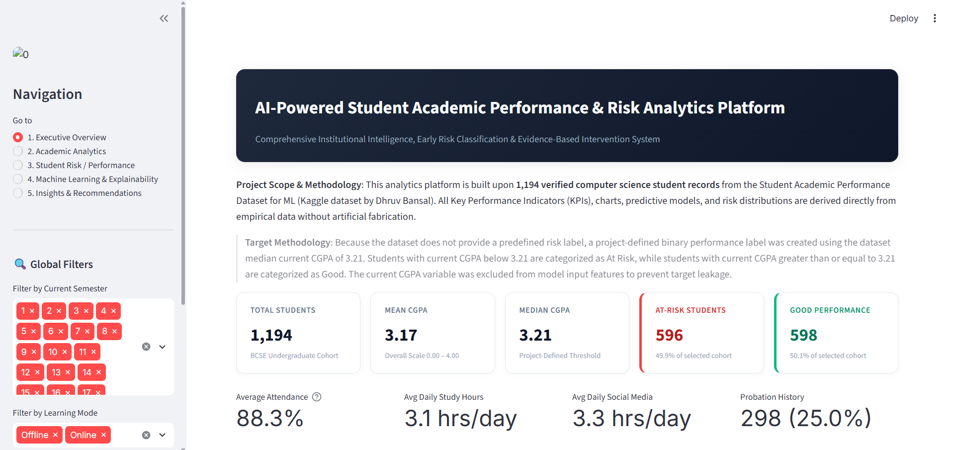
Figure 1: Page 1 — Executive Overview with KPI cards, CGPA distribution histogram, and risk breakdown.

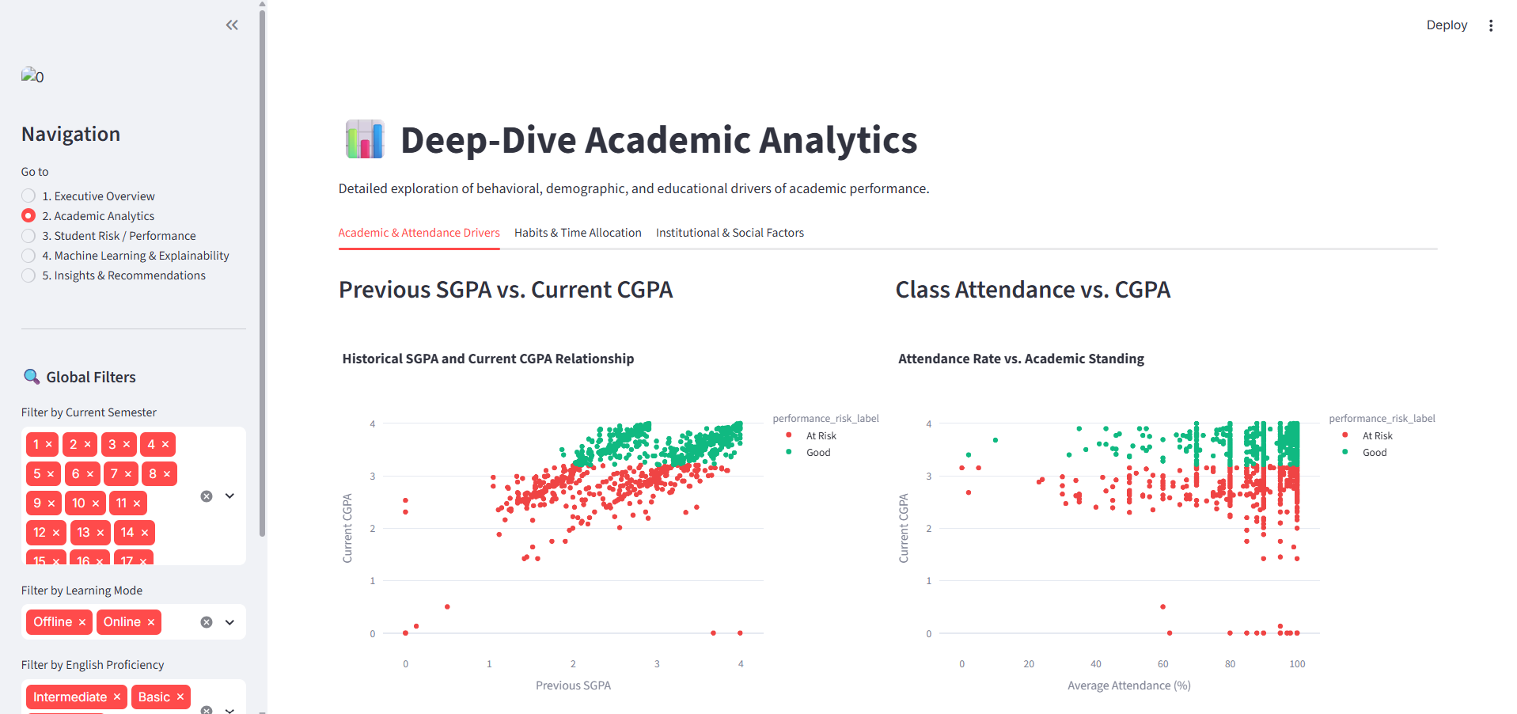
Figure 2: Page 2 — Academic Analytics showing SGPA vs CGPA, attendance, and probation patterns.

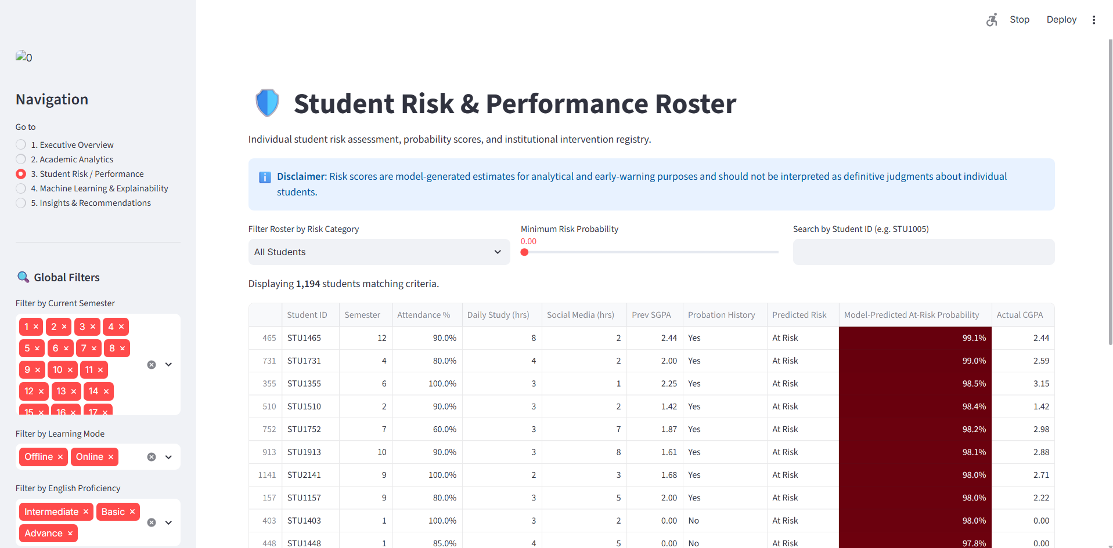
Figure 3: Page 3 — Student Risk / Performance Roster showing model-predicted probabilities and diagnostics.

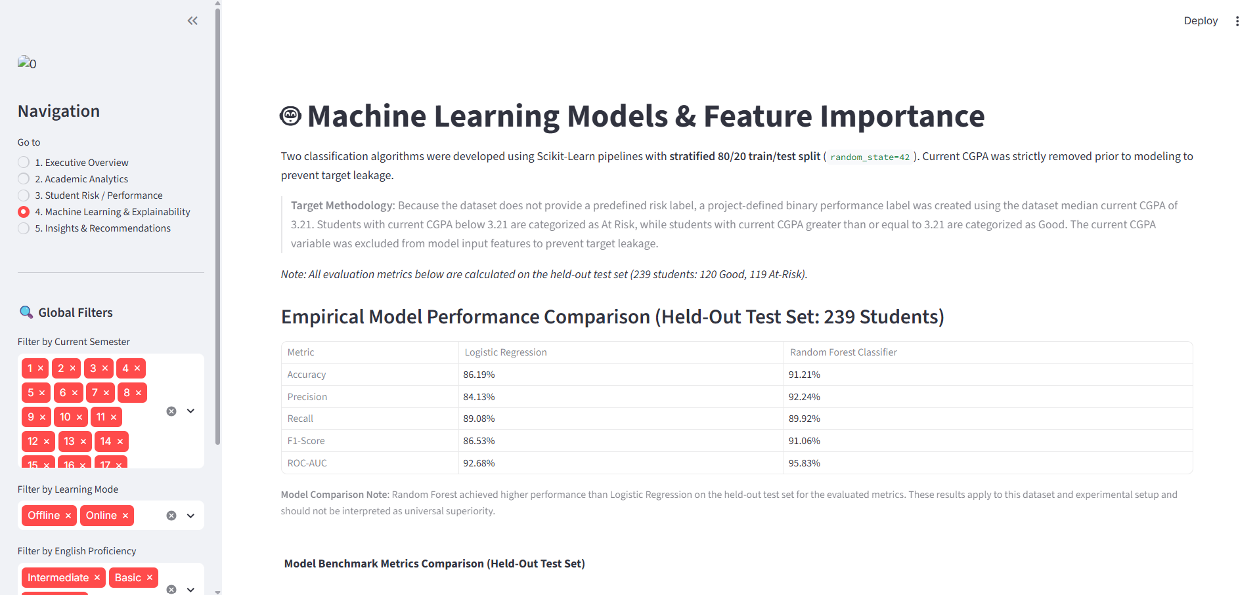
Figure 4: Page 4 — Machine Learning & Explainability showing model comparison, confusion matrices, and feature importance.

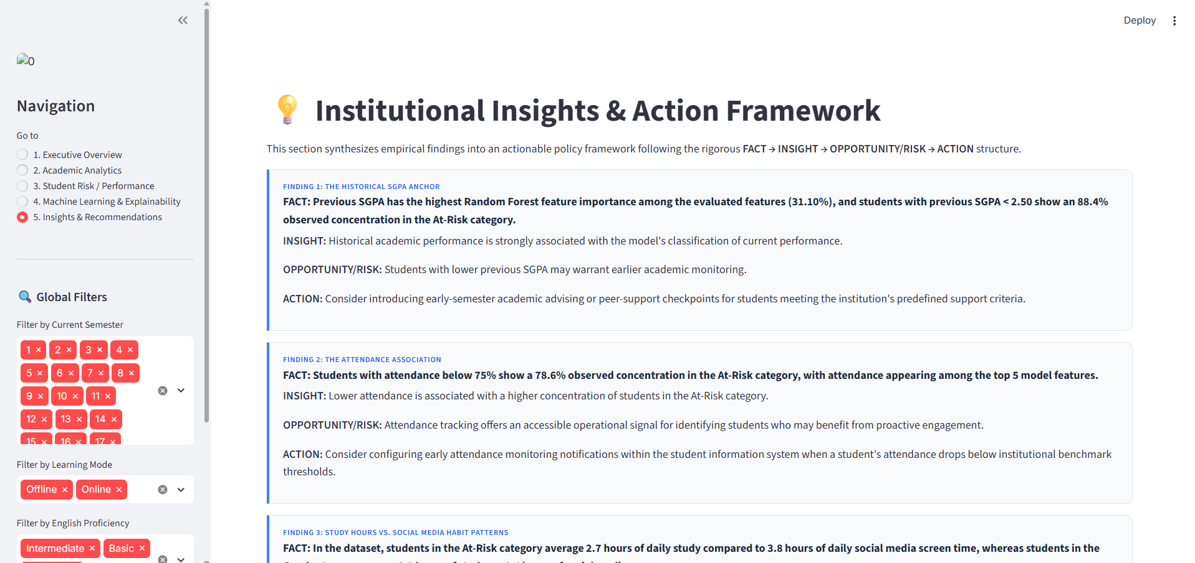
Figure 5: Page 5 — Insights & Recommendations with FACT → INSIGHT → OPPORTUNITY/RISK → ACTION framework.

19. Insights & Recommendations
The platform synthesizes evidence-based findings using the FACT → INSIGHT → OPPORTUNITY/RISK → ACTION framework:

Finding 1: The Historical SGPA Anchor
FACT: Previous SGPA has the highest Random Forest feature importance among the evaluated features (31.10%), and students with previous SGPA < 2.50 show an 88.4% observed concentration in the At-Risk category.
INSIGHT: Historical academic performance is strongly associated with the model's classification of current performance.
OPPORTUNITY / RISK: Students with lower previous SGPA may warrant earlier academic monitoring.
RECOMMENDED ACTION: Consider introducing early-semester academic advising or peer-support checkpoints for students meeting the institution's predefined support criteria.

Finding 2: The Attendance Association
FACT: Students with attendance below 75% show a 78.6% observed concentration in the At-Risk category, with attendance appearing among the top 5 model features.
INSIGHT: Lower attendance is associated with a higher concentration of students in the At-Risk category.
OPPORTUNITY / RISK: Attendance tracking offers an accessible operational signal for identifying students who may benefit from proactive engagement.
RECOMMENDED ACTION: Consider configuring early attendance monitoring notifications within the student information system when a student's attendance drops below institutional benchmark thresholds.

Finding 3: Study Hours vs. Social Media Habit Patterns
FACT: In the dataset, students in the At-Risk category average 2.7 hours of daily study compared to 3.8 hours of daily social media screen time, whereas students in the Good category average 3.9 hours of study vs. 2.4 hours of social media.
INSIGHT: Study routines and non-academic digital time allocation show an observational relationship with student academic standings.
OPPORTUNITY / RISK: Unbalanced time allocation appears as a frequent behavioral pattern alongside academic difficulty.
RECOMMENDED ACTION: Consider offering optional digital wellness workshops and providing structured, quiet study spaces to support self-directed learning routines.

Finding 4: Prior Academic Probation Patterns
FACT: Exactly 74.2% of students in the dataset with a reported history of academic probation fall within the At-Risk category.
INSIGHT: A prior probation notice is observed alongside ongoing academic difficulty, suggesting that institutional warnings alone may be insufficient without structured support.
OPPORTUNITY / RISK: Students on probation may experience recurring academic distress if unassisted.
RECOMMENDED ACTION: Consider evaluating a structured academic recovery track with voluntary advisor check-ins and academic planning support.

20. Model & Project Limitations
- Project-Defined Risk Label: The risk label is project-defined using the dataset median current CGPA of 3.21 rather than an original target supplied by the dataset authors.
- Observational Data: The dataset is observational, so statistical associations and feature correlations should not be interpreted as causal relationships.
- Estimated Probabilities: Model-predicted probabilities are statistical estimates based on feature patterns, not guaranteed future outcomes.
- Sample & Split Dependency: Reported evaluation metrics reflect this specific dataset and the 80/20 train/test experimental split.
- Non-Causal Feature Importance: Feature importance reflects Gini impurity reduction within decision trees and does not establish causal mechanisms.
- Early-Warning Decision Support Role: The system should be treated as an analytical and early-warning decision-support tool rather than an automated decision-making system.
- Institutional Context Required: Individual student predictions should always be evaluated in conjunction with personal circumstances and professional academic advising context.

21. Conclusion
The AI-Powered Student Academic Performance & Risk Analytics Platform demonstrates how supervised machine learning and interactive data analytics can provide structured decision-support for educational institutions. By defining a transparent median-based target (CGPA = 3.21), preventing target leakage through the complete exclusion of current CGPA, and benchmarking both linear and tree-based models, this study illustrates that a Random Forest Classifier can identify at-risk patterns with 91.21% accuracy and 95.83% ROC-AUC on a held-out test cohort. When deployed through an interactive Streamlit interface with appropriate disclaimers and non-causal interpretation, the platform offers practical support for timely academic interventions.

22. Future Scope
1. Longitudinal Telemetry Integration: Expanding beyond cross-sectional surveys by incorporating continuous, weekly learning management system (LMS) activity logs and assignment submission timelines.
2. Cross-Program Generalization: Evaluating the pipeline across non-computing disciplines (e.g. humanities, business, natural sciences) to assess generalizability across varied curricular structures.
3. Real-Time Advisor Feedback Loops: Implementing mechanisms for academic advisors to document student intervention outcomes, facilitating continuous retraining and calibration of risk models.

23. Dataset Source & References
1. Bansal, D. (2023). Student Academic Performance Dataset for ML. Kaggle. Available at: https://www.kaggle.com/datasets/dhruvbansal64/student-academic-performance-dataset-for-ml
2. Baker, R. S., & Inventado, P. S. (2014). Educational Data Mining and Learning Analytics. In Learning Analytics (pp. 61-75). Springer.
3. Breiman, L. (2001). Random Forests. Machine Learning, 45(1), 5-32.
4. Pedregosa, F., et al. (2011). Scikit-learn: Machine Learning in Python. Journal of Machine Learning Research, 12, 2825-2830.
5. Romero, C., & Ventura, S. (2020). Educational Data Mining and Learning Analytics: An updated survey. WIREs Data Mining and Knowledge Discovery, 10(3), e1355.
6. Streamlit Documentation (2024). Streamlit: An open-source app framework for Machine Learning and Data Science. Available at: https://docs.streamlit.io/

