Pl/Sql Assignment 1

1. Code:

declare

a number(1,0);

b number(1,0);

c number(1,0);

begin

a:=3;

b:=2;

c:=1;

if (a>b) and (a>c) then

dbms_output.put_line(a||' is greatest.');

elsif (b>c) then

dbms_output.put_line(b||' is greatest.');

else

dbms_output.put_line(c||' is greatest.');

end if;

end;

Output:

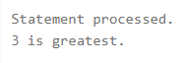

2. Code:

declare

a number(2,0);

begin

a:=65;

if (mod(a,2)=0) then

dbms_output.put_line(a||' is even.');

else

dbms_output.put_line(a||' is odd.');

end if;

end;

Output:



3. Code:

declare

marks number(3,0);

begin

marks:=65;

if (marks>80) then

dbms_output.put('A');

elsif (marks>70) then

dbms_output.put('B');

elsif (marks>50) then

dbms_output.put('C');

elsif (marks>40) then

dbms_output.put('D');

else

dbms_output.put('E');

end if;

dbms_output.put_line(' grade');

end;

Output:



4. Code:

declare

a number(1,0);

i number(2,0);

begin

a:=5;

for i in 1..10 loop

dbms_output.put_line(a||' * '||i||' = '||a*i);

end loop;

end;

Output:

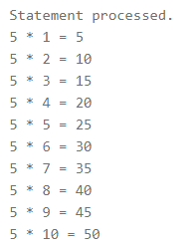

5. Code:

declare

a number(1,0);

i number(2,0);

p number(3,0);

begin

a:=5;

p:=1;

i:=1;

while (i<=a) loop

p:=p*i;

i:=i+1;

end loop;

dbms_output.put_line('Factorial of '||a||' is: '||p);

end;

Output:

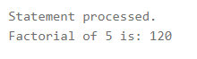

6. Code:

declare

a number(3,0);

b number(3,0);

c number(3,0);

i number(3,0);

begin

a:=0;

b:=1;

dbms_output.put_line('Fibonacci Series:');

dbms_output.put_line(a);

dbms_output.put_line(b);

for i in 3..10 loop

c:=a+b;

dbms_output.put_line(c);

a:=b;

b:=c;

end loop;

end;

Output:

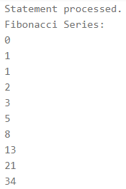

7. Code:

declare

a number(3,0);

n number(3,0);

d number(3,0);

s number(3,0);

begin

a:=123;

n:=a;

s:=0;

loop

d:=mod(n,10);

s:=s*10+d;

n:=n/10;

exit when n=0;

end loop;

dbms_output.put_line('Reverse of '||a||' is: '||s);

end;

Output:



8. Code:

declare

i number(3,0);

s varchar(25);

c varchar(1);

s1 varchar(25);

begin

s:='abcd';

s1:='';

for i in reverse 1..length(s) loop

c:=substr(s,i,1);

s1:=concat(s1,c);

end loop;

dbms_output.put_line('Reverse of '||s||' is: '||s1);

end;

Output:



Created by:

Name: Priyanshu

Roll No.: 101803114

Group: COE-06