Pl/Sql Assignment 2

1. Code:

create table emp (

eno number(3,0),

ename varchar(25),

bp number(5,0),

da number(5,0),

hra number(5,0),

total number(5,0),

primary key(eno)

);

insert into emp(eno,ename,bp,da,hra) values (100,'Sarah',60000,5000,10000);

declare

entry emp%rowtype;

begin

select * into entry from emp where eno=100;

entry.total:=entry.bp+entry.da+entry.hra;

update emp set total=entry.total where eno=100;

dbms_output.put_line('Employee no.:'||entry.eno||' Employee name:'||entry.ename||' Total Salary:'||entry.total);

end;

Output:

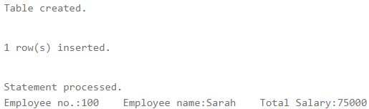

2. Code:

create table book (

rno number(3,0),

bookno number(5,0),

doi date,

dor date,

fine number(1,0)

);

insert into book(rno,bookno,doi,dor) values (100,12345,'22-Aug-2019','01-Sep-2019');

declare

entry book%rowtype;

days number(2,0);

begin

select * into entry from book where rno=100;

days:=entry.dor-entry.doi;

if days<7 then

entry.fine:=1;

elsif days<14 then

entry.fine:=2;

else

entry.fine:=3;

end if;

update book set fine=entry.fine where rno=100;

dbms_output.put_line('Roll no.:'||entry.rno||' Book no.:'||entry.bookno||' Fine:'||entry.fine);

end;

Output:

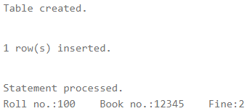

3. Code:

declare

ch int;

n1 int;

n2 int;

begin

n1:=5;

n2:=8;

dbms_output.put_line('Enter 1 for addition, 2 for subtraction, 3 for multiplication, 4 for division.');

dbms_output.put_line('Enter your choice: ');

ch:=&ch;

if ch=1 then

dbms_output.put_line(n1||' + '||n2||' = '||(n1+n2));

elsif ch=2 then

dbms_output.put_line(n1||' - '||n2||' = '||(n1-n2));

elsif ch=3 then

dbms_output.put_line(n1||' * '||n2||' = '||(n1*n2));

elsif ch=4 then

dbms_output.put_line(n1||' / '||n2||' = '||(n1/n2));

end if;

end;

Output:

Input is not available in live sql so ‘ch‘ variable was initialised to 3

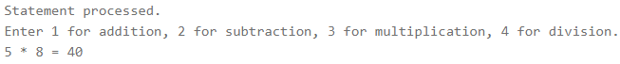

4. Code:

declare

a number(1,0);

i number(2,0);

n number(2,0);

begin

a:=3;

dbms_output.put_line('Enter value on n:');

n:=&n;

for i in 1..n loop

dbms_output.put_line(a||' * '||i||' = '||a*i);

end loop;

end;

Output:

Input is not available in live sql so ‘n‘ variable was initialised to 5

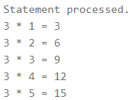

5. Code:

declare

n number(2,0);

i number(2,0);

begin

n:=5;

for i in 1..4 loop

dbms_output.put_line(n);

n:=n+5;

end loop;

end;

Output:

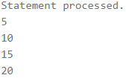

6. Code:

declare

hour number(2,0);

begin

hour:=to_char(sysdate,'hh');

if hour<6 then

dbms_output.put_line('Good Night!');

elsif hour<12 then

dbms_output.put_line('Good Morning!');

elsif hour<18 then

dbms_output.put_line('Good Afternoon!');

elsif hour<24 then

dbms_output.put_line('Good Evening!');

end if;

end;

Output:



7. Code:

create table si

(

principal number(4,0),

time number(1,0),

rate number(2,0),

interest number(3,0)

);

declare

r si.rate%type;

i si.interest%type;

begin

for r in 5..15 loop

i:=1000*r*2/100;

insert into si(principal,time,rate,interest) values(1000,2,r,i);

end loop;

end;

select * from si;

Output:

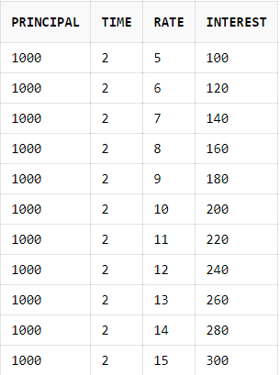

Created by:

Name: Priyanshu

Roll No.: 101803114

Group: COE-06