Pl/Sql Assignment 4

1. Code:

create table library_table

(

rno number(5,0),

book_no number(5,0),

date_of_issue date,

date_of_return date,

primary key(rno)

);

create table late_return

(

rno number(5,0),

book_no number(5,0),

foreign key(rno) references library_table(rno)

);

insert into library_table(rno,book_no,date_of_issue,date_of_return) values (100,1234,'13-Oct-19','4-Nov-19');

declare

no_of_days number(2,0);

entry library_table%rowtype;

delayed_return exception;

begin

select * into entry from library_table where rno=100;

no_of_days:=entry.date_of_return-entry.date_of_issue;

if no_of_days>15 then

raise delayed_return;

end if;

exception

when delayed_return then

insert into late_return(rno,book_no) values (entry.rno,entry.book_no);

end;

select * from late_return;

Output:

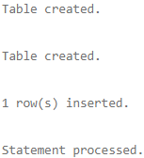

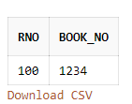

2. Code:

create table library_table

(

rno number(5,0),

book_no number(5,0),

date_of_issue date,

date_of_return date,

primary key(rno)

);

create table errors

(

error_code number(5,0),

error_msg varchar(50)

);

insert into library_table(rno,book_no,date_of_issue,date_of_return) values (100,1234,'13-Oct-19','4-Nov-19');

insert into library_table(rno,book_no,date_of_issue,date_of_return) values (200,5678,'20-Dec-19','11-Jan-20');

declare

a int;

i int;

ec number(5,0);

em varchar(50);

entry library_table%rowtype;

begin

i:=0;

<<trans>>

begin

i:=i+1;

if i=1 then

select * into entry from library_table where rno=300;

elsif i=2 then

select * into entry from library_table;

elsif i=3 then

insert into library_table(rno,book_no,date_of_issue,date_of_return) values (200,9012,'17-Feb-20','5-Mar-20');

elsif i=4 then

insert into library_table(rno,book_no,date_of_issue,date_of_return) values (300,'9O12','17-Feb-20','5-Mar-20');

elsif i=5 then

a:=to_number('555S');

elsif i=6 then

a:=1/0;

end if;

exception

when others then

ec:=sqlcode;

em:=substr(sqlerrm,1,50);

insert into errors(error_code,error_msg) values (ec,em);

end;

if (i<=6) then

goto trans;

end if;

end;

select * from errors;

Output:

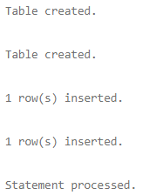

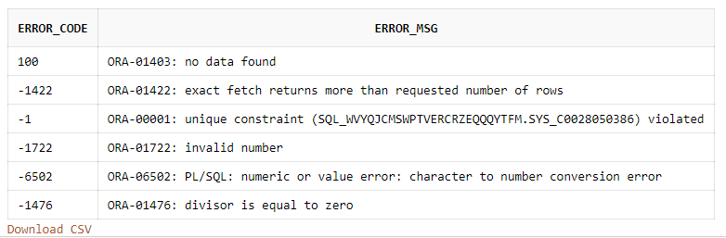

3. Code:

begin

declare

n number(5,0):='111I';

begin

NULL;

end;

exception

when others then

dbms_output.put_line('An error in declare section of inner block has occurred which is being handled by enclosing block. ');

end;

Output:



4. Code:

begin

declare

n number(5,0);

begin

n:='888B';

exception

when others then

dbms_output.put_line('An error in begin section has occurred.');

n:='888B';

end;

exception

when others then

dbms_output.put_line('An error in exception section of inner block in being handled in enclosing block.');

end;

Output:



5. Code:

begin

declare

n number(5,0);

begin

n:='666b';

exception

when others then

dbms_output.put_line('An error occurred in this block will now be again raised to be handled by its enclosing block.');

raise;

end;

exception

when others then

dbms_output.put_line('An error occured in begin section of inner block is now being handled in its enclosing block.');

end;

Output:



Created by:

Name: Priyanshu

Roll No.: 101803114

Group: COE-06