Pl/Sql Assignment 5

Table and records used:

create table emp

(

empno number(5),

ename varchar(25),

job varchar(15),

sal number(5),

deptno number(2)

);

insert into emp values (100,'Fiora','Marketing',48000,10);

insert into emp values (200,'Garen','Sales',45000,20);

insert into emp values (300,'Hecarim','Production',40000,30);

insert into emp values (400,'Jayce','Finance',56000,10);

insert into emp values (500,'Kaisa','Human Resource',63000,20);

select * from emp;

Output:

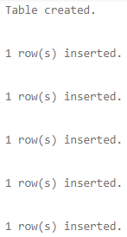 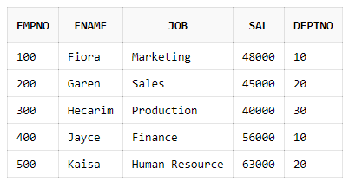

1. Code:

begin

delete from emp where empno=100;

if sql%found then

dbms_output.put_line('A record was found and has been deleted.');

else

dbms_output.put_line('A record to be deleted was not found.');

end if;

end;

Output:



2. Code:

begin

delete from emp where empno=100;

if sql%found then

dbms_output.put_line(sql%rowcount||' row has been deleted.');

end if;

end;

Output:



3. Code:

declare

cursor c1 is

select * from emp where deptno=10;

entry emp%rowtype;

begin

open c1;

loop

exit when c1%notfound;

fetch c1 into entry;

dbms_output.put_line('Employee No:'||entry.empno||' Name:'||entry.ename||' Job:'||entry.job);

end loop;

close c1;

end;

Output:



4. Code:

declare

cursor c1 is

select * from emp order by sal desc;

entry emp%rowtype;

begin

open c1;

loop

exit when c1%notfound;

fetch c1 into entry;

dbms_output.put_line('Employee No:'||entry.empno||' Name:'||entry.ename);

end loop;

close c1;

end;

Output:

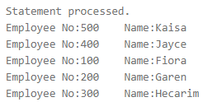

5. Code:

declare

cursor c1 is

select * from emp where deptno=10;

begin

for entry in c1 loop

dbms_output.put_line('Employee No:'||entry.empno||' Name:'||entry.ename||' Job:'||entry.job);

end loop;

end;

Output:



6. Code:

declare

cursor c1 is

select * from emp order by sal desc;

begin

for entry in c1 loop

dbms_output.put_line('Employee No:'||entry.empno||' Name:'||entry.ename);

end loop;

end;

Output:



Created by:

Name: Priyanshu

Roll No.: 101803114

Group: COE-06