Pl/Sql Assignment 6

Table and records used for Ans.1-2:

create table cust (

cno number(2) primary key,

meterno number(3) unique,

prev_reading number(4),

current_reading number(4),

units number(4),

bill_amount number(6,2)

);

insert into cust(cno,meterno,prev_reading,current_reading) values (89,100,300,800);

insert into cust(cno,meterno,prev_reading,current_reading) values (67,101,790,1000);

insert into cust(cno,meterno,prev_reading,current_reading) values (90,200,800,1200);

insert into cust(cno,meterno,prev_reading,current_reading) values (62,789,200,800);

insert into cust(cno,meterno,prev_reading,current_reading) values (70,889,3200,8700);

insert into cust(cno,meterno,prev_reading,current_reading) values (66,500,3000,9800);

select cno,meterno,prev_reading,current_reading from cust;

Output:

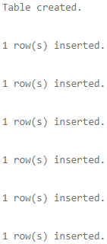 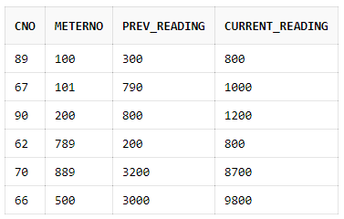

1. Code:

declare

cursor c1 is

select * from cust where cno=89;

entry cust%rowtype;

begin

open c1;

fetch c1 into entry;

entry.units:=entry.current_reading-entry.prev_reading;

if entry.units<=100 then

entry.bill_amount:=0.5*entry.units;

else

entry.bill_amount:=0.75*(entry.units-100)+0.5*100;

end if;

update cust set units=entry.units,bill_amount=entry.bill_amount where cno=89;

close c1;

end;

select * from cust where cno=89;

Output:



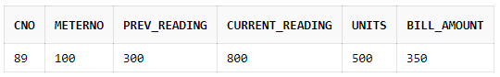

2. Code:

declare

cursor c1 is

select * from cust;

begin

for entry in c1 loop

entry.units:=entry.current_reading-entry.prev_reading;

if entry.units<=100 then

entry.bill_amount:=0.5*entry.units;

else

entry.bill_amount:=0.75*(entry.units-100)+0.5*100;

end if;

update cust set units=entry.units,bill_amount=entry.bill_amount where cno=entry.cno;

end loop;

end;

select * from cust;

Output:



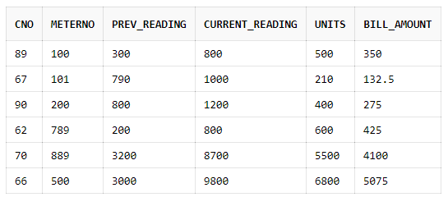

3. Code:

create table temp

(

empno number(5),

old number(5),

new number(5)

);

declare

cursor c1 is

select * from emp;

begin

for entry in c1 loop

if entry.deptno=10 then

insert into temp values (entry.empno,entry.sal,entry.sal+1000);

elsif entry.deptno=20 then

insert into temp values (entry.empno,entry.sal,entry.sal+500);

elsif entry.deptno=30 then

insert into temp values (entry.empno,entry.sal,entry.sal+800);

end if;

end loop;

end;

select * from temp;

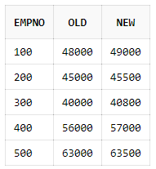

Output:





4. Code:

create table student

(

rno number(5),

marks_subject1 number(3),

marks_subject2 number(3),

marks_subject3 number(3),

marks_subject4 number(3),

total number(3),

percentage number(5,2)

);

insert into student(rno,marks_subject1,marks_subject2,marks_subject3,marks_subject4) values (100,89,69,68,79);

insert into student(rno,marks_subject1,marks_subject2,marks_subject3,marks_subject4) values (200,83,71,84,84);

insert into student(rno,marks_subject1,marks_subject2,marks_subject3,marks_subject4) values (300,93,79,81,85);

declare

cursor c1 is

select * from student;

begin

for entry in c1 loop

entry.total:=entry.marks_subject1+entry.marks_subject2+entry.marks_subject3+entry.marks_subject4;

entry.percentage:=entry.total/4;

update student set total=entry.total,percentage=entry.percentage where rno=entry.rno;

end loop;

end;

select * from student;

Output:



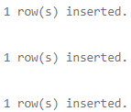



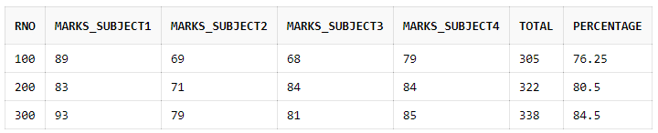

5. Code: It can be done using simple SQL query.

update student set total=marks_subject1+marks_subject2+marks_subject3+marks_subject4,percentage=(marks_subject1+marks_subject2+marks_subject3+marks_subject4)/4;

select * from student;

Output: Same output as in Ans. 4



6. Code:

declare

cursor c1(n number) is

select * from emp where deptno=n;

begin

for entry in c1(20) loop

dbms_output.put_line('Employee No:'||entry.empno||' Name:'||entry.ename||' Job:'||entry.job);

end loop;

end;

Output:



7. Code:

create table emp

(

eno number(3),

ename varchar(25),

bp number(5),

da number(5),

hra number(5),

total number(5)

);

insert into emp(eno,ename,bp,da,hra) values (100,'Lucian',48000,8800,5710);

insert into emp(eno,ename,bp,da,hra) values (200,'Zoe',63000,9750,5600);

declare

cursor c1(n number) is

select * from emp where rownum<=n;

begin

for entry in c1(2) loop

entry.total:=entry.bp+entry.da+entry.hra;

update emp set total=entry.total where eno=entry.eno;

end loop;

end;

select * from emp;

Output:

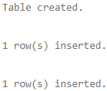



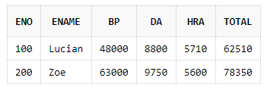

Created by:

Name: Priyanshu

Roll No.: 101803114

Group: COE-06