Pl/Sql Assignment 7

1. Code:

declare

num1 number;

num2 number;

add number;

sub number;

mul number;

div number;

procedure cal (n1 in number,n2 in number,a out number,s out number,m out number,d out number) is

begin

a:=n1+n2;

s:=n1-n2;

m:=n1*n2;

d:=n1/n2;

end;

begin

num1:=5;

num2:=2;

cal(num1,num2,add,sub,mul,div);

dbms_output.put_line(num1||' + '||num2||' = '||add);

dbms_output.put_line(num1||' - '||num2||' = '||sub);

dbms_output.put_line(num1||' * '||num2||' = '||mul);

dbms_output.put_line(num1||' / '||num2||' = '||div);

end;

Output:

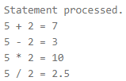

2. Code:

create table emp

(

empno number,

salary number

);

insert into emp values (123,60000);

insert into emp values (456,72000);

select * from emp;

declare

empid emp.empno%type:=123;

bonus emp.salary%type:=5000;

procedure raise_salary (empid emp.empno%type,bonus emp.salary%type) is

old_sal emp.salary%type;

begin

select salary into old_sal from emp where empno=empid;

update emp set salary=old_sal+bonus where empno=empid;

end;

begin

raise_salary(empid,bonus);

end;

select * from emp;

Output:

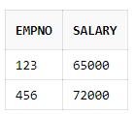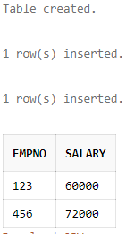

3. Code:

create or replace procedure cal (n1 in number,n2 in number,a out number,s out number,m out number,d out number) is

begin

a:=n1+n2;

s:=n1-n2;

m:=n1*n2;

d:=n1/n2;

end;

declare

num1 number;

num2 number;

add number;

sub number;

mul number;

div number;

begin

num1:=5;

num2:=2;

cal(num1,num2,add,sub,mul,div);

dbms_output.put_line(num1||' + '||num2||' = '||add);

dbms_output.put_line(num1||' - '||num2||' = '||sub);

dbms_output.put_line(num1||' * '||num2||' = '||mul);

dbms_output.put_line(num1||' / '||num2||' = '||div);

end;

Output:





4. Code:

create table emp

(

empno number,

salary number

);

insert into emp values (123,60000);

insert into emp values (456,72000);

select * from emp;

create or replace procedure fire_employee (empid emp.empno%type) is

begin

delete from emp where empno=empid;

end;

declare

empid emp.empno%type:=123;

begin

fire_employee(empid);

end;

select * from emp;

Output:



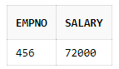

5. Code:

create table cust

(

acc_no number,

name varchar(25),

balance number

);

insert into cust values (12345,'Xayah',25000);

select * from cust;

declare

ac cust.acc_no%type:=12345;

function get_balance (ac cust.acc_no%type) return cust.balance%type is

bal cust.balance%type;

begin

select balance into bal from cust where acc_no=ac;

return bal;

end;

begin

dbms_output.put_line('The balance of a/c no.:'||ac||' is:'||get_balance(ac));

end;

Output:

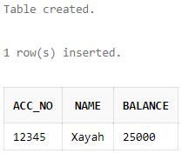



6. Code:

create table emp

(

empno number,

salary number

);

insert into emp values (123,60000);

insert into emp values (456,72000);

declare

function emp_count return number is

total_emp number;

begin

select count(*) into total_emp from emp;

return total_emp;

end;

begin

dbms_output.put_line('Number of employess is:'||emp_count());

end;

Output:





7. Code:

create or replace function cal_sum (n1 in number,n2 in number) return number is

a number;

begin

a:=n1+n2;

return a;

end;

declare

num1 number;

num2 number;

add number;

begin

num1:=5;

num2:=2;

add:=cal_sum(num1,num2);

dbms_output.put_line(num1||' + '||num2||' = '||add);

end;

Output:





8. Code:

create table emp

(

empno number(5),

ename varchar(25),

job varchar(15),

salary number(6),

deptno number(2)

);

insert into emp values (100,'Fiora','Marketing',48000,10);

insert into emp values (200,'Garen','Sales',45000,20);

insert into emp values (300,'Hecarim','Production',40000,30);

insert into emp values (400,'Jayce','Finance',56000,10);

insert into emp values (500,'Kaisa','Human Resource',63000,20);

create or replace function dept_sal (dept in emp.deptno%type) return emp.salary%type is

tot_sal emp.salary%type;

begin

select sum(salary) into tot_sal from emp where deptno=dept;

return tot_sal;

end;

declare

dept emp.deptno%type:=10;

begin

dbms_output.put_line('Total salary of employees in dept no.:'||dept||' is:'|| dept_sal(dept));

end;

Output:

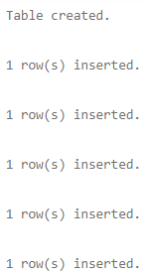





Created by:

Name: Priyanshu

Roll No.: 101803114

Group: COE-06