Pl/Sql Assignment 8

Table and records used for Ans. 1-2:

drop table emp;

create table emp

(

empno number(5),

ename varchar(25),

job varchar(15),

salary number(6),

deptno number(2)

);

insert into emp values (100,'Fiora','Marketing',48000,10);

insert into emp values (200,'Garen','Sales',45000,20);

insert into emp values (300,'Hecarim','Production',40000,30);

insert into emp values (400,'Jayce','Finance',56000,10);

insert into emp values (500,'Kaisa','Human Resource',63000,20);

select * from emp;

Output:

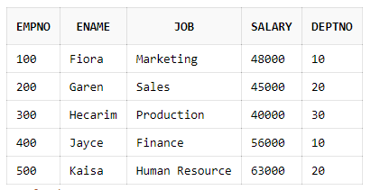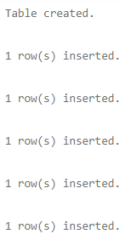

1. Code:

create or replace procedure add_record (entry emp%rowtype) is

begin

insert into emp values (entry.empno,entry.ename,entry.job,entry.salary,entry.deptno);

end;

declare

entry emp%rowtype;

begin

entry.empno:=600;

entry.ename:='Camille';

entry.job:='Service';

entry.salary:='43000';

entry.deptno:=30;

add_record(entry);

end;

select * from emp where empno=600;

Output:



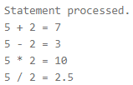

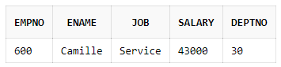

2. Code

create or replace function delete_record (dept emp.deptno%type) return number is

begin

delete from emp where deptno=dept;

return sql%rowcount;

end;

declare

dept emp.deptno%type:=10;

begin

dbms_output.put_line('The number of records deleted with dept no.:'||dept||' is:'||delete_record(dept));

end;

select * from emp;

Output:





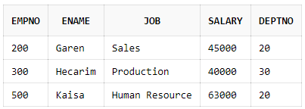

3. Code:

create or replace function stored_update_record (empid emp.empno%type) return number is

begin

update emp set ename='Camille' where empno=empid;

return sql%rowcount;

end;

declare

empid emp.empno%type:=100;

dept emp.deptno%type:=20;

function local_update_record (dept emp.deptno%type) return number is

begin

update emp set salary=salary+5000 where deptno=dept;

return sql%rowcount;

end;

begin

dbms_output.put_line('The number of records updated by stored function is:'||stored_update_record(empid));

dbms_output.put_line('The number of records updated by local function is:'||local_update_record(dept));

end;

select * from emp;

Output:



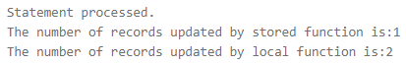

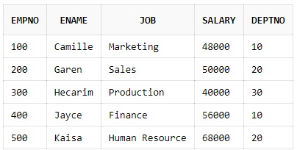

4. Code:

create table item

(

item_code number(1),

name varchar(20),

rate number(5)

);

insert into item values (1,'Smartphone',20000);

insert into item values (2,'Charger',15000);

insert into item values (3,'Earphones',1000);

insert into item values (4,'Memory Card',500);

insert into item values (5,'Power Bank',3000);

select * from item;

create table sale

(

item_code number(1),

cno number(3),

qty number(1)

);

insert into sale values (1,100,2);

insert into sale values (2,100,2);

insert into sale values (4,200,2);

insert into sale values (3,300,1);

insert into sale values (5,300,1);

select * from sale;

create or replace function cal_amount (ic item.item_code%type) return number is

price item.rate%type;

quantity sale.qty%type;

begin

select rate into price from item where item_code=ic;

select sum(qty) into quantity from sale where item_code=ic;

return price*quantity;

end;

declare

total_amount number:=0;

begin

for i in 1..5 loop

total_amount:=total_amount+cal_amount(i);

end loop;

dbms_output.put_line('The total amount is:'||total_amount);

end;

Output:

Table: item Table: sale



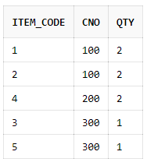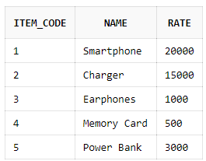





5. Code:

create table stu

(

rno number(3),

name varchar(25),

mst number(2),

quiz number(2),

est number(2),

total number(3)

);

insert into stu(rno,name,mst,quiz,est) values (100,'Varus',25,15,45);

insert into stu(rno,name,mst,quiz,est) values (200,'Braum',22,12,37);

insert into stu(rno,name,mst,quiz,est) values (300,'Neeko',27,18,43);

insert into stu(rno,name,mst,quiz,est) values (400,'Morgana',23,13,39);

select * from stu;

create or replace function cal_total (entry stu%rowtype) return stu.total%type is

begin

return entry.mst+entry.quiz+entry.est;

end;

declare

cursor c1 is

select * from stu;

begin

for entry in c1 loop

entry.total:=cal_total(entry);

update stu set total=entry.total where rno=entry.rno;

end loop;

end;

select * from stu;

Output:



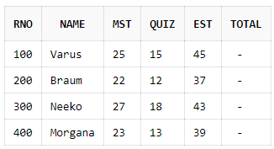🡪Initial stu table





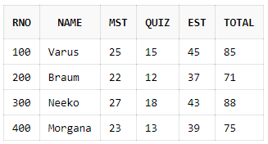🡪Final stu table

Table and records used for Ans. 6-7:

create table cust

(

cno number(2) primary key,

meterno number(3) unique,

prev_reading number(4),

current_reading number(4),

units number(4),

bill_amount number(6,2)

);

insert into cust(cno,meterno,prev_reading,current_reading) values (89,100,300,800);

insert into cust(cno,meterno,prev_reading,current_reading) values (67,101,790,1000);

insert into cust(cno,meterno,prev_reading,current_reading) values (90,200,800,1200);

insert into cust(cno,meterno,prev_reading,current_reading) values (62,789,200,800);

insert into cust(cno,meterno,prev_reading,current_reading) values (70,889,3200,8700);

insert into cust(cno,meterno,prev_reading,current_reading) values (66,500,3000,9800);

select * from cust;

Output:

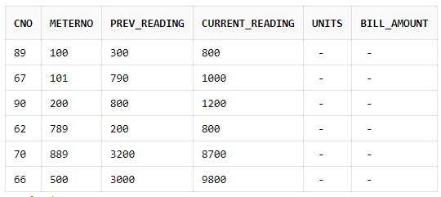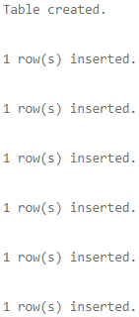

6. Code:

create or replace procedure cal_units_amt (custno cust.cno%type) is

entry cust%rowtype;

begin

select * into entry from cust where cno=custno;

entry.units:=entry.current_reading-entry.prev_reading;

if entry.units<=100 then

entry.bill_amount:=0.5*entry.units;

else

entry.bill_amount:=0.75*(entry.units-100)+0.5*100;

update cust set units=entry.units,bill_amount=entry.bill_amount where cno=custno;

end if;

end;

declare

custno cust.cno%type:=89;

begin

cal_units_amt(custno);

end;

select * from cust where cno=89;

Output:





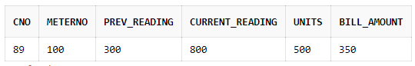

7. Code:

create or replace procedure cal_units_amt is

cursor c1 is

select * from cust;

begin

for entry in c1 loop

entry.units:=entry.current_reading-entry.prev_reading;

if entry.units<=100 then

entry.bill_amount:=0.5*entry.units;

else

entry.bill_amount:=0.75*(entry.units-100)+0.5*100;

update cust set units=entry.units,bill_amount=entry.bill_amount where cno=entry.cno;

end if;

end loop;

end;

begin

cal_units_amt();

end;

Output:

Created by:

Name: Priyanshu

Roll No.: 101803114

Group: COE-06





