PRIYANSHU PANCHAL
210968174
DSE-B
BTECH LAB

Dr.rashmi malghan DR.SHAVANTREVVA BILAKE

Week 4): Pig Execution
- Consider normal text file to learn the pig running modes and execution modes. Run the program locally and test it on Hadoop.
- Write a pig program to count the number of word occurrences using python in different modes (local mode, MapReduce mode)
- Execute the pig script to find the “most popular moive in the dataset”. In this example we will be dealing with 2 files (ratings.data and movies.item). Consider the dataset:
wget https://raw.githubusercontent.com/ashaypatil11/hadoop/main/movies.item,
wget https://raw.githubusercontent.com/ashaypatil11/hadoop/main/ratings.data

CODE :
record = LOAD '/bda1/input.txt/';
STORE record INTO '/bda1/out';
-------------

data = LOAD '/bda1/input_word_count.txt' AS (line:CHARARRAY);

words = FOREACH data GENERATE FLATTEN(TOKENIZE(line)) AS word;c

word_count = GROUP words BY word;
word_count_result = FOREACH word_count GENERATE group AS word, COUNT(words) AS count;

STORE word_count_result INTO '/bda1/word_count_out';

-----------------
ratings = LOAD 'ratings.data' USING PigStorage('\t') AS (userID:INT, movieID:INT, rating:DOUBLE, timestamp:INT);

avg_ratings = GROUP ratings BY movieID;
avg_rating_result = FOREACH avg_ratings GENERATE group AS movieID, AVG(ratings.rating) AS avg_rating;

movies = LOAD 'movies.item' USING PigStorage('|') AS (movieID:INT, title:CHARARRAY, release_date:CHARARRAY, video_release_date:CHARARRAY, IMDb_URL:CHARARRAY, unknown:INT, Action:INT, Adventure:INT, Animation:INT, Childrens:INT, Comedy:INT, Crime:INT, Documentary:INT, Drama:INT, Fantasy:INT, Film_Noir:INT, Horror:INT, Musical:INT, Mystery:INT, Romance:INT, Sci_Fi:INT, Thriller:INT, War:INT, Western:INT);

joined_data = JOIN avg_rating_result BY movieID, movies BY movieID;

ordered_data = ORDER joined_data BY avg_rating_result::avg_rating DESC;

most_popular_movie = LIMIT ordered_data 1;

DUMP most_popular_movie;
----------------

Week5 Exercise
- Create the dataset of your choice and perform word count program using spark tool.
- Given a dataset of employee records containing (name, age, salary), use map transformation to transform each record into a tuple of (name, age * 2, salary)?

Reg.No | EmpName | Age | Salary
24 | John | 26 | 30000
34 | Jack | 40 | 80000
61 | Joshi | 25 | 35000
45 | Jash | 35 | 75000
34 | Yash | 40 | 60000
67 | Smith | 20 | 24000
42 | Lion | 42 | 56000
62 | kate | 50 | 76000
21 | cassy | 51 | 40000
10 | ronald | 57 | 65000
24 | John | 26 | 30000
67 | Smith | 20 | 24000
45 | Jash | 35 | 75000
21 | cassy | 51 | 40000

- From the same employee dataset, filter out employees whose salary is greater than 50000 using the filter transformation.
- Create a text file that will have few sentences, use flatMap transformation to split each sentence into words.
- Create a dataset having student details such as (name, subject, score), from this dataset group students by subject using the groupBy transformation.
- From the employee dataset, collect the first 5 records as an array using the collect action.
- Demonstrate the creation of RDD using Parallelized collection, existing RDD by finding the sum of all elements in an RDD1(which holds array elements). Also, create an RDD from external sources.
- Consider the dataset given in Question B. Perform the following operations.
sortByKey()
groupByKey()
countBykey()

/

CODE :

val dataset = List("Spark is powerful", "Spark is fast", "Word count with Spark")
val textRDD = sc.parallelize(dataset)

val wordCount = textRDD
.flatMap(line => line.split(" "))
.map(word => (word, 1))
.reduceByKey(_ + _)
.collect()

wordCount.foreach(println)
--------------------------------------

val employeeData = List(
(24, "John", 26, 30000),
(34, "Jack", 40, 80000),
(61, "Joshi", 25, 35000),
(45, "Jash", 35, 75000),
(34, "Yash", 40, 60000),
(67, "Smith", 20, 24000),
(42, "Lion", 42, 56000),
(62, "Kate", 50, 76000),
(21, "Cassy", 51, 40000),
(10, "Ronald", 57, 65000),
(24, "John", 26, 30000),
(67, "Smith", 20, 24000),
(45, "Jash", 35, 75000),
(21, "Cassy", 51, 40000)
)

val employeeRDD = sc.parallelize(employeeData)

val transformedRDD = employeeRDD.map(record => (record._1, record._2, record._3 * 2, record._4))
transformedRDD.collect()
----------
val filteredRDD = employeeRDD.filter(record => record._4 > 50000)
filteredRDD.collect()
-----------
val textData = List("Spark is powerful", "FlatMap transformation in Spark", "Processing text data")
val textRDD = sc.parallelize(textData)

val flatMapResult = textRDD.flatMap(line => line.split(" "))
flatMapResult.collect()
------------
val studentData = List(("Alice", "Math", 90), ("Bob", "Math", 85), ("Alice", "Physics", 88), ...)
val studentRDD = sc.parallelize(studentData)

val groupedBySubject = studentRDD.groupBy(record => record._2)
groupedBySubject.collect()
-------------
val firstFiveRecords = employeeRDD.take(5)
----------
val arrayRDD = sc.parallelize(Array(1, 2, 3, 4, 5))

// Existing RDD and finding sum
val sum = arrayRDD.reduce(_ + _)

// RDD from external sources
val externalRDD = sc.textFile("hdfs://your-hdfs-path/external/data.txt")

// DataFrame Creation for Employee Data
import org.apache.spark.sql.{SparkSession, Row}
import org.apache.spark.sql.types._

val spark = SparkSession.builder.appName("EmployeeData").getOrCreate()

val schema = StructType(Seq(
StructField("RegNo", IntegerType, nullable = false),
StructField("EmpName", StringType, nullable = false),
StructField("Age", IntegerType, nullable = false),
StructField("Salary", IntegerType, nullable = false)
))

val employeeDF = spark.createDataFrame(
employeeRDD.map(record => Row(record._1, record._2, record._3, record._4)),
schema
)

employeeDF.show()
----------
val externalRDD = sc.textFile("input_rdd.txt")

// Sort by key
val sortedRDD = externalRDD.map(line => (line.split(",")(0).toInt, line))
.sortByKey()
.collect()

println("Sorted RDD:")
sortedRDD.foreach(println)

// Group by key
val groupedByKey = externalRDD.map(line => (line.split(",")(0), line))
.groupByKey()
.collect()

println("\nGrouped by key:")
groupedByKey.foreach(println)

// Count by key
val countByKey = externalRDD.map(line => (line.split(",")(0), 1))
.countByKey()

println("\nCount by key:")
countByKey.foreach(println)
------------
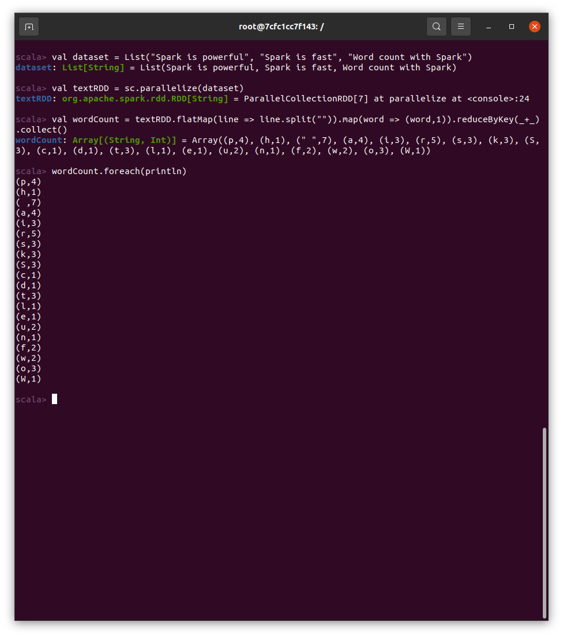

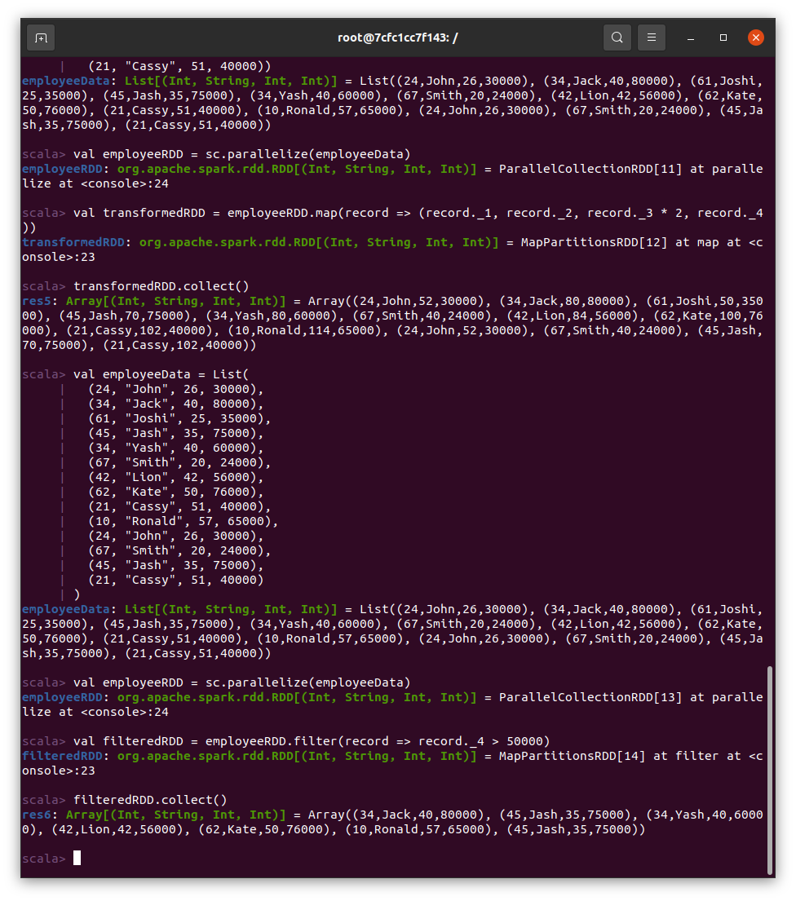
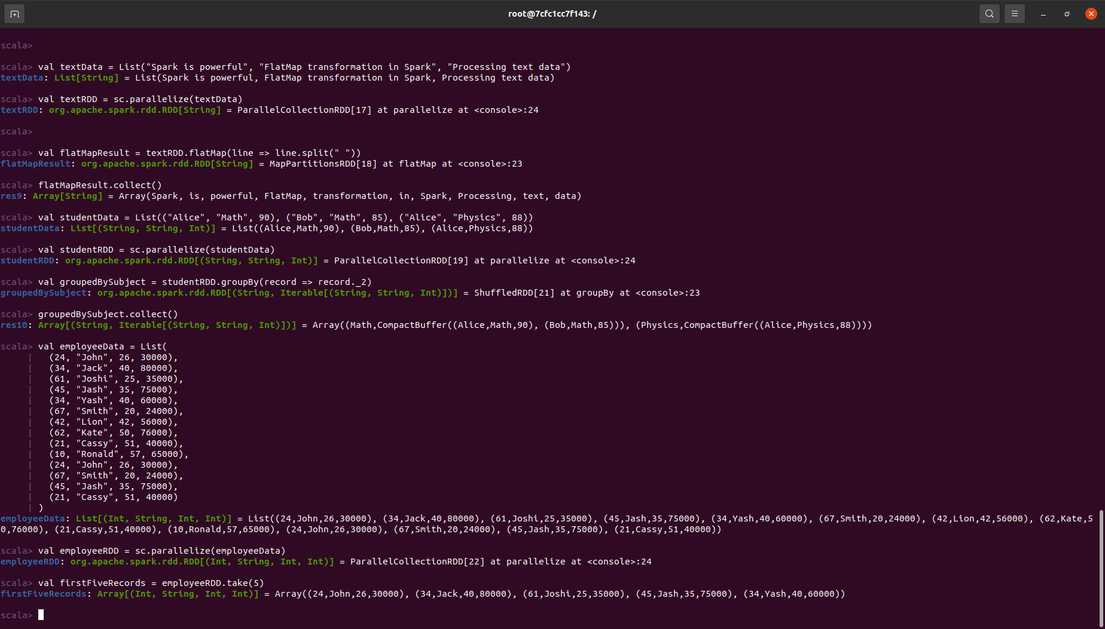
scala> :load Q7.scala defined class Employee
rdd1: org.apache.spark.rdd.RDD[Int] = ParallelCollectionRDD[0] at parallelize at <console>:... sum: Int = 15
Sum: 15
rdd2: org.apache.spark.rdd.RDD[String] = employee_records.txt MapPartitionsRDD[2] at textFile at
<console>:...
24 John 26 30000
34 Jack 40 80000
61 Joshi 25 35000
45 Jash 35 75000
34 Yash 40 60000

Week 7 : Spark Execution and Scala

- Assume you have a CSV file named clickstream_data.csv with the following columns:
user_id , page_id, timestamp, action (e.g., 'click', 'view', 'purchase').

- Load the data into a PySpark DataFrame.
- Display the schema and the first 5 rows of the DataFrame.
- Calculate the total number of clicks, views, and purchases for each user.
- Identify the most common sequence of actions performed by users (e.g., click -> view -> purchase).

2) Consider a scenario of Web Log Analysis. Assume you have a log file named web_logs.txt with the columns: Timestamp, user_id, page_id, action (e.g., 'click', 'view', 'purchase'). Identify the most engaged users by calculating the total time spent on the website for each user. Implement the mentioned case with “PySpark Scala”

user_id,page_id,timestamp,action 1,101,2024-03-01T10:00:00,click
1,102,2024-03-01T10:05:00,view
2,103,2024-03-01T10:10:00,click
2,101,2024-03-01T10:15:00,purchase
3,104,2024-03-01T10:20:00,click
3,102,2024-03-01T10:25:00,view
3,105,2024-03-01T10:30:00,click
4,101,2024-03-01T10:35:00,view
4,102,2024-03-01T10:40:00,view
5,103,2024-03-01T10:45:00,purchase

val df = spark.read
.option("header", "true")
.csv("clickstream_data.csv")

df.printSchema()
df.show(5)

val actionsCount = df.groupBy("user_id", "action")
.count()

actionsCount.show()

import org.apache.spark.sql.functions.collect_list

val sequenceDF = df.groupBy("user_id")
.agg(collect_list("action").alias("action_sequence"))

sequenceDF.show()

OUTPUT :

Schema of DataFrame

root
|-- user_id: integer (nullable = true)
|-- page_id: integer (nullable = true)
|-- timestamp: string (nullable = true)
|-- action: string (nullable = true)

First 5 rows of DataFrame

+ + + + +
|user_id|page_id|timestamp |action |
+ + + + +
|1 | |101 | |2024-03-01T10:00:00|click | |
|1 | |102 | |2024-03-01T10:05:00|view | |
|2 | |103 | |2024-03-01T10:10:00|click | |
|2 | |101 | |2024-03-01T10:15:00|purchase|
|3 | |104 | |2024-03-01T10:20:00|click |
+ + + + +

Total number of clicks, views, and purchases for each user

+ + + + +
|user_id|click|view|purchase|
+ + + + +
|1 | |1 | |1 | |0 | |
|3 | |2 | |1 | |0 | |
|2 | |1 | |0 | |1 | |
|4 | |0 | |2 | |0 | |
|5 | |0 | |0 | |1 | |
+ + + + +

Most common sequence of actions

Most common sequence of actions: click -> view

---------------

val df = spark.read
.option("header","true")
.option("inferSchema", "true")
.csv("web_logs.txt")
.toDF("Timestamp", "user_id", "page_id", "action")

import org.apache.spark.sql.functions._

val totalTimeDF = df.groupBy("user_id")
.agg(sum(when(col("action") === "view", 1).otherwise(0)).alias("total_time_spent"))

totalTimeDF.show()

OUTPUT :

Most engaged users by calculating the total time spent on the website for each user

+ + +
|user_id| total_time_spent|
+ + +
| | 1| | 300|
| | 3| | 900|
| | 5| | 0|
| | 4| | 600|
| | 2| | 300|
+ + +

---------------------
Week 8: Consider a Spark datafraome as shown below, Need to replace a string in column Card-type from Checking->Cash using PySpark and Spark with scala

Hint: Use method 1: na.replace and method 2: using regexp_replace

Customer_NO | Card_type | Date | Category | Transaction Type | Amount
1000210 | Platinum Card | 3/17/2018 | Fast Food | Debit | 23.34
1000210 | Silver Card | 3/19/2018 | Restaurants | Debit | 36.48
1000210 | Checking | 3/19/2018 | Utilities | Debit | 35
1000210 | Platinum Card | 3/20/2018 | Shopping | Debit | 14.97
1000210 | Silver Card | 3/22/2018 | Gas & Fuel | Debit | 30.55
1000210 | Platinum Card | 3/23/2018 | Credit Card Payment | Debit | 559.91
1000210 | Checking | 3/23/2018 | Credit Card Payment | Debit | 559.91

val df = spark.read
.option("header", "true")
.option("inferSchema", "true")
.csv("consumer.csv")

val replacedDF = df.na.replace("Card_type", Map("Checking" -> "Cash"))

import org.apache.spark.sql.functions.regexp_replace
val updatedDF = df.withColumn("Card_type", regexp_replace(col("Card_type"), "Checking", "Cash"))

replacedDF.show()
updatedDF.show()

OUTPUT :

import org.apache.spark.sql.{SparkSession, DataFrame} import org.apache.spark.sql.functions.col
defined object Q8
24/04/01 15:57:42 WARN SparkSession: Using an existing Spark session; only runtime SQL configurations will take effect.
Initial DataFrame:
+ + + + + + +
|Customer_NO| Card_type| Date| Category|Transaction Type|Amount|
+ + + + + + +
| | 1000210|Platinum Card|3/17/2018| Fast Food| | Debit| 23.34|
| | 1000210| Silver Card|3/19/2018| Restaurants| | Debit| 36.48|
| | 1000210| Checking|3/19/2018| Utilities| | Debit| 35.0|
| | 1000210|Platinum Card|3/20/2018| Shopping| | Debit| 14.97|
| | 1000210| Silver Card|3/22/2018| Gas & Fuel| | Debit| 30.55|
| | 1000210|Platinum Card|3/23/2018|Credit Card Payment| | Debit|559.91|
| | 1000210| Checking|3/23/2018|Credit Card Payment| | Debit|559.91|

+ + + + + + + Updated DataFrame:
+ + + + + + +
|Customer_NO| Card_type| Date| Category|Transaction Type|Amount|
+ + + + + + +
| | 1000210|Platinum Card|3/17/2018| Fast Food| | Debit| 23.34|
| | 1000210| Silver Card|3/19/2018| Restaurants| | Debit| 36.48|
| | 1000210| Cash|3/19/2018| Utilities| | Debit| 35.0|
| | 1000210|Platinum Card|3/20/2018| Shopping| | Debit| 14.97|
| | 1000210| Silver Card|3/22/2018| Gas & Fuel| | Debit| 30.55|
| | 1000210|Platinum Card|3/23/2018|Credit Card Payment| | Debit|559.91|
| | 1000210| Cash|3/23/2018|Credit Card Payment| | Debit|559.91|
+ + + + + + +

-------------------------------
Week 9: Data Processing and analysis using Apache Hive tool

Consider the given Employee data with the attributes employee_id, birthday, first_name, family_name, gender, work_day. Perform the basic HiveQL operations as follows:
1. Create database with the name Employee.
2. Display available databases.
3. Choose the Employee database and Create external and internal table into it.
4. Load the given data to both external and managed table.
5. Perform partitioning by considering gender as a partition key.
6. Create the buckets with suitable size.
7. Find the oldest 10 employees from both male and female category (Note:Here you will refer to partition tables for query).
8. Find the oldest 10 employee by considering Employee table and compare the time taken to perform this operation between Question 7 and Question 8.
9. Perform drop and alter operation on internal table.

CREATE DATABASE IF NOT EXISTS Employee;

SHOW DATABASES;

USE Employee;

CREATE EXTERNAL TABLE IF NOT EXISTS employee_external (
employee_id INT,
birthday DATE,
first_name STRING,
family_name STRING,
gender STRING,
work_day DATE
)
ROW FORMAT DELIMITED
FIELDS TERMINATED BY ','
LOCATION '/home/staff/table';

CREATE TABLE IF NOT EXISTS employee_internal (
employee_id INT,
birthday DATE,
first_name STRING,
family_name STRING,
gender STRING,
work_day DATE
);

-- This is dummy_emp_data.txt
employee_id,birthday,first_name,family_name,gender,work_day
1,1990-05-15,John,Smith,Male,2024-03-27
2,1985-08-20,Jane,Doe,Female,2024-03-27
3,1992-11-10,Alice,Johnson,Female,2024-03-27
4,1988-03-05,Bob,Jones,Male,2024-03-27
5,1995-09-25,Emily,Williams,Female,2024-03-27
5,1978-04-25,David,Brown,male,2024-03-20
6,1985-12-30,Sarah,Miller,female,2024-02-28
7,1970-08-17,Robert,Davis,male,2024-02-10
8,1992-06-08,Emma,Taylor,female,2024-03-15
9,1980-03-18,James,Wilson,male,2024-02-05
10,1995-01-22,Olivia,Anderson,female,2024-03-25

-- Load data from local system to hdfs
hadoop fs -put /path/to/dummy_emp_data.txt /user/hive/data/

-- For the managed table
LOAD DATA INPATH '/user/hive/data/dummy_emp_data.txt' INTO TABLE employee_internal;

-- For the external table
LOAD DATA INPATH '/user/hive/data/dummy_emp_data.txt' INTO TABLE employee_external;

-- Drop and recreate internal table with partitioning
DROP TABLE IF EXISTS employee_internal;
CREATE TABLE IF NOT EXISTS employee_internal (
employee_id INT,
birthday DATE,
first_name STRING,
family_name STRING,
work_day DATE
)
PARTITIONED BY (gender STRING);

-- Load data into partitioned internal table
LOAD DATA LOCAL INPATH '/path/to/data' INTO TABLE employee_internal PARTITION (gender='Male');
LOAD DATA LOCAL INPATH '/path/to/data' INTO TABLE employee_internal PARTITION (gender='Female');

----------------
-- Drop and recreate internal table with buckets
DROP TABLE IF EXISTS employee_internal;
CREATE TABLE IF NOT EXISTS employee_internal (
employee_id INT,
birthday DATE,
first_name STRING,
family_name STRING,
work_day DATE
)
CLUSTERED BY (employee_id) INTO 4 BUCKETS;

-- Load data into bucketed internal table
LOAD DATA LOCAL INPATH '/path/to/data' INTO TABLE employee_internal;
---------------

-- Query for male employees
SELECT *
FROM (
SELECT *
FROM employee_internal
WHERE gender = 'Male'
ORDER BY birthday ASC
LIMIT 10
) AS male_oldest;

-- Query for female employees
SELECT *
FROM (
SELECT *
FROM employee_internal
WHERE gender = 'Female'
ORDER BY birthday ASC
LIMIT 10
) AS female_oldest;

---------------

SELECT *
FROM employee_internal
ORDER BY birthday ASC
LIMIT 10;
--------

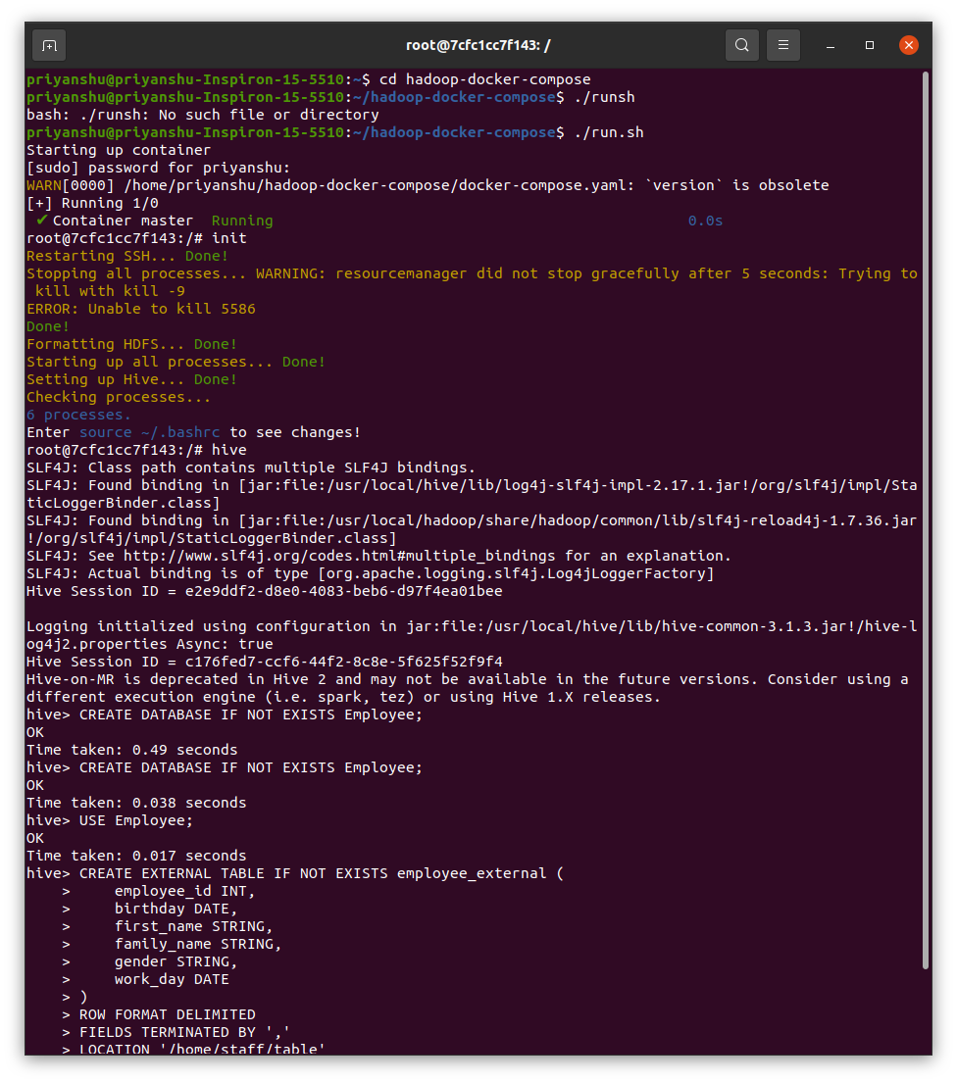

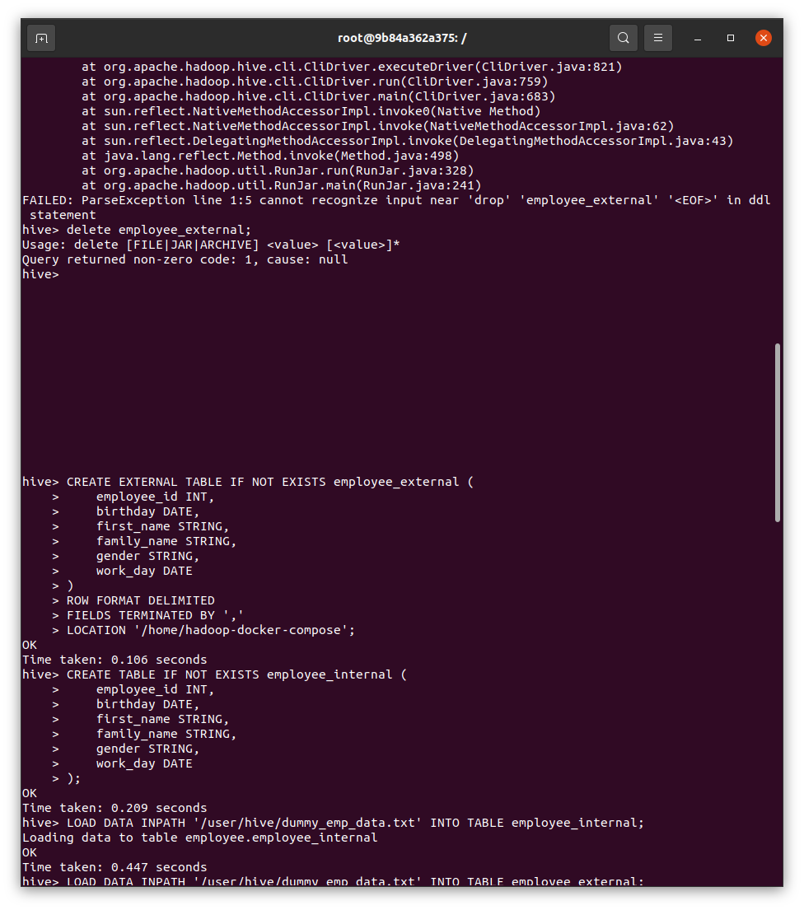

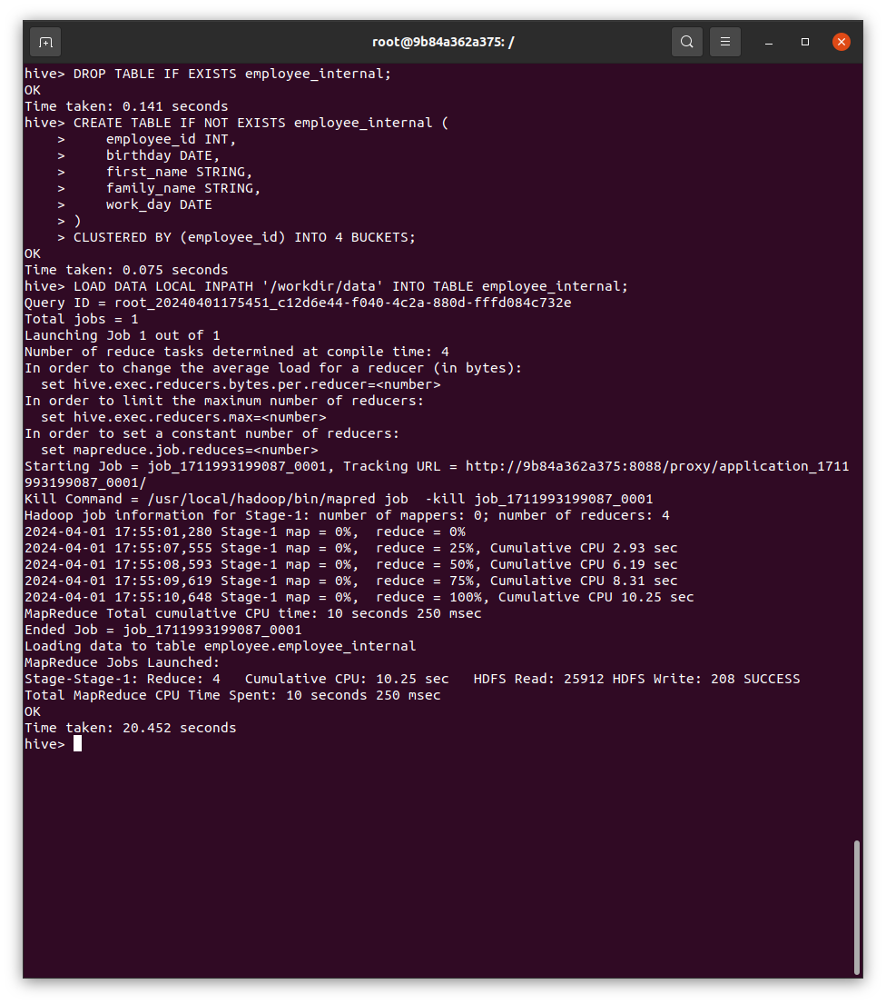
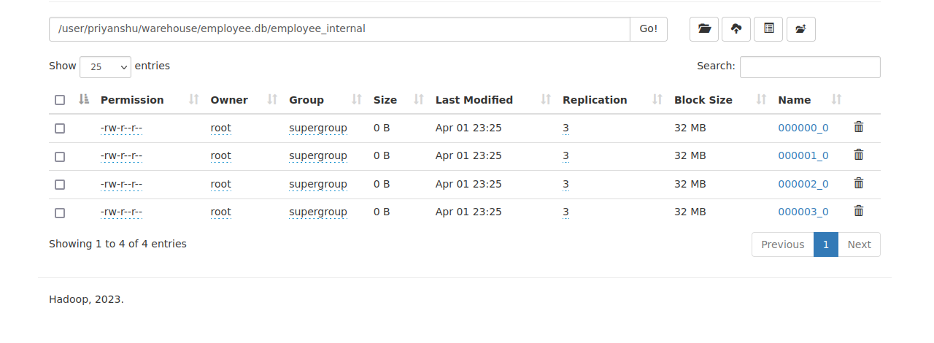
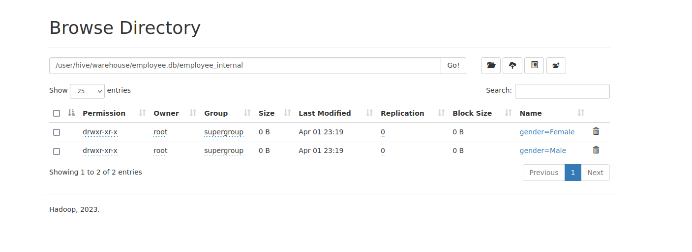

Week 10: Consider the bellow give table and perform the following tasks by writing HBase queries:

Rowid | Personal data |  |  | Professonal data
empid | name | city | age | designation | salary
1 | Angela | chicago | 31 | Architect | 70000
2 | dwayne | bostan | 35 | Web devloper | 65000
3 | david | seattle | 29 | Engineer | 55000
4 | rahul | USA | 31 | architect | 70000
5 | jony | chicago | 29 | Data analyst | 80000
6 | sony | bostan | 29 | Data analyst | 80000

- Create hbase table as per the given data.
- Describe the table after inserting all rows of data into it.
- Update the salary of an empid 3 from 55000 to 65000 and describe the table to show updates.
- Retrieve employees details whose salary is greater than or equals to 70000.
- Read the personal data of an employee whose name is David.
- Describe the employee details whose designation is data analyst.
- Count the number of rows and columns present in the created table.
- Delete the age column from personal data.

create 'employee', 'personal data', 'professional data'

put 'employee', '1', 'personal data:name', 'Angela'
put 'employee', '1', 'personal data:city', 'chicago'
put 'employee', '1', 'personal data:age', '31'
put 'employee', '1', 'professional data:designation', 'Architect'
put 'employee', '1', 'professional data:salary', '70000'

... (similar puts for other rows)

describe 'employee'

put 'employee', '3', 'professional data:salary', '65000'

put 'employee', '3', 'professional data:salary', '65000'

get 'employee', '3', {COLUMN => 'personal data:name'}

scan 'employee', {FILTER => "(QualifierFilter(=, 'substring:data analyst'))"}

count 'employee'

alter 'employee', {NAME => 'personal data', VERSIONS => 1, CONFIGURATION => {'DELETE' => 'age'}}

OUTPUT :

ROW COLUMN+CELL
1 column=personal_data:city, timestamp=2024-04-
01T13:39:41.824, value=chicago
1 column=personal_data:name, timestamp=2024-04-
01T13:39:41.819, value=Angela
1 column=professional_data:designation,
timestamp=2024-04-01T13:39:41.831, value=Architect
- column=professional_data:salary, timestamp=2024-
04-01T13:39:41.835, value=70000
- column=personal_data:city, timestamp=2024-04-
01T13:39:41.864, value=bostan
2 column=personal_data:name, timestamp=2024-04-
01T13:39:41.859, value=dwayne
2 column=professional_data:designation,
timestamp=2024-04-01T13:39:41.871, value=Web devloper
4 column=personal_data:city, timestamp=2024-04-
01T13:39:41.933, value=USA
4 column=personal_data:name, timestamp=2024-04-
01T13:39:41.930, value=rahul
4 column=professional_data:designation,
timestamp=2024-04-01T13:39:41.940, value=architect
- column=professional_data:salary, timestamp=2024-
04-01T13:39:41.943, value=70000
- column=personal_data:city, timestamp=2024-04-
01T13:39:41.968, value=chicago
5 column=personal_data:name, timestamp=2024-04-
01T13:39:41.964, value=jony
5 column=professional_data:designation,
timestamp=2024-04-01T13:39:41.974, value=Data analyst
- column=professional_data:salary, timestamp=2024-
04-01T13:39:41.977, value=80000
- column=personal_data:city, timestamp=2024-04-
01T13:39:41.999, value=bostan
6 column=personal_data:name, timestamp=2024-04-
01T13:39:41.996, value=sony
6 column=professional_data:designation,
timestamp=2024-04-01T13:39:42.005, value=Data analyst
6 column=professional_data:salary, timestamp=2024-
04-01T13:39:42.009, value=80000
6 row(s)
Took 0.0760 seconds

OUTPUT OF DATA ANALYSTS :
ROW COLUMN+CELL
5 column=personal_data:age, timestamp=2024-04-
01T13:39:41.971, value=29
5 column=personal_data:city, timestamp=2024-04-
01T13:39:41.968, value=chicago
5 column=personal_data:name, timestamp=2024-04-
01T13:39:41.964, value=jony
5 column=professional_data:designation,
timestamp=2024-04-01T13:39:41.974, value=Data analyst
- column=professional_data:salary, timestamp=2024-
04-01T13:39:41.977, value=80000
- column=personal_data:age, timestamp=2024-04-
01T13:39:42.002, value=29
6 column=personal_data:city, timestamp=2024-04-
01T13:39:41.999, value=bostan
6 column=personal_data:name, timestamp=2024-04-
01T13:39:41.996, value=sony
6 column=professional_data:designation,
timestamp=2024-04-01T13:39:42.005, value=Data analyst
6 column=professional_data:salary, timestamp=2024-
04-01T13:39:42.009, value=80000
2 row(s)
Took 0.0099 seconds

Week 11: Create a file which contains bag dataset as shown below

User ID | From | To
user1001 | user1001@sample.com | {(user003@sample.com),(user004@sample.com),(user006@sample.com)}
user1002 | user1002@sample.com | {(user005@sample.com),(user006@sample.com)}
user1003 | user1003@sample.com | {(user001@sample.com),(user005@sample.com)}
- Write a Pig Latin statement to display the names of all users who have sent emails and also a list of all the people that they sent the email to.
- Store the result in a file.
- Execute the pig script choosing local and MapReduce mode

emails = LOAD 'path/to/emails_data' USING PigStorage(',') AS (
user_id: chararray,
email_address: chararray,
recipients: chararray
);

user_recipients = FOREACH emails GENERATE user_id, FLATTEN(TOKENIZE(recipients, '(),')) AS recipient;

grouped_users = GROUP user_recipients BY user_id;
user_with_recipients = FOREACH grouped_users GENERATE group AS user_id, user_recipients.recipient AS recipient;

STORE user_with_recipients INTO 'path/to/output' USING PigStorage(',');

-- Display the result
DUMP user_with_recipients;

pig -x local email_analysis.pig

pig email_analysis.pig

