INTERNSHIP REPORT
ON
C++ PROGRAMMING
Submitted To
School of Computer Science and Engineering
IILM University, Greater Noida, U.P.
In partial fulfilment of the requirement of degree of
B.Tech CSE

By
PRIYANSHU KUMAR SINGH
Enrollment No.: 25SCS1003004444
B.Tech CSE, 3rd Semester
Batch: 2026-27
Organization: CodSoft

CANDIDATE’S DECLARATION
I, Priyanshu Kumar Singh, do hereby declare that the internship report titled “C++ Programming” has been completed by me to fulfil the requirement for the award of the degree of Bachelor of Technology in CSE. All the references have been quoted and I have not taken as such any material from any other source. I affirm to you that this report is my own and has not been submitted to any other institute for any degree/diploma requirement and further I shall be solely responsible for any kind of copyright violation in this regard.

Signature: ____________________
Student Name: Priyanshu Kumar Singh
Roll/Enrollment No.: 25SCS1003004444

ACKNOWLEDGEMENT
I am using this opportunity to express my gratitude to everyone who supported me throughout the Internship Program. I am thankful for their aspiring guidance, invaluably constructive criticism and friendly advice during this work. I am sincerely grateful to them for sharing their truthful and illuminating views on a number of issues related to this work.
I express my gratitude to my parents for their blessings.

Signature: ____________________
Student Name: Priyanshu Kumar Singh
Roll/Enrollment No.: 25SCS1003004444

INTERNSHIP COMPLETION CERTIFICATE
The Internship Completion Certificate issued by the organization/industry should be attached on this page.

Organization: CodSoft
Internship Domain: C++ Programming
Student: Priyanshu Kumar Singh
Enrollment No.: 25SCS1003004444

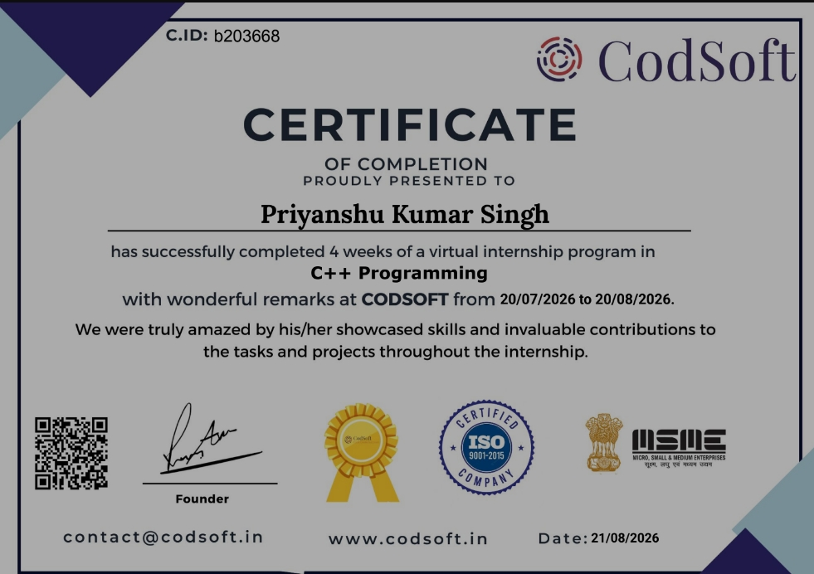

4. PROJECT DESCRIPTION
4.1 Introduction
The internship at CodSoft focused on C++ programming and console-based application development. During the internship, I practiced programming logic, problem-solving, control structures, functions and user input handling. The practical work involved developing multiple mini-projects using C++.
4.2 Organization Profile
CodSoft provided an internship focused on C++ Programming, with emphasis on practical programming and application development. The internship offered an opportunity to apply programming concepts through console-based projects.
4.3 Problem Statement
The main problem addressed during the internship was to convert basic programming concepts into functional, interactive console applications. This required designing correct program logic, handling user inputs, managing application flow, and testing different possible cases.
4.4 Project Objectives
• Strengthen C++ programming fundamentals.
• Improve logical thinking and problem-solving.
• Understand control structures and functions.
• Gain practical experience through projects.
• Develop user-interactive console applications.
4.5 Scope of the Project
The project work covers console-based C++ applications and the practical use of programming fundamentals. The developed applications include a Number Guessing Game, To-Do List, and Tic-Tac-Toe. The scope includes programming logic, user input handling, control structures, functions, testing and debugging.
4.6 Technologies and Tools Used
• C++
• C++ Standard Library
• VS Code / C++ Compiler
• Console-based interface

4.7 System Architecture
The applications follow a simple console-based architecture. User input is received through the console, processed using C++ programming logic, and the corresponding output is displayed back to the user. The general flow is: User Input → Program Logic → Processing → Output.
4.8 Methodology
• Understanding the problem.
• Breaking it into smaller steps.
• Designing the logic.
• Implementing the solution in C++.
• Testing and debugging.
Project 1: Number Guessing Game
The Number Guessing Game is a console-based C++ application in which the user attempts to guess a number. The project uses conditions and control structures and provides an interactive way to practice programming logic.
Project 2: To-Do List
The To-Do List is a console-based task management application that allows users to manage tasks. It uses C++ programming concepts and user input handling and focuses on organizing information through programming logic.
Project 3: Tic-Tac-Toe
Tic-Tac-Toe is a two-player console-based game. It implements game logic using C++ and uses conditions, loops and functions. The application handles player input and game outcomes.
4.9 Expected Outcomes
• Improved confidence in C++.
• Better understanding of programming fundamentals.
• Ability to convert ideas into working applications.
• Improved debugging and problem-solving abilities.
• Hands-on experience in developing and testing C++ applications.

4.10 Certificates of Completion and Other Communication Mail Proof
The internship certificate, project screenshots and relevant completion/proof documents should be attached in this section.


[Attach project screenshots here]
[Attach relevant communication mail proof here]

SKILLS DEVELOPED
• C++ Programming
• Logical Thinking
• Problem-Solving
• Debugging
• User Input Handling
• Console Application Development
CHALLENGES FACED
• Designing correct program logic.
• Handling different user inputs.
• Debugging errors.
• Managing game/application flow.
• Testing different possible cases.
LEARNING OUTCOMES
• Improved confidence in C++.
• Better understanding of programming fundamentals.
• Learned to convert ideas into working applications.
• Improved debugging and problem-solving abilities.
CONCLUSION
The internship provided practical exposure to C++ programming. During the internship, three console-based applications were developed: Number Guessing Game, To-Do List, and Tic-Tac-Toe. The work strengthened programming logic and problem-solving skills and provided hands-on experience in developing and testing C++ applications.

5. BIBLIOGRAPHY / REFERENCES
1. C++ Standard Library documentation and learning resources used during the internship.
2. CodSoft internship project materials and instructions.
3. Relevant C++ programming references consulted during project development.

