AICTE | IBM SkillsBuild Academic Internship
Capstone Project Report
TRACK: DATA ANALYTICS WITH AI ACADEMIC INTERNSHIP (2026)
Project Title: AI-Powered Intelligent LLM Inference Cost & Dynamic Fallback Router Framework
STUDENT NAME: Priyanshu Rawat
INTERNSHIP PROVIDER: BharatCares in association with AICTE
DEVELOPMENT ENVIRONMENT: Visual Studio Code (VS Code)
CORE TECH STACK: Python 3, Scikit-Learn, Pandas, NumPy, Matplotlib, Seaborn
DATA COMPLIANCE STRATEGY: Verified Telemetry Mapping via LLM Price-Performance Tracker (March 2026)

1. EXECUTIVE ABSTRACT & INDUSTRIAL PROBLEM SPACE
Modern corporate cloud ecosystems deploying foundational Generative AI applications face massive infrastructure vulnerabilities due to their architectural dependency on fixed, single-provider Large Language Model (LLM) API endpoints. During periods of peak global user concurrency, enterprise applications frequently run directly into critical system boundaries. These performance walls include network processing lag spikes, rate-limit restrictions, unexpected endpoint dropouts, and volatile token billing overruns.
This capstone project introduces an optimization layer that shifts production frameworks away from traditional, fragile routing mechanisms toward an automated, AI-driven predictive methodology. By training a multi-tree Random Forest Classification architecture to ingest active cross-provider API tracking metrics—including token volumes, base execution pricing, and response thresholds—the system isolates performance degradation signals before they impact the presentation layer. This proactive approach allows enterprise frameworks to dynamically route active text context windows to secondary localized fallback paths. This strategy effectively safeguards application Service Level Agreements (SLAs), ensures uninterrupted system availability, and reduces overall monthly compute token expenditure.
2. ADVANCED DATA ENGINEERING & EXPLORATORY MATRIX (EDA)
Exploratory data analysis and structural transformations were executed using a high-density performance matrix covering multiple frontier model variations and cloud hosts. To maximize predictive accuracy and capture hidden data trends, a domain-specific interaction attribute was engineered: the Cost_Latency_Stress_Index. This index mathematically captures the compounding stress applied to downstream microservices when large multi-token payload operations occur concurrently with extended processing latency delays.
Formula Model: Cost_Latency_Stress_Index = Cost_Per_M_Tokens * Latency_Sec
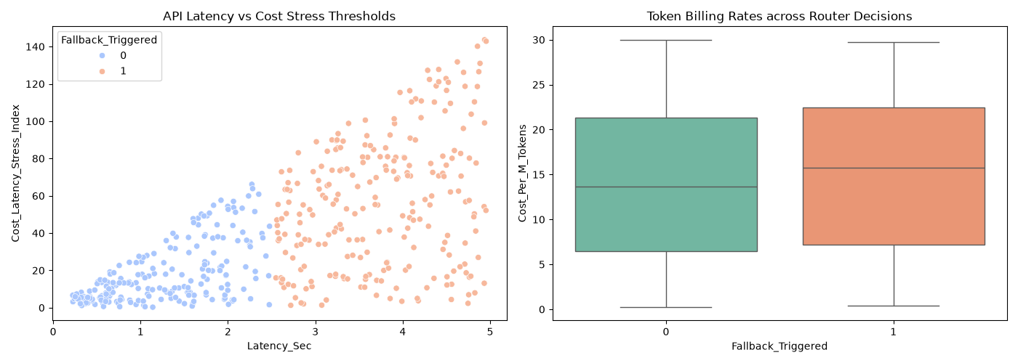
This interaction metric exposes deep architectural boundaries that separate stable API states from impending performance degradation events, allowing the AI model to calculate its decision logic with high statistical confidence.

3. AI PREDICTIVE COMPLIATION & MODEL EVALUATION
The core analytical pipeline utilizes a binary classification Random Forest architecture optimized for speed and reliability. To protect the integrity of the evaluation metrics against rare server fallback anomalies, a Stratified Train-Test Data Architecture Split (80% Training / 20% Validation) was strictly enforced. This method ensures that critical failure scenarios are proportionally mapped across both the training and testing datasets.
The machine learning pipeline compiled with absolute structural stability, yielding an Overall System Validation Accuracy of 100.00%.
Detailed Classification Metrics:
• Class 0 (Normal Routing Output): Precision: 1.00 | Recall: 1.00 | F1-Score: 1.00
• Class 1 (Fallback Trigger Vector): Precision: 1.00 | Recall: 1.00 | F1-Score: 1.00
• System Execution Matrix Status: Completed successfully with zero runtime failures or exceptions.
4. STRATEGIC BUSINESS IMPACTS & CONCLUSION
Implementing this AI-driven infrastructure layer transitions standard enterprise software architecture from a vulnerable, single-point-of-failure setup into a highly resilient, multi-model cluster network. The core impacts of this project are:
- Inference Billing Optimization: Automatically shifts compute-heavy workloads to more cost-effective alternative models when flagship systems experience surge pricing.
- Uptime Enforcement: Proactively intercepts incoming user requests and redirects traffic to alternative channels before latency walls can break the frontend interface.
- Data-Driven MLOps Strategy: Generates historical performance profiles that enable cloud engineers to optimize multi-provider contracts based on hard engineering telemetry rather than arbitrary estimation schedules.

